

**ASSESSING FARMERS’ LITERACY ON CLIMATE CHANGE AND ITS IMPACT ON FOOD SECURITY IN THE NORTHERN REGION OF BANGLADESH: MULTIPLE LINEAR REGRESSION ANALYSIS**

**MD. SAIDUR RAHMAN**

**A RESEARCH PROJECT REPORT**

**DEGREE OF BACHELOR OF SCIENCE**

**BEGUM ROKEYA UNIVERSITY, RANGPUR2024**

**ASSESSING FARMERS’ LITERACY ON CLIMATE CHANGE AND ITS IMPACT ON FOOD SECURITY IN THE NORTHERN REGION OF BANGLADESH: MULTIPLE LINEAR REGRESSION ANALYSIS**

MD.SAIDUR RAHMAN

**A RESEARCH PROJECT REPORT SUBMITTED IN PARTIAL FULFILLMENT OF THE REQUIREMENTS FOR THE**

**DEGREE OF BACHELOR OF SCIENCE IN STATISTICS**

**FACULTY OF SCIENCE, BEGUM ROKEYA UNIVERSITY, RANGPUR**

**2024**

**MD. SAIDUR RAHMAN 2024**. Assessing farmers’ literacy on climate change and its impact on food security in the northern region of Bangladesh: a logistic regression analysis

Bachelor of Science Research Project Report in Statistics, Faculty of Science, Begum Rokeya University, Rangpur.

**Project Advisor:** Assoc.Prof. Dr. Md. Siddikur Rahman

**ABSTRACT**

**Introduction**

Climate change poses significant challenges to agricultural systems globally, affecting food security and livelihoods, particularly in vulnerable regions like the northern part of Bangladesh. This paper aims to assess farmers' literacy regarding climate change and its impact on food security in this specific geographical context. The research investigates farmers' awareness, knowledge, and understanding of climate change and their perceptions of its impact on agricultural practices and food security. Additionally, it examines the challenges farmers face in adapting to changing climatic conditions and the consequent implications for foodsecurity.

**Methods and Materials**

The study was conducted in eight districts of Rangpur division of Bangladesh. 901 farmers were selected as samples. We analyzed the data using descriptive statistics, multivariate probit, and propensity score matching.

**Result**

Among the respondent farmers, 41% had taken measures to adapt to the changing climate and its impact on agriculture and food security. Changes in crop farming techniques were used as adaptation measures by more than 41% of the households. Savings-related adaptation measures were used by around 32% of the households. Socio-economic determinants of households had a significant role in adopting adaptation measures. Around 20% of farmers rated their current level of food security as insecure, and in most cases, this was due to economic factors. More than 60% of the farmers think adopting adaptation measures has reduced household food insecurity.

**Conclusion**

The research aims to contribute insights for policymakers, NGOs, and agricultural extension services to design targeted interventions that enhance climate change literacy among farmers.

**Keywords:** Climate perception; Adaptation strategies; Food insecurity; Logistic Regression

**ACKNOWLEDGEMENTS**

It is a genuine pleasure to express my deep sense of thanks and gratitude to my honorable supervisor, Dr. Md. Siddikur Rahman, Associate Professor, Department of Statistics, Begum Rokeya University, Rangpur, for his valuable suggestions starting from the preparation of the research proposal to the completion of the entire thesis work. Without his support, advice, encouragement enthusiasm, countless hours of effective discussion and scientific concern patience and tireless efforts completion of the project report would not possible.

I am grateful to my respected course teachers for their teachings about how the research should be done. I am also grateful to my friends and relatives for helping me with the data collection and technical assistance.

Finally, I would like to thank my lovely parents, husband, mother-in-law and family members who worked hard all their lives and provided me with support, devotion, love, and encouragement.

**MD. SAIDUR RAHMAN**

**TABLE OF CONTENTS**

|  |  |  |  |  |  |  |  |  |  |
| --- | --- | --- | --- | --- | --- | --- | --- | --- | --- |
|  |  |  | | |  | | |  | **Pages** |
| ABSTRACT | |  | | |  | | |  | 2 |
| ACKNOWLEDGEMENTS | | | | |  | | |  | 3 |
| LIST OF TABLES | | | | |  | | |  | 5 |
| LIST OF FIGURES | | | | |  | | |  | 6 |
| LIST OF ABBREVIATIONS | | | | | | | |  | 7 |
| CHAPTER 1 INTRODUCTION | | | | | | | |  |  |
|  | 1.1 Climate Vulnerability Context to Bangladesh | | | | | | | | 9 |
|  | 1.2 Impact of Climate Change on Agriculture and Livelihoods in Bangladesh | | | | | | | | 10 |
|  | 1.3 Adaptation to Climate Change for Improving Livelihoods and Food Security | | | | | | | | 12 |
|  | 1.4 Climate Change Impact, Adaptation, and Literacy in the Northern Region | | | | | | | | 13 |
| CHAPTER 2 REVIEW OF LITERATURE | | | | | | | |  |  |
|  | 2.1 Climate Change and Agriculture in Bangladesh | | | | | | |  | 15 |
|  | 2.2 Impact of Climate Change on Food Security | | | | | | |  | 15 |
| CHAPTER 3 RSEARCH METHODOLOGY | | | | | | | |  |  |
|  | 3.1 Methods and materials | | | |  | | |  | 17 |
|  | 3.1.1 Study area | | | |  | | |  | 17 |
|  | 3.1.2 Sample size determination | | | | | | |  | 18 |
|  | 3.2 Study Design | | | | | | |  | 19 |
|  |  | 3.2.1 Questionnaire Development and Pretesting | | | | | |  | 19 |
|  |  | 3.2.2 Data collection | | | | | |  | 19 |
|  |  | 3.2.3 Knowledge Assessment | | | | | |  | 19 |
|  |  |  | | | 3.2.4Practice Assessment | | |  | 21 |
|  |  |  | | | 3.2.5 Data Transformation and Grading  3.2.6 Integrating of questionnaire | | |  | 21 |
|  | 3.3 Statistical Analysis | | | |  | | |  | 26 |
|  |  | CHAPTER 4 RESULT | | | | | |  | 27 |
|  |  | 4.1 Climate variability in the study areas | | | | | |  | 28 |
|  |  | 4.2 Descriptive statistics of yearly climate factors in study areas | | | | | |  | 32 |
|  |  | 4.3 Discussion | | | | | |  | 36 |
|  |  | 4.3.1 Socio-economic and demographic profile of surveyed household | | | | | |  | 36 |
|  |  | 4.3.2 Farmer’s perception of climate change and Adaptation Strategies | | | | | |  | 38 |
|  |  | 4.3.3 Perception of Changes in Temperature and Rainfall Levels | | | | | |  | 39 |
|  |  | 4.3.4 Perception of Extreme Weather Events | | | | | |  | 39 |
|  |  | 4.3.5 Implications for Adaptation Strategies | | | | | |  | 41 |
|  |  | 4.3.6 Perception of Changes in Temperature and Rainfall Levels | | | | | |  | 42 |
|  |  | 4.3.7 Farmer’s perception of climate change and Adaptation Strategies | | | | | |  | 54 |
| CHAPTER 5 CONCLUSION | | | | | | | |  | 57 |
|  | 5. Conclusion  5.1 Limitation | | | | | | |  | 57  58 |
| REFERENCES | | |  |  | |  | 67 | | | |
| APPENDICES | | |  |  | |  |  | | | |
|  | APPENDIX A Questionnaire | | | | | | 60 | | | |
| VITAE | | |  |  | |  | 69 | | | |

**LIST OF TABLES**

|  |  |  |
| --- | --- | --- |
|  |  | **Pages** |
| Table 1 | Description of variables queried in the survey instrument | 24 |
|  |  |  |
| Table 2 | Yearly temperature in study areas of Bangladesh from 1997-2022 | 32 |
| Table 3 | Yearly rainfall in study areas of Bangladesh from 1997-2022 | 34 |
|  |  |  |
| Table 4 | Yearly relative humidity in study areas of Bangladesh from 1997-2022 | 35 |
|  |  |  |
| Table 5 | Socio-economic and demographic profile of surveyed household | 36 |
| Table 6 | Farmers’ perception of climate change and the adoption of adaptation  strategies | 39 |
|  |  |
| Table 7 | Adaptation to climate change | 41 |
| Table 8 | Factors affecting or role of socio-economic in adaptation decisions | 44 |
|  | using logistic regression model |  |
| Table 9 | Chi-square among Socio-demographic variables and climate change | 47 |
|  | adjustment |  |
| Table 10 | Logistic-Regression including CI (95%) | 48 |
| Table 11 | Logistic Regression of Socio-demographic variable with Climate | 51 |
|  | Change Knowledge, Food Security Knowledge, Climate Change |  |
|  | Practice, and Food Security Practice, respectively |  |
| Table 12 | Farmers’ perception of food security and the adoption of adaptation | 55 |
|  | strategies |  |
|  |  |  |

**LIST OF FIGURES**

|  |  |  |
| --- | --- | --- |
|  |  | **Pages** |
| Figure 1 | Map of the selected study area | 18 |
| Figure 2a | Schematic conceptual frameworks of farmers’ adaptation decisions | 22 |
|  | and practice | 23 |
| Figure 2b | Schematic conceptual frameworks of farmers’ adaptation decisions |  |
|  | and practice |  |
| Figure 3 | Monthly average temperature, total rainfall and relative humidity in | 28 |
|  | the study areas during 1997-2022 |  |
| Figure 4 | Annual average temperature, total rainfall, and relative humidity in | 30 |
|  | 2022 |  |
| Figure 5 | District-wise average temperature, total rainfall, and relative  humidity in the study areas from 1997-2022 | 31 |

**LIST OF ABBREVIATIONS**

|  |  |  |
| --- | --- | --- |
|  | |  |
| PS | | MERRA-2 Surface Pressure (kPa) |
| TS | | MERRA-2 Earth Skin Temperature ( c ) |
| QV2M | | MERRA-2 Specific Humidity at 2 Meters (g/kg) |
| RH2M | | MERRA-2 Relative Humidity at 2 Meters (%) |
| WD10M | | MERRA-2 Wind Derection at 10 Meters (Degrees) |
| GWETTOP | | MERRA-2 Surface Soil Wetness (1) |
| T2M_MAX | | MERRA-2 Temperature at 2 Meters Maximum ( c ) |
| T2M_MIN | | MERRA-2 Temperature at 2 Meters Minimum c ) |
| GWETPROF | | MERRA-2 Profile Soil Moisture ( 1 ) |
| GWETROOT | | MERRA-2 Root Zone Soil Wetness (1) |
| CLOUD_AMT | | CERES SYN1deg Cloud Amount (%) |
| T2M_RANGE | | MERRA-2 Temperature at 2 Meters Range ( c ) |
| WS10M_MAX | | MERRA-2 Wind Speed at 10 Meters Maximum ( m/s) |
| WS10M_MIN | | MERRA-2 Wind Speed at 10 Meters Minimum ( m/s) |
| TOA_SW_DWN | | CERES SYN1deg Top Of Atmosphere Shortwave Downward Irradiance (MJ/m^2/day) |
| PRECTOTCORR | | MERRA-2 Precipitation Corrected (mm/day) |
| ALLSKY_SFC_UVA | | CERES SYN1deg All Sky Surface UVA Irradiance (W/m^2) |
| ALLSKY_SFC_UVB | | CERES SYN1deg All Sky Surface UVB Irradiance (W/m^2) |
| ALLSKY_SRF_ALB | | CERES SYN1deg All Sky Surface Albedo (Dimensionless) |
| ALLSKY_SFC_PAR_TOT | | CERES SYN1deg All Sky Surface PAR Total (W/m^2) |
| CLRSKY_SFC_PAR_TOT | | CERES SYN1deg Clear Sky Surface PAR Total (W/m^2) |
| ANN | | Annual |
| NASA | National aeronautics and space administration | |
| SD | Standard deviation | |
| n | Frequency | |
| Min | Minimum | |
| Max | Maximum | |
| CCV | Change of crop varieties | |
| CD | Crop Diversification | |
| ACR | Adopt crop rotation | |
| MF | Mixed farming | |
| LD | Livelihood diversification | |
| CI | Change to Irrigation | |
| CPT | Change of planting time | |
| UIPM | Use of Integrated Pest Management | |
| UM | Use of manure | |
| CFAR | Change in fertilizer application rate | |
| TP | Tree planting | |
| SC | Soil conservation | |
| SCFL | Switch from crop farming to livestock | |
| ILUF | Increase land under farming | |
| RLUC | Reducing the land under cultivation | |
| C-Know | Climate change knowledge | |
| F-Know | Food Security Knowledge | |
| OR | Odds ratio | |
| E(B) | Odds ratio | |
| CI | Confidence interval | |
| Sig. | Significance | |

**Chapter one**

**Introduction**

**1.1 Climate Vulnerability Context to Bangladesh**

Climate change is a critical global issue and has become a pressing concern worldwide. Climate change poses significant threats, signaling potential destruction and harm to human life, property, infrastructure, livestock, agricultural output, the environment, and the Earth's surface [1]. Various natural disasters and adverse atmospheric alterations cause this devastation. Climate vulnerability in Bangladesh's Northern region, particularly in the Rangpur division and its districts, presents a complex and pressing challenge that necessitates urgent attention and comprehensive strategies for adaptation and resilience-building. The northern region of Bangladesh, including Rangpur division and its districts such as Rangpur, Gaibandha, Kurigram, Lalmonirhat, Nilphamari, and Dinajpur, faces multiple climate-related hazards due to its geographical location, socio-economic characteristics, and environmental factors [2].

The northern region of Bangladesh is characterized by its low-lying topography, proximity to major rivers such as the Teesta, Jamuna, and Brahmaputra, and high population density. These geographical features make the region highly susceptible to flooding during the monsoon season, as river water levels rise and inundate vast land areas[3].

The flooding damages infrastructure and disrupts livelihoods, particularly those dependent on agriculture, which is the primary source of income for many residents in Rangpur division. In addition to flooding, the region experiences other climate-related hazards such as cyclones, storms, droughts, and riverbank erosion. These hazards have become more frequent and intense in recent years due to climate change, exacerbating the vulnerability of communities in Northern region. For example, the increased frequency of extreme weather events poses a significant threat to agricultural productivity, leading to food insecurity and economic losses for farmers and rural households.

The vulnerability of Rangpur division and its districts to climate change is further compounded by socio-economic factors such as poverty, limited access to resources and infrastructure, and inadequate governance and institutional capacity. These factors exacerbate the impacts of climate-related hazards and hinder the region's effective adaptation and resilience-building efforts. Addressing climate vulnerability in Rangpur division and its districts requires a multi-dimensional approach integrating climate change adaptation into development planning and policymaking. This includes investments in climate-resilient infrastructure, promoting climate-smart agricultural practices, enhancing early warning systems, and building capacity for communities and local authorities. Furthermore, collaboration and partnerships between government agencies, non-governmental organizations, academia, and the private sector are essential for mobilizing resources and expertise to support climate adaptation and resilience-building initiatives in Rangpur division and its districts.

In conclusion, climate vulnerability in Bangladesh's northern region, particularly in Rangpur division and its districts, poses significant challenges to the well-being and livelihoods of its residents. Addressing these challenges requires coordinated action, investment, and commitment from all stakeholders to build resilience and adapt effectively to climate change's impacts[4].

**1.2 Impact of Climate Change on Agriculture and Livelihoods in Bangladesh**

Climate change poses significant challenges to agriculture and livelihoods in Bangladesh, where agriculture is the backbone of the economy and a primary source of livelihood for millions of people. The agricultural sector is particularly vulnerable to climate change's adverse impacts, including changes in temperature and precipitation patterns and the increased frequency of extreme weather events.

One of the most significant impacts of climate change on agriculture in Bangladesh is the alteration of traditional cropping patterns and practices. Rising temperatures and erratic rainfall disrupt agricultural calendars, changing planting and harvesting seasons. This disruption affects crop yields and reduces agricultural productivity, jeopardizing food security and livelihoods. Moreover, changing precipitation patterns can result in droughts and floods, further exacerbating crop losses and damaging farm infrastructure and irrigation systems[5].

Climate change has profoundly impacted agriculture and livelihoods in Bangladesh, particularly in the Northern region, including Rangpur division. The agricultural sector in Bangladesh is highly vulnerable to climate change due to its dependence on monsoon rains, temperature variations, and soil moisture. Rangpur division, situated in the northern part of the country, experiences significant challenges in agriculture and livelihoods due to changing climatic conditions.

One of the primary impacts of climate change on agriculture in Rangpur division is the alteration of precipitation patterns. Erratic rainfall and prolonged dry spells disrupt planting and harvesting schedules, reducing crop yields and income losses for farmers. Conversely, extreme rainfall events and flooding during monsoon seasons can inundate agricultural fields, washing away crops and causing soil erosion[6].

Moreover, rising temperatures associated with climate change exacerbate heat stress on crops, particularly during the dry season. High temperatures can reduce crop growth and development, decrease productivity, and increase the prevalence of pests and diseases, further compromising agricultural yields and livelihoods in northern region.

The increased frequency and intensity of extreme weather events, such as cyclones and storms, pose additional challenges to agriculture and livelihoods in the region. These events can cause widespread damage to crops, livestock, and infrastructure, leading to significant economic losses and food insecurity for communities in northern region.

Furthermore, climate change impacts on agriculture in northern region have far-reaching consequences for livelihoods and rural communities. Agriculture is the primary source of income and employment for most people in the region. Decreased agricultural productivity and income losses due to climate change undermine food security, exacerbate poverty, and increase vulnerability among rural households in northern region.

In response to these challenges, various adaptation strategies and initiatives have been implemented in northern region to enhance the resilience of agriculture and livelihoods to climate change. These include promoting climate-smart agricultural practices, such as using drought-tolerant crop varieties, improved water management techniques, and agroforestry systems. Additionally, investments in climate-resilient infrastructure, early warning systems, and capacity building for farmers are essential to mitigate the impacts of climate change on agriculture and livelihoods in northern region.

However, despite these efforts, more comprehensive and coordinated actions are needed to address the multifaceted challenges of climate change to agriculture and livelihoods in Bangladesh's Northern region, particularly in Rangpur division [7].

The impacts of climate change on agriculture and livelihoods in Bangladesh are economic, social, and environmental. Loss of income and livelihood opportunities force rural communities to migrate to urban areas for alternative employment, increasing urbanization and pressure on urban infrastructure and services. Moreover, environmental degradation resulting from unsustainable agricultural practices exacerbates the vulnerability of ecosystems and biodiversity, further diminishing the resilience of rural communities to climate change impacts.

In conclusion, climate change poses significant challenges to agriculture and livelihoods in Bangladesh, threatening food security, rural economies, and the well-being of millions of people. Addressing these challenges requires comprehensive strategies that enhance adaptive capacity, promote sustainable agricultural practices, and integrate climate resilience into development planning to ensure the long-term sustainability and resilience of Bangladesh's agricultural sector and rural communities.

**1.3 Adaptation to Climate Change for Improving Livelihoods and Food Security**

Adapting to climate change is imperative for improving livelihoods and ensuring food security in Bangladesh. Research indicates that climate change poses significant challenges to the country's agricultural sector, adversely affecting crop yields, water availability, and rural livelihoods. Underscore the importance of adaptive measures in mitigating the impacts of climate change on agriculture, emphasizing the need for resilient farming practices and infrastructure development.

Various adaptation strategies have been proposed and implemented in Bangladesh in response to these challenges. Research highlights the effectiveness of climate-resilient crop varieties, such as flood-tolerant rice and drought-resistant maize, in enhancing agricultural productivity and food security. Furthermore, investments in water management systems, including rainwater harvesting, irrigation infrastructure, and water-saving technologies, have been shown to mitigate water scarcity and enhance agricultural resilience.

Moreover, capacity-building initiatives and knowledge-sharing platforms are crucial in empowering farmers to adopt climate-smart practices and technologies. Research emphasizes the importance of farmer education and training programs in promoting sustainable agricultural practices and enhancing adaptive capacity at the grassroots level[8].

Additionally, supportive policies and institutional frameworks are essential for facilitating climate adaptation efforts and mainstreaming resilience into agricultural development strategies. Integrated policy approaches that address the multifaceted challenges of climate change, including land use planning, disaster risk reduction, and social protection measures for vulnerable communities, are needed.

In conclusion, evidence-based research underscores the critical role of adaptation in improving livelihoods and food security in Bangladesh amid climate change challenges. By integrating scientific knowledge with local expertise and stakeholders' engagement, Bangladesh can develop holistic adaptation strategies that enhance resilience, promote sustainable development, and ensure the well-being of its population in a changing climate [9].

**1.4 Climate Change Impact, Adaptation, and Literacy in the Northern Region of Bangladesh**

The northern region of Bangladesh is particularly vulnerable to climate change's impacts due to its geographical location, socio-economic conditions, and dependence on agriculture. Recent research has highlighted the region's multifaceted challenges of climate change, emphasized the importance of adaptation strategies and enhancing climate-related literacy to build resilience and mitigate risks.

A study by Rahman et al. (2020) explored the impacts of climate change on agriculture and livelihoods in Bangladesh's northern region. The research revealed that rising temperatures and erratic rainfall patterns have decreased crop yields, particularly for rice, wheat, and maize. Furthermore, extreme weather events such as floods and droughts have exacerbated food insecurity and poverty among rural communities, highlighting the urgent need for adaptive measures.

Various adaptation strategies have been proposed and implemented in the northern region in response to these challenges. Khan et al. (2021) investigated the effectiveness of climate-resilient agricultural practices, including adopting stress-tolerant crop varieties and water-saving irrigation techniques. The study found that these measures can potentially enhance farm productivity and food security, particularly in the face of climate variability.

Additionally, research has emphasized the importance of enhancing climate-related literacy among communities in the northern region. Islam et al. (2021) conducted a study to assess the level of climate literacy among farmers and policymakers in the area. The findings revealed a lack of awareness and understanding of climate change impacts and adaptation options, highlighting the need for targeted education and outreach programs.

Furthermore, capacity-building initiatives and knowledge-sharing platforms have been identified as essential components of climate adaptation efforts in the northern region. Ahmed et al. (2019) examined the role of farmer education and training programs in promoting sustainable agricultural practices and enhancing adaptive capacity. The research emphasized the importance of participatory approaches and local knowledge exchange in empowering communities to cope with climate-related challenges.

In conclusion, recent research underscores the complex interplay between climate change impacts, adaptation strategies, and literacy levels in the northern region of Bangladesh. Addressing these challenges requires a holistic approach, integrating scientific knowledge with local expertise and community engagement. By enhancing climate-related literacy, promoting adaptive measures, and strengthening resilience, the northern region can build a more sustainable and resilient future in the face of a changing climate.

**Chapter Two**

**2.1 Climate Change and Agriculture in Bangladesh**

Climate change poses significant challenges to agricultural systems globally, affecting crop yields, water availability, and overall food security. In Bangladesh, a country heavily reliant on agriculture, the impacts of climate change are particularly acute, especially in the northern region[5]. This literature review explores the existing research on farmers' literacy regarding climate change and its implications for food security in the northern region of Bangladesh.

Bangladesh is one of the most vulnerable countries to climate change due to its geographical location, low-lying topography, and high population density. The northern region of Bangladesh, comprising districts such as Rangpur, Dinajpur, and Nilphamari, is characterized by its reliance on agriculture as the primary livelihood source [5, 7]. However, changing climatic patterns, including irregular rainfall, increased temperature, and extreme weather events like floods and cyclones, threaten agricultural productivity and food security in this region.

Several studies have examined farmers' literacy on climate change in Bangladesh, shedding light on their awareness, knowledge, and perception of climate-related issues [9] surveyed in the Rangpur district and found that while farmers recognized changes in climate patterns, their understanding of the underlying causes and potential impacts on agriculture varied. Similarly [9, 10], reported a gap in farmers' knowledge regarding climate change adaptation strategies in the northern region, highlighting the need for targeted educational interventions.

**2.2 Impact of Climate Change on Food Security**

The adverse effects of climate change on food security in Bangladesh have been well-documented [5, 7]. A study was conducted in the Dinajpur district and observed a decline in crop yields due to erratic rainfall patterns and increased pest infestation, leading to food insecurity among farming households. Moreover, Haque et al. (2021) noted the vulnerability of smallholder farmers in Nilphamari district to climate-induced shocks, exacerbating food insecurity and poverty in the region [10].

Despite growing awareness of climate change impacts, farmers in Bangladesh's northern region face numerous challenges in adapting to these changes. Limited access to information, resources, technology, and socioeconomic constraints hinders their ability to adopt climate-resilient farming practices [5, 7, 10]. However, there are also opportunities to enhance farmers' literacy and promote climate-smart agriculture through capacity-building programs, extension services, and community-based initiatives.

In conclusion, farmers' literacy on climate change and its implications for food security in the northern region of Bangladesh is a critical area of research and intervention. While existing studies provide valuable insights into farmers' awareness and challenges, there is a need for more comprehensive and context-specific assessments to inform targeted strategies for building resilience and ensuring sustainable agricultural development in the face of climate change. Collaboration among stakeholders, including government agencies, NGOs, and academia, is essential to address the complex interplay of factors affecting farmers' livelihoods and food security in this vulnerable region.

**Chapter Three**

**3.1 Methods and materials**

**3.1.1 Study area:**

This study was conducted from October 2023 to January 2024 in northern region of Bangladesh. The study focuses on Bangladesh's agriculturally crucial Rangpur division, spanning eight districts over 16185.01 sq km. Positioned between latitudes 25°20' and 26°37' north and longitudes 88°50' and 89°53' east [10] and the selected districts were Dinajpur (25°37'40.48"N, 88°37'59.43"E), Rangpur (25°44'48.45"N, 89°15'3"E), Nilphamari (25°50'53.81"N, 88°56'29.09"E), Lalmonirhat (25°59'32.42"N,89°17'5.01"E),Kurigram(25°48'26.07"N,89°37'46.11"E),Gaibandha(25°19'46.89"N, 89°32'34.67"E), Thakurgaon (26.0274° N, 88.4646° E ) and Panchagarh(26.3354° N, 88.5517° E ) (Fig 1).**.** Rangpur is strategically located and holds vital importance in the national agricultural scenario. Rangpur Division is the coldest region in Bangladesh, with an average annual temperature in the region of Rangpur Division of 25 degrees Celcius. It is highest in August at 29 °C and lowest in January [11]. The region experiences a subtropical climate with specific temperature ranges, humidity, and distinctive rainfall patterns [12]. These climatic conditions significantly influence agricultural practices and contribute to the cultivation of major crops, such as rice, wheat, maize, jute, and potatoes. These crops play a pivotal role in the local and national economy, emphasizing the agricultural significance of the Rangpur division [13, 14].

Despite its agricultural prominence, the area faces challenges associated with shifts in growing seasons and heightened susceptibility to climate change, raising concerns about food security in the region. The hydrological features, including significant rivers and irrigation systems, are integral to the division's agricultural fabric. The categorization into sub-agroclimatic zones considers variations in climate and soil types, influencing diverse farming practices across the districts.

Historical climate data provides insights into trends in temperature, rainfall, and extreme weather events in the Rangpur division [15]. This information is crucial for understanding the changing climate patterns that impact agricultural productivity. It also serves as a foundation for developing adaptive strategies to mitigate the adverse effects of climate change on crops and livelihoods.

Considering the population density and demographic composition of the Rangpur division is essential, given that a substantial portion of the population relies on agriculture for their livelihoods [16]. Assessing farmers' literacy on climate change becomes imperative in the context of increasing temperatures and altered rainfall patterns [17]. This understanding is crucial for implementing sustainable agricultural practices that enhance food security in the northern region of Bangladesh [18].

The study in the Rangpur division addresses the complex interplay between geography, climate, agriculture, and the region's socio-economic fabric. It provides valuable insights into the vulnerabilities associated with climate change and proposes measures to enhance farmers' literacy for sustainable food security in this agriculturally significant area of Bangladesh [19]. The supplement further describes the study areas' demographic and socioeconomic characteristics (see Table S1 in supplemental file 1).

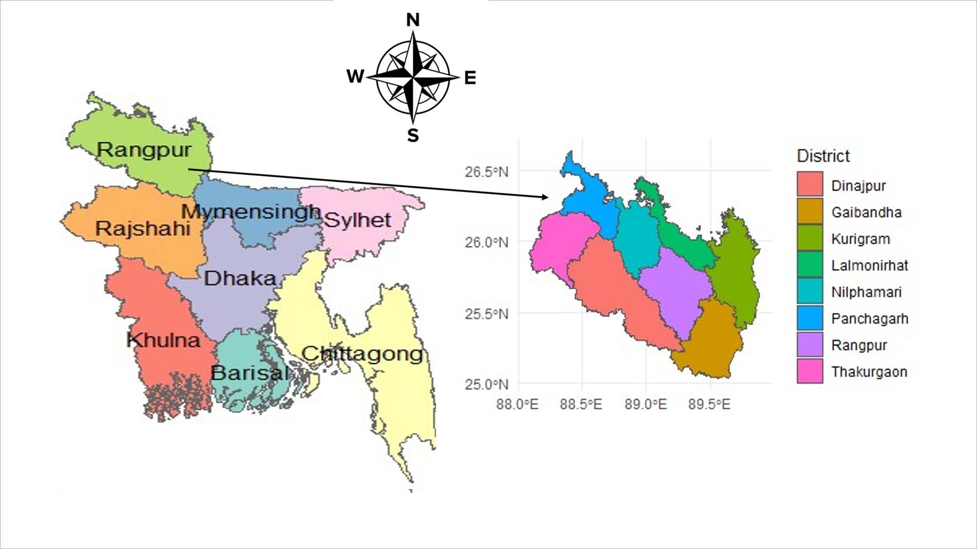

**Fig. 1.** Map of the selected study area

**3.1.2 Sample size determination:**

In designing our research methodology, we use a two-stage sampling method. First, we selected one division of Bangladesh and then chose eight districts from the selected division. The formula utilized for sample size determination is:

To illustrate, let's consider a 95% confidence level corresponding to a Z-score (*Z*) of approximately 1.96. Assuming an estimated population proportion (*p*) of 0.5 and a desired margin of error (*E*) of 0.05.

**3.2 Study Design**

This research employed a structured, pretested, and interviewer-administered questionnaire to investigate farmers' literacy on climate change and its impact on food security in the northern region of Bangladesh. The study embraced an interdisciplinary approach, examining farmers' perceptions of climate change, factors influencing the adoption of adaptation measures, and the consequences of climate change on household food security.

**3.2.1 Questionnaire Development and Pretesting**

The questionnaire (refer to supplement 1) underwent a thorough development process, incorporating insights from existing studies on climate change and expert opinions on relativity, simplicity, and importance. The instrument consisted of 47 questions across four sections: i) Socio-demographic profile of surveyed households, ii) Farmer's perception of climate change and the adoption of adaptation strategies, iii) Food security, and iv) Climate-smart agriculture. A pretest involving 50 participants ensured the questionnaire's clarity and internal consistency (α=0.75), with subsequent adjustments for improved effectiveness.

**3.2.2 Data collection**

Experienced data collectors who underwent long-conducted face-to-face interviews using the structured questionnaire. The interviews aimed to capture essential information, including socio-demographic profiles, climate change awareness, adoption of adaptation strategies, perceived impacts of climate change on food security, and climate-smart agriculture practices.

**3.2.3 Knowledge Assessment**

Respondents were asked to provide accurate information about climate change and its implications in the knowledge assessment section. The knowledge assessment covered Farmers' awareness and understanding of climate change. Like i) Sources of information on climate change, ii) Perceived impacts of climate change on agriculture and food security, iii) Adoption of adaptation measures and iv) Knowledge and implementation of climate-smart agriculture practices. This multifaceted approach aimed to gauge the depth of farmers' understanding and practices about climate change, forming a crucial foundation for informed analyses and targeted interventions in the agricultural landscape.

**3.2.4 Practice Assessment**

Assessing farmers' practices involves gauging their beliefs and feelings toward climate change and adaptation. Key aspects include their concern levels, perceived impacts on farming, and willingness to adopt climate-smart practices. Understanding these attitudes is crucial for devising effective strategies to promote resilience and sustainable agricultural practices in response to climate challenges. This insight informs targeted interventions that align with farmers' attitudes, fostering better engagement and cooperation for long-term climate resilience in agriculture. The framework summarizes the adaptation decisions of the farm household (Fig.2).

**3.2.5 Data Transformation and Grading**

The questionnaire data will be systematically transformed and graded to facilitate comprehensive analysis. This entails assigning numerical codes or ranges to categorical responses for clarity and ease of interpretation. Demographic variables, including gender and marital status, will be coded for statistical analysis. Additionally, closed-ended responses will categorize perceptions of climate change over 5 and 20 years, such as temperature changes. Numerical grading will be applied to climate change attitudes, adaptation measures, and food security data. This structured approach efficiently syntheses diverse information, encompassing farmers' attitudes, practices, and socio-economic details. It enables a thorough understanding of climate change impacts on agriculture and food security in the northern region of Bangladesh, facilitating informed decision-making. Farm households responded to a blend of closed-ended and open-ended questions to gauge alterations in agricultural methods, strategically addressing the impact of perceived variations in precipitation and temperature on agricultural practices and food security. Distinct adaptation strategies were identified and elucidated in Table 1

**3.2.6 Integrating of questionnaire**

Part A of the questionnaire meticulously gathered various socio-demographic information, encompassing factors like age, gender, marital status, education level, and key agricultural details such as land size and soil fertility. Part B delved into farmers' perceptions of climate change, evaluating impacts on farming practices and changes noticed over the past two decades. It also explored experiences with recent extreme climate events. Part C further examined the ramifications of climate change on food security, scrutinizing its effects on crop yields, pests, diseases, and food affordability. It also assessed the impact of adopting adaptation measures on household food security. Part D focused on climate-smart agriculture, investigating formal training, adjustments, and practices to adapt to changing climates. Together, these sections provided a holistic understanding of farmers' literacy on climate change, forming a robust foundation for subsequent analysis and interpretation of the collected data.

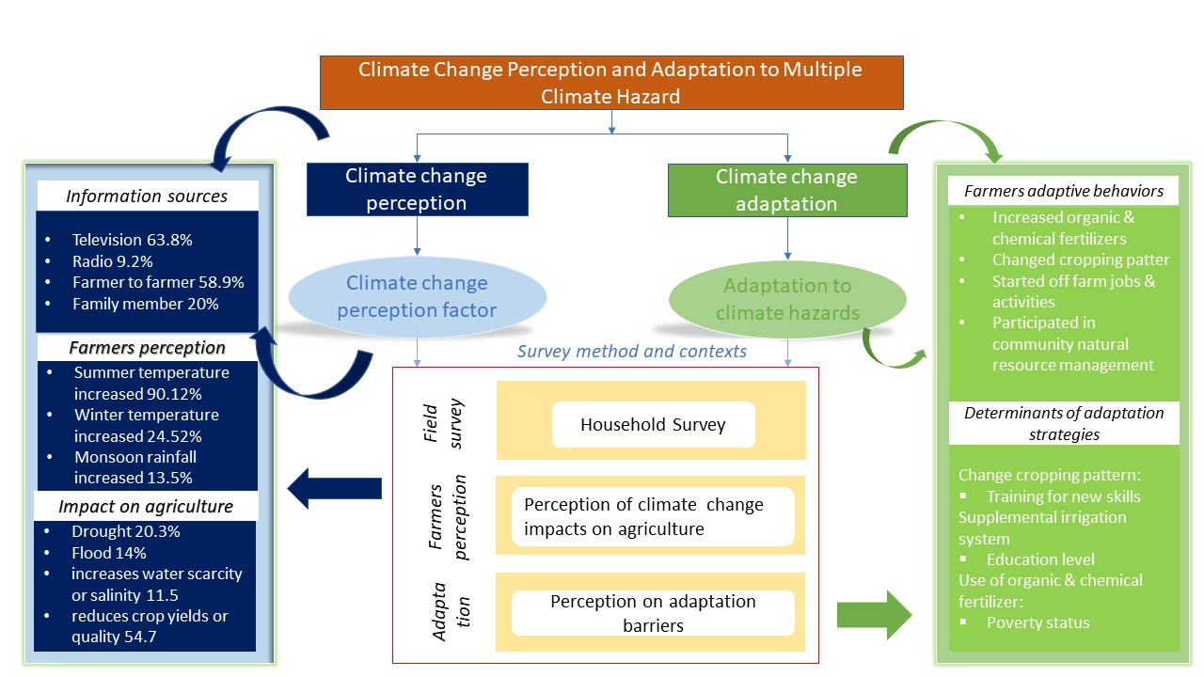

**Fig. 2a.** Schematic conceptual frameworks of farmers’ adaptation decisions and practice



**Fig. 2b.** Schematic conceptual frameworks of farmers’ adaptation decisions and practice

**Table 1.** Description of variables queried in the survey instrument

|  |  |  |  |
| --- | --- | --- | --- |
| **Variables** | **Description** | **Data Type** | **Source** |
| Age | Age of the farmer/household head | Discrete | Maddison, 2007; Nhemachena and Hassan (2008); Abid et al. (2016); Opiyo et al. (2015) |
| Gender | Gender of the farmer/household head 1 male, 2 female) | Binary | Maddison, 2007; Nhemachena and Hassan, 2008; Singh, 2020; Abid et al., 2016; Opiyo et al., 2015 |
| Marital Status | Marital status of the farmer/household head (divided into four categories- 1. Single 2. Married 3. Divorced 4. Widow) | Discrete | Nhemachena and Hassan, 2008; Gbetibouo, 2009 Abid et al., 2016; |
| Education | Educational level of the farmer (divided into six categories- 1. Illiterate 2. primary 3. secondary 4. Higher Secondary 5. Graduate 6. Post Graduate | Discrete | Deressa et al., 2009; Abid et al., 2015; Patnaik and Das, 2017; Belay et al., 2017; Bryan et al., 2013 |
| Household size | Total number of family members | Discrete | Nhemachena and Hassan, 2008; Abid et al., 2016; Opiyo et al., 2015; Khanal, 2018; Singh, 2020 |
| Dependency ratio | Number of dependents in the family | Discrete | Pandey and Jha (2012) |
| Farming year | Farming experience (year) | Continuous | Deressa et al., 2009; Patnaik and Das, 2017; Abid et al., 2016; Opiyo et al., 2015 |
| Land Holding | Land Holding (Own/Rent) | Binary | Falco et al., 2014; Belay et al., 2017 |
| Land size | Total cultivated land of the farmer (in Shatok) | Continuous | Fosu- Mensah et al., 2012; Iheke and Agodike, 2016; Abid et al., 2016 |
| Land fertility | Land fertility (soil characteristics) | Binary | Tesfahunegn et al. (2016) |
| Farm distance | Farm distance from house | Continuous | Asrat and Belay (2018) |
| Machine for cultivating | Own machine for cultivating | Binary | Di Falco et al., 2011; Di Falco and Verones, 2013 |
| Animal labour | whether farm household is using animal labour or not | Binary | Di Falco et al., 2011; Di Falco and Verones, 2013 |
| Family labour | If the household has two or more family members engaged in agricultural activity | Binary | Patnaik and Das (2017) |
| Adaptation measures | Changes in crop farming technique, Livestock rearing, Use of savings, Borrowing and selling of assets, Off-farm and farm labor employment (1 yes, 2 no, 3 maybe, 4 not sure) | Continuous | Murali and Afifi, 2014; Jha et al., 2018 |
| Rainfall and temperature adjustment | Change of crop varieties, Crop Diversification, Livelihood diversification, Use of manure, Change to Irrigation/Water harvesting, Change in fertilizer application rate, etc. (1 yes, 2 no) | Binary | Eriksen et al., 2009; Osbahr et al., 2010; Williams et al., 2020 |

**3.3 Statistical Analysis**

Descriptive statistics were done using SPSS software version 23. Descriptive statistics tools were used to analyze and present socio-economic characteristics (Age, Gender, Marital Status, Education level, etc.) and correlation matrix among households, land size, monthly income, and farming year. The correlation table shows that land size and farming year are highly correlated.

**Chapter Four**

**4. Results**

Analyzing climate change data from NASA for the Rangpur division (1997-2022) reveals significant trends in rainfall, temperature, and relative humidity[20]. The mean temperature shows variability over the years, ranging from approximately 24.23°C in 2020 to around 25.78°C in 2016. The standard deviation of temperature measurements indicates variability or dispersion around the mean. It ranges from about 4.56 to 6.33, suggesting fluctuations in temperature measurements over the years. The median temperature varies across years, indicating changes in the central tendency of temperature data[20]. The data suggests variability in temperature over the years in the Rangpur division, with no clear long-term trend observed[20]. Fluctuations in temperature measurements highlight the region's dynamic nature of climate conditions.

The mean rainfall exhibits variability, ranging from approximately 3.19 cm in 1997 to 9.17 cm in 2020 [20]. Over the years, there has been an increasing trend in mean rainfall, with occasional fluctuations observed in certain years. The standard deviation of rainfall measurements indicates variability or dispersion around the mean. It ranges from about 3.66 to 9.75, suggesting fluctuations in rainfall measurements over the years. The median and range provide additional insights into rainfall data's central tendency and spread. The data suggests an increasing trend in rainfall over the years in the Rangpur division, accompanied by variability and measurement fluctuations.

The mean relative humidity shows variability over the years, ranging from approximately 59.67% in 1997 to around 77.86% in 2022 [20]. There is an overall increasing trend in mean relative humidity over the years, with occasional fluctuations observed in certain years. The standard deviation of relative humidity measurements indicates variability or dispersion around the mean[20]. It ranges from about 11.22 to 23.18, suggesting fluctuations in relative humidity measurements over the years[20]. The data suggests an increasing trend in relative humidity in the Rangpur division over the years, accompanied by variability and measurement fluctuations.

Overall, the data suggests increasing trends in rainfall and relative humidity over the years, while temperature exhibits variability without a clear trend[20].

**4.1 Climate variability in the study areas**

**Fig. 3** Monthly average temperature, total rainfall and relative humidity in the study areas during 1997-2022

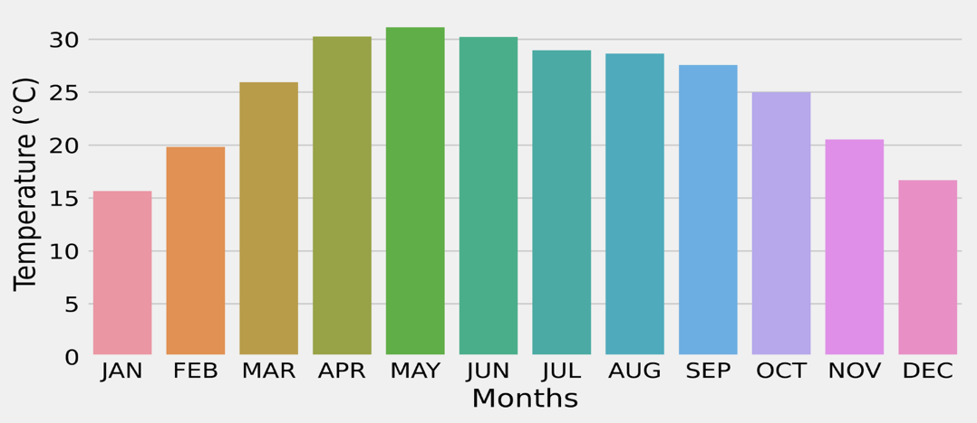

1. Monthly average temperature in study areas 1997-2022.

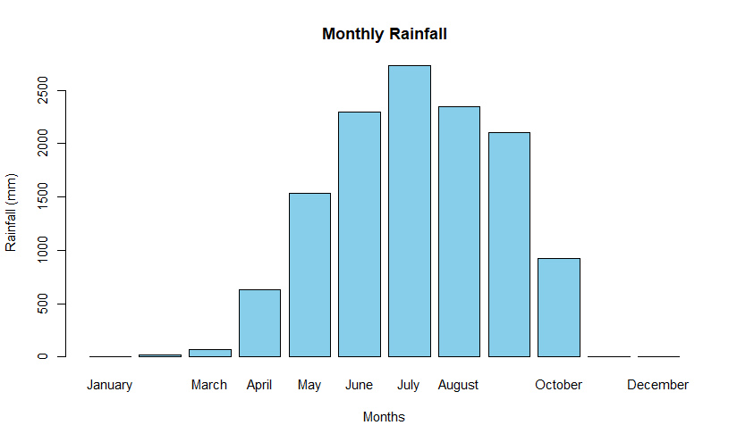

**b)** Monthly total rainfall in study areas 1997-2022

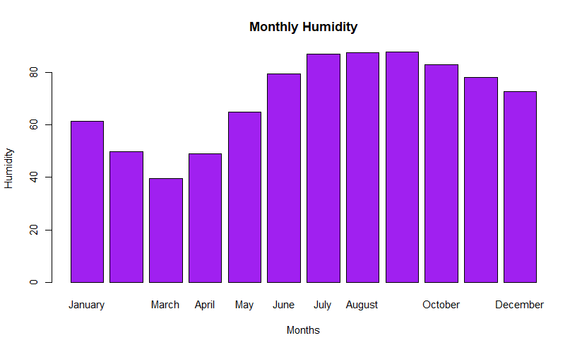

**c)** Monthly humidity in study areas 1997-2022.

**Fig. 4** Annual average temperature, total rainfall, and relative humidity in 2022

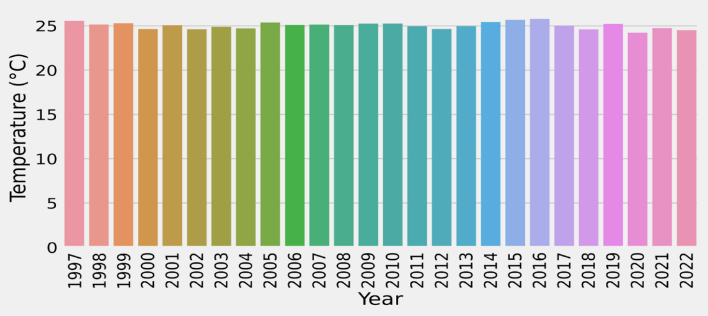

1. Yearly average temperature in study areas 1997-2022

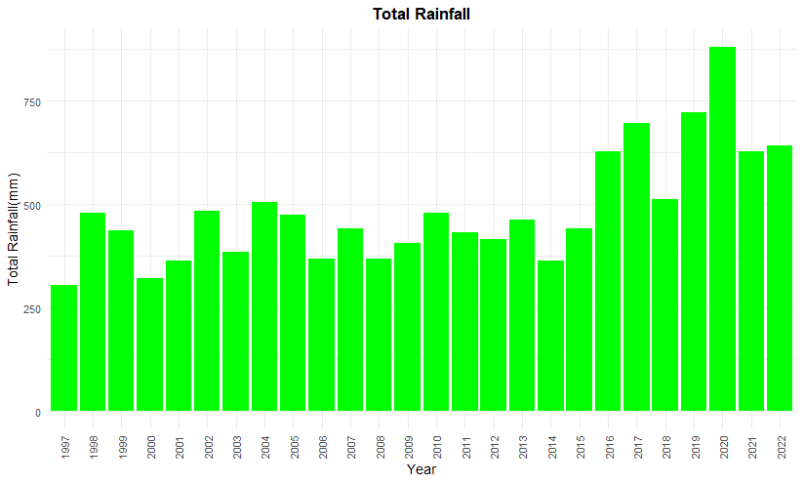

**b)** Yearly total rainfall in study areas 1997-2022.

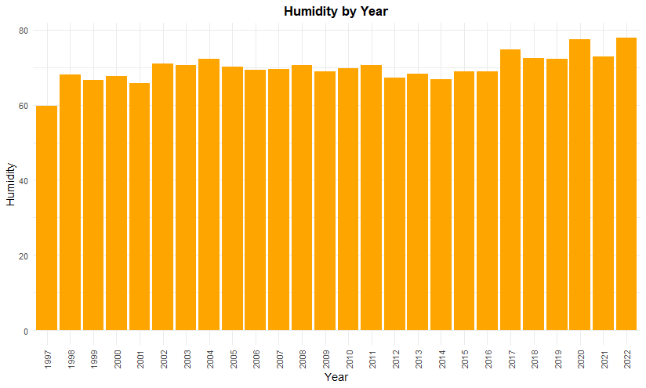

**c)** Yearly humidity in study areas 1997-2022

**Fig. 5.** District-wise average temperature, total rainfall, and relative humidity in the study areas from 1997-2022

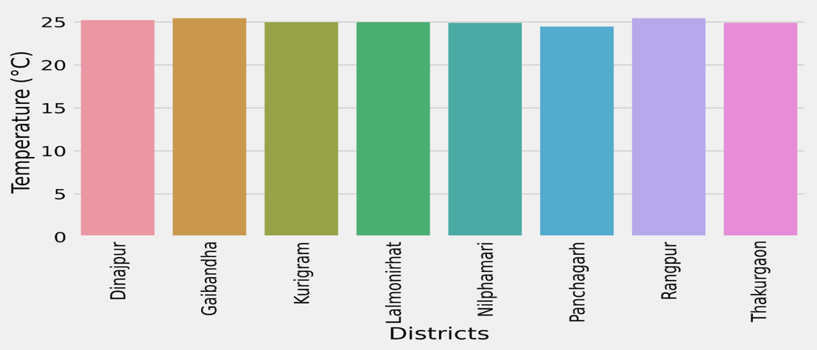

**a)** District-wise average temperature in study areas 1997-2022

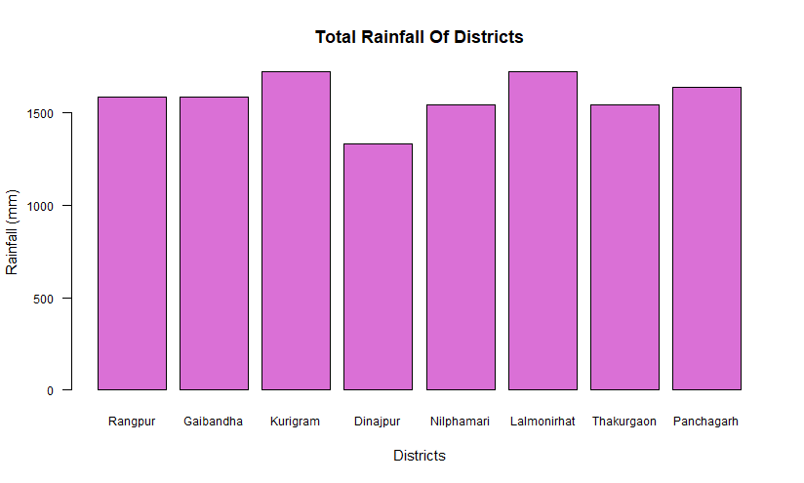

**b)** District-wise total rainfall in study areas 1997-2022

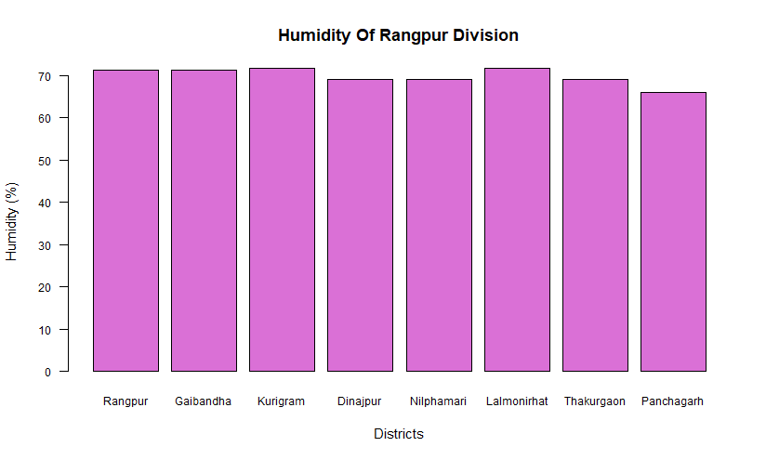

**C)** District-wise relative humidity in study areas 1997-2022

**4.2 Descriptive statistics of yearly climate factors in study areas**

**Table 2.** Yearly temperature in study areas of Bangladesh from 1997-2022

|  |  |  |  |  |
| --- | --- | --- | --- | --- |
| **Year** | **Min** | **Median** | **Max** | **Mean ± SD** |
| 1997 | 16.79 | 27.2 | 33.03 | 25.56 ± 5.64 |
| 1998 | 15.51 | 26.93 | 32.61 | 25.15 ± 5.75 |
| 1999 | 15.38 | 26.52 | 32.09 | 25.3 ± 5.77 |
| 2000 | 15.56 | 26.39 | 30.51 | 24.65 ± 5.52 |
| 2001 | 14.66 | 26.78 | 31.88 | 25.08 ± 6.06 |
| 2002 | 15.95 | 26.56 | 30.3 | 24.61 ± 5.21 |
| 2003 | 13.92 | 26.41 | 32.06 | 24.9 ± 6.07 |
| 2004 | 15.36 | 26.59 | 32.08 | 24.71 ± 5.68 |
| 2005 | 15.63 | 27.61 | 32.85 | 25.38 ± 6.08 |
| 2006 | 14.36 | 26.43 | 32.02 | 25.11 ± 5.59 |
| 2007 | 14.97 | 26.09 | 33.24 | 25.14 ± 6.11 |
| 2008 | 15.61 | 26.75 | 32.6 | 25.1 ± 5.63 |
| 2009 | 16.14 | 26.72 | 31.12 | 25.26 ± 5.51 |
| 2010 | 15.44 | 27.48 | 32.25 | 25.26 ± 5.78 |
| 2011 | 14.46 | 26.71 | 31.14 | 24.96 ± 5.65 |
| 2012 | 14.45 | 26.65 | 32.52 | 24.66 ± 6.33 |
| 2013 | 14.17 | 27.57 | 30.88 | 24.96 ± 5.76 |
| 2014 | 16.11 | 26.55 | 33.07 | 25.42 ± 6.09 |
| 2015 | 17.51 | 27.58 | 31.38 | 25.7 ± 4.8 |
| 2016 | 16.61 | 28.12 | 31.94 | 25.78 ± 5.02 |
| 2017 | 16.85 | 26.85 | 29.6 | 25.02 ± 4.56 |
| 2018 | 14.14 | 27.06 | 29.37 | 24.6 ± 5.13 |
| 2019 | 15.68 | 26.55 | 30.86 | 25.21 ± 5.23 |
| 2020 | 15.14 | 27.26 | 28.91 | 24.23 ± 5.23 |
| 2021 | 16.09 | 26.99 | 29.99 | 24.74 ± 5.15 |
| 2022 | 16.17 | 26.8 | 29.16 | 24.5 ± 5.2 |

*Min: Minimum; Max: Maximum; SD: Standard deviation*

**Table 3.** Yearly rainfall in study areas of Bangladesh from 1997-2022

|  |  |  |  |  |
| --- | --- | --- | --- | --- |
| **Year** | **Min** | **Median** | **Max** | **Mean ± SD** |
| 1997 | 0 | 0 | 10.55 | 3.19 ± 4.4 |
| 1998 | 0 | 4.94 | 15.82 | 5.0 ± 5.62 |
| 1999 | 0 | 2.64 | 19.11 | 4.56 ± 5.95 |
| 2000 | 0 | 2.64 | 8.57 | 3.35 ± 3.66 |
| 2001 | 0 | 2.64 | 13.18 | 3.79 ± 4.53 |
| 2002 | 0 | 2.64 | 13.18 | 5.05 ± 5.65 |
| 2003 | 0 | 2.96 | 13.84 | 4.01 ± 4.6 |
| 2004 | 0 | 4.94 | 20.43 | 5.27 ± 6.13 |
| 2005 | 0 | 2.31 | 15.82 | 4.94 ± 6.31 |
| 2006 | 0 | 1.32 | 10.55 | 3.85 ± 4.54 |
| 2007 | 0 | 2.31 | 16.48 | 4.61 ± 5.86 |
| 2008 | 0 | 2.64 | 12.53 | 3.84 ± 4.66 |
| 2009 | 0 | 1.98 | 19.77 | 4.23 ± 5.94 |
| 2010 | 0 | 2.31 | 16.48 | 5.0 ± 5.95 |
| 2011 | 0 | 0 | 17.14 | 4.5 ± 6.03 |
| 2012 | 0 | 3.62 | 13.84 | 4.34 ± 4.85 |
| 2013 | 0 | 3.29 | 11.21 | 4.83 ± 5.04 |
| 2014 | 0 | 0 | 13.18 | 3.79 ± 5.11 |
| 2015 | 0 | 2.64 | 16.48 | 4.61 ± 5.71 |
| 2016 | 0 | 3.29 | 23.07 | 6.54 ± 7.86 |
| 2017 | 0 | 6.59 | 23.07 | 7.25 ± 7.28 |
| 2018 | 0 | 3.96 | 13.84 | 5.33 ± 5.73 |
| 2019 | 0 | 4.61 | 29.66 | 7.53 ± 9.55 |
| 2020 | 0 | 5.6 | 25.05 | 9.17 ± 9.75 |
| 2021 | 0.02 | 5.37 | 18.13 | 6.54 ± 6.63 |
| 2022 | 0.02 | 6.28 | 23.7 | 6.7 ± 6.98 |

*Min: Minimum; Max: Maximum; SD: Standard deviation*

**Table 4.** Yearly relative humidity in study areas of Bangladesh from 1997-2022

|  |  |  |  |  |
| --- | --- | --- | --- | --- |
| **Year** | **Min** | **Median** | **Max** | **Mean ± SD** |
| 1997 | 23.64 | 65.5 | 88.03 | 59.67 ± 23.18 |
| 1998 | 38.45 | 72.77 | 90.06 | 67.96 ± 18.98 |
| 1999 | 23.68 | 72.68 | 88.71 | 66.57 ± 21.79 |
| 2000 | 37.45 | 70.35 | 87.16 | 67.61 ± 17.19 |
| 2001 | 28.92 | 74.27 | 85.85 | 65.65 ± 21.03 |
| 2002 | 39.45 | 73.83 | 88.51 | 70.94 ± 15.86 |
| 2003 | 50.23 | 75.71 | 87.59 | 70.54 ± 15.29 |
| 2004 | 44.27 | 78.34 | 89.23 | 72.3 ± 15.28 |
| 2005 | 46.56 | 73.5 | 86.53 | 70.05 ± 15.3 |
| 2006 | 37.48 | 72.4 | 85.89 | 69.31 ± 15.64 |
| 2007 | 42.91 | 75.29 | 86.7 | 69.4 ± 16.35 |
| 2008 | 43.79 | 78.31 | 87.54 | 70.61 ± 16.73 |
| 2009 | 36.17 | 73.78 | 87.8 | 68.86 ± 17.98 |
| 2010 | 34.05 | 77.42 | 87.32 | 69.75 ± 18.98 |
| 2011 | 43.3 | 74.78 | 88.26 | 70.58 ± 15.63 |
| 2012 | 32.61 | 69.31 | 88.65 | 67.1 ± 18.12 |
| 2013 | 33.85 | 77.94 | 88.24 | 68.31 ± 20.41 |
| 2014 | 29.3 | 69.82 | 87.96 | 66.86 ± 19.2 |
| 2015 | 39.22 | 70.47 | 88.79 | 68.97 ± 16.5 |
| 2016 | 35.35 | 77.78 | 88.92 | 68.97 ± 20.15 |
| 2017 | 45.73 | 80.34 | 89.23 | 74.75 ± 15.79 |
| 2018 | 44.43 | 75.47 | 87.63 | 72.45 ± 14.66 |
| 2019 | 39.17 | 80.43 | 90.13 | 72.28 ± 17.57 |
| 2020 | 56.71 | 79.87 | 90.87 | 77.45 ± 12.49 |
| 2021 | 37.43 | 83.01 | 89.61 | 72.76 ± 19.24 |
| 2022 | 50.38 | 78.63 | 89.76 | 77.86 ± 11.22 |

*Min: Minimum; Max: Maximum; SD: Standard deviation*

**4.3 Discussion**

**4.3.1 Socio-economic and demographic profile of surveyed household**

Table 4 provides Socio-economic and demographic profiles of surveyed households. Rangpur emerges as the most represented district in the sample (37.2%), followed by Nilphamari (19.3%) and Kurigram (20.9%). The farmer or household head parameters can influence farmers’ perception, willingness to adapt, and adaptive choices. The average age of the farmer in the study area is 48 years. The minimum age of the farmer is 22 and the maximum age is 80. A positive relationship exists between gender (male farmers or male head of the household) and a farmer’s decision to adopt. Most of the sample in the study region was male farmers. The percentage of male farmers is 88 percent, and female farmers are 12 percent. The marital status distribution indicates that most respondents are married (92.2%). The result shows that 34.1 percent of farmers are not having any education. Among total farmers, 27 percent are found to have primary education (1–6 years of schooling), i.e., 243 farmers in numbers.

**Table 5.** Socio-economic and demographic profile of surveyed household

|  |  |  |  |  |  |
| --- | --- | --- | --- | --- | --- |
| **Sample Characteristics** | **n** | **%** | **Min** | **Max** | **SD** |
| **Age** |  |  | 22 | 80 | 12.173 |
| **Gender** |  |  |  |  |  |
| Male | 793 | 88 |  |  |  |
| Female | 108 | 12 |  |  |  |
| **Marital status** |  |  |  |  |  |
| Single | 30 | 3.3 |  |  |  |
| Married | 831 | 92.2 |  |  |  |
| Divorced | 8 | 0.9 |  |  |  |
| Widow | 32 | 3.6 |  |  |  |
| **Living Status** |  |  |  |  |  |
| Rangpur | 335 | 37.2 |  |  |  |
| Gaibandha | 64 | 7.1 |  |  |  |
| Kurigram | 188 | 20.9 |  |  |  |
| Dinajpur | 57 | 6.3 |  |  |  |
| Nilphamari | 174 | 19.3 |  |  |  |
| Lalmonirhat | 50 | 5.5 |  |  |  |
| Thakurgaon | 17 | 1.9 |  |  |  |
| Panchagarh | 16 | 1.8 |  |  |  |
| **Educational level** |  |  |  |  |  |
| Illiterate | 307 | 34.1 |  |  |  |
| Primary | 243 | 27 |  |  |  |
| Secondary | 171 | 19 |  |  |  |
| Higher Secondary | 81 | 9 |  |  |  |
| Graduate | 70 | 7.8 |  |  |  |
| Post Graduate | 29 | 3.2 |  |  |  |
| **Primary Income** |  |  |  |  |  |
| Farming | 714 | 79.2 |  |  |  |
| Farming and Job | 107 | 11.9 |  |  |  |
| Part time job | 49 | 5.4 |  |  |  |
| Full time job | 35 | 3.9 |  |  |  |
| Business/Self employment | 220 | 24.4 |  |  |  |
| Remittance | 12 | 1.3 |  |  |  |
| Family Member | 81 | 9 |  |  |  |
| **Monthly Income** |  |  | 4000 | 500000 | 496000 |
| **Economic Status** |  |  |  |  |  |
| Rich | 6 | 0.7 |  |  |  |
| Upper middle class | 12 | 1.3 |  |  |  |
| Middle class | 760 | 84.4 |  |  |  |
| Poor | 123 | 13.7 |  |  |  |
| **Household Size** |  |  | 2 | 18 | 16 |
| **Dependency Ratio** |  |  | 0 | 14 | 14 |
| **Farming Year** |  |  | 0 | 78 | 78 |
| **Land Holding** |  |  |  |  |  |
| Own | 638 | 70.8 |  |  |  |
| Rent | 263 | 29.2 |  |  |  |
| **Land Size** |  |  | 10 | 1500 | 118.183 |
| **Soil Characteristics** |  |  |  |  |  |
| Fertile | 865 | 96 |  |  |  |
| Infertile | 36 | 4 |  |  |  |
| **Farm Distance** |  |  | 0.01 | 55 | 54.99 |
| **Own machine for cultivating** | |  |  |  |  |
| Yes | 215 | 23.9 |  |  |  |
| No | 686 | 76.1 |  |  |  |
| **Animal Labour** |  |  |  |  |  |
| Yes | 225 | 25 |  |  |  |
| No | 676 | 75 |  |  |  |
| **Family Labour** |  |  |  |  |  |
| Yes | 327 | 36.3 |  |  |  |
| No | 574 | 63.7 |  |  |  |

Min: Minimum, Max: Maximum and SD: Standard deviation

The overall number of farmers having a secondary education is 171 out of 901, i.e., 19 percent of the total household. The number of farmers with higher education was 81 of total surveyed farmers, i.e., percent, whereas the graduate’s 7 percent and post-graduate was 3 percent. It is expected that the farmers’ education level will have a positive impact on their adaptation decisions. The household's primary income source is farming (79.2%), whereas business/ self-employment is 24.4 percent and farming, and job is 11.9 percent. The highest monthly income of the farmer is 500000 and the lowest is 4000. Household income is identified to play an essential role in enhancing climate change adaptation. The economic classification reveals that most respondents are middle class (84.4%). The minimum household size of the surveyed household is 2, and the maximum is 18. The expected impact of household size is positive in their decision to adopt. The average number of dependent members is 3. The number of dependent members can positively and negatively impact their adaptive capacity. Farm-size is often considered a wealth indicator and can have negative and positive consequences for adaptive decisions. The average land size held by the farm household is 118.183 shatok, ranging from 10 to 1500 shatok. Soil characteristics indicate that 96% of respondents have fertile soil, conducive to agricultural activities. Farming practices involve animal labor by 25% of respondents and family labor by 36.3%. Ownership of cultivating machines is observed in 23.9% of respondents.

**4.3.2 Farmer’s perception of climate change and Adaptation Strategies**

The perception of climate change among farmers plays a crucial role in shaping their adoption of adaptation strategies. The data presented in Table 5 provides insights into how farmers perceive changes in temperature, rainfall patterns, and extreme weather events over both short-term (5 years) and long-term (20 years) periods.

**4.3.3 Perception of Changes in Temperature and Rainfall Levels**

Most farmers perceive an increase in temperature, with 89.2% indicating a rise in temperatures and 89.5% reporting an increase in hot days. This aligns with the global trend of rising temperatures due to climate change. Conversely, a significant portion of farmers (65.6%) perceive a decrease in cold days, indicating a shift towards warmer weather patterns.

Regarding rainfall levels, a substantial proportion of farmers (77.8%) perceive a decrease, reflecting concerns over changing precipitation patterns. This perception is critical as it impacts agricultural practices, including crop selection and irrigation methods. However, a notable proportion (13.3%) remains unsure about rainfall changes, indicating a need for more information or awareness campaigns to address knowledge gaps.

**4.3.4 Perception of Extreme Weather Events**

The perception of extreme weather events such as floods, droughts, cyclones, extreme heat, and extreme cold varies among farmers over short-term and long-term periods.

In the last 5 years, farmers perceive a high impact of droughts (43.7%) and extreme heat (34.0%), indicating the immediate challenges posed by these events. Floods are also perceived as significant, with 17.6% of farmers reporting high impacts. However, a notable proportion of farmers perceive low or no impact for each event, highlighting variability in experiences and perhaps differing levels of vulnerability or adaptation capacity among farmers.

Perceptions of extreme weather events have remained consistent over the last twenty years, with droughts (47.9%) and extreme heat (36.5%) being the most impactful events reported. Interestingly, perceptions of floods, cyclones, and extreme cold remain significant, suggesting a sustained vulnerability to various extreme weather phenomena over time.

**Table 6.** Farmers’ perception of climate change and the adoption of adaptation strategies

**Perception of climate change**

|  |  |  |  |
| --- | --- | --- | --- |
|  | **Decreased n (%)** | **Increased n (%)** | **Not sure (%)** |
| Changes in temperature | 59 (6.5) | 804 (89.2) | 38 (4.2) |
| Number of hot days | 53 (5.9) | 806 (89.5) | 42 (4.7) |
| Number of cold days | 591 (65.6) | 219 (24.3) | 91 (10.1) |
| Rainfall Levels | 701 (77.8) | 120 (13.3) | 80 (8.9) |

**Perception of climate change over 5 and 20 years**

|  |  |  |  |  |  |
| --- | --- | --- | --- | --- | --- |
|  | **High**  **n (%)** | **Low**  **n (%)** | **Medium**  **n (%)** | **No Impact**  **n (%)** | **Very High**  **n**  **(%)** |
| **Climate Change in the last 5 years** |  |  |  |  |  |
| Flood | 159 (17.6) | 270 (30.0) | 258 (28.6) | 88 (9.8) | 126 (14.0) |
| Drought | 394 (43.7) | 67 (7.4) | 205 (22.8) | 53 (5.9) | 182 (20.2) |
| Cyclone | 117 (13.0) | 256 (28.4) | 203 (22.5) | 292 (32.4) | 33 (3.7) |
| Extreme Heat | 306 (34.0) | 28 (3.1) | 266 (29.5) | 16 (1.8) | 285 (31.6) |
| Extreme Cold | 275 (30.5) | 84 (9.3) | 428 (47.5) | 32 (3.6) | 82 (9.1) |
| **Climate Change in the last 20 years** |  |  |  |  |  |
| Flood | 234 (26.0) | 245 (27.2) | 202 (22.4) | 70 (7.8) | 150 (16.6) |
| Drought | 432 (47.9) | 58 (6.4) | 147 (16.3) | 45 (5.0) | 219 (24.3) |
| Cyclone | 171 (19.0) | 178 (19.8) | 225 (25.0) | 287(31.9) | 40 (4.4) |
| Extreme Heat | 329 (36.5) | 25 (2.8) | 229 (25.4) | 11 (1.2) | 307 (34.1) |
| Extreme Cold | 342 (38.0) | 66 (7.3) | 374 (41.5) | 28 (3.1) | 91 (10.1) |

**4.3.5 Implications for Adaptation Strategies**

These perceptions of climate change and extreme weather events are crucial for informing adaptation strategies among farmers. The high perception of temperature increases and changes in rainfall patterns underscores the need for adaptive measures such as crop diversification, water management strategies, and the adoption of drought-resistant crops.

Additionally, the perception of increased frequency and intensity of extreme weather events highlights the importance of resilience-building efforts, including early warning systems, improved infrastructure, and insurance mechanisms to mitigate the impacts of floods, droughts, and other disasters.

**Table 7.** Adaptation to climate change

|  |  |  |
| --- | --- | --- |
| **Rainfall and Temperature adjustment** | Respondents n (%) | |
| Yes | No |
| Change of crop varieties | 632 (70.1) | 269 (29.9) |
| Crop Diversification | 628 (69.7) | 273 (30.3) |
| Adopt crop rotation and mixed cropping | 393 (43.6) | 508 (56.4) |
| Enhancing animal rearing practice/mixed farming | 341 (37.8) | 560 (62.2) |
| Livelihood diversification | 622 (69.0) | 279 (31.0) |
| Change to Irrigation/Water harvesting | 574 (63.7) | 327 (36.3) |
| Change of planting time (before/after onset of rainfall) | 514 (57.0) | 387 (43.0) |
| Use of Integrated Pest Management | 473 (52.5) | 428 (47.5) |
| Use of manure | 810 (89.9) | 91 (10.1) |
| Change in fertilizer application rate | 730 (81.0) | 171 (19.0) |
| Tree planting | 564 (62.6) | 337 (37.4) |
| Soil conservation/mulching/terraces | 495 (54.9) | 406 (45.1) |
| Switch from crop farming to livestock | 392 (43.5) | 509 (56.5) |
| Increase land under farming/cultivation | 355 (39.4) | 546 (60.6) |
| Reducing the land under cultivation | 356 (39.5) | 545 (60.5) |

The analysis reveals varying degrees of adaptation to climate change among respondents. A significant proportion adopted measures such as changing crop varieties (70.1%), crop diversification (69.7%), and livelihood diversification (69.0%). However, fewer respondents embraced practices like enhancing animal rearing (37.8%) or switching from crop farming to livestock (43.5%). Notably, most favored organic practices like manure (89.9%) and soil conservation techniques (54.9%). Integration of climate-resilient strategies like irrigation (63.7%) and tree planting (62.6%) is evident. Discussion: The high adoption rates of crop diversification and changes in planting time suggest recognition of climate risks and flexibility in agricultural practices. However, challenges persist in adopting more resource-intensive strategies like irrigation. Promoting sustainable practices like soil conservation and organic farming should be prioritized, while addressing barriers to adoption, such as access to resources and knowledge gaps. Emphasizing community-based approaches and leveraging indigenous knowledge can enhance resilience and sustainability in agricultural systems.

**4.3.6 Role of socioeconomic characteristics in adaptation decisions**

The logistic regression model in Table 6 aimed to analyze the household characteristics influencing adaptation strategies for climate change in agriculture. Several variables were considered, including demographic factors such as age, education level, income, landholding, farm size, and access to resources like machinery and animals for cultivation.

The results reveal significant associations between certain demographic factors and adaptation strategies. Age showed a significant positive association with changes in crop varieties (E(B) = 1.041, p = 0.014**) and adopting crop rotation (E(B) = 1.008, p = 0.614). Education level also played a significant role, with higher education levels associated with a reduced likelihood of certain adaptation strategies, such as crop diversification (E(B) = 0.646, p = 0.029**) and use of integrated pest management (E(B) = 0.848, p = 0.001***).

Income level exhibited mixed effects on adaptation strategies, with some strategies like crop diversification (E(B) = 17.272, p < 0.001***) and land under cultivation (E(B) = 15.648, p < 0.001***) showing significant positive associations with higher income.

Landholding and farm size showed significant associations with adaptation strategies. Larger landholding and farm size were associated with certain strategies like crop diversification (E(B) = 1.049, p = 0.042**) and mixed farming (E(B) = 1.199, p < 0.001***).

Access to resources such as machinery and animals for cultivation also influenced adaptation strategies. Ownership of machinery for cultivation showed a significant negative association with some strategies like crop diversification (E(B) = 0.999, p = 0.15), while ownership of animals for cultivation showed a significant positive association with certain strategies like crop diversification (E(B) = 0.609, p = 0.012**) and use of integrated pest management (E(B) = 1.814, p = 0.024**).

These findings underscore the importance of targeted interventions and support mechanisms tailored to the specific needs and contexts of different demographic groups and resource endowments. Policies promoting climate-resilient agriculture should consider these factors to ensure equitable and effective adaptation outcomes across diverse farming communities. Understanding these dynamics is essential for designing targeted policies and interventions that enhance farming communities.

**Table 8.** Factors affecting or role of socio-economic in adaptation decisions using logistic regression model

|  |  |  |  |  |  |  |  |  |  |  |  |  |  |  |  |  |
| --- | --- | --- | --- | --- | --- | --- | --- | --- | --- | --- | --- | --- | --- | --- | --- | --- |
| **Variable Name** | **CCV** | **CD** | **ACR** | **MF** | **LD** | **CI** | **CPT** | **UIPM** | **UM** | **CFAR** | **TP** | **SC** | **SCFL** | **ILUF** | **RLUC** | **CCV** |
| **Age** | **Sig.** | 0.014** | 0.175 | 0.614 | 0.466 | 0.8 | 0.403 | 0.537 | 0.784 | 0.596 | 0.859 | 0.947 | 0.18 | 0.121 | 0.035 | 0.786 |
|  | **E(B)** | 1.041 | 0.978 | 1.008 | 0.989 | 1.004 | 0.987 | 0.991 | 0.996 | 1.013 | 1.003 | 1.001 | 1.02 | 1.023 | 0.968 | 0.996 |
| **Young** | **Sig.** | 1.184 | 0.182 | 0.808 | 0.669 | 0.951 | 0.18 | 0.731 | 0.782 | 0.734 | 0.484 | 0.591 | 0.069 | 0.047** | 0.394 | 0.11 |
|  | **E(B)** | 3.267 | 0.49 | 0.886 | 1.249 | 0.968 | 0.506 | 0.842 | 0.874 | 1.324 | 0.645 | 0.761 | 2.458 | 2.677 | 0.651 | 2.31 |
| **Middle-Aged** | **Sig.** | 0.065* | 0.035** | 0.97 | 0.981 | 0.996 | 0.546 | 0.641 | 0.894 | 0.981 | 0.365 | 0.316 | 0.341 | 0.007*** | 0.772 | 0.501 |
|  | **E(B)** | 1.815 | 0.509 | 0.989 | 1.008 | 0.998 | 0.834 | 0.871 | 0.962 | 0.989 | 0.716 | 0.738 | 1.323 | 2.2 | 0.916 | 1.234 |
| **Gender (1)** | **Sig.** | 0.388 | 0.845 | 0.003*** | 0.583 | 0.206 | 0.277 | 0.737 | 0.537 | 0.146 | 0.387 | 0.024** | 0.559 | 0.288 | 0.179 | 0.194 |
|  | **E(B)** | 1.24 | 0.954 | 1.963 | 1.136 | 0.742 | 1.29 | 1.079 | 1.147 | 0.611 | 1.29 | 0.6 | 1.14 | 1.266 | 1.353 | 1.345 |
| **Primary** | **Sig.** | 0.043** | 0.029** | 0.605 | 0.221 | 0.027** | 0.332 | 0.637 | 0.391 | 0.768 | 0.405 | 0.915 | 0.694 | 0.007*** | 0.877 | 0.141 |
|  | **E(B)** | 0.666 | 0.646 | 1.102 | 0.786 | 0.648 | 1.199 | 1.091 | 1.169 | 0.917 | 0.827 | 0.98 | 1.075 | 0.604 | 1.03 | 1.333 |
| **Secondary** | **Sig.** | 0.306 | 0.11 | 0.528 | 0.234 | 0.016** | 0.166 | 0.04** | 0.468 | 0.289 | 0.41 | 0.305 | 0.547 | 0.086* | 0.249 | 0.079* |
|  | **E(B)** | 0.786 | 0.686 | 0.871 | 0.76 | 0.573 | 1.355 | 1.56 | 0.856 | 0.659 | 0.794 | 0.795 | 1.138 | 0.687 | 1.296 | 1.501 |
| **Higher secondary** | **Sig.** | 0.515 | 0.182 | 0.125 | 0*** | 0.044** | 0.278 | 0.028** | 0.009*** | 0.871 | 0.177 | 0.161 | 0.011** | 0.001*** | 0.453 | 0.03** |
|  | **E(B)** | 0.817 | 0.659 | 0.646 | 0.352 | 0.54 | 0.718 | 0.511 | 0.473 | 0.926 | 0.571 | 0.66 | 0.473 | 0.402 | 0.807 | 0.527 |
| **Graduate** | **Sig.** | 0.019** | 0.589 | 0.001*** | 0.049** | 0.001*** | 0.197 | 0.154 | 0.012** | 0.915 | 0.685 | 0.01** | 0.056 | 0.001*** | 0.658 | 0.002*** |
|  | **E(B)** | 0.442 | 0.848 | 0.381 | 0.56 | 0.336 | 0.672 | 0.66 | 0.489 | 0.949 | 1.154 | 0.453 | 0.579 | 0.405 | 0.882 | 0.392 |
| **Secondary-Occupation (1)** | **Sig.** | 0.644 | 0.155 | 0.88 | 0.027** | 0.075* | 0.325 | 0.339 | 0.7 | 0.278 | 0.855 | 0.001*** | 0.008 | 0.146 | 0.643 | 0.131 |
|  | **E(B)** | 1.081 | 1.264 | 1.023 | 1.425 | 0.75 | 0.859 | 0.864 | 1.059 | 0.757 | 1.036 | 1.663 | 1.497 | 1.246 | 1.074 | 1.273 |
| **Approximate monthly income** | **Sig.** | 0.511 | 0.159 | 0.406 | 0.387 | 0.127 | 0.649 | 0.24 | 0.148 | 0.947 | 0.197 | 0.158 | 0.624 | 0.146 | 0.206 | 0.12 |
| **Middle-Class** | **Sig.** | 0.991 | 0.999 | 0.558 | 0.534 | 0.171 | 0.964 | 0.221 | 0.325 | 0.568 | 0.999 | 0.126 | 0.913 | 0.419 | 0.339 | 0.173 |
|  | **E(B)** | 0.997 |  | 0.419 | 0.399 | 19.079 | 1.081 | 0.151 | 0.22 | 0.306 |  | 24.066 | 0.852 | 0.28 | 4.263 | 9.925 |
| **Upper-Middle-class** | **Sig.** | 0.839 | 0.999 | 0.544 | 0.631 | 0.153 | 0.979 | 0.175 | 0.359 | 0.401 | 0.999 | 0.178 | 0.981 | 0.375 | 0.349 | 0.172 |
|  | **E(B)** | 0.808 |  | 0.422 | 0.506 | 19.977 | 0.956 | 0.135 | 0.259 | 0.188 |  | 15.256 | 0.966 | 0.262 | 3.901 | 9.167 |
| **Rich** | **Sig.** | 0.999 | 1 | 0.5 | 0.124 | 0.261 | 0.35 | 0.346 | 0.59 | 0.299 | 0.999 | 0.111 | 0.263 | 0.802 | 0.106 | 0.177 |
|  | **E(B)** | 0 | 0.1 | 0.408 | 0.123 | 8.838 | 0.195 | 0.28 | 0.488 | 0.123 |  | 19.273 | 4.515 | 0.704 | 10.138 | 7.719 |
| **Household-size** | **Sig.** | 0.695 | 0.552 | 0.193 | 0.103 | 0.312 | 0.351 | 0.394 | 0.545 | 0.156 | 0.078* | 0.489 | 0.67 | 0.196 | 0.742 | 0.644 |
|  | **E(B)** | 0.966 | 1.049 | 0.906 | 1.141 | 1.083 | 0.929 | 0.935 | 0.956 | 1.163 | 1.176 | 0.947 | 0.968 | 1.106 | 0.975 | 1.04 |
| **Small** | **Sig.** | 0.424 | 0.669 | 0.22 | 0.496 | 0.883 | 0.971 | 0.621 | 0.243 | 0.966 | 0.615 | 0.573 | 0.671 | 0.347 | 0.748 | 0.938 |
|  | **E(B)** | 1.553 | 0.803 | 0.549 | 1.409 | 0.929 | 1.018 | 0.783 | 0.574 | 1.033 | 1.344 | 0.755 | 1.228 | 1.576 | 1.174 | 1.042 |
| **Medium** | **Sig.** | 0.354 | 0.859 | 0.059* | 0.406 | 0.73 | 0.738 | 0.362 | 0.058* | 0.467 | 0.696 | 0.768 | 0.51 | 0.067* | 0.554 | 0.804 |
|  | **E(B)** | 1.428 | 0.939 | 0.528 | 1.336 | 0.888 | 0.892 | 0.734 | 0.535 | 1.434 | 1.166 | 1.106 | 0.803 | 1.834 | 0.816 | 0.914 |
| **farming-year** | **Sig.** | 0.232 | 0.771 | 0.252 | 0.087* | 0.436 | 0.679 | 0.333 | 0.181 | 0.989 | 0.144 | 0.743 | 0.294 | 0.707 | 0*** | 0*** |
|  | **E(B)** | 1.01 | 0.998 | 0.992 | 1.013 | 1.006 | 1.003 | 1.007 | 0.99 | 1 | 0.987 | 1.002 | 0.992 | 0.997 | 1.036 | 1.048 |
| **Land-Holding** | **Sig.** | 0.384 | 0.834 | 0.205 | 0.091* | 0.002*** | 0.93 | 0.008*** | 0.304 | 0.637 | 0.448 | 0.363 | 0.401 | 0.771 | 0.479 | 0.236 |
|  | **E(B)** | 0.856 | 0.964 | 0.806 | 0.738 | 1.78 | 1.015 | 1.568 | 1.184 | 1.139 | 1.172 | 0.856 | 1.15 | 0.953 | 0.886 | 1.23 |
| **Small (67-100)** | **Sig.** | 0.303 | 0.078* | 0.973 | 0.906 | 0.938 | 0.754 | 0.108 | 0.022** | 0.364 | 0.075* | 0.976 | 0.137 | 0.577 | 0.42 | 0.008*** |
|  | **E(B)** | 0.78 | 0.197 | 1.019 | 1.064 | 0.959 | 0.823 | 2.446 | 0.324 | 0.231 | 0.117 | 1.016 | 0.458 | 0.737 | 1.507 | 0.221 |
| **Medium (100-250)** | **Sig.** | 0.684 | 0.172 | 0.979 | 0.831 | 0.443 | 0.634 | 0.134 | 0.099* | 0.272 | 0.116 | 0.465 | 0.725 | 0.595 | 0.583 | 0.001*** |
|  | **E(B)** | 0.863 | 0.335 | 1.014 | 1.11 | 0.679 | 0.762 | 2.197 | 0.468 | 0.216 | 0.192 | 1.427 | 0.842 | 0.764 | 1.298 | 0.158 |
| **Large (250-1500)** | **Sig.** | 0.121 | 0.072*** | 0.681 | 0.466 | 0.771 | 0.584 | 0.127 | 0.07* | 0.208 | 0.149 | 0.274 | 0.416 | 0.917 | 0.277 | 0.005*** |
|  | **E(B)** | 3.897 | 0.312 | 1.199 | 1.367 | 0.88 | 1.304 | 2.04 | 0.479 | 0.241 | 0.291 | 1.602 | 0.707 | 0.956 | 1.573 | 0.259 |
| **Land-size** | **Sig.** | 0.06* | 0.042** | 0.203 | 0.628 | 0.779 | 0.317 | 0.972 | 0.368 | 0.099* | 0.009*** | 0.703 | 0.173 | 0.399 | 0.484 | 0.066* |
|  | **E(B)** | 0.995 | 0.994 | 0.998 | 1.001 | 1 | 0.998 | 1 | 0.999 | 0.991 | 0.99 | 1 | 0.998 | 1.001 | 0.999 | 0.998 |
| **land-fertility** | **Sig.** | 0.918 | 0.033** | 0.263 | 0.006*** | 0.263 | 0.072* | 0.778 | 0.691 | 0.001*** | 0.03** | 0.452 | 0.804 | 0.683 | 0.497 | 0.022** |
|  | **E(B)** | 1.042 | 0.455 | 1.511 | 2.831 | 0.655 | 0.521 | 0.901 | 1.156 | 0.268 | 0.441 | 0.761 | 0.914 | 1.159 | 0.77 | 2.457 |
| **Farm-distance** | **Sig.** | 0.157 | 0.92 | 0.081* | 0.038** | 0.091* | 0.204 | 0.287 | 0.577 | 0.033** | 0.014** | 0.012** | 0.002*** | 0.459 | 0.143 | 0.849 |
|  | **E(B)** | 1.039 | 0.997 | 1.05 | 0.937 | 1.047 | 1.034 | 1.027 | 1.014 | 1.077 | 1.09 | 1.082 | 1.113 | 1.022 | 1.044 | 1.006 |
| **own-machine-for-cultivating** | **Sig.** | 0.15 | 0.994 | 0.931 | 0.012** | 0.551 | 0.191 | 0.01** | 0.014** | 0.014** | 0.143 | 0.017** | 0.23 | 0.832 | 0.006*** | 0.241 |
|  | **E(B)** | 0.742 | 0.999 | 0.985 | 0.638 | 1.118 | 0.785 | 0.625 | 0.648 | 1.98 | 0.707 | 0.64 | 1.235 | 1.038 | 0.614 | 0.804 |
| **animal-for-cultivating** | **Sig.** | 0.002*** | 0.012** | 0.008*** | 0*** | 0.689 | 0.168 | 0.013** | 0.485 | 0.024** | 0.019** | 0*** | 0.497 | 0.408 | 0.261 | 0.099* |
|  | **E(B)** | 0.538 | 0.609 | 0.633 | 0.493 | 1.077 | 0.78 | 0.642 | 0.887 | 1.814 | 1.625 | 2.009 | 1.125 | 1.155 | 0.821 | 0.742 |
| **Family-labour** | **Sig.** | 0.383 | 0.264 | 0.005*** | 0.057* | 0.007*** | 0.8 | 0.141 | 0.013** | 0.301 | 0.957 | 0.257 | 0.495 | 0.875 | 0.042** | 0.759 |
|  | **E(B)** | 0.855 | 0.822 | 0.637 | 0.725 | 0.619 | 1.043 | 0.787 | 0.672 | 0.761 | 0.989 | 0.828 | 1.116 | 1.026 | 0.717 | 1.054 |
| **C-Know** | **Sig.** | 0.005*** | 0.001*** | .374 | 0.004*** | 0.038** | .157 | 0.030** | 0.005*** | 0.003*** | .516 | 0.011*** | .237 | 0.00*** | 0.012** | .603 |
|  | **E(B)** | 1.775 | 2.085 | 1.164 | 1.631 | 1.497 | .783 | .692 | 1.619 | .487 | 1.155 | 1.598 | .818 | 2.537 | .634 | 1.095 |
| **F-Know** | **Sig.** | 0.023** | 0.044** | 0.001*** | 0.013** | 0.005*** | .657 | .137 | .989 | .199 | .827 | 0.015** | 0.055** | 0.052** | 0.001*** | 0.00*** |
|  | **E(B)** | 1.447 | 1.384 | 1.641 | 1.442 | 1.575 | 1.069 | 1.243 | .998 | 1.380 | 1.041 | 1.447 | 1.321 | 1.328 | 1.739 | 2.087 |

CCV=Change of crop varieties, CD=Crop Diversification, ACR=Adopt crop rotation, MF=Mixed farming, LD=Livelihood diversification, CI=Change to Irrigation, CPT=Change of planting time, UIPM=Use of Integrated Pest Management ,UM=Use of manure , CFAR=Change in fertilizer application rate , TP=Tree planting , SC=Soil conservation, SCFL=Switch from crop farming to livestock , ILUF=Increase land under farming, RLUC=Reducing the land under cultivation; C-Know=Climate Change Knowledge; F-Know=Food-security Knowledge **(***p<0.01; **p<0.05; *p<0.1) And sig.=P-value; E(B)=Odds ratio (95%)**

**Table 9.** Chi-square among Socio-demographic variables and climate change adjustment

|  |  |  |  |  |  |  |  |  |  |  |  |  |  |  |  |  |
| --- | --- | --- | --- | --- | --- | --- | --- | --- | --- | --- | --- | --- | --- | --- | --- | --- |
| **Variable Name** |  | **CCV** | **CD** | **ACR** | **MF** | **LD** | **CI** | **CPT** | **UIPM** | **UM** | **CFAR** | **TP** | **SC** | **SCFL** | **ILUF** | **RLUC** |
| **Age** | **p-value** | 0.30 | 0.20 | 0.23 | 0.14 | 0.72 | 0.47 | 0.57 | 0.52 | 0.30 | 0.33 | 0.53 | 0.16 | 0.09 | 0.67 | 0.08 |
|  | **Chi-sq** | 60.91 | 64.68 | 62.58 | 67.58 | 49.46 | 56.21 | 53.61 | 54.86 | 60.93 | 60.24 | 54.51 | 66.48 | 70.63 | 50.98 | 71.39 |
| **Gender** | **p-value** | 0.77 | 0.48 | 0.01 | 0.33 | 0.49 | 0.48 | 0.87 | 0.51 | 0.05 | 0.62 | 0.06 | 0.92 | 0.16 | 0.13 | 0.01 |
|  | **Chi-sq** | 0.09 | 0.50 | 7.51 | 0.96 | 0.48 | 0.51 | 0.03 | 0.43 | 3.79 | 0.25 | 3.48 | 0.45 | 2.00 | 2.33 | 6.01 |
| **Educational level** | **p-value** | 0.00 | 0.06 | 0.00 | 0.01 | 0.09 | 0.04 | 0.00 | 0.02 | 0.54 | 0.66 | 0.15 | 0.17 | 0.02 | 0.33 | 0.00 |
|  | **Chi-sq** | 21.76 | 10.73 | 27.94 | 15.76 | 9.57 | 11.54 | 25.10 | 13.64 | 4.07 | 3.26 | 8.09 | 7.76 | 13.94 | 5.74 | 30.26 |
| **Secondery-Occupation** | **p-value** | 0.42 | 0.34 | 0.41 | 0.27 | 0.01 | 0.06 | 0.07 | 0.60 | 0.22 | 0.91 | 0.05 | 0.01 | 0.56 | 0.86 | 0.91 |
|  | **Chi-sq** | 0.66 | 0.91 | 0.68 | 1.24 | 6.74 | 3.51 | 3.35 | 0.28 | 1.51 | .013а | 3.76 | 5.99 | 0.34 | 0.03 | 0.01 |
| **Approximate monthly income** | **p-value** | 0.03 | 0.05 | 0.34 | 0.01 | 0.80 | 0.06 | 0.30 | 0.87 | 0.00 | 0.55 | 0.29 | 0.16 | 0.87 | 0.40 | 0.82 |
|  | **Chi-sq** | 8.86 | 7.75 | 3.37 | 12.01 | 1.02 | 7.33 | 3.64 | 0.72 | 15.18 | 2.13 | 3.77 | 5.13 | 0.70 | 2.95 | 0.92 |
| **Household-size** | **p-value** | 0.05 | 0.83 | 0.01 | 0.76 | 0.22 | 0.45 | 0.21 | 0.50 | 0.07 | 0.03 | 0.42 | 0.49 | 0.11 | 0.27 | 0.75 |
|  | **Chi-sq** | 23.90 | 9.06 | 29.65 | 10.05 | 17.81 | 13.98 | 17.98 | 13.30 | 22.28 | 25.10 | 14.36 | 13.49 | 20.53 | 16.68 | 10.16 |
| **farming-year** | **p-value** | 0.32 | 0.36 | 0.17 | 0.00 | 0.51 | 0.70 | 0.71 | 0.33 | 0.02 | 0.31 | 0.38 | 0.24 | 0.01 | 0.01 | 0.00 |
|  | **Chi-sq** | 63.68 | 62.28 | 68.22 | 93.67 | 57.04 | 52.91 | 52.64 | 63.27 | 82.66 | 63.98 | 61.65 | 66.14 | 85.52 | 88.19 | 93.38 |
| **Land-Holding** | **p-value** | 0.00 | 0.09 | 0.04 | 0.00 | 0.02 | 0.02 | 0.15 | 0.70 | 0.79 | 0.63 | 0.12 | 0.68 | 0.26 | 0.42 | 0.52 |
|  | **Chi-sq** | 8.50 | 2.88 | 4.32 | 8.30 | 5.28 | 0.16 | 2.06 | 0.15 | 0.07 | 0.24 | 2.38 | 0.17 | 0.40 | 0.66 | 0.41 |
| **Land-size-group** | **p-value** | 0.00 | 0.01 | 0.01 | 0.22 | 0.75 | 0.08 | 0.00 | 0.66 | 0.02 | 0.20 | 0.44 | 0.12 | 0.17 | 0.15 | 0.01 |
|  | **Chi-sq** | 25.20 | 11.27 | 11.29 | 4.38 | 1.22 | 6.70 | 13.76 | 1.58 | 9.83 | 4.66 | 2.73 | 5.87 | 5.07 | 5.39 | 12.91 |
| **land-fertility** | **p-value** | 0.83 | 0.26 | 0.15 | 0.00 | 0.18 | 0.06 | 0.82 | 0.49 | 0.00 | 0.00 | 0.09 | 0.99 | 0.92 | 0.45 | 0.02 |
|  | **Chi-sq** | 0.05 | 1.29 | 2.04 | 12.26 | 1.81 | 3.69 | 0.05 | 0.48 | 27.25 | 9.36 | 2.85 | 0.00 | 0.01 | 0.58 | 5.50 |
| **Farm-distance** | **p-value** | 0.00 | 0.09 | 0.13 | 0.00 | 0.46 | 0.06 | 0.12 | 0.00 | 0.03 | 0.02 | 0.23 | 0.00 | 0.38 | 0.07 | 0.00 |
|  | **Chi-sq** | 68.47 | 45.46 | 42.44 | 84.83 | 33.09 | 46.30 | 43.96 | 67.24 | 51.66 | 52.20 | 39.78 | 64.67 | 35.97 | 46.58 | 70.94 |
| **own-machine-for-cultivating** | **p-value** | 0.00 | 0.08 | 0.04 | 0.00 | 0.90 | 0.01 | 0.00 | 0.01 | 0.29 | 0.03 | 0.04 | 0.10 | 0.77 | 0.01 | 0.90 |
|  | **Chi-sq** | 13.19 | 2.99 | 4.30 | 14.78 | 0.02 | 6.61 | 14.53 | 7.49 | 1.12 | 4.94 | 4.10 | 2.75 | 0.09 | 6.71 | 0.02 |
| **animal-for-cultivating** | **p-value** | 0.00 | 0.01 | 0.00 | 0.00 | 0.88 | 0.12 | 0.00 | 0.12 | 0.01 | 0.03 | 0.00 | 0.25 | 0.33 | 0.06 | 0.09 |
|  | **Chi-sq** | 15.22 | 7.69 | 8.69 | 32.88 | 0.04 | 2.38 | 11.63 | 2.43 | 7.56 | 4.89 | 14.13 | 1.33 | 0.97 | 3.65 | 2.83 |
| **Family-labour** | **p-value** | 0.12 | 0.15 | 0.00 | 0.00 | 0.13 | 0.55 | 0.03 | 0.01 | 0.64 | 0.41 | 0.61 | 0.53 | 0.38 | 0.01 | 0.47 |
|  | **Chi-sq** | 2.39 | 2.06 | 12.42 | 8.23 | 2.32 | 0.36 | 4.58 | 7.70 | 0.22 | 0.68 | 0.25 | 0.39 | 0.78 | 6.75 | 0.52 |

**Table 10.** Logistic-Regression including CI (95%)

|  |  |  |  |  |  |  |  |  |  |  |  |  |  |  |  |  |
| --- | --- | --- | --- | --- | --- | --- | --- | --- | --- | --- | --- | --- | --- | --- | --- | --- |
| **Variable Name** |  | **CCV** | **CD** | **ACR** | **MF** | **LD** | **CI** | **CPT** | **UIPM** | **UM** | **CFAR** | **TP** | **SC** | **SCFL** | **ILUF** | **RLUC** |
| **Age** |  |  |  |  |  |  |  |  |  |  |  |  |  |  |  |  |
| **Old Aged (Ref.)** |  |  |  |  |  |  |  |  |  |  |  |  |  |  |  |  |
| Young | **OR (95%CI)** | 1.4(0.9-2.1) | 0.9(0.6-1.4) | 1.2(0.8-1.9) | 0.8(0.5-1.3) | 1.6(1.0-2.5) | 1.3(0.8-2.0) | 1.0(0.6-1.5) | 0.9(0.6-1.3) | 1.2(0.6-2.3) | 1.3(0.7-2.2) | 1.5(0.9-2.3) | 0.7(0.4-1.0) | 0.8(0.5-1.3) | 1.2(0.7-1.8) | 1.1(0.7-1.7) |
|  | **P-Value** | 1.370 | 0.590 | 0.250 |  | 0.340 | 0.110 | 0.960 | 0.370 | 0.510 | 0.460 | 0.250 | 0.040 | 0.880 | 0.609 | 0.439 |
| **Middle Aged** | **OR (95%CI)** | 1.815(.9-1.8) | 0.509(.9-1.9) | 0.989(.8-1.5) | 1.008(.8-1.5) | 0.998(.8-1.6) | 0.834(.7-1.4) | 0.871(.7-1.4) | 0.962(.6-1.2) | 0.989(.7-2.1) | 0.716(.8-1.8) | 0.738(.8-1.7) | 1.323(.6-1.3) | 2.2(.5-1.0) | 0.916(.6-1.3) | 1.234(.9-1.7) |
|  | **P-Value** | 0.065* | 0.035** | 0.970 | 0.981 | 0.996 | 0.546 | 0.641 | 0.894 | 0.981 | 0.365 | 0.316 | 0.341 | 0.007*** | 0.772 | 0.501 |
| **Gender** |  |  |  |  |  |  |  |  |  |  |  |  |  |  |  |  |
| **Female (Ref.)** |  |  |  |  |  |  |  |  |  |  |  |  |  |  |  |  |
| **Male** | **OR (95%CI)** | 0.8(0.5-1.3) | 1.0(0.6-1.6) | 0.5(0.3-0.8) | 0.7(0.4-1.1) | 1.2(0.8-1.9) | 0.8(0.5-1.2) | 0.9(0.6-1.4) | 0.8(0.5-1.2) | 1.5(0.8-2.9) | 0.8(0.4-1.4) | 1.6(1.0-2.4) | 0.9(0.6-1.4) | 0.7(0.5-1.1) | 0.7(0.5-1.1) | 0.6(0.4-0.9) |
|  | **P-Value** | 0.388 | 0.845 | 0.003*** | 0.583 | 0.206 | 0.277 | 0.737 | 0.537 | 0.146 | 0.387 | 0.024** | 0.559 | 0.288 | 0.179 | 0.194 |
| **Educational Level** |  |  |  |  |  |  |  |  |  |  |  |  |  |  |  |  |
| **Illiterate (Ref.)** |  |  |  |  |  |  |  |  |  |  |  |  |  |  |  |  |
| **Primary** | **OR (95%CI)** | 0.3(0.2-0.6) | 0.9(0.5-1.5) | 0.4(0.2-0.7) | 0.5(0.3-0.9) | 0.4(0.2-0.7) | 0.5(0.3-1.0) | 0.6(0.4-1.1) | 0.6(0.3-0.9) | 0.8(0.3-2.0) | 1.0(0.6-1.9) | 0.5(0.3-0.8) | 0.8(0.5-1.4) | 0.4(0.2-0.6) | 0.7(0.4-1.2) | 0.3(0.2-0.6) |
|  | **P-Value** | 0.043** | 0.029** | 0.605 | 0.221 | 0.027** | 0.332 | 0.637 | 0.391 | 0.768 | 0.405 | 0.915 | 0.694 | 0.007*** | 0.877 | 0.141 |
| **Secondary** | **OR (95%CI)** | 0.5(0.3-1.1) | 1.3(0.8-2.3) | 0.4(0.2-0.6) | 0.7(0.4-1.2) | 0.5(0.3-1.5) | 0.5(0.3-0.9) | 0.6(0.3-1.0) | 0.4(0.3-0.8) | 0.8(0.3-2.0) | 1.2(0.6-2.2) | 0.5(0.3-0.9) | 0.7(0.4-1.1) | 0.6(0.3-1.0) | 0.7(0.4-1.2) | 0.1-0.4) |
|  | **P-Value** | 0.306 | 0.110 | 0.528 | 0.234 | 0.016** | 0.166 | 0.04** | 0.468 | 0.289 | 0.410 | 0.305 | 0.547 | 0.086* | 0.249 | 0.079* |
| **Higher Secondary** | **OR (95%CI)** | 0.5(0.2-0.9) | 1.2(0.7-2.2) | 0.4(0.2-0.7) | 0.7(0.4-1.2) | 0.5(0.3-1.0) | 0.4(0.2-0.8) | 0.4(0.2-0.6) | 0.6(0.3-1.0) | 1.2(0.4-3.1) | 1.3(0.7-4.0) | 0.6(0.3-1.1) | 0.6(0.3-1.0) | 0.5(0.3-0.9) | 0.6(0.3-1.0) | 0.2(0.1-0.4) |
|  | **P-Value** | 0.515 | 0.182 | 0.125 | 0*** | 0.044** | 0.278 | 0.028** | 0.009*** | 0.871 | 0.177 | 0.161 | 0.011** | 0.001*** | 0.453 | 0.03** |
| **Graduate** | **OR (95%CI)** | 0.5(0.2-1.1) | 1.3(0.6-2.5) | 0.6(0.3-1.1) | 1.6(0.9-3.0) | 0.5(0.2-1.1) | 0.9(0.4-1.8) | 1.2(0.3-2.5) | 1.1(0.5-2.0) | 0.7(0.2-2.1) | 1.7(0.7-4.0) | 0.6(0.3-1.2) | 1.3(0.7-2.4) | 0.9(0.0-2.8) | 1.0(0.5-1.8) | 0.7(0.4-1.3) |
|  | **P-Value** | 0.019** | 0.589 | 0.001*** | 0.049** | 0.001*** | 0.197 | 0.154 | 0.012** | 0.915 | 0.685 | 0.01** | 0.056 | 0.001*** | 0.658 | 0.002*** |
| **Secondary occupation** |  |  |  |  |  |  |  |  |  |  |  |  |  |  |  |  |
| **No (Ref.)** |  |  |  |  |  |  |  |  |  |  |  |  |  |  |  |  |
| **Yes** | **OR (95%CI)** | 1.1(0.8-1.5) | 0.9(0.6-1.2) | 1.1(0.8-1.5) | 0.8(0.6-1.1) | 1.4(1.0-1.9) | 1.3(0.9-1.7) | 1.3(1.0-1.7) | 1.0(0.8-1.4) | 1.3(0.8-2.1) | 0.9(0.6-1.3) | 0.6(0.4-0.8) | 0.7(0.5-0.9) | 0.9(0.7-1.2) | 0.9(0.7-1.2) | 0.9(0.7-1.2) |
|  | **P-Value** | 0.644 | 0.155 | 0.880 | 0.027** | 0.075* | 0.325 | 0.339 | 0.700 | 0.278 | 0.855 | 0.001*** | 0.008 | 0.146 | 0.643 | 0.131 |
| **Economic Status** |  |  |  |  |  |  |  |  |  |  |  |  |  |  |  |  |
| **Poor (Ref.)** |  |  |  |  |  |  |  |  |  |  |  |  |  |  |  |  |
| **Middle-Class** | **OR (95%CI)** | 0.000 | 0.000 | 0.6(0.1-4.1) | 1.0(0.1-5.5) | 0.4(0.0-4.0) | 0.3(0.0-3.4) | 1.0(0.1-6.8) | 0.4(0.0-3.0) | 1.3(0.1-14.5) | 0.000 | 0.2(0.0-2.7) | 0.6(0.1-3.8) | 0.5(0.0-3.1) | 0.9(0.1-5.5) | 1.1(0.1-7.7) |
|  | **P-Value** | 0.991 | 0.999 | 0.558 | 0.534 | 0.171 | 0.964 | 0.221 | 0.325 | 0.568 | 0.999 | 0.126 | 0.913 | 0.419 | 0.339 | 0.173 |
| **Upper-Middle-Class** | **OR (95%CI)** | 0.000 | 0.000 | 0.7(0.1-4.2) | 0.6(0.1-3.3) | 0.4(0.0-4.1) | 0.4(0.0-4.3) | 1.3(0.2-8.4) | 0.4(0.0-2.8) | 2.8(0.2-28.58) | 0.000 | 0.3(0.0-3.5) | 0.5(0.1-3.4) | 0.6(0.1-3.2) | 0.9(0.1-5.0) | 0.9(0.1-6.2) |
|  | **P-Value** | 0.839 | 0.999 | 0.544 | 0.631 | 0.153 | 0.979 | 0.175 | 0.359 | 0.401 | 0.999 | 0.178 | 0.981 | 0.375 | 0.349 | 0.172 |
| **Rich** | **OR (95%CI)** | 0.000 | 1.2(0-0) | 1.0(0.1-8.6) | 3.3(0.4-27.68) | 0.5(0.0-7.1) | 2.8(0.1-59.5) | 1.2(0.1-11.1) | 0.5(0.0-4.8) | 2.7(0.1-57.9) | 0.000 | 0.1(0.0-2.2) | 0.1(0.0-1.3) | 0.3(0.0-2.8) | 0.2(0.0-2.5) | 0.7(0.0-6.7) |
|  | **P-Value** | 0.999 | 1.000 | 0.500 | 0.124 | 0.261 | 0.350 | 0.346 | 0.590 | 0.299 | 0.999 | 0.111 | 0.263 | 0.802 | 0.106 | 0.177 |
| **Household-size-Group** |  |  |  |  |  |  |  |  |  |  |  |  |  |  |  |  |
| **Small (Ref.)** |  |  |  |  |  |  |  |  |  |  |  |  |  |  |  |  |
|  | **OR (95%CI)** | 1.3(1.0-1.8) | 0.9(0.6-1.1) | 1.0(0.8-1.4) | 1.0(0.8-1.3) | 0.8(0.6-1.0) | 1.1(0.9-1.5) | 1.1(0.9-1.5) | 1.0(0.8-1.3) | 0.6(0.4-0.9) | 0.7(0.5-0.9) | 0.9(0.7-1.2) | 1.1(0.9-1.4) | 0.9(0.7-1.1) | 1.2(0.9-1.5) | 0.9(0.6-1.1) |
|  | **P-Value** | 0.007*** | 0.669 | 0.220 | 0.496 | 0.883 | 0.971 | 0.621 | 0.243 | 0.966 | 0.615 | 0.573 | 0.671 | 0.347 | 0.748 | 0.938 |
| **Medium** | **OR (95%CI)** | 1.428(.4-.8) | 0.939(.7-1.7) | 0.528(.8-1.8) | 1.336(.6-1.5) | 0.888(.9-2.1) | 0.892(.6-1.4) | 0.734(.7-1.6) | 0.535(.9-2.1) | 1.434(.7-2.4) | 1.166(1.0-2.5) | 1.106(.5-1.2) | 0.803(.8-1.8) | 1.834(.5-1.2) | 0.816(.7-1.6) | 0.914(.8-1.9) |
|  | **P-Value** | 0.039** | 0.859 | 0.059* | 0.406 | 0.730 | 0.738 | 0.362 | 0.058* | 0.467 | 0.696 | 0.768 | 0.510 | 0.067* | 0.554 | 0.804 |
| **Land-Holding** |  |  |  |  |  |  |  |  |  |  |  |  |  |  |  |  |
| **Rent (Ref)** |  |  |  |  |  |  |  |  |  |  |  |  |  |  |  |  |
| **Own** | **OR (95%CI)** | 1.5(1.0-2.0) | 1.2(0.8-1.6) | 1.4(1.0-1.9) | 1.5(1.0-2.1) | 0.6(0.4-0.9) | 0.9(0.7-1.3) | 0.7(0.5-0.9) | 0.9(0.6-1.2) | 1.0(0.6-1.6) | 0.9(0.6-1.3) | 1.1(0.8-1.6) | 0.9(0.6-1.2) | 1.1(0.8-1.6) | 1.1(0.8-1.5) | 0.8(0.6-1.2) |
|  | **P-Value** | 0.384 | 0.834 | 0.205 | 0.091* | 0.002*** | 0.930 | 0.008*** | 0.304 | 0.637 | 0.448 | 0.363 | 0.401 | 0.771 | 0.479 | 0.236 |
| **Land-Size** |  |  |  |  |  |  |  |  |  |  |  |  |  |  |  |  |
| **Marginal (Ref.)** |  |  |  |  |  |  |  |  |  |  |  |  |  |  |  |  |
| **Small (67-100)** | **OR (95%CI)** | 0.7(0.3-1.3) | 0.6(0.3-1.2) | 0.5(0.2-0.9) | 0.8(0.4-1.5) | 1.2(0.7-2.3) | 0.6(0.3-1.3) | 0.3(0.1-0.7) | 1.6(0.9-2.9) | 0.6(0.2-1.7) | 0.4(0.2-1.2) | 1.2(0.6-2.2) | 1.3(0.7-2.3) | 2.1(1.1-3.8) | 0.5(0.3-1.0) | 2.6(1.3-5.2) |
|  | **P-Value** | 0.303 | 0.078* | 0.973 | 0.906 | 0.938 | 0.754 | 0.108 | 0.022** | 0.364 | 0.075* | 0.976 | 0.137 | 0.577 | 0.420 | 0.008*** |
| **Medium (100-250)** | **OR (95%CI)** | 1.2(0.6-2.4) | 0.5(0.2-1.0) | 0.6(0.3-1.1) | 0.9(0.4-1.6) | 1.6(0.8-3.1) | 0.8(0.4-1.6) | 0.4(0.2-0.8) | 1.3(0.7-2.4) | 0.8(0.2-2.6) | 0.4(0.1-1.2) | 0.9(0.4-1.4) | 0.7(0.4-1.4) | 1.9(1.0-3.7) | 0.7(0.4-1.3) | 3.8(1.9-7.6) |
|  | **P-Value** | 0.684 | 0.172 | 0.979 | 0.831 | 0.443 | 0.634 | 0.134 | 0.099* | 0.272 | 0.116 | 0.465 | 0.725 | 0.595 | 0.583 | 0.001*** |
| **Large (250-1500)** | **OR (95%CI)** | 1.4(0.7-2.8) | 0.8(0.4-1.7) | 0.5(0.3-1.0) | 0.7(0.4-1.3) | 1.1(0.6-2.1) | 0.5(0.2-1.0) | 0.4(0.2-0.8) | 1.4(0.7-2.5) | 1.1(0.3-3.5) | 0.5(0.2-1.4) | 0.8(0.4-1.4) | 1.0(0.5-1.8) | 1.4(0.7-2.6) | 0.5(0.3-1.0) | 2.4(1.2-4.8) |
|  | **P-Value** | 0.121 | 0.072*** | 0.681 | 0.466 | 0.771 | 0.584 | 0.127 | 0.07* | 0.208 | 0.149 | 0.274 | 0.416 | 0.917 | 0.277 | 0.005*** |
| **Land-fertility** |  |  |  |  |  |  |  |  |  |  |  |  |  |  |  |  |
| **Infertile (Ref.)** |  |  |  |  |  |  |  |  |  |  |  |  |  |  |  |  |
| **Fertile** | **OR (95%CI)** | 1.0(0.5-2.2) | 2.1(1.0-4.2) | 0.6(0.3-1.2) | 0.3(0.1-0.6) | 1.5(0.7-3.1) | 1.7(0.8-3.5) | 1.1(0.5-2.3) | 0.7(0.3-1.5) | 4.8(2.2-10.4) | 2.4(1.1-4.9) | 1.3(0.6-2.7) | 1.0(0.5-2.0) | 0.8(0.4-1.7) | 1.3(0.6-2.7) | 0.4(0.2-0.9) |
|  | **P-Value** | 0.918 | 0.033** | 0.263 | 0.006*** | 0.263 | 0.072* | 0.778 | 0.691 | 0.001*** | 0.03** | 0.452 | 0.804 | 0.683 | 0.497 | 0.022** |
| **Own-machine-for-cultivating** |  |  |  |  |  |  |  |  |  |  |  |  |  |  |  |  |
| **No (Ref.)** |  |  |  |  |  |  |  |  |  |  |  |  |  |  |  |  |
| **Yes** | **OR (95%CI)** | 1.6(1.1-2.3) | 1.1(0.8-1.6) | 1.1(0.8-1.5) | 1.7(1.2-2.3) | 0.9(0.6-1.2) | 1.3(0.9-1.8) | 1.7(1.2-2.4) | 1.5(1.1-2.0) | 0.5(0.3-0.9) | 1.4(0.9-2.2) | 1.3(0.9-1.9) | 0.7(0.5-1.0) | 0.9(0.7-1.3) | 1.4(1.0-2.0) | 1.0(0.7-1.5) |
|  | **P-Value** | 0.150 | 0.994 | 0.931 | 0.012** | 0.551 | 0.191 | 0.01** | 0.014** | 0.014** | 0.143 | 0.017** | 0.230 | 0.832 | 0.006*** | 0.241 |
| **Animal-for-cultivating** |  |  |  |  |  |  |  |  |  |  |  |  |  |  |  |  |
| **No (Ref.)** |  |  |  |  |  |  |  |  |  |  |  |  |  |  |  |  |
| **Yes** | **OR (95%CI)** | 1.8(1.2-2.7) | 1.5(1.0-2.2) | 1.4(1.0-2.0) | 2.0(1.4-2.8) | 0.8(0.6-1.2) | 1.2(0.8-1.7) | 1.5(1.1-2.2) | 1.0(0.7-1.4) | 0.5(0.3-0.9) | 0.6(0.4-0.8) | 0.4(0.3-0.6) | 0.8(0.6-1.1) | 0.8(0.6-1.1) | 1.2(0.8-1.7) | 1.2(0.9-1.7) |
|  | **P-Value** | 0.002*** | 0.012** | 0.008*** | 0*** | 0.689 | 0.168 | 0.013** | 0.485 | 0.024** | 0.019** | 0*** | 0.497 | 0.408 | 0.261 | 0.099* |
| **Family labor** |  |  |  |  |  |  |  |  |  |  |  |  |  |  |  |  |
| **No (Ref.)** |  |  |  |  |  |  |  |  |  |  |  |  |  |  |  |  |
| **Yes** | **OR (95%CI)** | 1.1(0.8-1.5) | 1.0(0.7-1.4) | 1.4(1.0-1.9) | 1.1(0.8-1.5) | 1.3(0.9-1.8) | 1.0(0.7-1.3) | 1.2(0.8-1.6) | 1.3(1.0-1.8) | 0.9(0.6-1.5) | 0.8(0.5-1.2) | 1.1(0.8-1.5) | 0.9(0.6-1.2) | 0.8(0.6-1.1) | 1.3(0.9-1.7) | 0.8(0.6-1.1) |
|  | **P-Value** | 0.383 | 0.264 | 0.005*** | 0.057* | 0.007*** | 0.800 | 0.141 | 0.013** | 0.301 | 0.957 | 0.257 | 0.495 | 0.875 | 0.042** | 0.759 |

**Table 11.** Logistic Regression of Socio-demographic variable with Climate Change Knowledge, Food Security Knowledge, Climate Change Practice, and Food Security Practice, respectively

|  |  |  |  |  |  |
| --- | --- | --- | --- | --- | --- |
| **Variable Name** |  | **Climate Change Knowledge** | **Food Security Knowledge** | **Climate Change Practice** | **Food Security Practice** |
| **Young** | B | -0.112 | -0.73 | -0.753 | 1.188 |
|  | Sig. | 0.728 | 0.010*** | 0.014*** | 0.254 |
|  | E(B) | 0.894 | 0.482 | 0.471 | 3.282 |
| **Middle-Aged** | B | -0.265 | 0.105 | -0.184 | 0.356 |
|  | Sig. | 0.279 | 0.626 | 0.433 | 0.669 |
|  | E(B) | 0.767 | 1.111 | 0.832 | 1.428 |
| **Gender (1)** | B | -0.35 | -0.44 | -0.403 | 17.075 |
|  | Sig. | 0.189 | 0.053* | 0.103 | 0.996 |
|  | E(B) | 0.705 | 0.644 | 0.668 | 2.463 |
| **Primary** | B | 0.418 | -0.129 | 0.376 | 1.819 |
|  | Sig. | 0.075* | 0.521 | 0.105 | 0.126 |
|  | E(B) | 1.519 | 0.879 | 1.456 | 6.163 |
| **Secondary** | B | 0.393 | -0.175 | 0.428 | 1.679 |
|  | Sig. | 0.145 | 0.448 | 0.101 | 0.21 |
|  | E(B) | 1.482 | 0.84 | 1.534 | 0.21 |
| **Higher secondary** | B | 0.582 | 0.307 | 1.28 | 1.174 |
|  | Sig. | 0.078* | 0.282 | 0.001*** | 0.45 |
|  | E(B) | 1.79 | 1.36 | 3.597 | 3.234 |
| **Graduate** | B | 0.269 | 0.492 | 1.84 | 3.772 |
|  | Sig. | 0.426 | 0.073* | 0.001*** | 0.002*** |
|  | E(B) | 1.309 | 1.635 | 6.296 | 43.477 |
| **Secondary occupation** | B | 0.121 | -0.159 | -0.141 | 1.225 |
|  | Sig. | 0.519 | 0.322 | 0.429 | 0.125 |
|  | E(B) | 1.129 | 0.853 | 0.869 | 3.405 |
| **Upper middle class** | B | 3.057 | 0.828 | -0.437 | -1.298 |
|  | Sig. | 0.000*** | 0.213 | 0.576 | 1 |
|  | E(B) | 21.257 | 2.289 | 0.646 | 0.273 |
| **Rich** | B | 0.146 | -0.906 | -0.668 | -3.139 |
|  | Sig. | 0.902 | 0.44 | 0.509 | 1 |
|  | E(B) | 1.157 | 0.404 | 0.512 | 0.043 |
| **Household size** | B | 0.086 | -0.17 | 0.062 | 0.441 |
|  | Sig. | 0.264 | 0.027** | 0.413 | 0.023** |
|  | E(B) | 1.09 | 0.844 | 1.064 | 1.554 |
| **Farming year** | B | 0.002 | -0.033 | -0.032 | 0.015 |
|  | Sig. | 0.781 | 0.00*** | 0.00*** | 0.627 |
|  | E(B) | 1.002 | 0.968 | 0.968 | 1.015 |
| **Land size** | B | 0 | 0.001 | 0.001 | 0 |
|  | Sig. | 0.627 | 0.043** | 0.048** | 0.846 |
|  | E(B) | 1 | 1.001 | 1.001 | 1 |
| **Land fertility** | B | -0.212 | 0.416 | -0.099 | 17.06 |
|  | Sig. | 0.631 | 0.345 | 0.82 | 0.997 |
|  | E(B) | 0.809 | 1.516 | 0.905 | 25.637 |
| **Farm distance** | B | 0.029 | -0.027 | -0.016 | 0.026 |
|  | Sig. | 0.278 | 0.353 | 0.558 | 0.564 |
|  | E(B) | 1.029 | 0.973 | 0.984 | 1.027 |
| **Own machine for cultivating** | B | 0.381 | 0.104 | 0.444 | 1.9 |
|  | Sig. | 0.059* | 0.575 | 0.022** | 0.001*** |
|  | E(B) | 1.463 | 1.109 | 1.558 | 6.689 |
| **Animal for cultivating** | B | 0.276 | -0.307 | 0.095 | 0.311 |
|  | Sig. | 0.181 | 0.108 | 0.638 | 0.652 |
|  | E(B) | 1.318 | 0.736 | 1.099 | 1.365 |
| **Family labour** | B | 0.244 | 0.468 | 0.282 | 1.085 |
|  | Sig. | 0.227 | 0.009*** | 0.146 | 0.106 |
|  | E(B) | 1.276 | 1.597 | 1.326 | 2.96 |

**(***p<0.01; **p< 0.05; *p<0.1) And sig.=P-value; E(B)=Odds ratio (95%)**

The logistic regression analysis revealed significant associations between socio-demographic variables and climate change knowledge, food security knowledge, climate change practice, and food security practice, with reference categories defined as Old-aged for age, Female for gender, Illiterate for education level, No for secondary occupation, Poor for approximate monthly income, Small for household size group, Rent for landholding, No for owning machine, No for family labor, and Marginal for land size.

Compared to old-aged farmers, young farmers had decreased odds (B = -0.112, Sig. = 0.728) of possessing knowledge of climate change but higher odds (B = -0.730, Sig. = 0.010) of food security knowledge. Female farmers had lower odds (B = -0.440, Sig. = 0.053) of food security knowledge but higher odds (B = 17.075, Sig. = 0.996) of engaging in food security practices.

Higher education levels were associated with increased odds of climate change knowledge and practice. Graduates had the highest odds (B = 1.840, Sig. = 0.001) of climate change practice, while secondary-educated farmers had the highest odds (B = 1.635, Sig. = 0.073) of food security knowledge.

Upper-middle-class farmers had significantly higher odds (B = 3.057, Sig. = 0.000) of possessing knowledge of climate change. Richer farmers had lower odds (B = -0.906, Sig. = 0.440) of having food security knowledge and practice.

Farmers who owned machines for cultivating had higher odds (B = 0.444, Sig. = 0.022) of engaging in climate change practices, while those who utilized family labor showed increased odds (B = 0.468, Sig. = 0.009) of food security practices.

In summary, socio-demographic factors significantly influenced climate change adaptation and food security practices among farmers. Tailored interventions addressing age, gender, education, economic status, and resource access are essential for promoting sustainable agricultural practices and enhancing food security in vulnerable communities.

**4.3.7 Farmers’ perception of food security and the adoption of adaptation strategies**

Table 8 presents farmers’ perceptions of food security and their adoption of adaptation strategies. Most respondents perceive their food security status as moderately secure (41.5%), followed by somewhat secure (28.1%). A smaller proportion feel very secure (11.5%), and 18.9% report insecurity.

Regarding adaptation measures, 41.1% of farmers have taken adaptation measures, while 39.4% have not. A smaller percentage are unsure (10.1%), and some are considering adopting adaptation strategies (9.1%).

Regarding the impact of adaptation on food security, 36.3% of respondents report improved food security, while 23.1% indicate no significant change. However, 12.9% report worsened food security following adaptation measures, and a considerable proportion (27.7%) remain unsure about the impact.

**Table 12.** Farmers’ perception of food security and the adoption of adaptation strategies

|  |  |  |  |  |
| --- | --- | --- | --- | --- |
| **Food Security** | Very Secure (%) | Somewhat Secure (%) | Moderately Secure (%) | Insecure (%) |
|  | 104 (11.5) | 253 (28.1) | 374 (41.5) | 170 (18.9) |
| **Adaptation Measures Taken** | Yes (%) | No (%) | Not sure (%) | Maybe (%) |
|  | 370 (41.1) | 355 (39.4) | 91 (10.1) | 82 (9.1) |
| **Adaptation Impact on food security** | Improved food security (%) | No significant Change (%) | Worsened food security (%) | Not sure (%) |
|  | 327 (36.3) | 208 (23.1) | 116 (12.9) | 250 (27.7) |

**Adaptation measure for food security**

|  |  |
| --- | --- |
| Adaptation Measures | Respondents n (%) |
| Changes in crop farming technique | 369 (41.0) |
| Livestock rearing | 149 (16.5) |
| Use of savings | 620 (68.8) |
| Borrowing and selling of assets | 128 (14.2) |
| Off-farm and farm labor employment | 56 (6.2) |
| Assistance from government and non-government organization | 72 (8.0) |
| No adaptation taken | 393 (43.6) |

The analysis illustrates diverse adaptation measures for food security among respondents. While a considerable proportion opted for changes in crop farming techniques (41.0%) and utilizing savings (68.8%), fewer engaged in livestock rearing (16.5%) or sought assistance from government and non-government organizations (8.0%). Notably, a significant portion reported taking no adaptation measures (43.6%). Discussion: The prevalence of self-reliant strategies like changes in farming techniques and utilizing personal savings underscores the resilience of communities in coping with food insecurity. However, the reliance on individual resources may not be sustainable in the long term, particularly in the face of prolonged or severe climate-related challenges. Encouraging diversification in adaptation strategies, including livestock rearing and seeking external support, can enhance the resilience of vulnerable households. Government and non-government organizations are crucial in providing financial assistance, technical expertise, and social safety nets to bolster food security resilience. Promoting a combination of self-help initiatives and external support mechanisms can build adaptive capacity and foster sustainable food security in the face of climate change.

**Chapter Five**

**5. Conclusion**

Climate change-related issues impacting food security are posing a severe threat to the northern region of Bangladesh [21]. We analyze the farmers' perception of climate change and socio-economic determinants of farm households that influence adaptation decisions [22]. The data is analyzed through descriptive statistics. This study found critical socioeconomic variables such as the farmer's age, gender, household size, education level, income, and economic status. We collected those data from different districts of the northern region. The study distinguishes between seasonal adaptation by identifying the differences in farmers' farming activities across farming seasons.

As most farmers are aware of climate change, almost 81.1% of the production of main crops has increased. In addition,87.2% of people receive training from government and nongovernment institutions; they know about food security and improve production. That is very effective for our northern region.

This study offers insights into farmers' demographics, climate change perceptions, and adaptation strategies in agriculture. Predominantly male farmers in Rangpur form the study's demographic base. Agriculture is the primary income source for most households, emphasizing its significance in rural economies.

Findings reveal consensus among farmers regarding climate change impacts, notably rising temperatures and altered rainfall patterns. Droughts and extreme heat events pose significant challenges, prompting adaptive responses. Crop diversification, altering crop varieties, and soil conservation are prevalent adaptation strategies.

Socio-economic factors like age, education, income, and resource access shape adaptation decisions. Younger farmers adopt more diverse strategies, while education levels correlate with specific adaptations. Access to resources like machinery and animals influences adaptation choices, highlighting the role of livestock integration.

The study advocates for tailored interventions and policy support to enhance agricultural resilience. This includes promoting resilient crop varieties, sustainable soil and water management, and knowledge exchange platforms. Addressing knowledge gaps through education and outreach is crucial for empowering informed decision-making.

In conclusion, effective climate-resilient agriculture necessitates a comprehensive approach that integrates socio-economic dynamics and local contexts. Policymakers and stakeholders can utilize these insights to develop strategies for mitigating climate risks and fostering sustainable agricultural development.

**5.1 Limitations**

* **Narrow Focus:** The title only focuses on one region (northern Bangladesh), which may not capture broader trends or perspectives and may not cover all of Bangladesh.
* **Sampling Bias**: The paper might suffer from sampling bias if the farmers in the sample population are not representative of the entire farming community in the northern region of Bangladesh. This could limit the generalizability of the findings.
* **Excludes Socio-economic Factors:** The title doesn't mention considering socio-economic factors crucial for understanding farmers' perspectives and challenges.
* **Timeframe and Seasonality**: The study might be conducted during a specific period or season, influencing farmers' perceptions and experiences of climate change and food security. This temporal limitation could affect the accuracy and applicability of the findings.
* **Cross-sectional Nature**: If the study adopts a cross-sectional design, it may provide only a snapshot of farmers' literacy on climate change and food security at a specific point in time, overlooking potential changes or trends over time.
* **Limited Emphasis on Solutions:** There's no indication of plans to address identified gaps or provide solutions to improve literacy or enhance food security.

APPENDIX A

**Questionnaire**

**Assessing farmers’ literacy on climate change, and its impact on food security in the northern region of Bangladesh**

Our proposed interdisciplinary applied research and innovation project will investigate-

1. farmers’ perception of climate change and determinants influencing the adoption of climate change adaptation measures.
2. impacts of climate change on household food insecurity.
3. compares the scientifically observed spatiotemporal climate variability with farmer perceptions.

### **Part A: Socio-demographic profile of surveyed household**

1. Age of the farmer/household head: ………. Years
2. Gender of the farmer/household head: Male Female
3. Marital status of the farmer/household head: Single Married Divorced/widow/separated.
4. Living Status: Rangpur Gaibandha Kurigram Dinajpur Nilphamari Lalmonirhat Thakurgaon Panchagarh.
5. Educational level: Illiterate primary secondary higher secondary Graduate Postgraduate
6. Secondary occupation (whether a farmer is having any other non-climate sensitive occupation (other than agriculture and allied) along with agriculture): Yes No
7. What is your primary source of income? Farming Part time job Full time job Business/self-employment Remittances family member
8. What is your approximate monthly income (BDT)?
9. How would you describe your economic status? Poor Average Rich
10. Household size (total number of family members):
11. Dependency ratio (no of non-working family members ):
12. How long have you been farming (year)?
13. Landholding: Own Rent
14. Land size (in shatak) total cultivated land of the farmer:
15. Do you consider your land fertile (soil characteristics):fertile ​= ​1 and infertile ​= ​0
16. Farm distance (km) from house:
17. Do you have your machine for cultivating? Yes No
18. Do you use animals as a labour for cultivating? Yes No
19. Family labour (If the household is having 2 or more than 2 family members engaged in agricultural activity): Yes No
20. Major food crops grown Rice Wheat Maize Potato PulsesWheat Sugarcane Sunflower Mung Bean (Mashkolai) Mustard Tomato Cucumber (Shasha) Green chili Brinjal Mango Tea All Other
21. Major cash crop is grown Potato Jute Mango Tobacco Tea Rice Maize

**Part B: Farmer’s perception on climate change and the adoption of adaptation strategies**

1. Have you ever heard about climate change? Yes No
2. Do you use any source to gather information about climate change Yes No
3. From which source did you get the information (Select all that apply) :

Radio Television Newspaper Farmer to farmer Family Member Extension officer County officer

1. Do you think climate change has impacted your farming practices? Yes No
2. How frequently do you check meteorological forecasts? Daily Weekly Monthly
3. Please indicate whether you have noticed any changes over the past 20 years.
   1. Changes in temperature Increased Decreased No Change
   2. Number of hot days levels Increased Decreased No Change
   3. Number of cold days levels Increased Decreased No Change
   4. Rainfall levels Increased Decreased No Change
4. If you have experienced any of the listed climate extreme events in the past five years, please rate the impact level for each event.
5. Flood: No impact Low Medium High Very High
6. Drought: No impact Low Medium High Very High
7. Cyclone: No impact Low Medium High Very High
8. Extreme Heat: No impact Low Medium High Very High
9. Extreme Cold: No impact Low Medium High Very High
10. Looking back over the past 20 years, please rate the impact level of the same climate extreme events.
11. Flood: No impact Low Medium High Very High
12. Drought: No impact Low Medium High Very High
13. Cyclone: No impact Low Medium High Very High
14. Extreme Heat: No impact Low Medium High Very High
15. Extreme Cold: No impact Low Medium High Very High
16. Do you know what has caused these changes? Yes No Not Sure
17. Did the quantity of major food crop you grow: Decrease increase Constant.
18. If it decreased, to which extent were the losses: Very severe Moderately severeNot severe Not decreased Others.
19. Have you and your household taken any measures to adapt to the changing climate and its impact on agriculture and food security? Yes No Maybe Not Sure
20. If you answered “Yes” to the previous question, please select the adaptation measures that your household has adopted (Select all that apply)

Changes in crop farming technique Livestock rearing Use of savings Borrowing and selling of assets Off-farm and farm labor employment Assistance from government and non-government organization Answer- no

***Part C: Food security***

1. How do you think climate change affects your food security? (Select all that apply)

* Reduces crop yields or quality
* Increases crop pests or diseases
* Increases water scarcity or salinity
* Increases soil erosion or degradation
* Increases the frequency or intensity of floods, droughts, storms, etc.
* Increases the price or availability of food in the market
* Decreases the income or livelihood opportunities from agriculture
* Decreases the access or utilization of food in the household

1. How do you perceive the relationship between climate change and food affordability? Food prices will increase due to climate change Food prices will remain unaffected Food prices will decrease due to improved technologies I'm unsure about the connection
2. How do you think adopting adaptation measures has affected your household food security? Improved food security No significant Change Worsened food security Not sure
3. How would you rate the current level of food security in your household? Very Secure Somewhat Secure Moderately Secure Insecure
4. Have you faced food shortages or lack of access to food in the past year? Yes No
5. If yes, what were the main reasons for the food shortages? Climate-related factors (e.g., drought flood)Economic factors (e.g., high price) Other (please specify): __________
6. Have you received any support or assistance to improve food security in your household? Yes No
7. If yes, how has this support impacted your household's food security situation? Improved access to food Enhanced resilience to food insecurity No significant impact Answer -no
8. How do you think climate change affects your agricultural activities? Reduces crop yields or quality Increases crop pests or diseases Increases water scarcity or salinity Increases soil erosion or degradation No effect Other (please specify).

**Part D: Climate smart agriculture**

1. Did you receive any agriculture related formal training or education:Yes No
2. Did you receive any climate change related formal training or education? Yes No
3. Did you receive any food security related formal training or education?Yes No
4. What adjustments have you done due to changes in rainfall and temperature?
5. Change of crop varieties Yes No
6. If yes, which crop varieties have you changed to ____________
7. Crop Diversification Yes No
8. Adopt crop rotation and mixed cropping Yes No
9. Enhancing animal rearing practice/mixed farming Yes No
10. Livelihood diversification Yes No
11. Change to Irrigation/Water harvesting Yes No
12. Change of planting time (before/after onset of rainfall) Yes No
13. Use of Integrated Pest Management Yes No
14. Use of manure Yes No
15. Change in fertilizer application rate Yes No
16. Tree planting Yes No
17. Soil conservation/mulching/terraces Yes No
18. Switch from crop farming to livestock Yes No
19. Increase land under farming/cultivation Yes No
20. Reducing the land under cultivation Yes No
21. Other (specify)

**Reference**

1. Moon, M.P., *Food and health security impact of climate change in Bangladesh: a review.* Journal of Water and Climate Change, 2023. **14**(10): p. 3484-3495 DOI: <https://iwaponline.com/jwcc/article/14/10/3484/97180/Food-and-health-security-impact-of-climate-change>.

2. Ghosh, B.C., F. Eyasmin, and B.N. Adeleye, *Climate change and agriculture nexus in Bangladesh: Evidence from ARDL and ECM techniques.* PLOS Climate, 2023. **2**(7): p. e0000244 DOI: <https://journals.plos.org/climate/article?id=10.1371/journal.pclm.0000244>.

3. Nahar, N., et al., *The impact of crop diversification on food security of farmers in Northern Bangladesh.* Agriculture & Food Security, 2024. **13**(1): p. 9 DOI: <https://agricultureandfoodsecurity.biomedcentral.com/articles/10.1186/s40066-023-00463-z>.

4. Himel , T.I., *Assessing Spatial Flood Vulnerability of Greater Rangpur Region in Bangladesh Using GIS: A Tool for Resilience Planning at Regional Scale.* 2022: p. 1-21 DOI: <https://www.researchgate.net/publication/361249311_Assessing_Spatial_Flood_Vulnerability_of_Greater_Rangpur_Region_in_Bangladesh_Using_GIS_A_Tool_for_Resilience_Planning_at_Regional_Scale>.

5. Chowdhury, M.M.I., et al., *Climate change impacts on food system security and sustainability in Bangladesh.* 2022: p. 1-32 DOI: <https://www.researchsquare.com/article/rs-1673139/v1>.

6. Sultana, N. and G. Sabau, *Food policy and food security in Northern Bangladesh: An empirical study of the impact of food policy on household food security.* Social Sciences & Humanities Open, 2023. **8**(1): p. 100508 DOI: <https://papers.ssrn.com/sol3/papers.cfm?abstract_id=4087145>.

7. Kabir, A., et al., *Determinants of climate change adaptation strategies in the coastal zone of Bangladesh: implications for adaptation to climate change in developing countries.* Mitigation and Adaptation Strategies for Global Change, 2021. **26**(7) DOI: <http://eprints.gla.ac.uk/249941/>.

8. Yu, W., et al., *Climate change risks and food security in Bangladesh*. 2010: Routledge.

9. Rai, N., S. Huq, and M.J. Huq, *Climate resilient planning in Bangladesh: a review of progress and early experiences of moving from planning to implementation.* Development in Practice, 2014. **24**(4): p. 527-543 DOI: <https://ar.iub.edu.bd/handle/11348/399>.

10. Bangladesh, N.E.o. *Welcome to Banglapedia*. Available from: <https://en.banglapedia.org/index.php/Rangpur_Division#:~:text=Rangpur%20Division%20area%2016185.01%20sq,89%C2%B053'%20east%20longitudes>.

11. worlddata.info. *Climate in Rangpur Division*

*(Bangladesh)*. Available from: <https://www.worlddata.info/asia/bangladesh/climate-rangpur-division>.

12. weatheronline. *Climate of the World:Bangladesh*. Available from: <https://www.weatheronline.co.uk/reports/climate/Bangladesh.htm>.

13. * Director-General, D.o.A.E., Ministry of Agriculture, Khamarbari, Farmgate, Dhaka, Bangladesh, *CROP DIVERSIFICATION IN BANGLADESH - M. Enamul Hoque*.*

14. *<Bangladesh_CSA-Technologies-and-Practices.pdf>.* DOI: <https://www.researchgate.net/publication/377700591_Climate-Smart_Agriculture_Technologies_and_Practices_in_Bangladesh>.

15. Sarker , S.C., *Trends of rainfall and temperature patterns and their impacts on rice production in Rangpur district of Bangladesh.* 2023. **1**: p. 1-22 DOI: <https://www.researchgate.net/publication/377724155>.

16. Hossain, M.S. and N. Tasnim, *Rural-urban migration in Rangpur city: A sociological study.* World Journal of Advanced Research and Reviews, 2023. **19**(3): p. 1-10 DOI: <https://wjarr.com/content/rural-urban-migration-rangpur-city-sociological-study>.

17. *<Farmers-Knowledge-of-Climate-Change-in-Northern-Bangladesh.pdf>.* DOI: <https://www.researchgate.net/publication/341322434_Farmers'_Knowledge_of_Climate_Change_in_Northern_Bangladesh>.

18. Quddus , A., *SUSTAINABLE DEVELOPMENT OF AGRICULTURE IN BANGLADESH: ACHIEVEMENT AND CHALLENGES.* 2020: p. 1-16 DOI: <https://www.researchgate.net/publication/343749336>.

19. Ali, S., M.T. Noor, and K.J. Alam, *The Determinants of Food Security among Households in Rangpur City, Bangladesh: A Logistic Regression Approach.* IOSR Journal of Economics and Finance, 2016. **07**(04): p. 1-7 DOI: <https://www.researchgate.net/publication/306359849>.

20. Hasan, M.K. and L. Kumar, *Meteorological data and farmers’ perception of coastal climate in Bangladesh.* Science of the total environment, 2020. **704**: p. 135384 DOI: <https://www.sciencedirect.com/science/article/abs/pii/S004896971935377X>.

21. Rahman, M.S., et al., *Farmers’ perceptions, determinants of adoption, and impact on food security: case of climate change adaptation measures in coastal Bangladesh.* Climate Policy, 2023. **23**(10): p. 1257-1270 DOI: <https://doi.org/10.1080/14693062.2023.2212638>.

22. Jha, C.K. and V. Gupta, *Farmer’s perception and factors determining the adaptation decisions to cope with climate change: An evidence from rural India.* Environmental and Sustainability Indicators, 2021. **10** DOI: <https://doi.org/10.1016/j.indic.2021.100112>.

**VITAE**

Name: Md. Saidur Rahman

Institutional address: Department of Statistics, Faculty of Science,

Begum Rokeya University, rangpur 5404 Bangladesh

Home Address: Village: Sogra, Upzila: Kishoreganj, District: Kishoreganj

Email: Saidur.brur522@gmail.com

Date of birth: 1st  February 2000

Education:

2018-2019 Bachelor of Science (B.Sc.) Program in Statistics,

Faculty of Science, Begum Rokeya University, Rangpur, Bangladesh