Bdcert.net diagram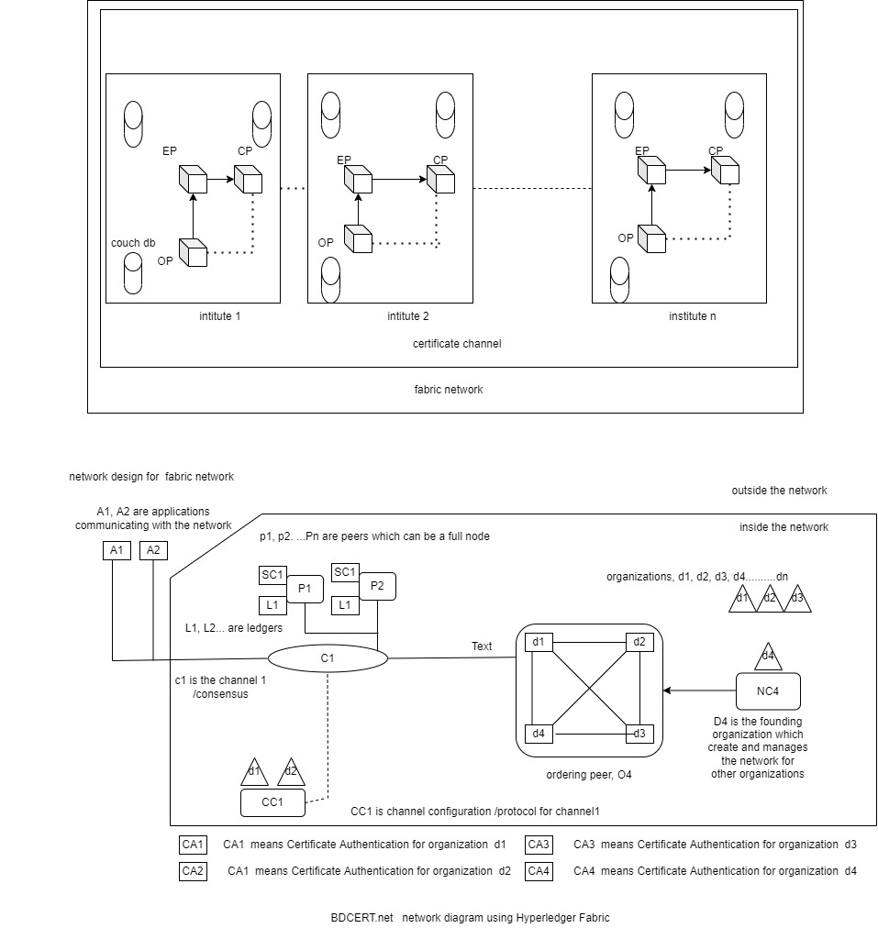

Here is network designed for n number of organizations, where there is founder organization , who initiates the network and manages the network for n number of organizations, where NC4 – network protocol is where the rules for this network is defined and stored for the orderer peer. There is orderer peer O4 initiates the network according to the rules /configuration written in NC4, it also fixes the order of the blocks that come to get to be added on the DB/ledgers at the same time, This orderer peer which serialized the blocks that are to be added in the ledger. The smart contracts , communicate with the chain code application , where or what changes to make in the ledger. CC1 for Channel Configuration/ Protocol, is similar to network protocol where rules inside the channel is stored. This Channel Configuration/ protocol , is similar to network Configuration/protocol where rules inside the consensus is stored. For every organization who are the members of the network, the identity card , is CA certificate Authority, which validates the organization as valid member of the network. The organization d1,d2, d3,…………dn, n number of organizations who are part of the network.