**Number Theory**

**Rule 1.** If the prime factorization of a number **N** can be defined by the following equation,

N = (p1)x1 *(p2)x2  * (p3)x3  * . . . . . . . . . . . . . . . . . * (pn)xn ; where p1, p2, p3 . . . . . . pn are primes.

Then the **number of all the divisors** of N, which can be expressed as **n**, can be defined by the following equation,

**n = (x1+1) * (x2+1) * (x3+1) * . . . . . . . . . . . . . . . . . . * (xn+1) ________________ (i)**

**Example :** Prime factorization of 18 is,

18 = 21 * 32

and 18 = 1 * 18 = 2 * 9 = 3 * 6 ; which means,

18 has n = **6** *Divisors*.

From **Equation (i)**, we get, **n** = (1+1) * (2+1) = 2 * 3 = **6**.

So, the results are matched.

**Rule 2.** If the prime factorization of a number **N** can be defined by the following equation,

N = (p1)x1 *(p2)x2  * (p3)x3  * . . . . . . . . . . . . . . . . . * (pn)xn ; where p1, p2, p3 . . . . . . pn are primes.

Then the ***sum of all the divisors*** of N, which can be expressed as **S**, can be defined by the following equation,

**S = ((p1(x1+1)-1)/(p1-1)) * ((p2(x2+1)-1)/(p2-1)) * ((p3(x3+1)-1)/(p3-1)) * . . . . . . . . . . . . . . . . . . * ((pn(xn+1-1))/(pn-1)) ________________ (ii)**

***Example :*** Prime factorization of 18 is,

18 = 21 * 32

and 18 = 1 * 18 = 2 * 9 = 3 * 6 ; which means,

18 has n = 6 *Divisors*

and *Sum* of them = 1 + 2 + 3 + 6 + 9 + 18 = **39**.

From **Equation (ii)**, we get, **S** = ((2(1+1)-1)/(2-1)) * ((3(2+1)-1)/(3-1)) = ((22-1)/1) * ((33-1)/2) = ((4-1)/1) * ((27-1)/2) = (3/1) * (26/2) = 3 * 13 = **39**.

So, the results are matched.

**Rule 3.** If a number can be expressed as in the form, n = 10x, x ≥ 0;

Then the ***Number of all the Divisors*** of n is (x+1)2 or d2 where d is the number of total digits of n.

***Example :*** 100 = 1 has (0+1)2 = 1 divisor (1); 101 = 10 has (1+1)2 = 4 divisors (1,2,5,10); 103 = 100 has (2+1)2 = 9 divisors (1,2,4,5,10,20,25,50,100) and so on.

**Rule 4.** The number of digits of the factorial of an integer n, can be expressed as,

**S = floor (log (n!)) + 1**

We know, log (a*b) = log (a) + log (b).

So, for log (n!) = S = log (1) + log (2) + log (3) + ……….. + log (n)

Since, the value can be fractional, we take the ceiling value of the result then increment it by 1.

***Example :*** Suppose, we have to find the digits of 5! , which is 120.

So, log (5!) = log(1) + log(2) + log(3) + log (4) + log (5) = 2.079181

Finally, S = floor (2.079181) + 1 = 3.

**Rule 5.** The number of digits of the factorial of an integer n in base b.

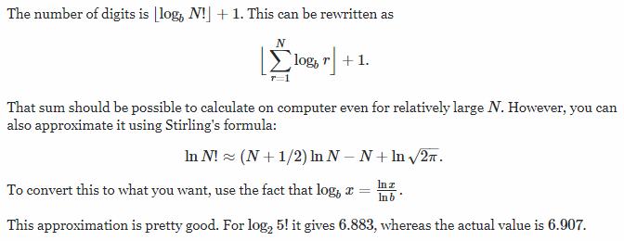

**Rule 6. Let’s see the following equation,**

N = (p1)x1 *(p2)x2  * (p3)x3  * . . . . . . . . . . . . . . . . . * (pn)xn ; where p1, p2, p3 . . . . . . pn are primes.

**The number of bases of N from 2 to infinite that has at least one trailing zero(es),**

**R = ((x1+1) * (x2+1) * (x3+1) * ….. * (xn+1)) – 1.**

***Example :*** Suppose, N = 30.

So, 30 = 21 * 31 * 51 , then R = ((1+1) * (1+1) * (1+1)) - 1 = 7

**Rule 7. If x be a prime number, then**

**(an + bn + cn + … ) mod x = (an mod Φ(n) + bn mod Φ(n) + cn mod Φ(n) + … ) mod x = (an mod Φ(x) + bn mod Φ(x) + cn mod Φ(x) + … ) mod x**

***Example :*** Suppose, n = 4 and x = 5.

So, L.H.S = (14 + 24 + 34 ) mod 5 = (1 + 16 + 81) mod 5 = 98 mod 5 = 3.

and we know that, Φ(5) = 4, so n mod Φ(x) = 4 mod 4 = 0.

R.H.S = (10 + 20 + 30 ) mod 5 = (1 + 1 + 1) mod 5 = 3 mod 5 = 3.

Therefore, L.H.S = R.H.S.