Feature Report for Photons project:

Feature 1: Photon Map (kd-tree)

What is a photon map? A photon map is a data structure used to store “photons”, which are are stored after each ray bounce starting from the light sources in the scene. It holds the surface point, power (flux) and incident direction.

Why use kd-trees? kd-trees are k-dimensional trees, they are optimized for multi-dimensional search keys (range search, nearest neighbour search, etc.). In this case I'm using a 3-dimensional kd-tree.

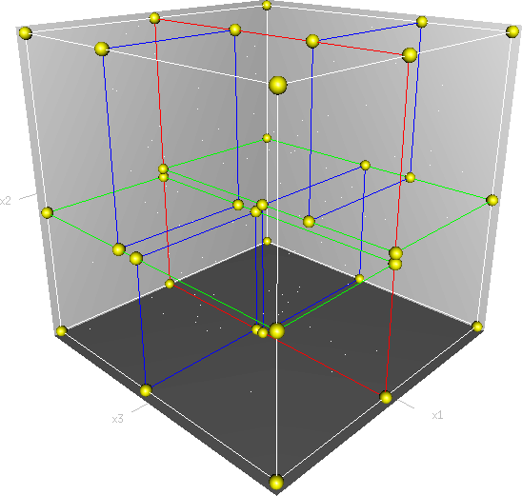
The first feature I implemented was the photon map structure, it needed to be able to hold thousands and even millions of photons. The common way to handle this is with a balanced kd-tree. The idea is to pick the largest dimension on the parent node, sort all points by largest dimension axis, pick median point and split, then store all preceding points in the first child, and the rest on the second. You proceed to do the same in the children until all nodes qualify as leaf nodes.

The first implementation of this had a few funny outcomes:
This was easy to fix though, the sphere lookup code was only going through the first child... It then started to look a bit more like expected:

Next step was proper flux integration in discrete form over a disk on the surface.

photon flux weighting based on how far they are from the hit position, on their projected height along the normal and their incident direction. This is called cone filtering.

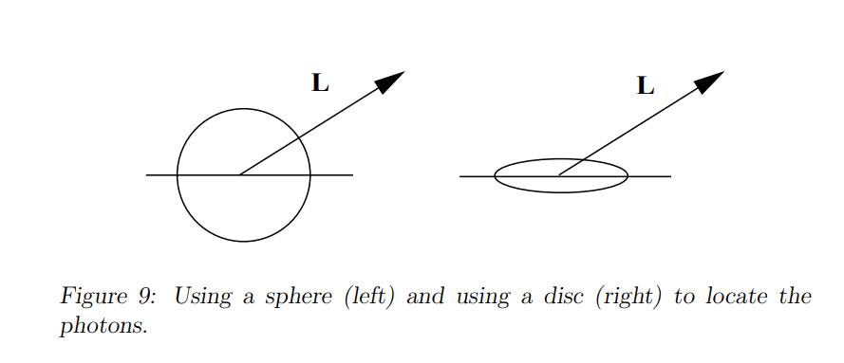
Here, is a filter constant characterizing the filter (falloff) and is the maximum radius. The normalization of the filter based on a 2d-distribution of the photons isand the filtered radiance estimate becomes:

I started to calculate direct lighting using standard ray tracing and indirect global illumination with photon mapping and combining them. First image is only calculating flux output from first hit point, whereas the second render is taking multiple random samples in a hemisphere from surface point (final gather) which then have to be multiplied by the surface albedo:

The lighting equation is split into two steps, a photon casting step, where light is scattered around the scene starting from the light source until reaching a termination point. The second pass is the final gather pass where radiance is calculated for the intersection point sampling a hemisphere.

Both of these passes use cosine-weighted hemisphere sampling, which lowers the number of samples required to compute Lambertian reflectance.

The first is the uniform hemisphere sampling:

The following is the improved cosine weighted equation:

And the ray sampling function based on random uniforms (random value between 0 and 1) u_1 and u_2 is as follows:

There were still many things wrong, for example in this image I was not taking into account Lambertian reflectance factor this is why sometimes the corners look so bright as the photons gain power as they are reflected which is a violation of the law of conservation of energy.

As I was doing cosine weighted hemisphere sampling, getting all factors right took a while.

During the first pass the correct formula is:

And, in the final gather step, the photon flux is added without any additional factor.

Another issue is I had a typo in my random number generator function which was causing bad distribution of rays and thus the result was unnatural. After all of these issues were resolved the output was much clearer and more accurate.

One of the big challenges with this was speed, to render a simple scene at 512x512 pixels it took more than 2 minutes ... So I fired up AMD uProf and these are the results I was got:
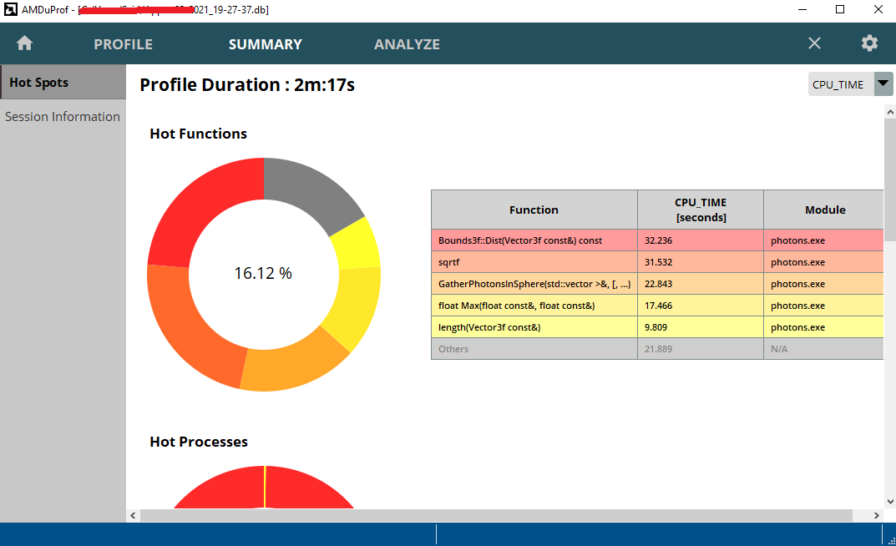
As you can see, most of the time was taken by Bounds3f::Dist followed by sqrtf and length, which is used in KD-Tree lookup to find all photons within a sphere. I replaced this by a Dist2 (squared distance) function to avoid sqrt, and I lowered the use of this function. The second thing I did was use squared length to the KD node splitting plane rather than calculating the actual length, and same for when checking if photons in a leaf node are within the sphere. This improved the performance greatly. I wrote a simple “thread pool” system as well to render the final frame in parts asynchronously.

Feature 2: Mirror reflections
Reflection is when photons are re-emitted perfectly on the surface without any energy exchange, so the angle between the incoming ray and the normal and the reflection ray and the normal are equal.
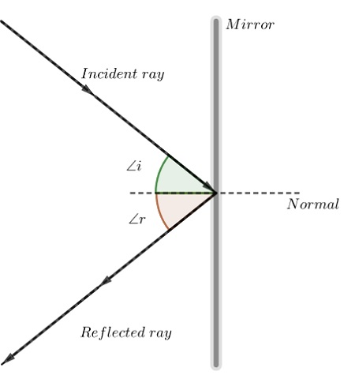

Mirror reflections were to be honest quite easy to add, they are a part of direct lighting, nothing to say here except that diffuse photons don't accumulate on perfectly glossy surfaces. They are also perfect mirrors but on a microscopic level, the photon is reflected on a very specific direction as opposed to diffusion where the flux is equal on all sides. The photons bounce off and are saved on diffuse surfaces only.

Feature 3: Perfect refraction caustics

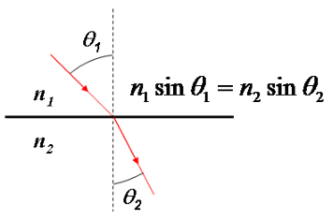
Refraction is when light penetrates a surface and is bent cause of the medium change. This is described by Snell’s Law. The angle at which the light is refracted is based on the ratio of the first and second media’s index of refraction values.
One property of this is that if you have a convex refractive object like a sphere with a higher IOR than air, the image ends up flipped upside down when refracted through it, but if the IOR is less than air, then the surface becomes reflective. Also, internal reflections have to be taken care of which is when the light keeps reflecting inside the object before exiting.

Caustics were a bit more tricky as you have to bias the photons specifically on visible “caustic generators”. The foundation was already laid. The caustic photon map was exactly the same as the diffuse map, except that the number of photons it had could be more without affecting performance that much, and the radius would be generally smaller as it's a higher resolution map. The idea is you want to aim the photons from the light source directly at the surfaces which have a refractive property (biasing – selecting directions from the light source which are more likely to affect the result more often).Similar to reflective/specular surfaces, you don't save the photons on refraction, but only once they hit a diffuse surface, if they are bounced into the void before hitting a diffuse surface then that whole path is discarded.
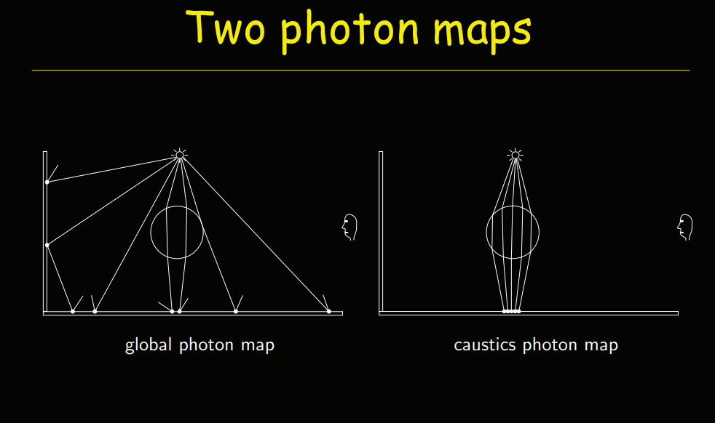

This is how it looked at first (left image), and once the power factors were tuned and the cosine of the angle was taken into count (right). You can see that there is a concentrated spot of light but falls off gently:

General render showcasing GI and refractive sphere:

This increases the realism quite a bit by simulating these effects, as you can see indirect light on spheres, floor, refraction, etc…

Feature 4: Texturing & Texture filtering

Adding texturing was quite straight forward, I first implemented a simple Texture class with bilinear filtered sampling. Which helps smooth out low frequency textures. The idea is that if you are sampling a colour value from a texture, and it’s at a fraction of an integer coordinate, you would take the 4 corner pixel values and linearly interpolate left to right, then bottom to top.
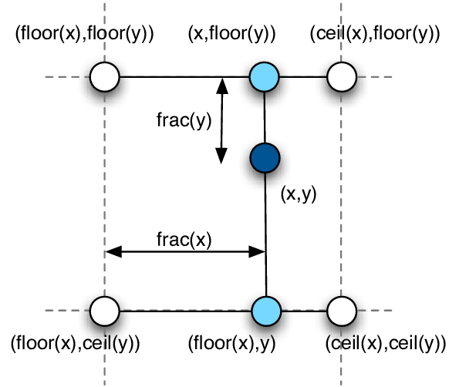
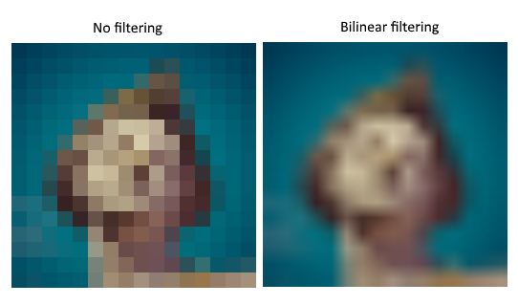

The following render uses an albedo texture. The UV mapping for the sphere is simple cylindrical unwrap. (https://en.wikipedia.org/wiki/UV_mapping)

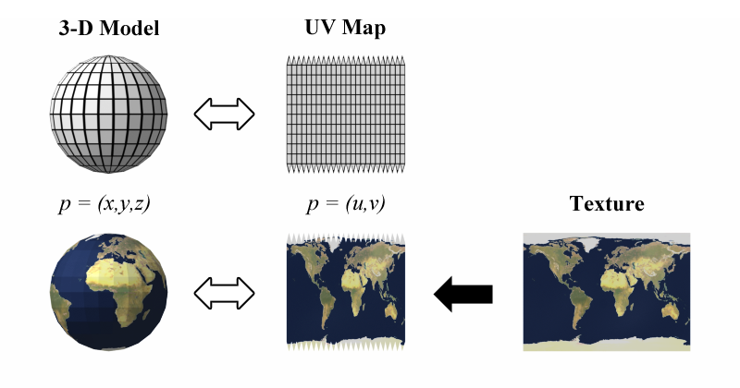

Extra Features: Gamma correction, Linear to sRGB & Tone Mapping

Gamma correction is quite simple to understand, the idea is that light value is not perceived by the eye linearly, but actually we perceive darks and grays as lighter than they actually are, thus it's quite common to use a power ramp to replicate this effect. (https://www.cambridgeincolour.com/tutorials/gamma-correction.htm)

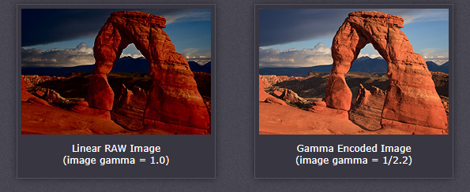
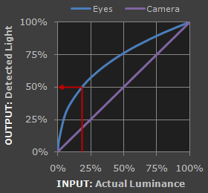
Linear to sRGB is a conversion for sRGB colour space which is the standard RGB colour space used by most monitors. Monitors don't replicate 100% reds, greens and blues equally, this function has the purpose to adapt the colour values for the display to look best.

Tone Mapping finally is similar to a colour palette, in this case it also handles scaling for camera exposition and makes the colours more vivid and alive.

The following image shows one of the previous renders but with these post effects and filters which make the ambience way more natural:

Other cool stuff to implement:
Proper Material system based on BSDFs and integrators (Cook-Torrance, GGX, Burley, etc…)
This is because physical materials are way more complex than perfect Lambertian reflectance, perfect reflections and perfect refractions. Accounting for this though is quite tricky to avoid things like variance, sampling issues, etc… Physically based shading is the scientifically physically accurate modelling of light material interaction. Modelling different materials such as milk, aluminium, glossy & rough surfaces, metallic & dielectric.

MIS (Multiple Importance Sampling)
Mesh loading and rendering
Mesh loading and rendering is a bit of a challenge especially when handling large models. The data has to be stored effectively and spacial organization has to be efficient for ray tracing. Having a proper scene format would help greatly in something like JSON or XML. Common formats would be FBX, Obj and GLTF mesh formats which allow a great deal of flexibility for scenes as well.

Scene acceleration (BVH, BSP, KD-Tree, etc...)

Source Information:
https://www.cs.princeton.edu/courses/archive/fall16/cos526/lectures/03-photonmapping.pdf\
https://cgg.mff.cuni.cz/~pepca/lectures/pdf/pg2-23-photonmapping.en.pdf
https://www.pbr-book.org/3ed-2018/contents
https://web.cs.wpi.edu/~emmanuel/courses/cs563/write_ups/zackw/photon_mapping/PhotonMapping.html
https://www.youtube.com/watch?v=4BBkjzwqMSU
http://www.cim.mcgill.ca/~derek/ecse689_a5.html

