**Brief : Restaurant dynamic website**

Objective : creating restaurant management website to make life easier for the restaurant owner.

***User Stories***

User story 1: The project must contain an admin dashboard (user dashboard optional can be added if time allows)

User story 2: Admin can manage all operations (users and contents related) through the website e.g:

* Updating list of products
* Adding categories of products
* Verification of orders

User Story 3: For user they can access :

* Home page
* Information page
* Contact page

User Story 4: to order the user must sign in

***Functional requirements***

* Admin have a dashboard to manage all contents and users related operations
* Admin can add/modify/delete products
* Admin can add/modify/delete users
* User can access products page and sign in to order
* When user order he need to confirm or he cancel to go back
* When a user order is confirmed the admin must receive a notification though email
* Admin can access and add/modify/delete orders.

***Non-functional requirements:***

* The website must be operational on laptop and mobile
* Database must be secured against sql injection.

***Sitemap :***

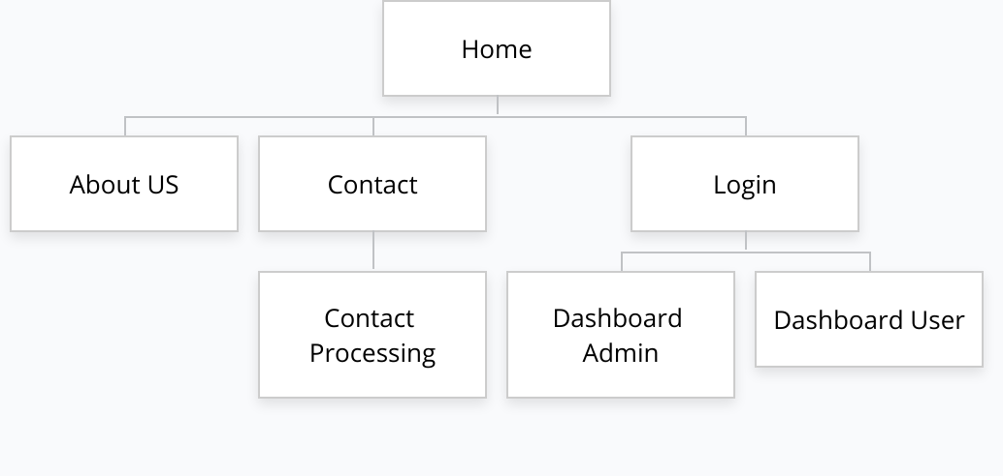

***Class Diagram***

***ERD Diagram***

***Sequence Diagram***