EXPERIMENT-5
Aim: To practice SQL queries on the EMPLOYEES table to retrieve, filter, and display specific employee information based on conditions such as salary, manager, department, and last name.
SQL Queries
Create Database

Use Database

Create Table
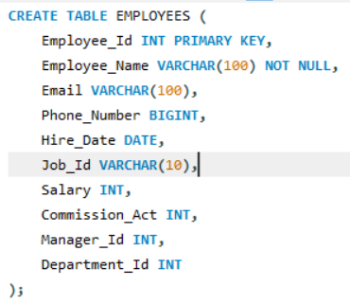

(a) Employee ID, Names, and Salaries of all employees
INPUT:
OUTPUT:
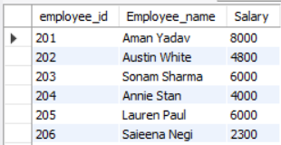
(b) Employees who work under manager 100
INPUT:
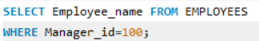
OUTPUT:
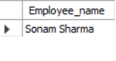
(c) Employees with salary >= 4800
INPUT:
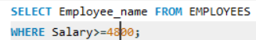
OUTPUT:
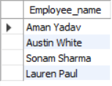
(d) Employees whose last name is ‘AUSTIN’
INPUT:
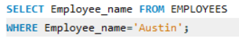
OUTPUT:
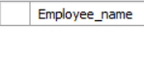
(e) Employees who work in departments 60, 70, 80
INPUT:
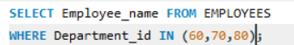
OUTPUT:
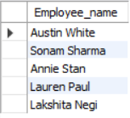
(f) Display the unique Manager_Id
INPUT:
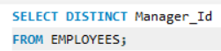
OUTPUT:
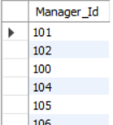
EXPERIMENT-6
Aim: To create and manipulate a Client_master table in MySQL, including inserting records, filtering based on balance due, updating data, renaming the table, and customizing column headings.
SQL Queries
Create Database
Use Database
Create Table
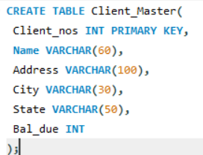

( a ) Insert five records
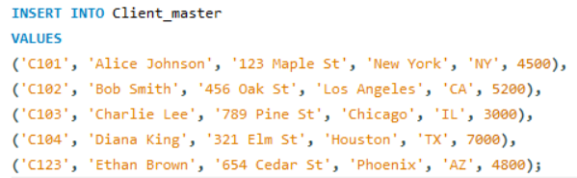
( b ) Find the names of clients whose bal_due> 5000
INPUT:
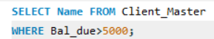
OUTPUT:
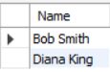
( c ) Change the bal_due of ClientNO “ C123” to Rs. 5100
INPUT:
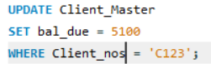
OUTPUT:
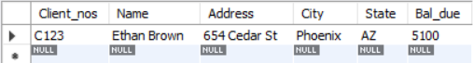

( d ) Change the name of Client_master to Client12.
INPUT:
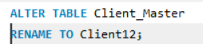
OUTPUT:
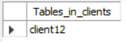
( e ) Display the bal_due heading as “BALANCE”
INPUT:

OUTPUT:
