This project consists of a loan management system.

Upon login the program will check if the user is a customer or a bank administrator and will display the appropriate frame

A new customer can sign up but banks are predefined

When you click on next

If cin already exists or is not a number or is null or its size is different than 8 then the appropriate message will be displayed

If first name or lasname are null a message is displayed

If all field are correct The user is passed to the next panel

If the username already exists or is null the appropriate message will be displayed.

Is the password is null a message will be displayed

Any user can change its credentials (Verified in class).

Upon login a customer can request a loan, values of loan after interest monthly payment change dynamically within the panel, the customer can also view his pending loans (Verified in class).

and accepted loans

Upon login a bank administrator can see the number of pending loans on the top right of the corner it varies when the bank admin accepts or refuses a loan.

The bank admin can accept/refuse a pending loan (Values are taken straight from the JTable based on selected row)

or view the registered loans at his bank.

Database diagram It uses a remote mysql database (remotemysql.com)

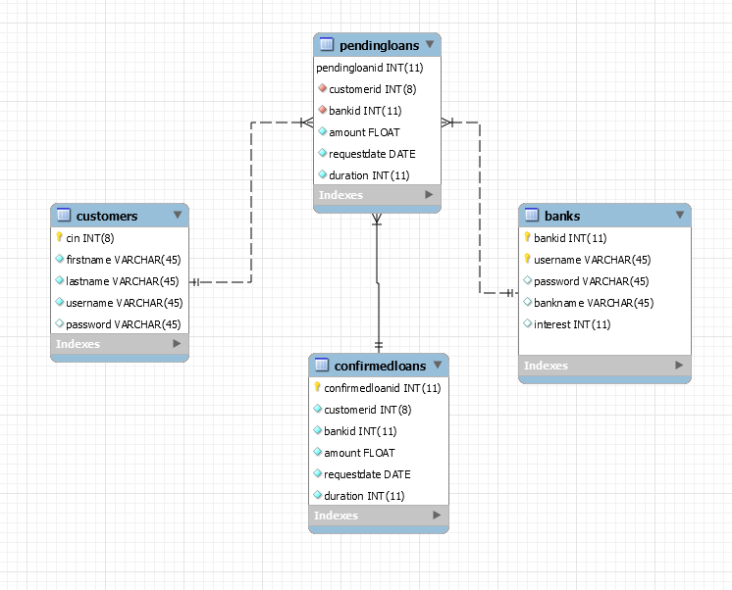

Class diagram

