Docker a Containerization Tool

Installed docker:

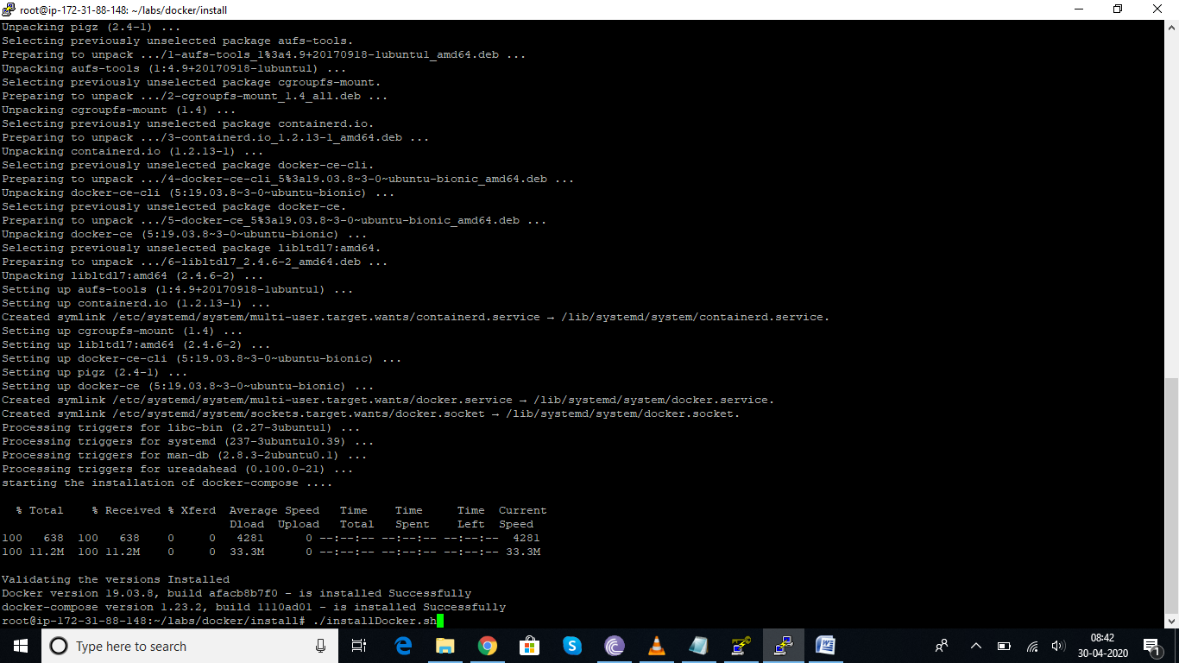

Docker pull and docker history

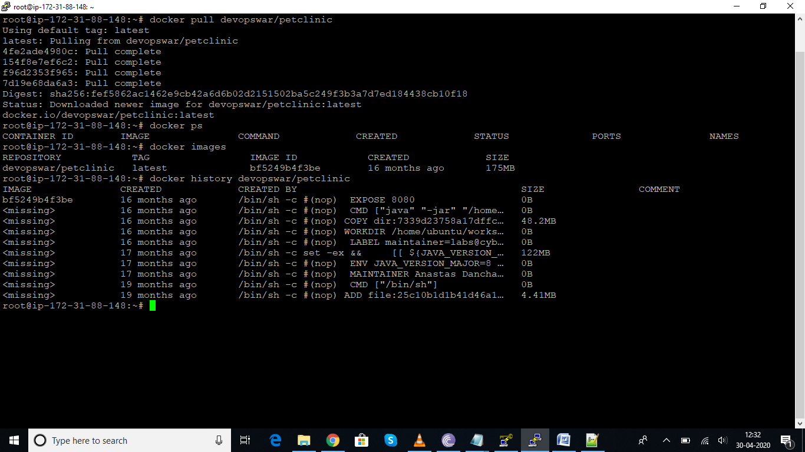

Docker pull tomcat for pulling the tomcat image

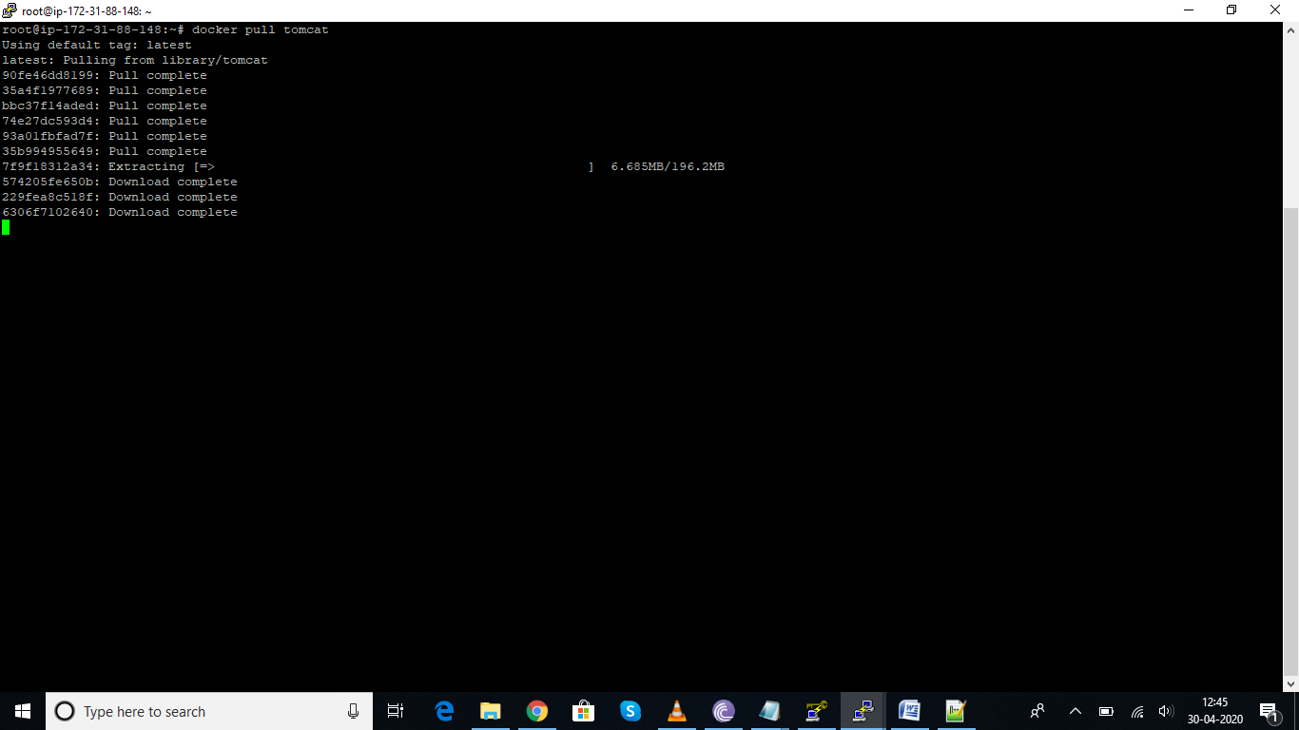

How to stop a container and delete the container

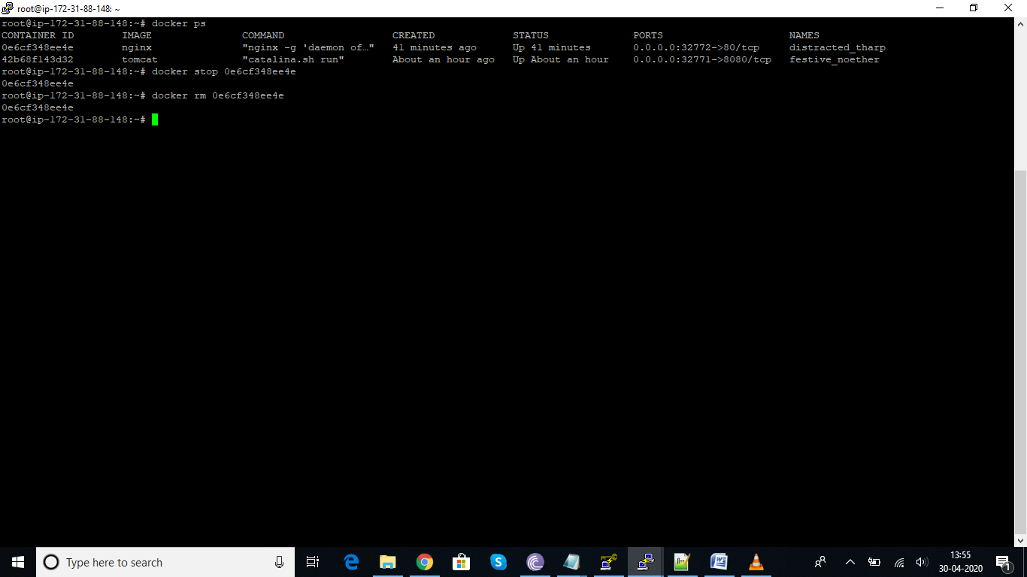

Docker exec command will allow to login to running container, we can pass the argument to running container form outside or we can login to container by docker exec -it containerid /bin/bash and perform the required operations

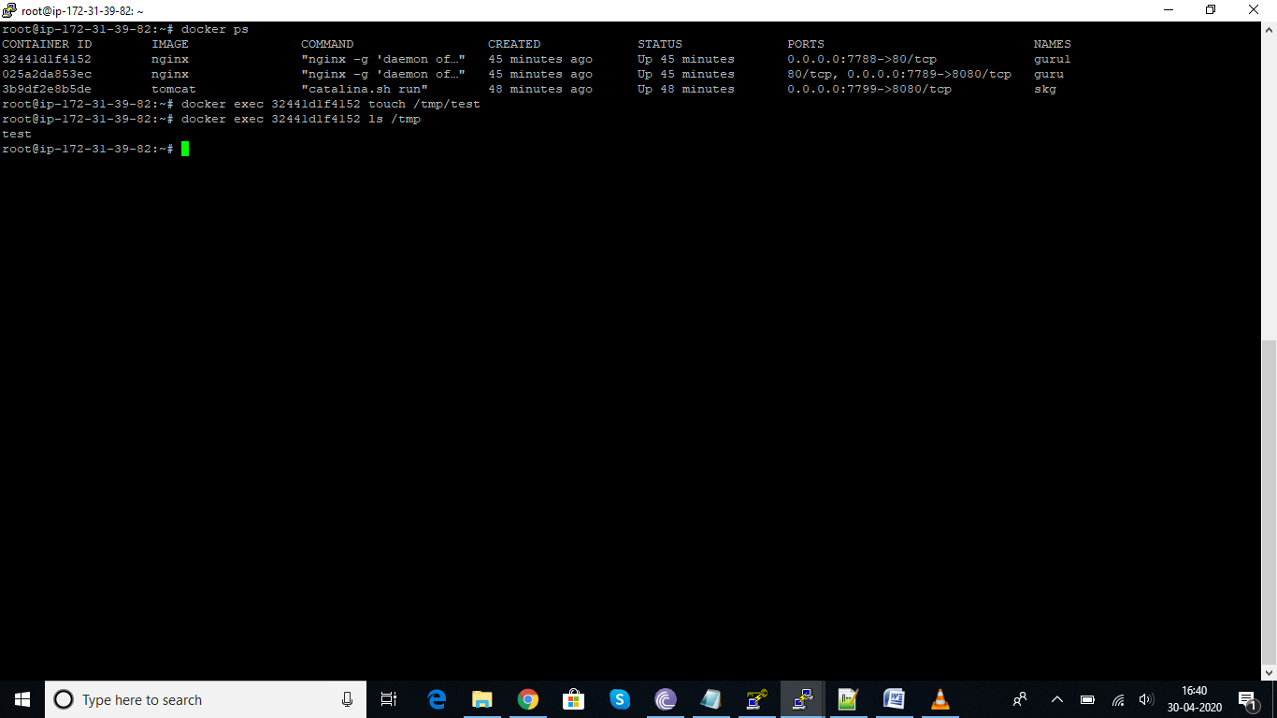

Docker logs containerid----these will give the log details of container

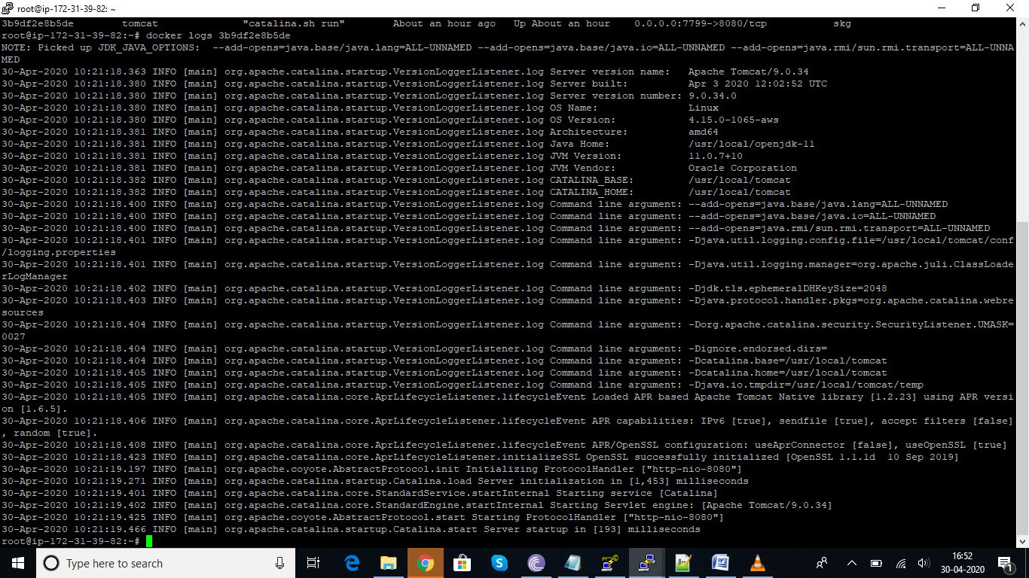

Docker images:

Custom images: we can pull the OS as per requirement and install all the required things and commit it . these will create a new image, now we can run the container with new image which has been created

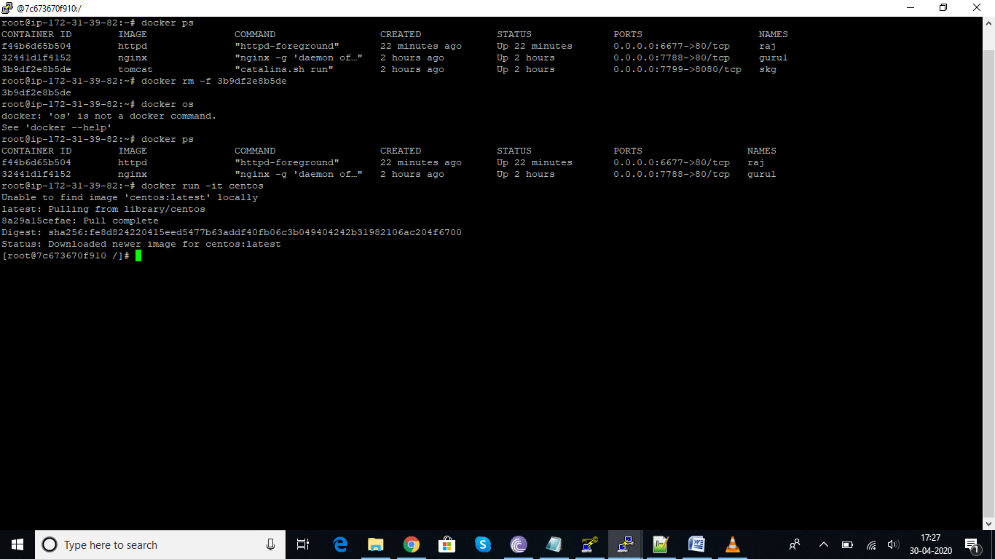

Created centos image and now will install the required softwares

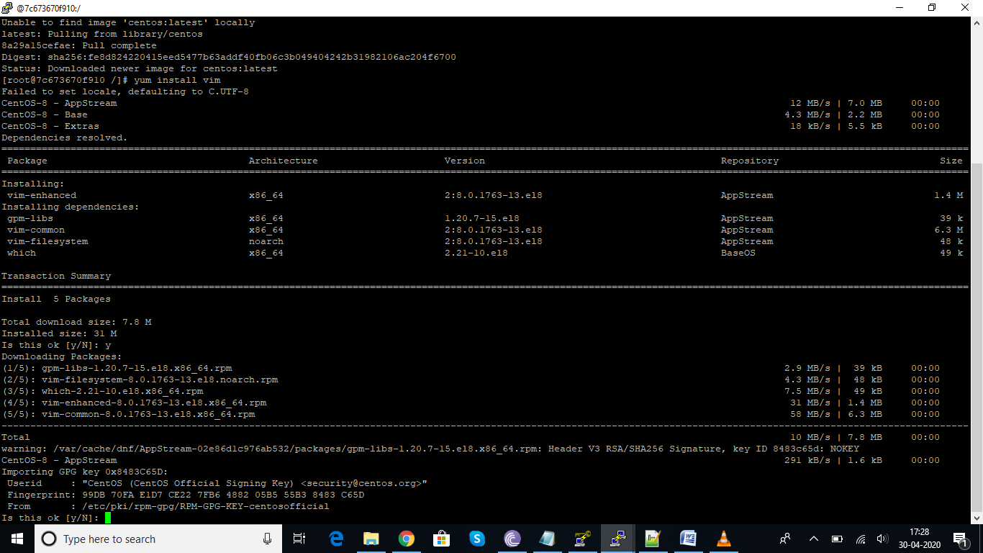

Now I have created new image with using docker commit command

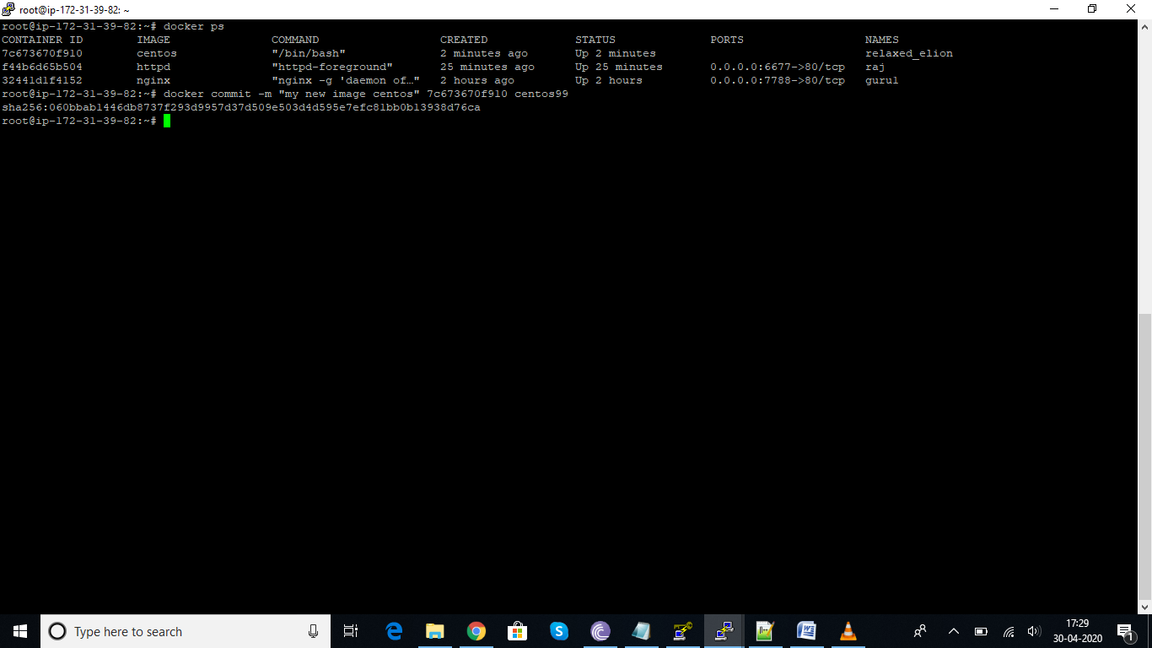

Docker file creation

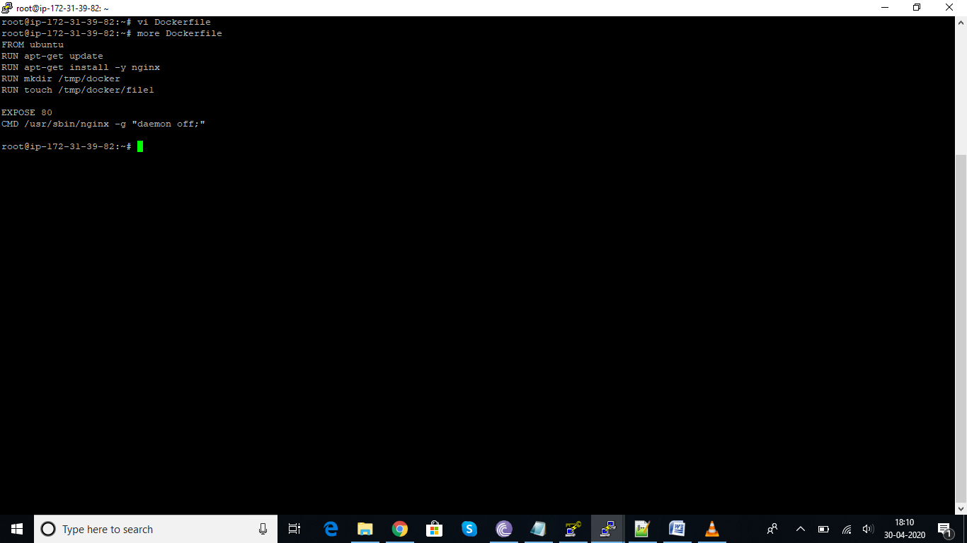

Now build the docker file image with docker build command

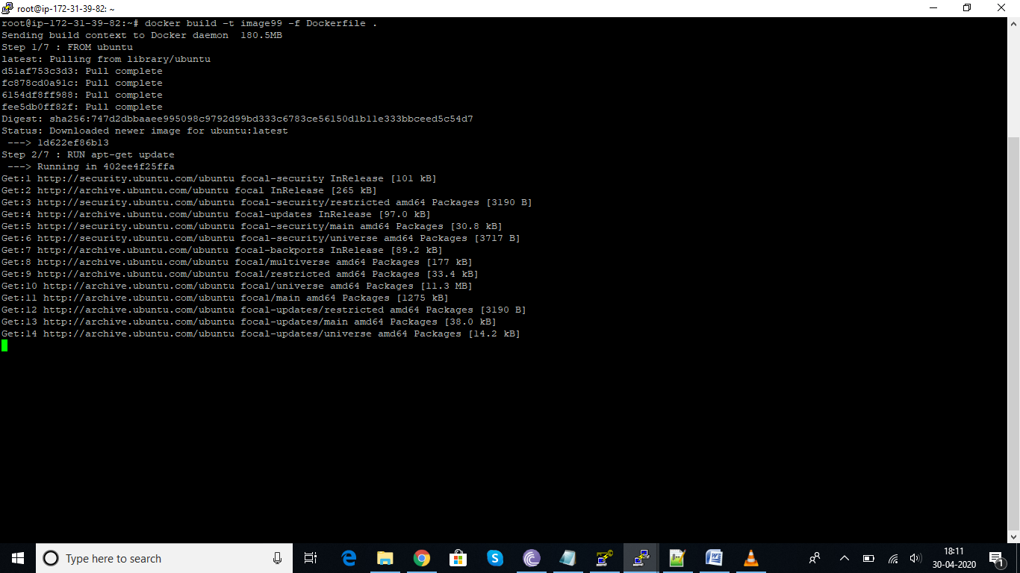

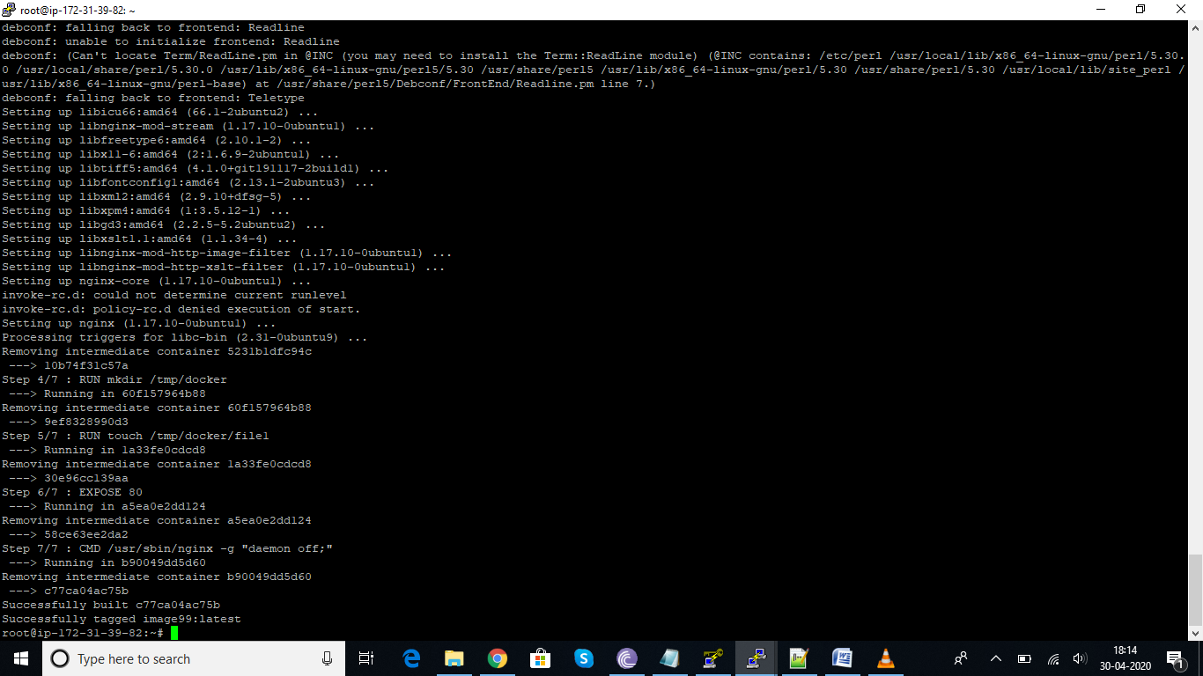

Docker entrypoint example:

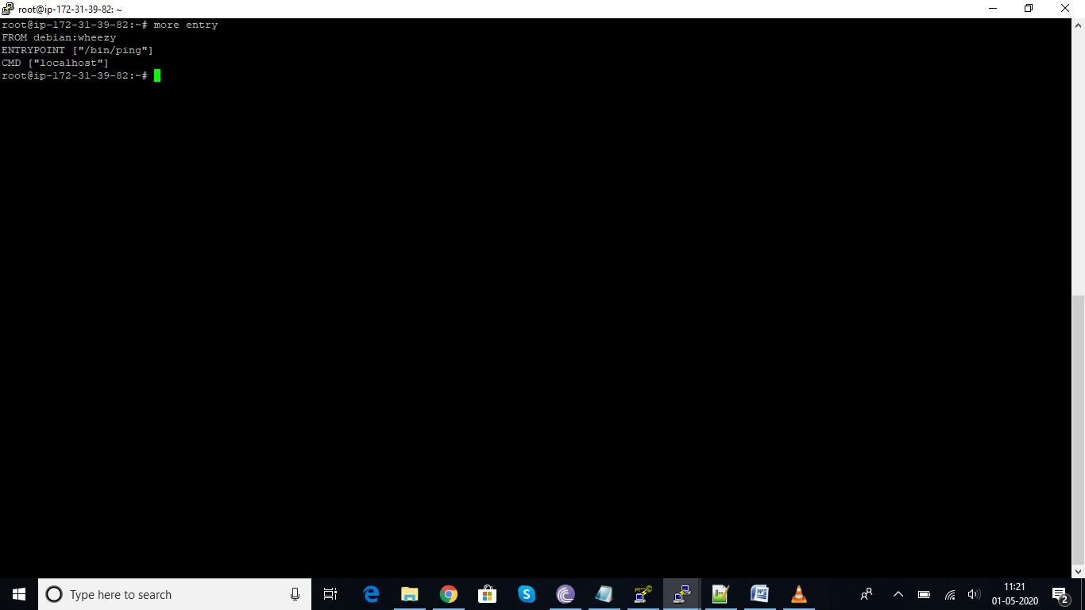

If we run the container it will ping the localhost output, if we give google.com at the end of run command it will provide the google.com output, but if we give echo command we will get error, because entry point has only ping command to be executed.

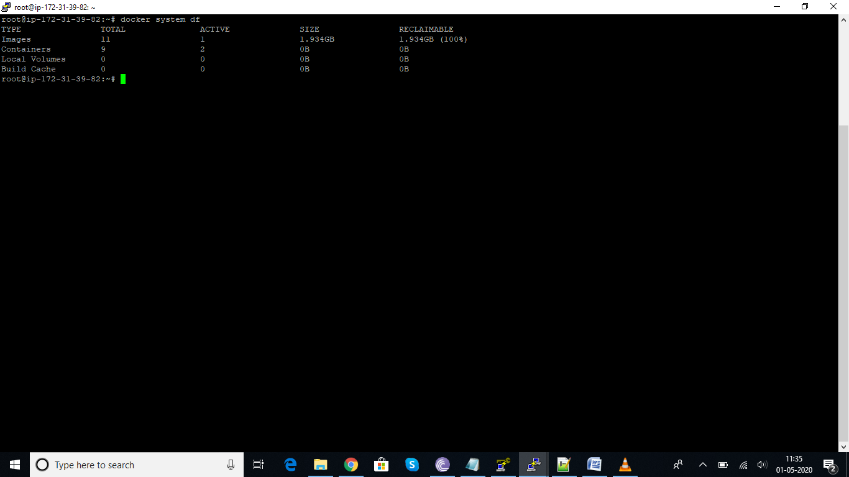

Docker system df—will complete details about the system

Docker push

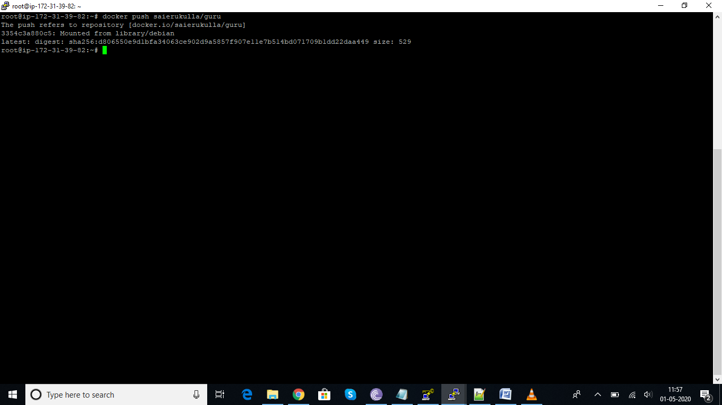

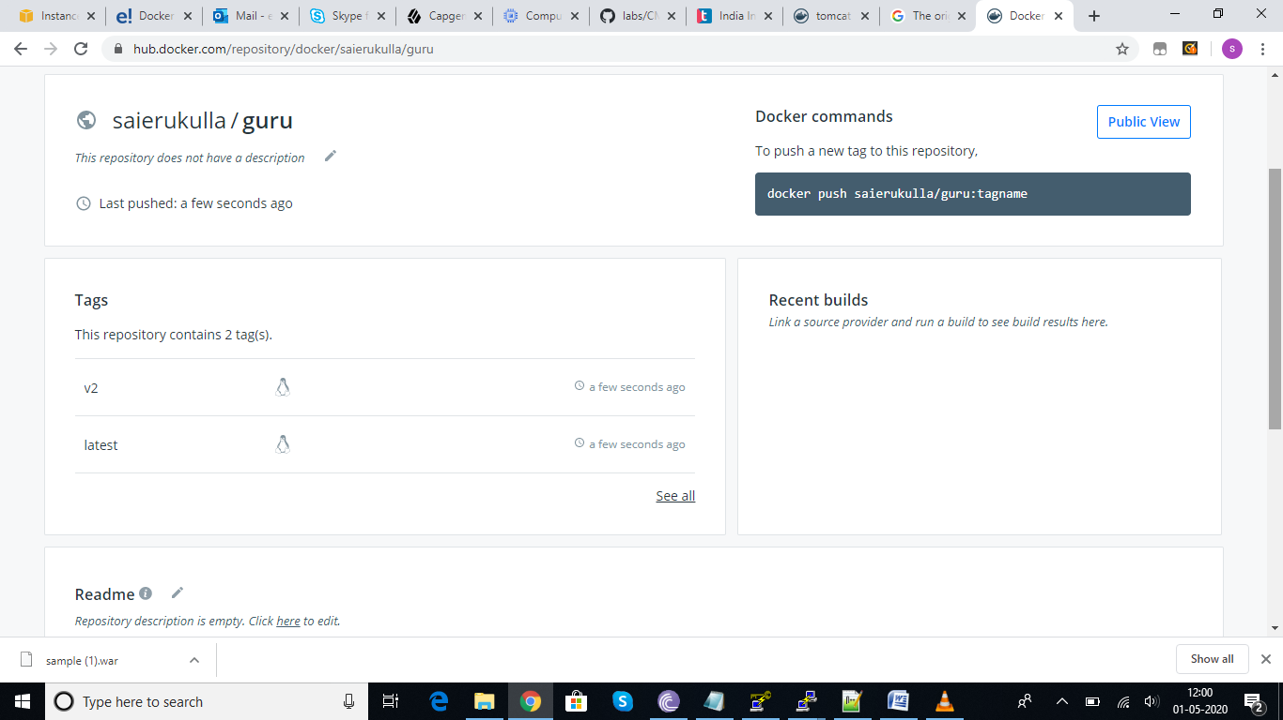

Docker pull

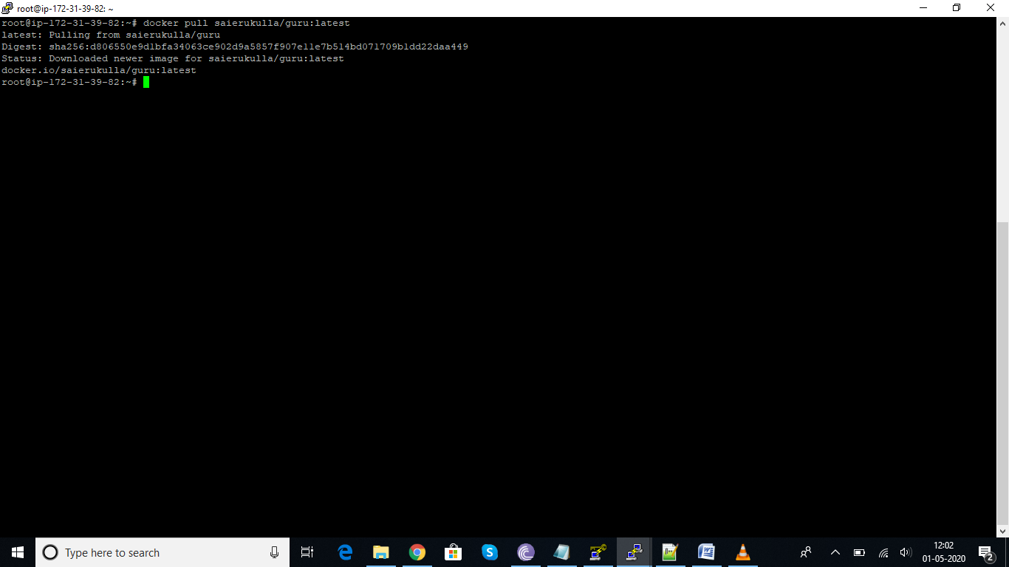

How to create volumes and copy the volumes to containers

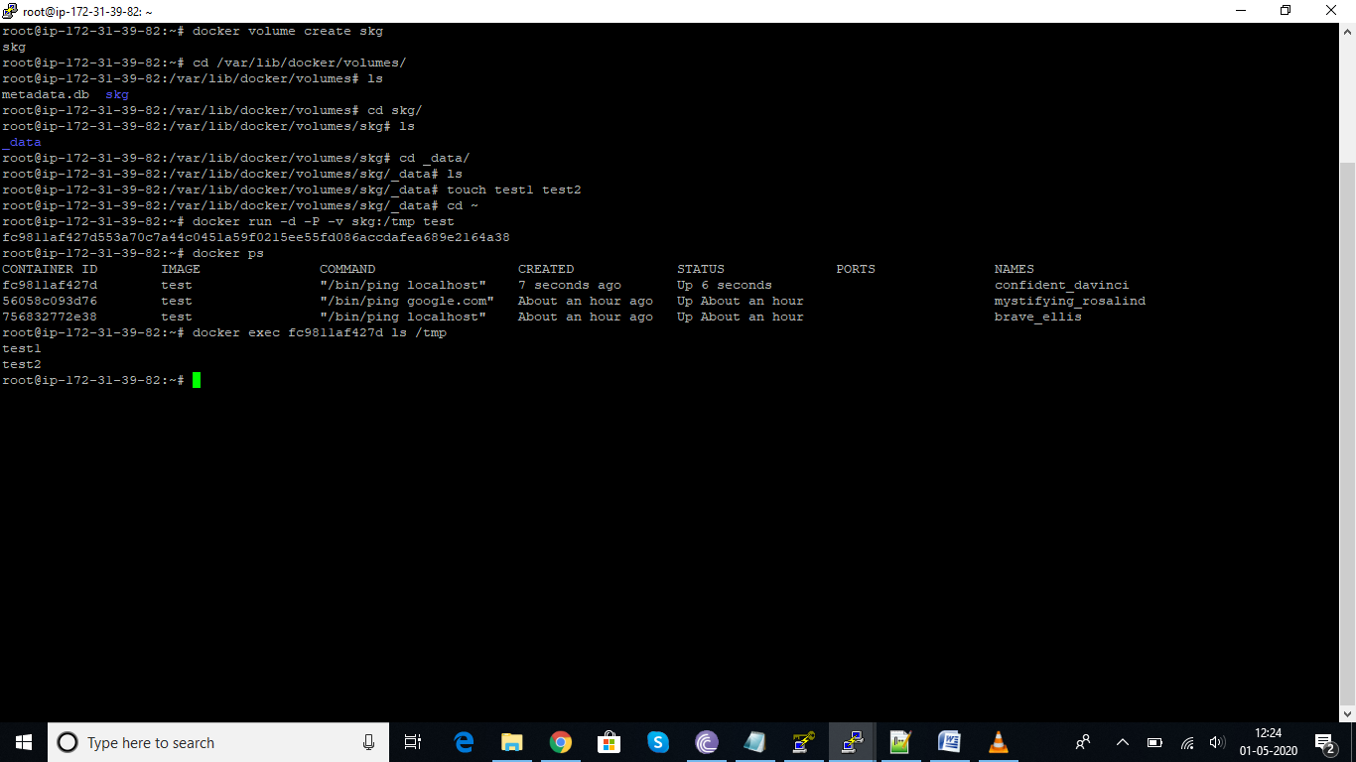

Docker compose, we need to install docker compose in order to run compose commands

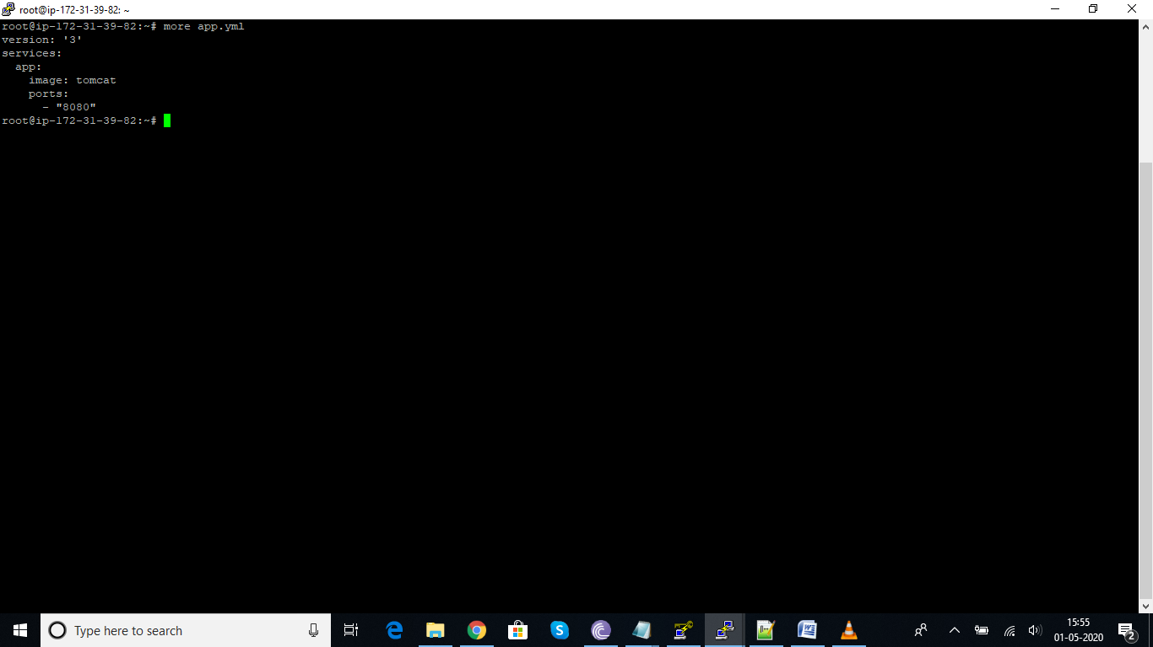

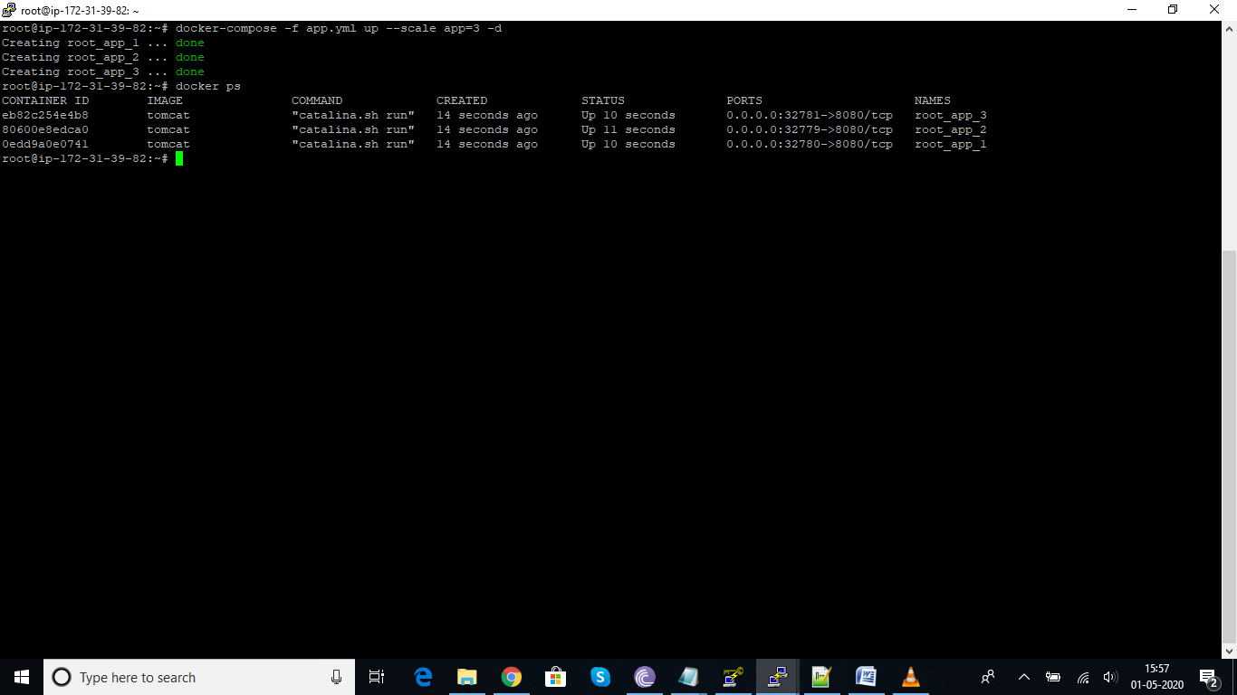

Launched wordpress application using docker

