By default kubernets does not have network like docker, we need to explicitly create the network using plugins like flannel, calico, OVN, Romana

Indocker by default you get the network called docker zero

kubeadm join 10.128.0.2:6443 --token w8ri8a.m220vhjo7mu0si6j \
--discovery-token-ca-cert-hash sha256:b80da91b37e55e2e4478a3399aee94f3343a5e29bb234572cb19a74c1eb3a834

Kubectl get pods --all-namespaces
Kubelet ----it is the only one which runs as the service, but not as container.
service kubelet status to check the status of kubelet

----kubernets token keeps on changing, in docker token will there for 3 months by default.
---When ever you create a node, we will generate a new token and join the nodes to master.
Kubectl explain pod---command to show the api version
Kubectl explain deployment—comand to show the api version
Kubectl explain service ---command to show the api version

Kubectl describle pods myfirstpod----these will give the complete details about the pod.
Kubectl get pods -o wide---these will give the output in shorter format.
Conditions or Lifecycle of pod: Initialized---→Ready---→Containers ready---→podscheduled
Events for pod scheduled : Scheduled(it first assigns the pod)-→Pulling-→Pulled--→Created---→Started

Events:
Type Reason Age From Message
---- ------ ---- ---- -------
Normal Scheduled 8m24s default-scheduler Successfully assigned default/myfirstpod to node1
Normal Pulling 8m24s kubelet, node1 Pulling image "tomcat"
Normal Pulled 8m6s kubelet, node1 Successfully pulled image "tomcat"
Normal Created 8m2s kubelet, node1 Created container sai
Normal Started 8m2s kubelet, node1 Started container sai

Kubernetes Topics: pods, replica sets, deployments, services and dashboard
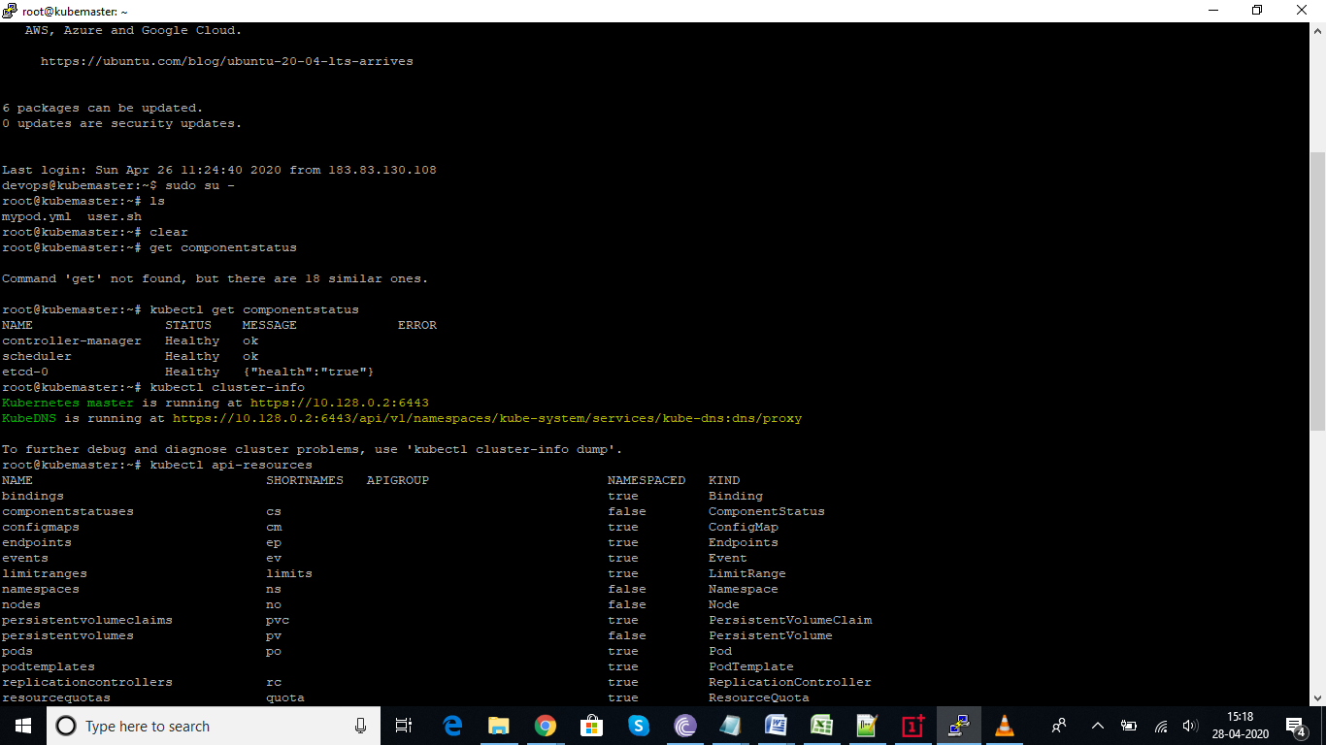

How to check api-versions and below is the output
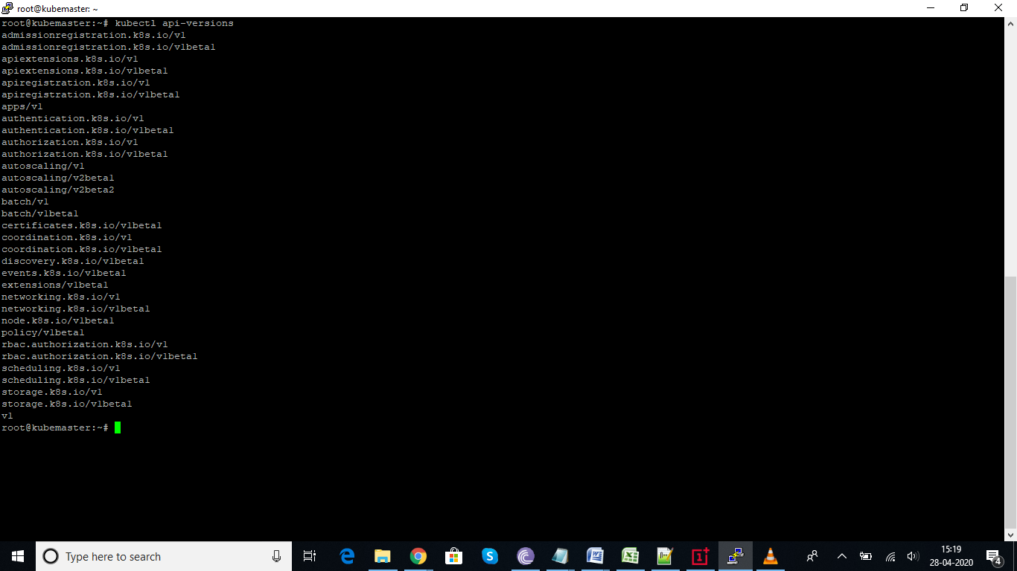

How to check kubelet service status
Service kubelet status----these is the only thing runs as service, not as container.
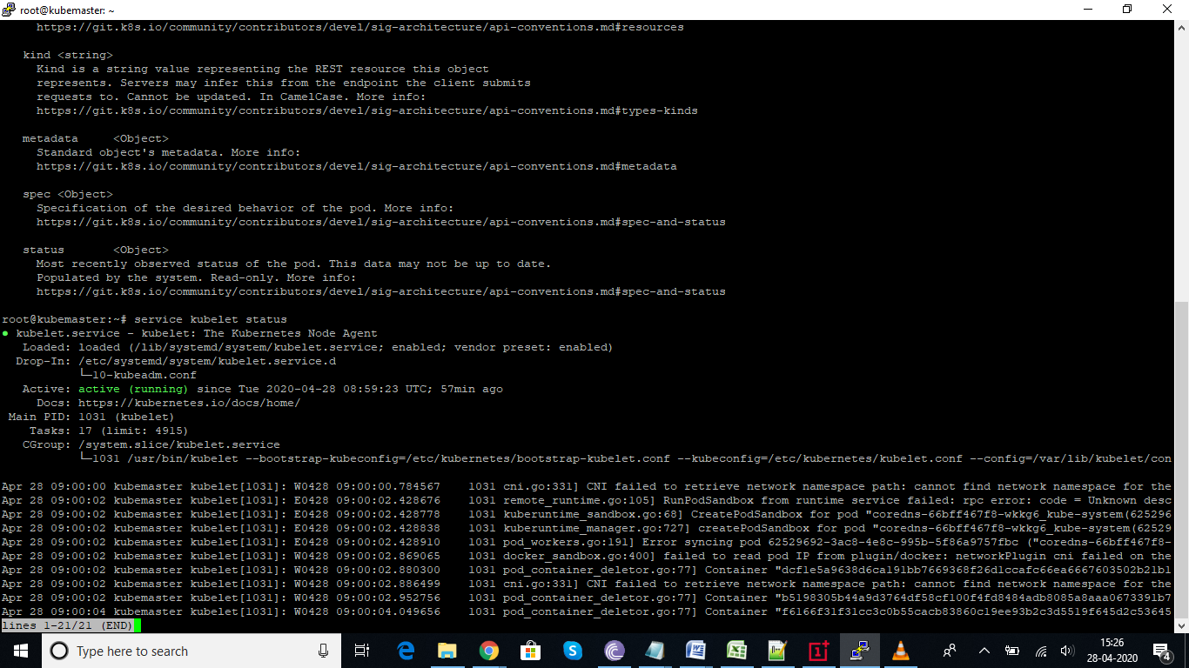
How to check the api version for pod, it is better to check the api version beform writing the pod.yml file.
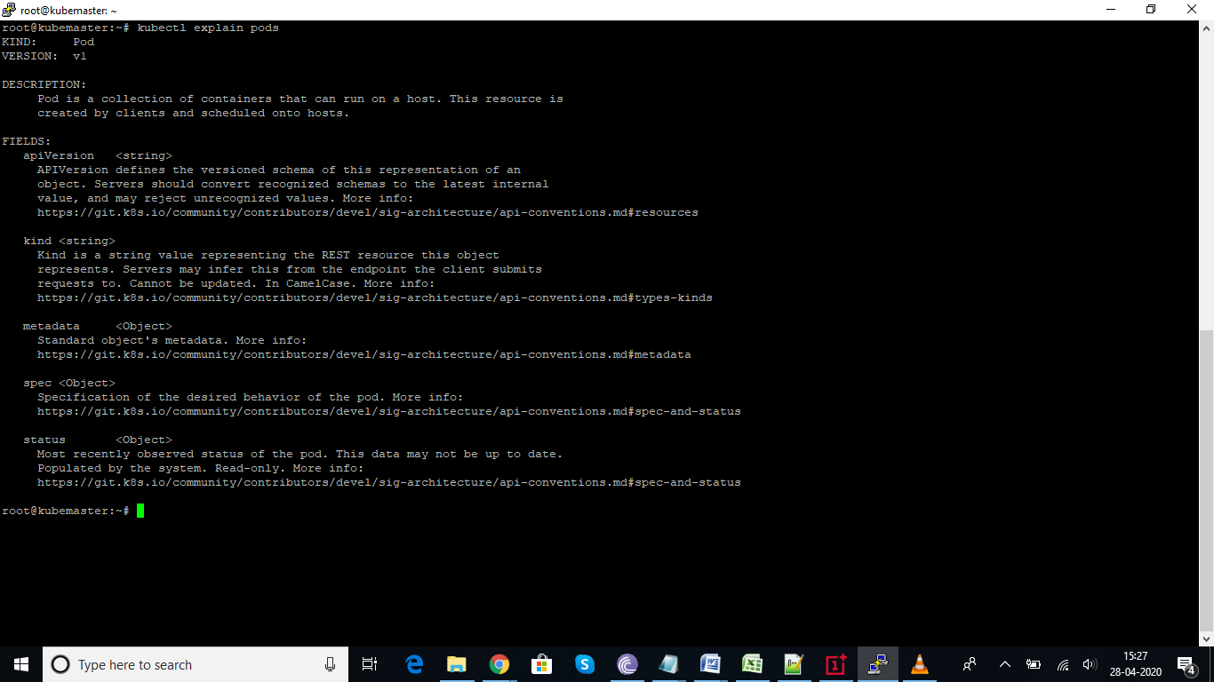
Contents of pod file
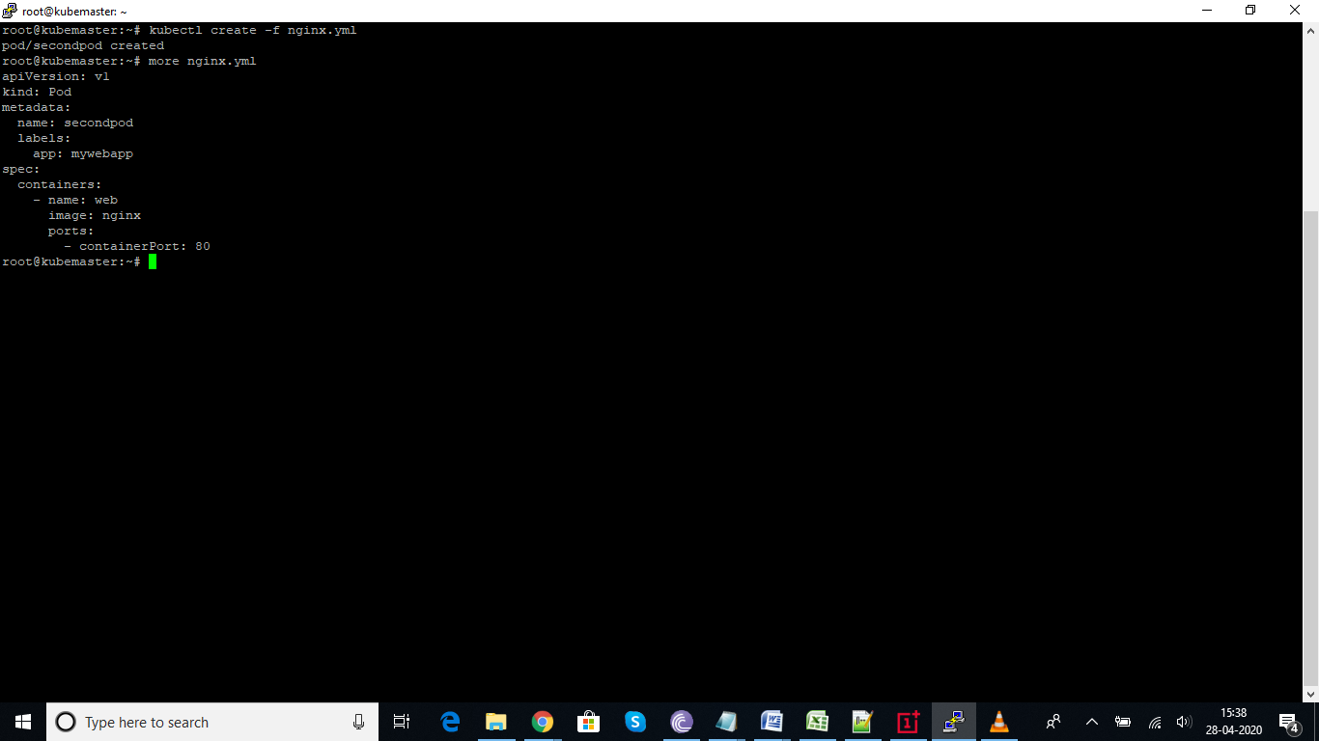

Command to list the pods
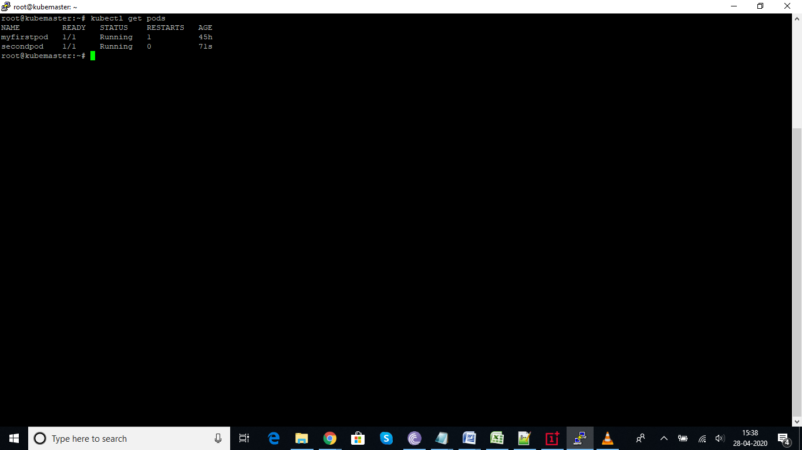
Command to delete the pods
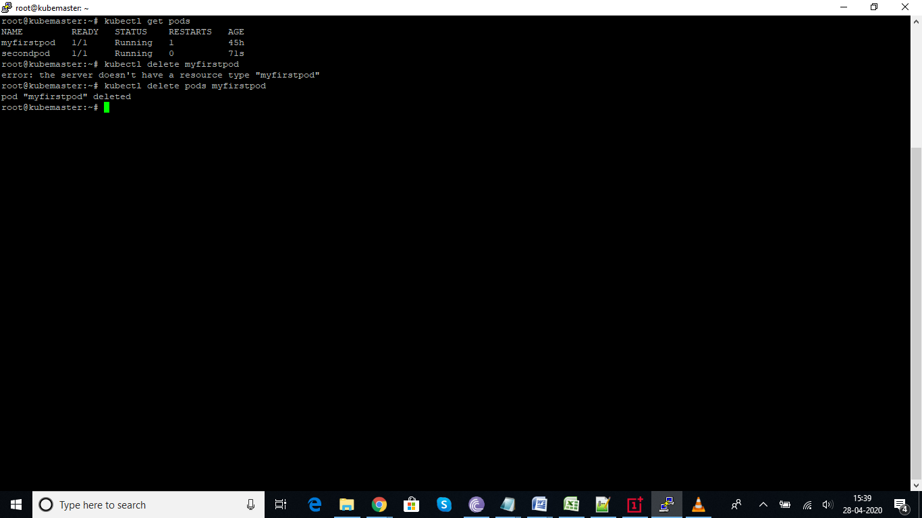

How to check the nodes
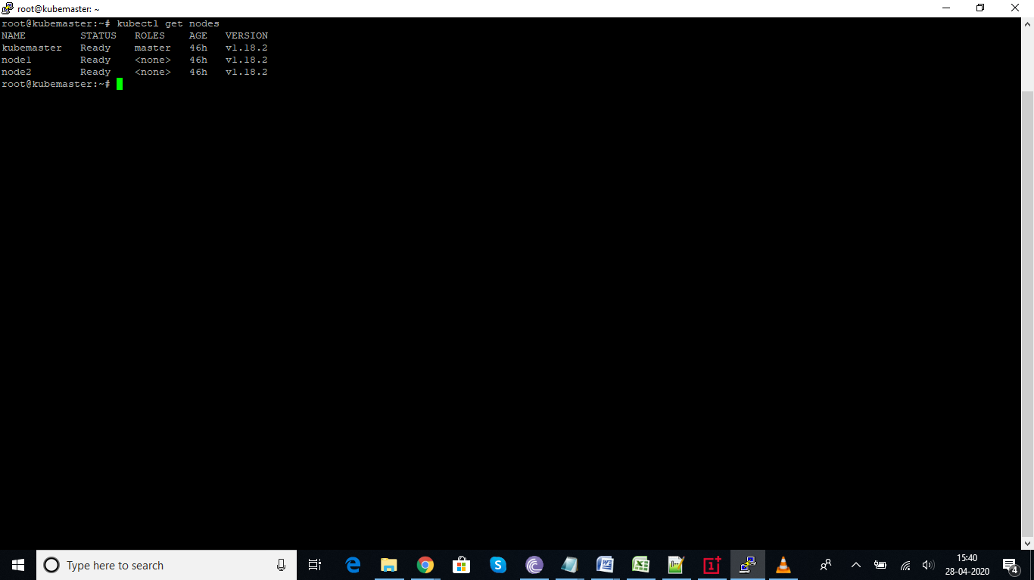
If we want to the check complete lifecycle and events and other information related to pods, we can user describe command.
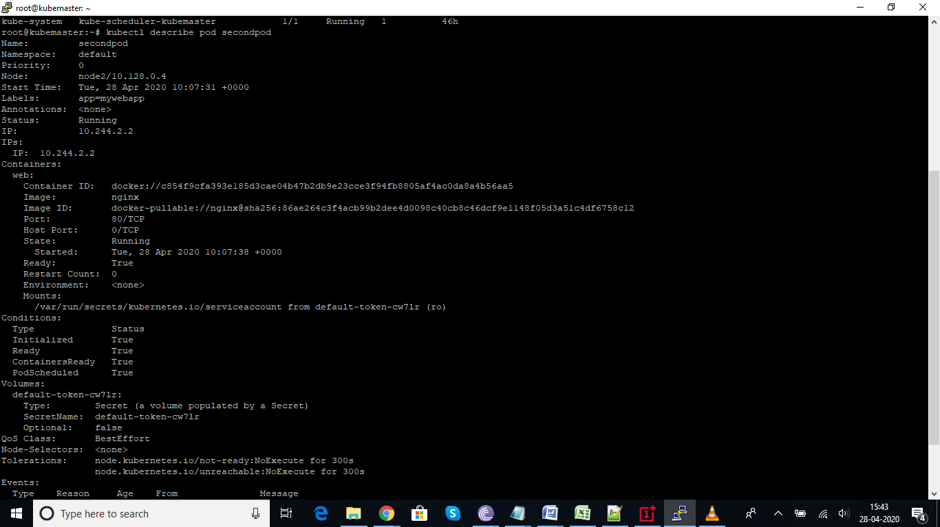

How to check the detail status of nodes
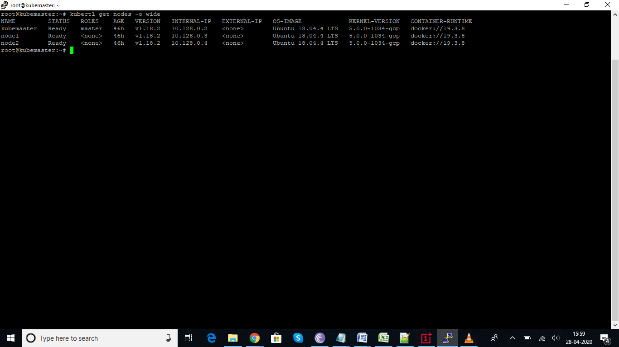

Replica Sets It is one of the Kubernetes controllers used to make sure that we have a specified number of pod replicas running (A controller in Kubernetes is what takes care of tasks to make sure the desired state of the cluster matches the observed state). Without it, we will have to create multiple manifests for the number of pods we need which is a lot of work to deploy replicas of a single application. In previous versions of Kubernetes, it was called “Replication Controller”. The main difference between the two is that ReplicaSets allow us to use something called “Label Selector”.

How to check replicaset version or rs:
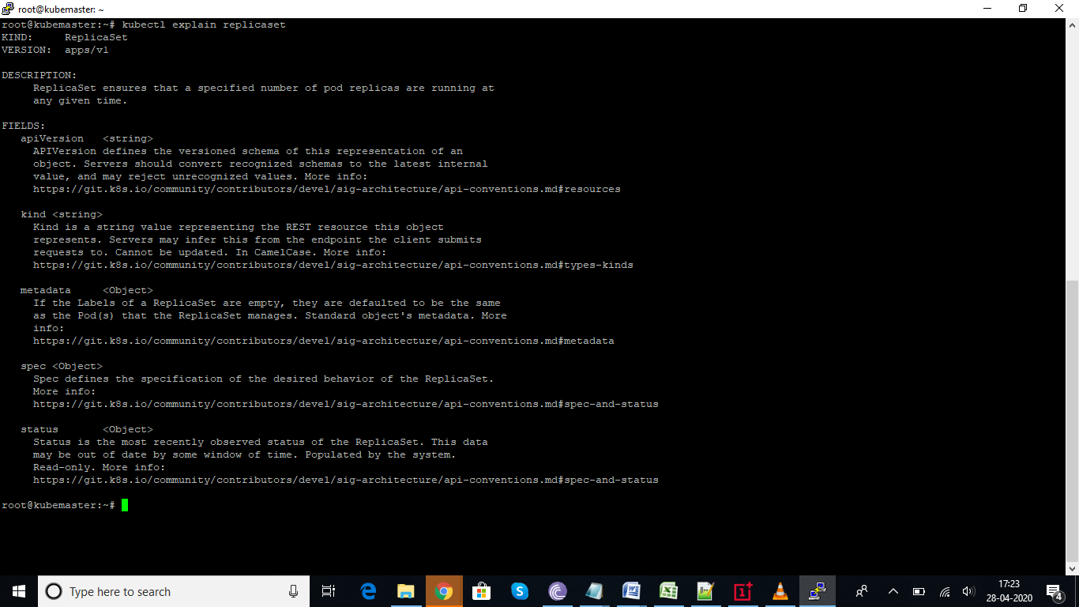
Wrote rs.yml for replica set, will maintain desired set of 3 pods at any given time, with tomcat running on it.
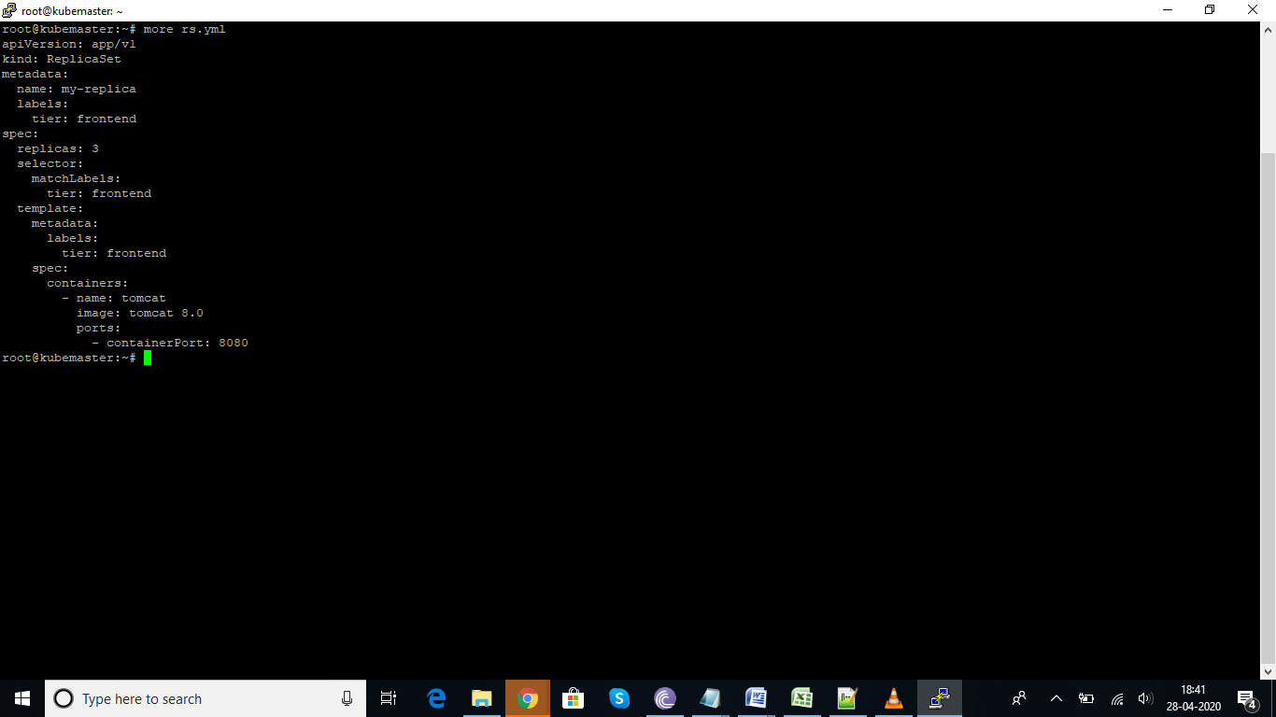
Debugging an error, please find the below
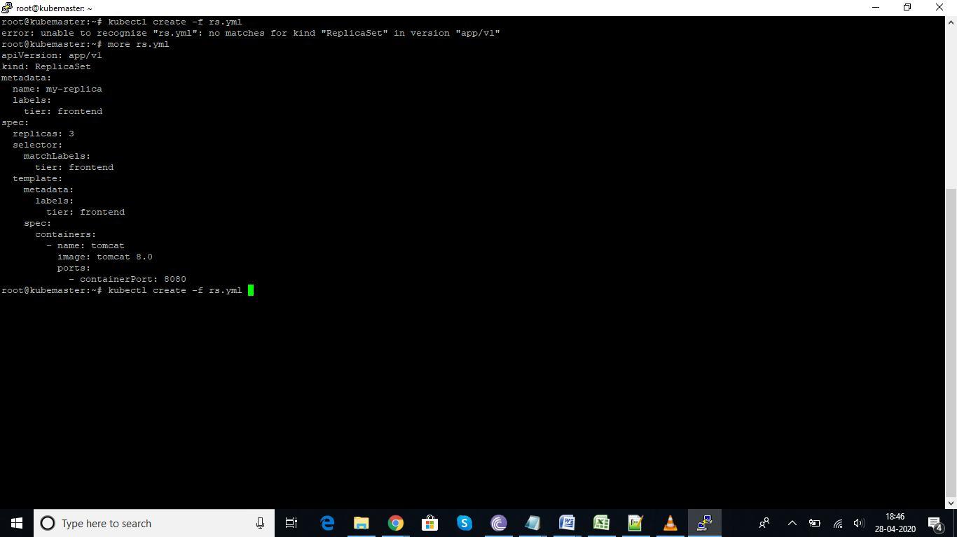
In the below screen shot, we have ran the command to list the pods and we have deleted the pod from the replica set. But we have mentioned the desired state as 3, once deleted, it again start creating the pod in seconds. That the concept behind the replica-set.
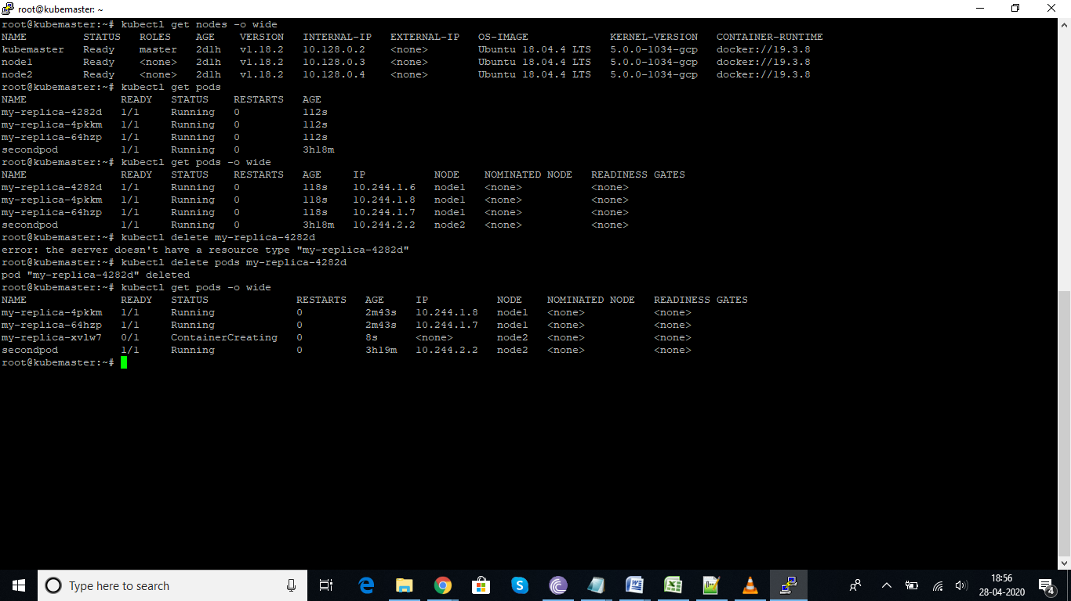
Service is the concept related to cluster ip and node port
Service ip will forwards the request to the pods which are part of that particular service in roundrobin or random method.
Cluster ip and Nodeport
Cluster ip: will used to connect with ip address internally, within the cluster range.
If we want to access the pod or container or application from external world. We need to expose or use the nodeport to connect.
How to create a service for the existing resources
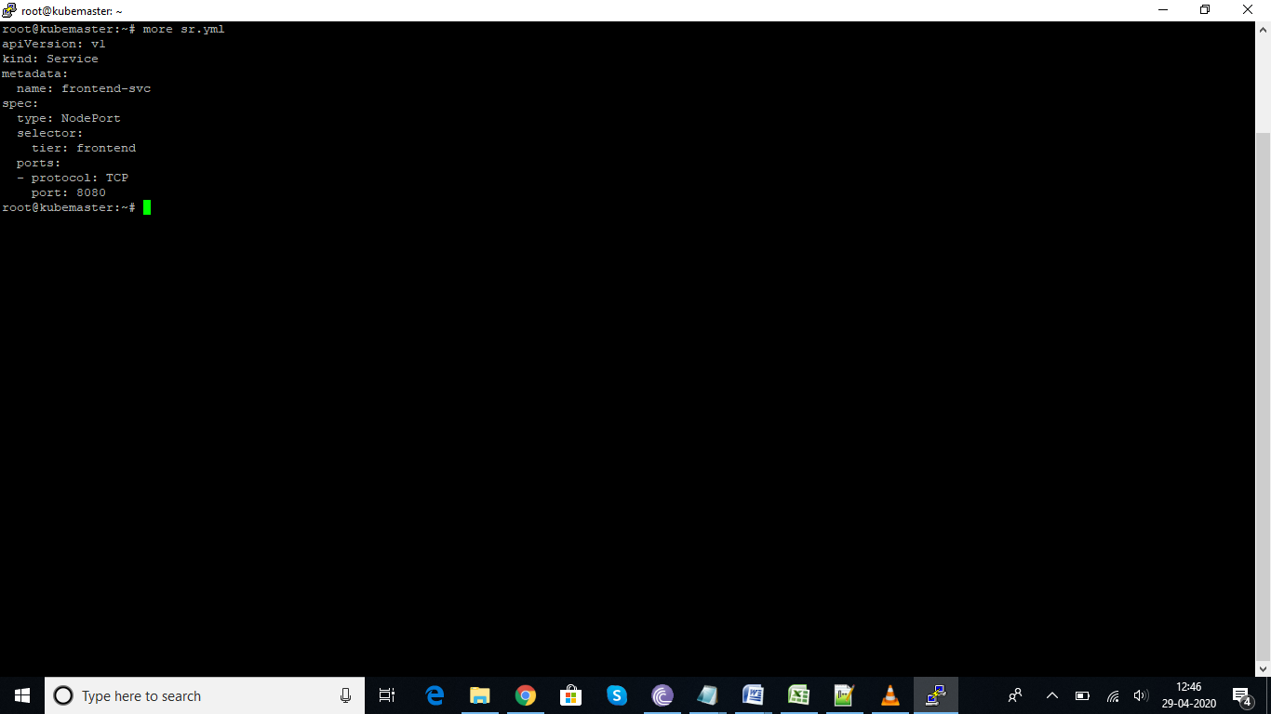

Difference between match labels and Labels in replica sets
MatchLabels is used to identify if there are any pods, which are already there with the same label name, if yes it will add to same label group, else it will create pods based on replica set number (Replica set video 1.16 Min)
Labels: is the name we give to identify the other things in the yaml file and to create the pod with same labels.

How to check the service status and port on which it is running
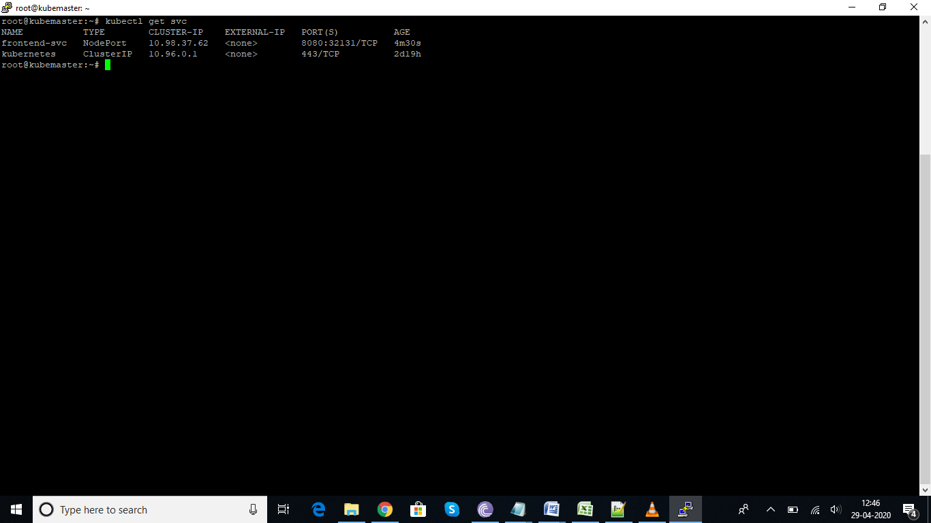
The below command will show the complete details about the service, for which pods it is sending the request and what are the ips of pods, on which port the containers are running and other details aswell
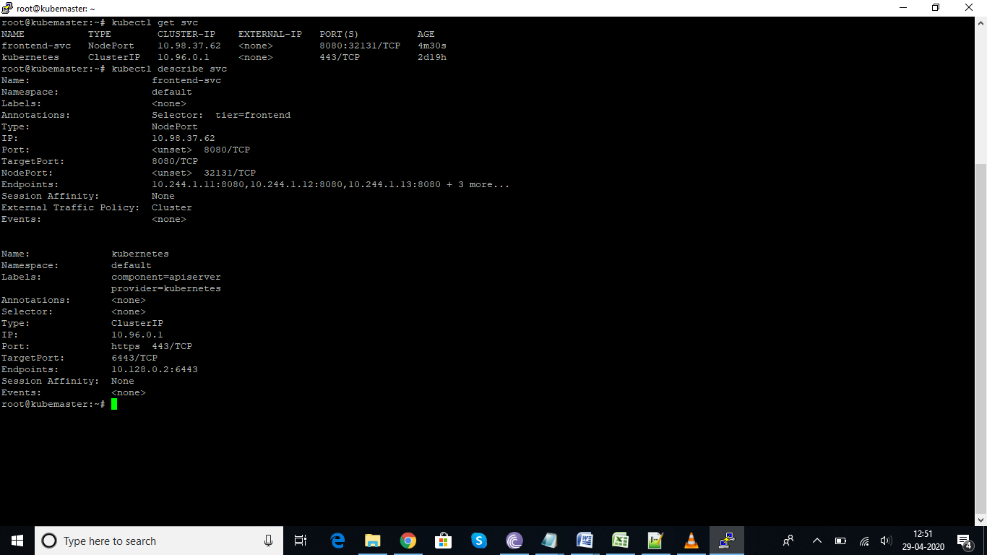

Deployment in kubernetes:
Deployment is next level of replicaset with some more added features. My use of deployment is used for rolling update, it is like if we want to update the existing application with newer version without downtime. We will use deployment, wherein these will update the pods one after the other, replacing one by one to newer version without downtime. Below is the snap shot of deployment file.
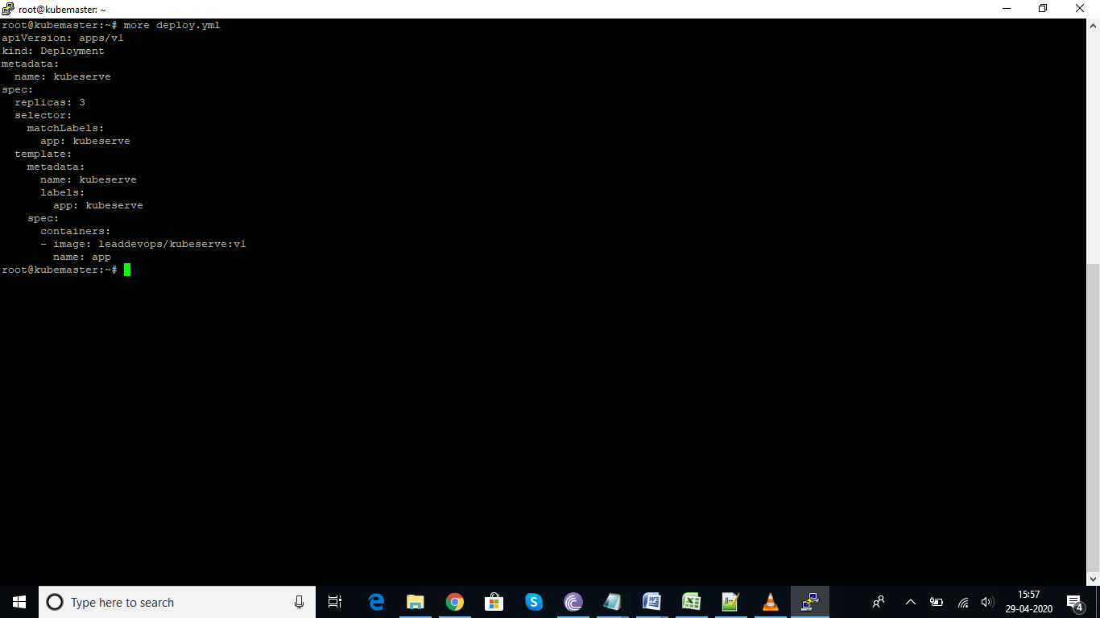

Scaling up the pods using scale up command
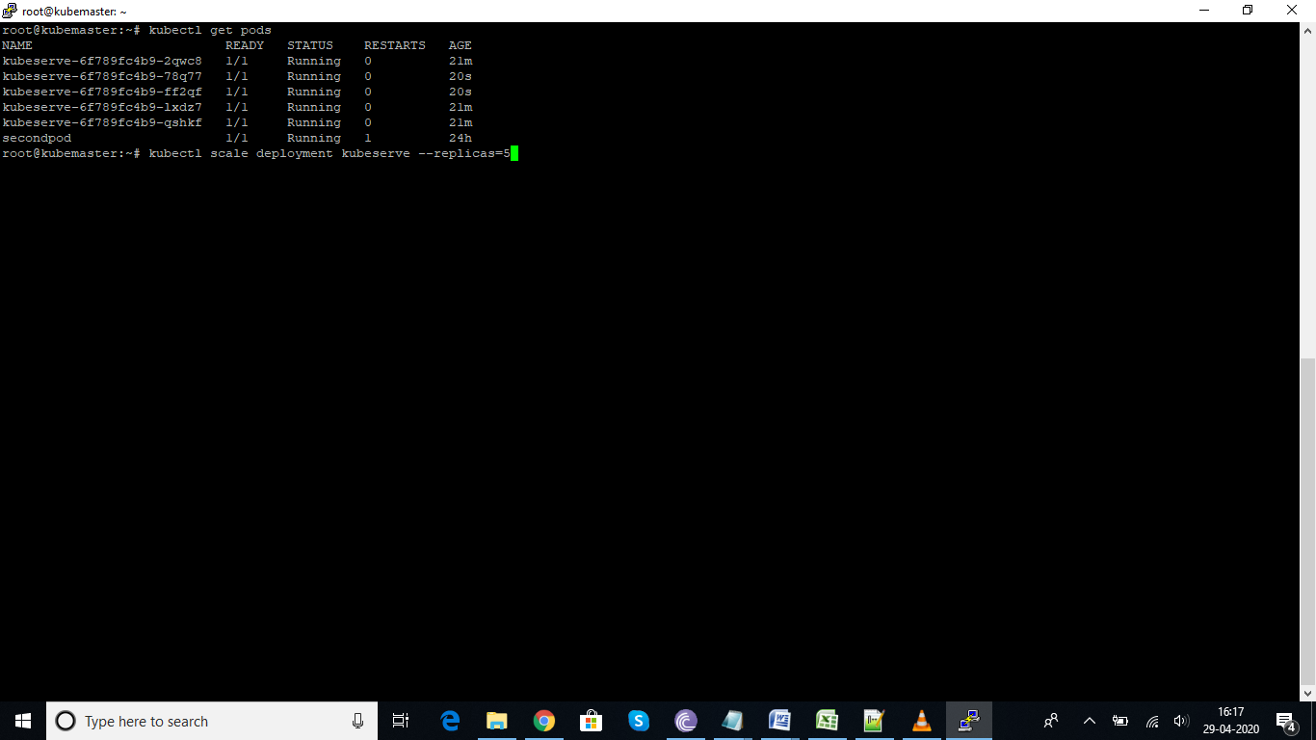
Now expose the port: we can do these activity by writing the service(yaml file) or use these command
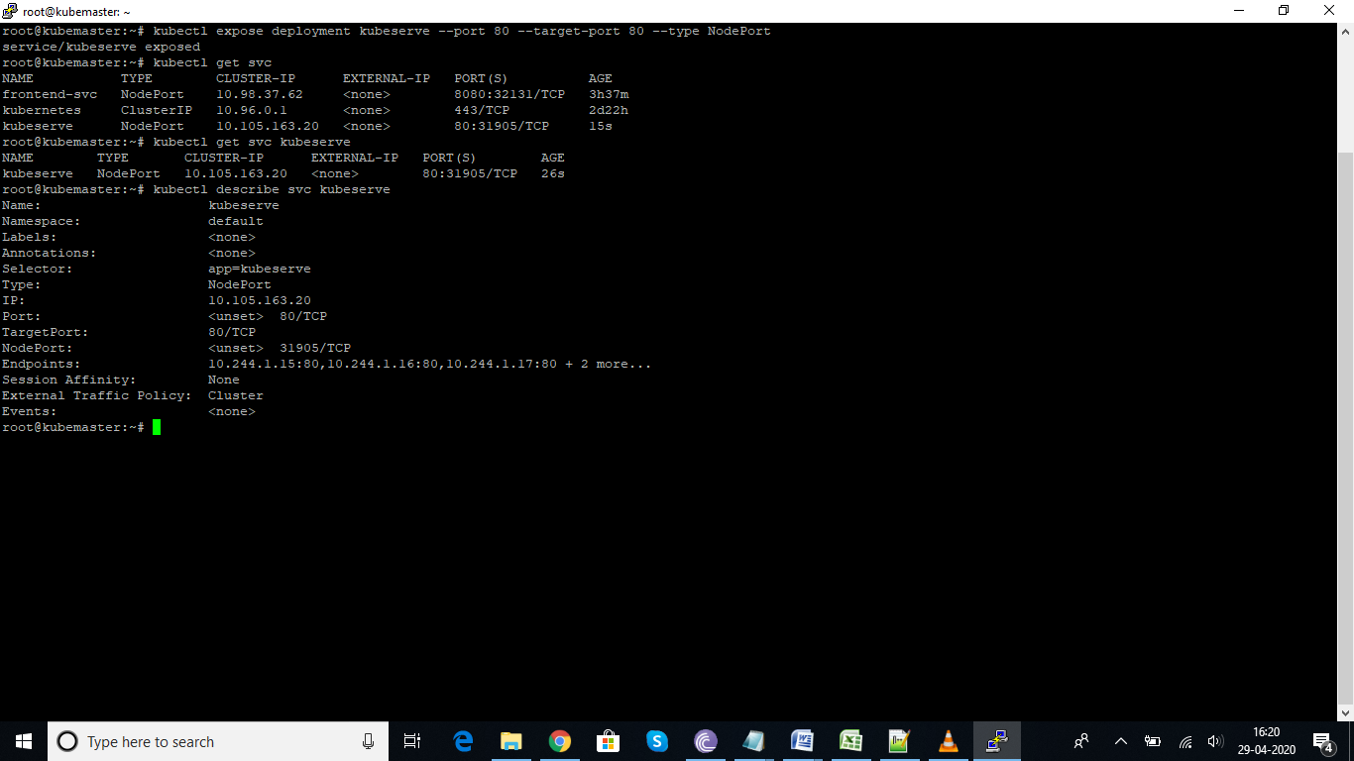

In the below screen shot you can see the olderversion is getting terminated and updating with new version:
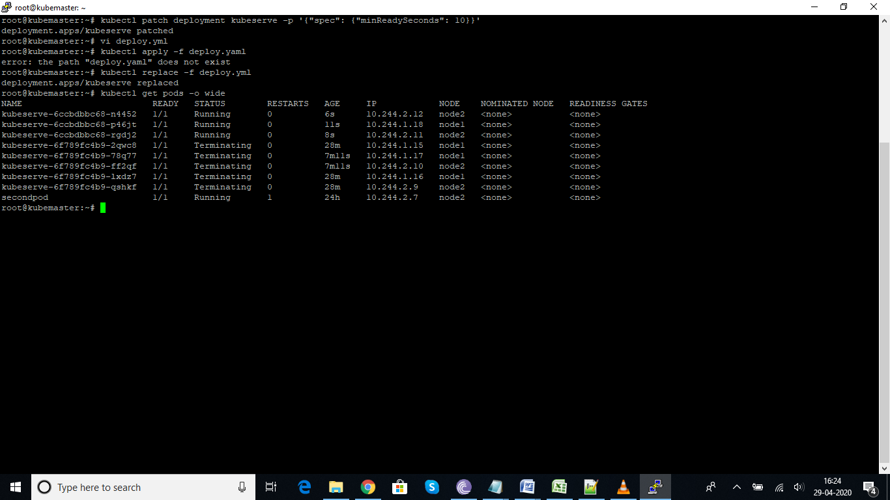
Below snapshot show the information about , which pods is getting the request and the order of it.
while true; do curl http://10.105.163.20; done
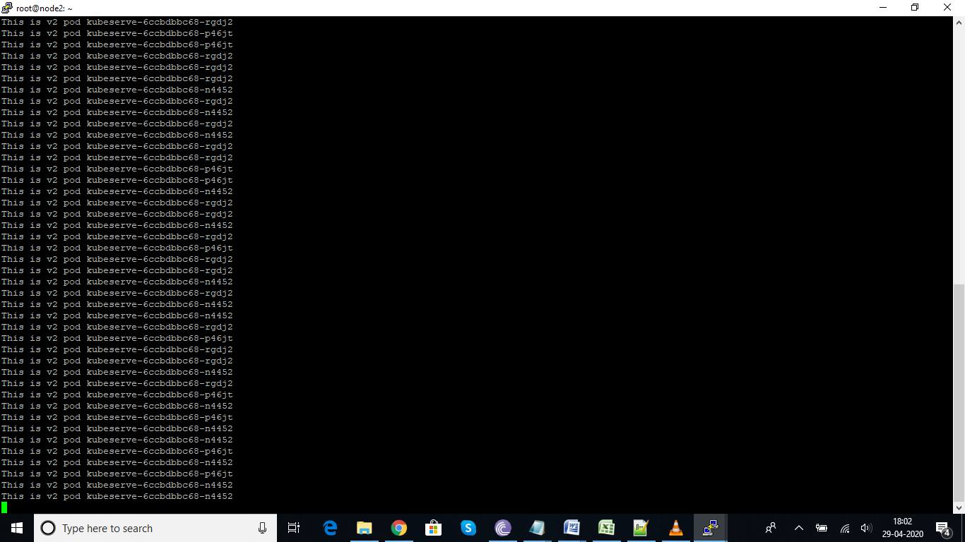
I have changed the version from v2 to v3, it started terminiating the v2 version one by one and replacing with v3
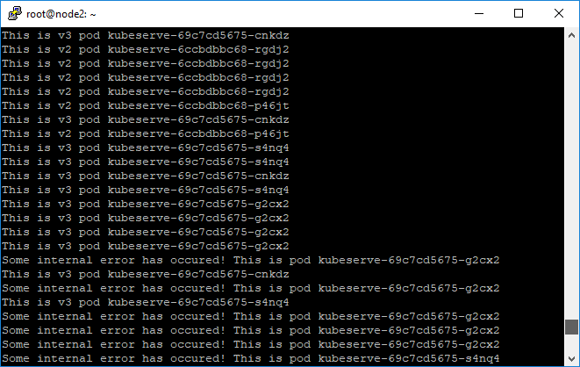
I see some errors with V3 version, now I wanted to rollback to previous version v2. We can do these by using below command. Now you can in node2 screen, it started rolling back to v2
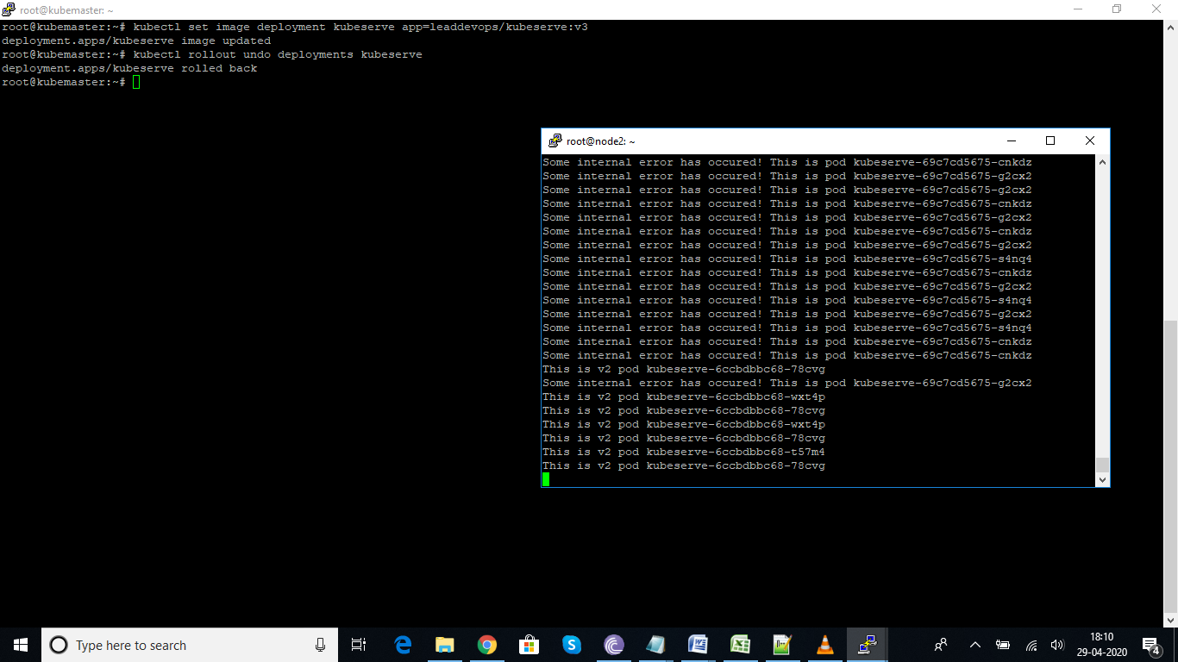

The beauty of deployments is we can move from any version to other previous version, by given the directly the version number. Let see below in these we have given the revision number to rollback to that particular revision.
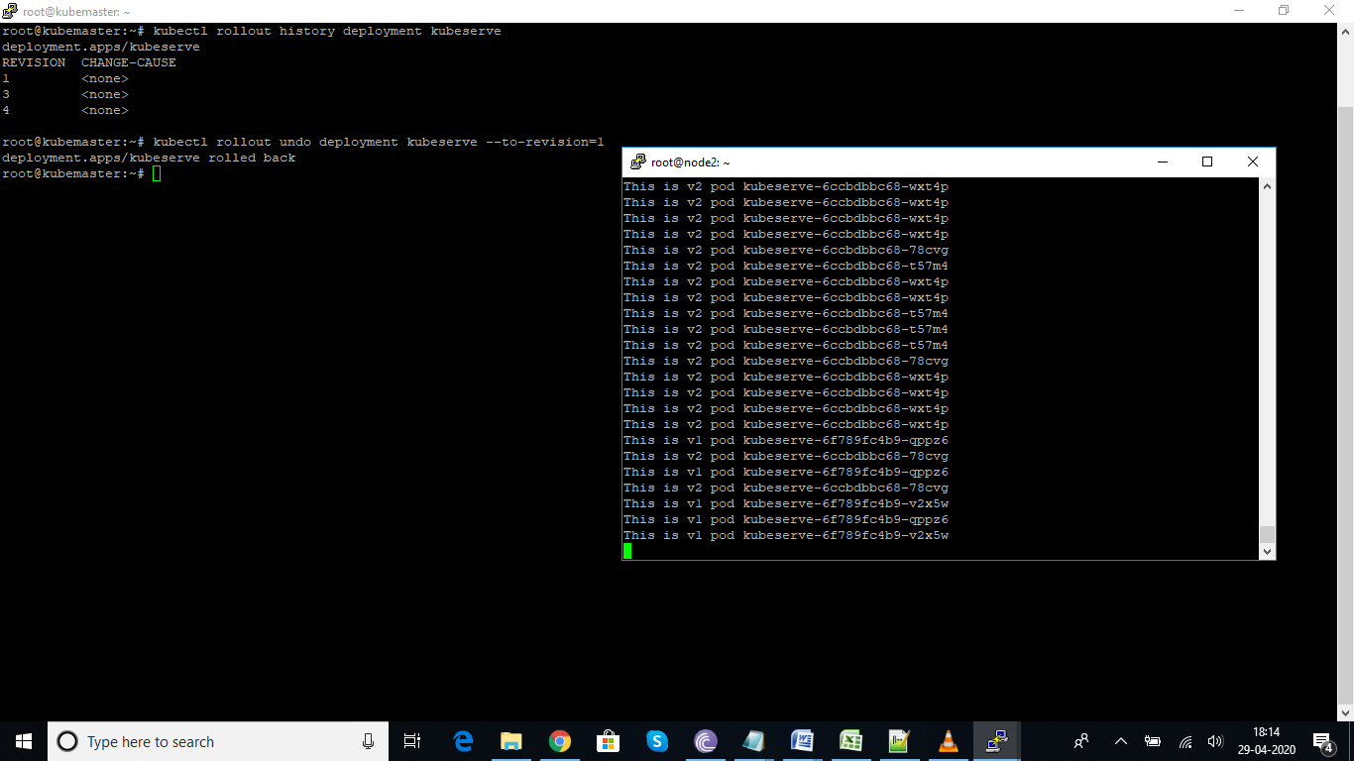

By default it will update 25% of pods from our deployment, if we want to make changes to default percentage%, we can use the command
Kubectl edit deployments <deploymentname> #in these file we can change the parameters min % to what ever required.

