**AWS Code Commit:**

**AWS CodeCommit vs GitHub: What are the differences?**

Developers describe **AWS CodeCommit** as "*Fully-managed source control service that makes it easy for companies to host secure and highly scalable private Git repositories*". CodeCommit eliminates the need to operate your own source control system or worry about scaling its infrastructure. You can use CodeCommit to securely store anything from source code to binaries, and it works seamlessly with your existing Git tools. On the other hand, **GitHub** is detailed as "*Powerful collaboration, review, and code management for open source and private development projects*". GitHub is the best place to share code with friends, co-workers, classmates, and complete strangers. Over three million people use GitHub to build amazing things together.

AWS CodeCommit and GitHub can be primarily classified as **"Code Collaboration & Version Control"** tools.

Some of the features offered by AWS CodeCommit are:

* Collaboration
* Encryption
* Access Control

On the other hand, GitHub provides the following key features:

* Command Instructions
* Source Browser
* Git Powered Wikis

Step1: We need to create IAM user, down load the access and secretkey and attached code commit policy to user.

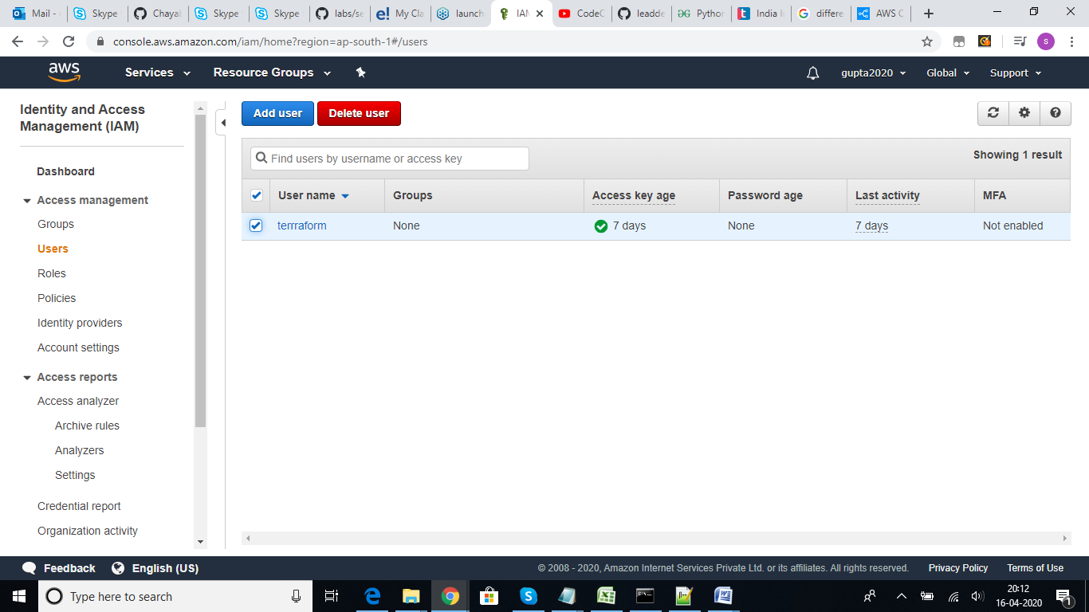

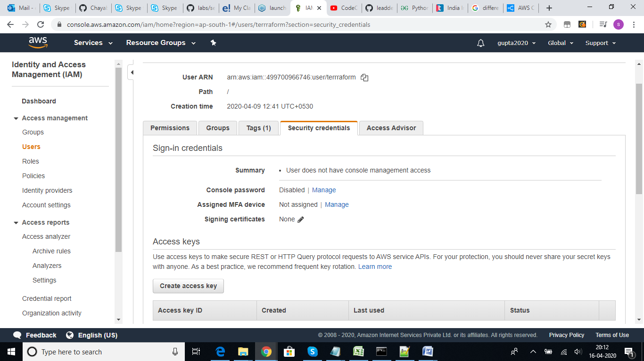

Click on Add permission:

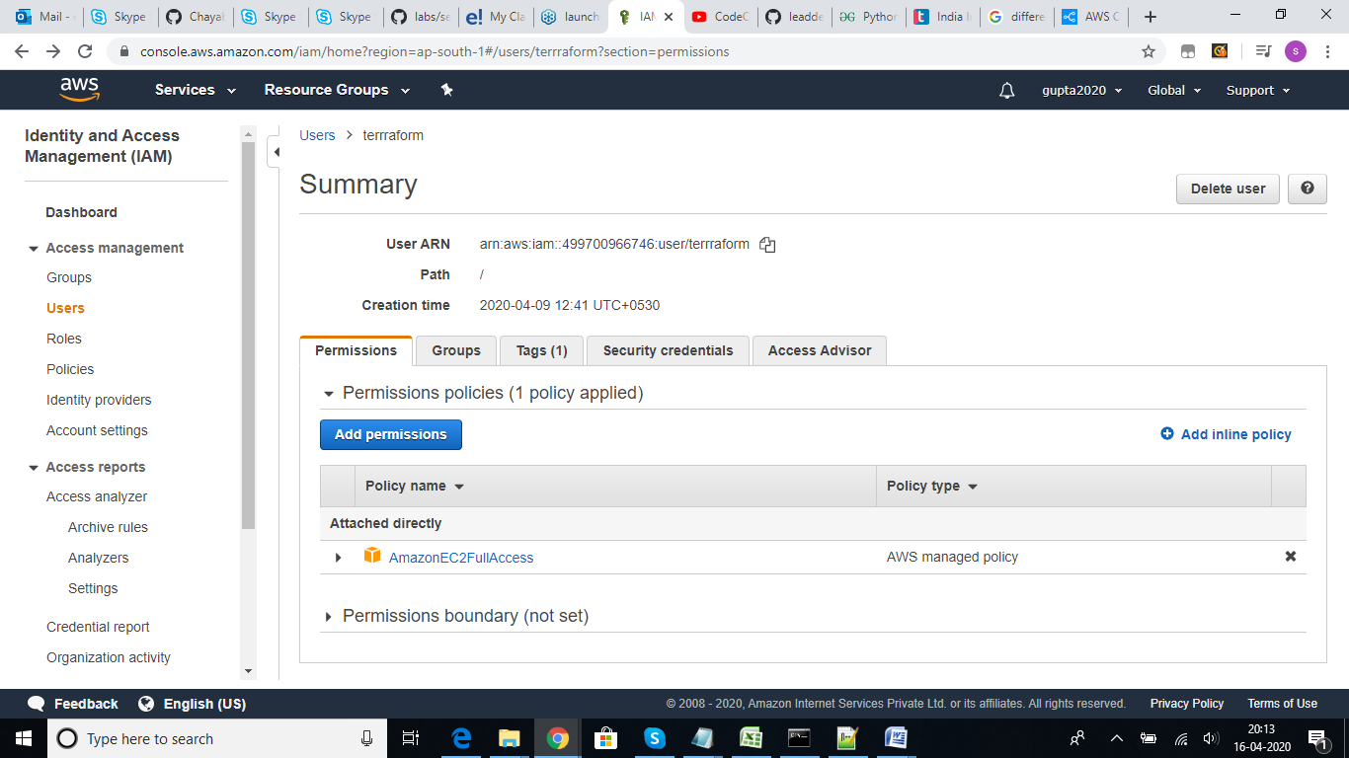

Click on attach existing policy directly and select code-commit full access

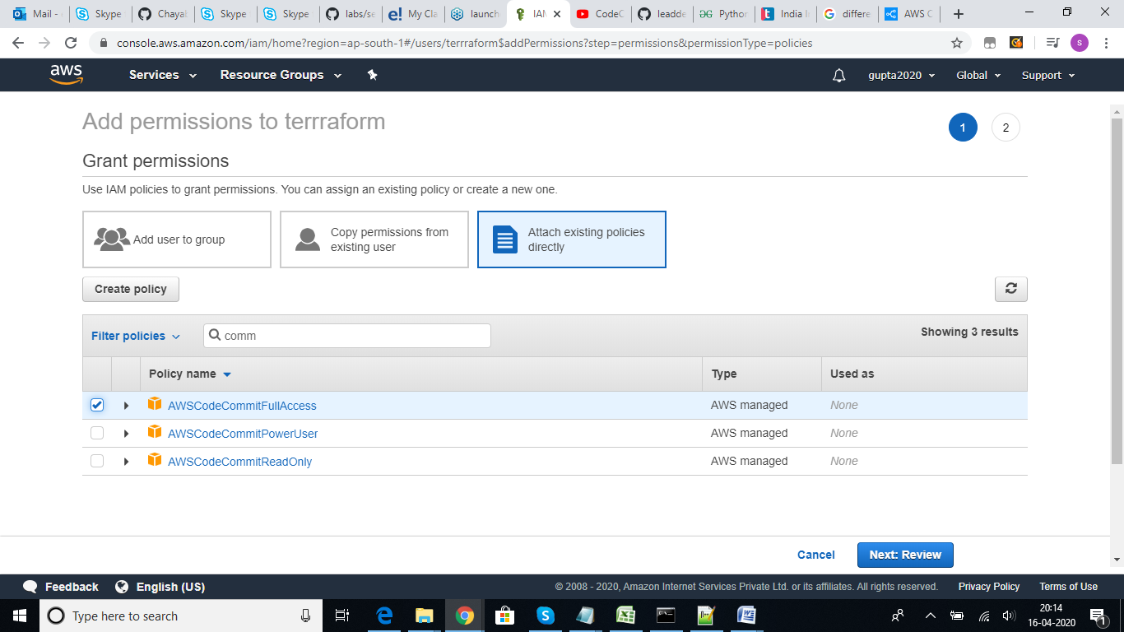

Now login IAM console using IAM user and

Now login IAM console using IAM user and generate git credentials for code commit HTTPS

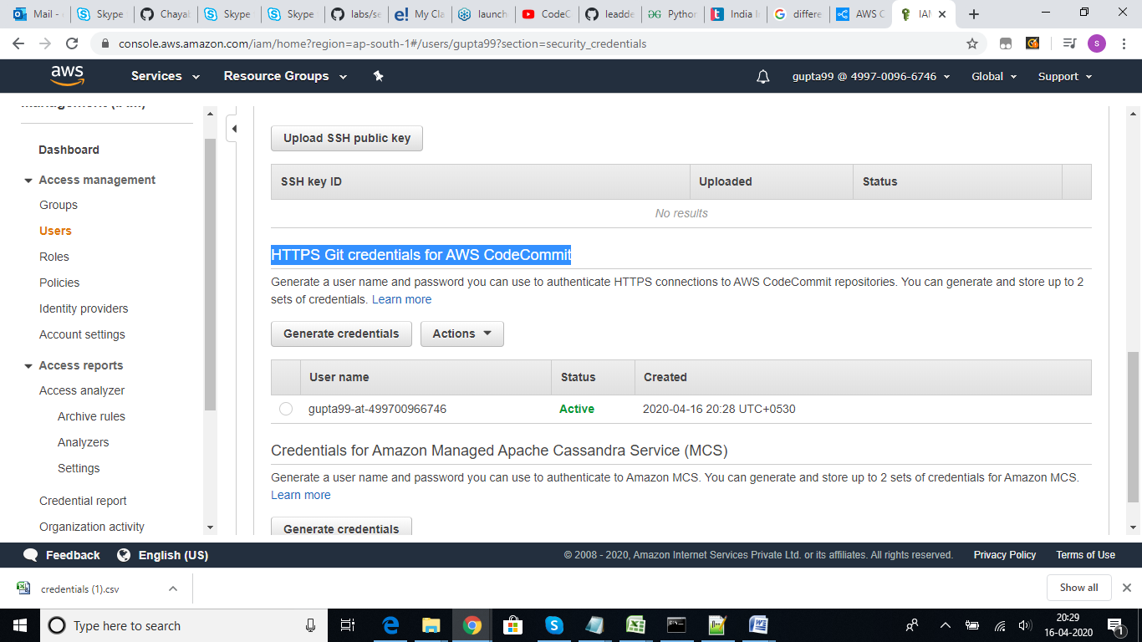

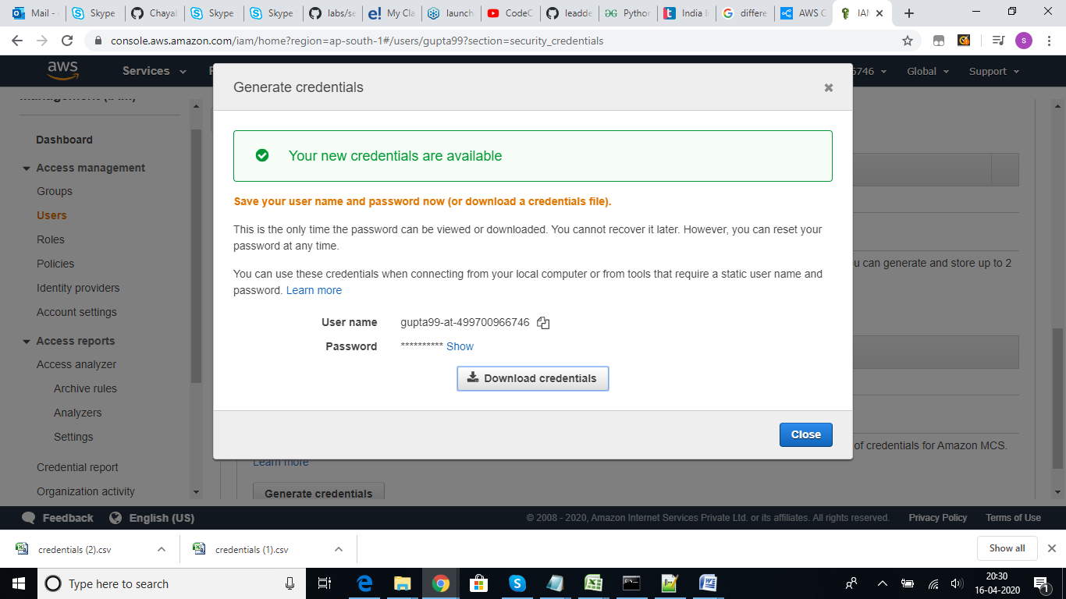

Now Goto Code-Commit console, click on get started and create repository

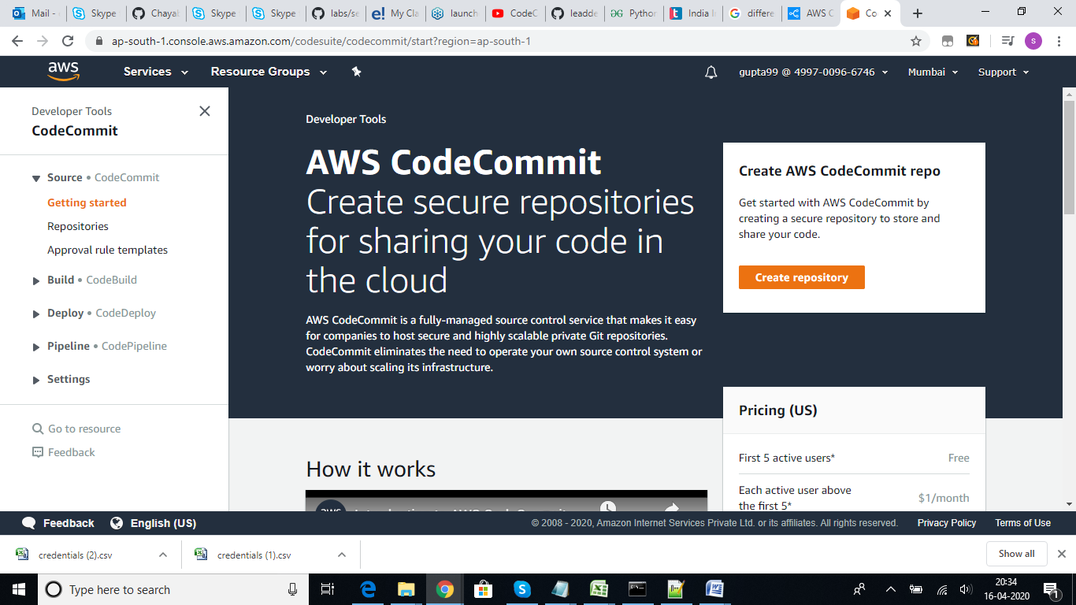

Give the repo name and other details then click on create

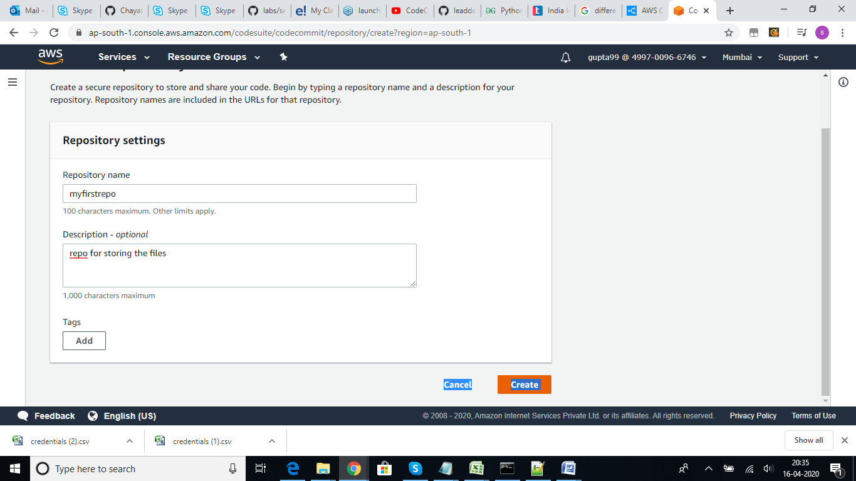

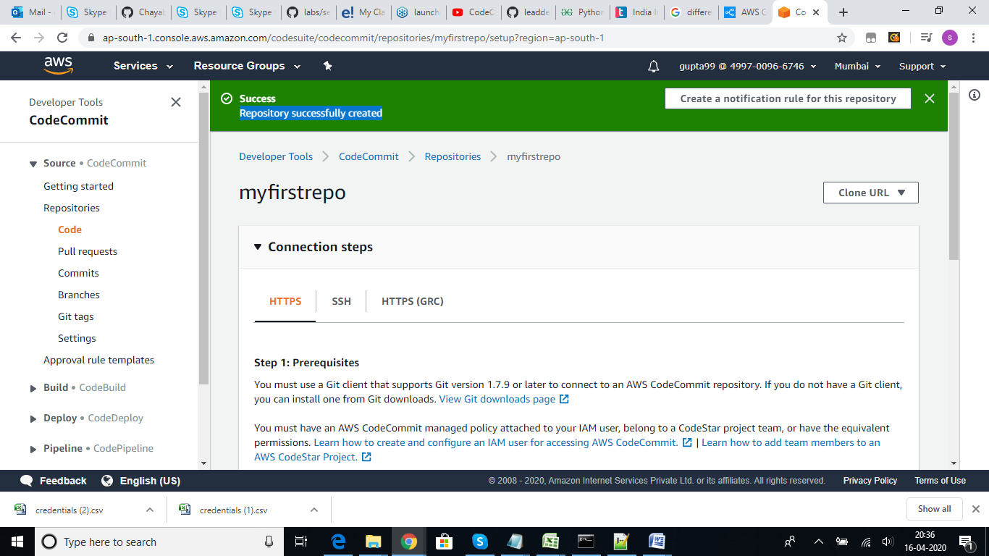

Now lets add a file to the repository, click on add file and upload a file

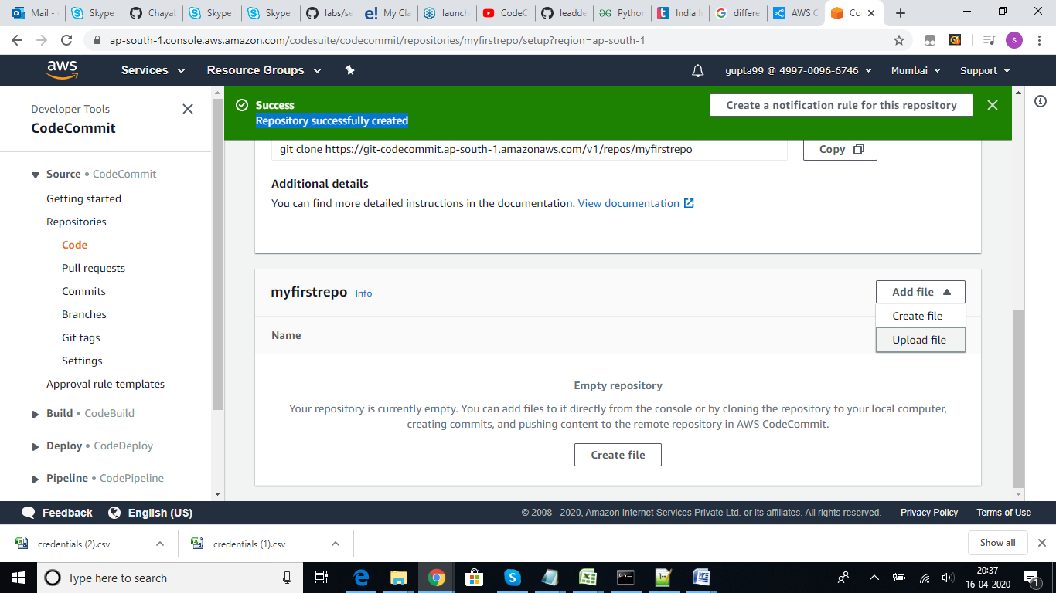

Click on commit changes, file will get upload to the repository.

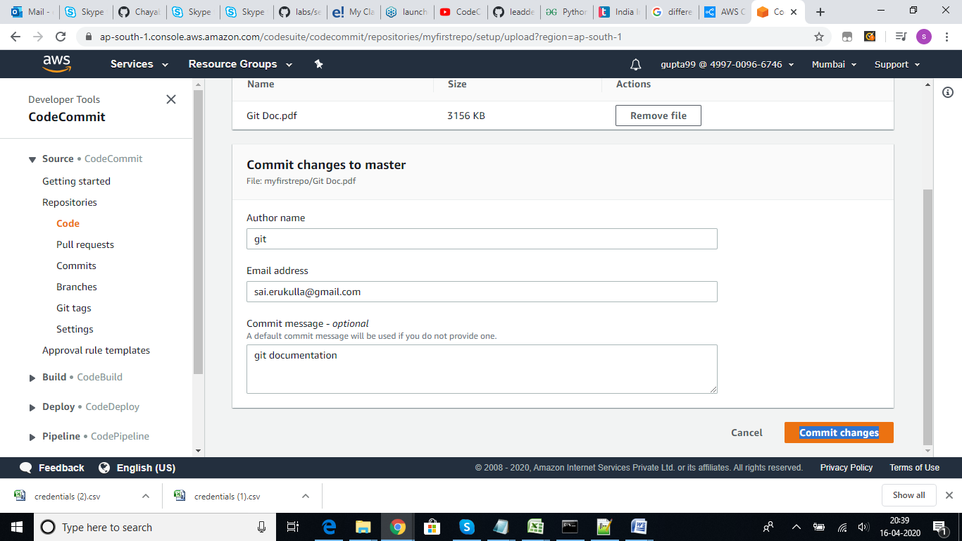

Once the file is uploaded we can see the output of the file as show

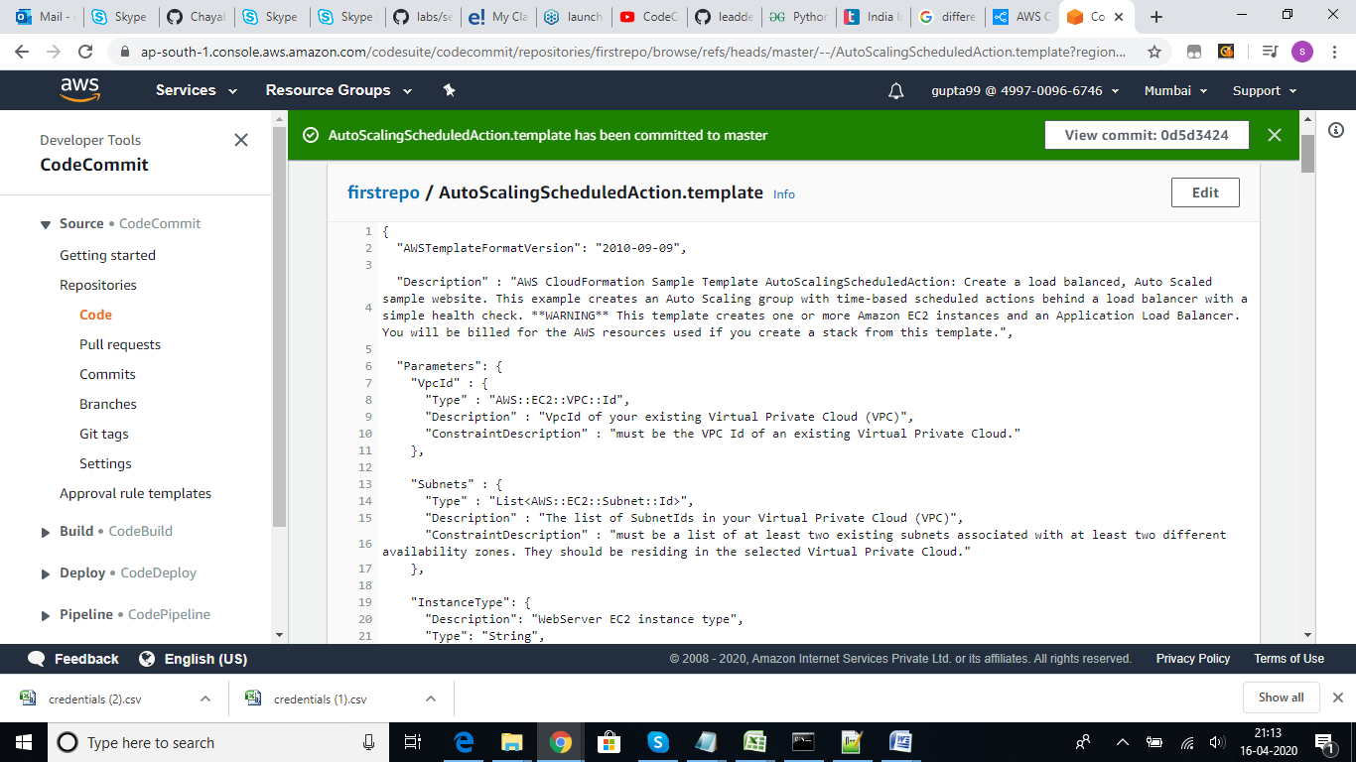

Create a pull request, it will create the request and show the status is open

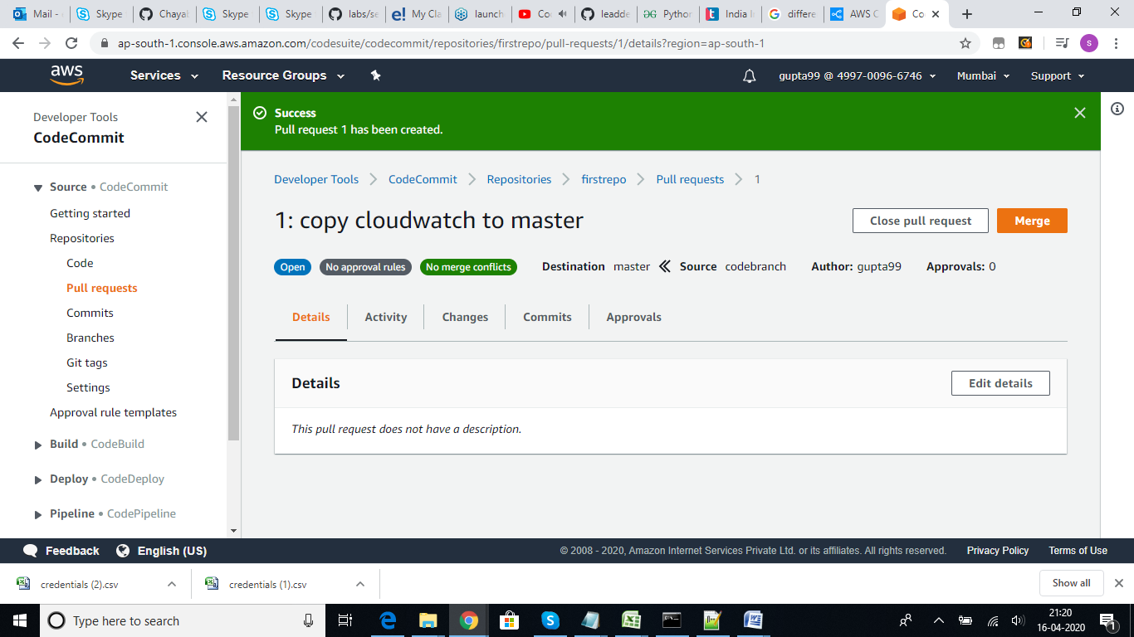

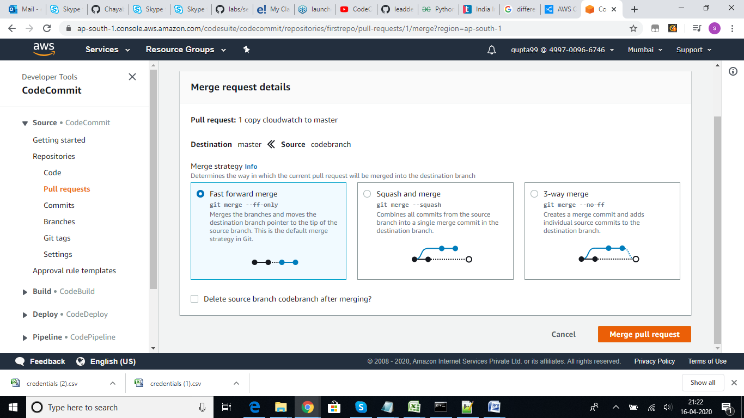

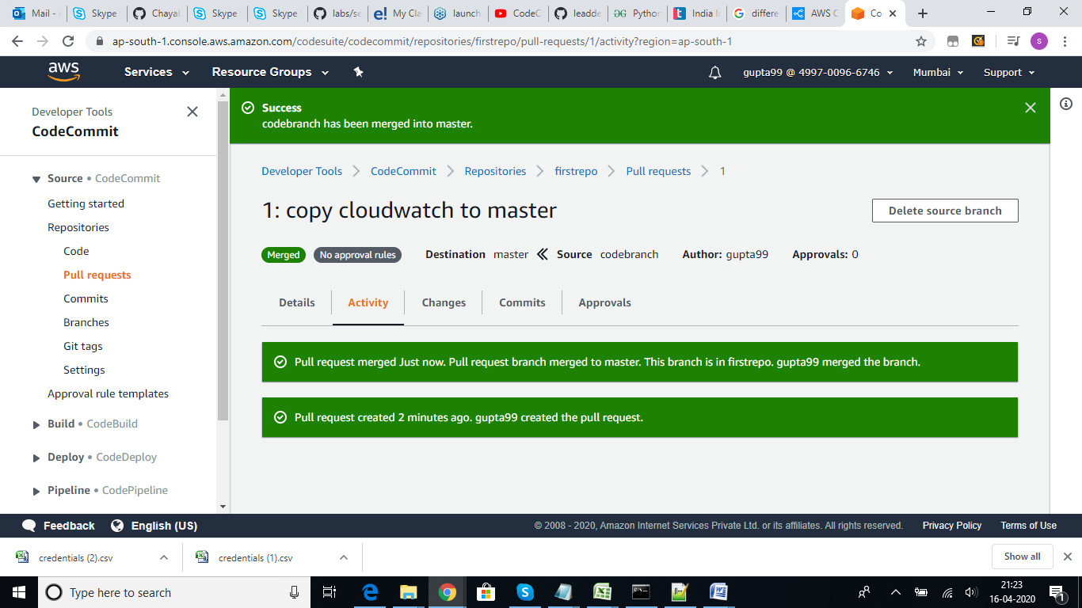

**Done with merge**