**AWS Lambda**

How to create AWS Lambda function, go to Lambda console and Click on create.

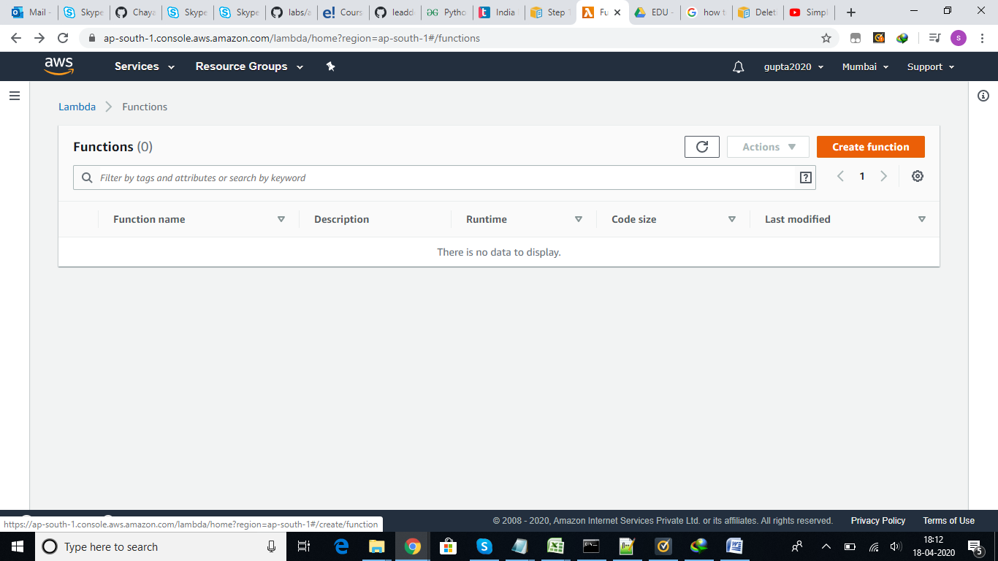

Once we click on Create function it will show few options, We can create our own template and update to function, we can use the sample lambda function template and change as per our requirement. We can select our language to write lambda function, like nodejs, python,ruby,dotnet,java.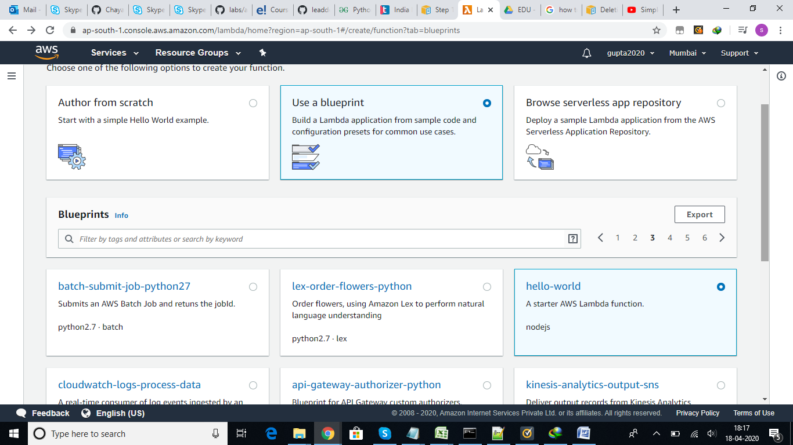

Once selected the Sample function, give the function name and select the IAM role to run the function.

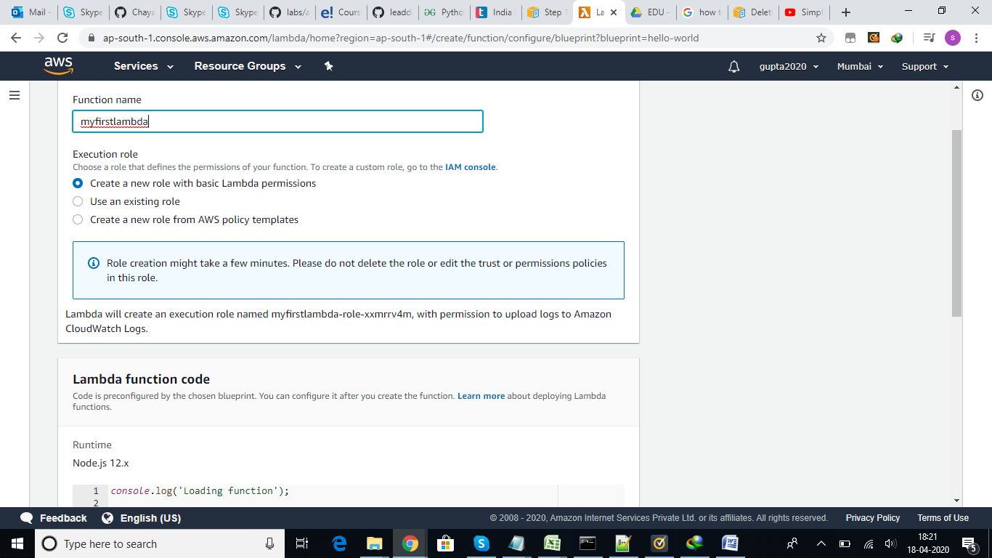

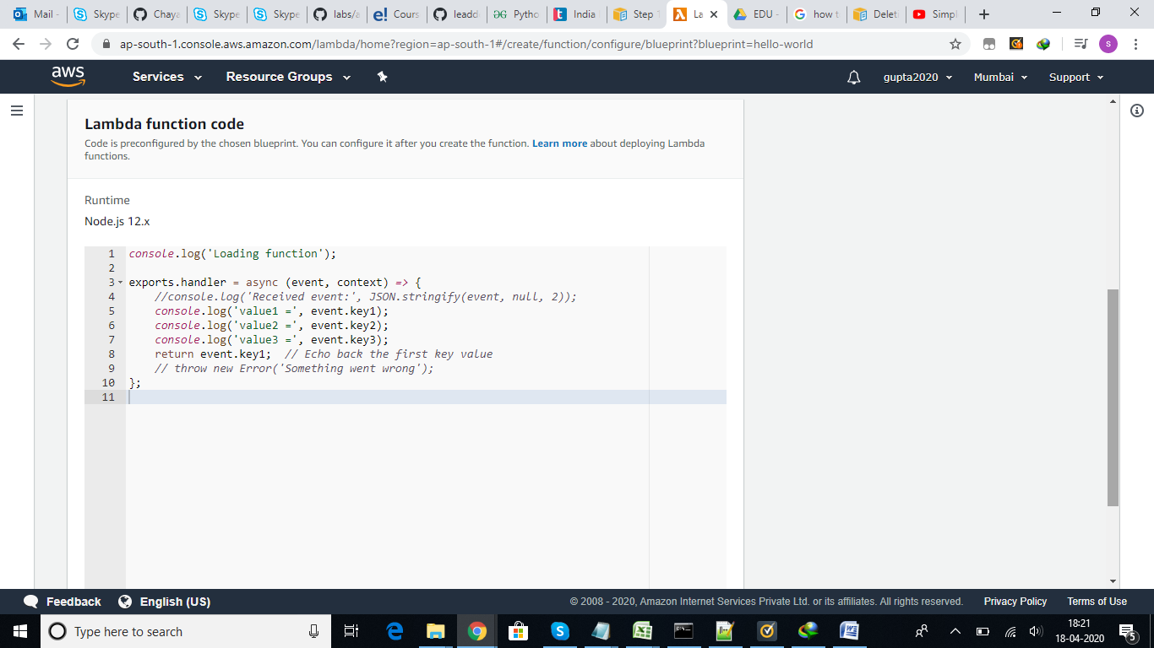

Once the function is created it will open the page as show, we can make the changes like VPC, execution time etc as per our requirement.

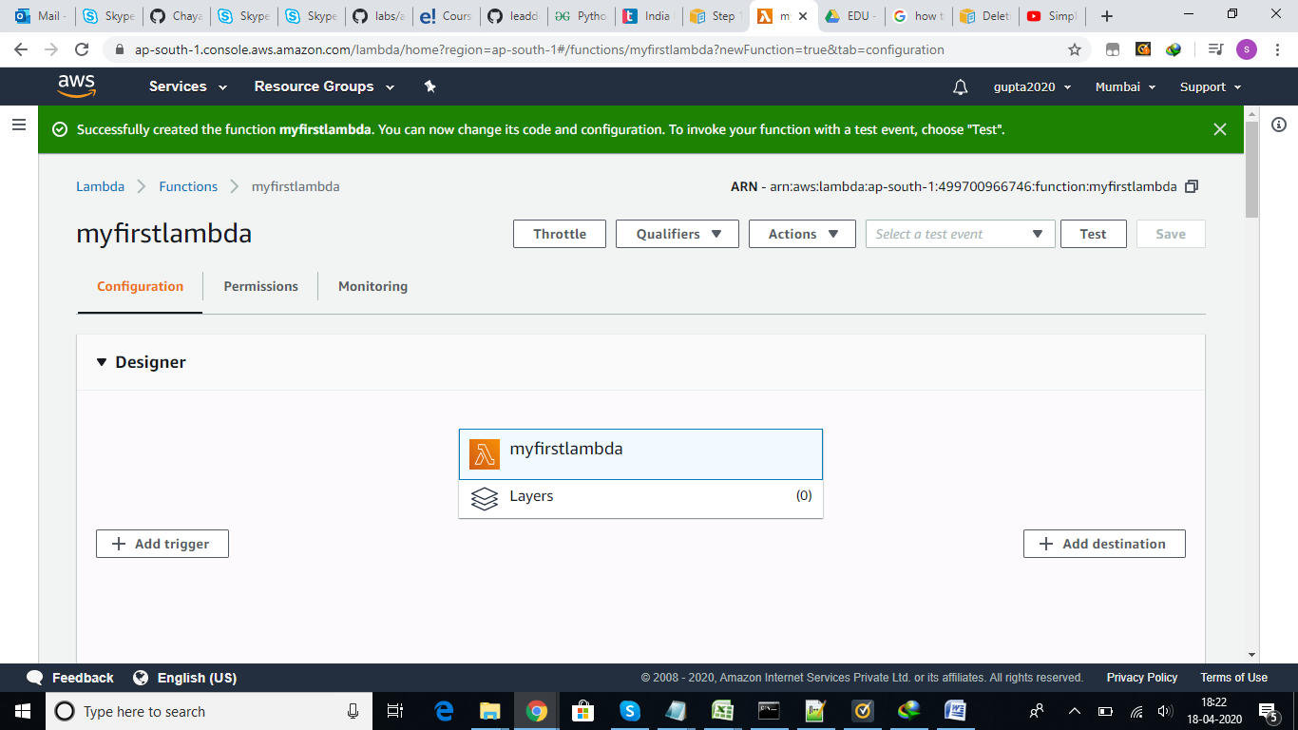

We need to create the test event , to test our lambda function,

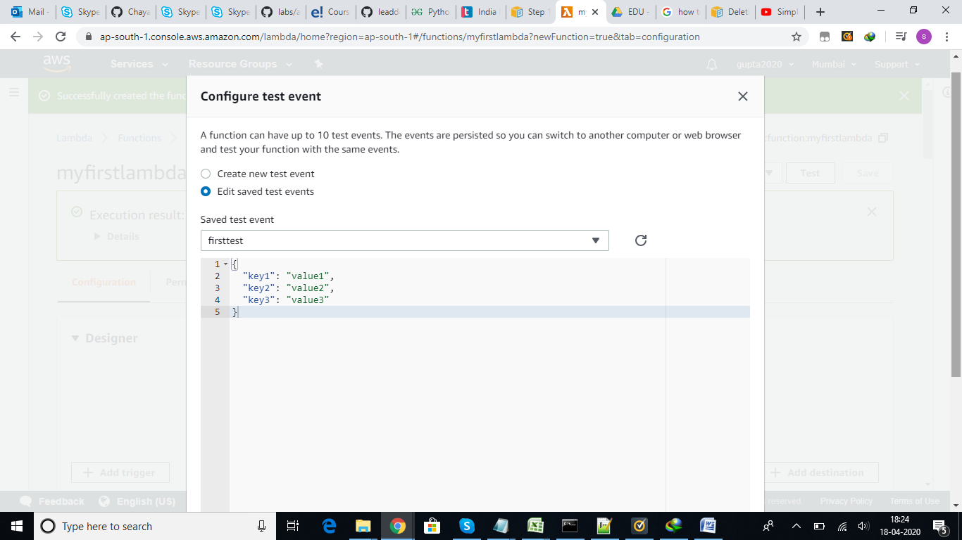

Once you click on create, event will be created and we can test the function using that. Below are the test results.

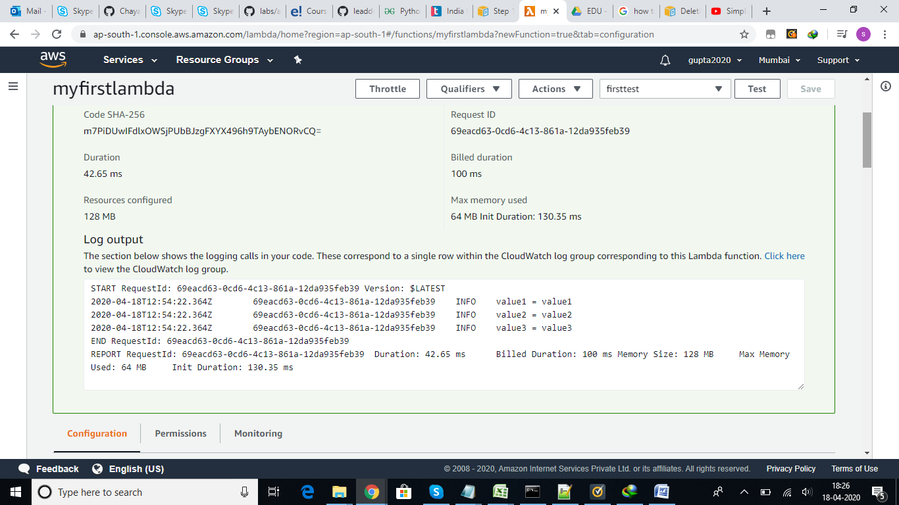

Versioning in Lambda, we can create version using publish version option, which is useful if we want to point the new version of lambda for testing in dev after the changes.

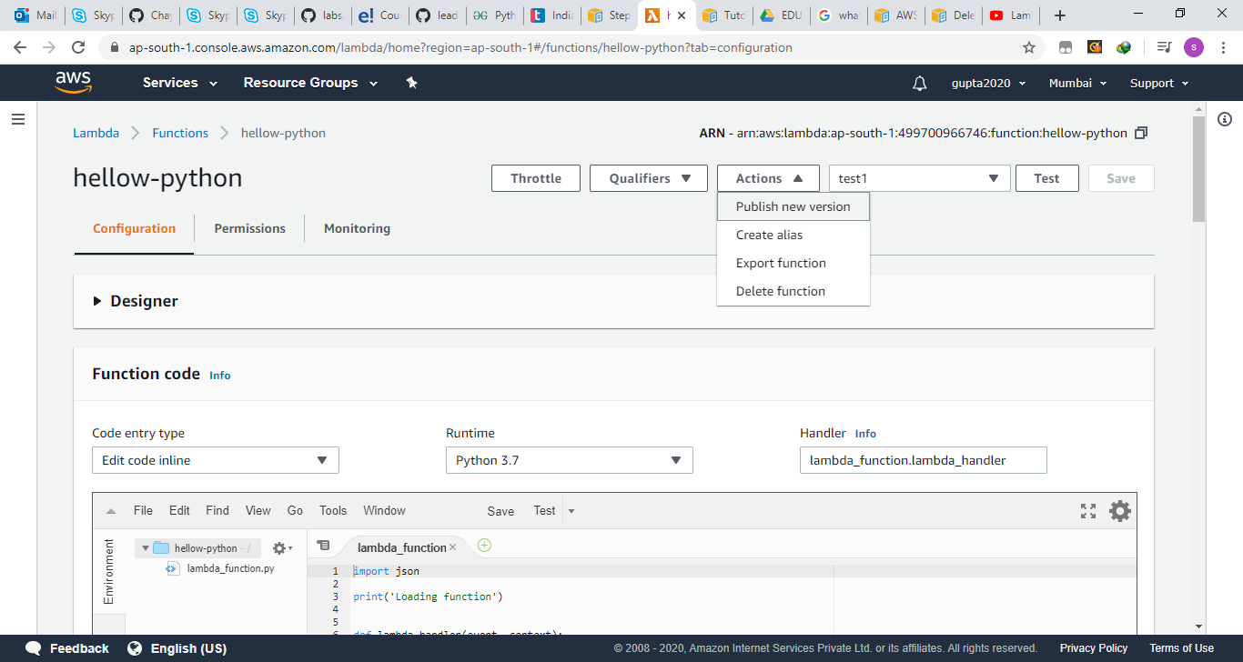

I have created version 1 from the existing one, now we can see version 1 and latest in the drop down

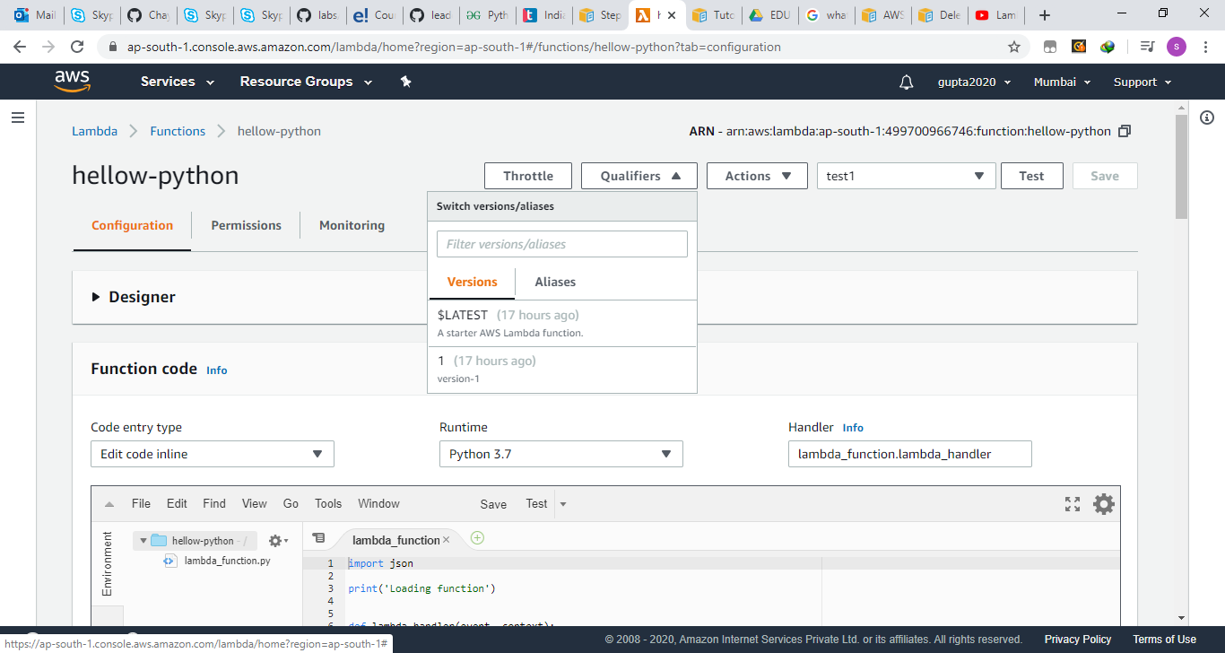

We can create the alias and use the same for production env traffic routing and check the update using the load %.

