By default kubernets does not have network like docker, we need to explicitly create the network using plugins like flannel, calico, OVN, Romana

Indocker by default you get the network called docker zero

kubeadm join 10.128.0.2:6443 --token w8ri8a.m220vhjo7mu0si6j \
--discovery-token-ca-cert-hash sha256:b80da91b37e55e2e4478a3399aee94f3343a5e29bb234572cb19a74c1eb3a834

Kubectl get pods --all-namespaces
Kubelet ----it is the only one which runs as the service, but not as container.
service kubelet status to check the status of kubelet

----kubernets token keeps on changing, in docker token will there for 3 months by default.
---When ever you create a node, we will generate a new token and join the nodes to master.
Kubectl explain pod---command to show the api version
Kubectl explain deployment—comand to show the api version
Kubectl explain service ---command to show the api version

Kubectl describle pods myfirstpod----these will give the complete details about the pod.
Kubectl get pods -o wide---these will give the output in shorter format.
Conditions or Lifecycle of pod: Initialized---→Ready---→Containers ready---→podscheduled
Events for pod scheduled : Scheduled(it first assigns the pod)-→Pulling-→Pulled--→Created---→Started

Events:
Type Reason Age From Message
---- ------ ---- ---- -------
Normal Scheduled 8m24s default-scheduler Successfully assigned default/myfirstpod to node1
Normal Pulling 8m24s kubelet, node1 Pulling image "tomcat"
Normal Pulled 8m6s kubelet, node1 Successfully pulled image "tomcat"
Normal Created 8m2s kubelet, node1 Created container sai
Normal Started 8m2s kubelet, node1 Started container sai

Kubernetes Topics: pods, replica sets, deployments, services and dashboard
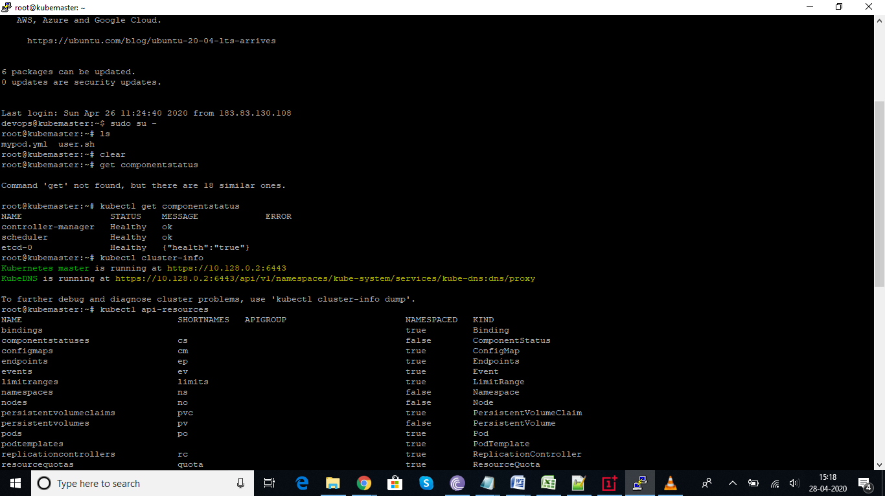

How to check api-versions and below is the output
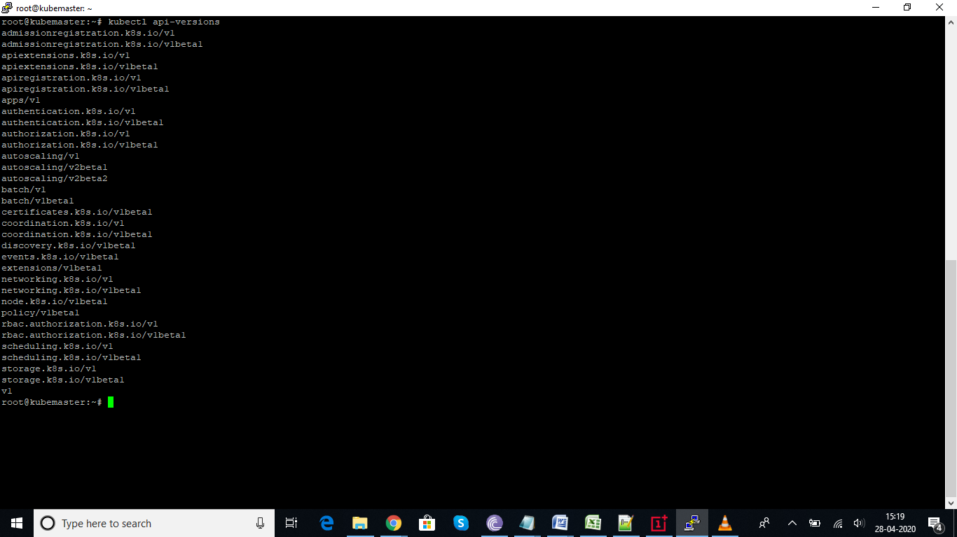

How to check kubelet service status
Service kubelet status----these is the only thing runs as service, not as container.
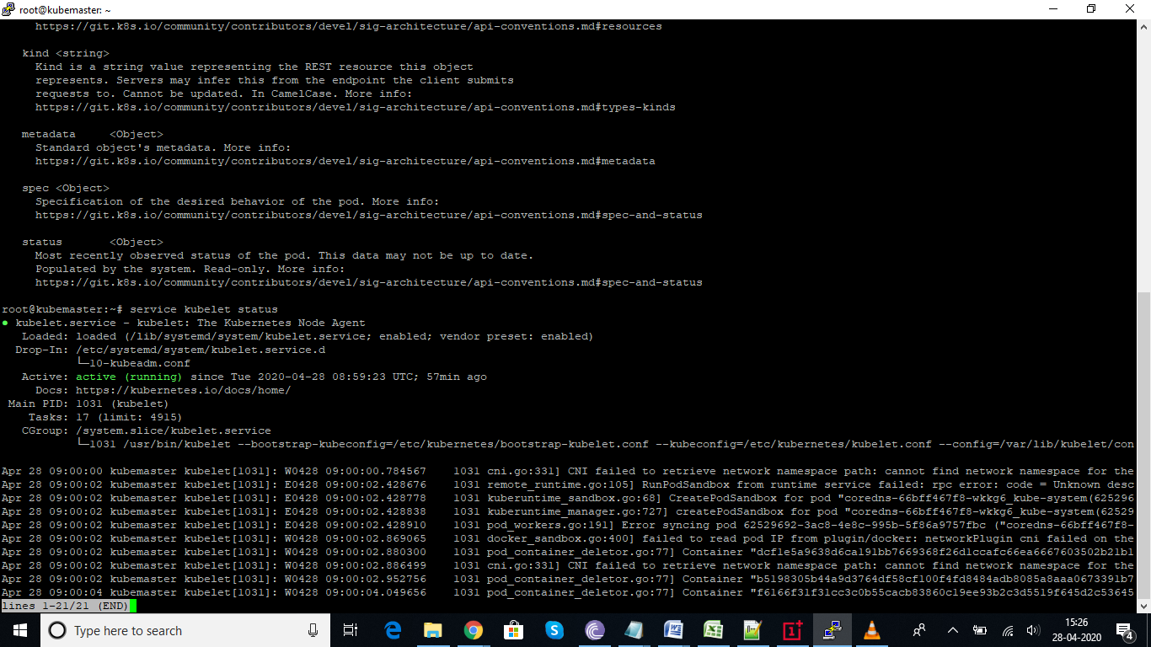
How to check the api version for pod, it is better to check the api version beform writing the pod.yml file.
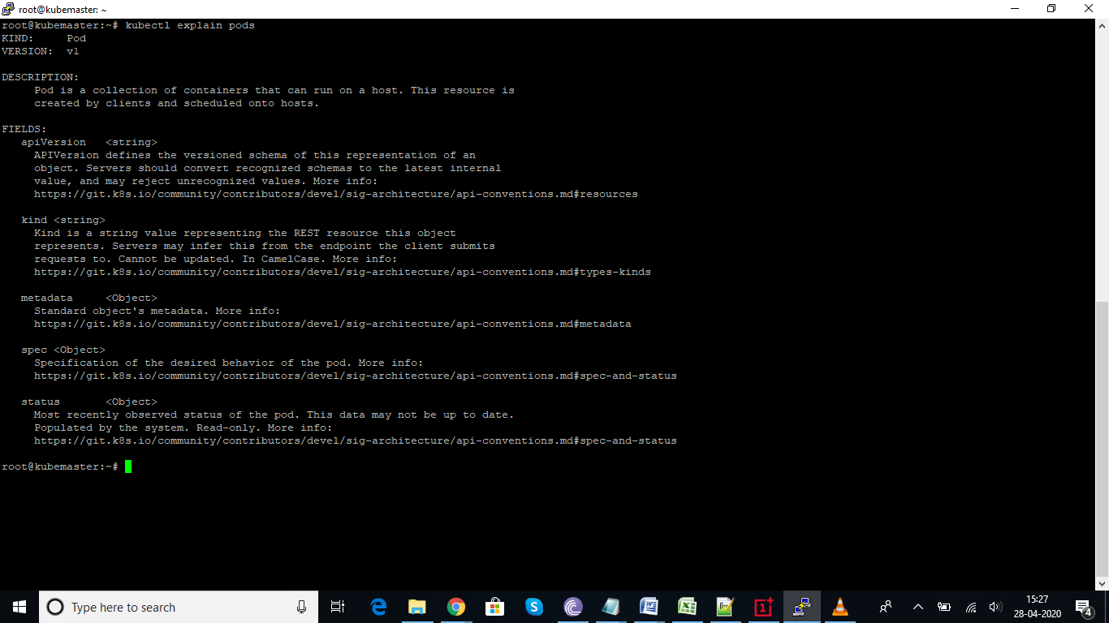
Contents of pod file
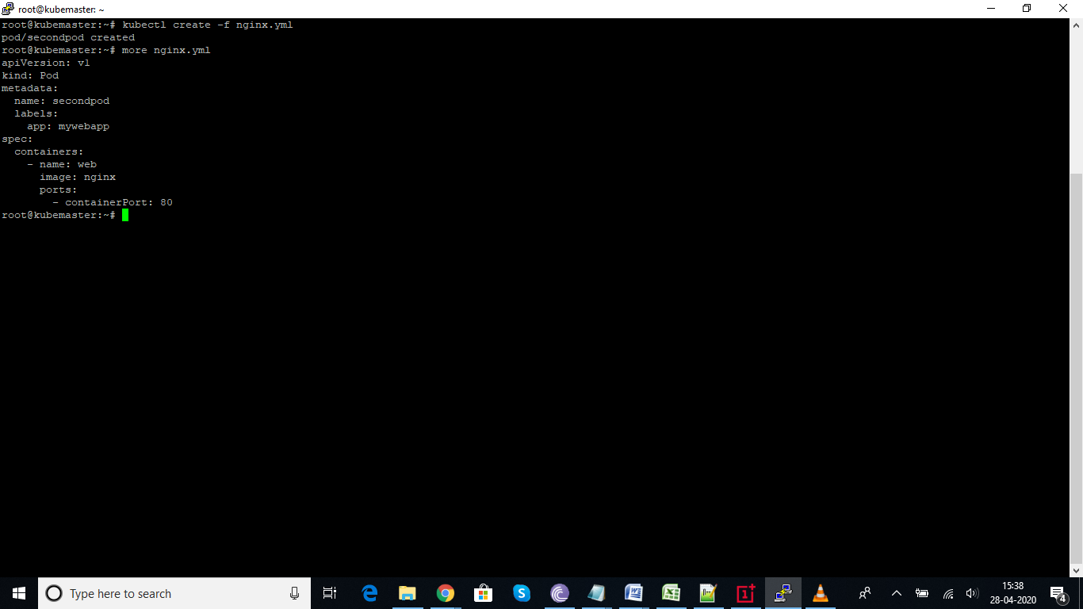

Command to list the pods
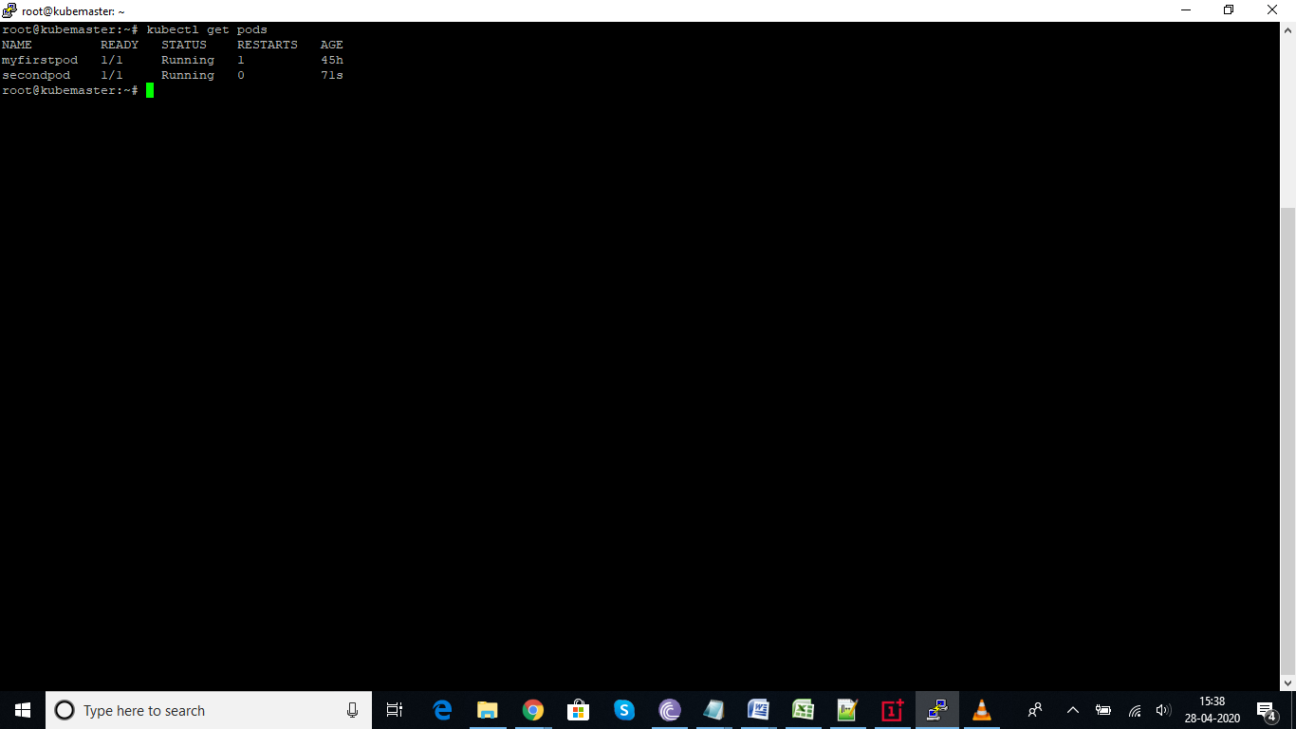
Command to delete the pods
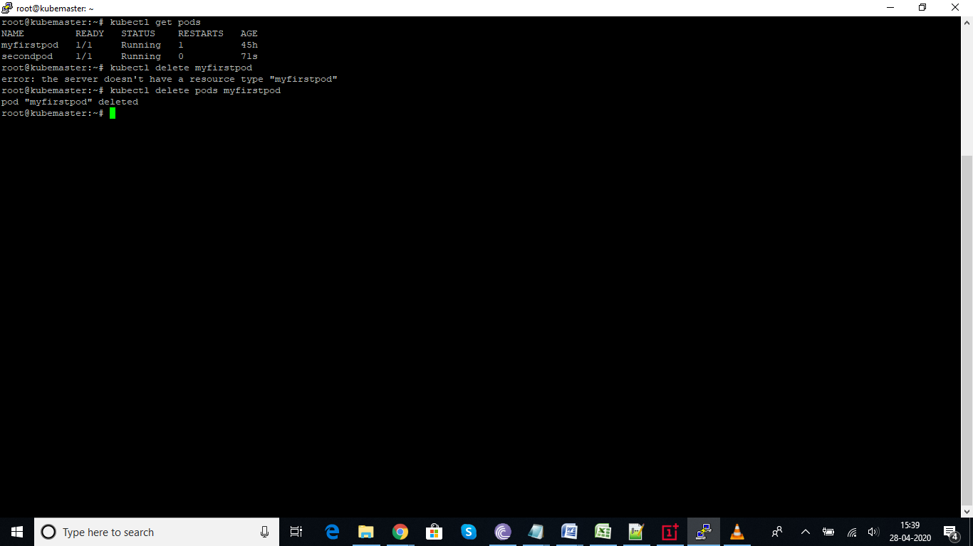

How to check the nodes
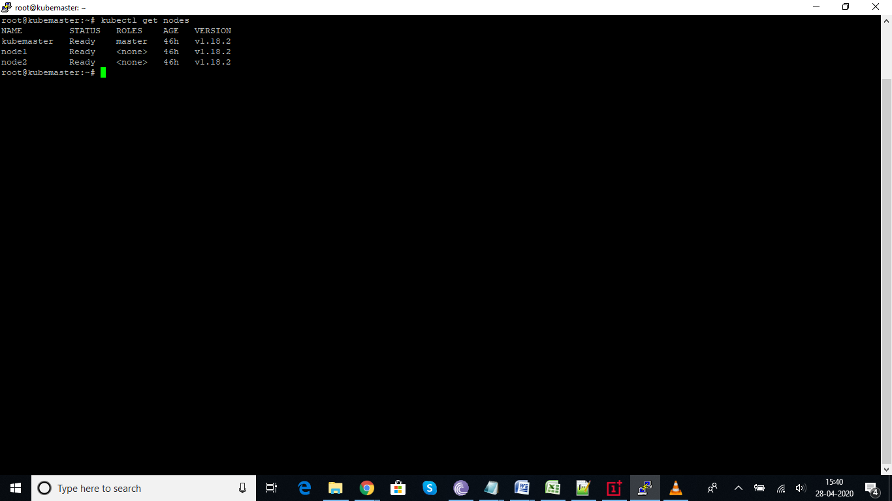
If we want to the check complete lifecycle and events and other information related to pods, we can user describe command.
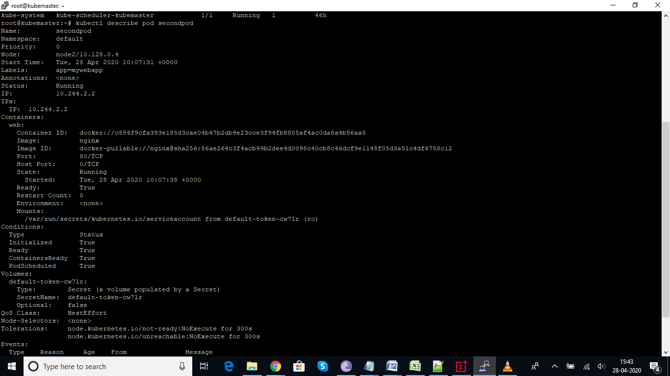

How to check the detail status of nodes
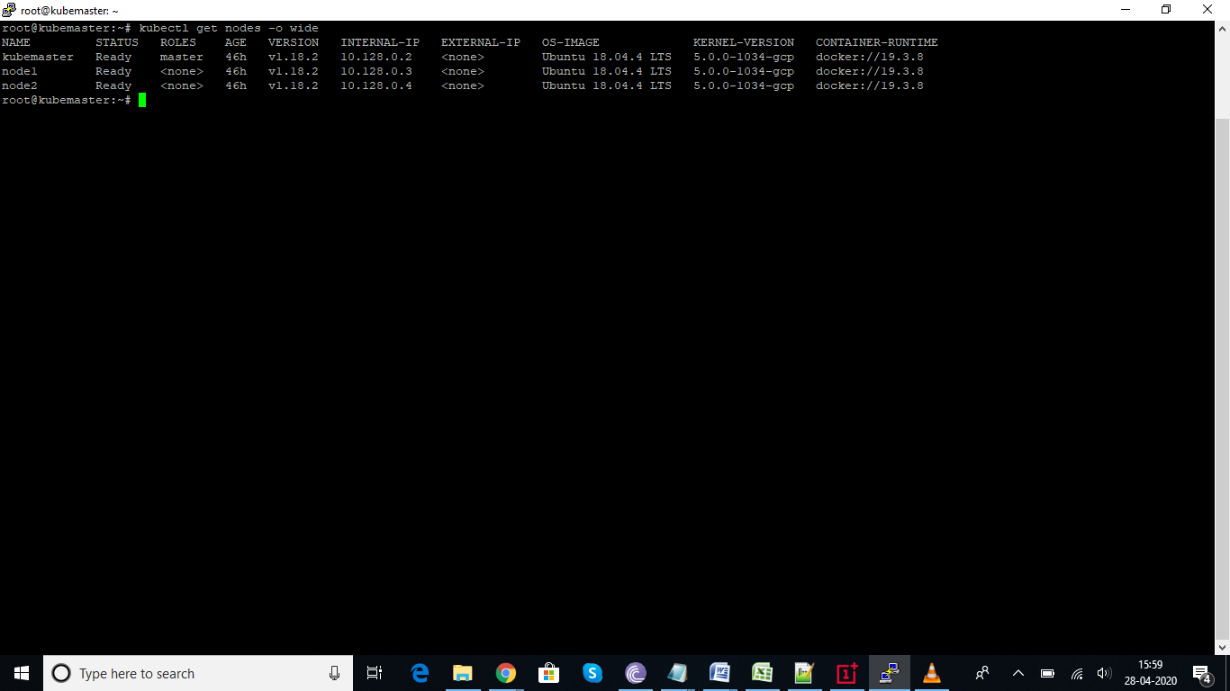

Replica Sets It is one of the Kubernetes controllers used to make sure that we have a specified number of pod replicas running (A controller in Kubernetes is what takes care of tasks to make sure the desired state of the cluster matches the observed state). Without it, we will have to create multiple manifests for the number of pods we need which is a lot of work to deploy replicas of a single application. In previous versions of Kubernetes, it was called “Replication Controller”. The main difference between the two is that ReplicaSets allow us to use something called “Label Selector”.

How to check replicaset version or rs:
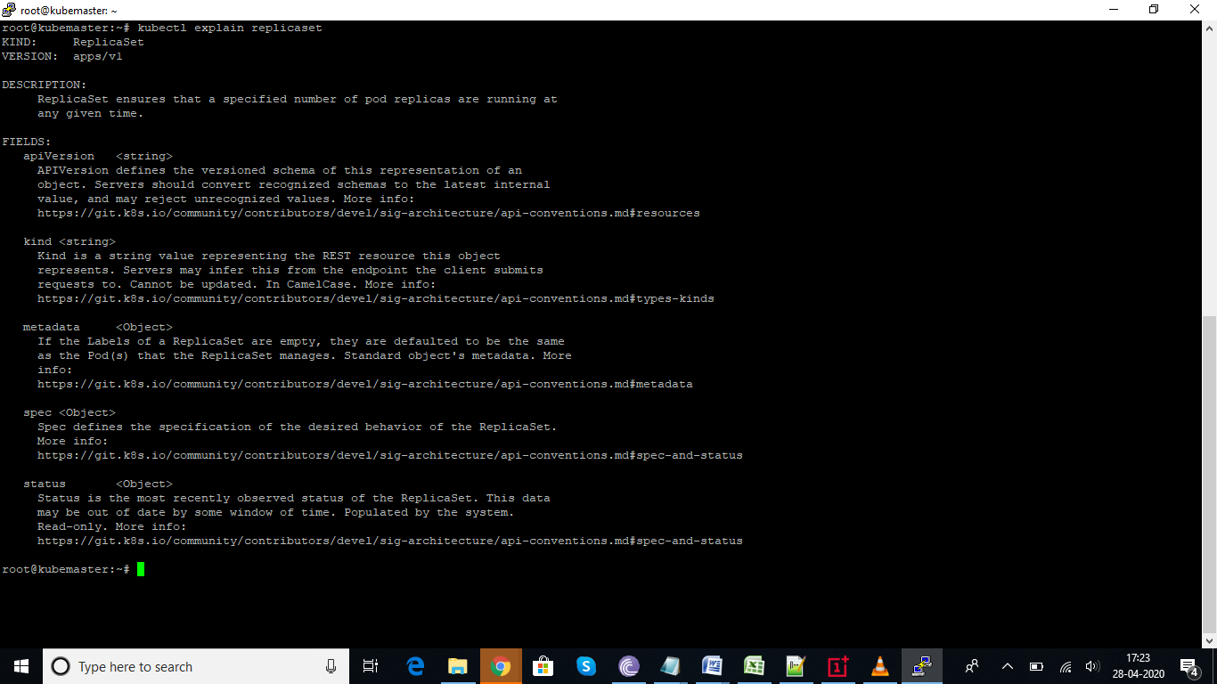
Wrote rs.yml for replica set, will maintain desired set of 3 pods at any given time, with tomcat running on it.
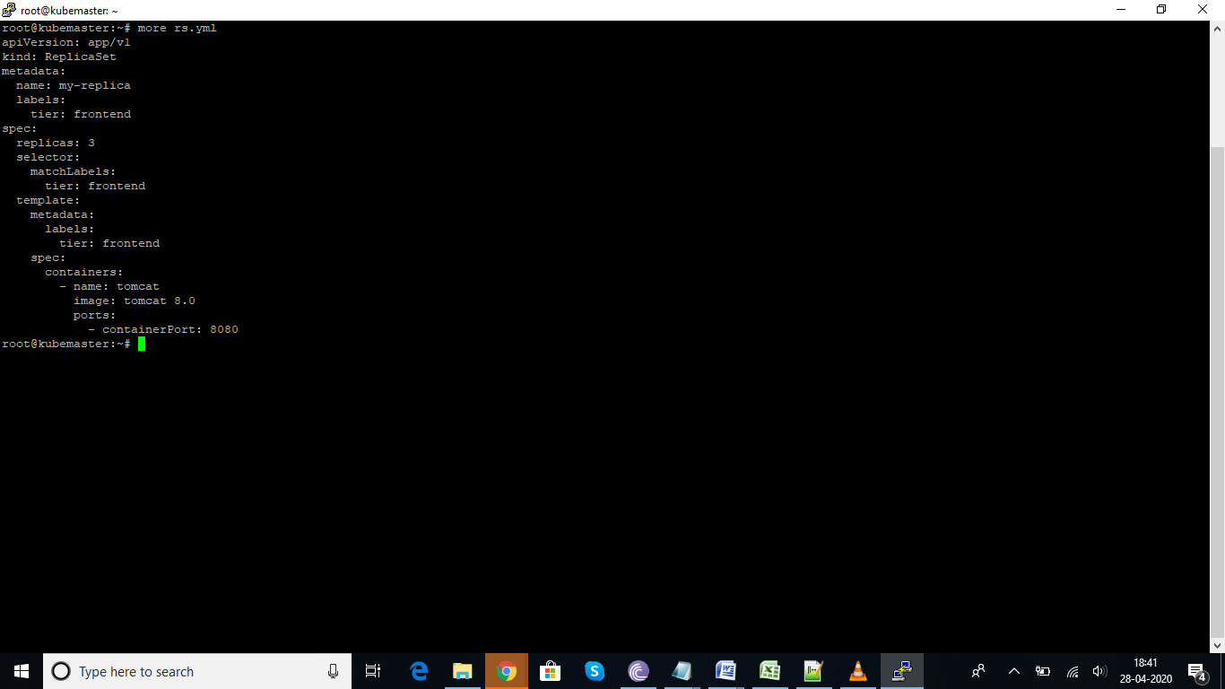
Debugging an error, please find the below
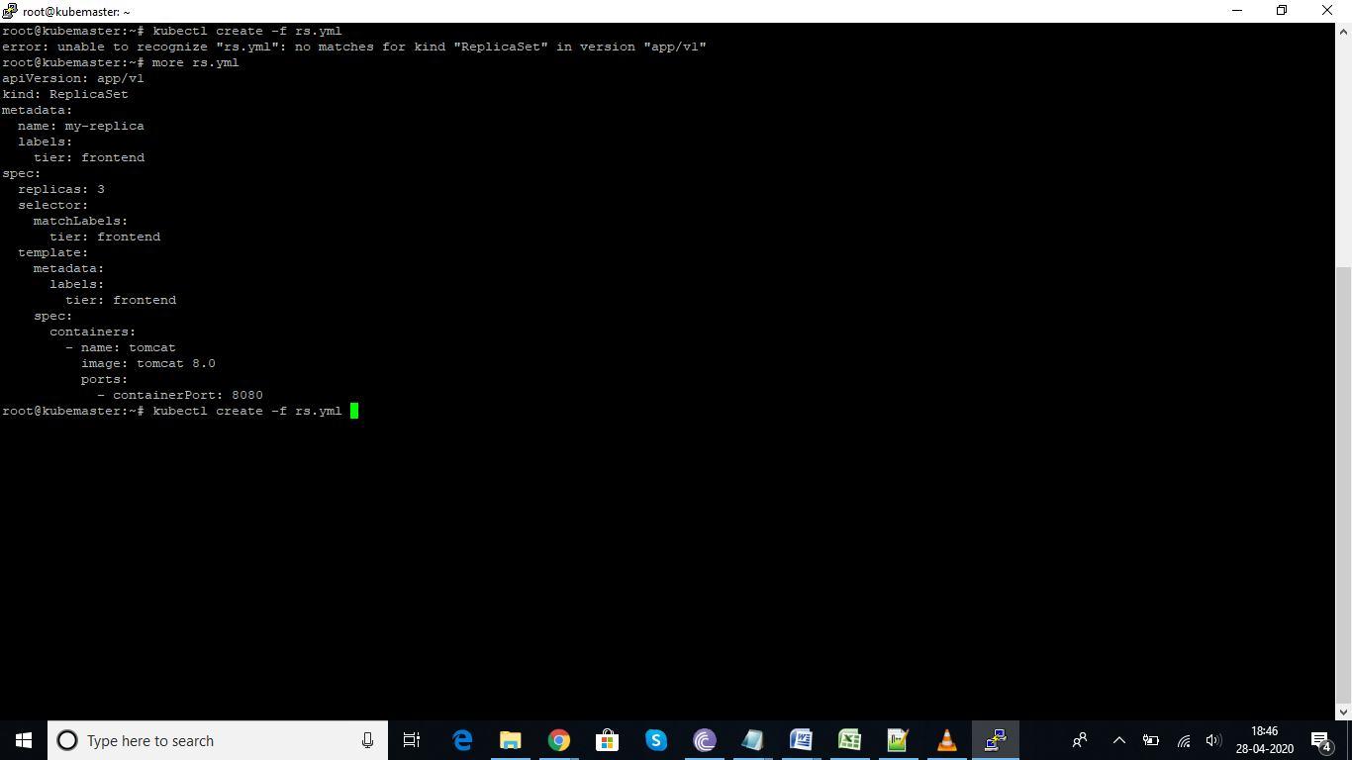
In the below screen shot, we have ran the command to list the pods and we have deleted the pod from the replica set. But we have mentioned the desired state as 3, once deleted, it again start creating the pod in seconds. That the concept behind the replica-set.
