

American International University-Bangladesh (AIUB)  
**Department of Computer Science  
Faculty of Science &Technology (FST)  
Fall 19_20**

**Section: H**

**Hospital Management System with AI**

A software Engineering project submitted

By

*Chinmoy Mondol (17-35926-3) (GitHub: ChinmoyMondol)*

The project will be evaluated for the following Course Outcomes

|  |  |
| --- | --- |
| CO3: Choose appropriate software engineering model in a software development environment | Total Marks |
|  |
| Project Background Analysis (needs, goal, benefits, etc.) [5Marks] |  |
| Appropriate Process Model Selection [5Marks] |  |
| Argumentation for model selection with Evidence [5Marks] |  |
| Completeness, Spelling, Grammar and Organization of the Answer [5Marks] |  |
|  | |
| CO4: Explain the roles and their responsibilities in the software project management activities | Total Marks |
|  |
| Content Knowledge (e.g. System Requirements, System Design) [5Marks] |  |
| Project Role identification [5Marks] |  |
| Responsibility Description [5Marks] |  |
| Completeness, Spelling, grammar and Organization of the Answer [5Marks] |  |

**2.0 Chapter 2: Methodology**

Literature studies were carried out throughout the project to find facts and references. The literature included books, electronic articles, and web pages. Function analysis was used for analyzing and developing the product requirements and also list them as functions in an easy way in order to provide an overview of the intended product. C# and Python were chosen as the preferred programming languages.

Agile methodology[1] was used as the backbone of the development process. The seven phases of Agile methodology, Planning, Designing, Development, Testing, Deployment, Review, and Launch, were strictly followed throughout the development process. First, the overall project was delicately planned. After that, the database and other aspects of the project were designed according to the plan. After receiving the system design, the actual coding process was started. After the code was developed, it was tested against the requirements to make sure that the product was actually solving the needs. After successful testing of the product, it was delivered to the customers for their use. It was not the final product, it was only for beta testing. After reviewing the feedback from the beta tests, required adjustments were made and bugs were fixed. Finally, the application was published.

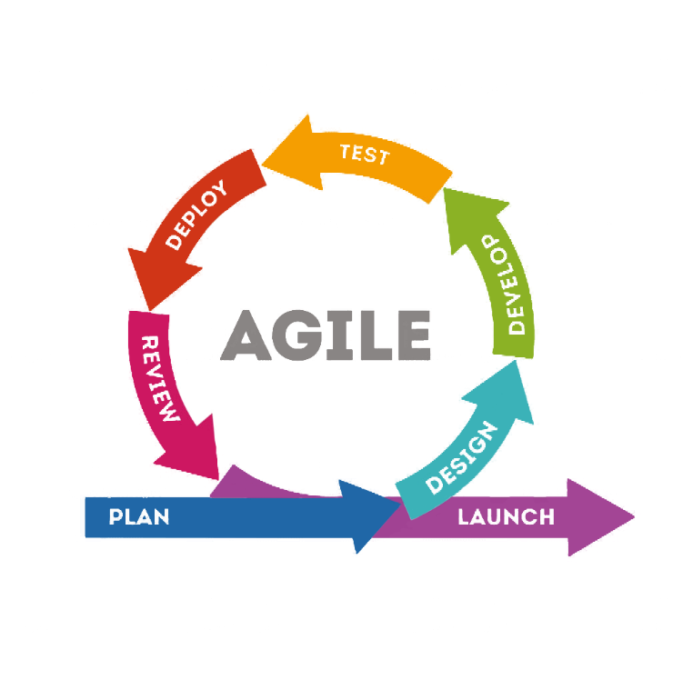

Figure 1: Phases of Agile Methodology

Scrum[2] was selected as the framework for the development process. Scrum[2] was selected for its feature Sprint. A product backlog was created. Sprint meetings were planned based to the product backlog. After every Sprint meeting, a Sprint backlog was created and a Scrum team was selected with a Scrum master. Each Sprint was created within a 3-week timebox. Daily Scrum were held. Each Sprint gradually leads to the final product.

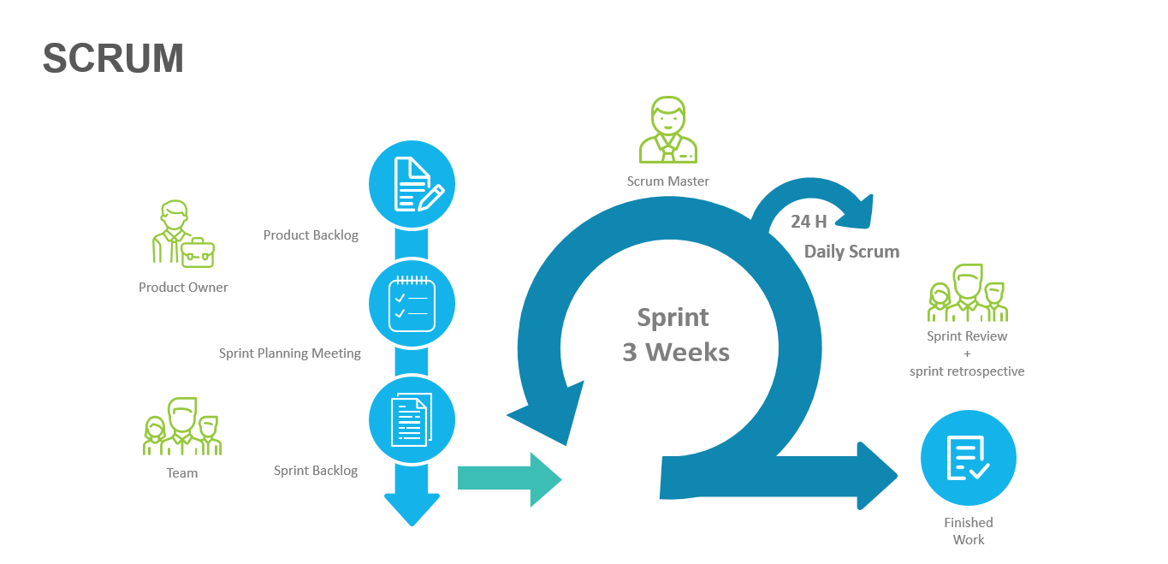

Figure 2: Agile Scrum Process

Artificial Intelligence was also used to enhance the performance and efficiency of the system. It was used for automating the customer relationship managements, improving the medical records and treatment solutions, tracking the vital status of ICU patients, more efficient identification of lab reports. AI aided chatbots were used to work with the knowledge sharing systems in order to provide relevant solutions. Artificial Neural Networks (ANN)[3] were used for the interpretation of complex data. Natural Language Processing[4] methods were used to identify the lab results more efficiently.

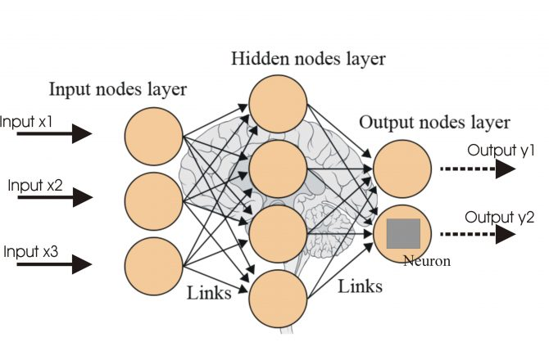

Figure 3: Neural Network Structure

The database was designed according to the following ER diagram.

**1**

**M**

**1**

**1**

**M**

**1**

**Doctor**

**D_id**

**Name**

**Address**

**Ph. No**

**Department**

**Treats**

**Patient**

**P**

**_id**

**Name**

**Address**

**Ph.No**

**Age**

**Gender**

**Bill**

**Issued**

**Assign**

**Room**

**Type**

**Room_id**

**BILL NO.**

**Doc_Charges**

**Room**

**Charges**

**Gender**

Figure 4: Hospital Management System ER Diagram

The Hospital Management System is like any other management system, except for the fact that it is enhanced by AI. At first, a login page appears and prompts for login credentials. After a successful login, the home page appears. The home page allows for registration for inpatients and outpatients, doctor and room information, and billing options. The homepage limits the options according to the user type that logs in to the system. The searching methods are enhanced by utilizing Natural Language Processing[4] and Expert System[5]. Artificial Intelligence was also used to suggest doctors according to their field of medical expertise and the condition of the patient.

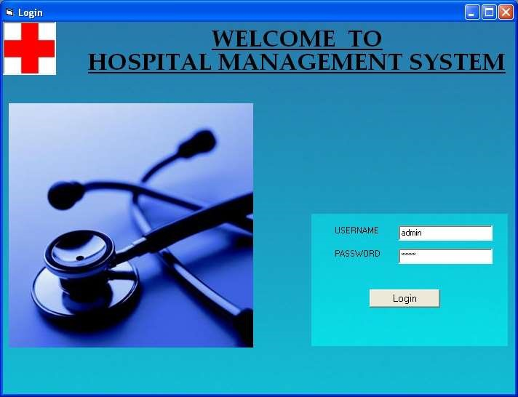

Figure 5: Login Page

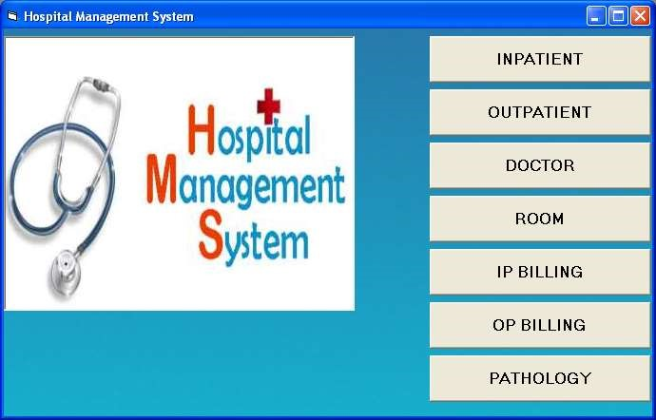

Figure 6: Homepage

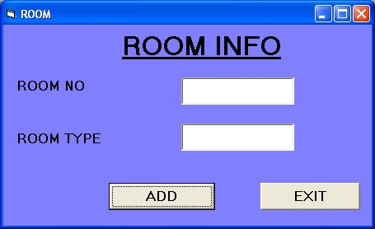

Figure 7: Room Info

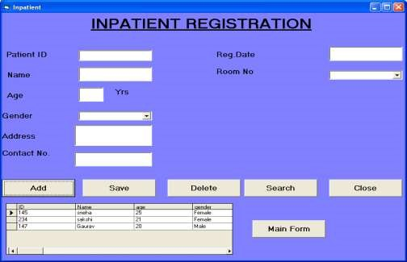

Figure 8: Inpatient Registration

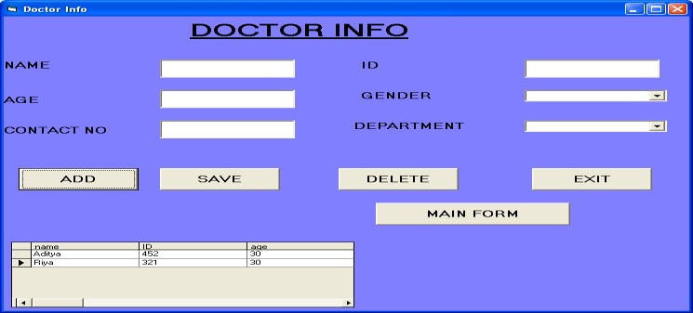

Figure 9: Doctor info page

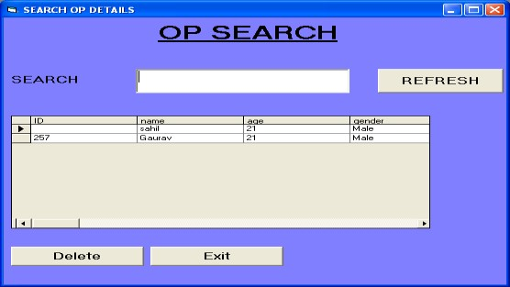

Figure 10: Outpatient search page

A survey for the performance of the system was conducted with 20 users. The survey included the following questions,

1. How often do you visit a hospital? (Very often/Moderately/Not very often)
2. Are the hospitals around you automated? (Yes/No)
3. How much inconvenience have you faced in a manually handled hospitals? (Very much/Moderate/Not much)
4. How much inconvenience have you faced in an automated hospital? (Very much/Moderate/Not much)
5. Do you feel the need for an automated hospital management system? (Yes/No)

**References:**

1. DaYong Sang, Wang Ying, and LiHua Wu, "Agile Software Development Methods and Practices" in, Xi-an:XIDIAN University press, pp. 160-180, 2010.
2. K. Schwaber, Agile project management with Scrum, USA:Microsoftpress, 2004.
3. R.P. Lippmann, "An Introduction to Computing with Neural Nets", *IEEE ASSP Magazine*, vol. 4, no. 2, pp. 4-22, Apr. 1987.
4. S F Fickas, "Automating the Analysis Process", *4th International Workshop on Software Specification and Design*, 1987.
5. Β Adelson, E Soloway, "The Role of Domain Experience in Algorithm Design", *IEEE Trans. on Software Eng.*, vol. SE-11, no. 11, pp. 222-241, Nov. 1985.