Md. Syful Islam.

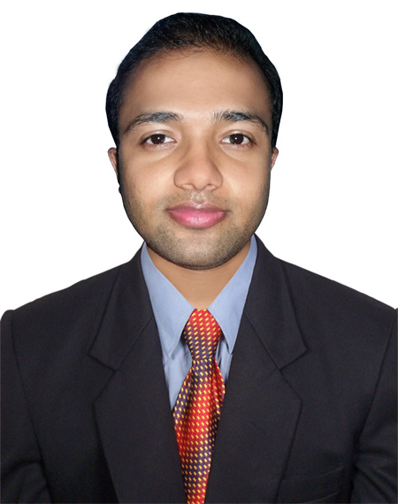

Email Id: [syful.cse.bd@gmail.com](mailto:syful.cse.bd@gmail.com)

Contract: +8801707 080401

**Objective**

Looking forward to an opportunity for working in a dynamic, challenging environment, where I can utilize my skills for developing my career and for the growth of the organization.

**Academic Qualification**

* B.Sc. in Computer Science & Engineering from North Western University, Khulna with CGPA 3.80 (Out Of 4) in 2017.
* HSC in Science from Dhaka Board with 3.90 GPA (Out Of 5) in 2010.
* SSC in Science from Jessore Board with 4.20 GPA (Out Of 5) in 2008.

**Technical Skills**

* Operating System: Windows & Linux.
* Web Technology: HTML, CSS, JavaScript, PHP, etc.
* Proficient in MS Office (MS Word, MS Excel, MS PowerPoint and Internet Applications).
* Completed divisional two days long “Basic Training: Call Center Agent” Organized by ICT Division under “Mobile Phone Based National Help Desk for Citizen Program”.

**Academic Project**

* Project Name 1: Library Management
* Language of Implementation: PHP, JavaScript, MySQL, Bootstrap.
* Description: “Library management” is a sub-discipline of [institutional management](https://en.wikipedia.org/wiki/Management) that focuses on specific issues faced by libraries.
* Project Name 2: Doctor’s point
* Language of Implementation: HTML, CSS, PHP, MySQL.
* Description: “Doctor’s point” is hospital based project. By browsing this site any one can easily find out doctors’ details, hospital's details, and all ambulance's number at a specific area.

**Personal Strengths**

* Positive Thinking.
* To any challenging work.
* Good learner by observation.

**Extra-Curricular Activities and Hobbies**

* Participated and won shuttle in various competitions at high school level.

Interested in listening music and Net surfing.

**Key Strengths**

* Hardworking, Regular, Disciplined, Sincere in Work.

**Personal Information**

Father’s Name: Md. Mamun - Or - Rashid.

Mother’s mane: Dulia Begum.

Date of Birth: 25-12-1992

Languages Known: Bangla, English.

Nationality: Bangladeshi.

Interest: In Computer Technology.

Present Address: House# 350, Road# 18, Nirala Residential Area, Khulna.

Permanent address: 1182/07 West Rajoyer, Sarankhola, Bagerhat.

**Declaration**

I hereby declare that all the above information given here is true and best of my knowledge & if any irregularities found i will be solely responsible for that.

Date : Syful Islam