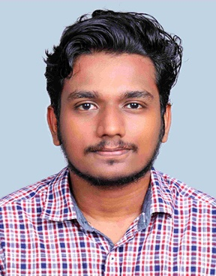DEVARAG S

OBJECTIVE

Recent Robotics, AI & ML graduate with a solid academic background in Robotics, electronics and programming. I am enthusiastic about contributing fresh insights, embracing challenges, and learning from experienced professionals. My adaptability, teamwork, and passion for technology make me a valuable asset to any team.

TECHNICAL SKILLS

* C programming
* Python programming
* Arduino
* Raspberry pi
* ROS

SKILLS

* Microsoft 365
* Critical thinking
* Communication
* Designing
* Sportsmanship

EDUCATION

* *SRINIVAS UNIVERSITY INSITUTE OF ENGINEERING AND TECHNOLOGY*
  + ~B.Tech Robotics , AI & ML (2020- pursuing)
* *GHSS UDINUR*
  + ~Higher Secondary Education | Science( Maths-Biology) | passed - 91%| (2018-2020)
* *GVHSS KANHANGAD SOUTH*
  + ~SSLC | passed – 95%| (2017-2018)

INTERNSHIP

At *K-TECH CENTRE OF EXCELLENCE IN AEROSPACE AND DEFENCE – BANGLORE*

*Project : “Robotic Arm” Design , Assembly and Kinematics using 3Dexperience by Dassault Systems*

At *TECHSPRITZ – MANGLORE*

*Projects : Working on – Two wheeled Security Robot(Arduino)*

*-Voice commanded Four wheeled Robot(Raspberry Pi)*

*-Automatic Irrigation system with rainfall detection*

*-Iot based smart cradle for baby monitoring*

*\*Other projects : Working on “Chess playing Robot”.*

*Smart Intrusion detection system*

*Smart Irrigation system using ML*

LANGUAGES

English : Conversational , Reading , writing

Malayalam : (Mother Tounge) Conversational , Reading , writing

Hindi : Conversational , Reading , writing

PERSONAL INFORMATION

Date of Birth : 03/04/2003

Gender : Male

Nationality : Indian

CONTACT

Phone : 9496016182

Email : [devaragsatheesan@gmail.com](mailto:devaragsatheesan@gmail.com)

LinkedIn : [www.linkedin.com/in/devarag-s-897b7a259](http://www.linkedin.com/in/devarag-s-897b7a259)

Address : Ragalayam

Udinur, Udinur P.O

Kasargode(D), Kerala(S)

671310