Experiment - 3

(a) Write a shell script that takes a command line argument and reports on whether it is a directory or a file.

Command: nano filename.sh

echo “enter filename”

read a

if test -f $a

then echo “this is a file”

elif test -d $a

then echo “this is a directory”

else

echo “it does not exist”

fi

(ctrl+o : save & ctrl+x : exit)

Terminal: chmod +x filename.sh

./nameofthefile.sh

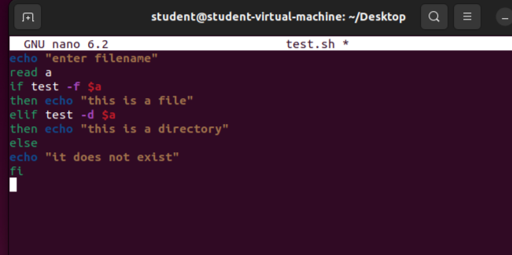

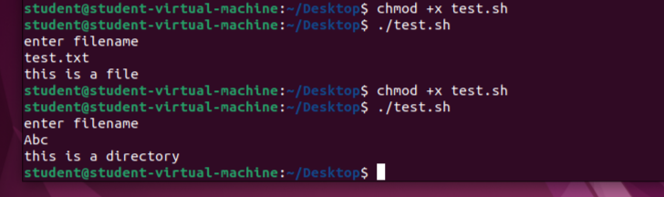

(b) Write a shell script that takes a file name as arguments and converts all of them to uppercase

Command: nano filename.sh

echo -n “enter filename”

read filename

if [ ! -f $filename ]

then

echo “filename $filename does not exist”

exit 1

fi

tr ‘[a-z]’ ‘[A-Z]’ < $filename

(ctrl+o : save & ctrl+x : exit)

Terminal: chmod +x filename.sh

./nameofthefile.sh

