Experiment 4

a) Write a shell script that determines the period which a specified user is working on the system.

Command: (From gedit filename.sh)

echo “Enter the user”

read user

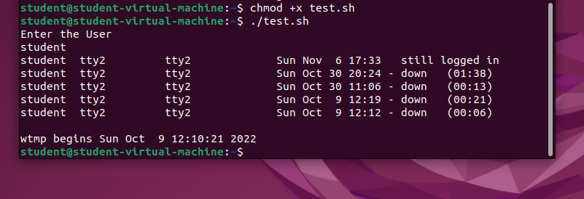

b) Write a shell script that displays all the lines between start and end line numbers passed as arguments.

Command:

echo “Enter the filename”

read file

echo “Enter the starting line no.”

read t

echo “Enter the last line no.”

read n

sed -n $t,$n/p $file

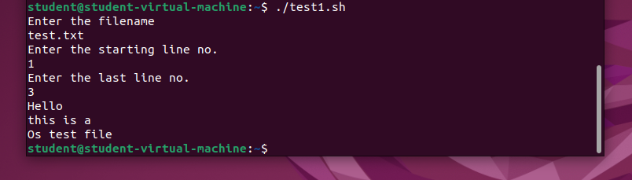

c) Write a shell script that deletes all lines containing a specified word in one or more than line files supplied as argument to it.

Command:

echo “Enter a word”

read word

echo “the filename are $\*”

for i in $\*

do

echo “The name of the file:”$i

grep –v $word $i

done

