Experiment – 5

Write a shell script and C program to perform the following string operations.

a) To extract a substring from a given string.

Code:

STR=”WELCOME TO MIET”

echo ${STR:3:5}

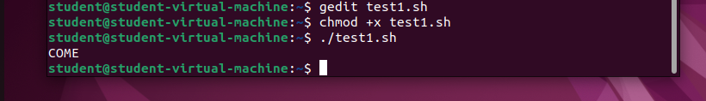

b) To find the length of a given string.

Code:

str=”this is a string”

n=${#str}

echo “Length of the string is: $n”

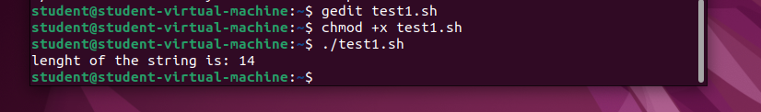

c) To extract a substring from a given string using C program.

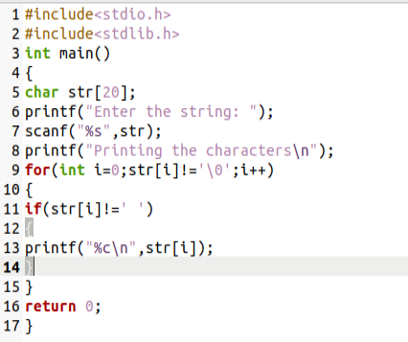

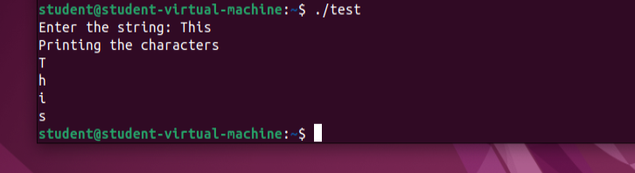

d) To find the length of a given string using C program.

