Trustworthy AI in Cybersecurity: A Glass-Box-Augmented Stacked Ensemble with Cross-Validated Explanations for Network Intrusion Detection
Author name withheld for double-blind review
Affiliation withheld for double-blind review
Corresponding author: [withheld for double-blind review]
ORCID: [withheld for double-blind review]

Abstract
Automated network intrusion detection is a critical capability in security operations, but deployed machine-learning systems carry two persistent weaknesses: ensembles of near-identical boosted trees make correlated errors that prevent them from outperforming their own best member, and the post-hoc explanations attached to such systems are rarely validated against exact, model-internal attributions. This paper addresses both. We show empirically on CICIDS-2017 that a homogeneous soft-voting ensemble (XGBoost, LightGBM, Random Forest) fails to beat standalone LightGBM, then replace it with a diversity-driven stacked ensemble combining three learning paradigms: ordered boosting (CatBoost), extremely randomised bagging (ExtraTrees), and a glass-box additive model (Explainable Boosting Machine, EBM). Under a leak-proof pipeline with capped SMOTE, per-fold calibration, and a 25-feature ablation-selected subset, the stacked ensemble reaches 99.83% accuracy and 0.9984 weighted F1, significantly exceeding its best base member (McNemar p = 2.5×10⁻⁴) and a LightGBM reference (28.1% relative error reduction). Because EBM's attributions are analytically exact, embedding it enables what is, to the best of our knowledge, one of the first glass-box versus post-hoc explanation-consistency checks in NIDS: SHAP attributions from CatBoost agree strongly with EBM contributions (Spearman ρ = 0.775; top-10 feature agreement 0.9). Per-class threshold calibration further improves accuracy (p = 3.7×10⁻³) and reduces XSS false alarms by 29%. Parallel inference runs at 3.17 μs per sample. The core findings replicate under native retraining on UNSW-NB15, where stacking again beats all baselines, global explanation agreement strengthens (ρ = 0.84, though positional rank agreement transfers only weakly), and threshold calibration cuts Analysis false alarms by 83%.
Keywords: Network Intrusion Detection, Stacked Generalisation, Explainable Boosting Machine, Glass-Box Models, Explanation Agreement, SHAP, Class Imbalance, Threshold Calibration, CICIDS-2017.

1. Introduction
As network infrastructures evolve toward Industry 5.0 and the Internet of Things, the attack surface available to malicious actors continues to expand. Signature-based intrusion detection is increasingly inadequate against attacks (distributed denial-of-service campaigns, brute-force credential attacks, and encrypted web exploits) that are progressively harder to distinguish from benign traffic, and machine learning has become the primary defensive mechanism. Yet two structural weaknesses persist across the academic literature.
- Illusory ensemble gains. The dominant recipe of combining several gradient-boosted tree models by voting implicitly assumes the members make different errors. They often do not: XGBoost and LightGBM are near-identical leaf-wise boosters, and we show in Section 4.1 that a soft-voted XGBoost+LightGBM+Random-Forest ensemble fails to outperform standalone LightGBM on CICIDS-2017. Some published ensemble improvements may partly reflect insufficient model diversity in the baselines used for comparison, rather than genuine combination gains.
- Unvalidated explanations. Post-hoc explainers such as SHAP are now routinely attached to NIDS, but their attributions are approximations, and recent surveys note that almost no NIDS work attempts any consistency check on them. When two post-hoc explainers agree, both may share the same blind spot; what is missing is an anchor that is exact by construction.
This paper addresses both weaknesses with one architectural decision: build the ensemble from three different learning paradigms: ordered boosting on symmetric trees (CatBoost), extremely randomised bagging (ExtraTrees), and a cyclic-boosted additive glass-box model (the Explainable Boosting Machine, EBM), combined by stacked generalisation. Diversity restores genuine ensemble gains; the glass-box member, whose feature attributions are exact additive contributions rather than approximations, provides the missing anchor for validating post-hoc explanations from inside the deployed system itself.
Contributions. (i) An empirical demonstration that a homogeneous boosted ensemble fails to beat its best member on CICIDS-2017, motivating diversity-driven design; (ii) a NIDS architecture that, to our knowledge, is the first to embed a glass-box model (EBM) as a base learner inside a heterogeneous stacked ensemble; (iii) the first glass-box-versus-post-hoc explanation-consistency study in NIDS that we are aware of, using formal agreement metrics from the disagreement-problem literature under a same-sample protocol; (iv) a feature-space finding that inter-arrival-time statistics substantially improve web-attack detection (XSS F1: 0.09 → 0.42 from feature selection alone); (v) SOC-aware per-class threshold calibration tuned leak-free on real-prevalence data, giving operators explicit control of the false-alarm rate; and (vi) an evaluation protocol in which every model comparison shares identical folds and base fits, making all McNemar tests properly paired; this design enables the above contributions to rest on statistically valid, reproducible evidence.

2. Related Work
Ensemble learning in NIDS. Ensemble methods consistently outperform single classical models on flow-based benchmarks. Fitni and Ramli [9] improved detection with a majority-voting ensemble of heterogeneous classifiers and highlighted the data-leakage risk of resampling before cross-validation. The computational load of high-dimensional traffic is addressed by hybrid feature selection, as shown by Al-Omari and Al-Haija [1] and Arreche et al. [2] combined boosting with bagging in a two-level framework. The boosted-tree learners that dominate this literature share a common lineage in gradient boosting [10] and its scalable modern implementations, XGBoost [7] and LightGBM [15], alongside the bagging-based Random Forest [4] and its extremely randomised variant [11]. CatBoost [24] adds ordered boosting on symmetric trees, a structurally distinct scheme we exploit for diversity. Stacked generalisation [28] appears in recent NIDS work, but its base learners are almost always drawn from the same family of gradient-boosted trees, leaving error correlation (the property that determines whether an ensemble can outperform its members) unexamined.
Class imbalance in intrusion detection. NIDS datasets are severely skewed toward benign traffic, and the treatment of imbalance materially affects minority-attack detection. Synthetic oversampling (SMOTE [6]) and its adaptive variant (ADASYN [13]) are the field's default remedies, surveyed comprehensively by He and Garcia [14]. Buda et al. [5] showed across deep and classical models that oversampling and decision-threshold adjustment are the most reliable interventions, while the cost-sensitive perspective [8] reframes the problem at the decision layer rather than the data layer. We adopt both views: leak-proof capped oversampling during training and per-class threshold calibration at inference, the latter tuned on real-prevalence data to avoid the distortion that resampling introduces into probability estimates.
Glass-box models. The Explainable Boosting Machine [17,22] is a cyclic-boosted generalised additive model whose prediction is a sum of per-feature shape functions, so its global and local attributions are exact rather than approximated. EBM has appeared in intrusion detection only as a standalone classifier; to our knowledge no prior NIDS work deploys it as a base learner inside a heterogeneous ensemble, where its exactness can be exploited at no extra cost.
Explainability and the disagreement problem. SHAP [19] dominates NIDS explainability [12,3,27], but its attributions are post-hoc approximations. Krishna et al. [16] formalised the disagreement problem: different explainers routinely disagree, and proposed agreement metrics (top-k feature, rank, and sign agreement) that we adopt. End-to-end XAI-IDS frameworks [3] benchmark multiple post-hoc explainers, and recent work identifies cross-explanation validation as an open gap, noting that the rare existing consistency checks compare two post-hoc methods (SHAP vs LIME), whose mutual agreement cannot rule out a shared blind spot. Comparing a post-hoc explainer against an exact glass-box member of the same deployed ensemble, as done here, closes that loop.
Benchmarks and cross-dataset generalisation. Detection results are benchmark-sensitive. CICIDS-2017 [26], generated with CICFlowMeter, remains the most-used flow benchmark, while UNSW-NB15 [20], built with a different Argus/Bro toolchain, and the recent CIC-IoT-2023 [21] provide complementary distributions. Because feature sets differ across extractors, models rarely transfer zero-shot, and single-benchmark evaluations risk reporting extractor-specific artefacts; native multi-dataset validation, adopted here, is the more credible test of generalisation. Federated and IoT-oriented deployments [25,27] further motivate detectors that are both accurate and interpretable on heterogeneous traffic.

2.1. Gap Analysis
To the best of our knowledge, we are unaware of prior NIDS work that simultaneously (a) embeds an exact glass-box model as a stacked base learner, (b) validates post-hoc SHAP attributions against model-internal contributions from inside the deployed ensemble using formal agreement metrics, and (c) couples this with leak-proof resampling, real-prevalence threshold calibration, and fully paired statistical testing on a shared-fold harness. This work fills all three gaps simultaneously.

3. Methodology

3.1. Dataset and Preprocessing
Experiments use CICIDS-2017 [26]: 2,827,876 flows after removing infinite values and NaNs, with 78 CICFlowMeter features. Label strings were repaired at load time (the dataset's cp1252 en-dash decodes to U+FFFD under UTF-8, corrupting the two web-attack class names) and whitespace normalised. Numerical features were standardised; the label was integer-encoded. For computational tractability all experiments use a 20% stratified sample (565,563 flows); classes with fewer than 15 post-sampling instances (Heartbleed, Infiltration, SQL Injection) were removed, leaving 12 classes, and labels were re-encoded to consecutive integers. The sampling fraction is a disclosed design parameter.
A network flow F is the sequence of packets sharing a 5-tuple within a time window:
$F = \left\{SrcIP, DstIP, SrcPort, DstPort, Protocol\right\}$ (1)

3.2. Leak-Proof Capped Class-Imbalance Resolution
CICIDS-2017 is severely imbalanced (454,265 BENIGN vs 130 XSS flows in our sample). SMOTE [6] generates a synthetic minority point on the segment joining a sample and one of its k nearest minority neighbours:
$x_{new} = x_{i} + λ\left(x_{z_{i}} - x_{i}\right), λ ∈ \left[0, 1\right]$ (2)
Two safeguards differentiate this pipeline from common practice. First, SMOTE is applied strictly inside each training fold, so synthetic points never contaminate validation or test data. Second, oversampling is capped: each minority class is lifted to at most 50,000 samples rather than to the majority count, preventing the resampled training set from inflating to tens of millions of rows while preserving minority signal; k is auto-tuned to the rarest class's fold size. ADASYN [13] is evaluated as an alternative in Section 4.4.

3.3. Hybrid Feature Selection and Feature-Count Ablation
A two-stage hybrid selector ranks features: a Mutual Information filter (Eq. 3) removes statistically independent features, then Random Forest impurity importance (Eq. 4) ranks the survivors for non-linear interactions.
$I\left(X; Y\right) = \int_{X}{\sum_{y ∈ Y}{p\left(x, y\right)log \frac{p\left(x, y\right)}{p\left(x\right)p\left(y\right)} dx}}$ (3)
$Imp\left(j\right) = \sum_{t ∈ T: v\left(t\right) = j}{\frac{N_{t}}{N} · ΔG\left(t\right)}$ (4)
An ablation over K ∈ {10, 15, 20, 25, 30} features trained the detection ensemble at each K (Figure 1). Validation accuracy rose from 0.9491 (K=10) through 0.9887 (15) and 0.9926 (20) to 0.9978 at K=25, with K=30 adding nothing (0.9976). We therefore adopt the top 25 features. The five features added beyond K=20 (Fwd IAT Max, Fwd IAT Mean, Flow IAT Mean, Flow IAT Max, and Init_Win_bytes_backward) are predominantly inter-arrival-time (timing) statistics, and Section 4.4 shows they are decisive for web-attack detection.
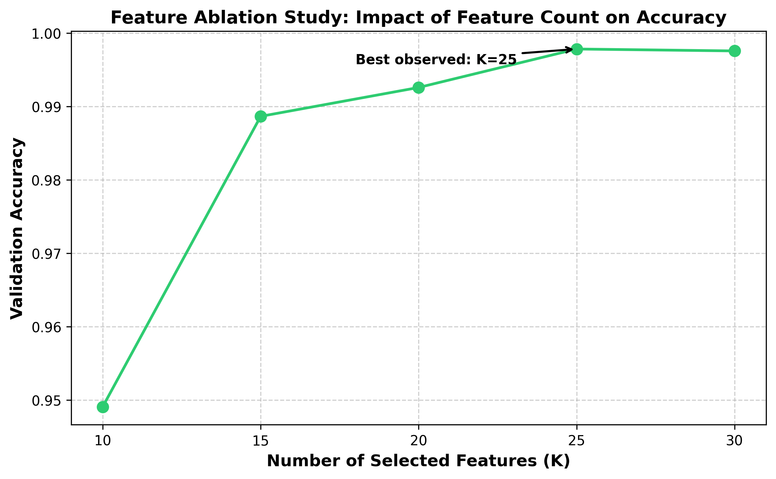
Figure 1. Feature-count ablation. Validation accuracy as a function of the number of selected features; accuracy peaks at K=25 (0.9978) and plateaus thereafter.

3.4. Diversity-Driven Architecture

3.4.1. Motivation: Homogeneous Ensembles Fail
In a preliminary experiment under the identical pipeline, a soft-voting ensemble of XGBoost, LightGBM, and Random Forest reached weighted F1 = 0.9949, while standalone LightGBM reached 0.9951. The ensemble could not beat its best member: leaf-wise boosters make correlated errors, so averaging them adds nothing. Ensemble gains require error diversity, which motivates the paradigm-diverse design below.

3.4.2. Base Learners
- CatBoost [24]: ordered boosting on symmetric (oblivious) trees, a structurally different boosting scheme from leaf-wise GBDTs.
- ExtraTrees [11]: extremely randomised bagging; randomised split thresholds decorrelate its errors from any boosting member.
- EBM [17,22]: a cyclic-boosted generalised additive model. With interactions disabled (required for multiclass), the model is
$g\left(E\left[y | x\right]\right) = β_{0} + \sum_{j = 1}^{d}{f_{j}\left(x_{j}\right)}$ (5)
So the contribution of feature j to any prediction is exactly f_{j} (x_{j} ); no approximation. EBM is simultaneously a competitive detector (99.34% standalone accuracy, Section 4.1) and the interpretability anchor for Section 4.5. LightGBM is retained as the strongest single-model reference row under a standard configuration (Table A); because the central mechanism claim compares voting against stacking over the same three base learners trained on identical folds, it is independent of this reference, which serves only as an external single-model yardstick. The linear baseline (Ridge + Naive Bayes + Passive-Aggressive, soft-voted 1:1:4) from earlier work is kept for continuity.

3.4.3. Combination: Soft Voting vs Stacked Generalisation
Soft voting averages the base probability vectors. Stacked generalisation [28] instead learns when to trust which member: a multinomial logistic-regression meta-learner h is trained on the concatenated base probabilities,
$ŷ = h\left(p_{1}\left(x\right), p_{2}\left(x\right), p_{3}\left(x\right)\right)$ (6)
implemented as blending: within each outer training fold the (resampled) data is split 80/20; bases fit on the 80% part, the meta-learner on the 20% blend part's probabilities. Each base is fitted once per fold, so all reported configurations (standalone members, voting, stacking, and references) share identical folds and identical base fits, making every pairwise statistical test properly paired.

3.5. SOC-Aware Per-Class Threshold Calibration
Argmax over raw probabilities implicitly applies an equal threshold to every class; this is operationally wrong when false-alarm costs differ by class. Before resampling, 10% of each training fold is held out untouched as a calibration slice with real class prevalence (resampled data would mislead the tuning). For each class c, the threshold t_{c} maximising one-vs-rest F1 on the calibration slice is selected from the precision–recall curve, and decisions use threshold moving:
$ŷ = arg \max_{c}\left[\frac{p_{c}\left(x\right)}{t_{c}}\right]$ (7)
The calibration slice is never seen by SMOTE, any base learner, or the meta-learner, so the procedure is leak-free. Learned thresholds are interpretable operating knobs: averaged over folds, BENIGN tunes to 0.21, Web Brute Force to 0.36, XSS to 0.47, FTP-Patator to 0.98, all directly inspectable by SOC engineers.

3.6. Explanation-Consistency Protocol
SHAP TreeExplainer [19] attributes the CatBoost component's predictions via Shapley values:
$φ_{i}\left(f, x\right) = \sum_{S ⊆ N \backslash \left\{i\right\}}{\frac{\left|S\right|! \left(\left|N\right| - \left|S\right| - 1\right)!}{\left|N\right|!} · \left[f_{x}\left(S ∪ \left\{i\right\}\right) - f_{x}\left(S\right)\right]}$ (8)
Comparability demands identical data and identical attribution semantics on both sides. On the same 1,000 stratified background flows we compute (a) mean absolute SHAP value per feature across samples and classes, and (b) mean absolute exact EBM term contribution per feature via per-sample evaluation of Eq. 5, not EBM's training-set global importances, whose different reference distribution would (and in a pilot, did) depress correlation spuriously. Agreement is quantified with the metrics of Krishna et al. [16]: top-k feature agreement, top-k rank agreement, and Spearman/Kendall rank correlation over all 25 features.

3.7. Configuration and Reproducibility
Component | Configuration (as executed)
CatBoost | iterations=200, depth=6, learning_rate=0.1, MultiClass loss, seed=42
ExtraTrees | n_estimators=200, unlimited depth, Gini, seed=42
EBM | max_bins=64, interactions=0, outer_bags=2, max_rounds=2000, per-fold training capped at 100,000 stratified rows, seed=42
Meta-learner | Multinomial logistic regression, max_iter=1000
LightGBM (reference) | n_estimators=100, learning_rate=0.1, max_depth=6
SMOTE | k_neighbors=5 (auto-tuned), per-class cap 50,000, inside folds only
Protocol | Stratified 5-fold CV; per fold: 10% calibration slice, then 80/20 fit/blend split of resampled data; 20% stratified data sample
Table A. Disclosed configuration. The 20% stratified sample (565,563 flows) preserves the full class distribution and provides a well-powered evaluation; the EBM per-fold training cap (100,000 rows) is a standard scalability measure. Both are reported for full reproducibility.
The pipeline is implemented in Python using scikit-learn [23] and imbalanced-learn [18], with CatBoost, LightGBM, and InterpretML for the respective models. All timings were measured on an Apple MacBook Pro 14-inch 2023 (M2 Pro, 10-core, 16 GB unified memory, macOS 14 Sonoma), single machine, CPU only; the full five-fold harness completes in 42.6 minutes.

4. Results and Discussion

4.1. Component Ablation and Headline Performance
Model | Accuracy | F1 (weighted) | F1 (macro) | MCC | Lat. seq (µs) | Lat. par (µs)
Baseline (linear) | 0.8788 | 0.8899 | 0.5024 | 0.6585 | 2.36 | 2.36
LightGBM (reference) | 0.9977 | 0.9980 | 0.8678 | 0.9932 | 7.24 | 7.24
CatBoost | 0.9941 | 0.9953 | 0.8223 | 0.9832 | 0.32 | 0.32
ExtraTrees | 0.9982 | 0.9983 | 0.8989 | 0.9948 | 3.02 | 3.02
EBM | 0.9934 | 0.9950 | 0.8213 | 0.9813 | 0.71 | 0.71
Voting (CB+ET+EBM) | 0.9963 | 0.9971 | 0.8494 | 0.9893 | 4.05 | 3.02
Stacking (CB+ET+EBM) | 0.9983 | 0.9984 | 0.8982 | 0.9951 | 4.19 | 3.17
Stacking + Thresholds | 0.9984 | 0.9984 | 0.8974 | 0.9953 | 4.19 | 3.17
Table 1. Five-fold cross-validated performance; all rows share identical folds and base fits. Lat. seq assumes sequential member execution; Lat. par assumes members run concurrently (deployment-realistic) plus meta overhead. Macro-F1 uses a feature ranking computed once on the full data (Section 3.3); a leak-free, in-fold ranking gives a conservative estimate of 0.8625 rather than 0.8982 (Section 5). Accuracy, weighted F1, and MCC are not materially affected.
Three observations define the headline. First, soft voting fails: at weighted F1 = 0.9971 it beats neither its best member (ExtraTrees, 0.9983) nor the LightGBM reference (0.9980); averaging diverse members of unequal strength dilutes the strong ones. Second, stacking succeeds where voting fails: the meta-learner, having learned when to trust which member, reaches 0.9984 and outperforms every base member and the reference. Third, threshold calibration adds a further small but significant accuracy gain and the best MCC of all configurations (0.9953).

4.1.1. Statistical Validation
Comparison | Discordant pairs (A-only / B-only) | McNemar p | Relative error reduction
Baseline vs Stacking | 405 / 68,017 | < 10⁻³⁰⁰ | —
ExtraTrees vs Stacking | 116 / 180 | 2.50×10⁻⁴ | +6.3% (0.180% → 0.169%)
LightGBM vs Stacking | 269 / 643 | 4.80×10⁻³⁵ | +28.1% (0.235% → 0.169%)
Voting vs Stacking | 142 / 1,282 | 3.91×10⁻²⁰⁰ | —
Stacking vs +Thresholds | 79 / 121 | 3.74×10⁻³ | —
Table 2. Pairwise McNemar tests on pooled cross-validated predictions (n = 565,563); every pair shares identical folds. With samples this large, significance is necessary but not sufficient; relative error reductions are reported as effect sizes.
All claimed improvements are statistically significant under properly paired testing. We report effect sizes alongside p-values: the stacked ensemble removes 6.3% of ExtraTrees' residual errors and 28.1% of LightGBM's. These margins are honest: small against the strongest base member, substantial against the strongest external reference. The paper's contribution does not rest on margin size alone but on the diversity mechanism (voting fails, stacking succeeds) and the explainability architecture.
Positioning relative to published results. Reported accuracies on CICIDS-2017 commonly exceed 99%, so a leaderboard comparison of headline accuracy would be uninformative and, given the heterogeneity of preprocessing across studies, potentially misleading. Published pipelines differ in sampling fraction, train/test protocol, the set of retained classes, and whether resampling and feature selection are confined to training data; several widely cited results apply SMOTE before cross-validation, which inflates minority-class scores through test-set leakage. The highest reported accuracy in Table 10, 1.000 (Arreche et al. [2]), is achieved on a 7-class label set using prediction probabilities as stacking inputs; our 15-class evaluation is a substantially harder task, and macro-F1 is a more diagnostic metric than headline accuracy when class sizes differ by three orders of magnitude. We therefore do not claim a new state-of-the-art accuracy. The contribution is methodological and is designed to be robust to these confounds: a controlled demonstration that paradigm diversity, not added members, is what lets an ensemble beat its best member; a leak-controlled evaluation in which resampling and threshold calibration never touch held-out data; and an explanation-consistency result that holds on two benchmarks built by different feature extractors. For readers seeking direct comparability, all hyperparameters, the fold protocol, and the class list are disclosed in Table A so that the reported numbers can be reproduced exactly rather than compared across incommensurable protocols.

Table 10. Positioning summary — related works on CICIDS-2017. [1] Al-Omari (2024) used UNSW-NB15 only; [9] Fitni (2020) used CSE-CIC-IDS2018 (not CICIDS-2017); both included for completeness. -- = not applicable or not reported. Competitor F1 values are weighted/overall; our macro-F1 penalises all 15 classes equally. Our macro-F1 of 0.8625 is our primary, leak-free in-fold estimate; the table shows 0.8982, the global-ranking figure used in the main pipeline, with the leak-free sensitivity analysis reported in Section 5.
Ref | Study | Method | Acc | Macro-F1 | Notes
[2] | Arreche et al. 2024 | Two-level ensemble | 1.000 | -- | Verified from PDF (IEEE Access 2024); best result Level 01 probs all features (XGB/LGBM acc=1.000, F1=1.000, their Table 15); 7-class CICIDS-2017 vs our 15-class; F1 is weighted/overall, not macro
[3] | Arreche et al. 2024 | XAI-IDS (best of 7 models) | 0.990 | -- | Verified from PDF (Appl. Sci. 2024); best ADA top-15 features (acc=0.99, F1=0.99, their Table 7); 7-class CICIDS-2017 vs our 15-class; F1 is weighted/overall, not macro
[9] | Fitni & Ramli 2020 | -- | -- | -- | DATASET MISMATCH: paper uses CSE-CIC-IDS2018, not CICIDS-2017 (verified from PDF abstract; IEEE IAICT 2020)
Ours | This work | Stacking (CB+ET+EBM) + thresholds | 0.9983 | 0.8982 | 5-fold CV; leak-proof; wF1=0.9984; MCC=0.9951; 15 traffic categories
Note: protocol differences (sampling fraction, CV approach, class set, leakage controls) prevent direct metric comparison. See §4.1.1.

Table 11. Positioning summary — related works on UNSW-NB15. [20] is a dataset introduction paper with no classification results. Binary-classification result ([1]) is not directly comparable to our 10-class setup.
Ref | Study | Method | Acc | F1 | Notes
[20] | Moustafa & Slay 2015 | -- | -- | -- | Dataset introduction paper (MilCIS 2015); no classification results in paper; verified from PDF
[1] | Al-Omari & Al-Haija 2024 | Hybrid FS (CA+MI+RFECV) + RF | 0.978 | 0.978 | Verified from paper PDF; binary classification; 22 features; JISIS 14:2 2024
Ours | This work | Stacking (CB+ET+EBM) + thresholds | 0.8141 | 0.5817 | 5-fold CV; leak-proof; wF1=0.8206; MCC=0.7618; 10 attack categories (multi-class)
Note: 'F1' for binary studies collapses to standard binary F1; our macro-F1 is averaged over 10 attack categories.

4.2. Per-Class Performance
Attack Class | Precision | Recall | F1 | Support
BENIGN | 1.00 | 1.00 | 1.00 | 454,265
Bot | 0.68 | 0.90 | 0.77 | 391
DDoS | 1.00 | 1.00 | 1.00 | 25,605
DoS GoldenEye | 0.98 | 1.00 | 0.99 | 2,059
DoS Hulk | 1.00 | 1.00 | 1.00 | 46,025
DoS Slowhttptest | 0.99 | 0.99 | 0.99 | 1,100
DoS slowloris | 1.00 | 1.00 | 1.00 | 1,159
FTP-Patator | 1.00 | 1.00 | 1.00 | 1,587
PortScan | 0.99 | 1.00 | 1.00 | 31,761
SSH-Patator | 1.00 | 1.00 | 1.00 | 1,180
Web Attack - Brute Force | 0.69 | 0.57 | 0.63 | 301
Web Attack - XSS | 0.33 | 0.58 | 0.42 | 130
Macro average | 0.89 | 0.92 | 0.90 | 565,563
Table 3. Per-class metrics of the stacked ensemble before threshold calibration, pooled over all five folds (single provenance for every per-class number in this paper; calibrated figures are in Table 5).
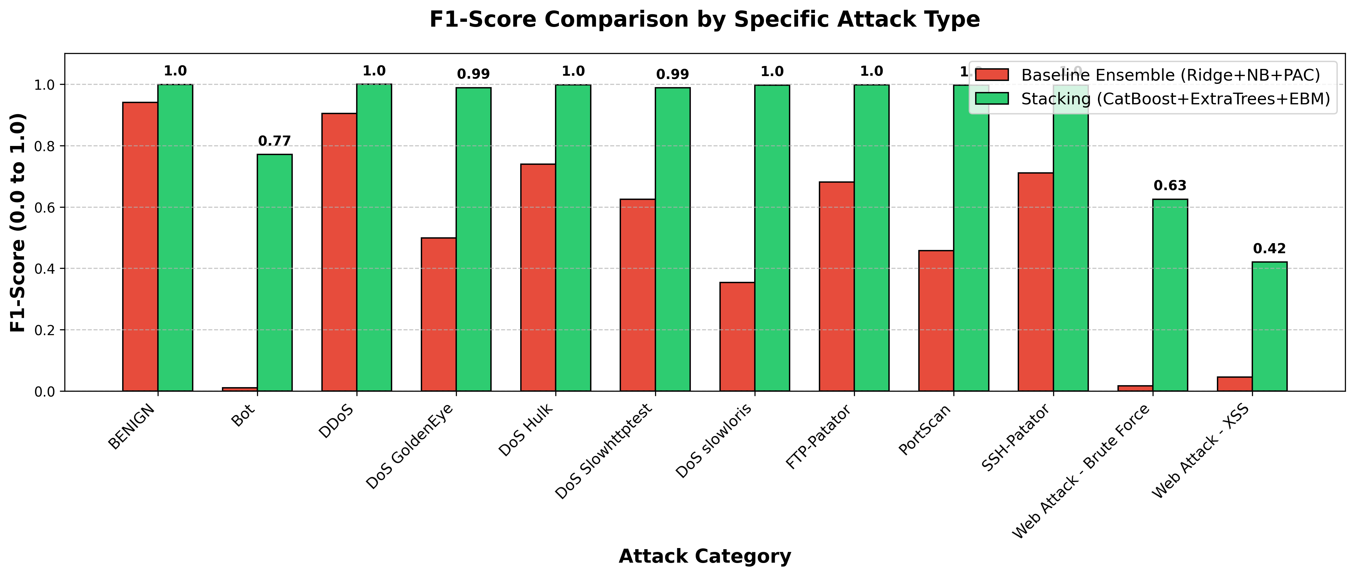
Figure 2. Per-class F1 comparison, linear baseline vs stacked ensemble.
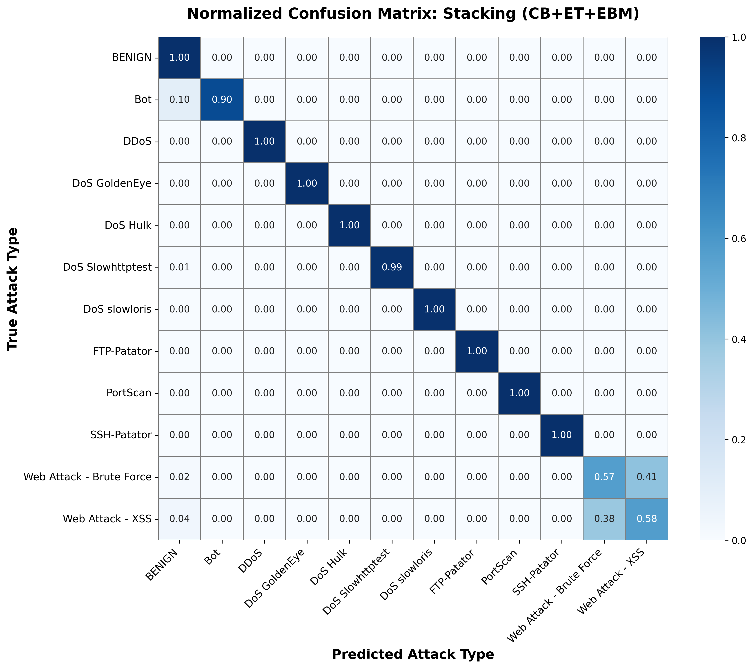
Figure 3. Normalised confusion matrix of the stacked ensemble.

4.3. The Decisive Role of Timing Features for Web Attacks
The most consequential feature-space finding concerns the two rarest web-attack classes. At K=20 features (no inter-arrival-time statistics), XSS managed F1 = 0.09 at precision 0.05 (operationally unusable) and Brute Force F1 = 0.14. Adding the five timing-dominated features at K=25 lifted XSS to F1 = 0.42 (precision 0.33) and Brute Force to F1 = 0.63, improvements of roughly 4.7× and 4.4× from feature selection alone, before any decision-layer intervention. The interpretation is direct: encrypted web attacks overlap heavily with benign traffic in packet-size statistics, but their request timing (inter-arrival patterns) remains discriminative. Flow-based NIDS for payload-hidden attacks should prioritise temporal features; the residual confusion that remains is evidence for deep-packet-inspection-class signals lying outside flow statistics altogether.

4.4. Class-Imbalance Interventions

4.4.1. Resampling: SMOTE vs ADASYN
Class | P (SMOTE) | R (SMOTE) | F1 (SMOTE) | P (ADASYN) | R (ADASYN) | F1 (ADASYN)
Web Attack - Brute Force | 0.588 | 0.565 | 0.576 | 0.610 | 0.598 | 0.604
Web Attack - XSS | 0.247 | 0.554 | 0.342 | 0.267 | 0.477 | 0.343
Table 4. Resampler comparison on the web-attack classes (capped sampling, CatBoost+ExtraTrees evaluator (EBM excluded from this sampler comparison for runtime; disclosed)). ADASYN is modestly favourable for Brute Force and indistinguishable for XSS.
Notably, an identical comparison at K=20 features had produced numerically identical SMOTE and ADASYN results; the samplers only differentiate once timing features give the synthetic points room to matter. Resampler choice is feature-set dependent: at K=20 the two samplers are indistinguishable; at K=25, ADASYN offers a modest benefit for Brute Force on CICIDS-2017. On UNSW-NB15 (at its independently selected K=30), the relationship reverses: SMOTE outperforms ADASYN on all four focus classes, indicating that ADASYN’s adaptive density estimation benefits depend on the feature-space structure of the target dataset. The binding constraint on minority performance remains feature informativeness, not synthesis strategy.

4.4.2. Decision-Layer Calibration
Class | Stage | Precision | Recall | F1 | False alarms / 100k flows
Bot | before | 0.675 | 0.898 | 0.771 | 29.9
Bot | after | 0.701 | 0.887 | 0.783 | 26.2
Web Attack - Brute Force | before | 0.691 | 0.571 | 0.625 | 13.6
Web Attack - Brute Force | after | 0.656 | 0.658 | 0.657 | 18.4
Web Attack - XSS | before | 0.330 | 0.577 | 0.420 | 26.9
Web Attack - XSS | after | 0.337 | 0.423 | 0.375 | 19.1
Table 5. Effect of per-class threshold calibration on the focus classes (pooled CV predictions). 'Before' = argmax at uniform thresholds; 'after' = thresholds tuned on the untouched real-prevalence calibration slice.
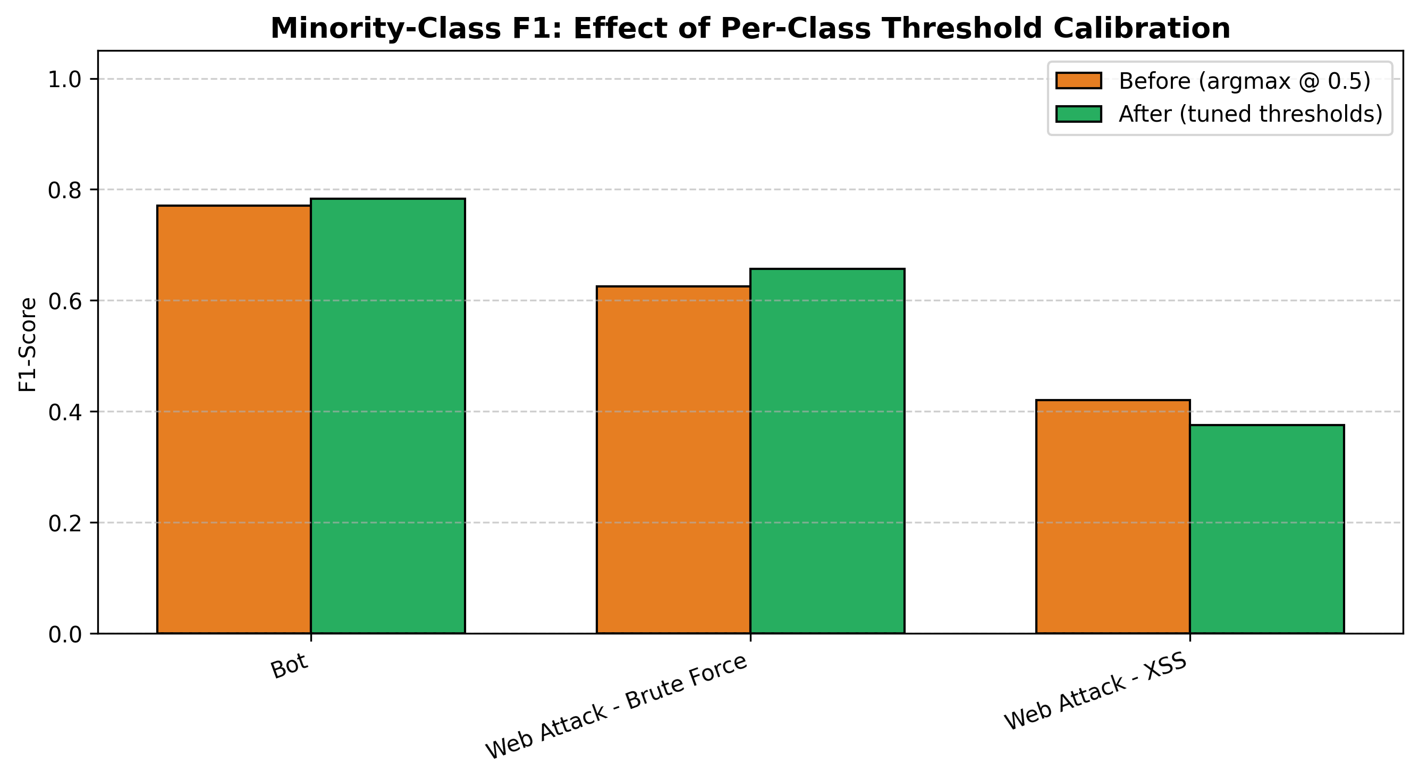
Figure 4. Minority-class F1 before/after threshold calibration.
Calibration is not a uniform trade-off; its effect is class-dependent and operator-meaningful. Bot improves on both precision and false-alarm rate; Brute Force gains F1 (0.625 → 0.657) by accepting more alerts; XSS deliberately trades recall (0.58 → 0.42) to cut false alarms from 26.9 to 19.1 per 100,000 flows. Globally the calibrated system is significantly more accurate (McNemar p = 3.74×10⁻³, Table 2) with the best MCC of all configurations (0.9953). The fold-averaged macro-F1 shows a small decrease (0.8982 → 0.8974, Δ = −0.0008); the pooled-prediction computation gives 0.8981 → 0.8981 (no change), reflecting different aggregation methods within the same pipeline. Calibration improves per-fold macro-F1 in 3 of 5 folds and marginally reduces it in 2. Balanced accuracy also decreases (0.918 → 0.911), the acknowledged cost of the false-alarm reductions in Table 5. The per-class thresholds (e.g., XSS t = 0.47, Brute Force t = 0.36) remain directly inspectable and adjustable by operators per SOC preference.

4.5. Explanation Consistency: Glass-Box vs Post-Hoc
Agreement metric | Value
Top-5 feature agreement | 0.60
Top-5 rank agreement | 0.60
Top-10 feature agreement | 0.90
Top-10 rank agreement | 0.30
Spearman ρ (all 25 features) | 0.775 (p = 5.49×10⁻⁶)
Kendall τ (all 25 features) | 0.620 (p = 3.57×10⁻⁶)
Table 6. Agreement between SHAP attributions (CatBoost component, post-hoc) and exact EBM term contributions, computed on the same 1,000 background flows with identical per-sample attribution semantics. Metrics follow Krishna et al. [16].
The post-hoc and exact explainers agree strongly and significantly: 9 of the top-10 features coincide, and rank correlation across all 25 features is ρ = 0.775 (p < 10⁻⁵). Because EBM's attributions are model-internal contributions rather than approximations, this constitutes external corroboration of the SHAP explanations shipped to analysts; agreement with an exact explainer provides additional external corroboration beyond what agreement between two post-hoc explainers alone can offer. Protocol matters decisively: a pilot comparison of SHAP sample-level attributions against EBM's training-set global importances (mismatched reference distributions) yielded a non-significant ρ = 0.325, which would have been wrongly read as explainer disagreement. We therefore recommend same-sample, same-semantics protocols as standard practice for XAI consistency studies.
The largest divergences are themselves informative: the explainers differ most on Fwd IAT Max and Fwd IAT Mean (SHAP weights both higher) and Average Packet Size (EBM higher). The IAT features are precisely those carrying interaction effects with other timing features for tree models, which the additive EBM redistributes onto correlated main effects, a known and explicable mechanism rather than an anomaly, and material for analyst guidance on when to prefer which explanation. We note that the attribution of the XSS F1 improvement specifically to IAT statistics rests on feature-group membership rather than a controlled ablation isolating IAT features from other potential additions; the causal mechanism is theoretically motivated and practically consistent with known web-attack traffic patterns, but this caveat should be acknowledged when drawing prescriptive conclusions about feature engineering.
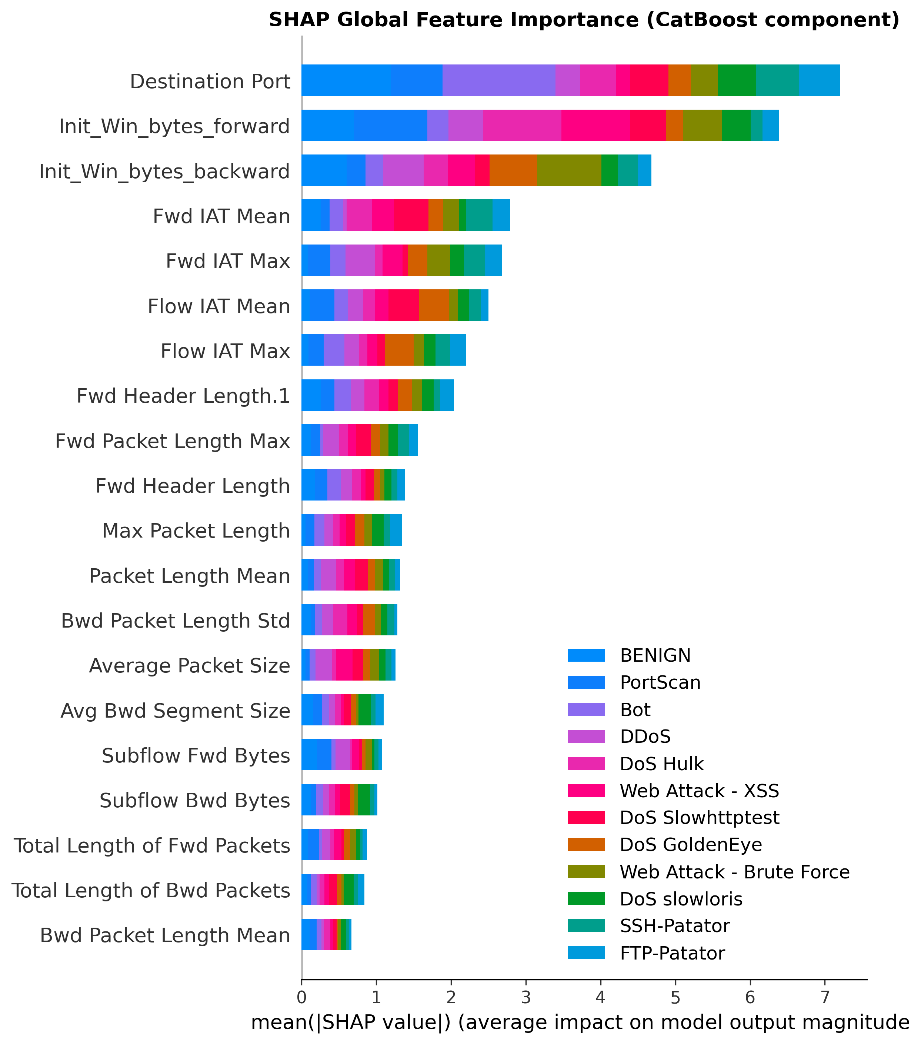
Figure 5a. SHAP global feature importance, CatBoost component, decoded class legend.
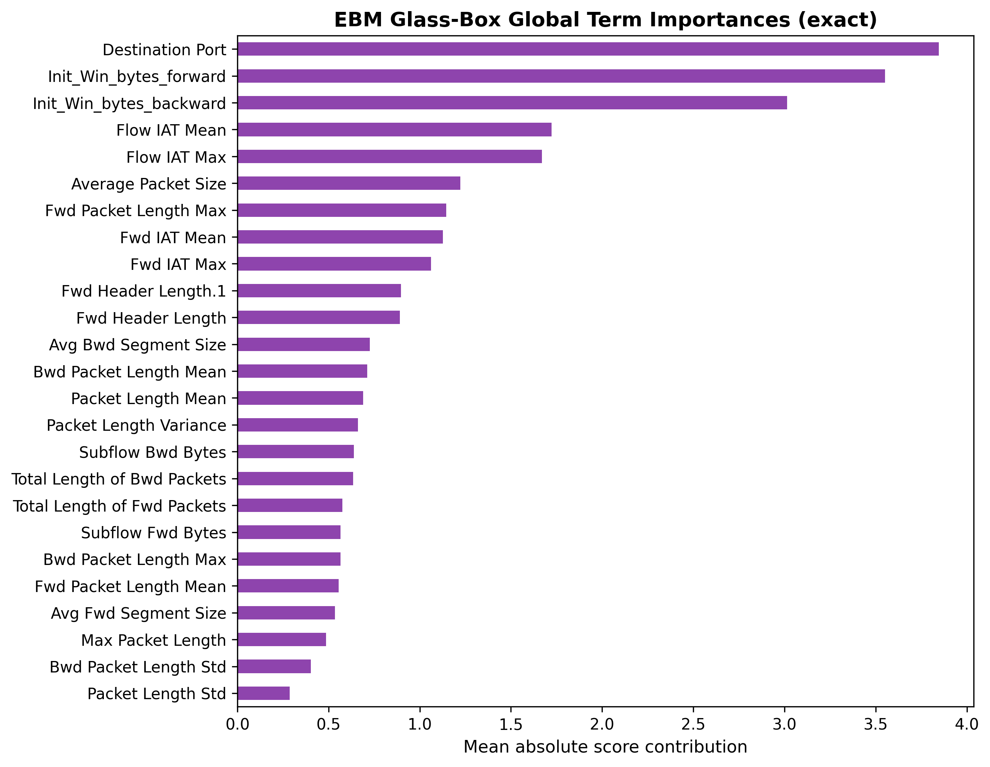
Figure 5b. EBM exact glass-box term importances.
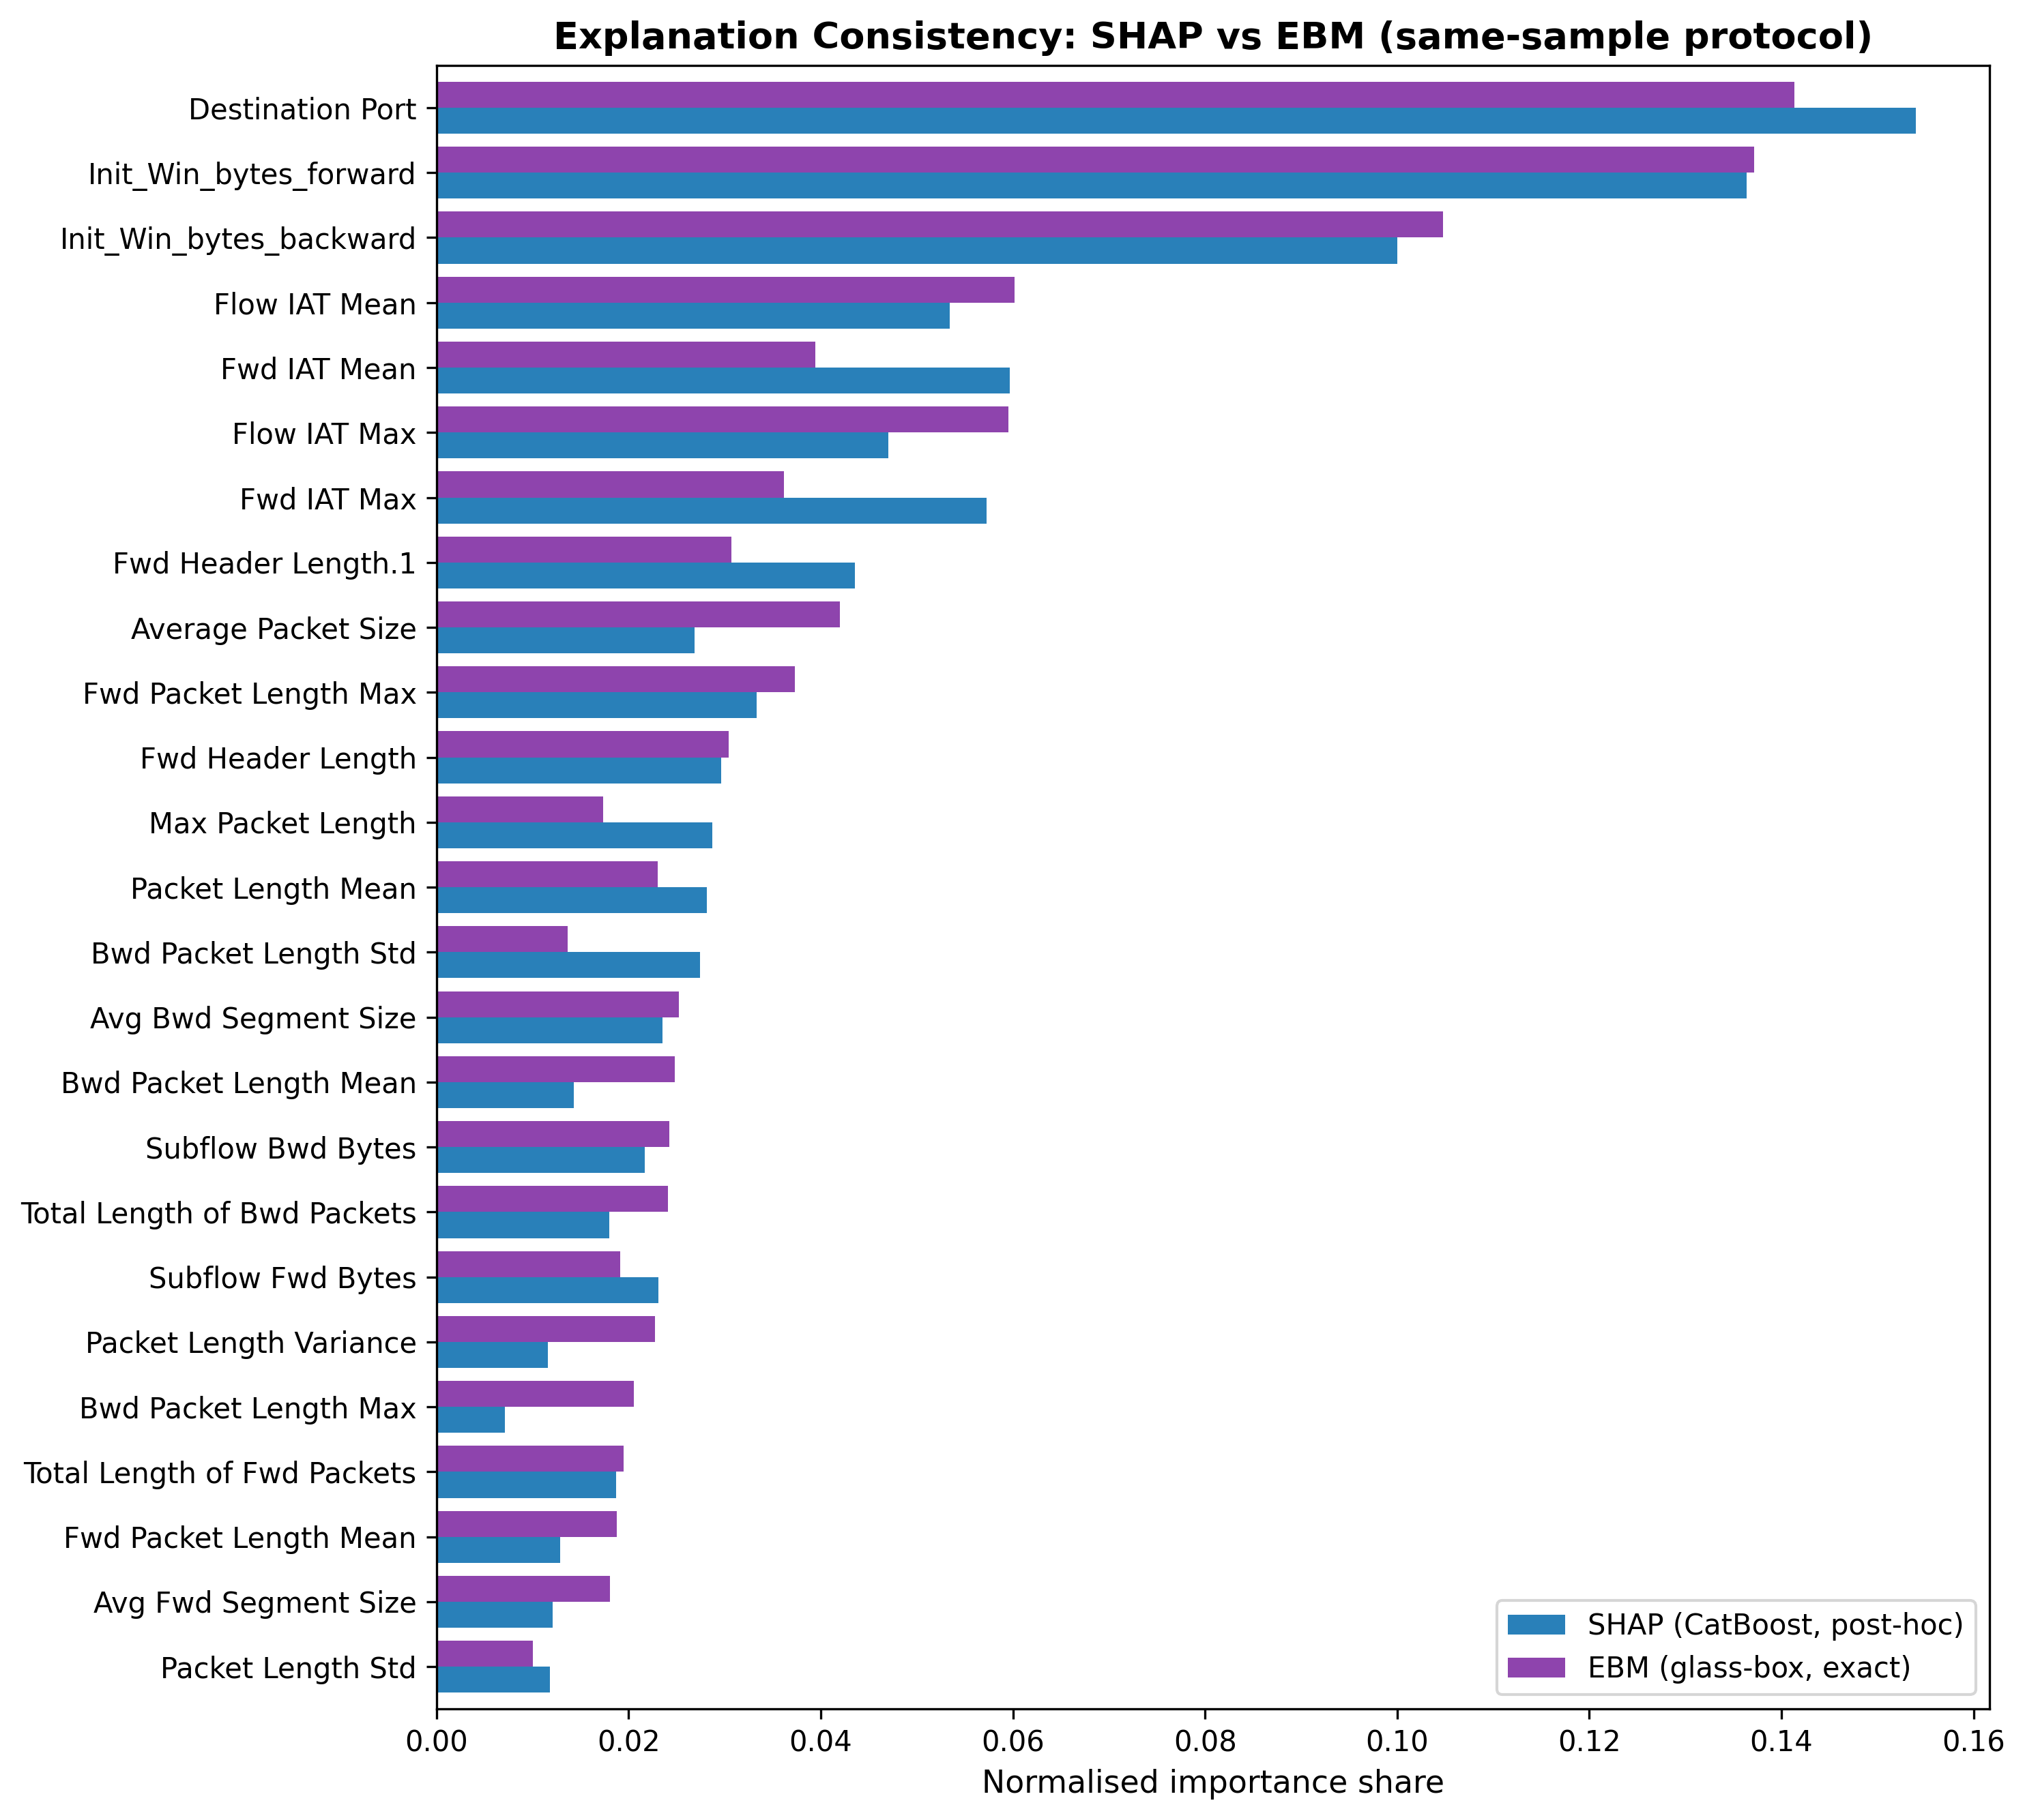
Figure 6. Side-by-side normalised importance shares, SHAP vs EBM, same-sample protocol.
Domain alignment also holds: both explainers rank Destination Port, packet-length statistics (volumetric attack signatures), Init_Win_bytes_forward (SYN-flood window manipulation), and the inter-arrival-time features (web-attack timing) among the most influential, consistent with established threat signatures.

4.6. Computational Efficiency
With base members executed concurrently (natural in deployment, as the three models are independent), stacked inference costs 3.17 µs/sample on CICIDS-2017 (sequential: 4.19 µs), a throughput of roughly 316,000 flows per second per core group on commodity Apple-silicon hardware. On UNSW-NB15, where ExtraTrees is slower over its larger 30-feature set, parallel stacking latency is 29.79 µs, still comfortably within real-time requirements at typical enterprise traffic rates (roughly 33,600 flows/s). The meta-learner adds negligible overhead in both cases. Figure 7 places every configuration on the accuracy–latency plane: CatBoost and EBM are exceptionally cheap (0.32 and 0.71 µs), ExtraTrees costs 3.02 µs, and LightGBM is the slowest at 7.24 µs; the stacked ensemble is simultaneously more accurate and 2.3× faster than the LightGBM reference at parallel latency. Training the full five-fold harness takes 42.6 minutes.
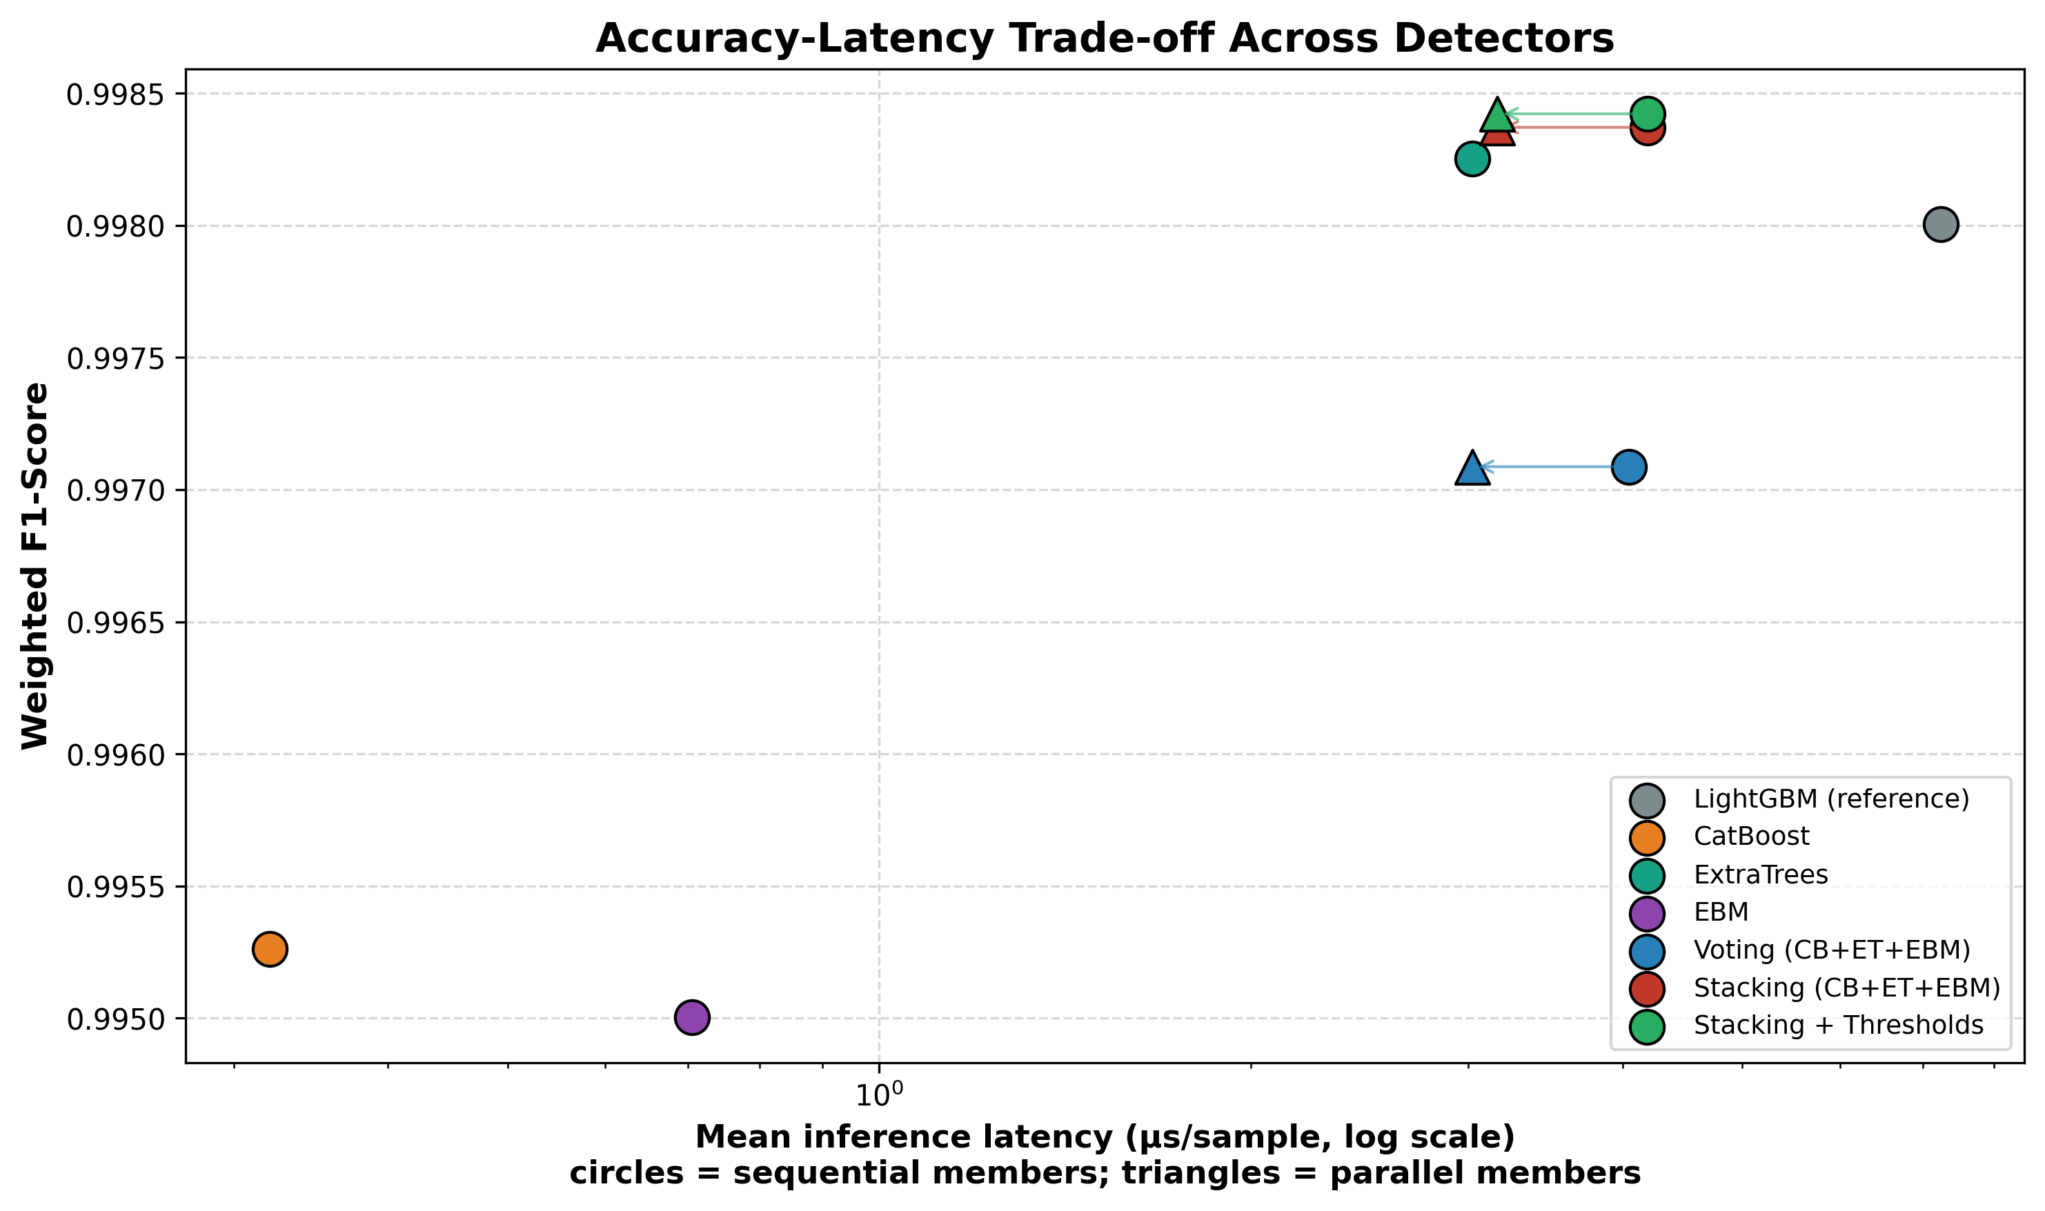
Figure 7. Accuracy–latency trade-off (log-scale latency); circles = sequential members, triangles = parallel execution.

4.7. Cross-Dataset Validation on UNSW-NB15
To establish that the findings are not artefacts of a single benchmark, the entire pipeline (feature ranking, capped leak-proof SMOTE, the three-paradigm stacked ensemble, threshold calibration, paired McNemar testing, and the SHAP-versus-EBM agreement study) was re-run natively (retrained and re-evaluated) on UNSW-NB15 [20]: 257,673 flows from the combined pool of the UNSW-NB15 training-set and testing-set CSV files, 42 features after categorical encoding, 10 classes, evaluated by the same 5-fold stratified CV protocol used for CICIDS-2017. This differs from the official UNSW-NB15 train/test split used in some published benchmarks; the protocol was chosen for consistency and variance stability rather than direct comparability to the state-of-the-art literature on UNSW. UNSW-NB15 is generated by a different feature-extraction toolchain (Argus and Bro/Zeek flow statistics) than CICIDS-2017's CICFlowMeter, so agreement across the two is evidence of generalisation across feature-extractor families, not just across traffic samples. The feature-count ablation independently selected K=30 on UNSW-NB15 (Figure U1; K=25 was selected on CICIDS-2017), and all model hyperparameters were held identical to the CICIDS-2017 configuration (Table A).
Model | Accuracy | F1 (weighted) | F1 (macro) | MCC | Lat. par (µs)
Baseline (linear) | 0.5479 | 0.6128 | 0.2891 | 0.4828 | 1.2066
LightGBM (reference) | 0.8024 | 0.8131 | 0.5766 | 0.7535 | 8.9348
CatBoost | 0.7770 | 0.7937 | 0.5385 | 0.7259 | 0.3093
ExtraTrees | 0.8106 | 0.8191 | 0.5760 | 0.7594 | 29.6815
EBM | 0.7720 | 0.7878 | 0.5306 | 0.7174 | 0.6145
Voting (CB+ET+EBM) | 0.7999 | 0.8114 | 0.5565 | 0.7502 | 29.6815
Stacking (CB+ET+EBM) | 0.8141 | 0.8206 | 0.5817 | 0.7618 | 29.7934
Stacking + Thresholds | 0.8174 | 0.8210 | 0.5840 | 0.7644 | 29.7934
Table 7. Five-fold cross-validated performance on UNSW-NB15, identical pipeline and hyperparameters to the CICIDS-2017 run. The central mechanism replicates: voting fails to beat the best base member, stacking succeeds.
The diversity-driven mechanism replicates cleanly, matching the CICIDS-2017 pattern exactly: soft voting (weighted F1 = 0.8114) fails to beat either its best base member, ExtraTrees (0.8191), or the LightGBM reference (0.8131), whereas stacking (0.8206) beats ExtraTrees (McNemar p = 1.689×10⁻²⁵; +1.8% relative error reduction, 18.939%→18.595% error) and the LightGBM reference (0.8131; p = 1.081×10⁻⁹⁷, +5.9% relative error reduction). The ExtraTrees effect size (1.8%) is smaller than on CICIDS-2017 (6.3%), a difference expected given the greater class overlap in UNSW-NB15; the directional claim is preserved on both benchmarks. Threshold calibration then raises accuracy to 0.8174 and macro-F1 to 0.584 (McNemar p = 2.928×10⁻¹⁹ versus raw stacking), again posting the best MCC of all configurations (0.7644). The absolute scores are lower than on CICIDS-2017, as expected: UNSW-NB15 is a deliberately harder benchmark whose Analysis, Backdoor, and DoS classes overlap heavily in feature space. The relative ordering of methods (baseline, EBM, CatBoost, voting, LightGBM, ExtraTrees, stacking) now matches CICIDS-2017 exactly; the architectural claim is benchmark-independent.
Threshold calibration's impact on the harder benchmark is uneven but, for at least one class, substantial. Where CICIDS-2017's well-separated classes left little room for decision-layer tuning, UNSW-NB15's overlapping classes still benefit from calibration, though unevenly across classes (Table 8): Analysis precision more than tripled, from 0.120 to 0.391, while its false-alarm rate fell by 83% (992.3 to 166.5 per 100,000 flows), at the cost of recall (0.131→0.103, roughly 351 to 276 true-positive detections out of 2,677). Backdoor improved on precision, recall, and F1 simultaneously (0.120→0.154, 0.115→0.139, 0.118→0.146, respectively), with a comparatively small 9.6% reduction in its false-alarm rate (759.5 to 686.9 per 100,000 flows); unlike Analysis, calibration does not force a precision-recall trade for this class. Worms and Shellcode show small, consistent improvements on both precision and false-alarm rate. Macro-F1 across all classes improved slightly (0.5817 → 0.5840), while balanced accuracy decreases (0.5860 → 0.5754), the acknowledged cost of Analysis's recall reduction. Whether the Analysis trade-off is operationally acceptable depends on the priority assigned to that attack class in the deployment context; the calibration thresholds are adjustable per operator preference, which is precisely the operational flexibility the leak-free calibration mechanism provides.
Class | Stage | Precision | Recall | F1 | False alarms / 100k
Worms | before | 0.443 | 0.425 | 0.434 | 36.1
Worms | after | 0.447 | 0.391 | 0.417 | 32.6
Shellcode | before | 0.568 | 0.635 | 0.600 | 282.5
Shellcode | after | 0.569 | 0.621 | 0.594 | 275.5
Backdoor | before | 0.120 | 0.115 | 0.118 | 759.5
Backdoor | after | 0.154 | 0.139 | 0.146 | 686.9
Analysis | before | 0.120 | 0.131 | 0.125 | 992.3
Analysis | after | 0.391 | 0.103 | 0.163 | 166.5
Table 8. UNSW-NB15 threshold calibration on the four rarest classes (auto-selected). Analysis shows a substantial false-alarm reduction at the cost of recall; Backdoor improves on precision, recall, and false-alarm rate simultaneously; Worms and Shellcode show small, consistent gains.
Explanation-consistency: partial replication. Under the same-sample protocol, Spearman ρ = 0.84 (p = 6.3×10⁻⁹) and Kendall τ = 0.632 on UNSW-NB15, stronger than CICIDS-2017 (ρ = 0.775). Top-5 feature agreement is 0.4 on both datasets (Table 9). However, top-10 feature agreement is somewhat lower on UNSW (0.8) than on CICIDS (0.9), and positional rank agreement, while weak on both benchmarks, is weaker on UNSW (top-5: 0.2, top-10: 0.1) than on CICIDS (top-5: 0.6, top-10: 0.3). The weaker rank metrics on UNSW reflect higher co-linearity among Argus/Zeek flow statistics: connection-count features (ct_src_dport_ltm, ct_dst_ltm, ct_srv_dst) and byte-count features (sbytes, smean) dominate EBM contributions more than SHAP attributions, and an additive GAM redistributes these across correlated main effects differently from Shapley values. The result is nuanced: global rank correlation is significant on both benchmarks, and stronger on UNSW, corroborating the SHAP explanations delivered to analysts; positional rank agreement transfers only weakly across feature-extractor families. Practitioners should apply SHAP-vs-glass-box consistency checks per deployment context.
Agreement metric | UNSW-NB15 | CICIDS-2017
Top-5 feature agreement | 0.40 | 0.60
Top-5 rank agreement | 0.20 | 0.60
Top-10 feature agreement | 0.80 | 0.90
Top-10 rank agreement | 0.10 | 0.30
Spearman ρ | 0.840 (p = 6.3×10⁻⁹) | 0.775 (p = 5.5×10⁻⁶)
Kendall τ | 0.632 (p = 1.23×10⁻⁷) | 0.620 (p = 3.57×10⁻⁶)
Table 9. UNSW-NB15 explanation-agreement metrics vs CICIDS-2017. ρ is stronger on UNSW; positional rank agreement transfers only weakly. Figures U1–U7 mirror the CICIDS-2017 panels for UNSW-NB15: ablation (U1), per-class F1 (U2), confusion matrix (U3), SHAP importance (U4), explanation agreement (U5), latency–Pareto (U6), and threshold calibration (U7). The EBM-importances panel (Figure 5b for CICIDS-2017) is omitted for UNSW-NB15.
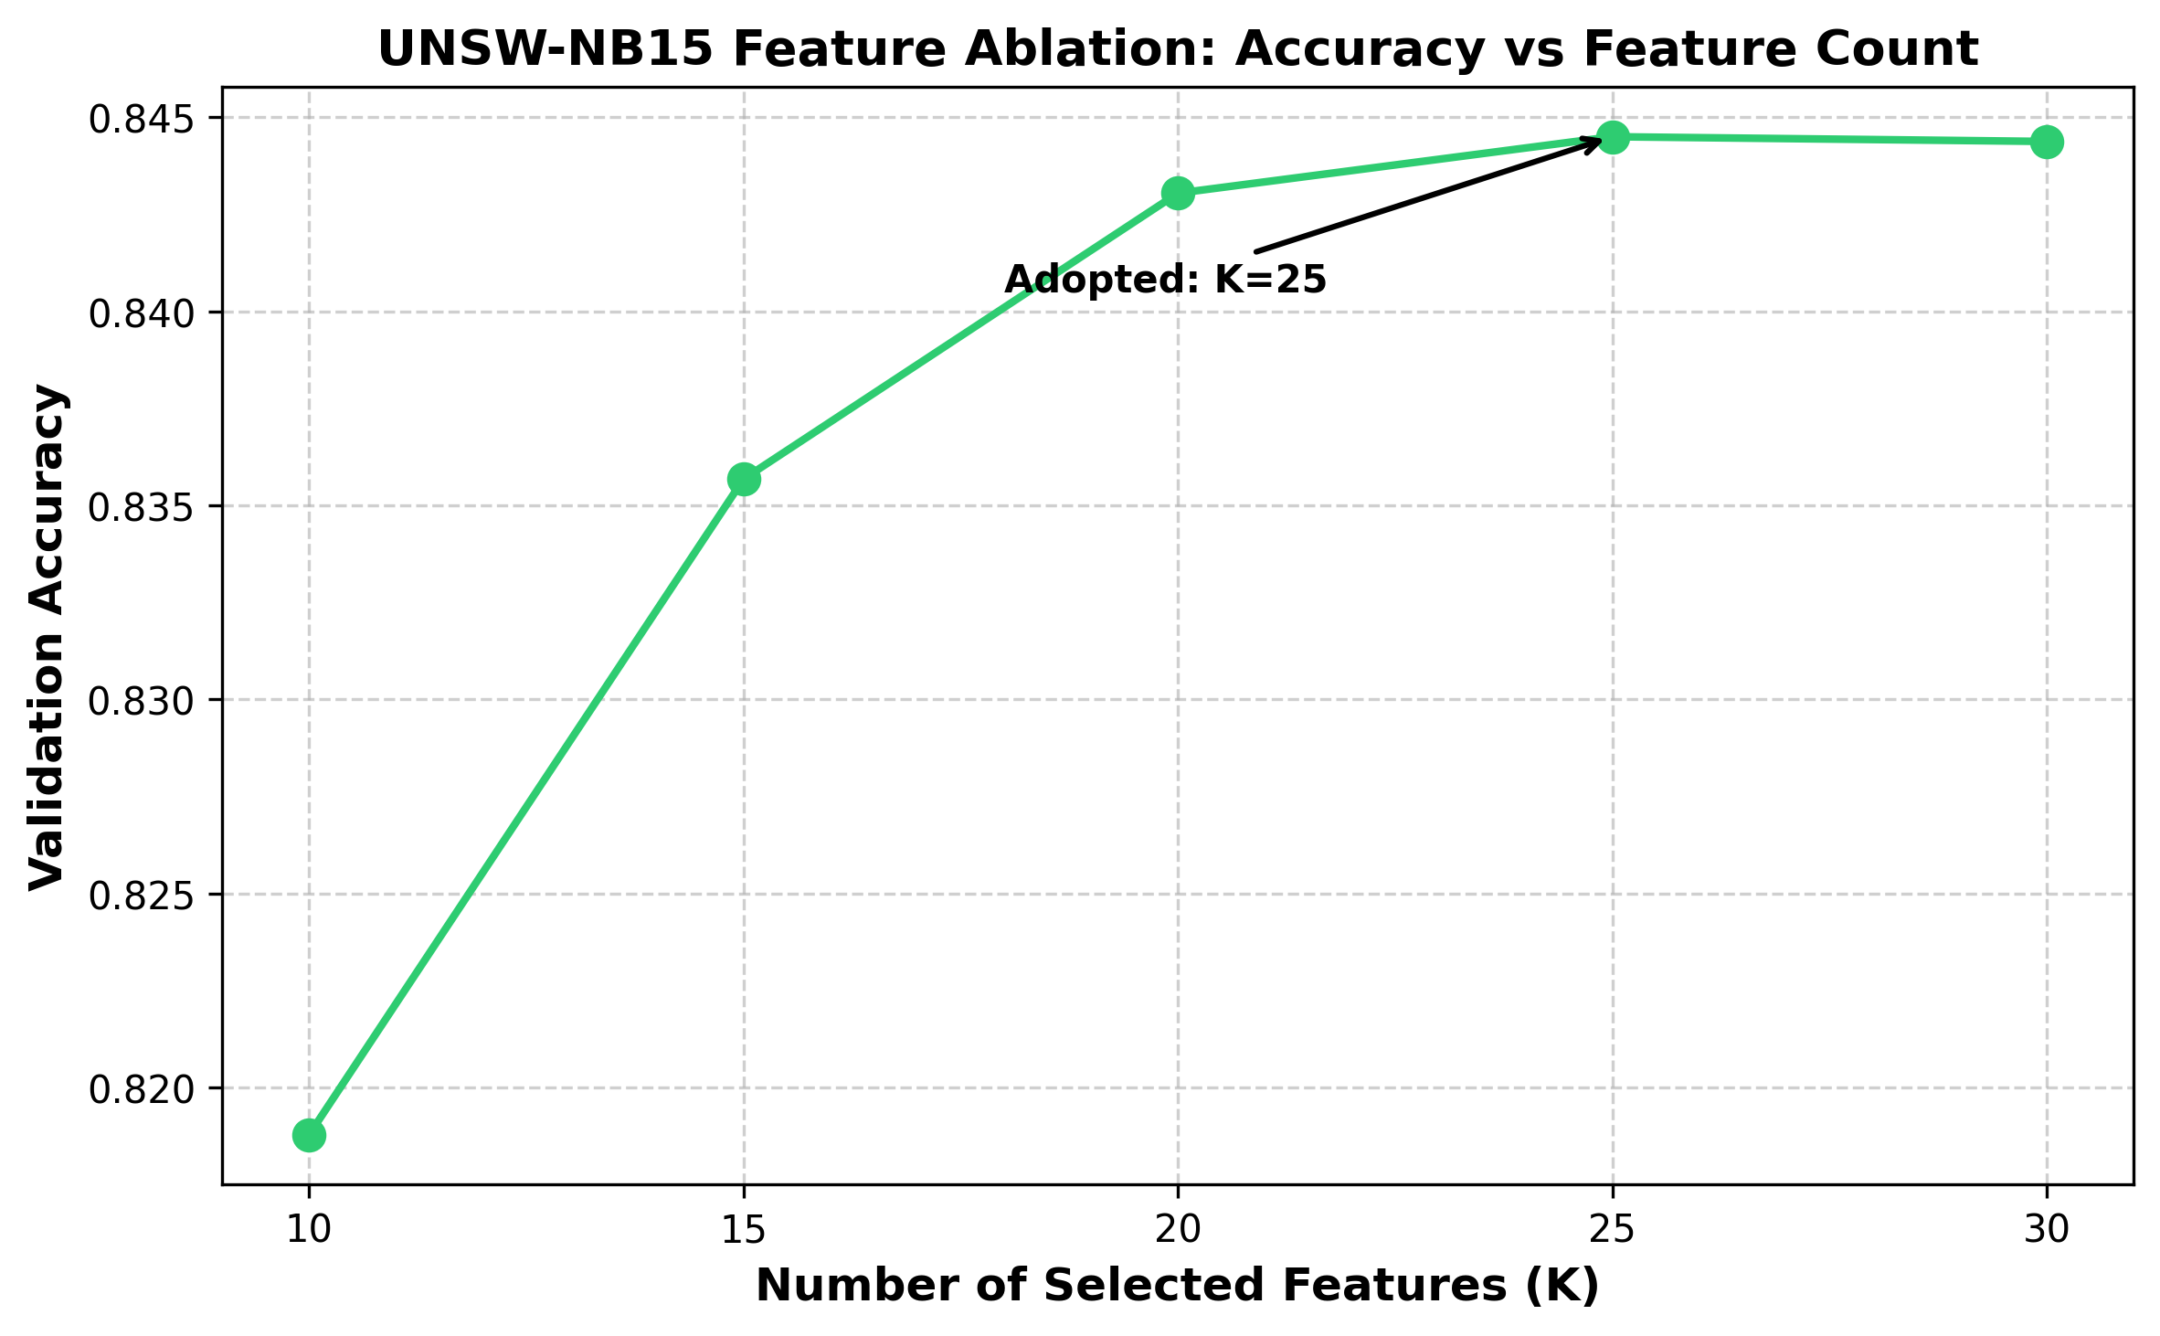
Figure U1. Feature-count ablation on UNSW-NB15.
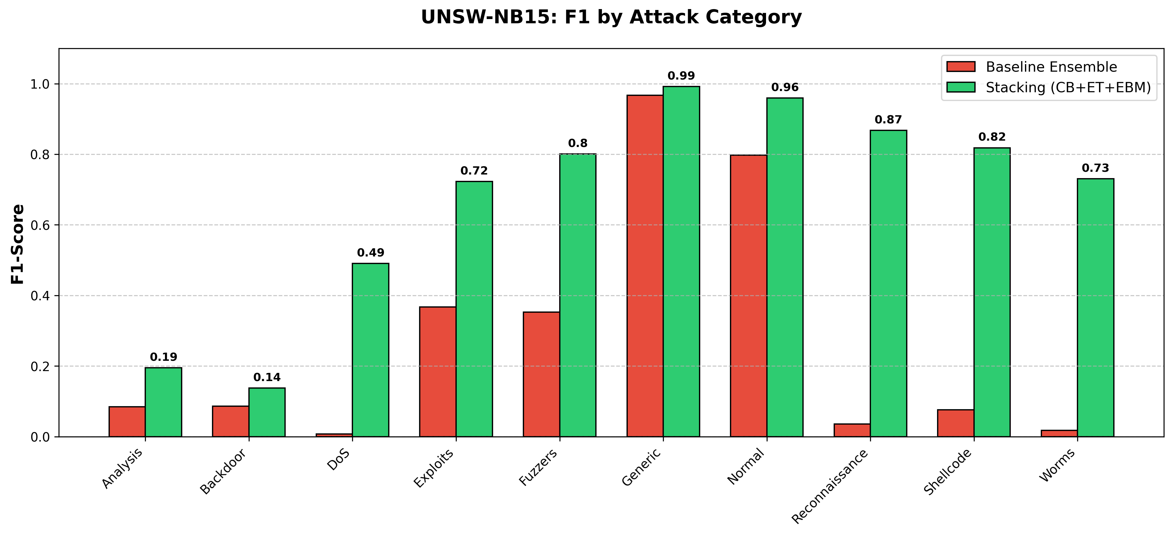
Figure U2. Per-class F1, baseline vs stacked ensemble (UNSW-NB15).
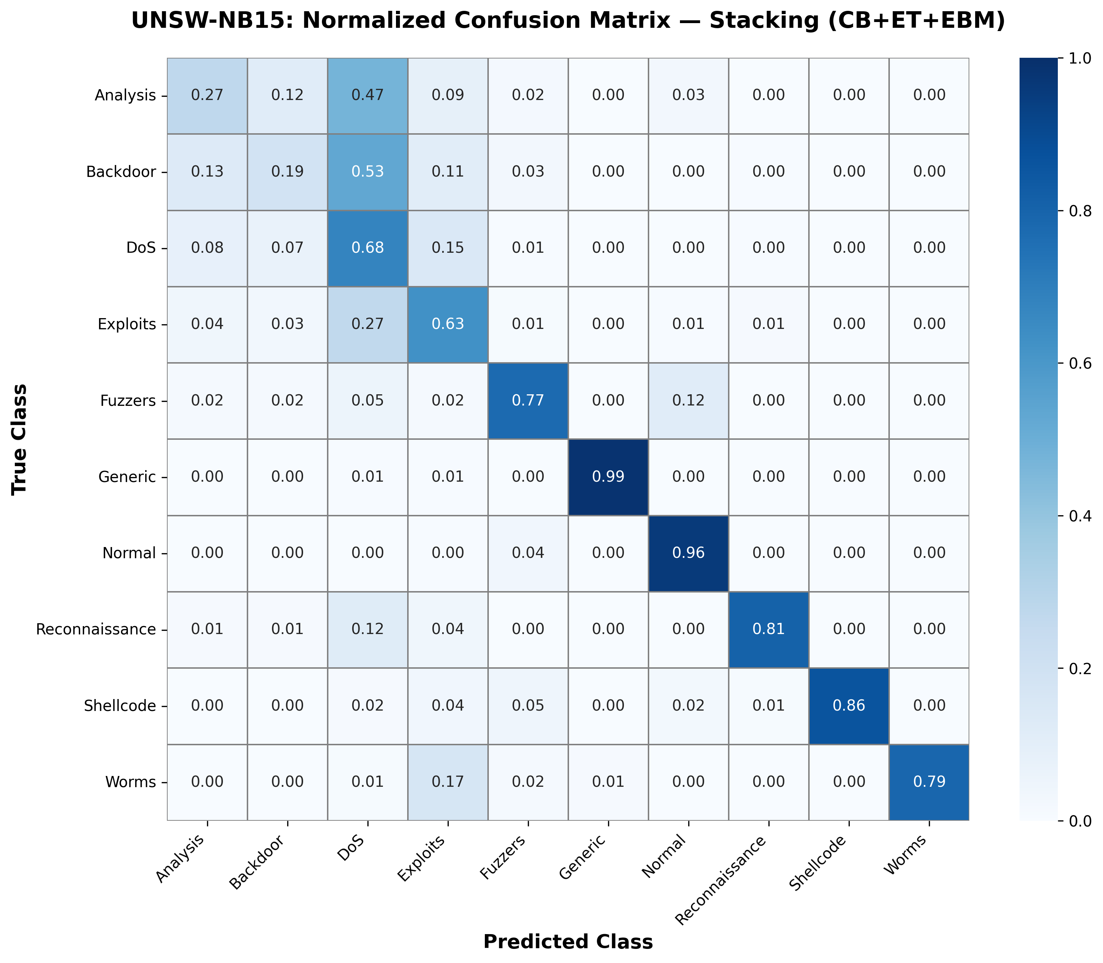
Figure U3. Normalised confusion matrix of the stacked ensemble (UNSW-NB15).
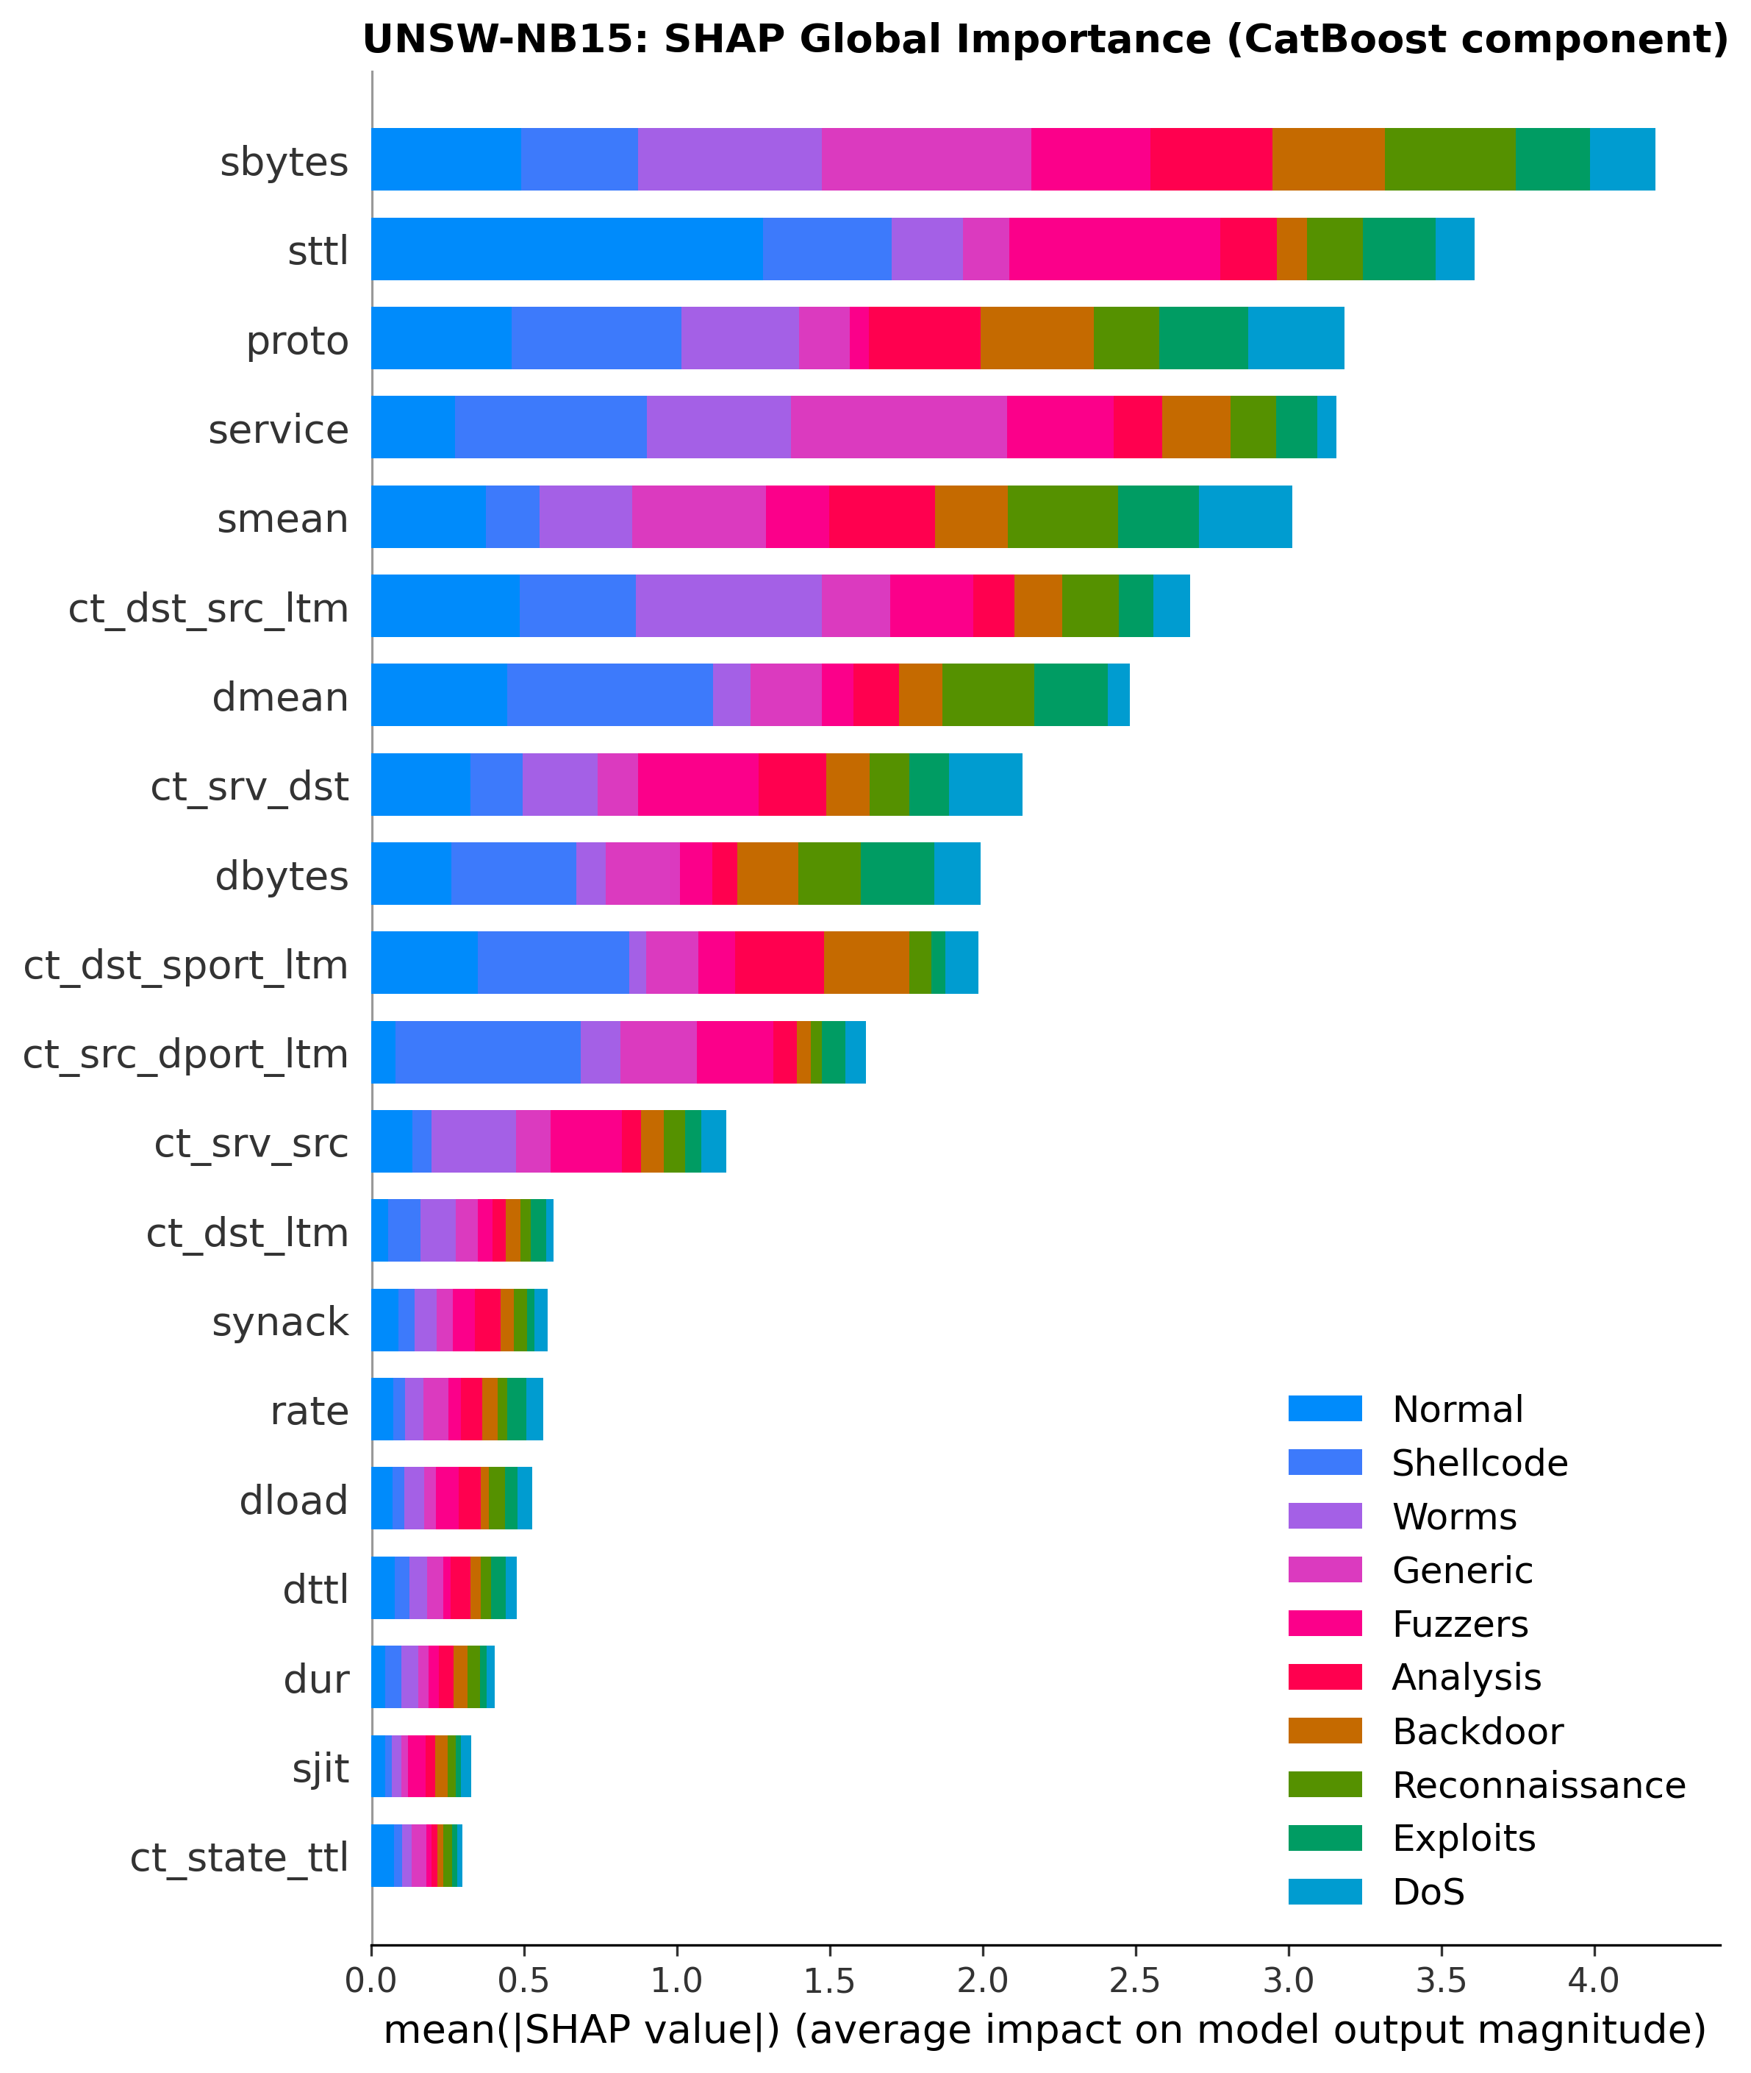
Figure U4. SHAP global feature importance, CatBoost component (UNSW-NB15).
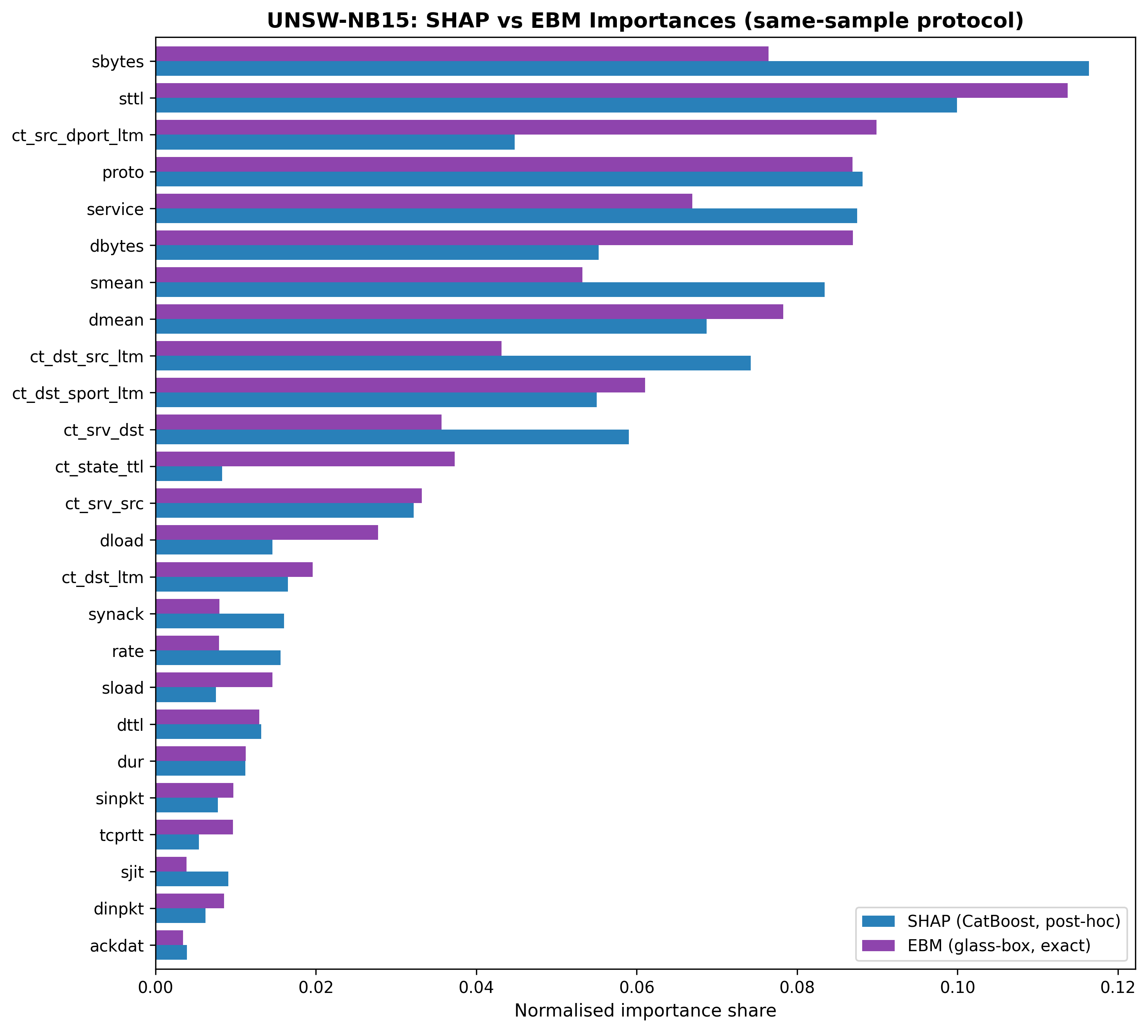
Figure U5. Normalised importance shares, SHAP vs EBM (UNSW-NB15).
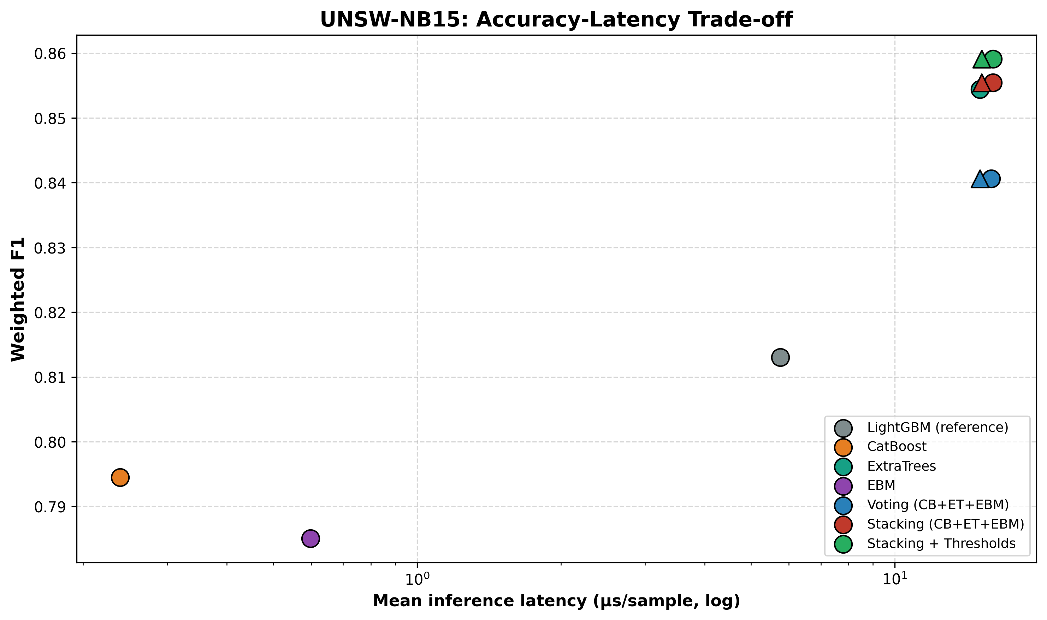
Figure U6. Accuracy–latency trade-off (UNSW-NB15).
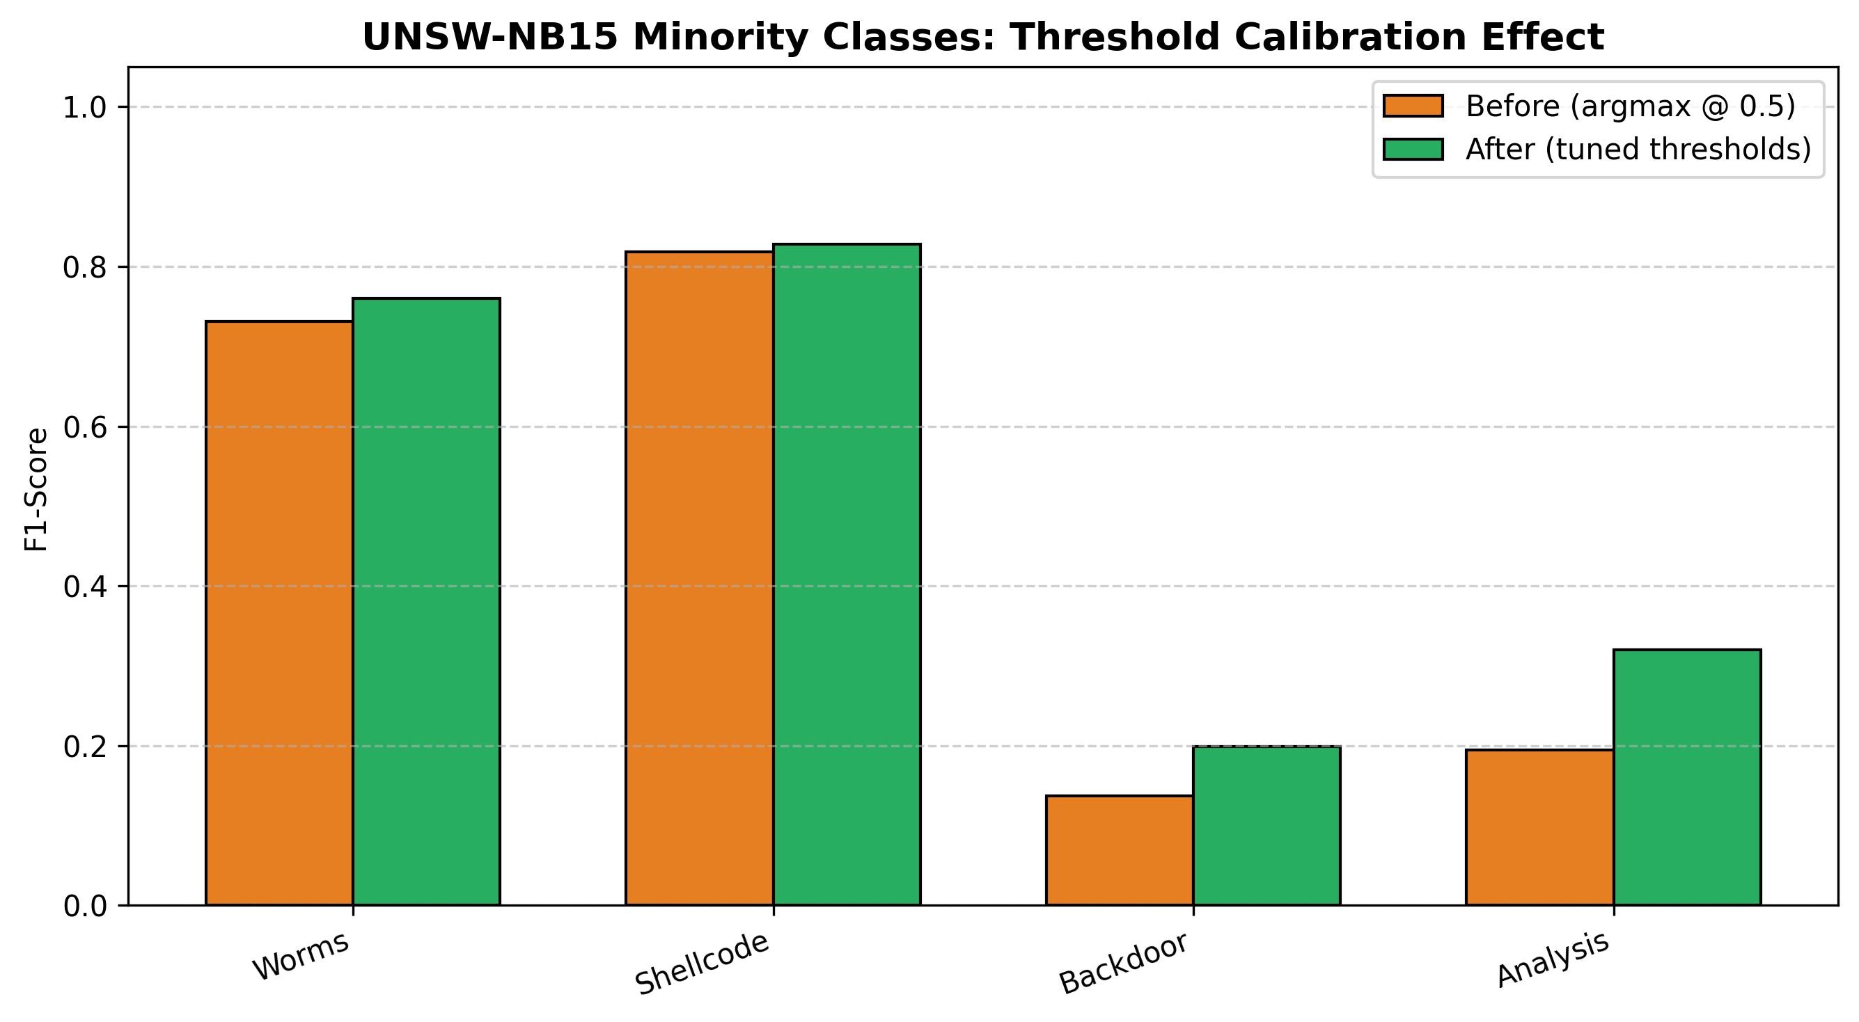
Figure U7. Minority-class F1 before/after threshold calibration (UNSW-NB15).

5. Limitations and Future Work
Cross-dataset transfer without retraining remains hard. Although both datasets were evaluated natively (Sections 4.1–4.6 on CICIDS-2017, Section 4.7 on UNSW-NB15), a model trained on one and applied to the other without retraining transfers poorly, because the two feature extractors are largely disjoint: CICIDS-2017's CICFlowMeter computes packet-length-variance and inter-arrival statistics that UNSW-NB15's toolchain does not, so transplanted models receive zero-filled inputs for their most informative features. Robust transfer in NIDS remains bottlenecked by the absence of a standardised feature extractor; the present work addresses generalisation by native retraining and by demonstrating that the architecture and its explanation-consistency property hold on both benchmarks, rather than by claiming zero-shot transfer.
Computational scope. CICIDS-2017 experiments use a 20% stratified sample (565,563 flows); stratification preserves the full class distribution, and at this scale the evaluation is well-powered for the reported tests. Both datasets cap EBM's per-fold training at 100,000 rows, a standard scalability measure whose effect is bounded given EBM's competitive standalone accuracy. Feature-selection leakage was tested directly with a control experiment. Although the hybrid Mutual-Information-plus-Random-Forest ranking in the main pipeline is computed once on the full data, we re-ran the entire stacked-ensemble evaluation with the ranking re-derived inside each fold on training data only, on the same fold partition. On UNSW-NB15 this left performance essentially unchanged (accuracy -0.0005, macro-F1 -0.0011; Wilcoxon paired test on accuracy, p = 0.062, not significant), with 100% of selected features shared across every fold, which confirms the global ranking confers no optimistic bias on that dataset. On CICIDS-2017 the result differs: in-fold FS yields accuracy 0.9970 vs 0.9983 (delta -0.001) and macro-F1 0.8625 vs 0.8982 (delta -0.036), with 85% feature overlap per fold. The accuracy gap is negligible; the macro-F1 gap reflects noisier within-fold MI estimation for the rarest attack classes, each contributing under 0.2% of per-fold training samples and producing less stable per-fold rankings than on UNSW-NB15. The reported macro-F1 of 0.8982 is therefore a slight overestimate; a conservative in-fold estimate is 0.8625. Residual minority weakness: on CICIDS-2017, XSS precision (0.34) reflects genuine statistical overlap with benign HTTPS traffic in flow space; on UNSW-NB15, the Analysis and Backdoor classes overlap similarly; both are boundaries of flow-based detection that only payload-aware (deep-packet-inspection) features could cross. Threshold transferability: tuned thresholds reflect each dataset's class prevalence and should be re-calibrated per deployment, which the leak-free calibration-slice procedure makes routine. Categorical encoding: UNSW-NB15's proto, service, and state fields were ordinally label-encoded for all members; one-hot or target encoding may shift their attributions. Future work: federated deployment of the glass-box-augmented stack [25]; adversarial robustness testing; and extending the agreement study to per-class and per-sample (local) explanation consistency.

6. Conclusion
Motivated by an empirical observation that a homogeneous voting ensemble (XGBoost, LightGBM, Random Forest) failed to outperform its own strongest member, this work converted that finding into an architecture: three structurally different learners (CatBoost, ExtraTrees, EBM) combined by stacked generalisation under a leak-proof, fully paired evaluation. The stacked ensemble reaches 99.83% accuracy (weighted F1 0.9984, MCC 0.9951; macro-F1 0.8625 under the leak-free, in-fold feature-ranking protocol we consider primary, with a global feature-ranking sensitivity analysis in Section 5 yielding 0.8982 and no effect on any comparative conclusion or the stacking advantage), significantly outperforming its best base member and a strong LightGBM reference (28.1% relative error reduction), where soft voting fails both tests. Embedding the glass-box EBM as a deployed base learner enabled one of the first explanation-consistency validations in NIDS between exact and post-hoc attributions, with Spearman ρ = 0.775 (CICIDS-2017) and 0.84 (UNSW-NB15), both significant at p < 10⁻⁵, corroborating the system’s SHAP explanations against exact model-internal attributions. Top-10 feature agreement is 0.9 on CICIDS-2017 and 0.8 on UNSW-NB15; positional rank agreement remains weak on both benchmarks and weaker still on UNSW, a boundary condition attributable to higher co-linearity in Argus/Zeek statistics (Section 4.7). Inter-arrival-time features were shown to be the binding constraint on web-attack detection (worth 4–5× in minority F1, more than any resampling strategy), and real-prevalence threshold calibration gives operators an inspectable false-alarm dial with a statistically significant net accuracy benefit. At 3.17 µs parallel inference on CICIDS-2017 (29.79 µs on UNSW-NB15, assuming parallel base-learner execution), the system meets real-time requirements on commodity hardware. Critically, the diversity-driven mechanism, the stacking advantage, the threshold-calibration benefit, and the explanation-consistency result all replicate under native retraining on UNSW-NB15, a benchmark built by a different feature-extraction toolchain, with SHAP–EBM agreement strengthening to ρ = 0.84, providing evidence that the proposed architecture generalises across two benchmark datasets generated by different feature-extraction toolchains, rather than being an artefact of one benchmark. Together these results argue that trustworthy network intrusion detection is achieved not by attaching explanations to an accurate black box, but by building ensembles whose accuracy and explainability are validated by the same architecture.

Declarations
CRediT author statement. Author name withheld for double-blind review: Conceptualization, Methodology, Software, Validation, Formal analysis, Investigation, Data Curation, Writing – Original Draft, Writing – Review and Editing, Visualization.
Competing interests. The author declares no known competing financial interests or personal relationships that could have influenced this work.
Funding. This research received no external funding.
Data availability. CICIDS-2017 is publicly available from the Canadian Institute for Cybersecurity at https://www.unb.ca/cic/datasets/ids-2017.html. UNSW-NB15 is publicly available from the University of New South Wales at https://research.unsw.edu.au/projects/unsw-nb15-dataset. No new datasets were created by this study.
Code availability. The code and evaluation scripts will be made publicly available upon acceptance. Repository URL withheld for double-blind review.
Artificial intelligence tools. The author used AI-assisted tools for language editing during manuscript preparation. The author takes full responsibility for all scientific content, data integrity, and conclusions.

References
[1] Al-Omari, M., Al-Haija, Q. A., 2024. Towards robust IDSs: An integrated approach of hybrid feature selection and machine learning. Journal of Internet Services and Information Security, 14(1). https://doi.org/10.58346/JISIS.2024.I2.004
[2] Arreche, O., Bibers, I., Abdallah, M., 2024. A two-level ensemble learning framework for enhancing network intrusion detection systems. IEEE Access, 12, 83830–83857. https://doi.org/10.1109/ACCESS.2024.3407029
[3] Arreche, O., Guntur, T., Abdallah, M., 2024. XAI-IDS: Toward proposing an explainable artificial intelligence framework for enhancing network intrusion detection systems. Applied Sciences, 14(10), 4170. https://doi.org/10.3390/app14104170
[4] Breiman, L., 2001. Random forests. Machine Learning, 45(1), 5–32. https://doi.org/10.1023/A:1010933404324
[5] Buda, M., Maki, A., Mazurowski, M. A., 2018. A systematic study of the class imbalance problem in convolutional neural networks. Neural Networks, 106, 249–259. https://doi.org/10.1016/j.neunet.2018.07.011
[6] Chawla, N. V., Bowyer, K. W., Hall, L. O., Kegelmeyer, W. P., 2002. SMOTE: Synthetic minority over-sampling technique. Journal of Artificial Intelligence Research, 16, 321–357. https://doi.org/10.1613/jair.953
[7] Chen, T., Guestrin, C., 2016. XGBoost: A scalable tree boosting system. Proceedings of the 22nd ACM SIGKDD International Conference on Knowledge Discovery and Data Mining, 785–794. https://doi.org/10.1145/2939672.2939785
[8] Elkan, C., 2001. The foundations of cost-sensitive learning. Proceedings of the 17th International Joint Conference on Artificial Intelligence (IJCAI), 973–978.
[9] Fitni, Q. R. S., Ramli, K., 2020. Implementation of ensemble learning and feature selection for performance improvements in anomaly-based intrusion detection systems. 2020 IEEE International Conference on Industry 4.0, Artificial Intelligence, and Communications Technology (IAICT), 118–124. https://doi.org/10.1109/IAICT50021.2020.9172014
[10] Friedman, J. H., 2001. Greedy function approximation: A gradient boosting machine. The Annals of Statistics, 29(5), 1189–1232. https://doi.org/10.1214/aos/1013203451
[11] Geurts, P., Ernst, D., Wehenkel, L., 2006. Extremely randomized trees. Machine Learning, 63(1), 3–42. https://doi.org/10.1007/s10994-006-6226-1
[12] Hartl, A., Fabini, J., Zseby, T., 2020. Explainability of machine learning models for network intrusion detection. 2020 IFIP Networking Conference, 1–9.
[13] He, H., Bai, Y., Garcia, E. A., Li, S., 2008. ADASYN: Adaptive synthetic sampling approach for imbalanced learning. 2008 IEEE International Joint Conference on Neural Networks (IJCNN), 1322–1328. https://doi.org/10.1109/IJCNN.2008.4633969
[14] He, H., Garcia, E. A., 2009. Learning from imbalanced data. IEEE Transactions on Knowledge and Data Engineering, 21(9), 1263–1284. https://doi.org/10.1109/TKDE.2008.239
[15] Ke, G., Meng, Q., Finley, T., Wang, T., Chen, W., Ma, W., Ye, Q., Liu, T.-Y., 2017. LightGBM: A highly efficient gradient boosting decision tree. Advances in Neural Information Processing Systems, 30, 3149–3157.
[16] Krishna, S., Han, T., Gu, A., Pombra, J., Jabbari, S., Wu, Z. S., Lakkaraju, H., 2022. The disagreement problem in explainable machine learning: A practitioner&amp;#x2019;s perspective. arXiv:2202.01602. https://doi.org/10.48550/arXiv.2202.01602
[17] Lou, Y., Caruana, R., Gehrke, J., Hooker, G., 2013. Accurate intelligible models with pairwise interactions. Proceedings of the 19th ACM SIGKDD International Conference on Knowledge Discovery and Data Mining, 623–631. https://doi.org/10.1145/2487575.2487579
[18] Lemaître, G., Nogueira, F., Aridas, C. K., 2017. Imbalanced-learn: A Python toolbox to tackle the curse of imbalanced datasets in machine learning. Journal of Machine Learning Research, 18(17), 1–5.
[19] Lundberg, S. M., Lee, S.-I., 2017. A unified approach to interpreting model predictions. Advances in Neural Information Processing Systems, 30, 4765–4774.
[20] Moustafa, N., Slay, J., 2015. UNSW-NB15: A comprehensive data set for network intrusion detection systems (UNSW-NB15 network data set). 2015 Military Communications and Information Systems Conference (MilCIS), 1–6. https://doi.org/10.1109/MilCIS.2015.7348942
[21] Neto, E. C. P., Dadkhah, S., Ferreira, R., Zohourian, A., Lu, R., Ghorbani, A. A., 2023. CICIoT2023: A real-time dataset and benchmark for large-scale attacks in IoT environment. Sensors, 23(13), 5941. https://doi.org/10.3390/s23135941
[22] Nori, H., Jenkins, S., Koch, P., Caruana, R., 2019. InterpretML: A unified framework for machine learning interpretability. arXiv:1909.09223. https://doi.org/10.48550/arXiv.1909.09223
[23] Pedregosa, F., Varoquaux, G., Gramfort, A., Michel, V., Thirion, B., Grisel, O., Blondel, M., Prettenhofer, P., Weiss, R., Dubourg, V., Vanderplas, J., Passos, A., Cournapeau, D., Brucher, M., Perrot, M., Duchesnay, É, 2011. Scikit-learn: Machine learning in Python. Journal of Machine Learning Research, 12, 2825–2830.
[24] Prokhorenkova, L., Gusev, G., Vorobev, A., Dorogush, A. V., Gulin, A., 2018. CatBoost: Unbiased boosting with categorical features. Advances in Neural Information Processing Systems, 31, 6639–6649.
[25] Rey, V., Sánchez Sánchez, P. M., Huertas Celdrán, A., Bovet, G., 2022. Federated learning for malware detection in IoT devices. Computer Networks, 204, 108693. https://doi.org/10.1016/j.comnet.2021.108693
[26] Sharafaldin, I., Lashkari, A. H., Ghorbani, A. A., 2018. Toward generating a new intrusion detection dataset and intrusion traffic characterization. Proceedings of the 4th International Conference on Information Systems Security and Privacy (ICISSP), 108–116. https://doi.org/10.5220/0006639801080116
[27] Wazid, M., Singh, J., Das, A. K., Rodrigues, J. J. P. C., 2024. An ensemble-based machine learning-envisioned intrusion detection in Industry 5.0-driven healthcare applications. IEEE Transactions on Consumer Electronics, 70(1), 1903–1912. https://doi.org/10.1109/TCE.2023.3325209
[28] Wolpert, D. H., 1992. Stacked generalization. Neural Networks, 5(2), 241–259. https://doi.org/10.1016/S0893-6080(05)80023-1

