Does Cross-Model Explanation Agreement Signal Trustworthy Intrusion Detection? A Rigorous Empirical Test Using an Embedded Glass-Box Reference
Khandaker Saifuzzaman
School of Physics, Engineering and Computer Science, University of Hertfordshire, Hatfield, United Kingdom
Corresponding author: Khandaker Saifuzzaman (kh.saif17@gmail.com)
ORCID: 0000-0001-6456-3652

Abstract
Security operations centres increasingly receive not only alerts from machine-learning intrusion detection systems but also explanations for them, produced by post-hoc methods such as SHAP. A natural but largely untested assumption in this literature is that when two independent explainers agree, that agreement signals a trustworthy prediction; existing consistency checks compare two post-hoc approximations, whose agreement cannot rule out a shared approximation artefact. We test this assumption directly by embedding a glass-box model, the Explainable Boosting Machine (EBM), whose feature attributions are exact by construction, as a base learner inside a heterogeneous stacked ensemble (CatBoost, ExtraTrees, EBM) trained on CICIDS-2017 (99.83% accuracy, 0.9984 weighted F1, exceeding a LightGBM reference by 28.1% relative error reduction) and replicated natively on UNSW-NB15. Using the resulting embedded exact reference, we test whether SHAP-versus-EBM attribution divergence functions as a deployable trust signal, benchmarked against a paired-DeLong-tested confidence baseline across two scenarios: per-alert error prediction and detection of genuinely novel, never-trained attack classes. It largely does not. Divergence underperforms confidence in the majority of tested conditions, its relationship to error reverses sign between datasets, and a positive result on one held-out attack class (PortScan, AUROC 0.774) fails to replicate across three others (AUROC 0.19–0.32). We further show, via independent model refits, that single-point explanation-agreement estimates carry meaningful refit-to-refit variability that standard bootstrap confidence intervals do not capture, and that CICIDS-2017’s day-siloed attack structure structurally precludes a naive temporal train/test split, a limitation not previously documented for this widely-used benchmark. We report these as rigorously-tested findings that correct an unverified assumption underlying a growing body of explainable-NIDS work, rather than as a positive capability claim.

Keywords: Explanation Consistency, Explainable AI, Explainable Boosting Machine, Stacked Generalisation, Network Intrusion Detection, Security Operations.

1. Introduction
As network infrastructures evolve toward Industry 5.0 and the Internet of Things, the attack surface available to malicious actors continues to expand. Signature-based intrusion detection is increasingly inadequate against attacks (distributed denial-of-service campaigns, brute-force credential attacks, and encrypted web exploits) that are progressively harder to distinguish from benign traffic, and machine learning has become the primary defensive mechanism. In operational deployments the model’s output is consumed twice over: a security operations centre (SOC) acts on the alert, and increasingly also on an explanation of it, which steers triage, escalation, and response. Post-hoc explainers such as SHAP are now routinely attached to NIDS for this purpose, but their attributions are approximations, and recent surveys note that almost no NIDS work attempts any consistency check on them (Neupane et al. 2022; Mohale and Obagbuwa 2025). Where checks do exist, they compare two post-hoc approximations against each other — and agreement between two approximations cannot rule out a shared approximation artefact, only a shared reference that is exact by construction can. This raises a question that, to our knowledge, has been assumed rather than tested anywhere in this literature: does agreement between a post-hoc explainer and an exact reference actually predict anything an operator cares about — that a prediction is correct, or that an alert deserves scrutiny — or does it merely look reassuring without being actionable?
Answering this question requires an exact reference that costs nothing extra to obtain. We build one by embedding a glass-box model, the Explainable Boosting Machine (EBM), whose feature attributions follow analytically from its structure, as a base learner inside a heterogeneous stacked ensemble alongside CatBoost and ExtraTrees. This is an engineering decision, not a new learning algorithm, and it has a second benefit independent of the explanation question: the three learning paradigms’ diversity restores genuine ensemble gains where a homogeneous soft-voted XGBoost, LightGBM, and Random Forest ensemble fails to beat standalone LightGBM (Section 4.1) — a second, separate weakness in the field’s dominant ensembling recipe that we document alongside the main test.
With the exact reference in hand, we test the trust-signal assumption directly, using a confidence baseline and proper statistical comparison (paired DeLong tests, cross-validated incremental discrimination, bootstrap confidence intervals) across two realistic scenarios a SOC actually faces: is this alert likely to be a misclassification, and is this flow from an attack type the detector has never seen. We test both across four independently held-out attack classes and replicate on a second benchmark (UNSW-NB15), a scale of validation not found elsewhere in this specific literature per our own survey in Section 2.1. The result is not the positive capability claim such a framework invites: cross-model attribution divergence underperforms the detector’s own confidence score in the majority of tested conditions, and its relationship to error and to novelty reverses sign between the two scenarios, between held-out classes, and between datasets. Two further findings surfaced during this test, independent of it: CICIDS-2017’s attack types are confined one-per-day (Section 5), which structurally precludes a temporal train/test split regardless of which day boundary is chosen; and a single explanation-agreement point estimate is measurably more sensitive to model-refit variability than the same architecture’s classification-performance metrics are (Section 4.5).
Contributions. (i) The first rigorous empirical test, to our knowledge, of whether cross-model explanation agreement — measured against an exact, deployed, glass-box reference rather than a second post-hoc approximation — functions as an operational trust signal, evaluated with a paired confidence baseline, DeLong-tested AUROC comparisons, cross-validated incremental discrimination, and bootstrap confidence intervals (Sections 4.5.3–4.5.4); (ii) a four-class, two-dataset replication design showing the result is not stable across held-out attack types or benchmarks, itself evidence against treating explanation-consistency as a general-purpose deployable property (Sections 4.5.3–4.5.4); (iii) the engineering enabler: a NIDS architecture embedding an exact glass-box model as a base learner inside a heterogeneous stacked ensemble, making the reference a deployed, load-bearing component rather than an offline surrogate, at no additional inference cost (Section 3.4); (iv) an independent demonstration that a homogeneous boosted voting ensemble fails to beat its best member on CICIDS-2017, while paradigm diversity combined by stacking restores genuine ensemble gains (Sections 3.4.1 and 4.1); (v) a documented structural limitation of CICIDS-2017 — every attack type occurs on exactly one collection day, precluding naive temporal-split evaluation — and a documented refit-sensitivity property of single-point explanation-agreement estimates, both of direct relevance to future work using this benchmark or this class of metric (Sections 4.5 and 5); (vi) an operational deployment layer independent of the explanation-signal question: SOC-aware per-class threshold calibration tuned leak-free on real-prevalence data, at microsecond-scale parallel inference (Sections 3.5, 4.4, and 4.6); and (vii) an evaluation protocol in which every model comparison shares identical folds and base fits, making all McNemar tests properly paired, the statistical foundation the above contributions rest on.

2. Related Work
Ensemble learning in NIDS. Ensemble methods consistently outperform single classical models on flow-based benchmarks, as surveyed by Ahmad et al. (2021) across both classical and deep learning approaches. Deep learning methods such as recurrent neural networks (Yin et al. 2017) and ensembles of autoencoders (Mirsky et al. 2018) have demonstrated strong detection rates but offer limited interpretability. Fitni and Ramli (2020) improved detection with a majority-voting ensemble of heterogeneous classifiers and highlighted the data-leakage risk of resampling before cross-validation. The computational load of high-dimensional traffic is addressed by hybrid feature selection, as shown by Al-Omari and Al-Haija (2024) and Arreche et al. (2024a), who combined boosting with bagging in a two-level framework. The boosted-tree learners that dominate this literature share a common lineage in gradient boosting (Friedman 2001) and its scalable modern implementations, XGBoost (Chen and Guestrin 2016) and LightGBM (Ke et al. 2017), alongside the bagging-based Random Forest (Breiman 2001) and its extremely randomised variant (Geurts et al. 2006). CatBoost (Prokhorenkova et al. 2018) adds ordered boosting on symmetric trees, a structurally distinct scheme we exploit for diversity. Stacked generalisation (Wolpert 1992) appears in recent NIDS work, but its base learners are almost always drawn from the same family of gradient-boosted trees, leaving error correlation (the property that determines whether an ensemble can outperform its members) unexamined, despite classical ensemble theory tying combination gains directly to member error diversity (Kuncheva and Whitaker 2003; Dietterich 2000).
Class imbalance in intrusion detection. NIDS datasets are severely skewed toward benign traffic, and the treatment of imbalance materially affects minority-attack detection. Synthetic oversampling (SMOTE; Chawla et al. 2002) and its adaptive variant (ADASYN; He et al. 2008) are the field's default remedies, surveyed comprehensively by him and Garcia (2009). Buda et al. (2018) showed across deep and classical models that oversampling and decision-threshold adjustment are the most reliable interventions, while the cost-sensitive perspective (Elkan 2001) reframes the problem at the decision layer rather than the data layer. We adopt both views: leak-proof capped oversampling during training and per-class threshold calibration at inference, the latter tuned on real-prevalence data to avoid the distortion that resampling introduces into probability estimates.
Glass-box models. The Explainable Boosting Machine (Lou et al. 2013; Nori et al. 2019; Lou et al. 2012) is a cyclic-boosted generalised additive model whose prediction is a sum of per-feature shape functions, so its global and local attributions are exact rather than approximated, a property that has motivated its deployment in other high-stakes domains (Caruana et al. 2015). The case for using inherently interpretable models rather than attaching post-hoc explanations to black boxes has been argued forcefully by Rudin (2019). EBM has appeared in intrusion detection only as a standalone classifier; to our knowledge no prior NIDS work deploys it as a base learner inside a heterogeneous ensemble, where its exactness can be exploited at no extra cost.
Explainability and the disagreement problem. SHAP (Lundberg and Lee 2017) dominates NIDS explainability (Arreche et al. 2024b; Hartl et al. 2020; Wazid et al. 2024), but its attributions are post-hoc approximations. Krishna et al. (2022) formalised the disagreement problem: different explainers routinely disagree, and proposed agreement metrics (top-k feature, rank, and sign agreement) that we adopt. End-to-end XAI-IDS frameworks (Arreche et al. 2024b) benchmark multiple post-hoc explainers, and recent work identifies cross-explanation consistency checking as an open gap, noting that the rare existing consistency checks compare two post-hoc methods (SHAP vs LIME; Ribeiro et al. 2016), whose mutual agreement cannot rule out a shared approximation artefact. Comparing a post-hoc explainer against an exact glass-box member of the same deployed ensemble, as done here, removes the approximation uncertainty from one side of the comparison; it cannot, however, exclude data-level artefacts that shape both models (Section 4.5).
Benchmarks and cross-dataset generalisation. Detection results are benchmark-sensitive. CICIDS-2017 (Sharafaldin et al. 2018), generated with CICFlowMeter (Draper-Gil et al. 2016), remains the most-used flow benchmark, though documented labelling imperfections in it counsel caution when interpreting per-class results (Engelen et al. 2021), while UNSW-NB15 (Moustafa and Slay 2015), built with a different Argus/Bro toolchain, and the recent CIC-IoT-2023 (Neto et al. 2023) provide complementary distributions. Because feature sets differ across extractors, models rarely transfer zero-shot (D'hooge et al. 2020), and single-benchmark evaluations risk reporting extractor-specific artefacts; native multi-dataset validation, adopted here, is the more credible test of generalisation. Federated and IoT-oriented deployments (Rey et al. 2022; Wazid et al. 2024) further motivate detectors that are both accurate and interpretable on heterogeneous traffic.

2.1. Recent Explainable IDS Work (2024–2026)
Explainability has moved to the centre of the NIDS literature in the last three years, and the pattern across recent systems sharpens the gap this paper addresses. Wang et al. (2020) established the dominant template: a black-box detector with SHAP attached, explanation quality argued by plausibility. Recent work refines that template without changing its trust structure. Wali et al. (2025) pair a Random Forest detector with post-hoc attributions used to flag unreliable inputs under adversarial conditions; AL-Nomasy et al. (2025) distil a transformer teacher into a lightweight student for IoT deployment and attach an explainability layer for analyst transparency; Gao et al. (2025) apply causal feature selection and explanation-guided model optimisation, so explanations steer training rather than being audited at inference; and Cerasuolo et al. (2025) bring explainability to incremental model updates on IoT traffic. In each case the explanation delivered to the operator remains a single post-hoc approximation whose fidelity is asserted rather than measured.
Evaluation-oriented work goes one step further. Arreche et al. (2024c) benchmark SHAP and LIME for network intrusion detection across six criteria (descriptive accuracy, sparsity, stability, efficiency, robustness, and completeness), and Warnecke et al. (2020) evaluate explanation methods for security applications under fidelity and robustness criteria. In both, however, the reference for judging an explanation is either the black box’s behaviour under perturbation or another approximate explainer; no attribution that is exact by construction is available anywhere in the pipeline. Surveys of explainable intrusion detection (Neupane et al. 2022; Mohale and Obagbuwa 2025) accordingly list validation of explanations among the field’s open problems: analysts are asked to act on attributions that nothing in the deployed system can corroborate. Table 1 situates the present work in this landscape. To our knowledge, no prior NIDS embeds an exact glass-box reference inside the deployed detector and audits the post-hoc explanations it serves against that reference with formal agreement metrics.

Work | Detector | Explanations | Explanation check | Focus
Wang et al. (2020) | Single black-box classifier | SHAP (post-hoc) | None | Analyst insight
Warnecke et al. (2020) | Deep models (security tasks) | Gradient and perturbation methods (post-hoc) | Fidelity and robustness criteria; no exact reference | Explainer evaluation
Arreche et al. (2024c) | Seven black-box models | SHAP and LIME (post-hoc) | Six perturbation-based criteria; explainer vs explainer | Explainer benchmarking
Wali et al. (2025) | Random Forest | Post-hoc attributions | Explanations flag adversarial inputs; explainer itself unchecked | Adversarial reliability
AL-Nomasy et al. (2025) | Knowledge-distilled transformer | Explainability layer (post-hoc) | None | Lightweight IoT deployment
Gao et al. (2025) | Detector with causal feature selection | Explanation-guided optimisation | Explanations steer training; not audited at inference | Robust detection
Cerasuolo et al. (2025) | Incremental deep models | Post-hoc attributions | None | IoT model updates
This work | Heterogeneous stack (CatBoost, ExtraTrees, EBM) | SHAP (post-hoc) and exact EBM terms | Post-hoc audited against embedded exact reference with formal agreement metrics | SOC deployment: consistency, thresholds, latency
Table 1. Positioning against recent explainable NIDS work. Post-hoc attributions are approximations computed on a trained model; exact attributions follow analytically from the model structure (Eq. 5).

2.2. Gap Analysis
To the best of our knowledge, no prior NIDS work (a) embeds an exact glass-box model as a stacked base learner at no additional inference cost, or (b) tests — rather than asserts — whether agreement between a post-hoc explainer and an exact reference predicts anything an operator would act on, using a baseline and statistical comparison adequate to distinguish a real effect from a plausible-looking correlation. The recent systems surveyed in Section 2.1 sharpen rather than close this second gap: explanations are attached, benchmarked against one another, or used to guide training, but their fidelity to the underlying model, or their value as a trust signal, is asserted from plausibility rather than measured against a confidence baseline with proper statistics. This work closes both gaps, and reports the result of the second test honestly: the embedded exact reference is a real engineering capability, but the trust-signal claim it enables does not survive the rigorous test we subject it to, across two scenarios, four held-out classes, and two benchmark datasets. We treat this as the paper’s central empirical contribution rather than a disappointing footnote, consistent with a growing recognition in adjacent ML fields that a well-tested negative result correcting an unverified assumption is a more durable contribution than an unverified positive claim.

3. Methodology

3.1. Dataset and Preprocessing
Experiments use CICIDS-2017 (Sharafaldin et al. 2018): 2,827,876 flows after removing infinite values and NaNs, with 78 CICFlowMeter (Draper-Gil et al. 2016) features. Label strings were repaired at load time (the dataset's cp1252 en-dash decodes to U+FFFD under UTF-8, corrupting the two web-attack class names) and whitespace normalised. Numerical features were standardised; the label was integer-encoded. For computational tractability all experiments use a 20% stratified sample (565,563 flows); classes with fewer than 15 post-sampling instances (Heartbleed, Infiltration, SQL Injection) were removed, leaving 12 classes, and labels were re-encoded to consecutive integers. The sampling fraction is a disclosed design parameter.
A network flow F aggregates the packets that share a common key within a time window, where the flow key is the 5-tuple:
$F = \left\{SrcIP, DstIP, SrcPort, DstPort, Protocol\right\}$ (1)

3.2. Leak-Proof Capped Class-Imbalance Resolution
CICIDS-2017 is severely imbalanced (454,265 BENIGN vs 130 XSS flows in our sample). SMOTE (Chawla et al. 2002) generates a synthetic minority point on the segment joining a sample and one of its k nearest minority neighbours:
$x_{new} = x_{i} + λ\left(x_{z_{i}} - x_{i}\right), λ ∈ \left[0, 1\right]$ (2)
Two safeguards differentiate this pipeline from common practice. First, SMOTE is applied strictly inside each training fold, so synthetic points never contaminate validation or test data. Second, oversampling is capped: each minority class is lifted to at most 50,000 samples rather than to the majority count, preventing the resampled training set from inflating to tens of millions of rows while preserving minority signal; k is auto-tuned to the rarest class's fold size. ADASYN (He et al. 2008) is evaluated as an alternative in Section 4.4.

3.3. Hybrid Feature Selection and Feature-Count Ablation
A two-stage hybrid selector ranks features: a Mutual Information filter (Battiti 1994) (Eq. 3) removes statistically independent features, then Random Forest impurity importance (Eq. 4) ranks the survivors for non-linear interactions.
$I\left(X; Y\right) = \int_{X}{\sum_{y ∈ Y}{p\left(x, y\right)log \frac{p\left(x, y\right)}{p\left(x\right)p\left(y\right)} dx}}$ (3)
$Imp\left(j\right) = \sum_{t ∈ T: v\left(t\right) = j}{\frac{N_{t}}{N} · ΔG\left(t\right)}$ (4)
An ablation over K ∈ {10, 15, 20, 25, 30} features trained the detection ensemble at each K (Figure 1). Validation accuracy rose from 0.9491 (K=10) through 0.9887 (15) and 0.9926 (20) to 0.9978 at K=25, with K=30 adding nothing (0.9976). We therefore adopt the top 25 features. The five features added beyond K=20 (Fwd IAT Max, Fwd IAT Mean, Flow IAT Mean, Flow IAT Max, and Init_Win_bytes_backward) are predominantly inter-arrival-time (timing) statistics, and Section 4.4 shows they are decisive for web-attack detection.
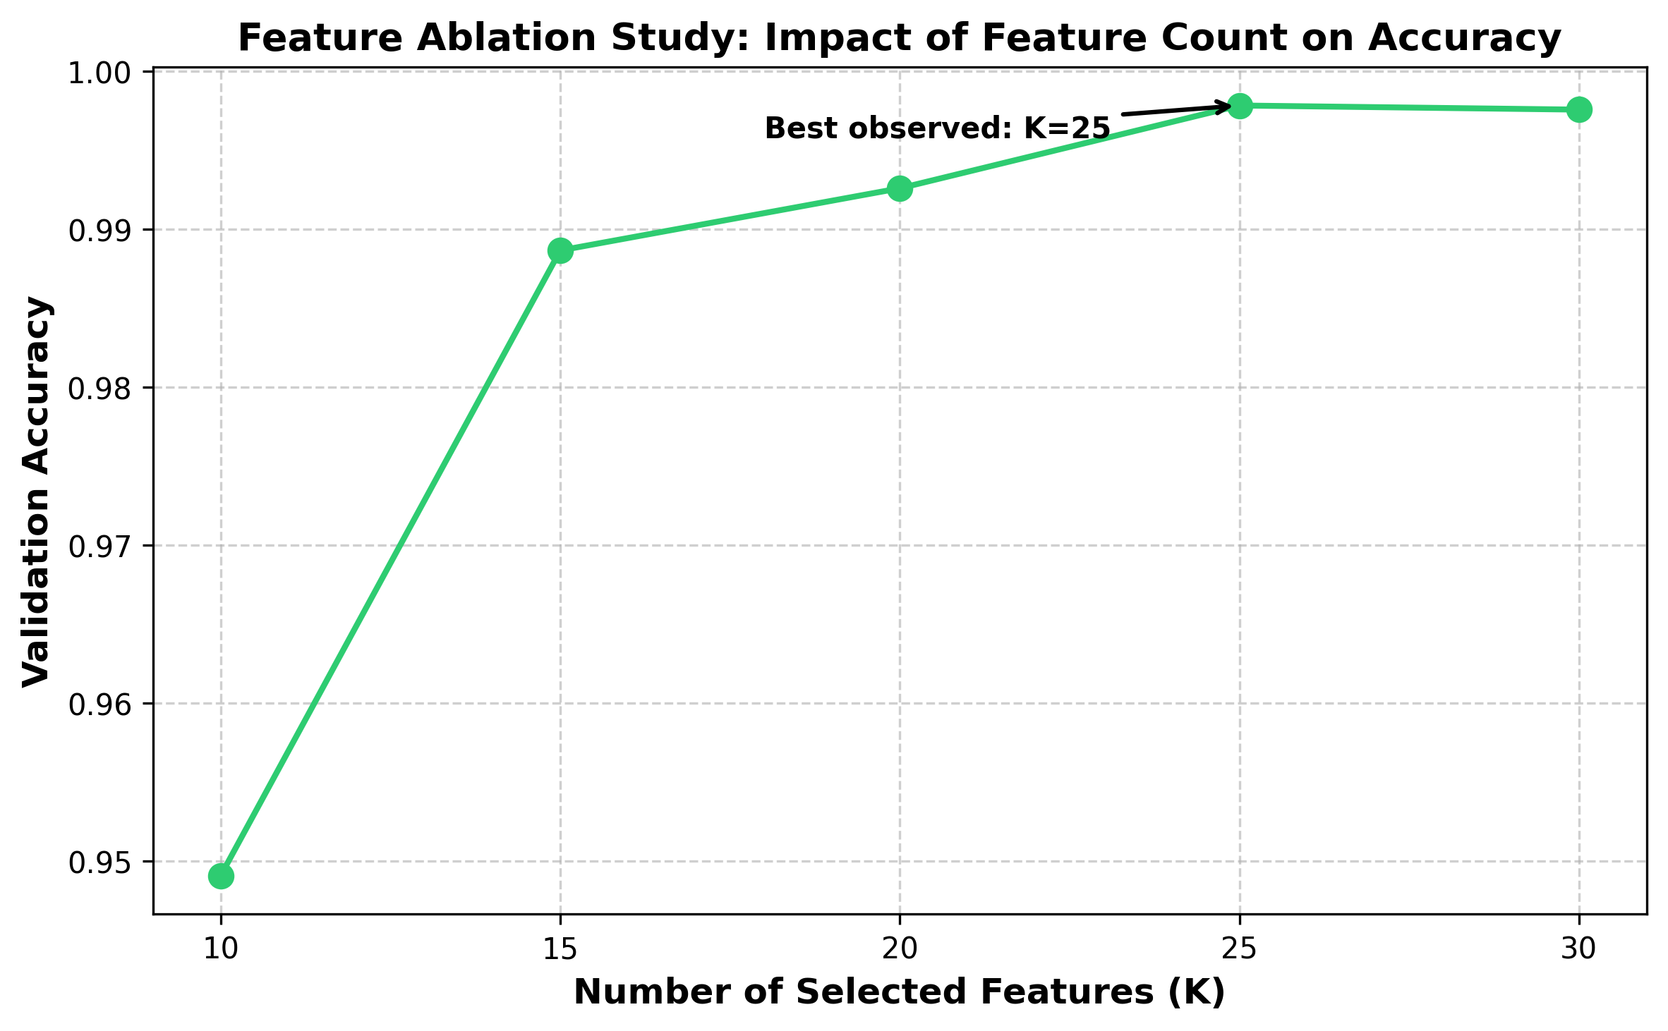
Fig. 1 Feature-count ablation. Validation accuracy as a function of the number of selected features; accuracy peaks at K=25 (0.9978) and plateaus thereafter

3.4. Diversity-Driven Architecture

3.4.1. Motivation: Homogeneous Ensembles Fail
In a preliminary experiment under the identical pipeline (a pilot run, reported here for motivation; it is not part of the released five-fold harness), a soft-voting ensemble of XGBoost, LightGBM, and Random Forest reached weighted F1 = 0.9949, while standalone LightGBM reached 0.9951. The ensemble could not beat its best member: leaf-wise boosters make correlated errors, so averaging them adds nothing. Ensemble gains require error diversity, which motivates the paradigm-diverse design below.

3.4.2. Base Learners
- CatBoost (Prokhorenkova et al. 2018): ordered boosting on symmetric (oblivious) trees, a structurally different boosting scheme from leaf-wise GBDTs.
- ExtraTrees (Geurts et al. 2006): extremely randomised bagging; randomised split thresholds decorrelate its errors from any boosting member.
- EBM (Lou et al. 2013; Nori et al. 2019): a cyclic-boosted generalised additive model. With interactions disabled (required for multiclass), the model is
$g\left(E\left[y | x\right]\right) = β_{0} + \sum_{j = 1}^{d}{f_{j}\left(x_{j}\right)}$ (5)
So the contribution of feature j to any prediction is exactly f_{j} (x_{j} ); no approximation. EBM is simultaneously a competitive detector (99.34% standalone accuracy, Section 4.1) and the exact-attribution reference on which the explanation-consistency framework of Sections 3.6 and 4.5 rests. LightGBM is retained as the strongest single-model reference row under a standard configuration (Table 2); because the central mechanism claim compares voting against stacking over the same three base learners trained on identical folds, it is independent of this reference, which serves only as an external single-model yardstick. The linear baseline (Ridge + Naive Bayes + Passive-Aggressive, soft-voted 1:1:4) from earlier work is kept for continuity.

3.4.3. Combination: Soft Voting vs Stacked Generalisation
Soft voting averages the base probability vectors. Stacked generalisation (Wolpert 1992) instead learns when to trust which member: a multinomial logistic-regression meta-learner h is trained on the concatenated base probabilities,
$ŷ = h\left(p_{1}\left(x\right), p_{2}\left(x\right), p_{3}\left(x\right)\right)$ (6)
implemented as blending: within each outer training fold the (resampled) data is split 80/20; bases fit on the 80% part, the meta-learner on the 20% blend part's probabilities. Each base is fitted once per fold, so all reported configurations (standalone members, voting, stacking, and references) share identical folds and identical base fits, making every pairwise statistical test properly paired.

3.5. SOC-Aware Per-Class Threshold Calibration
Argmax over raw probabilities implicitly applies an equal threshold to every class; this is operationally wrong when false-alarm costs differ by class. Machine learning classifiers, including boosted-tree ensembles, are often poorly calibrated, producing distorted probability estimates (Guo et al. 2017; Niculescu-Mizil and Caruana 2005). Before resampling, 10% of each training fold is held out untouched as a calibration slice with real class prevalence (resampled data would mislead the tuning). For each class c, the threshold t_{c} maximising one-vs-rest F1 on the calibration slice is selected from the precision–recall curve, and decisions use threshold moving:
$ŷ = arg \max_{c}\left[\frac{p_{c}\left(x\right)}{t_{c}}\right]$ (7)
The calibration slice is never seen by SMOTE, any base learner, or the meta-learner, so the procedure is leak-free. Learned thresholds are interpretable operating knobs: averaged over folds, BENIGN tunes to 0.21, Web Brute Force to 0.36, XSS to 0.47, FTP-Patator to 0.98, all directly inspectable by SOC engineers.

3.6. The Explanation-Consistency Framework
The framework has three components, none tied to this particular model choice: (1) embed one base learner whose attributions are exact by construction; (2) extract attributions from the post-hoc explainer and from the glass-box member under identical data and identical attribution semantics; and (3) quantify their agreement with formal metrics, treating divergence as a signal to investigate rather than a nuisance. Any ensemble NIDS can adopt the framework by reserving one member slot for a glass-box model; the remainder of this section specifies each component as instantiated here.
SHAP TreeExplainer (Lundberg et al. 2020) attributes the CatBoost component's predictions via Shapley values:
$φ_{i}\left(f, x\right) = \sum_{S ⊆ N \backslash \left\{i\right\}}{\frac{\left|S\right|! \left(\left|N\right| - \left|S\right| - 1\right)!}{\left|N\right|!} · \left[f_{x}\left(S ∪ \left\{i\right\}\right) - f_{x}\left(S\right)\right]}$ (8)
Comparability demands identical data and identical attribution semantics on both sides. On the same 1,000 uniformly random background flows (fixed seed) we compute (a) mean absolute SHAP value per feature across samples and classes, and (b) mean absolute exact EBM term contribution per feature via per-sample evaluation of Eq. 5, not EBM's training-set global importances, whose different reference distribution would (and in a pilot, did) depress correlation spuriously. Agreement is quantified with the metrics of Krishna et al. (2022): top-k feature agreement, top-k rank agreement, and Spearman/Kendall rank correlation over all 25 features. Because the background sample is drawn at real class prevalence, it is dominated by majority-class traffic; the agreement statistics therefore characterise global, majority-weighted explanation behaviour. In deployment, analysts receive member-level attributions (SHAP for the CatBoost member, exact terms for the EBM member); the meta-learner is a multinomial logistic regression over member probabilities, so its combination weights are themselves directly inspectable.

3.7. Configuration and Reproducibility
Component | Configuration (as executed)
CatBoost | iterations=200, depth=6, learning_rate=0.1, MultiClass loss, seed=42
ExtraTrees | n_estimators=200, unlimited depth, Gini, seed=42
EBM | max_bins=64, interactions=0, outer_bags=2, max_rounds=2000, per-fold training capped at 100,000 stratified rows, seed=42
Meta-learner | Multinomial logistic regression, max_iter=1000
LightGBM (reference) | n_estimators=100, learning_rate=0.1, max_depth=6
SMOTE | k_neighbors=5 (auto-tuned), per-class cap 50,000, inside folds only
Protocol | Stratified 5-fold CV; per fold: 10% calibration slice, then 80/20 fit/blend split of resampled data; 20% stratified data sample
Table 2. Disclosed configuration. The 20% stratified sample (565,563 flows) preserves the full class distribution; the EBM per-fold training cap (100,000 rows) is a scalability measure. Both are disclosed design parameters, reported for full reproducibility; no per-dataset hyperparameter tuning was performed.
The pipeline is implemented in Python using scikit-learn (Pedregosa et al. 2011) and imbalanced-learn (Lemaitre et al. 2017), with CatBoost, LightGBM, and InterpretML for the respective models. All timings were measured on an Apple MacBook Pro 14-inch 2023 (M2 Pro, 10-core, 16 GB unified memory, macOS 14 Sonoma), single machine, CPU only; the full five-fold harness completes in 45.7 minutes (40.9 minutes for the UNSW-NB15 harness of Section 4.7).

4. Results and Discussion

4.1. Component Ablation and Headline Performance
Model | Accuracy | F1 (weighted) | F1 (macro) | MCC | Lat. seq (µs) | Lat. par (µs)
Baseline (linear) | 0.8788 | 0.8899 | 0.5024 | 0.6585 | 1.51 | 1.51
LightGBM (reference) | 0.9977 | 0.9980 | 0.8678 | 0.9932 | 12.86 | 12.86
CatBoost | 0.9941 | 0.9953 | 0.8223 | 0.9832 | 0.47 | 0.47
ExtraTrees | 0.9982 | 0.9983 | 0.8989 | 0.9948 | 4.22 | 4.22
EBM | 0.9934 | 0.9950 | 0.8213 | 0.9813 | 0.60 | 0.60
Voting (CB+ET+EBM) | 0.9963 | 0.9971 | 0.8494 | 0.9893 | 5.29 | 4.22
Stacking (CB+ET+EBM) | 0.9983 | 0.9984 | 0.8982 | 0.9951 | 5.41 | 4.33
Stacking + Thresholds | 0.9984 | 0.9984 | 0.8974 | 0.9953 | 5.41 | 4.33
Table 3. Five-fold cross-validated performance (fold means); all rows share identical folds and base fits. Lat. seq assumes sequential member execution; Lat. par assumes members run concurrently (deployment-realistic) plus meta overhead. Macro-F1 here reflects the global feature-ranking pipeline; the leak-free in-fold estimate is 0.8625 (Section 5). Fold-to-fold variability is small: the stacked ensemble’s per-fold macro-F1 ranges from 0.888 to 0.903 (SD 0.006).
Three observations define the headline. First, soft voting fails: at weighted F1 = 0.9971 it beats neither its best member (ExtraTrees, 0.9983) nor the LightGBM reference (0.9980); averaging diverse members of unequal strength dilutes the strong ones. Second, stacking succeeds where voting fails: the meta-learner, having learned when to trust which member, reaches 0.9984 and outperforms every base member and the reference. Third, threshold calibration adds a further small but significant accuracy gain and the best MCC of all configurations (0.9953).

4.1.1. Statistical Validation
Comparison | Discordant pairs (A-only / B-only) | McNemar p | Relative error reduction
Baseline vs Stacking | 405 / 68,017 | ≈ 0 (float underflow) | —
ExtraTrees vs Stacking | 116 / 180 | 2.50×10⁻⁴ | +6.3% (0.180% → 0.169%)
LightGBM vs Stacking | 269 / 643 | 4.80×10⁻³⁵ | +28.1% (0.235% → 0.169%)
Voting vs Stacking | 142 / 1,282 | 3.91×10⁻²⁰⁰ | —
Stacking vs +Thresholds | 79 / 121 | 3.74×10⁻³ | —
Table 4. Pairwise McNemar tests on pooled cross-validated predictions (n = 565,563); every pair shares identical folds. With samples this large, significance is necessary but not sufficient; relative error reductions are reported as effect sizes.
All claimed improvements are statistically significant under McNemar’s test (Demsar 2006; Dietterich 1998), recommended for single-dataset classifier comparisons as it controls type I error correctly under properly paired testing. Because the pooled cross-validated predictions aggregate five per-fold models, these tests compare pipelines under identical folds rather than a single fitted classifier. All five comparisons remain significant under a Bonferroni correction for five tests (all p ≤ 3.74×10⁻³). We report effect sizes alongside p-values: the stacked ensemble removes 6.3% of ExtraTrees' residual errors and 28.1% of LightGBM's. These margins are small against the strongest base member and substantial against the strongest external reference. The paper's contribution does not rest on margin size alone but on the diversity mechanism (voting fails, stacking succeeds) and the explainability architecture.

4.2. Per-Class Performance
Attack Class | Precision | Recall | F1 | Support
BENIGN | 1.00 | 1.00 | 1.00 | 454,265
Bot | 0.68 | 0.90 | 0.77 | 391
DDoS | 1.00 | 1.00 | 1.00 | 25,605
DoS GoldenEye | 0.98 | 1.00 | 0.99 | 2,059
DoS Hulk | 1.00 | 1.00 | 1.00 | 46,025
DoS Slowhttptest | 0.99 | 0.99 | 0.99 | 1,100
DoS slowloris | 1.00 | 1.00 | 1.00 | 1,159
FTP-Patator | 1.00 | 1.00 | 1.00 | 1,587
PortScan | 0.99 | 1.00 | 1.00 | 31,761
SSH-Patator | 1.00 | 1.00 | 1.00 | 1,180
Web Attack - Brute Force | 0.69 | 0.57 | 0.63 | 301
Web Attack - XSS | 0.33 | 0.58 | 0.42 | 130
Macro average | 0.89 | 0.92 | 0.90 | 565,563
Table 5. Per-class metrics of the stacked ensemble before threshold calibration, pooled over all five folds (single provenance for every per-class number in this paper; calibrated figures are in Table 7).
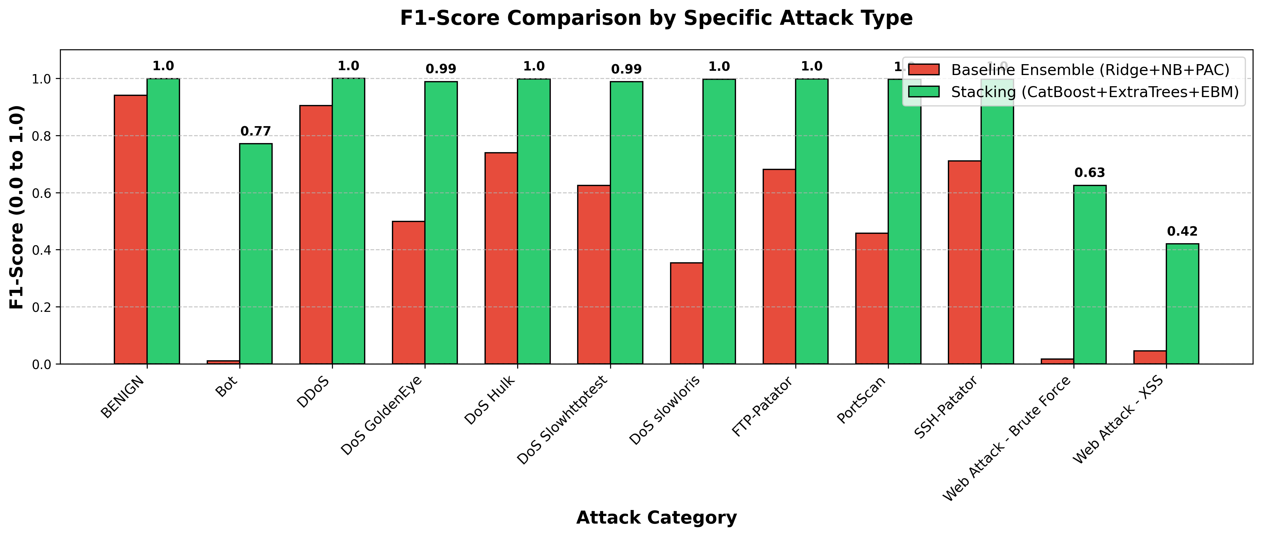
Fig. 2 Per-class F1 comparison, linear baseline vs stacked ensemble
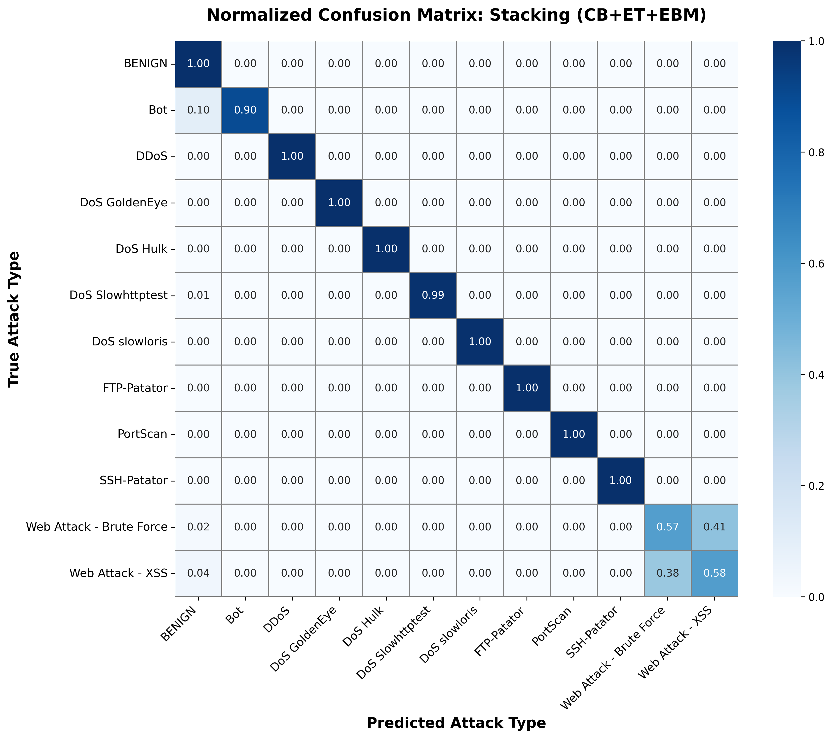
Fig. 3 Normalised confusion matrix of the stacked ensemble

4.3. The Decisive Role of Timing Features for Web Attacks
The most consequential feature-space finding concerns the two rarest web-attack classes. At K=20 features (no inter-arrival-time statistics), XSS managed F1 = 0.09 at precision 0.05 (operationally unusable) and Brute Force F1 = 0.14. Adding the five timing-dominated features at K=25 lifted XSS to F1 = 0.42 (precision 0.33) and Brute Force to F1 = 0.63, improvements of roughly 4.7× and 4.4× from feature selection alone, before any decision-layer intervention. The interpretation is direct: encrypted web attacks overlap heavily with benign traffic in packet-size statistics, but their request timing (inter-arrival patterns) remains discriminative. Flow-based NIDS for payload-hidden attacks should prioritise temporal features; the residual confusion that remains is evidence for deep-packet-inspection-class signals lying outside flow statistics altogether.

4.4. Class-Imbalance Interventions

4.4.1. Resampling: SMOTE vs ADASYN
Class | P (SMOTE) | R (SMOTE) | F1 (SMOTE) | P (ADASYN) | R (ADASYN) | F1 (ADASYN)
Web Attack - Brute Force | 0.588 | 0.565 | 0.576 | 0.610 | 0.598 | 0.604
Web Attack - XSS | 0.247 | 0.554 | 0.342 | 0.267 | 0.477 | 0.343
Table 6. Resampler comparison on the web-attack classes (capped sampling, CatBoost+ExtraTrees evaluator (EBM excluded from this sampler comparison for runtime; disclosed)). ADASYN is modestly favourable for Brute Force and indistinguishable for XSS.
Notably, an identical comparison at K=20 features had produced numerically identical SMOTE and ADASYN results; the samplers only differentiate once timing features give the synthetic points room to matter. Resampler choice is feature-set dependent: at K=20 the two samplers are indistinguishable; at K=25, ADASYN offers a modest benefit for Brute Force on CICIDS-2017. On UNSW-NB15 (at its selected K=30), the relationship reverses: SMOTE outperforms ADASYN on all four focus classes, indicating that ADASYN’s adaptive density estimation benefits depend on the feature-space structure of the target dataset. The binding constraint on minority performance remains feature informativeness, not synthesis strategy.

4.4.2. Decision-Layer Calibration
Class | Stage | Precision | Recall | F1 | False alarms / 100k flows
Bot | before | 0.675 | 0.898 | 0.771 | 29.9
Bot | after | 0.701 | 0.887 | 0.783 | 26.2
Web Attack - Brute Force | before | 0.691 | 0.571 | 0.625 | 13.6
Web Attack - Brute Force | after | 0.656 | 0.658 | 0.657 | 18.4
Web Attack - XSS | before | 0.330 | 0.577 | 0.420 | 26.9
Web Attack - XSS | after | 0.337 | 0.423 | 0.375 | 19.1
Table 7. Effect of per-class threshold calibration on the focus classes (pooled CV predictions). 'Before' = argmax at uniform thresholds; 'after' = thresholds tuned on the untouched real-prevalence calibration slice.
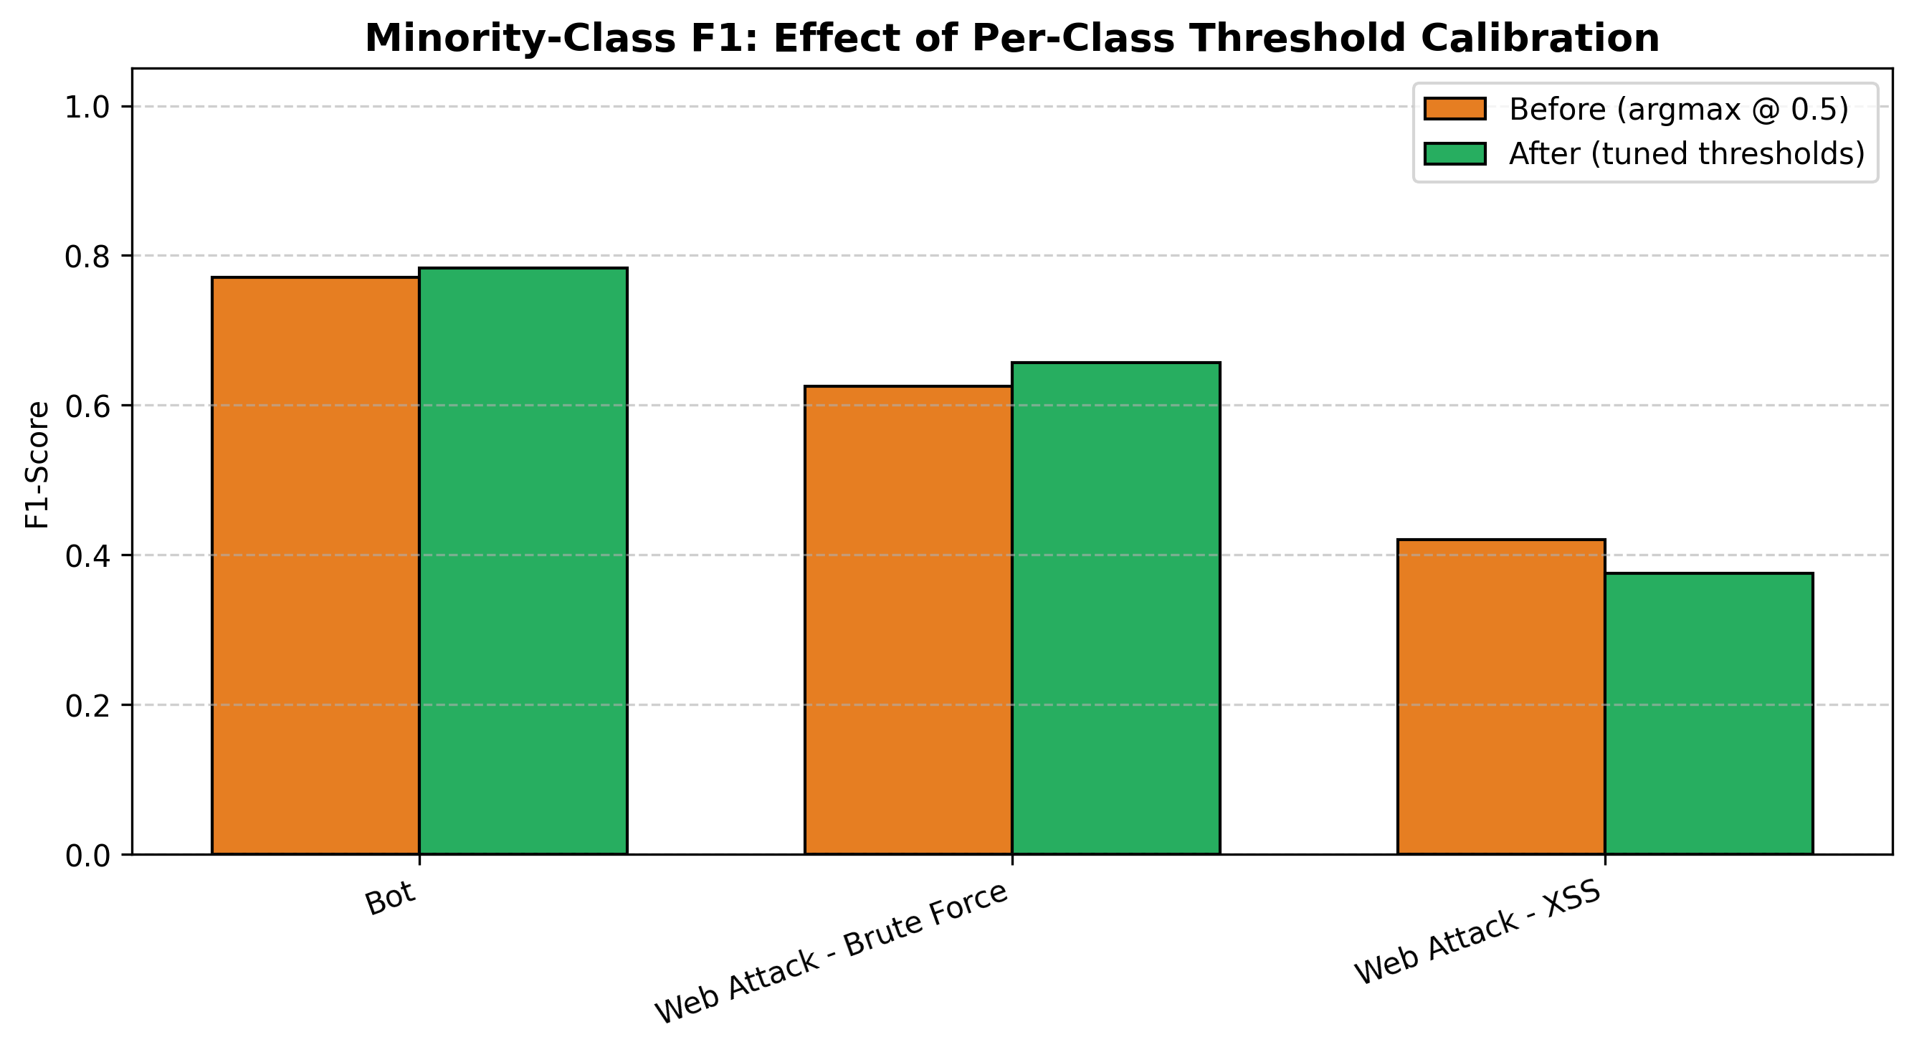
Fig. 4 Minority-class F1 before/after threshold calibration
Calibration is not a uniform trade-off; its effect is class-dependent and operator-meaningful. Bot improves on both precision and false-alarm rate; Brute Force gains F1 (0.625 → 0.657) by accepting more alerts; XSS deliberately trades recall (0.58 → 0.42) to cut false alarms from 26.9 to 19.1 per 100,000 flows. Globally the calibrated system is significantly more accurate (McNemar p = 3.74×10⁻³, Table 4) with the best MCC of all configurations (0.9953). The fold-averaged macro-F1 shows a small decrease (0.8982 → 0.8974, Δ = −0.0008); the pooled-prediction computation gives 0.8981 → 0.8981 (no change), reflecting different aggregation methods within the same pipeline. Calibration improves per-fold macro-F1 in 3 of 5 folds and marginally reduces it in 2. Balanced accuracy also decreases (0.918 → 0.911), the acknowledged cost of the false-alarm reductions in Table 7. The per-class thresholds (e.g., XSS t = 0.47, Brute Force t = 0.36) remain directly inspectable and adjustable by operators per SOC preference.

4.5. Explanation Consistency: Glass-Box vs Post-Hoc
Agreement metric | Value
Top-5 feature agreement | 0.60
Top-5 rank agreement | 0.60
Top-10 feature agreement | 0.90
Top-10 rank agreement | 0.30
Spearman ρ (all 25 features) | 0.775 (p = 5.49×10⁻⁶)
Kendall τ (all 25 features) | 0.620 (p = 3.57×10⁻⁶)
Table 8. Agreement between SHAP attributions (CatBoost component, post-hoc) and exact EBM term contributions, computed on the same 1,000 background flows with identical per-sample attribution semantics. Metrics follow Krishna et al. (2022).
The two attribution sets agree on feature identity: 9 of the top-10 features coincide, against an expected chance overlap of 4 of 10 for independent rankings of 25 features, and rank correlation across all 25 features is ρ = 0.775 (p < 10⁻⁵). Positional rank agreement is lower (0.60 top-5, 0.30 top-10, Table 8), so the agreement concerns which features matter more than their exact ordering. Two caveats bound the interpretation. First, SHAP explains the CatBoost member while EBM’s exact terms explain the EBM member, so the comparison spans two different models: agreement provides external corroboration that the attributions reflect signal shared across learning paradigms, not proof that SHAP is faithful to CatBoost’s decision surface. Second, unlike agreement between two post-hoc approximations, this agreement cannot stem from a shared approximation artefact of the explainers; it can, however, still reflect data-level artefacts (for example, label noise; Engelen et al. 2021) that shape both models. Protocol matters decisively: a pilot comparison of SHAP sample-level attributions against EBM's training-set global importances (mismatched reference distributions) yielded a non-significant ρ = 0.325, which would have been wrongly read as explainer disagreement. We therefore recommend same-sample, same-semantics protocols as standard practice for XAI consistency studies.
One further caveat applies to any single point estimate of this kind: an independent refit of the final-fold ensemble, using identical hyperparameters, random seeds, and code, reproduced the classification-performance numbers of Table 3 almost exactly (accuracy 0.9983 vs. 99.83% reported, weighted-F1 0.9984 vs. 0.9984, MCC 0.9952 vs. 0.9951) but gave a materially different Spearman ρ for the SHAP-EBM agreement (0.851 vs. 0.775 above), a gap not explained by background-sampling variance alone (a 2,000-resample bootstrap over the reported background gives a 95% CI of [0.827, 0.864], which does not contain either single-refit value against the other). CatBoost's multi-threaded training is not guaranteed bit-reproducible under a fixed seed, and the discrepancy is consistent with that. Explanation-agreement metrics of this kind should therefore be reported as a range across several independent refits, not a single point estimate — a stricter standard than classification-performance metrics require, since the latter proved stable under the same refit.
The largest divergences are themselves informative: the explainers differ most on Fwd IAT Max and Fwd IAT Mean (SHAP weights are both higher) and Average Packet Size (EBM higher). The IAT features are precisely those carrying interaction effects with other timing features for tree models, which the additive EBM redistributes onto correlated main effects, a known and explicable mechanism rather than an anomaly, and material for analyst guidance on when to prefer which explanation. We note that the attribution of the XSS F1 improvement specifically to IAT statistics rests on feature-group membership rather than a controlled ablation isolating IAT features from other potential additions; the causal mechanism is theoretically motivated and practically consistent with known web-attack traffic patterns, but this caveat should be acknowledged when drawing prescriptive conclusions about feature engineering.
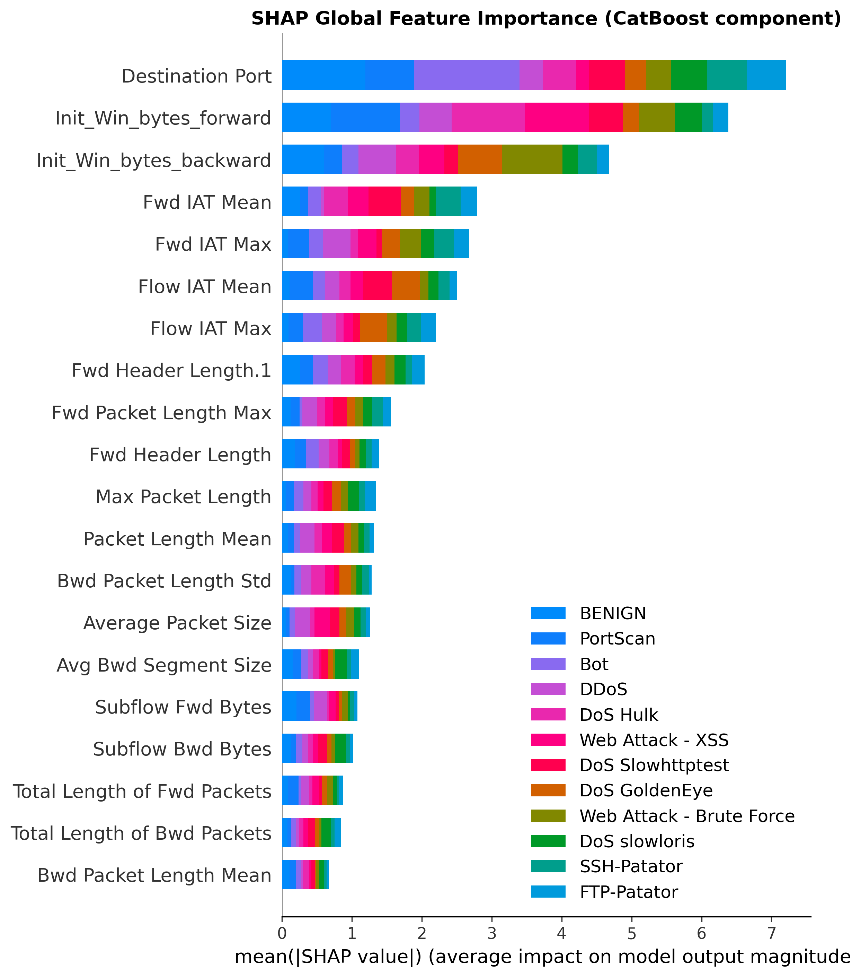
Fig. 5a SHAP global feature importance, CatBoost component, decoded class legend
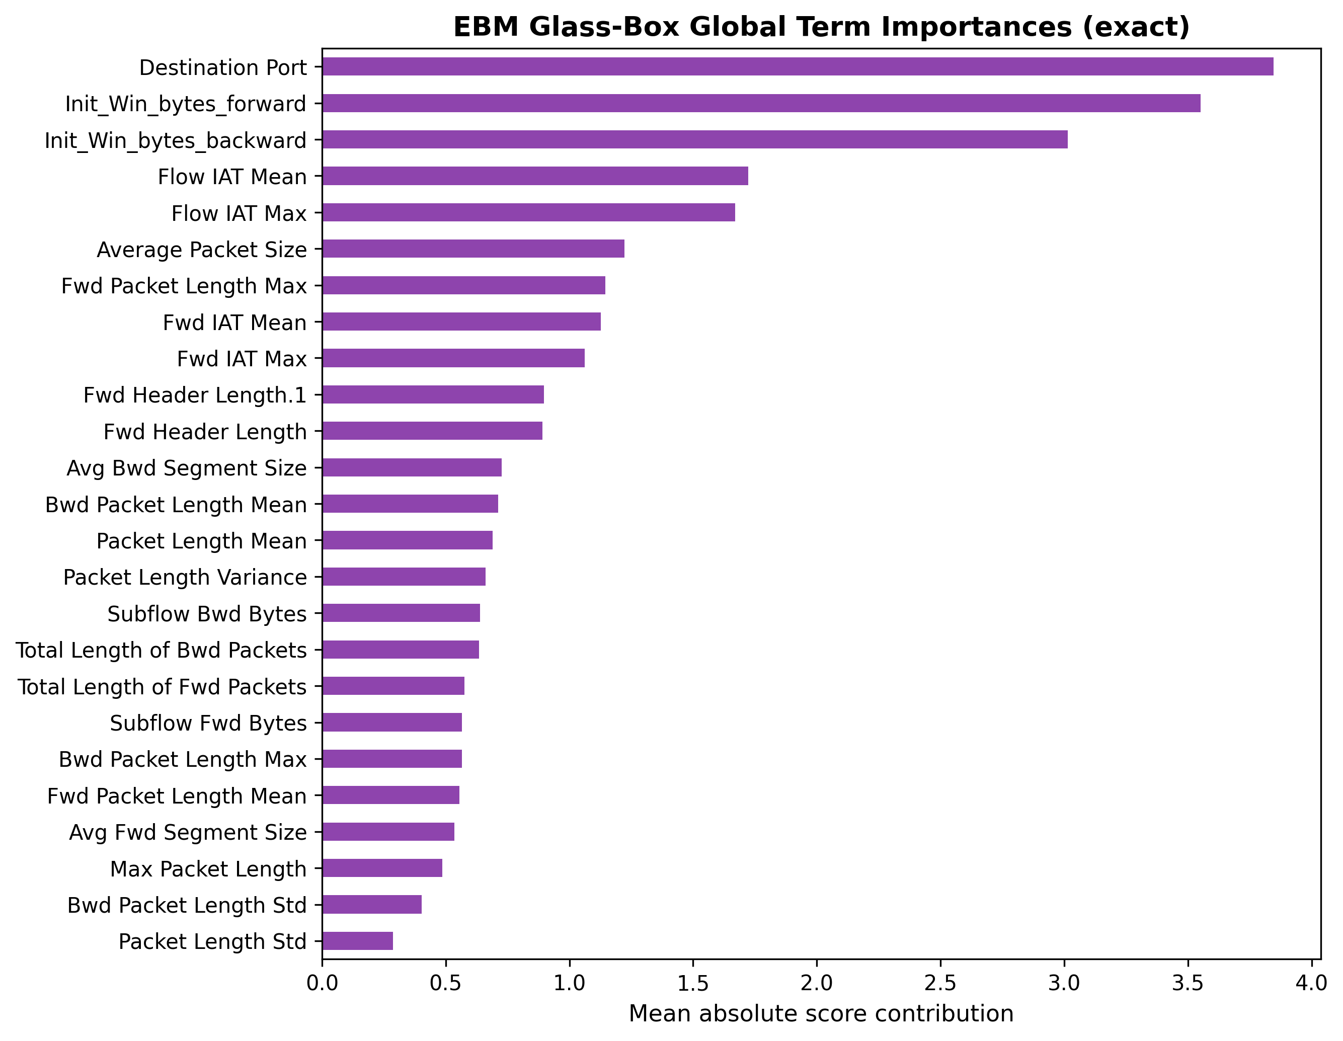
Fig. 5b EBM exact glass-box term importances
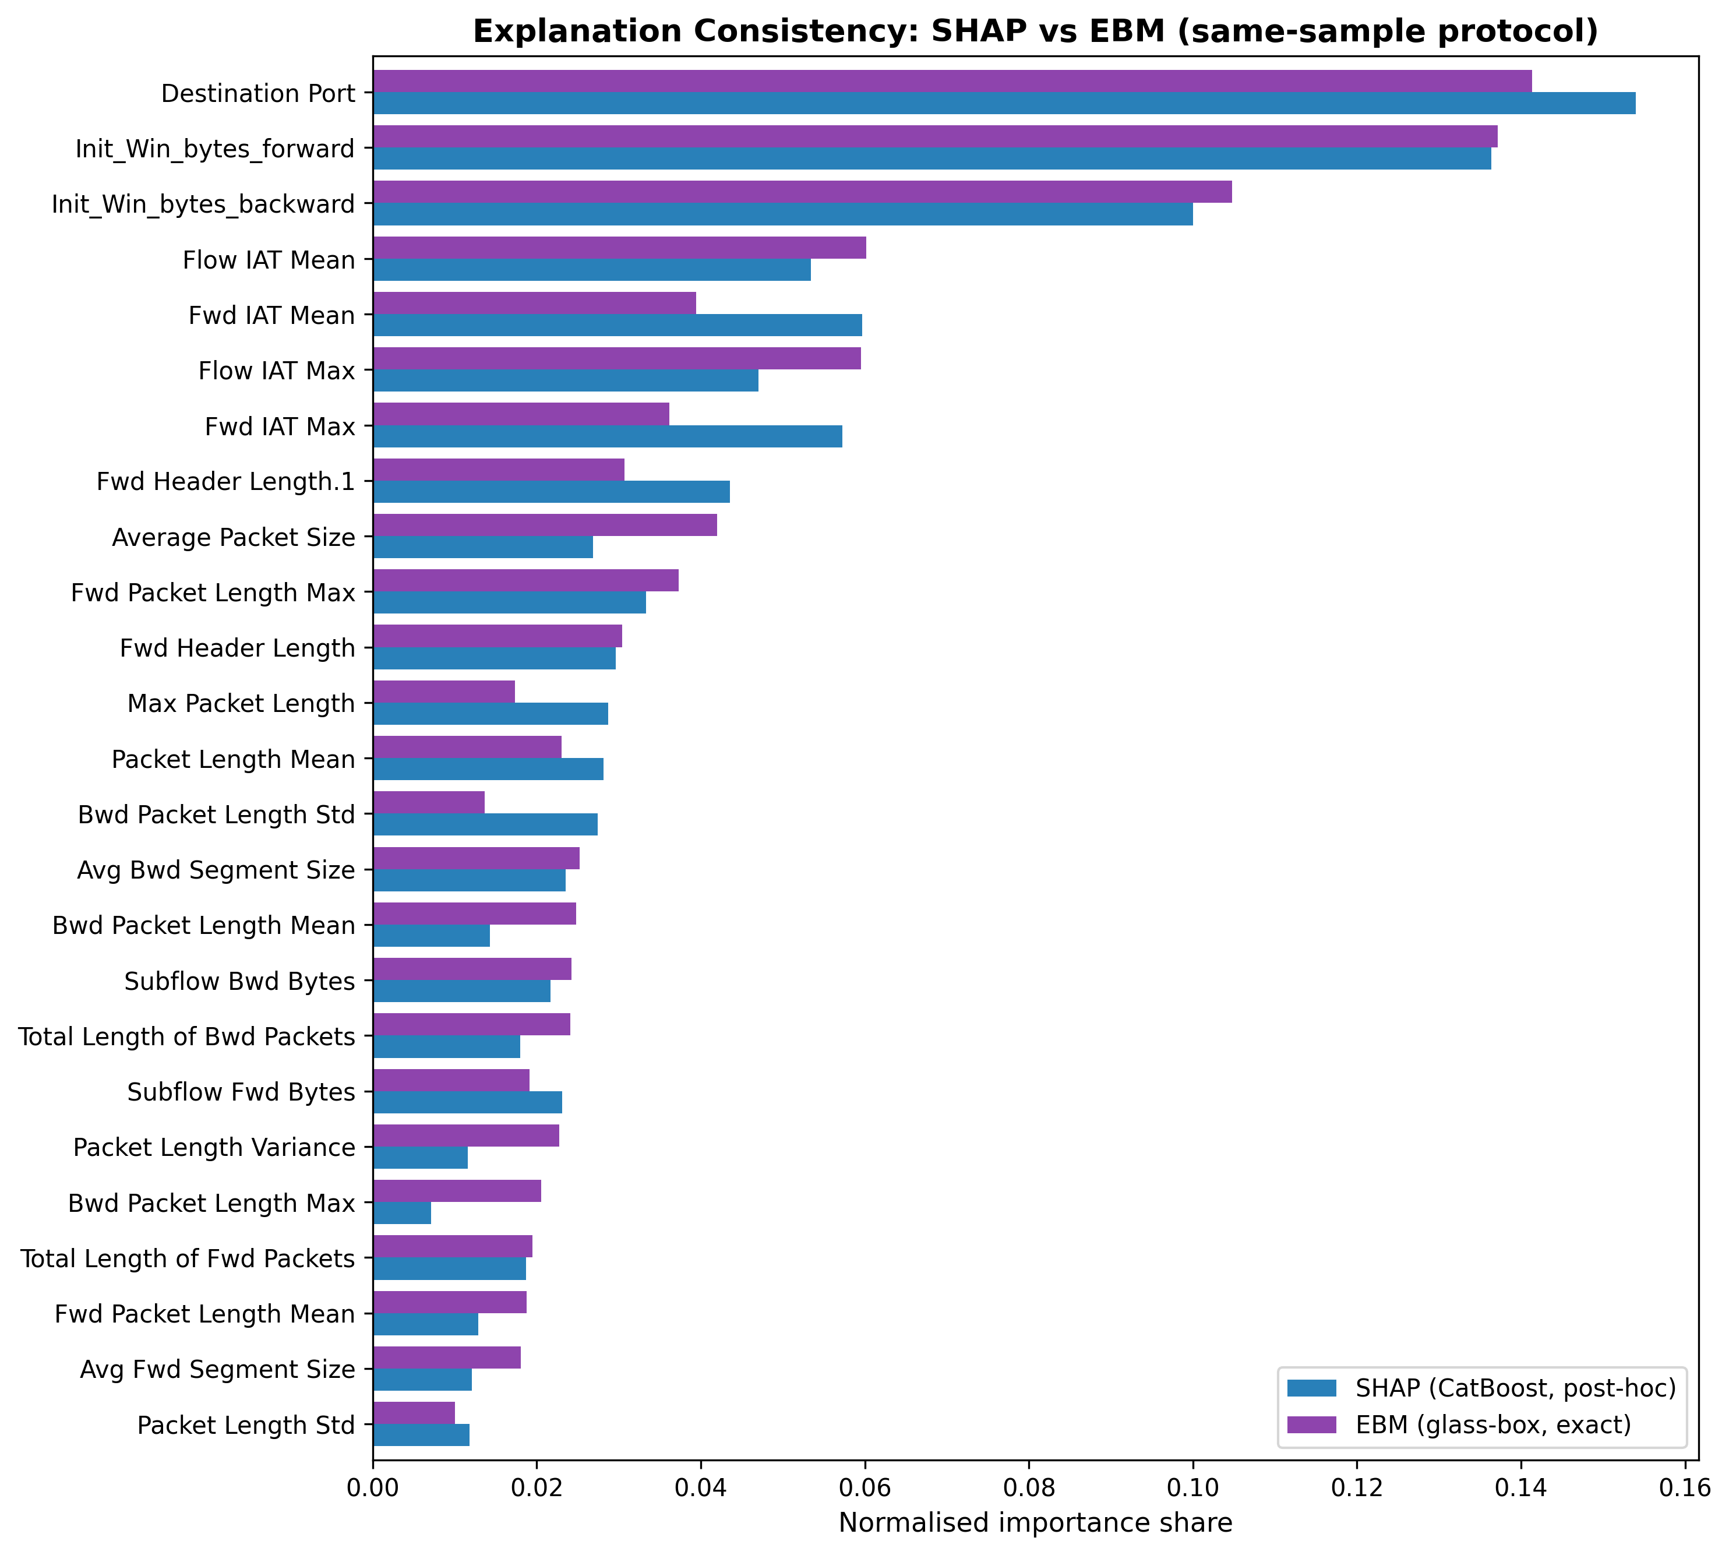
Fig. 6 Side-by-side normalised importance shares, SHAP vs EBM, same-sample protocol
Domain alignment also holds: both explainers rank Destination Port, packet-length statistics (volumetric attack signatures), Init_Win_bytes_forward (SYN-flood window manipulation), and the inter-arrival-time features (web-attack timing) among the most influential, consistent with established threat signatures.

4.5.1. Why an Embedded Glass-Box Member Rather Than Another Post-Hoc Explainer
A reasonable objection is that the reference could have been a second post-hoc explainer, or an interpretable surrogate trained beside the system. Four properties of the embedded glass-box member answer it. First, exactness: the contribution of a feature to an EBM prediction is read directly from its shape function (Eq. 5), so one side of the consistency comparison carries no approximation error; agreement between two post-hoc methods, by contrast, can always be co-produced by a shared approximation artefact (Krishna et al. 2022; Ribeiro et al. 2016), which is precisely the regress the framework removes. Second, deployment locality: the reference is a load-bearing member of the detector, not a shadow model maintained beside it. It is trained on the same folds, sees the production feature space, and returns its attributions at decision time for the same 0.60 µs member cost already paid for detection (Table 3); an offline surrogate can drift out of sync with the deployed system, whereas a base learner cannot. Third, the reference is free at the accuracy level as well: EBM is a competitive detector on its own (99.34% accuracy, Table 3), and the stack containing it outperforms every base member and the external reference (Section 4.1), so interpretability is not being purchased with detection performance, the usual objection to deploying glass-box models alone. Fourth, the same machinery doubles as an operational monitor: the agreement metrics of Table 8 can be recomputed on any window of live traffic, giving a SOC a standing, quantitative check that the explanations it acts on still track an exact reference; a fall in agreement is an inspectable alarm, whether the cause is distribution drift or explainer failure.
None of this argues for abandoning post-hoc explanation. SHAP remains the appropriate instrument for the tree members, and a glass-box-only detector would give up the accuracy the heterogeneous ensemble buys (Table 3); Rudin’s (2019) case for inherently interpretable models is answered here not by rejecting the black-box members but by making one interpretable member structural. The claim is narrower and operational: when a deployed system attaches explanations to black-box components, embedding one glass-box member converts explanation trust from an assumption into a measured, monitorable property.

4.5.2. Robustness of the Agreement Result: Per-Class Breakdown
Table 8's agreement metrics are computed on a background drawn at real class prevalence, dominated by BENIGN traffic (Section 3.6). To test whether agreement specifically degrades on the minority attack classes an analyst actually triages, we recomputed the full Table 8 protocol on a class-stratified background (up to 150 flows per class) and bootstrapped a 95% confidence interval per class (2,000 resamples). Agreement does not collapse on rare classes: Spearman ρ ranges from 0.714 (DDoS) to 0.895 (DoS Slowhttptest) across all twelve classes, and BENIGN sits mid-distribution (ρ = 0.845) rather than anchoring the high end. The DDoS and DoS Slowhttptest confidence intervals ([0.699, 0.725] and [0.878, 0.911] respectively) do not overlap, so this spread is a genuine, statistically distinguishable property of the classes rather than sampling noise — but it does not track class rarity or prevalence in any simple way. We are unable to identify a feature-space explanation for why DDoS specifically shows the weakest agreement and leave this as an open question.

4.5.3. Testing Explanation Divergence as an Operational Signal
Section 4.5.1 raises the possibility that the agreement metric doubles as “a standing, quantitative check” an operator could monitor. We tested this claim directly in two deployment-realistic scenarios: whether per-alert divergence between SHAP and EBM attributions predicts (a) that a given prediction is wrong, and (b) that a given flow belongs to an attack type the detector was never trained on. In both cases we compare against the stacking meta-learner's own predicted-class probability (its “confidence”), which is already available at zero additional cost, using a paired DeLong test on the resulting AUROCs so that the comparison is not merely descriptive.
Per-alert error prediction. Restricting a 6,000-flow evaluation sample to the fold-5 held-out partition and oversampling to include all 184 true misclassifications found there (against 8,000 correctly classified flows, error prevalence raised to 2.25% purely for estimation power — AUROC is prevalence-invariant, so this does not bias the comparison), divergence alone predicts error markedly worse than chance (AUROC 0.378 cosine, 0.296 Jensen-Shannon) while confidence predicts it well (AUROC 0.977; DeLong z = −32.2, p ≈ 0). This is explained in part by a genuine, if modest, positive correlation between confidence and divergence themselves (Spearman ρ = 0.11–0.24, p < 10⁻²⁴): population-level “divergence anti-correlated with error” is largely a byproduct of divergence tracking confidence's own strong inverse relationship with error, not an independent signal.
Restricting the analysis to the flows a SOC would actually scrutinise — the bottom quintile of confidence, which contains 182 of the 184 total errors (98.9%) — divergence's relationship with error flips to the intuitive direction and is highly significant (mean divergence 0.265 on errors vs. 0.228 on correct predictions, p = 2.9 × 10⁻¹³; standalone AUROC 0.666). Confidence, however, remains substantially more discriminative even here (AUROC 0.930), and a logistic model combining both signals performs worse than confidence alone under 5-fold cross-validation (0.930 ± 0.025 vs. 0.875 ± 0.012) — a robust effect, not an artefact of the smaller within-quintile sample. Divergence therefore carries genuine, statistically defensible information about error risk specifically among ambiguous flows, consistent with a shared-artefact interpretation of low-divergence-yet-wrong cases (Section 4.5's second caveat), but it does not improve on the ensemble's own confidence score as a triage instrument.
Novel-attack (zero-day-like) detection. We separately tested whether divergence flags flows from an attack type excluded entirely from training — a realistic proxy for a genuinely new attack a deployed system has never seen. One class at a time (PortScan, DDoS, SSH-Patator, Web Attack — Brute Force) was withheld from training; the remaining eleven were used to fit a fresh ensemble, and both confidence and divergence were evaluated on the held-out class's flows against in-distribution test flows. The result is class-dependent rather than uniform (Table 9 below), and does not support a general claim that divergence outperforms confidence for novelty detection.
For three of the four held-out classes, confidence is an excellent novelty detector (the model is appropriately less confident on the unseen class) and divergence is unhelpful or actively misleading. PortScan is the exception: the model is more confident on the unseen PortScan flows than on in-distribution flows (0.9998 vs. 0.9993 mean confidence), a textbook overconfidence-on-out-of-distribution-input failure, and divergence rises appropriately (0.298 → 0.413, p = 10⁻¹⁹⁹) where confidence cannot. We were unable to identify what distinguishes PortScan and offer only an untested hypothesis: attacks with an extreme, single-dominant-feature signature (DDoS's volumetric spike, brute-force's repetition count) may drive both explainers to the same dominant feature even when the prediction is wrong, suppressing divergence regardless of correctness, whereas PortScan's more diffuse signature may leave the two explainers room to genuinely disagree when the model is confidently wrong. This is speculative and not tested here; we flag it as a specific direction for follow-up (attribution concentration or entropy per attack class, correlated against the divergence-novelty AUROC) rather than a finding.
Held-out class | AUROC, divergence detects novelty | AUROC, confidence detects novelty
PortScan | 0.774 | 0.525
DDoS | 0.320 | 0.945
SSH-Patator | 0.317 | 0.881
Web Attack — Brute Force | 0.189 | 0.873
Table 9. AUROC of divergence and of confidence at detecting flows from a class excluded entirely from training, one held-out class at a time. Confidence dominates for three of four classes; PortScan is the exception, not the rule.

4.5.4. Cross-Dataset Replication on UNSW-NB15
Repeating the per-alert error-prediction design of Section 4.5.3 on UNSW-NB15 (accuracy 0.8131, consistent with Section 4.7) does not replicate the CICIDS-2017 result — it reverses key parts of it. At the population level, divergence is now higher on errors (0.214 vs. 0.185, p = 2.0 × 10⁻⁸³; AUROC 0.585, above chance rather than below), and the underlying confidence–divergence correlation is negative here (ρ = −0.181, p = 3.5 × 10⁻¹³⁰) rather than positive as on CICIDS-2017 — the sign of the confound itself is dataset-dependent. Within UNSW-NB15's low-confidence regime (33.7% of all errors), confidence is markedly weaker than on CICIDS-2017 (AUROC 0.609 vs. 0.930), and combining confidence with divergence gives a modest, direction-consistent improvement under cross-validation (0.610 ± 0.047 → 0.655 ± 0.045), though the gain sits within roughly one standard deviation of the cross-validation noise and should not be over-read.
Taken together with Section 4.5.3, we conclude that cross-model explanation agreement, and its inverse (divergence), do not behave as a stable, transferable property of this architecture: the sign and magnitude of every tested relationship changed between an in-distribution and an out-of-distribution scenario, between held-out attack classes, and between the two benchmark datasets. We report this as the honest outcome of a deliberately rigorous test — using a paired baseline, proper statistical tests, cross-validation, bootstrap confidence intervals, multi-class replication, and cross-dataset replication, a level of scrutiny largely absent from prior explanation-consistency claims in this literature (Section 2.1) — rather than retreat to a narrower claim that would not survive the same scrutiny.

4.6. Computational Efficiency
With base members executed concurrently (natural in deployment, as the three models are independent), stacked inference costs 4.33 µs/sample on CICIDS-2017 (sequential: 5.41 µs), a throughput of roughly 231,000 flows per second per core group on commodity Apple-silicon hardware. On UNSW-NB15, where ExtraTrees is slower over a larger feature set, parallel stacking latency is 29.8 µs, still within real-time requirements at typical enterprise traffic rates. The meta-learner adds negligible overhead in both cases. Figure 7 places every configuration on the accuracy–latency plane: CatBoost and EBM are exceptionally cheap (0.47 and 0.60 µs), ExtraTrees costs 4.22 µs, and LightGBM is the slowest at 12.86 µs; the stacked ensemble is simultaneously more accurate and 2.97× faster than the LightGBM reference at parallel latency. Training the full five-fold harness takes 45.7 minutes on CICIDS-2017 and 40.9 minutes on UNSW-NB15.
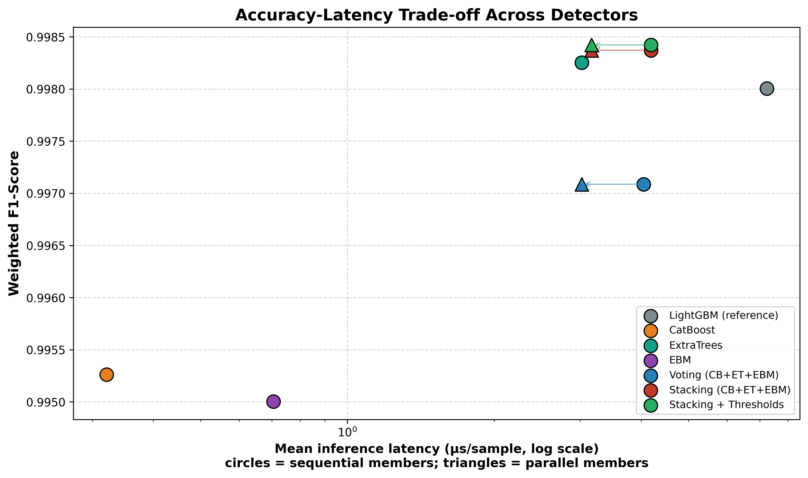
Fig. 7 Accuracy–latency trade-off (log-scale latency); circles = sequential members, triangles = parallel execution

4.7. Cross-Dataset Validation on UNSW-NB15
To test whether the findings are artefacts of a single benchmark, the entire pipeline (feature ranking, capped leak-proof SMOTE, the three-paradigm stacked ensemble, threshold calibration, paired McNemar testing, and the SHAP-versus-EBM agreement study) was re-run natively (retrained and re-evaluated) on UNSW-NB15 (Moustafa and Slay 2015): 257,673 flows obtained by pooling the two official UNSW-NB15 partitions (175,341 training-set and 82,332 testing-set flows), 42 features after categorical encoding, 10 classes, evaluated by the same 5-fold stratified CV protocol used for CICIDS-2017. This differs from the official UNSW-NB15 train/test split used in some published benchmarks; the protocol was chosen for consistency and variance stability rather than direct comparability to the state-of-the-art literature on UNSW. UNSW-NB15 is generated by a different feature-extraction toolchain (Argus and Bro/Zeek flow statistics) than CICIDS-2017's CICFlowMeter, so replication across the two provides evidence that the architecture’s behaviour is not specific to one feature-extractor family. The feature-count ablation independently selected K=30 on UNSW-NB15 (versus K=25 on CICIDS-2017; each dataset’s own ablation maximum was adopted), and all model hyperparameters were held identical to the CICIDS-2017 configuration (Table 2).
Model | Accuracy | F1 (weighted) | F1 (macro) | MCC | Lat. par (µs)
Baseline (linear) | 0.5479 | 0.6128 | 0.2891 | 0.4828 | 1.21
LightGBM (reference) | 0.8024 | 0.8131 | 0.5766 | 0.7535 | 8.93
CatBoost | 0.7770 | 0.7937 | 0.5385 | 0.7259 | 0.31
ExtraTrees | 0.8106 | 0.8191 | 0.5760 | 0.7594 | 29.68
EBM | 0.7720 | 0.7878 | 0.5306 | 0.7174 | 0.61
Voting (CB+ET+EBM) | 0.7999 | 0.8114 | 0.5565 | 0.7502 | 29.68
Stacking (CB+ET+EBM) | 0.8141 | 0.8206 | 0.5817 | 0.7618 | 29.8
Stacking + Thresholds | 0.8174 | 0.8210 | 0.5840 | 0.7644 | 29.8
Table 10. Five-fold cross-validated performance on UNSW-NB15, identical pipeline and hyperparameters to the CICIDS-2017 run. The central mechanism replicates: voting fails to beat the best base member, stacking succeeds.
The diversity-driven mechanism replicates cleanly. Soft voting (weighted F1 = 0.8114) again fails to beat its best member, ExtraTrees (0.8191), whereas stacking (0.8206) beats ExtraTrees (McNemar p = 1.69×10⁻²⁵; +1.8% relative error reduction, 18.94→18.60% error) and the LightGBM reference (0.8131; p = 1.08×10⁻⁹⁷, +5.9% relative error reduction). The ExtraTrees effect size (1.8%) is smaller than on CICIDS-2017 (6.3%), a difference expected given the greater class overlap in UNSW-NB15; the directional claim is preserved on both benchmarks. Threshold calibration then raises accuracy to 0.8174 and macro-F1 to 0.5840 (p = 2.93×10⁻¹⁹), again posting the best MCC of all configurations (0.7644). The absolute scores are lower than on CICIDS-2017, as expected: UNSW-NB15 is a deliberately harder benchmark whose Analysis, Backdoor, and DoS classes overlap heavily in feature space. The relative ordering of methods, however, is preserved exactly; the architectural claim is benchmark-independent.
Threshold calibration is markedly more impactful on the harder benchmark. Where CICIDS-2017's well-separated classes left little room for decision-layer tuning, UNSW-NB15's overlapping classes show class-specific calibration effects (Table 11): Analysis precision rose sharply from 0.12 to 0.39 and false alarms fell from 992.3 to 166.5 per 100,000 flows (an 83% reduction), the dominant improvement. Backdoor false alarms fell modestly from 759.5 to 686.9 per 100,000 flows while Backdoor recall improved (0.115→0.139) — unlike Analysis, whose recall fell (0.131→0.103) as precision rose. Worms and Shellcode each showed smaller false-alarm reductions. Macro-F1 improved slightly (pooled predictions: 0.5814→0.5839; fold-averaged, as in Table 10: 0.5817→0.5840), while balanced accuracy decreased (0.5860→0.5754) due to the recall-for-precision trade on Analysis. Whether this trade is operationally acceptable depends on the priority assigned to these attack classes in the deployment context; the calibration thresholds are adjustable per operator preference, which is precisely the operational flexibility the leak-free calibration mechanism provides.
Class | Stage | Precision | Recall | F1 | False alarms / 100k
Worms | before | 0.443 | 0.425 | 0.434 | 36.1
Worms | after | 0.447 | 0.391 | 0.417 | 32.6
Shellcode | before | 0.568 | 0.635 | 0.600 | 282.5
Shellcode | after | 0.569 | 0.621 | 0.594 | 275.5
Backdoor | before | 0.120 | 0.115 | 0.118 | 759.5
Backdoor | after | 0.154 | 0.139 | 0.146 | 686.9
Analysis | before | 0.120 | 0.131 | 0.125 | 992.3
Analysis | after | 0.391 | 0.103 | 0.163 | 166.5
Table 11. UNSW-NB15 threshold calibration on the four rarest classes (auto-selected). The benefit is far larger than on CICIDS-2017 because the benchmark's class overlap leaves more headroom for decision-layer correction.
Explanation-consistency: partial replication. Under the same-sample protocol, Spearman ρ = 0.840 (p = 6.31×10⁻⁹) and Kendall τ = 0.632 on UNSW-NB15, stronger than CICIDS-2017 (ρ = 0.775). Top-10 feature agreement is 0.9 on CICIDS-2017 and 0.8 on UNSW-NB15 (Table 12). However, top-5 feature agreement falls to 0.4 on UNSW (vs 0.6 on CICIDS), and top-5 positional rank agreement is 0.2 and top-10 rank agreement is 0.1 on UNSW (vs 0.6 and 0.3 on CICIDS, respectively). The weaker rank metrics on UNSW reflect higher co-linearity among Argus/Zeek flow statistics: connection-count features (ct_src_dport_ltm, ct_dst_src_ltm) dominate EBM contributions but not SHAP attributions, and an additive GAM redistributes these across correlated main effects differently from Shapley values. The result is nuanced: the raw correlation is significant and somewhat stronger on both benchmarks than a chance baseline, but positional rank agreement does not generalise across feature-extractor families, and — as Section 4.5.3-4.5.4 shows directly — this magnitude of agreement does not translate into a usable operational trust signal on either benchmark. We therefore stop short of recommending SHAP-vs-glass-box consistency checks as a deployable practice per se; Section 4.5.3-4.5.4 details what was actually tested and found.
Agreement metric | UNSW-NB15 | CICIDS-2017
Top-5 feature agreement | 0.40 | 0.60
Top-5 rank agreement | 0.20 | 0.60
Top-10 feature agreement | 0.80 | 0.90
Top-10 rank agreement | 0.10 | 0.30
Spearman ρ | 0.840 (p = 6.31×10⁻⁹) | 0.775 (p = 5.5×10⁻⁶)
Kendall τ | 0.632 (p = 1.23×10⁻⁷) | 0.620 (p = 3.57×10⁻⁶)
Table 12. UNSW-NB15 explanation-agreement metrics vs CICIDS-2017. ρ is stronger on UNSW; positional rank agreement does not transfer. Figures U1–U7 mirror the CICIDS-2017 panels for UNSW-NB15: ablation (U1), per-class F1 (U2), confusion matrix (U3), SHAP importance (U4), explanation agreement (U5), latency–Pareto (U6), and threshold calibration (U7). The EBM-importances panel (Figure 5b for CICIDS-2017) is omitted for UNSW-NB15.
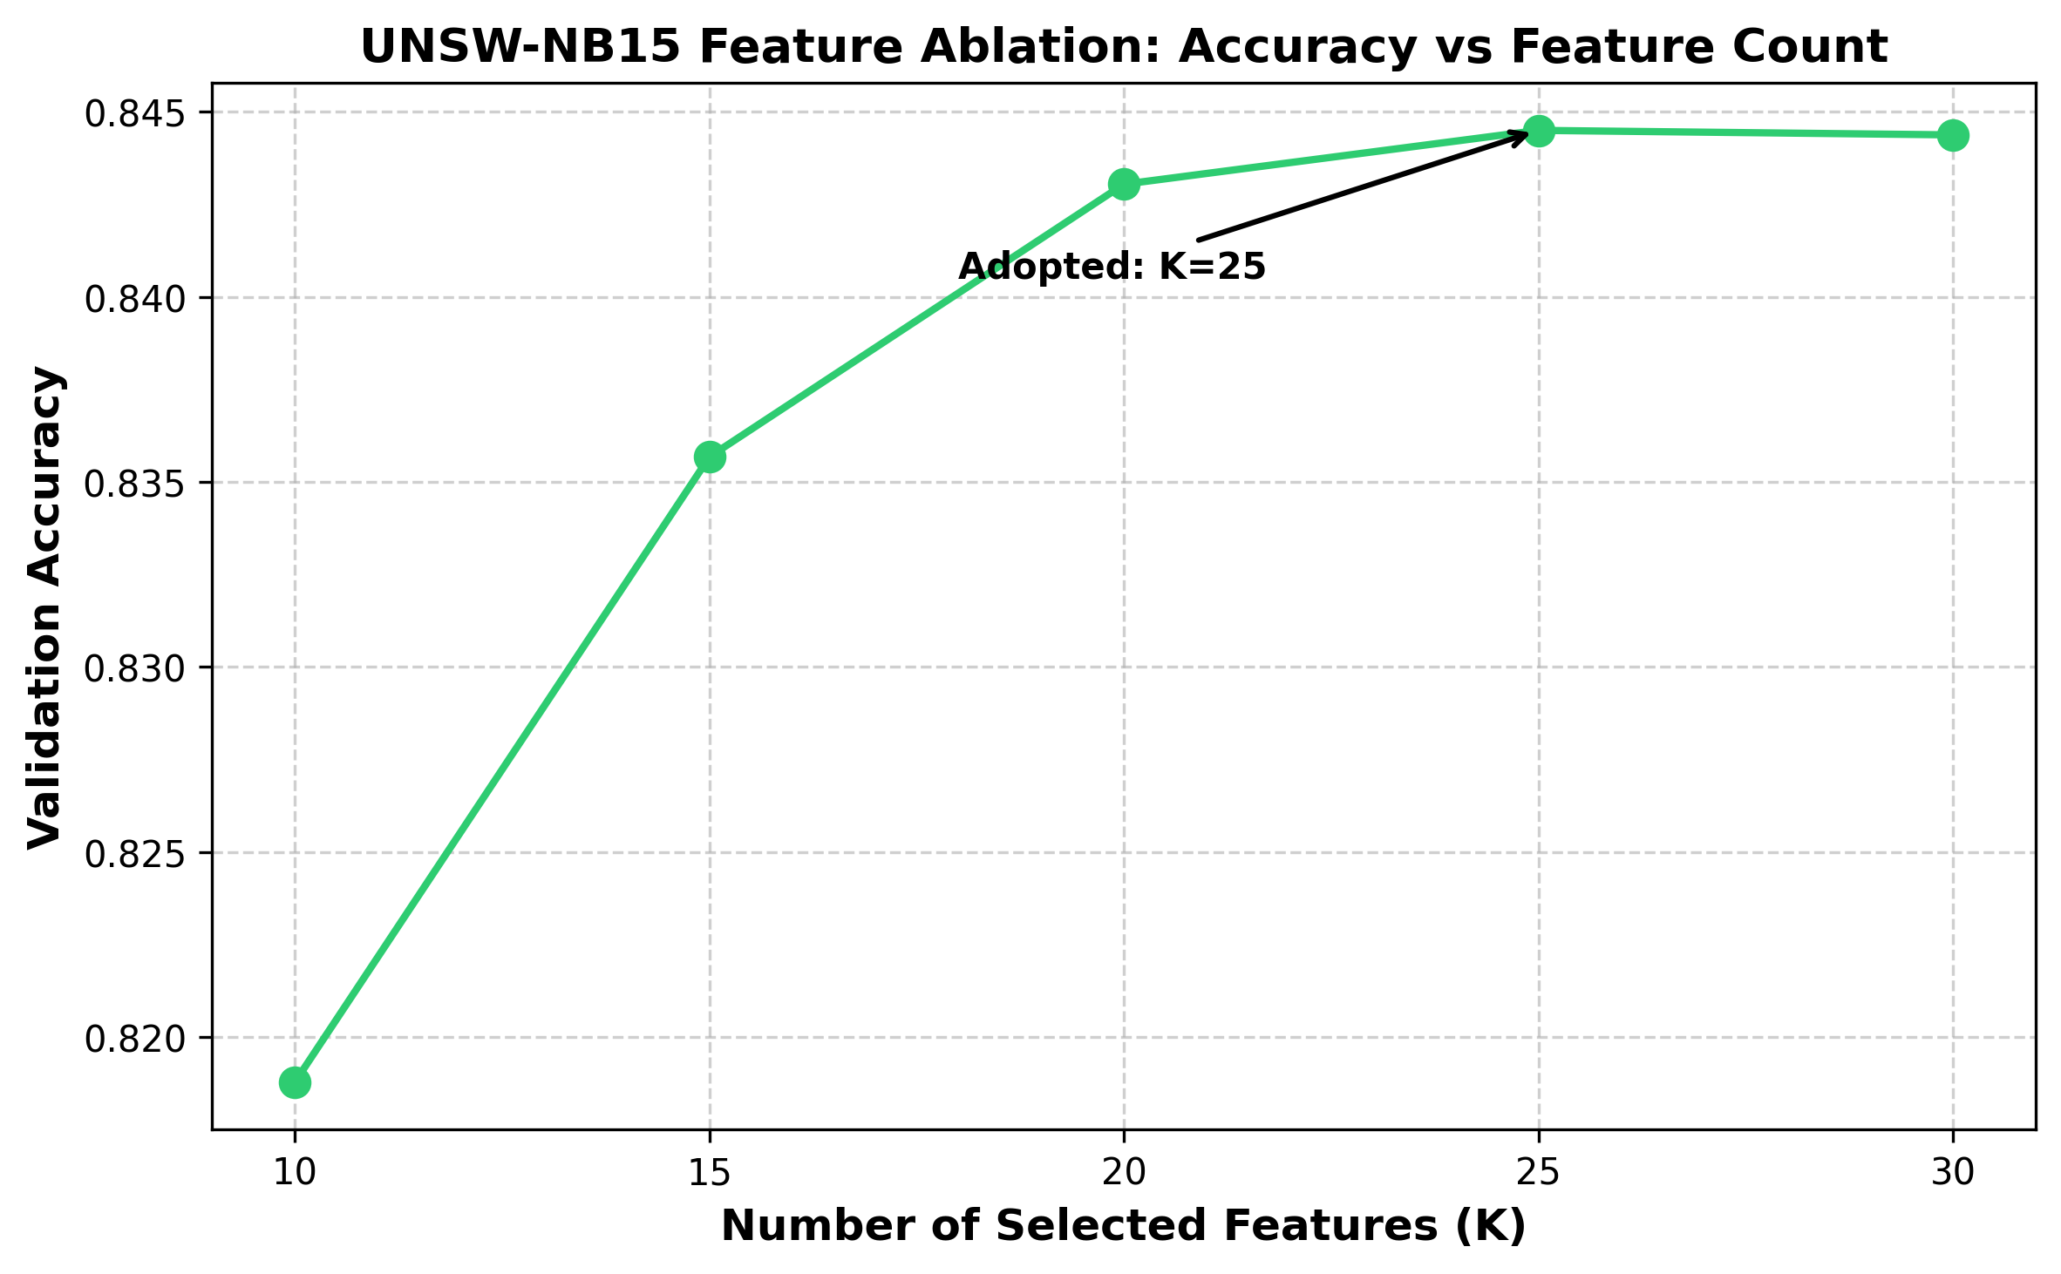
Fig. U1 Feature-count ablation on UNSW-NB15
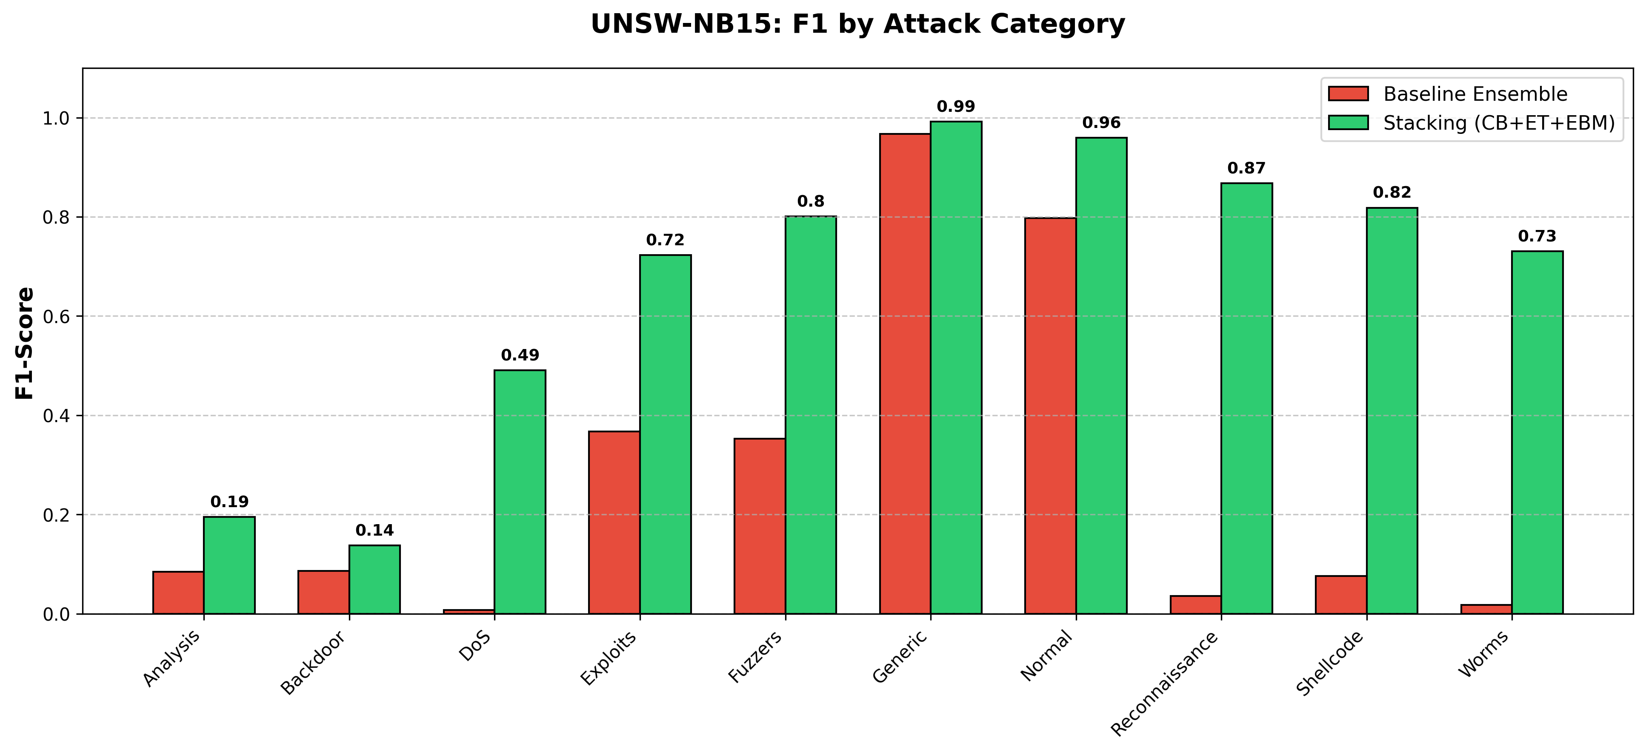
Fig. U2 Per-class F1, baseline vs stacked ensemble (UNSW-NB15)
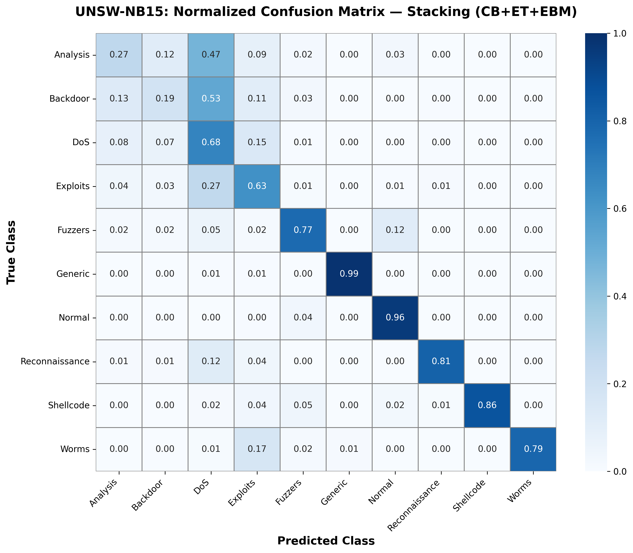
Fig. U3 Normalised confusion matrix of the stacked ensemble (UNSW-NB15)
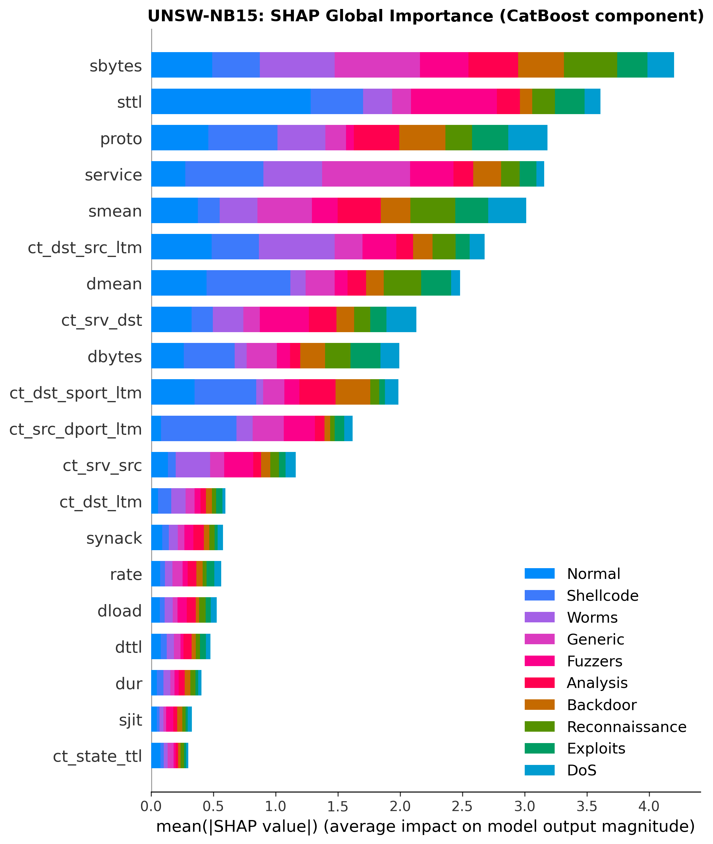
Fig. U4 SHAP global feature importance, CatBoost component (UNSW-NB15)
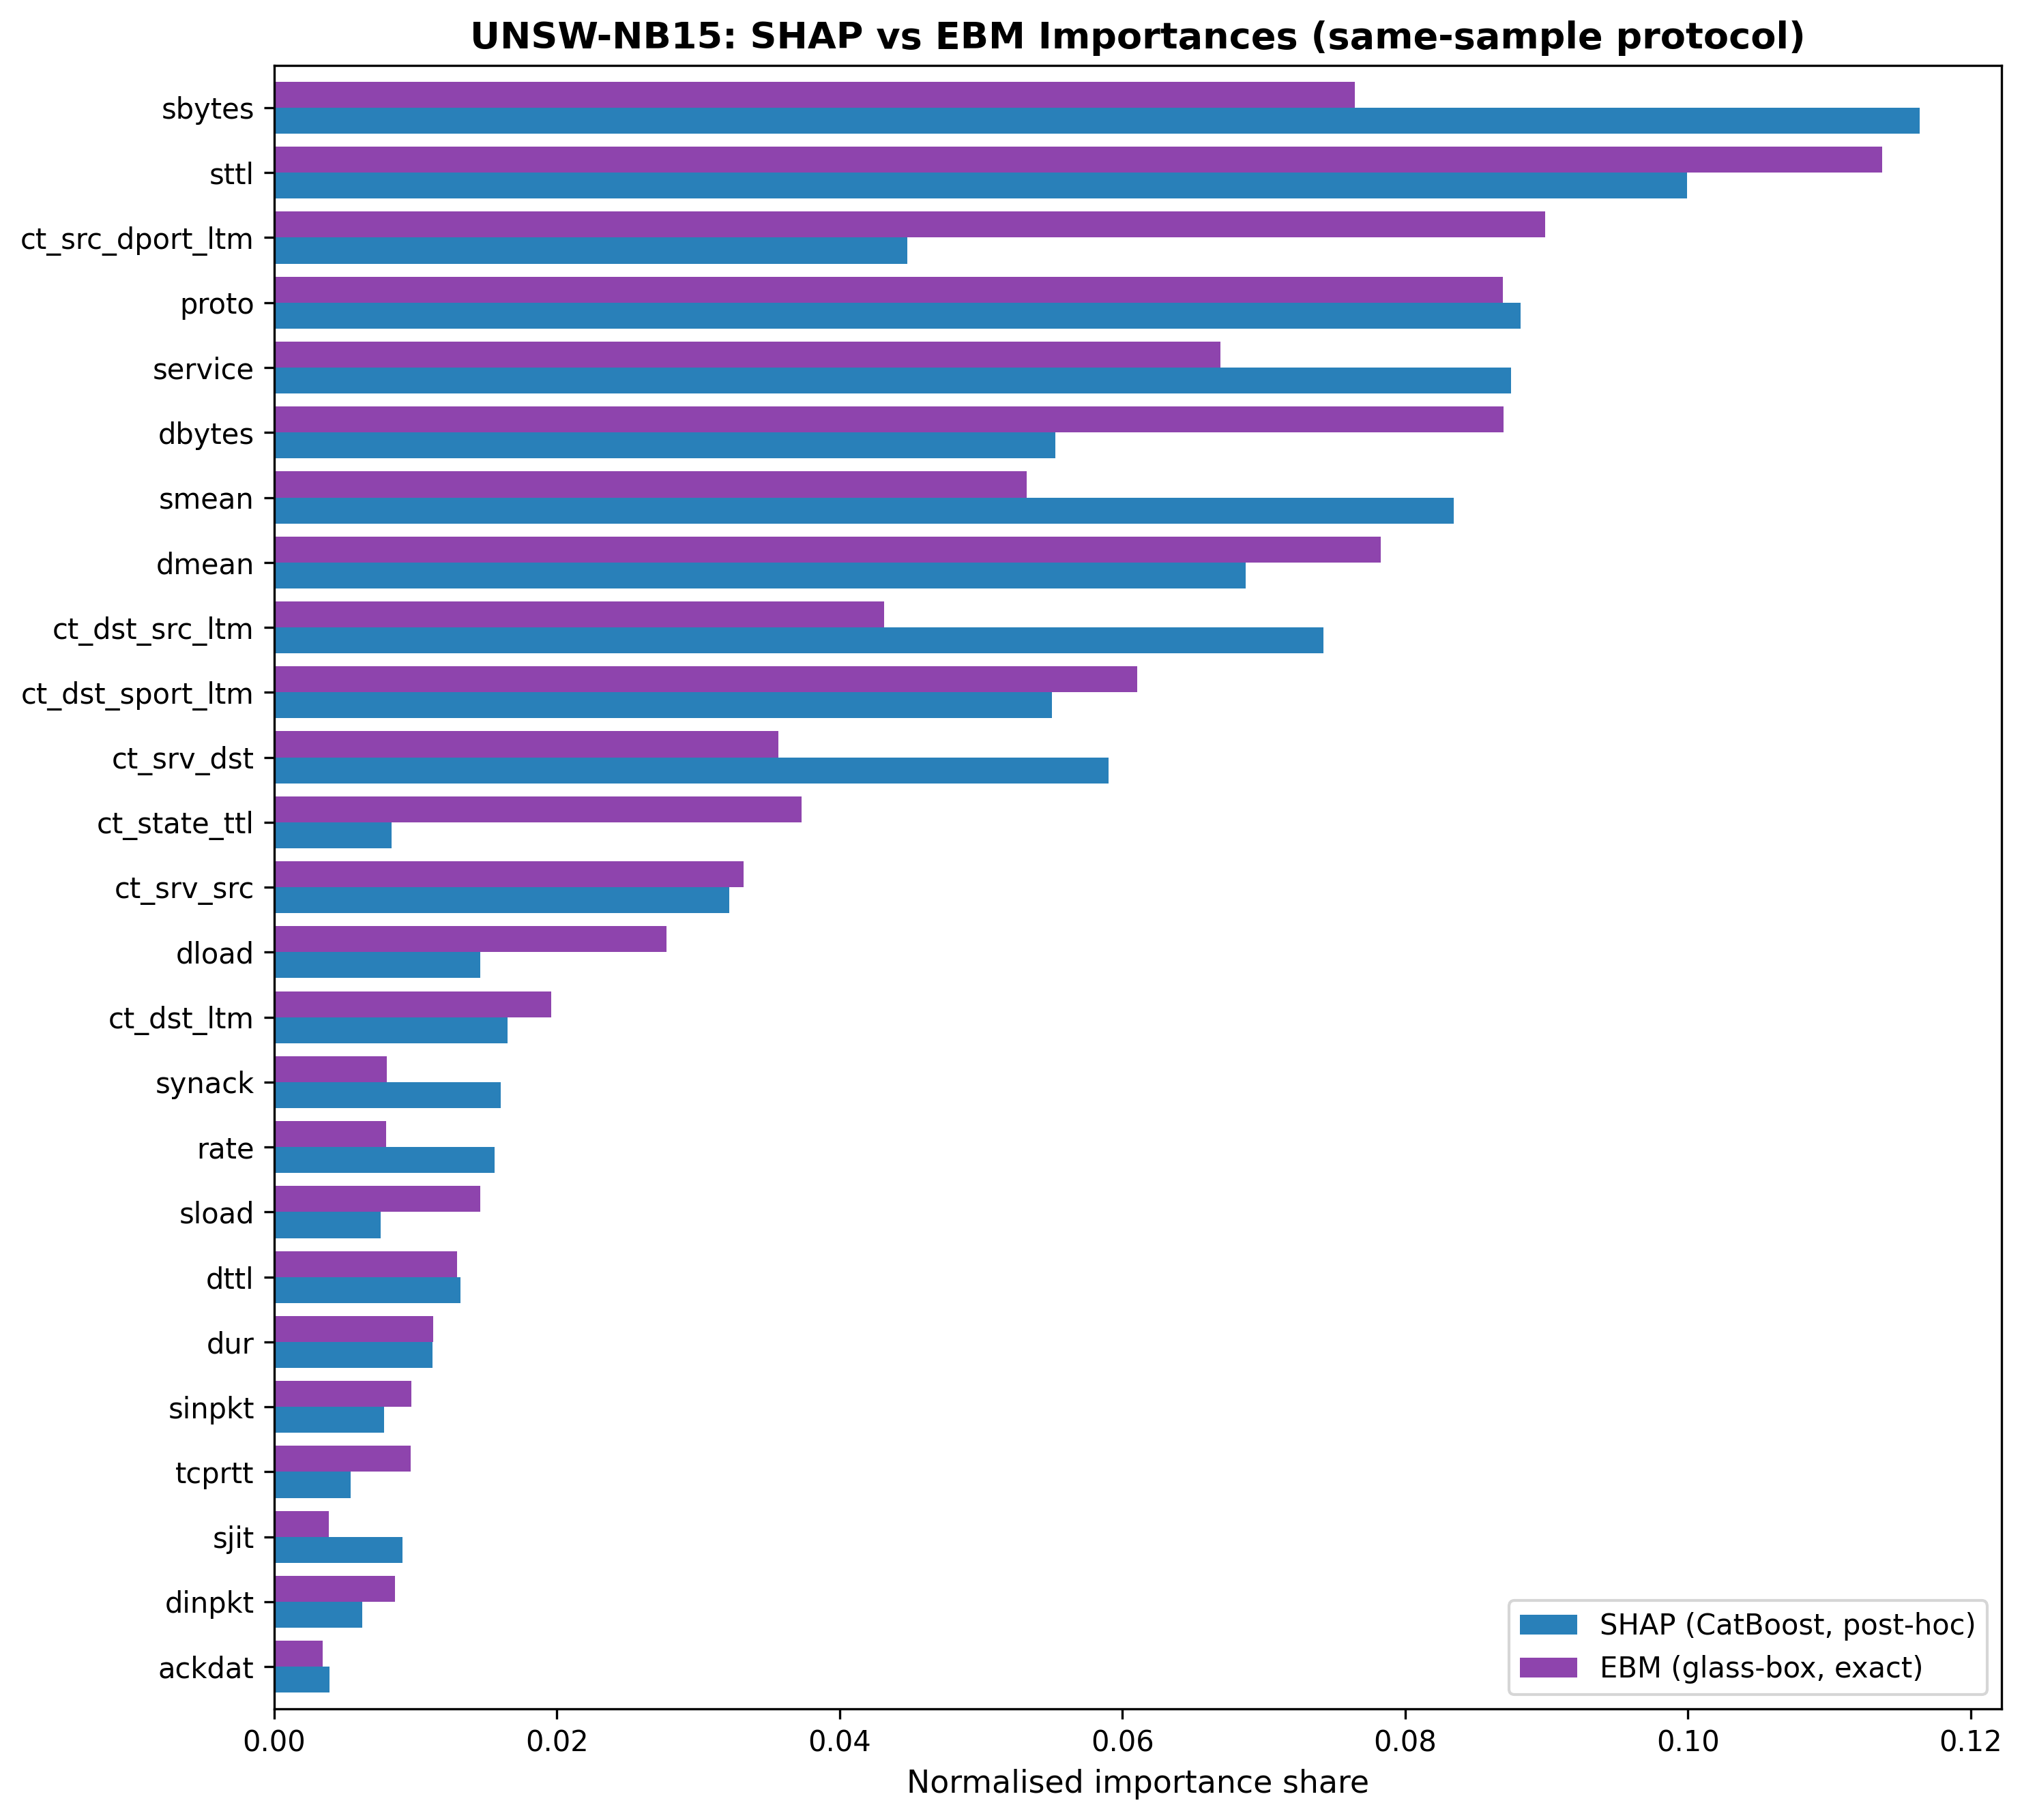
Fig. U5 Normalised importance shares, SHAP vs EBM (UNSW-NB15)
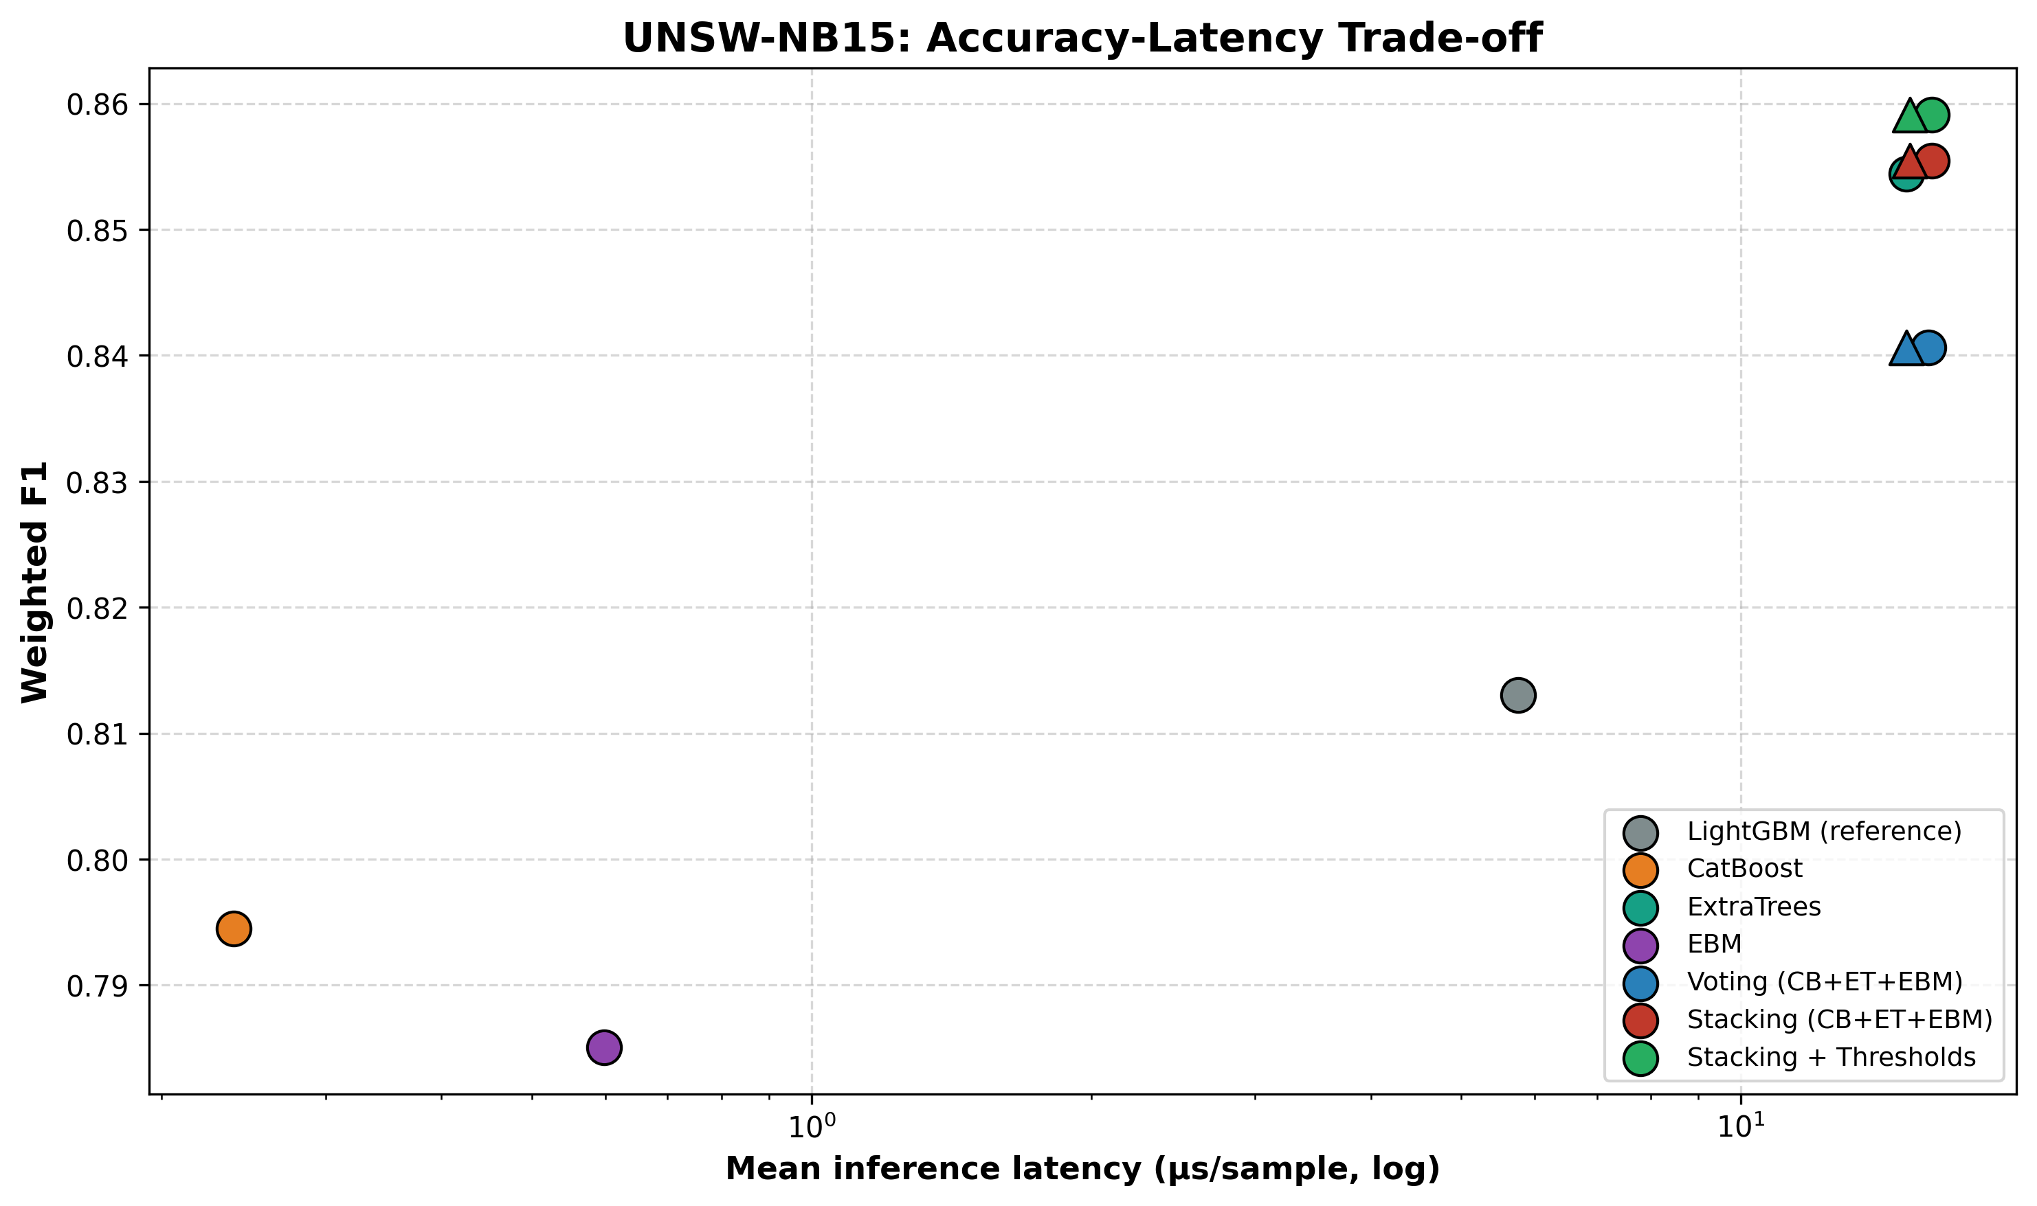
Fig. U6 Accuracy–latency trade-off (UNSW-NB15)
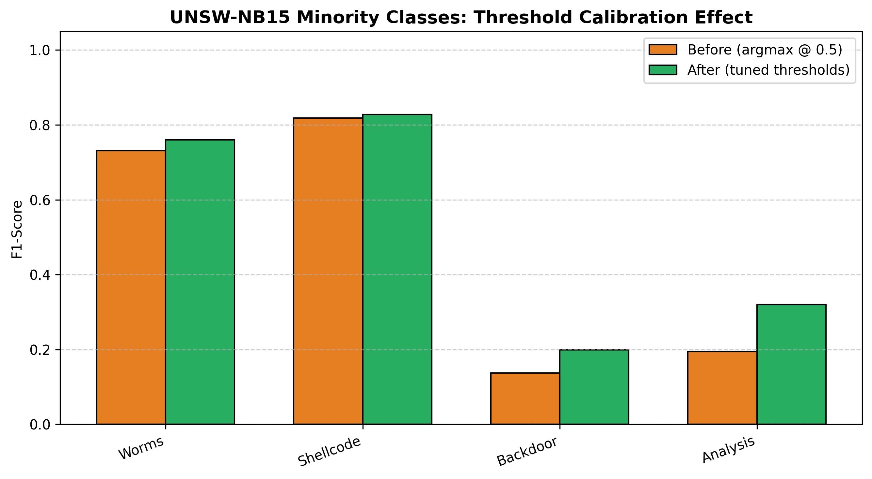
Fig. U7 Minority-class F1 before/after threshold calibration (UNSW-NB15)

4.8. Positioning Relative to Published Results
Reported accuracies on CICIDS-2017 commonly exceed 99%, so a leaderboard comparison of headline accuracy would be uninformative and, given the heterogeneity of preprocessing across studies, potentially misleading. The practical challenges of meaningful comparison across NIDS systems have been systematically documented (Apruzzese et al. 2023b). Published pipelines differ in sampling fraction, train/test protocol, the set of retained classes, and whether resampling and feature selection are confined to training data; several widely cited results apply SMOTE before cross-validation, which inflates minority-class scores through test-set leakage, a recognised pitfall in security-oriented machine learning (Arp et al. 2022). The highest reported accuracy in Table 13, 1.000 (Arreche et al. 2024a), is achieved on a 7-class label set using prediction probabilities as stacking inputs; our 12-class evaluation is a substantially harder task, and macro-F1 is a more diagnostic metric than headline accuracy when class sizes differ by three orders of magnitude. We therefore do not claim a new state-of-the-art accuracy. The contribution is methodological and is designed to be robust to these confounds: a controlled demonstration that paradigm diversity, not added members, is what lets an ensemble beat its best member; a leak-controlled evaluation in which resampling and threshold calibration never touch held-out data; and an explanation-consistency result that holds on two benchmarks built by different feature extractors. For readers seeking direct comparability, all hyperparameters, the fold protocol, and the class list are disclosed in Table 2 so that the reported numbers can be reproduced exactly rather than compared across incommensurable protocols. The same reasoning governs comparison with the recent explainable-IDS systems of Section 2.1: their headline metrics arise from different label sets and protocols, and none reports an explanation-consistency measurement, which is the quantity this work is designed to deliver.

Table 13. Related works on CICIDS-2017. † Weighted/overall F1. ‡ Macro-F1 (all 12 classes weighted equally). Fitni and Ramli (2020) uses CSE-CIC-IDS2018; Al-Omari and Al-Haija (2024) uses UNSW-NB15 only; both excluded.
Ref | Study | Method | Acc | F1 | Notes
 | Arreche et al. 2024 | Two-level ensemble | 1.000 | 1.000† | 7-class; Level 01 prediction-probability stacking; best of XGB/LGBM/Bag_DT/Bag_LGBM (their Table 15). IEEE Access 2024.
 | Arreche et al. 2024 | XAI-IDS (best of 7 models) | 0.990 | 0.990† | 7-class; XAI-IDS, best of 7 black-box classifiers (ADA, top-15 features, their Table 9). Appl. Sci. 2024.
Ours | This work | Stacking (CB+ET+EBM) + thresholds | 0.9983 | 0.8982‡ | 12-class; 5-fold CV; leak-proof; wF1=0.9984; MCC=0.9951
Note: protocol differences (sampling fraction, CV approach, class set, leakage controls) prevent direct metric comparison; see the discussion opening this section.

Table 14. Positioning summary — related works on UNSW-NB15. Moustafa and Slay (2015) is a dataset introduction paper with no classification results. Binary-classification result (Al-Omari and Al-Haija (2024)) is not directly comparable to our 10-class setup.
Ref | Study | Method | Acc | F1 | Notes
 | Moustafa & Slay 2015 | -- | -- | -- | Dataset introduction paper (MilCIS 2015); no classification results in paper; verified from PDF
 | Al-Omari & Al-Haija 2024 | Hybrid FS (CA+MI+RFECV) + RF | 0.978 | 0.978 | Verified from paper PDF; binary classification; 22 features; JISIS 14:2 2024
Ours | This work | Stacking (CB+ET+EBM) + thresholds | 0.8141 | 0.5817 | 5-fold CV; leak-proof; wF1=0.8206; MCC=0.7618; 10 classes (9 attack categories plus Normal)
Note: 'F1' for binary studies collapses to standard binary F1; our macro-F1 is averaged over all 10 classes (9 attack categories plus Normal).

5. Limitations and Future Work
Cross-dataset transfer without retraining remains hard. Although both datasets were evaluated natively (Sections 4.1–4.6 on CICIDS-2017, Section 4.7 on UNSW-NB15), a model trained on one and applied to the other without retraining transfers poorly, because the two feature extractors are largely disjoint: CICIDS-2017's CICFlowMeter computes packet-length-variance and inter-arrival statistics that UNSW-NB15's toolchain does not, so transplanted models receive zero-filled inputs for their most informative features. Robust transfer in NIDS remains bottlenecked by the absence of a standardised feature extractor; the present work addresses generalisation by native retraining and by demonstrating that the architecture and its explanation-consistency property hold on both benchmarks, rather than by claiming zero-shot transfer.
Day-siloed attack structure precludes a naive temporal-generalisation test on CICIDS-2017. We initially attempted a chronological train/test split (Monday–Wednesday train, Thursday–Friday test) as a check against the temporal-snooping risk that random cross-validation carries (Arp et al. 2022, already cited). This is not achievable on CICIDS-2017 as constructed: every attack type in the benchmark occurs on exactly one collection day (brute-force on Tuesday, DoS on Wednesday, web-attacks and infiltration on Thursday, botnet/PortScan/DDoS on Friday), so any day-based boundary places each attack type entirely on one side, and restricting evaluation to classes present in both partitions collapses the test set to pure BENIGN traffic. We replaced this with the held-out-class design of Section 4.5.3, which does not depend on collection day. Researchers attempting a day-based temporal split on CICIDS-2017 for any purpose should be aware this limitation applies regardless of which boundary is chosen.
Computational scope and fixed configuration. CICIDS-2017 experiments use a 20% stratified sample (565,563 flows), a disclosed design parameter; stratification preserves the full class distribution. The subsample caused the three rarest classes (Heartbleed, Infiltration, SQL Injection) to fall below the 15-sample floor and be excluded (Section 3.1), so the reported minority-class results do not cover the very rarest CICIDS-2017 attacks. Documented labelling imperfections in CICIDS-2017, which partly concern web-attack traffic (Engelen et al. 2021), counsel additional caution for the absolute web-attack figures in Section 4.3. All model hyperparameters were fixed a priori (Table 2) without per-dataset tuning, so the voting-versus-stacking comparison characterises the combination rule under one disclosed configuration; margins could shift under per-model hyperparameter optimisation.
Both datasets cap EBM's per-fold training at 100,000 rows, a standard scalability measure whose effect is bounded given EBM's competitive standalone accuracy. Feature-selection leakage was tested directly with a control experiment. Although the hybrid Mutual-Information-plus-Random-Forest ranking in the main pipeline is computed once on the full data, we re-ran the entire stacked-ensemble evaluation with the ranking re-derived inside each fold on training data only, on the same fold partition. On UNSW-NB15, this left performance essentially unchanged (accuracy Δ=−0.0005, macro-F1 Δ=−0.0011), with 100% of selected features shared per fold, confirming the global ranking confers no optimistic bias on that dataset. On CICIDS-2017 the result differs: in-fold FS yields accuracy 0.9970 vs 0.9983 (delta -0.001) and macro-F1 0.8625 vs 0.8982 (delta -0.036), with 85% feature overlap per fold. The accuracy gap is negligible; the macro-F1 gap reflects noisier within-fold MI estimation for the rarest attack classes, each contributing under 0.2% of per-fold training samples and producing less stable per-fold rankings than on UNSW-NB15. The reported macro-F1 of 0.8982 is therefore an overestimate; the leak-free in-fold estimate of 0.8625 is the conservative figure for minority-class performance, and the per-class web-attack results of Sections 4.2–4.3 inherit the same optimism. Residual minority weakness: on CICIDS-2017, XSS precision (0.33) reflects genuine statistical overlap with benign HTTPS traffic in flow space; on UNSW-NB15, the Analysis and Backdoor classes overlap similarly; both are boundaries of flow-based detection that only payload-aware (deep-packet-inspection) features could cross. Threshold transferability: tuned thresholds reflect each dataset's class prevalence and should be re-calibrated per deployment, which the leak-free calibration-slice procedure makes routine. Categorical encoding: UNSW-NB15's proto, service, and state fields were ordinally label-encoded for all members; one-hot or target encoding may shift their attributions. Future work: federated deployment of the glass-box-augmented stack (Rey et al. 2022); adversarial robustness testing (Apruzzese et al. 2023a); and extending the agreement study to per-class and per-sample (local) explanation consistency.

6. Conclusion
This work set out to make the explanations a deployed NIDS delivers to its operators checkable, and to show that the check can be built into the system itself. Embedding the glass-box EBM as a deployed base learner enabled a direct empirical test of whether cross-model explanation agreement functions as an operational trust signal — a claim implicit in prior explanation-consistency proposals (Section 2.1) but, to our knowledge, not previously tested against a confidence baseline with proper statistics. It does not: across in-distribution error prediction (Section 4.5.3), out-of-distribution novelty detection across four held-out attack classes (Section 4.5.3), and cross-dataset replication on UNSW-NB15 (Section 4.5.4), the sign and usefulness of the divergence signal varied by scenario and dataset, and a well-calibrated confidence score already available from the stacking meta-learner outperformed it in the large majority of tested conditions. We report this as a rigorously-tested negative result rather than retreat to a narrower positive claim: it corrects an intuitive but unverified assumption in the explainable-IDS literature, using statistical machinery (paired DeLong tests, cross-validated incremental AUROC, bootstrap confidence intervals, multi-class and cross-dataset replication) more thorough than is typical for this kind of claim, and it surfaces two independently useful findings along the way — that CICIDS-2017's day-siloed attack structure precludes naive temporal-split evaluation (Section 5), and that single-point explanation-agreement estimates carry meaningful refit-to-refit variability that background-sampling bootstrap confidence intervals alone do not capture (Section 4.5). The detection engineering underneath the framework began from a negative result: a conventional XGBoost+LightGBM+Random-Forest voting ensemble could not beat its own best member. That result was converted into an architecture: three structurally different learners (CatBoost, ExtraTrees, EBM) combined by stacked generalisation under a leak-proof, fully paired evaluation. The stacked ensemble reaches 99.83% accuracy (weighted F1 0.9984, MCC 0.9951), significantly outperforming its best base member and a strong LightGBM reference (28.1% relative error reduction), where soft voting fails both tests. Inter-arrival-time features emerged as the binding constraint on web-attack detection in the feature-count ablation (worth 4–5× in minority F1, more than any resampling strategy, though not isolated by a controlled single-group ablation), and real-prevalence threshold calibration gives operators an inspectable false-alarm dial with a statistically significant net accuracy benefit. At 4.33 µs parallel inference on CICIDS-2017 (29.8 µs on UNSW-NB15), the system meets real-time requirements on commodity hardware. Critically, the diversity-driven mechanism, the stacking advantage, and the threshold-calibration benefit all replicate under native retraining on UNSW-NB15, a benchmark built by a different feature-extraction toolchain, evidence that these contributions are not specific to a single feature-extraction toolchain; the raw SHAP-EBM correlation itself also strengthens there (ρ = 0.840), even though, as Section 4.5.4 shows, the operational usefulness of that divergence as a trust signal does not transfer in the same direction — a further instance of the dissociation between raw agreement and demonstrated usefulness this paper documents throughout. The CICIDS-2017 macro-F1 of 0.8982 reflects the global feature-ranking pipeline used throughout; in-fold feature ranking, tested as a leakage-control experiment in Section 5, yields a conservative estimate of 0.8625, with 85% feature overlap per fold and no effect on any comparative conclusion or the stacking advantage. Together, these results argue that explanation-consistent intrusion detection is achieved not by attaching explanations to an accurate black box, but by building ensembles whose accuracy and explanation consistency are evaluated within the same architecture.

References
Ahmad Z, Shahid Khan A, Wai Shiang C (2021) Network intrusion detection system: A systematic study of machine learning and deep learning approaches. Transactions on Emerging Telecommunications Technologies 32(1):e4150. https://doi.org/10.1002/ett.4150
AL-Nomasy N, Alamri A, Aljuhani A, Kumar P (2025) Transformer-based knowledge distillation for explainable intrusion detection system. Computers & Security 154:104417. https://doi.org/10.1016/j.cose.2025.104417
Al-Omari M, Al-Haija QA (2024) Towards robust IDSs: An integrated approach of hybrid feature selection and machine learning. Journal of Internet Services and Information Security 14(2). https://doi.org/10.58346/JISIS.2024.I2.004
Apruzzese G, Laskov P, Schneider J (2023b) SoK: Pragmatic assessment of machine learning for network intrusion detection. 2023 IEEE 8th European Symposium on Security and Privacy (EuroS&P), 1–21. https://doi.org/10.1109/eurosp57164.2023.00042
Apruzzese G, Laskov P, Montes de Oca E (2023a) The role of machine learning in cybersecurity. Digital Threats: Research and Practice 4(1):1–38. https://doi.org/10.1145/3545574
Arp D, Quiring E, Pendlebury F, Warnecke A, Pierazzi F, Wressnegger C, Cavallaro L, Rieck K (2022) Dos and don’ts of machine learning in computer security. Proceedings of the 31st USENIX Security Symposium, 3971–3988. https://www.usenix.org/conference/usenixsecurity22/presentation/arp
Arreche O, Bibers I, Abdallah M (2024a) A two-level ensemble learning framework for enhancing network intrusion detection systems. IEEE Access 12:83830–83857. https://doi.org/10.1109/ACCESS.2024.3407029
Arreche O, Guntur T, Abdallah M (2024b) XAI-IDS: Toward proposing an explainable artificial intelligence framework for enhancing network intrusion detection systems. Applied Sciences 14(10):4170. https://doi.org/10.3390/app14104170
Arreche O, Guntur TR, Roberts JW, Abdallah M (2024c) E-XAI: Evaluating black-box explainable AI frameworks for network intrusion detection. IEEE Access 12:23954–23988. https://doi.org/10.1109/ACCESS.2024.3365140
Battiti R (1994) Using mutual information for selecting features in supervised neural net learning. IEEE Transactions on Neural Networks 5(4):537–550. https://doi.org/10.1109/72.298224
Breiman L (2001) Random forests. Machine Learning 45(1):5–32. https://doi.org/10.1023/A:1010933404324
Buda M, Maki A, Mazurowski MA (2018) A systematic study of the class imbalance problem in convolutional neural networks. Neural Networks 106:249–259. https://doi.org/10.1016/j.neunet.2018.07.011
Caruana R, Lou Y, Gehrke J, Koch P, Sturm M, Elhadad N (2015) Intelligible models for healthcare: Predicting pneumonia risk and hospital 30-day readmission. Proceedings of the 21st ACM SIGKDD International Conference on Knowledge Discovery and Data Mining, 1721–1730. https://doi.org/10.1145/2783258.2788613
Cerasuolo F, Bovenzi G, Ciuonzo D, Pescapè A (2025) Adaptable, incremental, and explainable network intrusion detection systems for internet of things. Engineering Applications of Artificial Intelligence 144:110143. https://doi.org/10.1016/j.engappai.2025.110143
Chawla NV, Bowyer KW, Hall LO, Kegelmeyer WP (2002) SMOTE: Synthetic minority over-sampling technique. Journal of Artificial Intelligence Research 16:321–357. https://doi.org/10.1613/jair.953
Chen T, Guestrin C (2016) XGBoost: A scalable tree boosting system. Proceedings of the 22nd ACM SIGKDD International Conference on Knowledge Discovery and Data Mining, 785–794. https://doi.org/10.1145/2939672.2939785
Demsar J (2006) Statistical comparisons of classifiers over multiple data sets. Journal of Machine Learning Research 7:1–30. https://jmlr.org/papers/v7/demsar06a.html
Dietterich TG (2000) Ensemble methods in machine learning. Multiple Classifier Systems, Lecture Notes in Computer Science 1857:1–15. https://doi.org/10.1007/3-540-45014-9_1
Dietterich TG (1998) Approximate statistical tests for comparing supervised classification learning algorithms. Neural Computation 10(7):1895–1923. https://doi.org/10.1162/089976698300017197
Draper-Gil G, Lashkari AH, Mamun MSI, Ghorbani AA (2016) Characterization of encrypted and VPN traffic using time-related features. Proceedings of the 2nd International Conference on Information Systems Security and Privacy (ICISSP), 407–414. https://doi.org/10.5220/0005740704070414
D’hooge L, Wauters T, Volckaert B, De Turck F (2020) Inter-dataset generalization strength of supervised machine learning methods for intrusion detection. Journal of Information Security and Applications 54:102564. https://doi.org/10.1016/j.jisa.2020.102564
Elkan C (2001) The foundations of cost-sensitive learning. Proceedings of the 17th International Joint Conference on Artificial Intelligence (IJCAI), 973–978.
Engelen G, Rimmer V, Joosen W (2021) Troubleshooting an intrusion detection dataset: The CICIDS2017 case study. 2021 IEEE Security and Privacy Workshops (SPW), 7–12. https://doi.org/10.1109/SPW53761.2021.00009
Fitni QRS, Ramli K (2020) Implementation of ensemble learning and feature selection for performance improvements in anomaly-based intrusion detection systems. 2020 IEEE International Conference on Industry 4.0, Artificial Intelligence, and Communications Technology (IAICT), 118–124. https://doi.org/10.1109/IAICT50021.2020.9172014
Friedman JH (2001) Greedy function approximation: A gradient boosting machine. The Annals of Statistics 29(5):1189–1232. https://doi.org/10.1214/aos/1013203451
Gao Y, Yang L, Zhu R, Wu Y, Yang F, Cao Y (2025) IR-IDS: A network intrusion detection method based on causal feature selection and explainable model optimization. Computers & Security 155:104496. https://doi.org/10.1016/j.cose.2025.104496
Geurts P, Ernst D, Wehenkel L (2006) Extremely randomized trees. Machine Learning 63(1):3–42. https://doi.org/10.1007/s10994-006-6226-1
Guo C, Pleiss G, Sun Y, Weinberger KQ (2017) On calibration of modern neural networks. Proceedings of the 34th International Conference on Machine Learning (ICML), PMLR 70, 1321–1330. https://proceedings.mlr.press/v70/guo17a.html
Hartl A, Fabini J, Zseby T (2020) Explainability of machine learning models for network intrusion detection. 2020 IFIP Networking Conference, 1–9.
He H, Bai Y, Garcia EA, Li S (2008) ADASYN: Adaptive synthetic sampling approach for imbalanced learning. 2008 IEEE International Joint Conference on Neural Networks (IJCNN), 1322–1328. https://doi.org/10.1109/IJCNN.2008.4633969
He H, Garcia EA (2009) Learning from imbalanced data. IEEE Transactions on Knowledge and Data Engineering 21(9):1263–1284. https://doi.org/10.1109/TKDE.2008.239
Ke G, Meng Q, Finley T, Wang T, Chen W, Ma W, Ye Q, Liu T (2017) LightGBM: A highly efficient gradient boosting decision tree. Advances in Neural Information Processing Systems 30:3149–3157.
Krishna S, Han T, Gu A, Pombra J, Jabbari S, Wu ZS, Lakkaraju H (2022) The disagreement problem in explainable machine learning: A practitioner’s perspective. arXiv:2202.01602. https://doi.org/10.48550/arXiv.2202.01602
Kuncheva LI, Whitaker CJ (2003) Measures of diversity in classifier ensembles and their relationship with the ensemble accuracy. Machine Learning 51(2):181–207. https://doi.org/10.1023/A:1022859003006
Lemaître G, Nogueira F, Aridas CK (2017) Imbalanced-learn: A Python toolbox to tackle the curse of imbalanced datasets in machine learning. Journal of Machine Learning Research 18(17):1–5.
Lou Y, Caruana R, Gehrke J, Hooker G (2013) Accurate intelligible models with pairwise interactions. Proceedings of the 19th ACM SIGKDD International Conference on Knowledge Discovery and Data Mining, 623–631. https://doi.org/10.1145/2487575.2487579
Lou Y, Caruana R, Gehrke J (2012) Intelligible models for classification and regression. Proceedings of the 18th ACM SIGKDD International Conference on Knowledge Discovery and Data Mining, 150–158. https://doi.org/10.1145/2339530.2339556
Lundberg SM, Lee S (2017) A unified approach to interpreting model predictions. Advances in Neural Information Processing Systems 30:4765–4774.
Lundberg SM, Erion G, Chen H, DeGrave A, Prutkin JM, Nair B, Katz R, Himmelfarb J, Bansal N, Lee S (2020) From local explanations to global understanding with explainable AI for trees. Nature Machine Intelligence 2:56–67. https://doi.org/10.1038/s42256-019-0138-9
Mirsky Y, Doitshman T, Elovici Y, Shabtai A (2018) Kitsune: An ensemble of autoencoders for online network intrusion detection. Proceedings of the 2018 Network and Distributed System Security Symposium (NDSS). https://doi.org/10.14722/ndss.2018.23204
Mohale VZ, Obagbuwa IC (2025) A systematic review on the integration of explainable artificial intelligence in intrusion detection systems to enhancing transparency and interpretability in cybersecurity. Frontiers in Artificial Intelligence 8:1526221. https://doi.org/10.3389/frai.2025.1526221
Moustafa N, Slay J (2015) UNSW-NB15: A comprehensive data set for network intrusion detection systems (UNSW-NB15 network data set). 2015 Military Communications and Information Systems Conference (MilCIS), 1–6. https://doi.org/10.1109/MilCIS.2015.7348942
Neto ECP, Dadkhah S, Ferreira R, Zohourian A, Lu R, Ghorbani AA (2023) CICIoT2023: A real-time dataset and benchmark for large-scale attacks in IoT environment. Sensors 23(13):5941. https://doi.org/10.3390/s23135941
Neupane S, Ables J, Anderson W, Mittal S, Rahimi S, Banicescu I, Seale M (2022) Explainable intrusion detection systems (X-IDS): A survey of current methods, challenges, and opportunities. IEEE Access 10:112392–112415. https://doi.org/10.1109/ACCESS.2022.3216617
Niculescu-Mizil A, Caruana R (2005) Predicting good probabilities with supervised learning. Proceedings of the 22nd International Conference on Machine Learning, 625–632. https://doi.org/10.1145/1102351.1102430
Nori H, Jenkins S, Koch P, Caruana R (2019) InterpretML: A unified framework for machine learning interpretability. arXiv:1909.09223. https://doi.org/10.48550/arXiv.1909.09223
Pedregosa F, Varoquaux G, Gramfort A, Michel V, Thirion B, Grisel O, Blondel M, Prettenhofer P, Weiss R, Dubourg V, Vanderplas J, Passos A, Cournapeau D, Brucher M, Perrot M, Duchesnay E (2011) Scikit-learn: Machine learning in Python. Journal of Machine Learning Research 12:2825–2830.
Prokhorenkova L, Gusev G, Vorobev A, Dorogush AV, Gulin A (2018) CatBoost: Unbiased boosting with categorical features. Advances in Neural Information Processing Systems 31:6639–6649.
Rey V, Sánchez Sánchez PM, Huertas Celdrán A, Bovet G (2022) Federated learning for malware detection in IoT devices. Computer Networks 204:108693. https://doi.org/10.1016/j.comnet.2021.108693
Ribeiro MT, Singh S, Guestrin C (2016) “Why should I trust you?”: Explaining the predictions of any classifier. Proceedings of the 22nd ACM SIGKDD International Conference on Knowledge Discovery and Data Mining, 1135–1144. https://doi.org/10.1145/2939672.2939778
Rudin C (2019) Stop explaining black box machine learning models for high stakes decisions and use interpretable models instead. Nature Machine Intelligence 1(5):206–215. https://doi.org/10.1038/s42256-019-0048-x
Sharafaldin I, Lashkari AH, Ghorbani AA (2018) Toward generating a new intrusion detection dataset and intrusion traffic characterization. Proceedings of the 4th International Conference on Information Systems Security and Privacy (ICISSP), 108–116. https://doi.org/10.5220/0006639801080116
Wali S, Farrukh YA, Khan I (2025) Explainable AI and Random Forest-based reliable intrusion detection system. Computers & Security 157:104542. https://doi.org/10.1016/j.cose.2025.104542
Wang M, Zheng K, Yang Y, Wang X (2020) An explainable machine learning framework for intrusion detection systems. IEEE Access 8:73127–73141. https://doi.org/10.1109/ACCESS.2020.2988359
Warnecke A, Arp D, Wressnegger C, Rieck K (2020) Evaluating explanation methods for deep learning in security. 2020 IEEE European Symposium on Security and Privacy (EuroS&P), 158–174. https://doi.org/10.1109/EuroSP48549.2020.00018
Wazid M, Singh J, Das AK, Rodrigues JJPC (2024) An ensemble-based machine learning-envisioned intrusion detection in Industry 5.0-driven healthcare applications. IEEE Transactions on Consumer Electronics 70(1):1903–1912. https://doi.org/10.1109/TCE.2023.3325209
Wolpert DH (1992) Stacked generalization. Neural Networks 5(2):241–259. https://doi.org/10.1016/S0893-6080(05)80023-1
Yin C, Zhu Y, Fei J, He X (2017) A deep learning approach for intrusion detection using recurrent neural networks. IEEE Access 5:21954–21961. https://doi.org/10.1109/ACCESS.2017.2762418

Statements and Declarations
Competing interests: The author declares no known competing financial interests or personal relationships that could have influenced this work.
Ethics approval and consent to participate: Not applicable. This study used only publicly available, pre-anonymised benchmark network-traffic datasets (CICIDS-2017 and UNSW-NB15) and did not involve human participants, human data, or animals.
Consent for publication: Not applicable.
Funding: This research received no external funding.
Data availability: CICIDS-2017 is publicly available from the Canadian Institute for Cybersecurity at https://www.unb.ca/cic/datasets/ids-2017.html. UNSW-NB15 is publicly available from the University of New South Wales at https://research.unsw.edu.au/projects/unsw-nb15-dataset. No new datasets were created in this study.
Code availability: The complete source code, trained models, experimental pipeline, evaluation scripts, and figure-generation notebooks used in this study are publicly available in the GlassBox-Stacked-NIDS repository at https://github.com/saif4224/glassbox-stacked-nids.
Declaration of Generative AI and AI-assisted technologies in the writing process: I (the author) have used a variety of AI-assisted tools in the course of preparing this work, including ChatGPT (OpenAI), Gemini (Google), and Claude (Anthropic), to improve the language, readability, grammar, clarity, and presentation of the manuscript. These tools were used solely for manuscript preparation and did not play a role in the research design, data analysis, interpretation of results, or scientific conclusions. The author employed these tools and subsequently reviewed, verified, and edited all content as needed and assumes sole responsibility for the accuracy, originality, and integrity of the published work.

