1. LOGIN -

HOW TO OPEN AND LOGIN

STEPS-

1. Open MAPS URL in your browser.
2. You will see the login page as shown below.
3. Enter your user name and password to login into MAP digitization system.

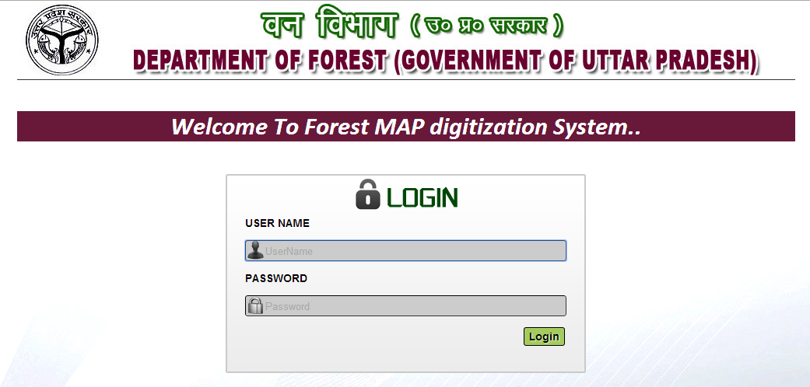

2. Forest Area (if pillars detail available) –

1. Click on Add forest Area button to create new MAP.
2. Click on Submit button after selecting Zone, Circle etc. to filter record.
3. Click on Edit button to edit that record.
4. Click on View button to view and export to excel that record.
5. Click on Enter link to enter Gazette detail of that record.
6. Click on View link to view Gazette detail of that record.
7. Click on Delete button to Delete permanently delete that record.

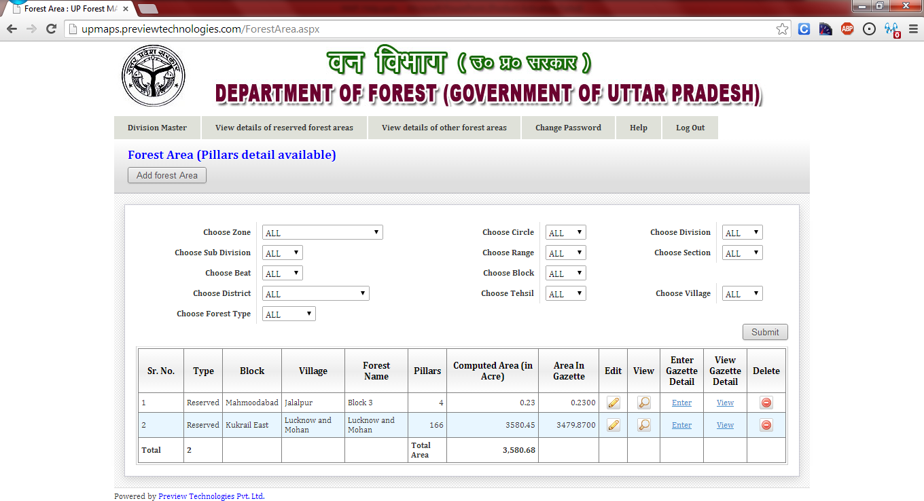

7

6

5

4

3

2

1

2. Enter Coordinates (New MAP) –

After Clicking Add forest Area button you will redirect to page shown below

1. Choose appropriate Zone, Circle, Division, Sub Division, Range, Section, Beat, Block etc.
2. Choose Reference Pillar Co-ordinates if you have co-ordinates of any pillar else if you have reference point co-ordinates choose Reference Point Co-ordinates.
3. Then enter Pillar no. or reference point no., latitude, longitude, forward bearings to next pillar, backward bearings to last pillar and distance in chains or meters.
4. Enter total pillar if you have reference point co-ordinates else enter total pillar numbers -1.
5. Enter Area in Gazette, Gazette date and Gazette No.
6. After entering total pillar numbers, a table generates with rows equal to numbers of pillar. You can enter Pillar no, Distance in Chains or meters, Back bearings to previous pillar and Forward bearings to next pillar. Bearing difference and GPS (Latitude and Longitude) will be calculated as per data entered by you.

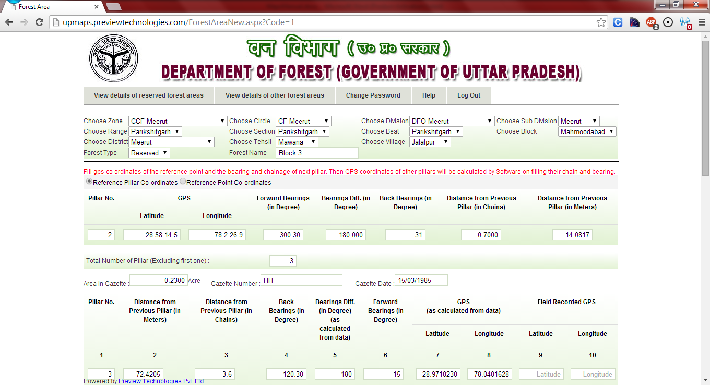

6

5

4

3

2

1

1. Enter all Distance and bearings in table.
2. After entering all data click Calculate Area button. This will calculate area of map entered by you
3. If you also entered field recorded GPS points then click on Calculate Field Area button to see field recorded map area.
4. If you have MAP images then upload them using Choose File button. You can upload multiple images.
5. After completing all actions click on Submit button to save all data in database.

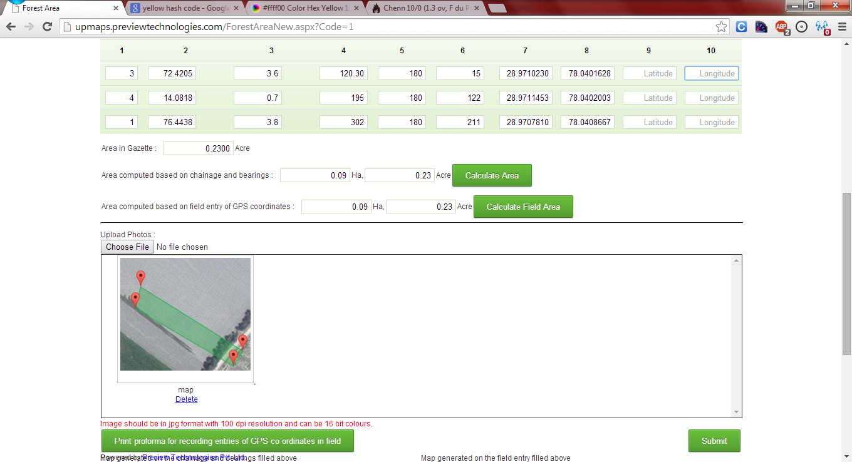

11

10

7

8

9

3. View MAP (Export to Excel) –

After creating new MAP if you want to export map data into excel file click on View button against that MAP.

1. Click on Export to Excel button to export co-ordinates into excel file.

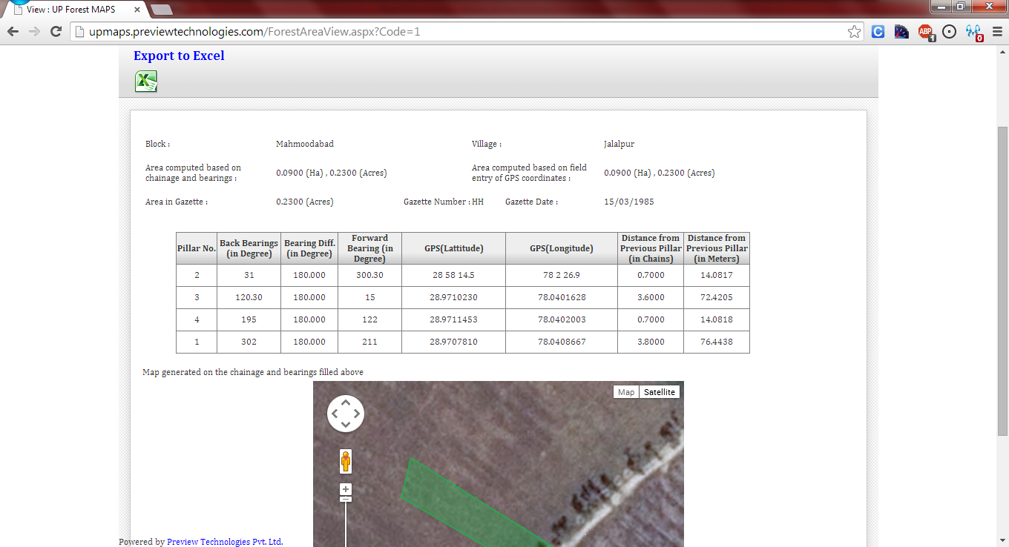

1

4. Enter Gazette Details –

After creating new MAP enter details of Gazette by clicking Enter Gazette Detail link against that map entry

1. Enter all details related to Gazette into provided textboxes.
2. Enter Pages in English/Hindi then click Add Photos button. A table will generate with rows equal to number of Pages entered.
3. Enter Gazette Page Number.
4. Click choose file to upload scanned copy of that page of Gazette.
5. Click delete button to remove row.
6. Click Save button to enter Gazette detail into database. Click discard to cancel.

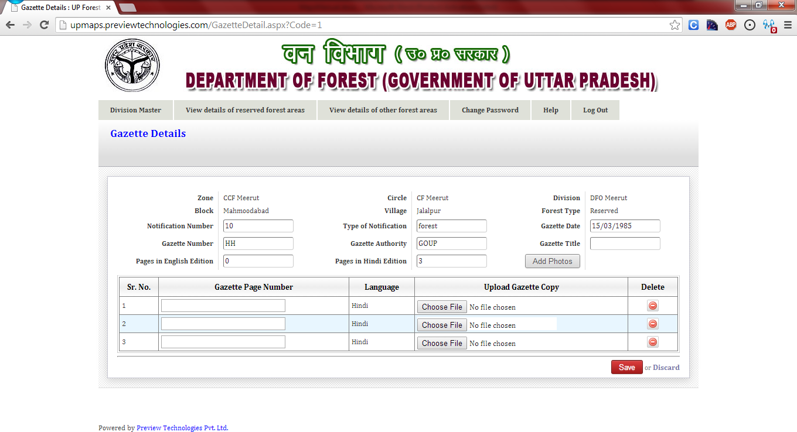

6

5

3

4

2

1

5. View/Download Gazette Details –

After entering details of Gazette if you want to view/download that detail click on View Gazette Detail link.

1. Click on download button to download scanned copy of that page.
2. Click on Show button to display scanned page.
3. Display panel to show scanned page.

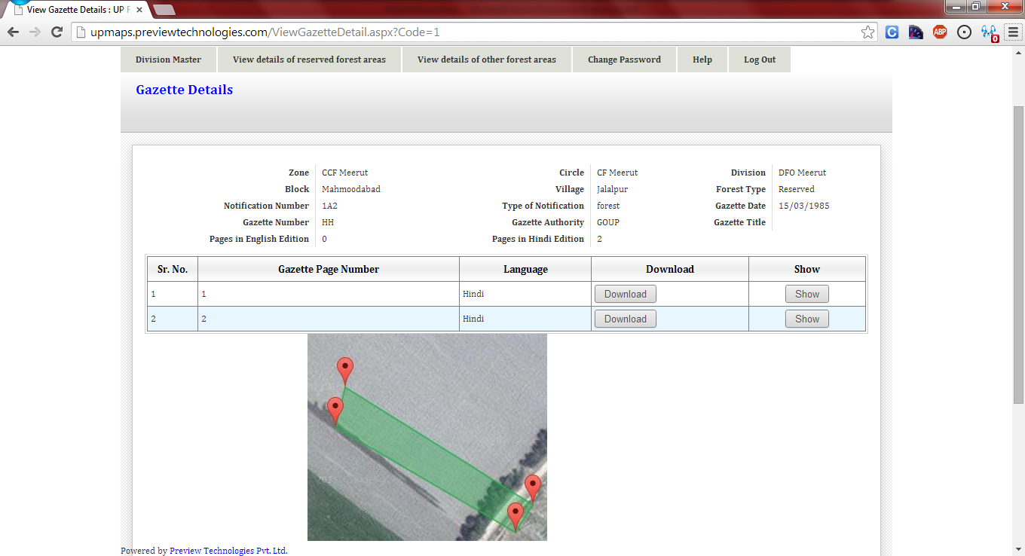

3

2

1

6. Forest Area (if pillars detail not available) –

1. Click on View details of other forest areas.
2. Click on Add forest Area button to create new record.
3. Click on Submit button after selecting Zone, Circle etc. to filter record.
4. Click on Edit button to edit that record.
5. Click on Delete button to delete that record.

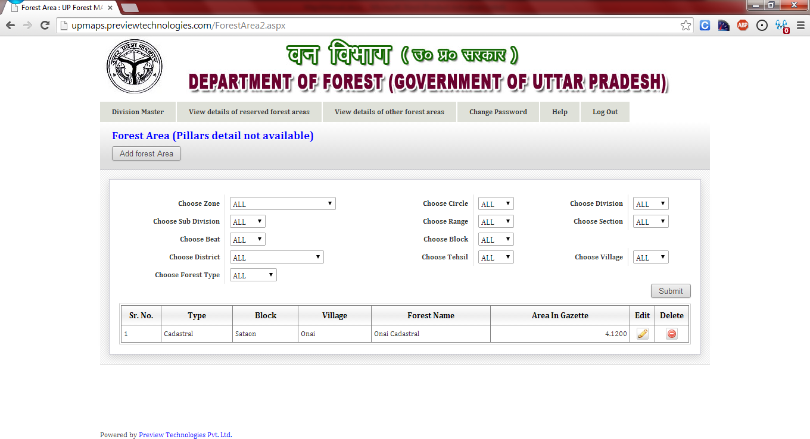

5

4

3

2

1

7. Enter Ground Truth Point (New MAP) –

After Clicking Add forest Area button you will redirect to page shown below

1. Choose appropriate Zone, Circle, Division, Sub Division, Range, Section, Beat, Block etc.
2. Enter total number of Ground Truth Points. A table will generate.
3. Enter Point No., Latitude and Longitude in generated table.
4. Enter Area in Gazette/Document, Gazette/Document No. and Gazette/Document Date.
5. Upload Scanned copy of MAP by using Choose file.
6. Click on Submit button to enter data into database.

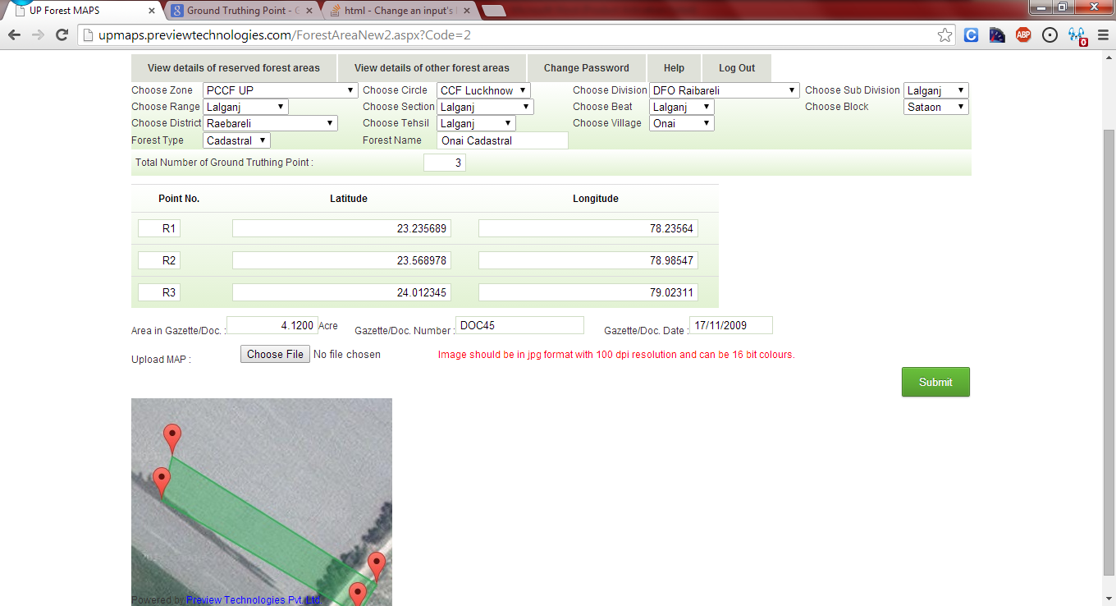

6

5

4

3

2

1