ADVANCED DATA VISUALIZATION
QUIZ-3 & TASK-3 / QUIZ-4 & TASK-4
FINAL TECHNICAL REPORT
Name: Saiful Hayat
Registration No: M25S0086AI006
Course: COMP-834 Advanced Data Visualization
Instructor: Dr Muhammad Zeeshan

Abstract
This report presents the design and implementation of an interactive Power BI dashboard and a predictive forecasting dashboard using World Bank Agriculture, Forestry and Fishing Value Added (% of GDP) data. The project covers data acquisition, cleaning, transformation, dimensional modeling, DAX calculations, visualization development, machine learning forecasting, evaluation, and dashboard deployment. Historical data from 1960–2024 was analyzed to identify trends and generate future predictions. Linear Regression was implemented in Python and integrated into Power BI for predictive analytics. The final solution demonstrates practical business intelligence, data visualization, and machine learning integration.This report presents the design and implementation of an interactive Power BI dashboard and a predictive forecasting dashboard using World Bank Agriculture, Forestry and Fishing Value Added (% of GDP) data. The project covers data acquisition, cleaning, transformation, dimensional modeling, DAX calculations, visualization development, machine learning forecasting, evaluation, and dashboard deployment. Historical data from 1960–2024 was analyzed to identify trends and generate future predictions. Linear Regression was implemented in Python and integrated into Power BI for predictive analytics. The final solution demonstrates practical business intelligence, data visualization, and machine learning integration.

Introduction
Business Intelligence enables organizations to transform data into actionable knowledge. Power BI provides a modern platform for data preparation, modeling, analysis, and visualization. Agriculture remains an important economic sector worldwide and contributes significantly to GDP in many developing economies. This project analyzes long-term agricultural contribution to GDP and develops forecasting models for future years. The project fulfills all requirements of Task-3 and Task-4 including web-based data integration, dashboard development, interactivity, forecasting, and analytical reporting.Business Intelligence enables organizations to transform data into actionable knowledge. Power BI provides a modern platform for data preparation, modeling, analysis, and visualization. Agriculture remains an important economic sector worldwide and contributes significantly to GDP in many developing economies. This project analyzes long-term agricultural contribution to GDP and develops forecasting models for future years. The project fulfills all requirements of Task-3 and Task-4 including web-based data integration, dashboard development, interactivity, forecasting, and analytical reporting.Business Intelligence enables organizations to transform data into actionable knowledge. Power BI provides a modern platform for data preparation, modeling, analysis, and visualization. Agriculture remains an important economic sector worldwide and contributes significantly to GDP in many developing economies. This project analyzes long-term agricultural contribution to GDP and develops forecasting models for future years. The project fulfills all requirements of Task-3 and Task-4 including web-based data integration, dashboard development, interactivity, forecasting, and analytical reporting.

Data Source Description
The project uses World Bank Open Data. The selected indicator is Agriculture, Forestry and Fishing Value Added (% of GDP). The dataset contains yearly observations from 1960–2024 and includes Country Name, Country Code, Year, and Agriculture GDP Percentage. The dataset is reliable, publicly available, globally recognized, and suitable for time-series forecasting and comparative analysis.The project uses World Bank Open Data. The selected indicator is Agriculture, Forestry and Fishing Value Added (% of GDP). The dataset contains yearly observations from 1960–2024 and includes Country Name, Country Code, Year, and Agriculture GDP Percentage. The dataset is reliable, publicly available, globally recognized, and suitable for time-series forecasting and comparative analysis.The project uses World Bank Open Data. The selected indicator is Agriculture, Forestry and Fishing Value Added (% of GDP). The dataset contains yearly observations from 1960–2024 and includes Country Name, Country Code, Year, and Agriculture GDP Percentage. The dataset is reliable, publicly available, globally recognized, and suitable for time-series forecasting and comparative analysis.

Methodology
The project methodology consisted of six phases: Data Collection, Data Transformation, Data Modeling, Dashboard Development, Machine Learning Forecasting, and Evaluation. Data was imported into Power BI, cleaned using Power Query, transformed into analytical format, modeled using a star schema, and visualized using KPI cards, charts, and slicers. Python was used to build forecasting models and the results were integrated back into Power BI.The project methodology consisted of six phases: Data Collection, Data Transformation, Data Modeling, Dashboard Development, Machine Learning Forecasting, and Evaluation. Data was imported into Power BI, cleaned using Power Query, transformed into analytical format, modeled using a star schema, and visualized using KPI cards, charts, and slicers. Python was used to build forecasting models and the results were integrated back into Power BI.The project methodology consisted of six phases: Data Collection, Data Transformation, Data Modeling, Dashboard Development, Machine Learning Forecasting, and Evaluation. Data was imported into Power BI, cleaned using Power Query, transformed into analytical format, modeled using a star schema, and visualized using KPI cards, charts, and slicers. Python was used to build forecasting models and the results were integrated back into Power BI.

Data Transformation
Data transformation included removing null values, removing duplicates, converting data types, renaming fields, handling missing observations, creating agriculture categories, and generating growth-rate calculations. These steps improved data quality and analytical consistency. Power Query was used extensively to prepare the dataset for reporting.Data transformation included removing null values, removing duplicates, converting data types, renaming fields, handling missing observations, creating agriculture categories, and generating growth-rate calculations. These steps improved data quality and analytical consistency. Power Query was used extensively to prepare the dataset for reporting.Data transformation included removing null values, removing duplicates, converting data types, renaming fields, handling missing observations, creating agriculture categories, and generating growth-rate calculations. These steps improved data quality and analytical consistency. Power Query was used extensively to prepare the dataset for reporting.

Data Modeling
A star schema was implemented. Fact_Agriculture contained the primary measures while Dim_Country, Dim_Year, and Dim_Category served as dimension tables. Relationships were established using one-to-many cardinality. This design improved performance, scalability, and report usability. DAX measures were created for Average Agriculture GDP %, Maximum Agriculture GDP %, Minimum Agriculture GDP %, and Country Count.A star schema was implemented. Fact_Agriculture contained the primary measures while Dim_Country, Dim_Year, and Dim_Category served as dimension tables. Relationships were established using one-to-many cardinality. This design improved performance, scalability, and report usability. DAX measures were created for Average Agriculture GDP %, Maximum Agriculture GDP %, Minimum Agriculture GDP %, and Country Count.A star schema was implemented. Fact_Agriculture contained the primary measures while Dim_Country, Dim_Year, and Dim_Category served as dimension tables. Relationships were established using one-to-many cardinality. This design improved performance, scalability, and report usability. DAX measures were created for Average Agriculture GDP %, Maximum Agriculture GDP %, Minimum Agriculture GDP %, and Country Count.

Task-3 Dashboard Design
The interactive dashboard includes KPI cards, a pie chart showing agriculture category distribution, a line chart showing historical trends, a bar chart showing country rankings, detailed data tables, and slicers for year, country, and category. Cross-filtering allows users to dynamically analyze subsets of data. The dashboard supports comparative and trend-based analysis.The interactive dashboard includes KPI cards, a pie chart showing agriculture category distribution, a line chart showing historical trends, a bar chart showing country rankings, detailed data tables, and slicers for year, country, and category. Cross-filtering allows users to dynamically analyze subsets of data. The dashboard supports comparative and trend-based analysis.The interactive dashboard includes KPI cards, a pie chart showing agriculture category distribution, a line chart showing historical trends, a bar chart showing country rankings, detailed data tables, and slicers for year, country, and category. Cross-filtering allows users to dynamically analyze subsets of data. The dashboard supports comparative and trend-based analysis.

Task-3 Analysis
Historical analysis shows that agriculture's contribution to GDP has generally declined over time as economies industrialize and expand service sectors. Comparative analysis identifies countries with higher dependence on agriculture. Distribution analysis reveals that most countries fall within the low-agriculture category while a smaller number remain heavily dependent on agriculture.Historical analysis shows that agriculture's contribution to GDP has generally declined over time as economies industrialize and expand service sectors. Comparative analysis identifies countries with higher dependence on agriculture. Distribution analysis reveals that most countries fall within the low-agriculture category while a smaller number remain heavily dependent on agriculture.Historical analysis shows that agriculture's contribution to GDP has generally declined over time as economies industrialize and expand service sectors. Comparative analysis identifies countries with higher dependence on agriculture. Distribution analysis reveals that most countries fall within the low-agriculture category while a smaller number remain heavily dependent on agriculture.

Machine Learning Forecasting
Linear Regression was selected for forecasting due to its simplicity, interpretability, and effectiveness in modeling long-term trends. The Year variable was used as the predictor and Agriculture GDP Percentage was used as the target variable. Historical observations were used for training and future years were predicted using the trained model.Linear Regression was selected for forecasting due to its simplicity, interpretability, and effectiveness in modeling long-term trends. The Year variable was used as the predictor and Agriculture GDP Percentage was used as the target variable. Historical observations were used for training and future years were predicted using the trained model.Linear Regression was selected for forecasting due to its simplicity, interpretability, and effectiveness in modeling long-term trends. The Year variable was used as the predictor and Agriculture GDP Percentage was used as the target variable. Historical observations were used for training and future years were predicted using the trained model.

Feature Engineering
The forecasting model required preparation of structured numerical inputs. Year values were converted into numerical features and missing values were removed. The target variable was standardized and verified. Forecasts were generated for future years and exported to CSV files before being imported into Power BI.The forecasting model required preparation of structured numerical inputs. Year values were converted into numerical features and missing values were removed. The target variable was standardized and verified. Forecasts were generated for future years and exported to CSV files before being imported into Power BI.The forecasting model required preparation of structured numerical inputs. Year values were converted into numerical features and missing values were removed. The target variable was standardized and verified. Forecasts were generated for future years and exported to CSV files before being imported into Power BI.

Model Evaluation
Model performance was evaluated using Mean Absolute Error (MAE), Root Mean Square Error (RMSE), and R² Score. These metrics quantify forecast accuracy and explainability. Lower MAE and RMSE values indicate better predictive performance, while higher R² values indicate stronger model fit.Model performance was evaluated using Mean Absolute Error (MAE), Root Mean Square Error (RMSE), and R² Score. These metrics quantify forecast accuracy and explainability. Lower MAE and RMSE values indicate better predictive performance, while higher R² values indicate stronger model fit.Model performance was evaluated using Mean Absolute Error (MAE), Root Mean Square Error (RMSE), and R² Score. These metrics quantify forecast accuracy and explainability. Lower MAE and RMSE values indicate better predictive performance, while higher R² values indicate stronger model fit.

Task-4 Dashboard Design
The predictive dashboard contains Actual vs Predicted line charts, Forecast Trend charts, KPI cards, forecast output tables, and slicers. Users can interactively explore forecasted values by country, year, and data type. The dashboard provides a practical forecasting environment suitable for analytical decision-making.The predictive dashboard contains Actual vs Predicted line charts, Forecast Trend charts, KPI cards, forecast output tables, and slicers. Users can interactively explore forecasted values by country, year, and data type. The dashboard provides a practical forecasting environment suitable for analytical decision-making.The predictive dashboard contains Actual vs Predicted line charts, Forecast Trend charts, KPI cards, forecast output tables, and slicers. Users can interactively explore forecasted values by country, year, and data type. The dashboard provides a practical forecasting environment suitable for analytical decision-making.

Results and Discussion
The forecasting model successfully captured long-term agricultural GDP trends. The Actual vs Predicted chart demonstrates reasonable agreement between observed and predicted values. Forecast results indicate continued gradual changes in agriculture's contribution to GDP over future years. Dashboard interactivity allows users to perform customized analysis.The forecasting model successfully captured long-term agricultural GDP trends. The Actual vs Predicted chart demonstrates reasonable agreement between observed and predicted values. Forecast results indicate continued gradual changes in agriculture's contribution to GDP over future years. Dashboard interactivity allows users to perform customized analysis.The forecasting model successfully captured long-term agricultural GDP trends. The Actual vs Predicted chart demonstrates reasonable agreement between observed and predicted values. Forecast results indicate continued gradual changes in agriculture's contribution to GDP over future years. Dashboard interactivity allows users to perform customized analysis.

Limitations
The model uses only the Year variable and does not incorporate external drivers such as inflation, climate, trade, population growth, or policy interventions. More advanced forecasting techniques such as ARIMA, Prophet, or LSTM may improve predictive accuracy. Future work can incorporate additional features and multivariate forecasting approaches.The model uses only the Year variable and does not incorporate external drivers such as inflation, climate, trade, population growth, or policy interventions. More advanced forecasting techniques such as ARIMA, Prophet, or LSTM may improve predictive accuracy. Future work can incorporate additional features and multivariate forecasting approaches.The model uses only the Year variable and does not incorporate external drivers such as inflation, climate, trade, population growth, or policy interventions. More advanced forecasting techniques such as ARIMA, Prophet, or LSTM may improve predictive accuracy. Future work can incorporate additional features and multivariate forecasting approaches.

Conclusion
This project successfully implemented an end-to-end Business Intelligence and Predictive Analytics solution using Power BI and Python. The developed dashboards satisfy all assignment requirements including data integration, transformation, modeling, visualization, forecasting, interactivity, and evaluation. The project demonstrates practical application of advanced data visualization and machine learning techniques for economic analysis.This project successfully implemented an end-to-end Business Intelligence and Predictive Analytics solution using Power BI and Python. The developed dashboards satisfy all assignment requirements including data integration, transformation, modeling, visualization, forecasting, interactivity, and evaluation. The project demonstrates practical application of advanced data visualization and machine learning techniques for economic analysis.This project successfully implemented an end-to-end Business Intelligence and Predictive Analytics solution using Power BI and Python. The developed dashboards satisfy all assignment requirements including data integration, transformation, modeling, visualization, forecasting, interactivity, and evaluation. The project demonstrates practical application of advanced data visualization and machine learning techniques for economic analysis.

References
World Bank Open Data; Microsoft Power BI Documentation; Scikit-Learn Documentation; Python Documentation; Course Material; Advanced Data Visualization Notes.

Figure 1: Task-3 Interactive Dashboard
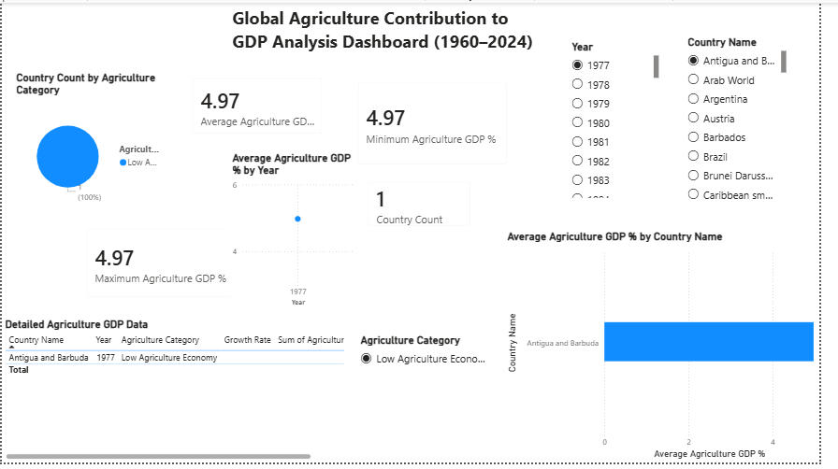
Dashboard screenshot and analysis reference figure.

Figure 2: Task-4 Forecasting Dashboard
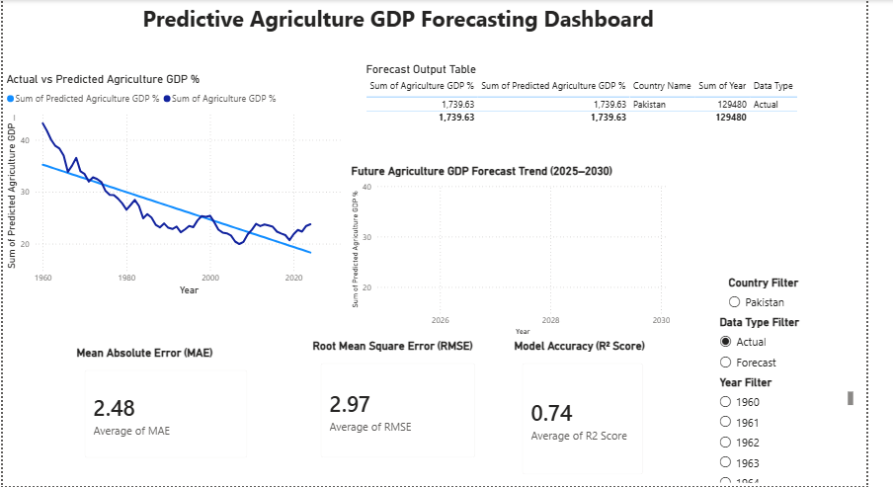
Dashboard screenshot and analysis reference figure.

Forecast Results

Model Evaluation Metrics
Country Name MAE RMSE R2 Score
Pakistan 2.478601 2.970713 0.736173

Forecast Sample Records
Country Name Year Agriculture GDP % Predicted Agriculture GDP % Data Type
Pakistan 1960 43.189201 35.227486 Actual
Pakistan 1961 41.727426 34.962990 Actual
Pakistan 1962 40.029233 34.698494 Actual
Pakistan 1963 38.840015 34.433997 Actual
Pakistan 1964 38.324054 34.169501 Actual
Pakistan 1965 36.968302 33.905004 Actual
Pakistan 1966 33.836897 33.640508 Actual
Pakistan 1967 35.053171 33.376011 Actual
Pakistan 1968 36.541675 33.111515 Actual
Pakistan 1969 33.950035 32.847019 Actual
Pakistan 1970 33.431761 32.582522 Actual
Pakistan 1971 31.966293 32.318026 Actual
Pakistan 1972 32.802297 32.053529 Actual
Pakistan 1973 32.458662 31.789033 Actual
Pakistan 1974 31.876688 31.524537 Actual

Actual vs Predicted Chart
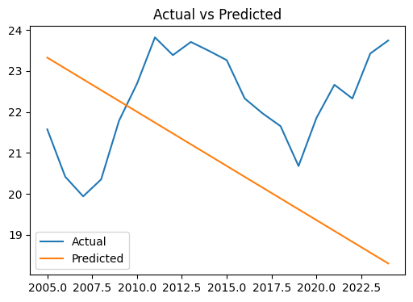

Forecast Trend Chart
