**Curriculum Vitae**

**ADNAN SAIF**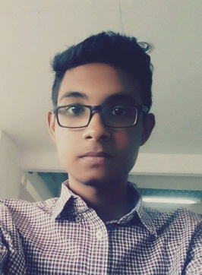

Mailing address:

328/D, Roman Tower, Ahmed Nagar Paikpara, Mipur-1, Dhaka-1216

Email: **adnan.saif9795@gmail.com**

Contact Number: **01627283957**

**Career objective:**

Seeking an entry-level position to begin my career in a high-level professional environment. To work in a dynamic and challenging organization where, I can use my knowledge and expertise with patience and integrity to enhance organizational development as well as my future career growth.

**Educational Backgrounds:**

|  |  |  |  |  |
| --- | --- | --- | --- | --- |
| **Examination** | Group/Subject | Board/University | **Passing Year** | **Class /Division/ CGPA** |
| **BSc** | Computer Science & Engineering | East West University | 6th Semester  Running | ---------- |
| **HSC** | Science | Dhaka | 2017 | 4.71 Scale of 5.00 |
| **SSC** | Science | Dhaka | 2015 | 4.89 Scale of 5.00 |

Computer Skills:

* Office Automation and Hardware maintenance.

Language Proficiencies:

* Bengali (Mother Language).
* English (Speaking, Listening, Writing, and Reading ability).

**Personal Information:**

|  |  |  |
| --- | --- | --- |
| **Name in full** | : | Adnan Saif |
| **Father’s name** | : | MD. Imdadul Islam |
| **Mother’s name** | : | Nargis Sultana |
| **Permanent address** | : | 328/D, Roman Tower, Ahmed Nagar Paikpara, Mipur-1, Dhaka-1216 |
| **Present address** | : | 328/D, Roman Tower, Ahmed Nagar Paikpara, Mipur-1, Dhaka-1216 |
| **Date of birth** | : | 24/09/1999 |
| **Place of birth** | : | Dhaka |
| **Nationality** | : | Bangladeshi (By Birth) |
| **Religion** | : | Islam |
| **Sex** | : | Male |
| **Marital Status** | : | Unmarried |
| **Blood group** | : | A+ |

I do hereby declare that the above statements are correct and complete to the best of my knowledge.



(Adnan Saif)