3. SYSTEM DESIGN AND ARCHITECTURE
The system constructed for this dissertation is organised as a five-component pipeline, shown in Figure 3.1: a shared data layer feeds two independent generation paths — a zero-shot baseline inference engine and a QLoRA fine-tuning module — the output of the fine-tuning module is consumed by the BMAD agentic correction loop, and the outputs of both the baseline path and the agentic loop converge on a common evaluation and statistical analysis module that produces the comparative results reported in Chapter 5. This chapter describes each component at the level of its responsibilities and interfaces; the concrete implementation of each component, including the engineering revisions made to the agentic loop after an initial design proved unreliable, is described in Chapter 4.
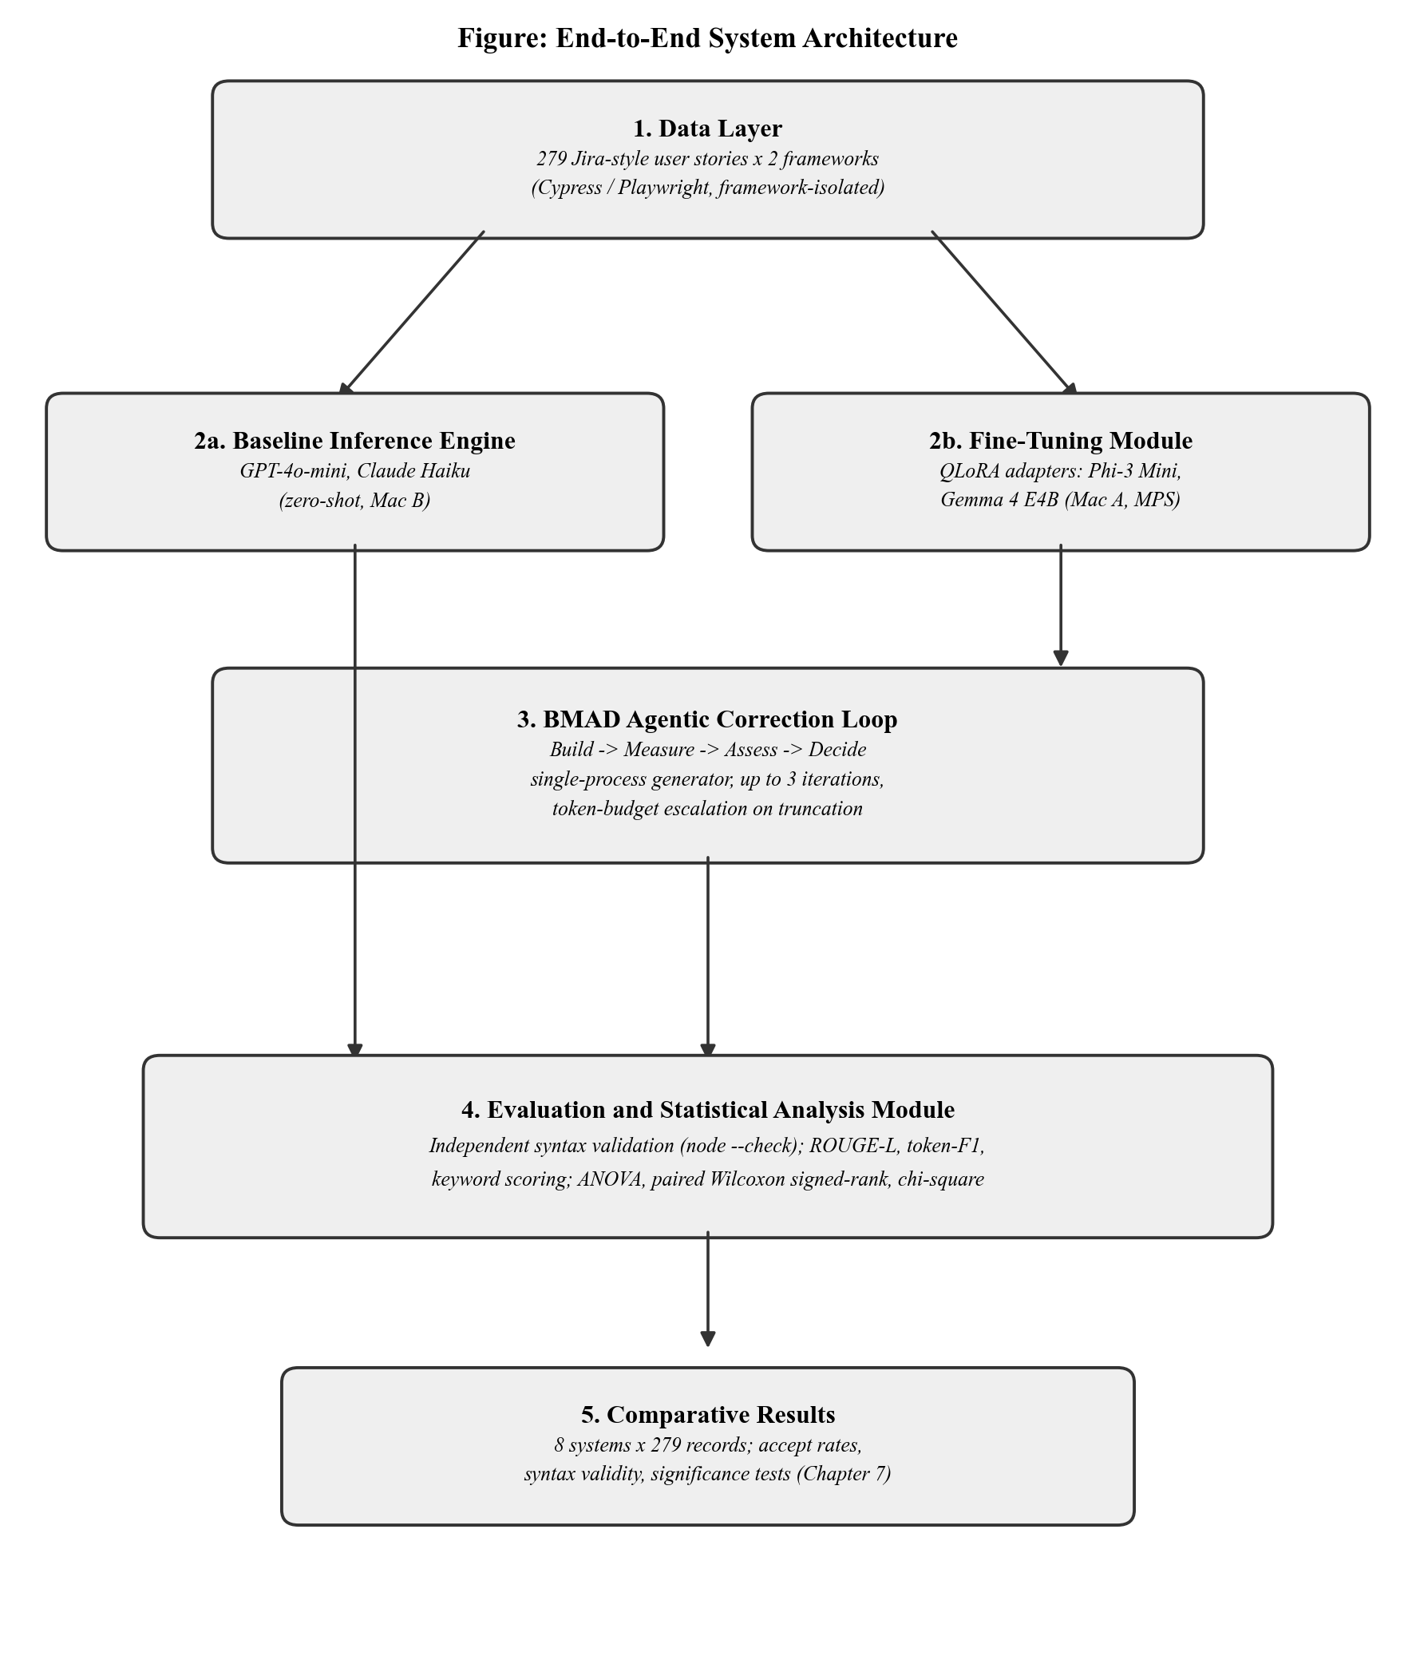
Figure 3.1: End-to-end system architecture

3.1 Data Layer
The data layer is the single source of truth consumed by every downstream component. It comprises the 279-story dataset described in Chapter 4, together with the two framework-isolated JSON Lines files derived from it — one restricted to Cypress reference scripts and one to Playwright reference scripts. Isolating the two frameworks at the data layer, rather than filtering by framework at consumption time, guarantees that a fine-tuning run or a baseline inference run for one framework has no access whatsoever to the other framework's syntax, eliminating a class of cross-contamination that would otherwise be possible if a single mixed-framework file were filtered downstream.

3.2 Baseline Inference Engine
The baseline inference engine routes each user story to the two commercial large language models under evaluation — GPT-4o-mini and Claude Haiku — using each provider's standard chat-completion API, and persists the result in a schema common to both providers. This component has no dependency on local model weights or specialised hardware, and consequently runs on the lower-specification of the two development machines described in Chapter 4. Architecturally, it is deliberately independent of the fine-tuning and agentic-loop components: a baseline result for a given story can be produced, and was in practice produced, before the corresponding fine-tuned adapters existed.

3.3 Fine-Tuning Module
The fine-tuning module applies QLoRA adapters to two frozen open-weight base models, Phi-3 Mini and Gemma 4 E4B, using the framework-isolated training splits from the data layer. Each of the two models is trained independently for each of the two frameworks, yielding four adapters in total, each stored separately from its base model so that a given base model can be paired with either adapter at inference time without reloading the (much larger) base weights. This design — one adapter per model per framework, rather than a single adapter trained on a mixed-framework corpus — is the architectural mechanism by which framework isolation, established at the data layer, is preserved through to the trained model itself.

3.4 BMAD Agentic Correction Loop
The BMAD loop is the component responsible for turning a single fine-tuned generation attempt into an accepted, quality-checked script. Architecturally it implements a closed cycle of four stages applied to each user story in turn: Build, in which the appropriate fine-tuned adapter generates a candidate script from the user story; Measure, in which the candidate is scored against a composite rubric combining syntax-keyword completeness, assertion density, and similarity to a retrieval-matched exemplar; Assess, in which that composite score is compared against an acceptance threshold; and Decide, in which the loop either accepts the candidate or constructs targeted corrective feedback and returns to Build for a further attempt, bounded at three iterations in total. This chapter treats the loop as an architectural unit with a defined input (a user story and a target framework) and output (an accepted or best-effort script plus its full scoring history); Chapter 4 describes how this unit is realised in code, including a significant revision to how the Build stage communicates with the underlying model.

3.5 Evaluation and Statistical Analysis Module
The evaluation module is the only component with visibility into the outputs of both generation paths simultaneously. It applies two independent forms of assessment to every script produced by any of the eight systems under study (two baseline models and two fine-tuned models, each across two frameworks): a static syntax check using each framework's underlying language parser, and a set of semantic-similarity metrics computed against the corresponding held-out reference script. A separate statistical analysis stage then consumes the per-record scores from all eight systems, joined by the common user-story identifier shared across the data layer, to compute the comparative significance tests reported in Chapter 5. Positioning this module downstream of, and architecturally independent from, both generation paths is a deliberate design choice: it ensures that syntax validity and semantic similarity are assessed identically and impartially regardless of which system — commercial baseline or fine-tuned adapter — produced the script being scored.

3.6 Design Rationale
Three architectural decisions recur across the components described above and are stated explicitly here because they are foundational to the validity of the comparison in Chapter 5. First, framework isolation is enforced at the data layer and preserved through fine-tuning rather than being applied only at evaluation time, so that no component in the fine-tuned path is ever exposed to the other framework's conventions. Second, the baseline inference engine and the fine-tuning/agentic-loop path are architecturally independent of each other, sharing only the common data layer and the common evaluation module; this allows either path to be re-run, extended, or replaced without affecting the other, and reflects the two-machine development split described in Chapter 4. Third, evaluation is deliberately decoupled from generation: the BMAD loop's own acceptance decision is never treated as the final word on a script's quality, and every script — regardless of which system produced it — is re-assessed by the same independent syntax and similarity checks in the evaluation module, which is what makes the comparison across all eight systems in Chapter 5 methodologically fair.

