Name: Saif eldin mousa Mohamed mousa

Sec: 17

Group: 3

B.N: 372

Date: 8/6/2021

Topic: Programming languages

# Application brief:

A programming language is a type of written language that tells computers what to do. Examples are: python, ruby, jupiter,java, JavaScript, C, C++, and C#. Programming languages are used to write all computer software. A programming language is like a set of instructions that the computer follows to do something.

A programmer writes text in the source code of a programming language to make programs. Usually, the programming language uses real words for some of the commands (e.g. "go to", "if... then... else...", etc.), so that the language is easier for a human to understand. Like any normal language, many programming languages use punctuation. Many

programs are then compiled, which means that the computer changes, or translates, the source code into another language (such as assembly language[1][2] or machine language) that a computer can read, but which is much harder for a person to read

# screenshots:

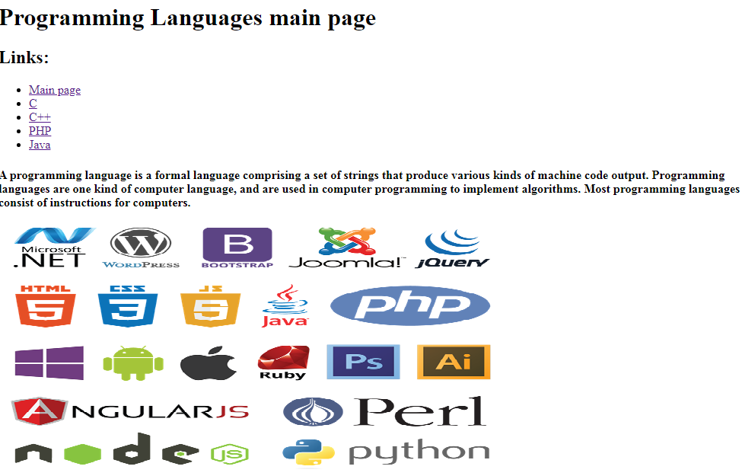

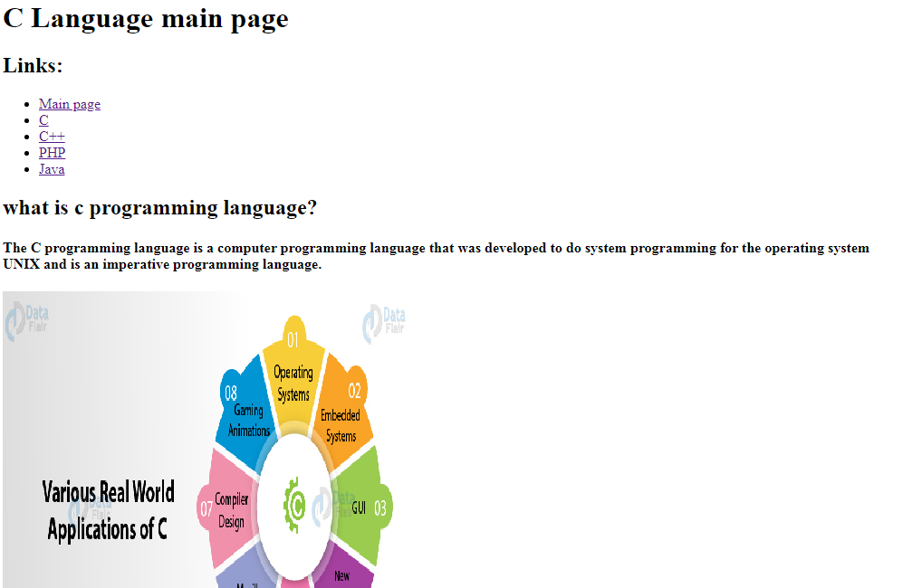

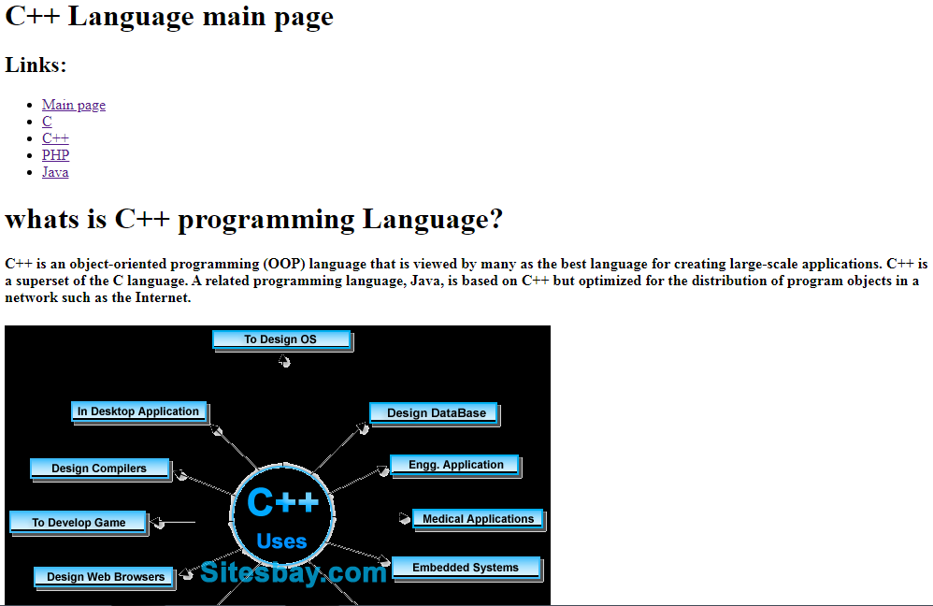

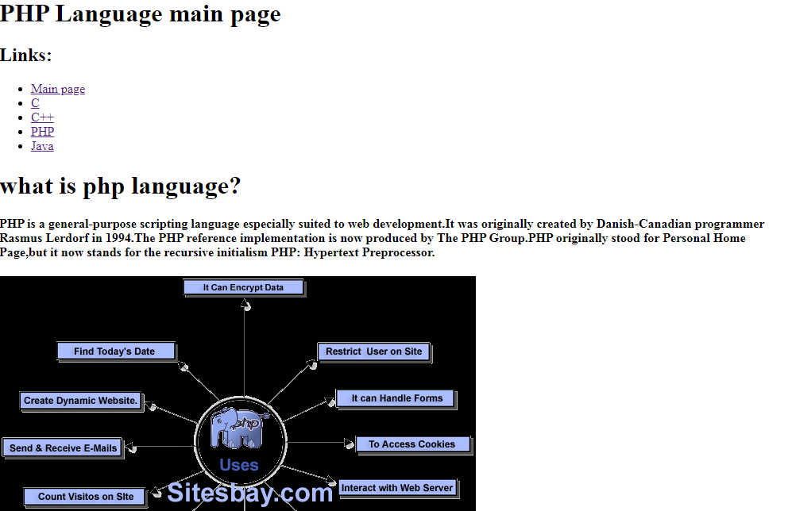

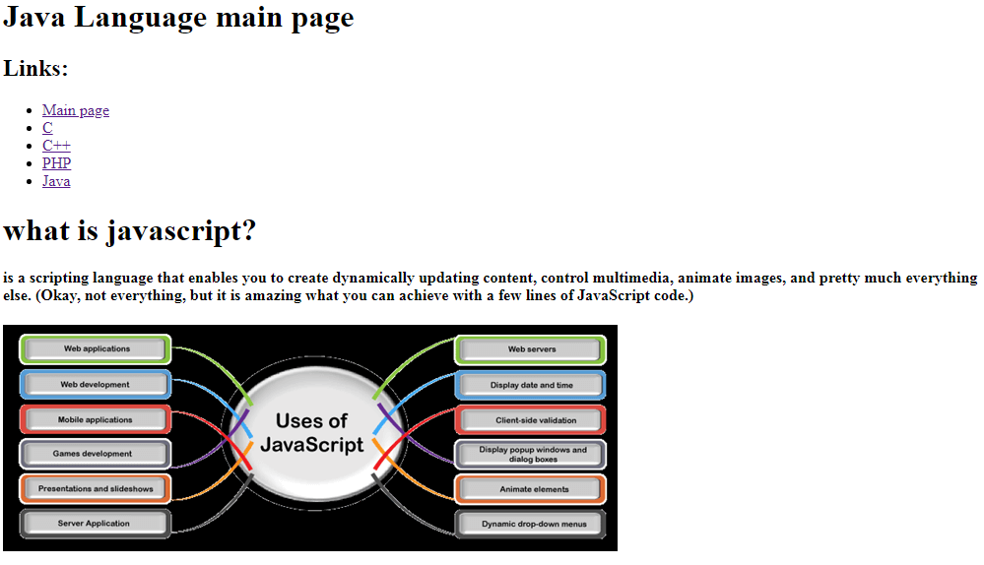

# Source code :

