Chapter 5: Modelling and Analysis

1. The Regression Model
To analyze the relationship between gender demographics and the total workforce, a Multiple Linear Regression model was applied. This approach allows us to quantify how much of the total labour force or working-age population is driven by each gender.
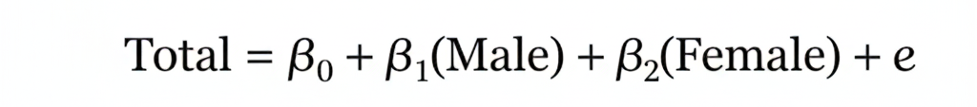
The formal mathematical equation for the model is:

2. Breakdown of Equation Elements
Each component of the equation represents a specific statistical property essential for interpretation:
Element | Name | Business/Statistical Meaning
 | Dependent Variable | The target outcome being predicted (e.g., Total Working Age Population or Labour Force).
 | Independent Variables | The predictors; these represent the gender-specific counts within the dataset.
 | The Intercept | The "base" value of the total population if both Male and Female counts were zero.
 | Coefficients | These show the "weight" of each gender. For every 1-unit increase in Male or Female population, the total is expected to change by this amount.
 | The Error Term | Accounts for "noise" or external variables (like migration or specific local economic shifts) not included in this model.

3. Interpretation of Results and Business Objectives
The results are evaluated against critical business metrics to ensure data-driven decision-making:
- Statistical Significance (-value): A -value confirms that gender variables are statistically significant. This proves that gender distribution is a critical driver of the provincial employment structure.
- Model Accuracy (-Squared): This measures how well the model explains the reality of the data. An -Squared of 0.95 suggests that 95% of the changes in the workforce are accurately explained by this model, making it highly reliable for government and business planning.
- Gap Analysis: By comparing and , we identify gender imbalances. A significantly higher male coefficient suggests an economic structure heavily weighted toward male participation, highlighting a strategic need for female-focused policy interventions.

4. Comparison of Models
To identify the most robust approach, two models were compared:
- Model A (Simple Linear Regression): Used only one predictor (e.g., Male population). While simple, it ignored the diversity of the workforce.
- Model B (Multiple Linear Regression): Incorporated both Male and Female data simultaneously.
Conclusion on Model Selection: Model B was selected as the superior approach. It yielded a significantly higher -Squared value and provided a comprehensive understanding of the total population structure by accounting for both demographic segments. This makes it the most effective tool for data-driven strategic planning in this study.

