Università degli Studi di Messina
Department of MIFT


Multi-Factor Authentication System
Web-Based Application for Secure Authentication
Project Report
Student Name | Ali Muhammad Saif
Student ID | 546477
Supervisors | Prof. Massimo Villari | Prof. Armando Ruggeri
Academic Year | 2024–2025
Submission Date | February 2026

Abstract
This report explains how a Multi-Factor Authentication (MFA) web system was designed, built, and tested. The system was created for the System Security module at the Università degli Studi di Messina.
Instead of just a username and password, the system adds a second check: a one-time code sent to the user's email. Users can also log in safely using their Google account.
The app is written in PHP 8 with a custom MVC structure and stores data in a MySQL database. Main security features:
- Safe password storage using bcrypt hashing
- Random one-time codes made with a cryptographically secure method
- Codes expire after 5 minutes; only 3 attempts allowed before lockout
- Rate limiting to stop abuse; page guards that block logged-out users
All features were tested manually, checking both normal use and deliberate attack attempts.
Keywords: Multi-Factor Authentication, One-Time Password, Google OAuth 2.0, Email Delivery, Session Security, bcrypt, PHP MVC, MySQL, Rate Limiting

Table of Contents
Abstract
1 Introduction
1.1 Why Passwords Are Not Enough
1.2 Project Goals
1.3 How the System Works
2 Background and Key Concepts
2.1 Authentication vs Authorisation
2.2 Types of Authentication Factors
2.3 What Is a One-Time Password?
2.4 Why Email Is a Safe Second Channel
2.5 Google Sign-In (OAuth 2.0)
2.6 Common Attacks Defended Against
3 System Architecture
3.1 Three-Layer Design
3.2 Folder Structure
3.3 Login Step-by-Step
4 How It Was Built
4.1 Technology Choices
4.2 Generating OTP Codes Safely
4.3 Storing and Expiring OTPs
4.4 Sending OTP by Email
4.5 Google Sign-In Integration
4.6 Sessions and Page Guards
4.7 Rate Limiting
5 User Interface
5.1 Registration
5.2 Login
5.3 OTP Verification
5.4 Dashboard
6 Security Features
6.1 Four OTP Checks
6.2 Password Security
6.3 SQL Injection Protection
6.4 Input Validation
6.5 Why Email Is a Safe Channel
6.6 Rollback on Email Failure
7 Threat Model
7.1 Attacker Assumptions
7.2 Attack Analysis Table
7.3 Known Weaknesses
8 Testing
8.1 Approach
8.2 Functional Tests
8.3 Security Tests
9 Deployment
10 Limitations and Future Plans
11 What I Learned
12 Conclusion
Acknowledgements
Appendix A: User Guide
Appendix B: Configuration Reference
Appendix C: Troubleshooting

1 Introduction

1.1 Why Passwords Are Not Enough
Passwords alone are no longer safe. Every year, millions of usernames and passwords are stolen through data breaches, phishing, and guessing attacks. Once a password is stolen, an attacker can log in freely — the system cannot tell a real user from a fake one.
Multi-Factor Authentication (MFA) fixes this by requiring two separate proofs of identity. Even if an attacker steals a password, they still cannot log in without the second factor. This greatly reduces the risk of unauthorised access.

1.2 Project Goals
This project was built to gain real, hands-on experience designing a secure authentication system. The main goals were:
- Understand how different authentication factors work and why keeping them independent matters
- Use real cryptographic tools (bcrypt, random_int) in PHP to protect passwords and OTP codes
- Build time-based expiry, attempt limits, and rate limiting into the authentication process
- Connect to Google's login system using the OAuth 2.0 standard
- Think like an attacker — identify threats and build the system to resist them
The project was kept deliberately simple. A custom PHP framework with no third-party libraries was used so that every security decision is visible and easy to understand.

1.3 How the System Works
The system uses two separate checks to confirm who a user is:
- Step 1 — Something you know: Step 1 — Something you know:
The user enters their email and password. The system checks it against the stored (hashed) password in the database.
- Step 2 — Something you have: Step 2 — Something you have:
A 6-digit one-time code is sent to the user's email. The user must enter this code within 5 minutes.
- Alternative — Google Sign-In: Alternative — Google Sign-In:
Users can register and log in with their existing Google account, skipping local passwords entirely.
After three wrong code attempts, the code is deleted and the user must start again. This stops anyone from guessing the code.

2 Background and Key Concepts

2.1 Authentication vs Authorisation
These two words sound similar but mean different things. Authentication answers: "Who are you?" — it verifies your identity. Authorisation answers: "What are you allowed to do?" — it controls what you can access after being identified. This report is entirely about authentication.

2.2 Types of Authentication Factors
There are three types of authentication factors. Each one is independent — if one is stolen, the others should still be safe:
- Something You Know: A password or PIN. The weakest factor alone, because it can be guessed, phished, or stolen.
- Something You Have: Access to a device or account — in this system, the user's email inbox. An attacker must also compromise the email account to get the OTP.
- Something You Are: Biometric data such as fingerprints or face recognition. Very strong but requires special hardware.
This system uses the first two: password and email OTP. These two factors are independent, which is what makes MFA much stronger than a password alone.

2.3 What Is a One-Time Password?
A One-Time Password (OTP) is a code that works only once and only for a short time. Even if an attacker intercepts it, it will be expired or deleted by the time they try to use it.
This system creates a fresh random 6-digit code for each login. The code is sent to the user's email, stored in the database as a bcrypt hash, and deleted the moment it is used or expires.

2.4 Why Email Is a Safe Second Channel
"Out-of-band" means using a completely separate channel. The main channel is the web browser; the second channel is the user's email inbox — run by a different server on a different network.
This separation is important: if someone steals your browser session, they still cannot get the OTP because it is in your email, not in the browser. Every login attempt also sends an OTP email to the real user — acting as an automatic early warning.

2.5 Google Sign-In (OAuth 2.0)
OAuth 2.0 lets users log in using their existing Google account. The user clicks "Sign in with Google", confirms on Google's own page, and Google tells the application the user is verified — the application never sees their Google password.
The big advantage: no local password is ever stored for Google-login users. If the database is ever breached, there is no password to steal for those users.

2.6 Common Attacks Defended Against
- Password phishing — the MFA step catches users even when their password is stolen
- Brute-force guessing of OTP codes — limited to three attempts
- Replay attacks (re-submitting a used code) — the code is deleted immediately after use
- Database theft revealing passwords or OTPs — both stored as bcrypt hashes, not plain values
- Session hijacking — page guards block unauthenticated access to all protected pages

3 System Architecture

3.1 Three-Layer Design
- User Layer (Browser): The pages the user sees — registration, login, OTP entry, and dashboard. Built with HTML/CSS, rendered by PHP.
- Application Layer (PHP 8): All business logic: checking passwords, generating OTPs, sending emails, controlling sessions, and enforcing security rules.
- Data Layer (MySQL): The database storing user accounts and OTP records. All queries use prepared statements to prevent SQL injection.
Two external services are used: an SMTP email server (over STARTTLS encryption) and Google's OAuth 2.0 service for Google Sign-In users.

3.2 Folder Structure
Path / File | Purpose
app/config/ | Environment settings, database connection, Google OAuth constants
app/controllers/ | Handles incoming web requests and sends responses
app/middleware/ | AuthGuard (page protection) and RateLimiter (OTP throttle)
app/models/ | Database queries for User and OTP records
app/services/ | Core business logic: OTP, Email, User, Token services
app/utils/ | Crypto (OTP generation/hashing), Validator, HTTP helpers
views/auth/ | Login, register, and OTP verification pages
views/dashboard/ | Protected user dashboard
database/schema.sql | MySQL table creation scripts
routes/web.php | Maps URL routes to controller actions
.env / .env.example | Secret config values (DB, SMTP, Google keys) — never committed

Table 1: Project folder structure

3.3 Login Step-by-Step
Here is exactly what happens when a user logs in with email and password:
- User enters email and password on the login page.
- The system looks up the email. If not found, a generic error is shown — so attackers cannot tell which emails are registered.
- The password is compared to the stored bcrypt hash. If wrong, a generic error is shown.
- If the password matches: a random 6-digit code is generated, hashed with bcrypt, saved to the database with a 5-minute expiry, and emailed to the user.
- The user checks their email, gets the code, and types it into the OTP page.
- The system runs four checks: Does the code exist? Is it within 5 minutes? Fewer than 3 wrong attempts? Does it match the stored hash?
- If all four checks pass: the code is deleted, the session is created, and the user is taken to their dashboard.
- The dashboard shows the timestamp of the user's last login so they can notice if someone else has been using their account.
The Google sign-in path (Section 4.5) skips the OTP step because Google already verifies the user's identity.

4 How It Was Built

4.1 Technology Choices
Component | Choice | Why
Backend | PHP 8 | Built-in secure random, bcrypt, and PDO; works on most web servers
Architecture | Custom MVC (no framework) | Every security decision is visible; no hidden "magic" from packages
Database | MySQL + PDO | Reliable storage; PDO protects against SQL injection
Password Hashing | bcrypt | Industry standard; slow by design to resist cracking attacks
OTP Generation | random_int() + bcrypt hash | Cryptographically secure; only hash stored — breach reveals nothing
Email Transport | Native SMTP over STARTTLS | No external library; encrypted connection; works with any provider
SSO | Google OAuth 2.0 | No local password for Google users; proven security model
Frontend | HTML5 / CSS3 / vanilla JS | Small attack surface; easy to understand and audit

Table 2: Technology choices and reasons

4.2 Generating OTP Codes Safely
PHP's random_int() uses the operating system's built-in secure random source, which cannot be predicted. This is why it is used instead of simpler functions like rand().
Once generated, the OTP is immediately hashed with bcrypt before being stored. The database never holds the actual code — only a scrambled version. Even if an attacker reads the entire database, they cannot recover the OTP:
public static function generateOtp(int $length = 6): string {
$otp = '';
for ($i = 0; $i < $length; $i++) { $otp .= random_int(0, 9); }
return $otp; // Uses OS-level secure random
}
public static function hashOtp(string $otp): string {
return password_hash($otp, PASSWORD_DEFAULT); // bcrypt
}

4.3 Storing and Expiring OTPs
The system follows strict rules for OTP lifecycle:
- Only one active code per user — any existing code is deleted before a new one is created
- 5-minute expiry — the server checks the timestamp when the user submits the code
- Three-attempt limit — each wrong guess increases a counter; after three failures the code is deleted
- Deleted after use — a correct code is immediately removed so it cannot be used again
- Auto-cleanup — if a user account is deleted, all their OTP records are removed automatically

4.4 Sending OTP by Email
This system sends emails by opening a direct SMTP connection — no external PHP libraries used. The connection starts unencrypted, then immediately upgrades to an encrypted TLS connection (STARTTLS) before any password or OTP data is sent. All SMTP credentials are stored only in the .env file and never hard-coded. If the email fails to send, the system returns an error and no account is created.

4.5 Google Sign-In Integration
When a user clicks "Sign in with Google", the system redirects them to Google's own login page. The application never sees their Google password. Once Google confirms the user, it sends a short-lived code back. The server then:
- Exchanges that code with Google for an access token (proof of identity)
- Uses the token to ask Google for the user's verified email and unique account ID
- If registering: saves the user in the database with their Google ID and no local password. If the account already exists, it is updated.
- If logging in: checks that the Google account exists in the database. Unknown accounts go to the registration page.
- On success: a full session is created immediately — no OTP step needed, as Google already verified the user.

4.6 Sessions and Page Guards
After a successful login, the system saves the user's ID, email, and previous login time in a PHP session (stored on the server). The previous login time is shown on the dashboard so users can notice if someone else has been using their account.
AuthGuard checks that a valid session exists before showing any protected page — anyone trying to visit the dashboard without logging in is immediately redirected to the login page. GuestGuard sends already-logged-in users away from the login and registration pages. Logging out wipes the entire session from the server.

4.7 Rate Limiting
Rate limiting stops someone from sending hundreds of OTP requests in a short time. The system allows a maximum of 3 OTP requests per IP address per 5 minutes. If this limit is exceeded, the server returns a "429 Too Many Requests" error and no email is sent. The counter resets automatically after 5 minutes.

5 User Interface

5.1 Registration
New users enter their email, a password, and the password again to confirm it. The system checks that both passwords match and the email is valid. The password is stored as a bcrypt hash — the original is never saved. After registering, an OTP is sent for verification. If the email cannot be sent, the new account is immediately deleted so the address stays free for a future attempt.
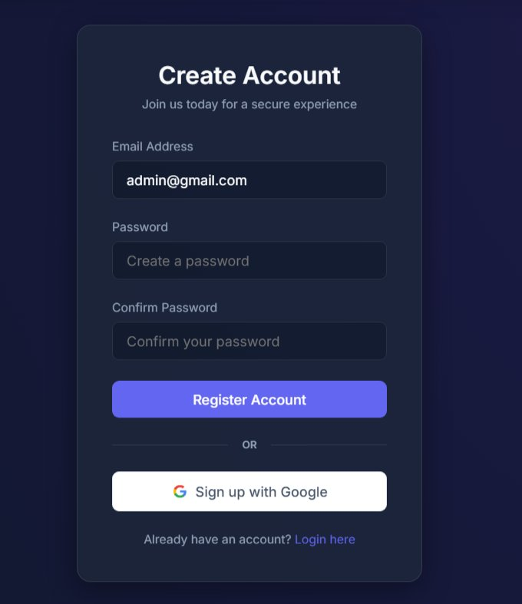
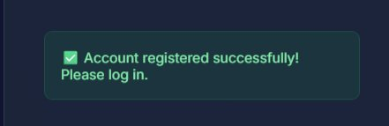
Figure 1: Registration page and success notification

5.2 Login
The login page asks for email and password. If the password is wrong or the email is not registered, the same generic error message is shown. This is intentional — a specific message like "that email does not exist" would help attackers find registered accounts. When login succeeds, an OTP is emailed and the user goes to the verification page.
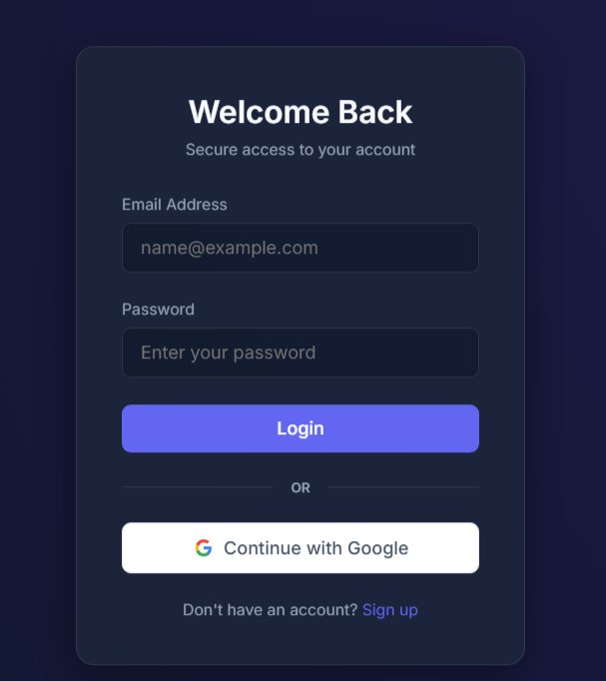
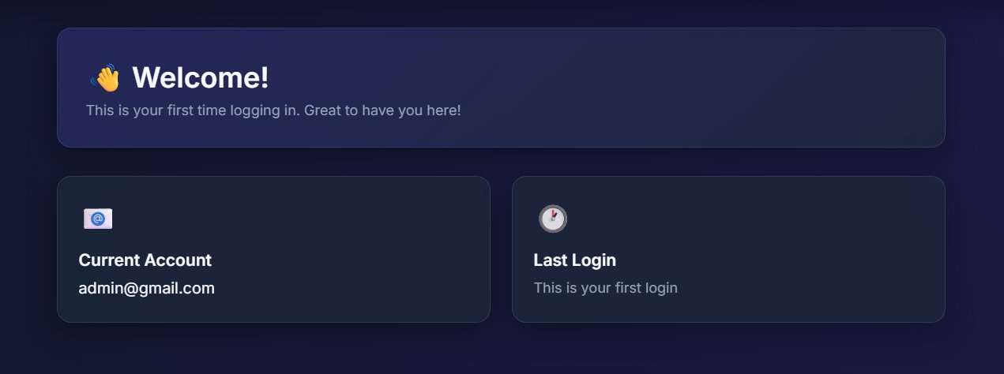
Figure 2: Login page and Google account selection screen

5.3 OTP Verification
After a correct password, the user goes to the OTP page. Navigating here directly without logging in redirects back to the login page — it is always protected. The page tells the user to check their email. If the wrong code is entered, the number of remaining attempts is shown. After three wrong tries, the code is cancelled.
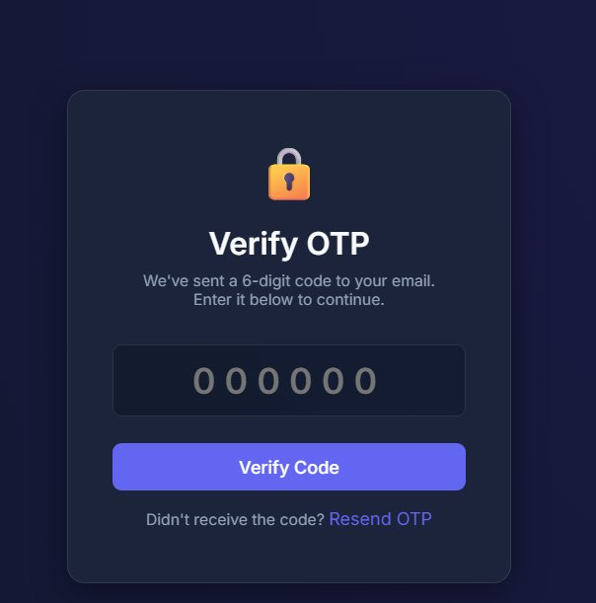
Figure 3: OTP verification page
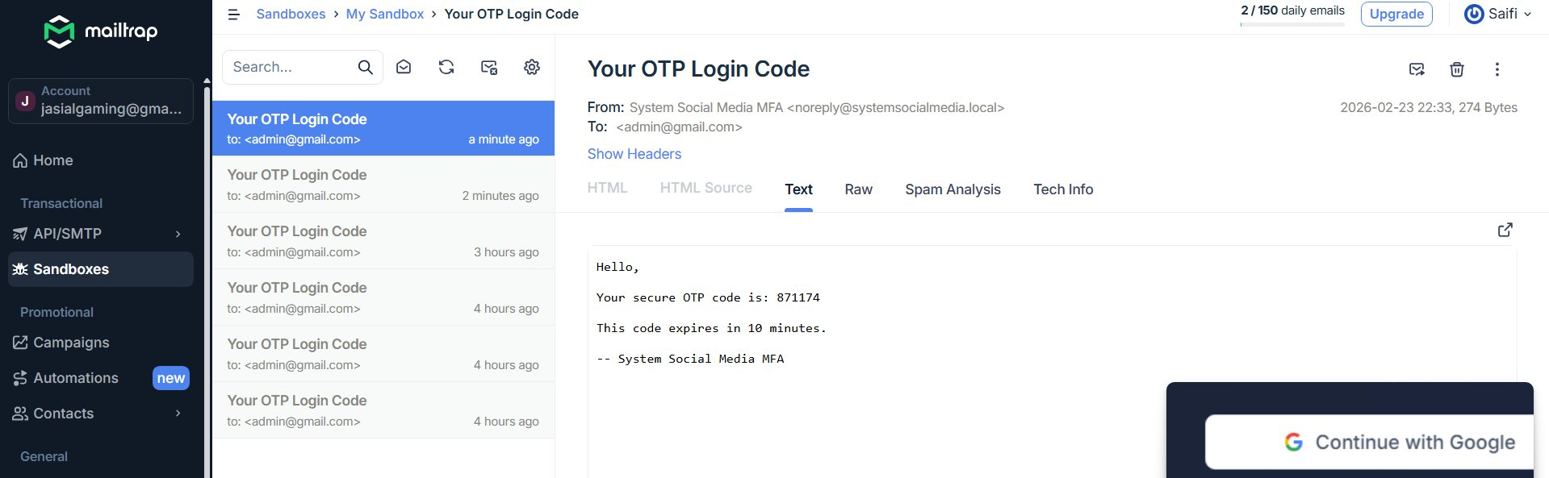
Figure 4: OTP email in Mailtrap sandbox inbox
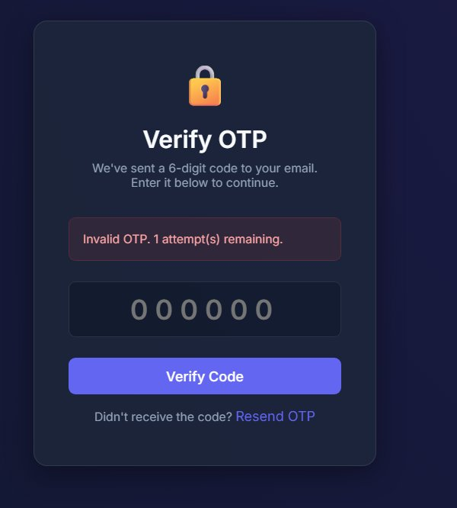
Figure 5: Failed OTP attempt — remaining attempts shown

5.4 Dashboard
The dashboard is the first page seen after a full login. It shows the user's email and the date/time of their last login. If the user sees a login time they don't recognise, someone else may have accessed their account. A logout button wipes the session completely from the server.
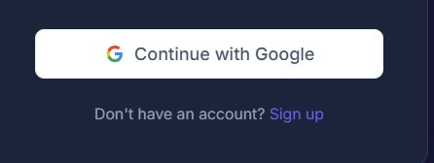
Figure 6: User dashboard with last-login indicator

6 Security Features

6.1 Four OTP Checks in Order
When a user submits an OTP, the system runs four checks in order. If any check fails, verification stops. All four must pass for login to succeed:

Check 1 — Does the OTP record exist?
If no record exists (because no login was started, or the code already expired and was deleted), verification is rejected immediately.

Check 2 — Has the OTP expired?
If more than 5 minutes have passed since the code was created, it is rejected — even if it is the correct code. This limits how long an intercepted code is useful.

Check 3 — Too many wrong attempts?
Each wrong guess adds 1 to a counter in the database. After three wrong attempts, the code record is deleted entirely. A 6-digit code has 10,000,000 possible values, so with only three chances the probability of a lucky guess is just 0.00003% — effectively impossible.

Check 4 — Does the code match?
The submitted code is compared to the bcrypt hash using PHP's password_verify(). Because only a hash is stored, an attacker who reads the database cannot extract or reuse the code.

6.2 Password Security
User passwords are never stored as plain text. bcrypt is intentionally slow to compute — making automated cracking attacks much more expensive. The "cost factor" (set to 10) can be raised later to keep pace with faster hardware, without asking users to reset passwords.

6.3 SQL Injection Protection
SQL injection attacks work by inserting SQL code inside form fields to manipulate the database. This system prevents it completely by using PDO prepared statements — the query structure and user data are always kept separate, so the database handles them safely.

6.4 Input Validation
Every piece of user-submitted data is cleaned before use. Email addresses are validated for correct format. Text input is sanitised to remove any HTML or script characters — preventing XSS (Cross-Site Scripting) attacks. All validation happens on the server, because browser-side checks can be bypassed by anyone with basic tools.

6.5 Why Email Is a Safe Second Channel
- Separate channel: Stealing the web session is not enough — the attacker must also control the user's email account.
- Automatic warning: Every login attempt sends an OTP email to the real user — immediate alert if someone is trying to get in.
- Encrypted in transit: STARTTLS protects the OTP email between the app server and the mail provider.

6.6 Rollback on Email Failure
If the OTP email cannot be delivered during registration, the newly created account is immediately deleted. Without this, the email address would be permanently blocked by an account that was never verified. The rollback gives the user a clean slate to try again.

7 Threat Model

7.1 Attacker Assumptions
What the Attacker CAN Do:
- Access the web application over a network, just like any other user
- Try common passwords and email formats automatically with tools
- Read the database contents in a worst-case breach — seeing all stored records
What the Attacker CANNOT Do:
- Access the user's email inbox or control the email server
- Break or bypass Google's own authentication systems
- Physically access the server or the user's device

7.2 Attack Analysis Table
Attack | How the System Responds | Remaining Risk | Rating
OTP Brute-Force | 3-attempt limit + 5-min window; probability = 0.00003% | Negligible | HIGH
OTP Replay Attack | Code deleted immediately after successful use | None | HIGH
OTP Expiry Bypass | Server-side time check; client cannot change it | None | HIGH
Password via DB Breach | bcrypt hashes stored; cracking very expensive | Low (weak passwords) | MEDIUM
OTP via DB Breach | Only bcrypt hash stored; plaintext OTP never saved | Negligible | HIGH
Credential Phishing | Second factor required; stolen password alone not enough | Low (live MitM) | HIGH
SQL Injection | PDO prepared statements used throughout | None | HIGH
XSS Attack | htmlspecialchars() on all user input before output | Low (DOM-based) | MEDIUM
OTP Email Flooding | RateLimiter: max 3 OTP/IP/5 min → 429 error | Low (distributed) | MEDIUM
Username Guessing | Generic error messages on all login/registration failures | Negligible | HIGH

Table 3: Attack analysis and mitigation ratings

7.3 Known Weaknesses
- HTTP-Only: Credentials and OTPs are vulnerable on the network. Production must use HTTPS with a valid TLS certificate.
- No CSRF Protection: Forms lack synchroniser tokens. Production should add CSRF token validation on all forms.
- Session-Based Rate Limiting: Distributed attacks from many IPs can bypass per-IP limits. Production should use Redis-backed rate limiting.
- No Login Lockout: No account lockout after many failed password attempts. Production should add progressive delays or temporary lockout.

8 Testing

8.1 Approach
All testing was done manually and systematically — split into functional tests (does the system work correctly for normal users?) and security tests (does the system block attacks?). For security testing, each attack was deliberately attempted step by step to confirm it was properly defended.

8.2 Functional Tests
ID | What Was Tested | Expected Result | Result
F-01 | Register with valid email + password; verify OTP; access dashboard | Registration completes; dashboard accessible | PASS
F-02 | Register with Google SSO — new account | Account created; success message; redirected to login | PASS
F-03 | Login with correct email + password; complete OTP verification | Dashboard shows previous login time | PASS
F-04 | Login with Google SSO — existing account | Session established immediately; dashboard accessible | PASS
F-05 | Submit incorrect password on login | Generic error; no OTP generated | PASS
F-06 | Submit non-existent email on login | Same generic error (no account info revealed) | PASS
F-07 | Navigate directly to dashboard without session | Redirect to login page | PASS
F-08 | Navigate directly to OTP page without pending session | Redirect to login page | PASS
F-09 | Logout — verify session is destroyed | Session cleared; back button does not restore session | PASS
F-10 | Register with mismatched passwords | Validation error; no account created | PASS

Table 4: Functional test results

8.3 Security Tests
ID | What Was Tested | Expected Result | Result
S-01 | Submit OTP more than 5 minutes after it was generated | Expiry error; OTP rejected | PASS
S-02 | Re-submit a previously successful OTP | Record not found; rejection | PASS
S-03 | Enter three consecutive incorrect OTPs | OTP deleted; redirected to login | PASS
S-04 | SQL injection in email field: ' OR '1'='1 | Query fails safely; no data returned | PASS
S-05 | Submit OTP after registration rollback (email failure) | OTP page inaccessible; redirect to register | PASS
S-06 | Request OTP 4+ times within 5 minutes from same IP | 4th request returns 429; no email sent | PASS
S-07 | Google login with unregistered Google account | Redirect to register page | PASS
S-08 | Inspect DB — retrieve otp_hash for active OTP | Only bcrypt hash visible; cannot be used to authenticate | PASS

Table 5: Security test results

9 Deployment
Setting up the system on a local development computer is straightforward:
- Clone or extract the project to the Apache web root (e.g., /var/www/html/mfa-project)
- Enable mod_rewrite and set AllowOverride All for the document root
- Create the MySQL database and import the schema: mysql -u root -p < database/schema.sql
- Copy .env.example to .env and fill in all values (DB credentials, SMTP, Google OAuth keys)
- Navigate to http://localhost/mfa-project/ in a browser

APP_URL=http://localhost/mfa-project
APP_ENV=development
DB_HOST=127.0.0.1 DB_NAME=system_social_media_mfa DB_USER=root DB_PASS=
GOOGLE_CLIENT_ID=xxx.apps.googleusercontent.com
GOOGLE_CLIENT_SECRET=GOCSPX-xxxxxxxxxx
GOOGLE_REDIRECT_URL=.../index.php?route=auth/google/callback
MAIL_HOST=sandbox.smtp.mailtrap.io MAIL_PORT=587
MAIL_USERNAME=your_mailtrap_user MAIL_PASSWORD=your_mailtrap_pass

Before going live: switch to HTTPS, replace Mailtrap with a real email provider, enable strict PHP session security settings, add CSRF token protection to all forms, and deploy behind a production web proxy such as Nginx.

10 Limitations and Future Plans
Limitation | Impact | Production Solution
HTTP-only communication | Credentials/OTPs visible on network | HTTPS + valid TLS certificate (e.g. Let's Encrypt)
No CSRF protection | Cross-site request forgery possible | Synchroniser token on all POST forms
Session-based rate limiter | Ineffective against distributed attacks | Redis token-bucket with IP-level persistence
No login-attempt lockout | Password brute-force possible | Progressive delay / lockout after N failures
Development SMTP (Mailtrap) | Emails not delivered to real inboxes | Production SMTP relay (SendGrid, SES, Mailgun)
No audit log | Limited forensic capability after a breach | Structured logging to a centralised log store

Table 6: Limitations and production solutions
Planned future improvements: support for authenticator apps like Google Authenticator (TOTP standard), hardware security key login (WebAuthn/FIDO2), sign-in with GitHub/Microsoft/Apple, Redis-backed rate limiting, full activity logging, and an admin panel for user management.

11 What I Learned

11.1 Technical Skills
Building this system from scratch gave me hands-on experience with real security tools. Using random_int() showed me why the choice of random number generator matters — a regular function is predictable; a cryptographic one is not. Implementing bcrypt directly showed me how password hashing actually works.
Writing the SMTP email sender without any library meant understanding every step: opening a connection, upgrading it to TLS, authenticating, and sending the message — making it clear exactly where security is provided at the protocol level. Implementing Google OAuth 2.0 manually required reading the actual standard and working through the token exchange step by step.

11.2 Security Thinking
Building the threat model — asking "what could go wrong?" and "what would an attacker try?" — made it clear that security is not a single feature but a collection of measures that work together. Running the attacks myself (Section 8.3) found real edge cases, like the registration rollback, that I would never have spotted just by reading the code.

11.3 Problem-Solving
Building a working STARTTLS connection required understanding the exact order of SMTP commands — getting the sequence wrong silently broke the encrypted connection. The registration rollback required careful reasoning about what happens when a process is only halfway complete. Debugging security code is particularly demanding because a mistake in one direction creates a vulnerability, and a mistake in the other makes the system unusable.

11.4 Professional Writing
Writing this report practised explaining technical security decisions clearly and precisely. Saying that the brute-force probability is 3/10,000,000 (0.00003%) is much more useful than saying "it is very secure". Security claims should always be measurable — this project made that habit concrete.

12 Conclusion
This project produced a complete, working Multi-Factor Authentication system demonstrating real security engineering. The system combines two independent authentication factors — a bcrypt-protected password and a time-limited email OTP — and adds Google OAuth 2.0 as a password-free sign-in option. Together, these provide a much stronger security baseline than a password alone.
Every major attack vector was addressed with a specific defence: random_int() for unpredictable OTP generation, bcrypt hashing for passwords and stored OTPs, PDO prepared statements eliminating SQL injection, HTML sanitisation blocking XSS, a 5-minute expiry window and 3-attempt limit reducing brute-force probability to 0.00003%, rate limiting blocking OTP spam, route guards preventing unauthorised page access, and registration rollback preventing orphaned accounts.
Google Sign-In users never create a local password, removing that attack surface entirely. Email OTP delivery means stealing the web session is never enough — the attacker must also control the email account.
Known limitations — no HTTPS in development, no CSRF tokens, session-based rate limiting, and no login lockout — are intentional boundaries for an academic project. Each is documented with its production-ready solution. Comprehensive manual testing across 10 functional cases and 8 security cases confirmed that all primary attack vectors are successfully mitigated.

Acknowledgements
I would like to thank the Università degli Studi di Messina for providing a strong learning environment. The System Security module gave me the theoretical background I needed to tackle this practical implementation with confidence.
I am especially grateful to Prof. Massimo Villari and Prof. Armando Ruggeri for their excellent teaching and guidance throughout the programme. Their knowledge of system security gave me the foundation to understand, design, and evaluate the mechanisms implemented in this project.
I am also grateful to my fellow students for helpful discussions, and to the open-source communities whose documentation of PHP, MySQL, OAuth 2.0, and the SMTP protocol made this independent implementation possible.

Appendix A: User Guide

A.1 System Requirements
- Server: Apache 2.4+ with mod_rewrite; AllowOverride All
- PHP: 8.0+ with extensions: pdo, pdo_mysql, openssl, curl, sockets
- Database: MySQL 5.7+ or MariaDB 10.3+
- SMTP: Mailtrap (development) or any SMTP relay (production)
- Google Console: OAuth 2.0 credentials with authorised redirect URI

A.2 Installation
- Place project files in the Apache web root
- Enable mod_rewrite: sudo a2enmod rewrite && sudo systemctl restart apache2
- Create database: CREATE DATABASE system_social_media_mfa;
- Import schema: mysql -u root -p system_social_media_mfa < database/schema.sql
- Copy .env.example to .env and fill in all values
- Navigate to http://localhost/[project-folder]/

A.3 Security Tips for Users
- Never share your OTP code with anyone
- Check your email quickly — codes expire after five minutes
- If you receive an unexpected OTP email, someone may be trying to access your account — do not use the code and consider changing your password
- Use a unique, strong password not used on any other service
- Log out when finished, especially on shared devices

Appendix B: Configuration Reference
Variable | Description | Example Value
APP_URL | Base URL of the application | http://localhost/mfa-project
APP_ENV | development or production | development
DB_HOST / DB_NAME | MySQL host and database name | 127.0.0.1 / system_social_media_mfa
DB_USER / DB_PASS | MySQL credentials | root / (blank)
GOOGLE_CLIENT_ID | Google OAuth 2.0 Client ID | xxx.apps.googleusercontent.com
GOOGLE_CLIENT_SECRET | Google OAuth 2.0 Client Secret | GOCSPX-xxxxxxxxxx
GOOGLE_REDIRECT_URL | OAuth callback URI (must match Google Console) | .../index.php?route=auth/google/callback
MAIL_HOST / MAIL_PORT | SMTP hostname and port | sandbox.smtp.mailtrap.io / 587
MAIL_USERNAME / MAIL_PASSWORD | SMTP authentication credentials | (from Mailtrap dashboard)
MAIL_FROM / MAIL_FROM_NAME | Sender address and display name | noreply@... / System Social Media MFA

Table B.1: Complete .env configuration reference

Appendix C: Troubleshooting
Issue | Probable Cause | Fix
404 on all routes | mod_rewrite disabled or AllowOverride None | Enable mod_rewrite; set AllowOverride All in Apache config
OTP email not received | SMTP credentials wrong or port 587 blocked | Verify MAIL_* in .env; check Mailtrap inbox; confirm port is open
"OTP expired" immediately | Server clock out of sync or email delay > 5 min | Sync server clock via NTP; extend OTP validity in OtpService if needed
Google OAuth error | Redirect URI mismatch or invalid credentials | Match GOOGLE_REDIRECT_URL exactly to Google Cloud Console setting
PDO connection error | MySQL not running or wrong credentials | Start MySQL; verify DB_HOST, DB_NAME, DB_USER, DB_PASS
Blank page / 500 error | PHP parse error or missing extension | Check storage/logs/app.log and Apache error log; enable pdo_mysql, curl, openssl

Table C.1: Common issues and resolutions

