System Architecture of
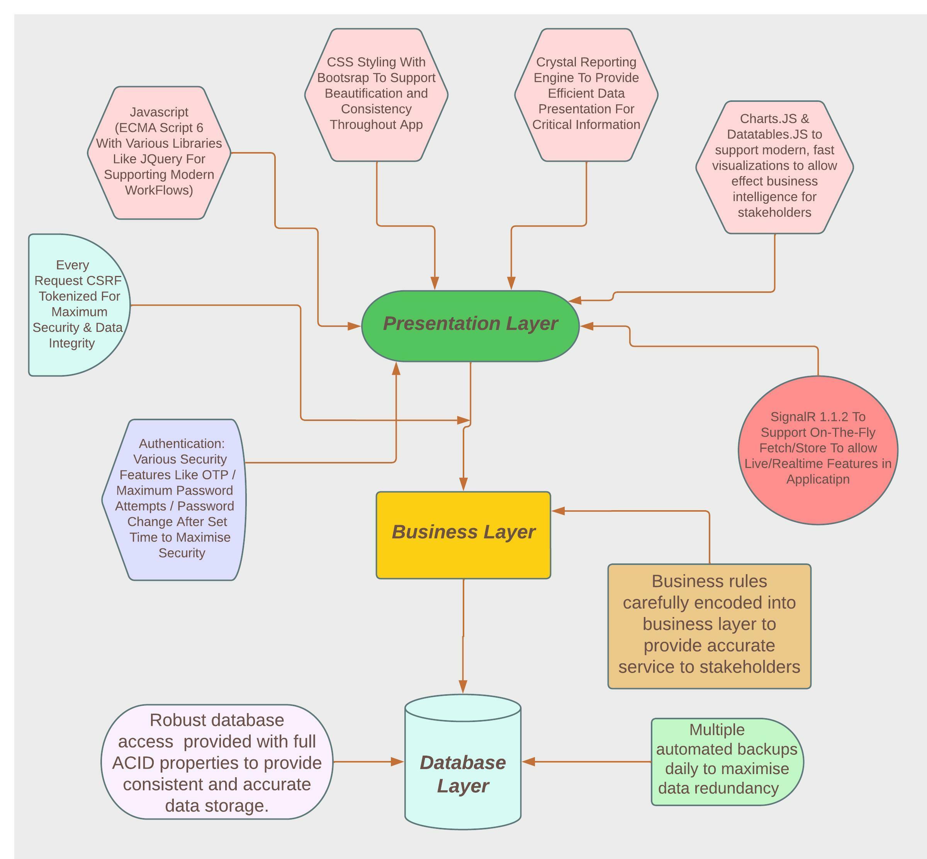
Online Framework for Risk Based Capital Adequacy (RBCA), Reconciliation of Consolidated Customer Account (CCA), Software for Regulatory Reporting and TREC Management

The system is developed using Agile methodology where the entire system is divided into several modules. The new modules could be integrated into the project in a very efficient manner. Here the code is optimized and can be easily reusable in other modules.
The Three Tier (3 – Tier) architecture has been maintained and deployed in this web application where the security features are developed in each layer. The application / web server and database server are hosted in separate hardware infrastructure.
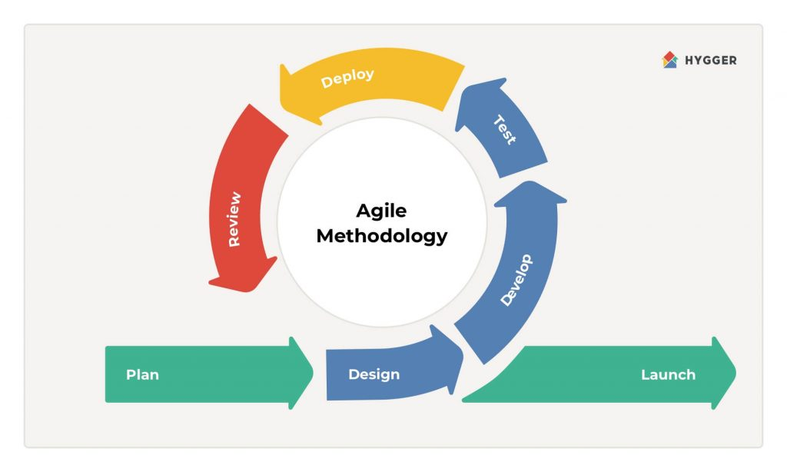
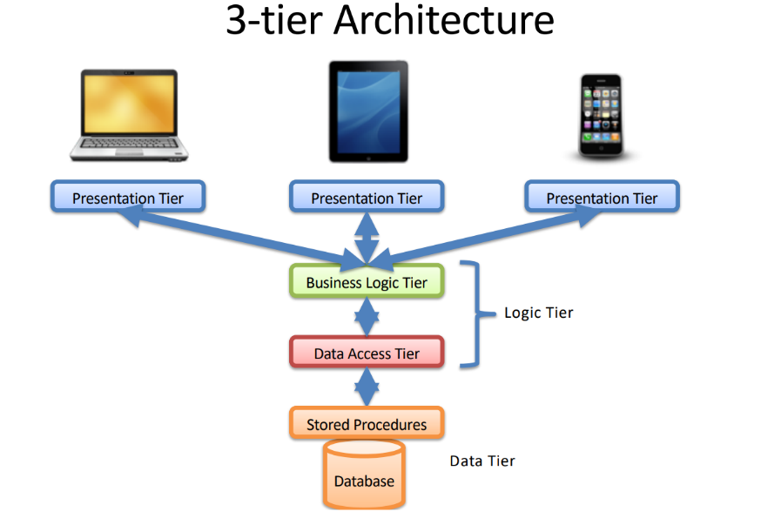

Maker and checker facilities have been incorporated in the projects where all the interfaces are designed in a very user friendly options and the reports are customized as per user choices and can be exported in different formats. There is an efficient user management module and the system maintains audit information for every database transaction. All of the intermediaries including Bangladesh Securities & Exchange Commission (BSEC) have been satisfactorily using this software. DSE already earned revenues from conducting training sessions and BSEC approved to impose fines or charges to the intermediaries for using RBCA system.

Syed Md Raquib Uddin
Senior Manager
Backoffice Development Department
ICT Division
Dhaka Stock Exchange Limited

