How TREC Information was managed before Go-Live of TREC Management System (TMS):

Sl No | Projects/Data Sources | Remarks
1 | In-house desktop application(FoxPro) | Obsolete system developed 15 years back
2 | Reminder desktop application built with Windows Forms (.Net) | To send alert notifications on the expiry of stock broker/Dealer license and authorized Representative license.
3 | APP Support web-based application (.Net) (http://10.218.1.17:9000/) | App support and IT Infrastructure Dept. are using this software for TREC vendor and network related information along with AMC related information.
4 | Excel to maintain Digital booth information
5 | Excel to maintain mobile and email information to communicate with Authorized Representatives.
6 | Excel to maintain CAMALCO , POWER OF ATTORNEYS, TREC HOLDER REPRESENTATIVE information.
7 | Maintain Hardcopy of TREC  Documents MoA and AoA, Incorporation Certificate etc.
8 | Excel to maintain Share Holding information, Director information and Share Transfer information
9 | DSE WEB SITE PHP Web based application  (https://www.dse.com.bd/search_member_with_branch.php)

Issues with the workflow:
- Data redundancy.
- Lack of data integrity results in misaligned and inconsistent reports.
- Feature enhancement was not possible with the current system FoxPro and .Net Desktop app.
- The desktop based was is challenging to maintain and requires reinstallation on client PCs after every update.
- Multiple servers were being used for databases.
- Redundant work for Manpower and man-hours for data entry and validation.
Data Flow Diagram before Go-Live of TREC Management System (TMS):
MSSQL
In-house
Sesktop application(FoxPro)

MSSQL
Reminder
Desktop application built with Windows Forms (.Net)

MSSQL
APP Support
web-based application (.Net)

DSE WEB SITE
PHP Web based application
Maintaining BY WEB
MySQL



What we developed to address the issues in the TMS phase-1:
- Developed a new web application called TREC Management System (TMS).
- Migrated data from the in-house system to a structured relational database using Oracle.
- Integrated all features from the InHouse and Reminder to the TMS
- Migrated the TREC related info from the legacy APP Support application to to the TMS.

Reminder
Desk Desktop based APP

Web based
Module for
BSEC

Web based

App Support
Web based

InHouse
FoxPro Application

ORACLE
Developed Web based named TMS for DSE

Milestones
- Replaced the in-house desktop application (FoxPro).
- Replaced the Reminder desktop application built with Windows Forms (.NET).
- Partially replaced the APP Support web-based application (.NET) (http://10.218.1.17:9000/).
- Data migration to a single database.
- Eliminated Excel dependency to establish a single point of entry and reduce data redundancy across multiple sources.
- Mapping of information of TWS with AR and Branch
- History of all information changes
- Additional features and Reports

What we developed to address the issues in the TMS phase-2:
- Developed a new web module for TREC Holder companies.
- Re-architected the user management module to enable TREC users to operate with minimal developer intervention, reducing paperwork.

Web based
Module for
BSEC

Web based

App Support
Web based

Reminder
Desk Desktop based APP

InHouse
FoxPro Application

ORACLE
Developed Web based module for TREC Holders Company
Developed Web based named TMS for DSE

User management module
User management module

Milestones
- Enabled TREC Holder Companies to verify their own data, ensuring integrity and consistent reports.
- Allowed TREC Holder Companies to manage their User Module independently without developer support.
- Minimized DSE interaction and reduced paperwork.

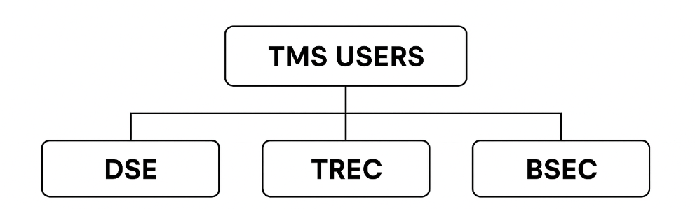
- DSE
- MIS & Development (Admin)
- TREC Affairs (All features)
- App Support (For AR and workstation manage)
- System & Market Administration (For AR and workstation view)
- Network Development (For network related info mange of the TREC and Offices)
- TREC
- Admin
- Maker
- Checker
- BSEC
- Admin
- Approver

Future Enhancement Scopes
- Develop a web-based module for TREC holders to facilitate an online application process.
TREC Maker > TREC Checker > TREC Verify > DSE Execute
- Develop a web-based module for BSEC to approve online application process.
TREC Maker > TREC Checker > TREC Verify > DSE Execute > BSEC Approve
- Synchronize the software with the DSE website to display relevant information about TREC holder companies.

