Trec management system
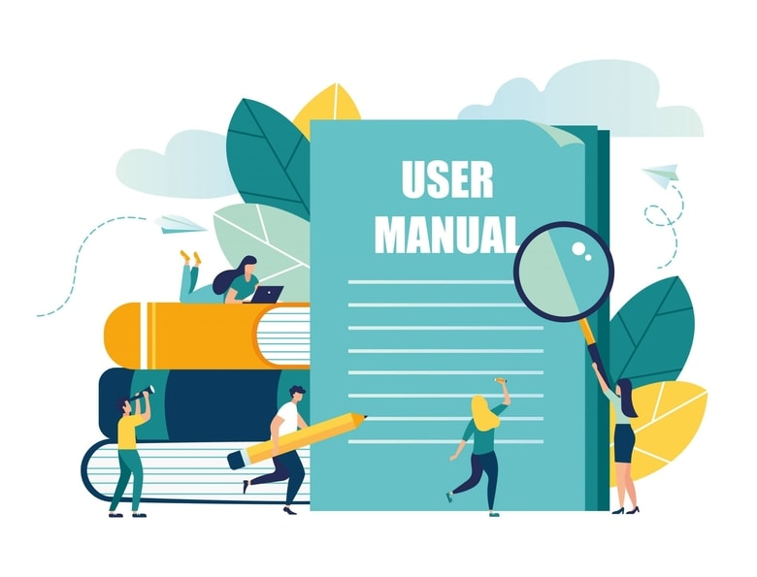

Developed By:
Dhaka Stock Exchange
https://www.dsebd.org/

Contents
1. TREC 6
1.1 TREC List & Add a TREC 6
1.2 Edit 7
1.3 Status History 7
1.4 Status Change 8
1.5 Edit Status 9
2. Dual TREC 10
2.1 Dual TREC List & ADD a Dual TREC 10
2.2 Dual TREC Edit 11
3. TREC Auditor 11
3.1 TREC Auditor List & Add a TREC 11
3.2 Edit 12
4 TREC Capital 12
4.1 TREC Capital list & Add A TREC Capital 12
4.2 Edit 13
5 TREC Parent Company 14
5.1 TREC Parent Company List & Add a TREC Parent Company 14
5.2 Edit 14
6 Broker 15
6.1 Broker List & Add Broker 15
6.2 Edit 16
6.3 Status History 17
6.4 Change status 17
6.5 Status History Edit 18
6.6 License Expire Remainder 19
6.7 Renew History 20
6.8 Renew 21
6.9 Renew History Edit 21
7 Dealer 22
7.1 Dealer list & Add Dealer 22
7.2 Edit 23
7.3 Status History 24
7.4 Status History Edit 24
7.5 Status History Change 25
7.6 License Expiry Remainder 26
7.7 Renew 27
7.8 Renew History 28
7.9 Renew History Edit 28
8. TREC Personnel 29
8.1 Personnel List & Add Personnel 29
8.2 Edit 30
9. Authorized Representative 31
9.1 Authorized Representative List & Add Authorized Representative 31
9.2 Edit 32
9.3 Status History 33
9.4 Status History Edit 33
9.5 Status History Change 34
9.6 License Expiry Remainder 35
9.7 Renew 36
9.8 Renew History 37
9.9 Renew History Edit 38
10. TREC Holder Representative 39
10.1 List & Add 39
10.2 Edit 39
10.3 Status History 40
10.4 Status Change 41
10.5 Status History Edit 42
11. Compliance Authorities 43
11.1 List & Add 43
11.2 Edit 44
11.3 Status History 44
11.4 Status History Change 45
11.5 Status History Edit 46
12. TREC CAMALCO 47
12.1 List & Add 47
12.2 Edit 48
12.3 Status History 49
12.4 Status Change 49
12.5 Status History Edit 50
13. TREC Power of Attorneys 51
13.1 List & Add 51
13.2 Edit 52
13.3 Status History 53
13.4 Status Change 53
13.5 Status History Edit 54
14. Offices 55
14.1 List & Add New 55
14.2 Edit 56
14.3 Status History 57
14.4 Status History Edit 57
14.5 Status History Change 58
14.6 Type History 59
14.7 Type History Edit 60
14.8 Type History Change 61
14.9 Shift History 62
14.10 Shift History Edit 62
14.11 Office Shift 64
14.12 In-charge History 65
14.13 In-charge History Edit 66
14.14 In-charge Change 67
14.15 Compliance Officer History 68
14.16 Compliance Officer History Edit 68
14.17 Compliance Officer Change 69
15. Office Network 71
15.1 List & Add 71
15.2 Edit 71
16. TMS Report 72
16.1 AR Renew Report 72
16.2 AR Search Report 73
16.3 AR Status Change Report 74
16.4 Broker Renew Report 74
16.5 Broker Status Change Report 75
16.6 Dealer Renew Report 76
16.7 Dealer Status Change Report 76
16.8 Office Search Report 77
16.9 Office Shift Report 78
16.10 Office Status Change Report 79
16.11 Office Type Change Report 79
16.12 TREC Code Change Report 80
16.13 TREC Name Change Report 80
16.14 TREC Status Change Report 81
16.15 Workstation Change Report 82
16.16 Workstation Office Change Report 83
16.17 Workstation Search Report 83
16.18 Workstation Status Change Report 84
17. Workstation 85
17.1 List & Add 85
17.2 Edit 85
17.3 Office History 86
17.4 Office History Change 87
17.5 Office History Edit 88
17.6 AR History 89
17.7 AR History Change 90
17.8 AR History Edit 91
17.9 Status History 92
17.10 Status Change 93
17.11 Status Edit 94

TREC

TREC List & Add a TREC
Process: Log in >TREC Management
>TREC List
>Add New
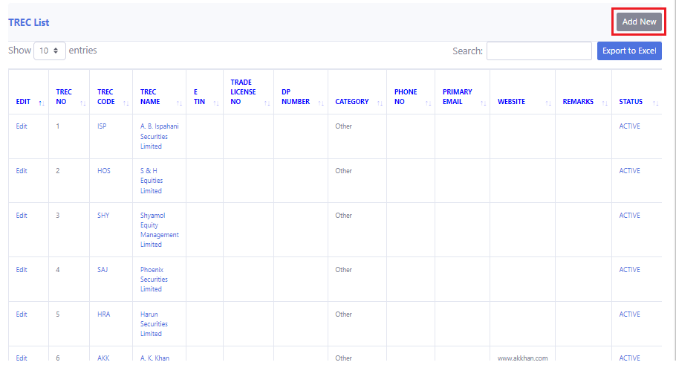
Description: Now click on the “Add New” option to add a new TREC.
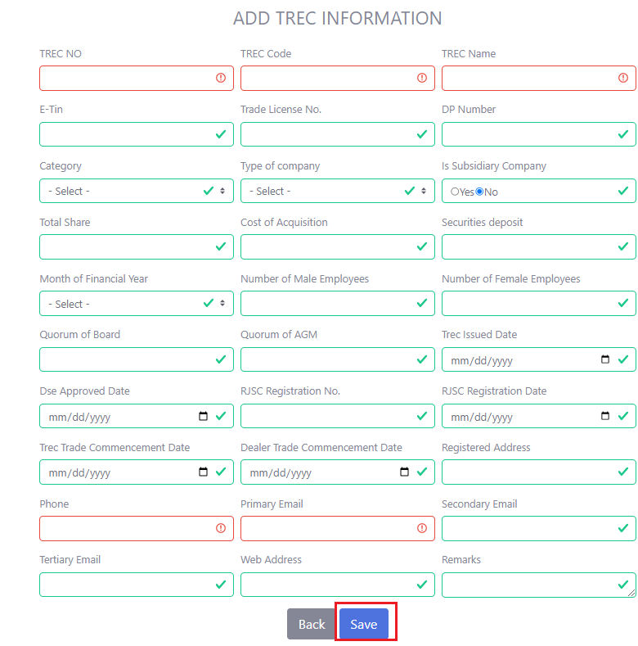
Description: After clicking the “Add New” option the user has to give some information in the required field and then he has to click the “Save” button. Red lined box should have to contain the required information.

Edit
Process: Log in > TREC Management
> TREC list
> Edit
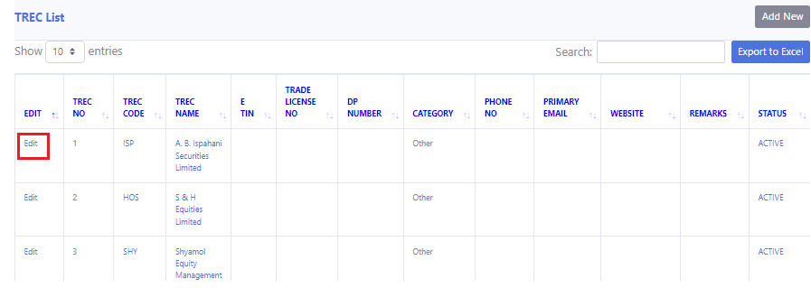
Description: Click on the “Edit” to change or edit any information.
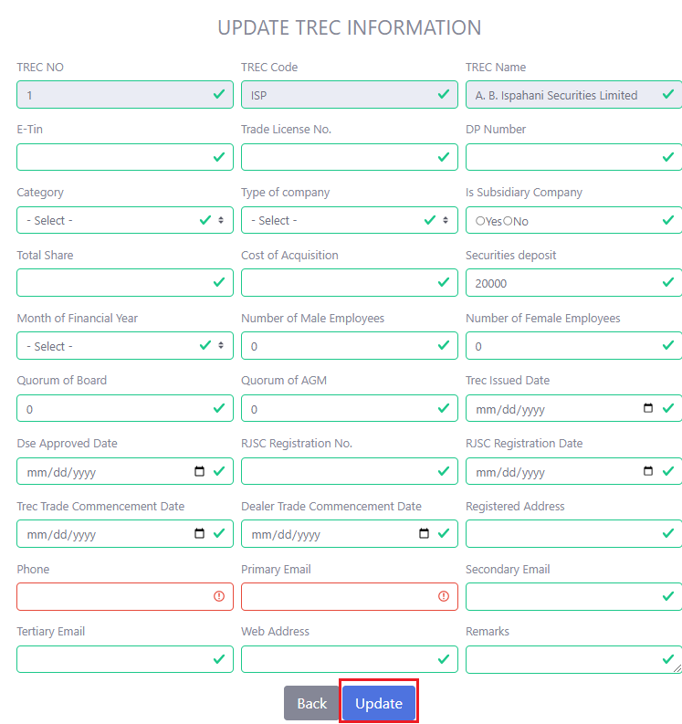
Description: Click on a specific “TREC No” to make any changes to the TRECs’ information. The user only needs to click "Edit" to make any changes. After changes, select "update."

Status History
Process: Log in > TREC Management
> TREC list
> Status(Active/Inactive/Suspend/Cancelled)
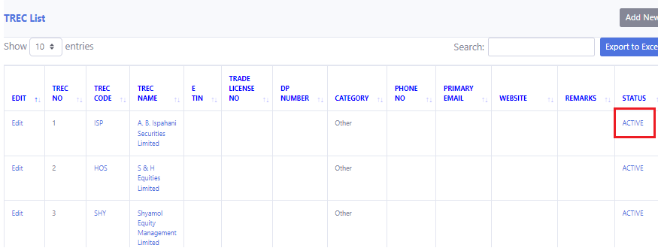
Description: Click on the “Status(Active/Inactive/Suspend/Cancelled)” to change the status of a TREC.

Description: Now you can see the status history.

Status Change
Process: Log in > TREC Management
> TREC list
> Status(Active/Inactive/Suspend/Cancelled)
> Status Change

Description: Click on “Status(Active/Inactive/Suspend/Cancelled)”.
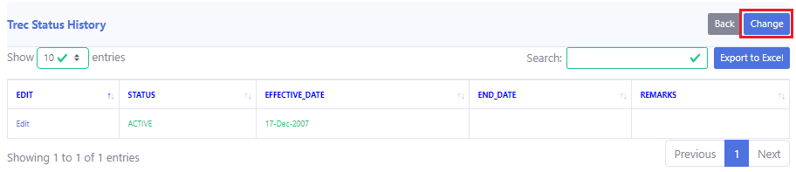
Description: Then click on “Change Status”.
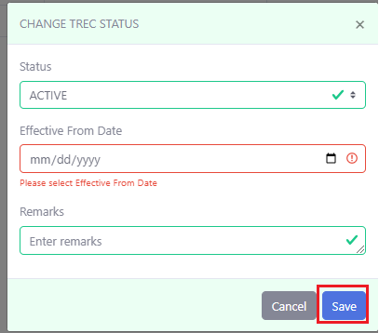
Description: After changing, click on “Save Changes”.

1.5 Edit Status
Process: Log in > TREC Management
> TREC list
> Status(Active/Inactive/Suspend/Cancelled)
> Edit

Description: Click on “Status(Active/Inactive/Suspend/Cancelled)”.
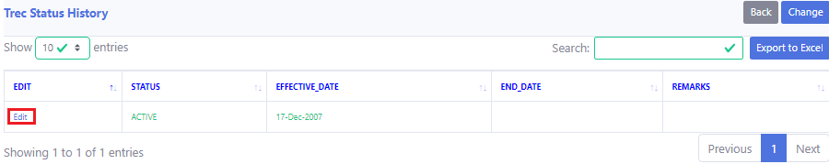
Description: Now click on “Edit”.
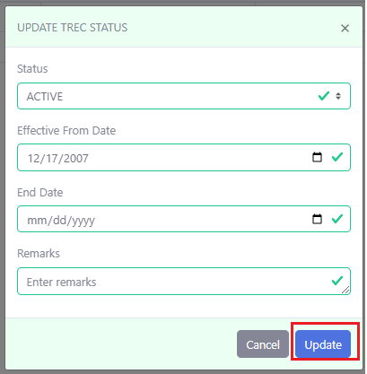
Description: After editing, click on Update.

2. Dual TREC

2.1 Dual TREC List & ADD a Dual TREC
Process: Log in >TREC Management
> Dual TREC
> Add New
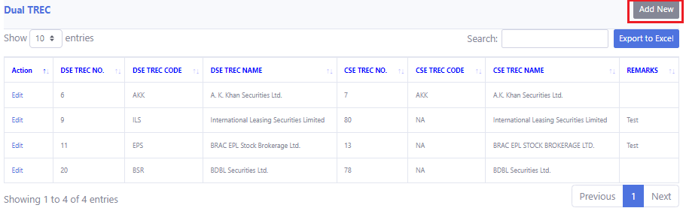
Description: Now click on “Add New”.
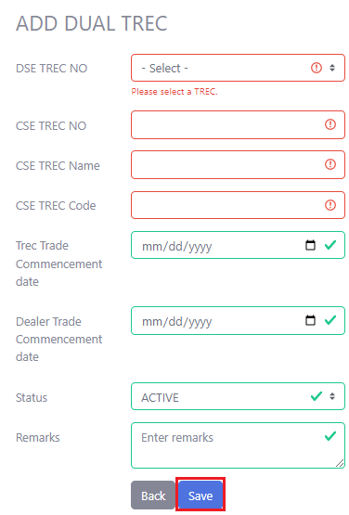
Description: After giving the information, click on “Save”. Red boxes must have to contain the valid information.

Dual TREC Edit
Process: Log in >TREC Management
> Dual TREC
> Edit.
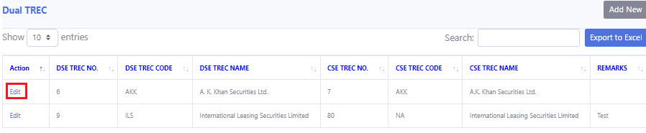
Description: Now click on “edit”.
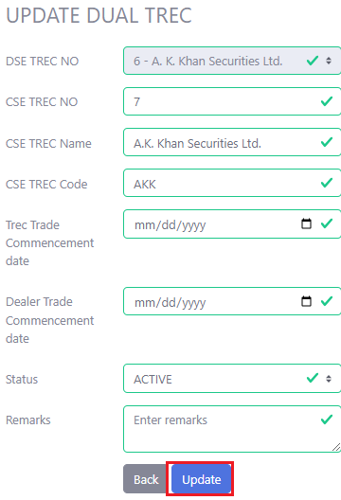
Description: Now click on “update”.

TREC Auditor

TREC Auditor List & Add a TREC
Process: Log in >TREC Management
>TREC Auditor
> Add New
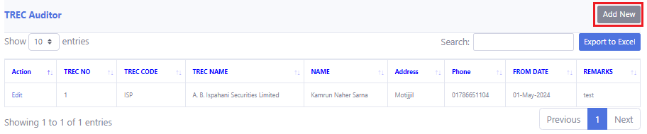
Description: Now click on “ADD New”.
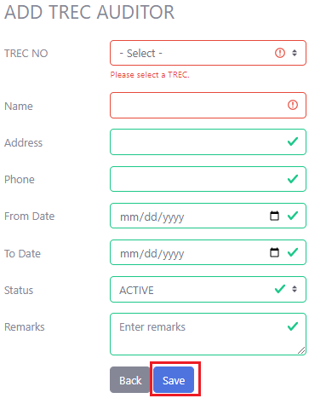
Description: After giving all the information, click on “Save”. Red boxes must have to contain the valid information.

Edit
Process: Log in >TREC Management
>TREC Auditor
> Edit
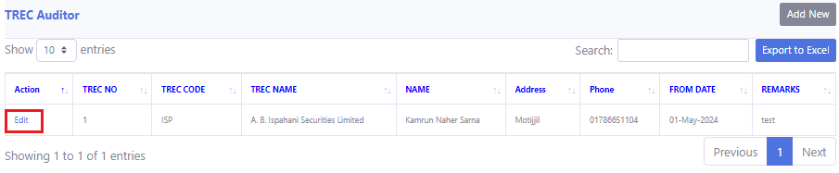
Description: Click on “Edit”.
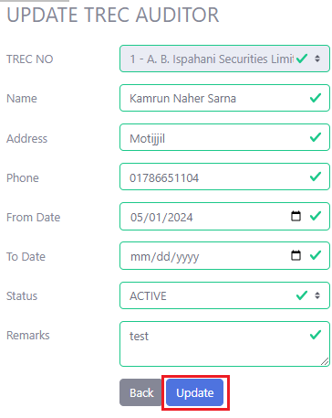
Description: After editing, click on “Update”.

TREC Capital

4.1 TREC Capital list & Add A TREC Capital
Process: Log in > TREC Management
> TREC Capital
> Add New
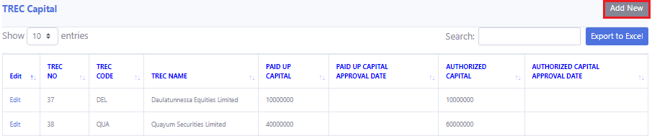
Description: Now click on “Add New”.
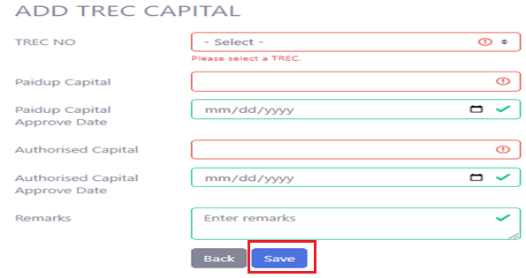
Description: After giving all the information, click “Save”.

Edit
Process: Log in > TREC Management
> TREC Capital
> Edit
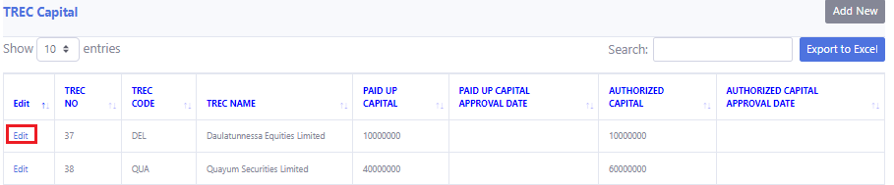
Description: Click on Edit.
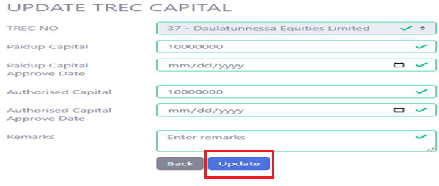
Description: After editing, click on “Update”.

TREC Parent Company

TREC Parent Company List & Add a TREC Parent Company

Process: Log in > TREC Management
> TREC Parent Company
> Add New
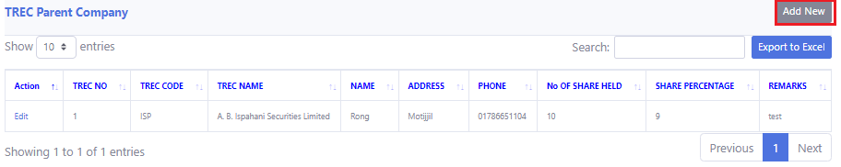
Description: Click on Add New.
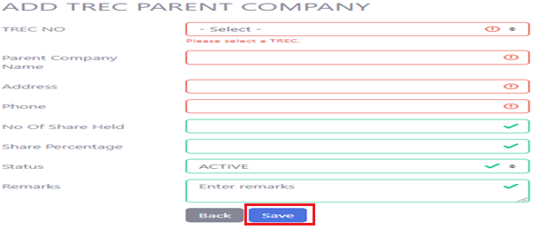
Description: After giving all information, click on “Save”.

Edit
Process: Log in > TREC Management
> TREC Parent Company
> Edit
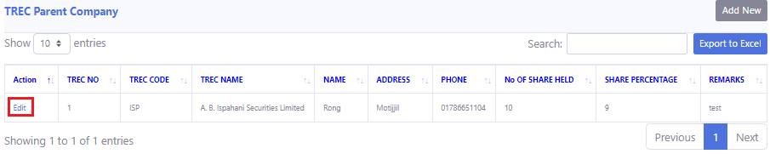
Description: Click on Edit.
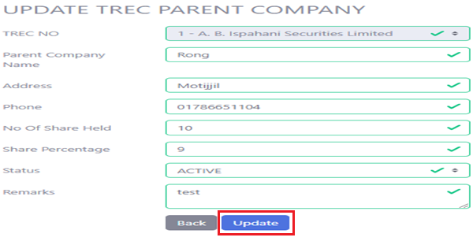
Description: After editing, click on “Update”.

Broker

Broker List & Add Broker
Process: Log in > Broker Management
> Broker License
> Add New

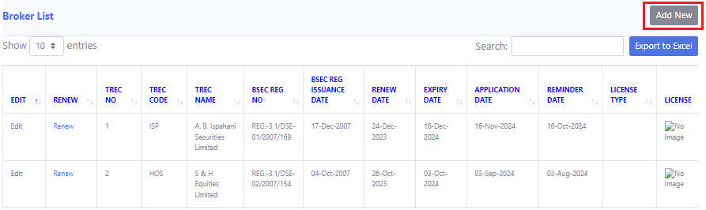
Description: Then click “Add New”.
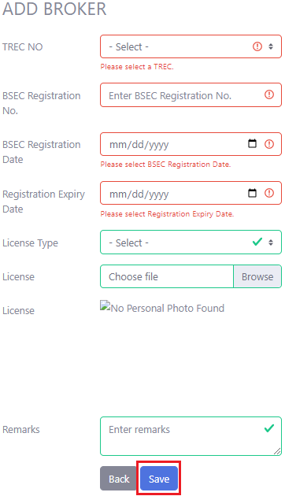
Description: Enter the “TREC No” in which you want to add the broker. Then enter the required the data and the red box must have to contain the required data. After that, click “Save”.

Edit
Process: Log in > Broker Management
> Broker License
> Edit
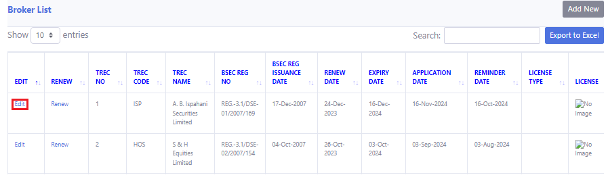
Description: Click on “Edit”.
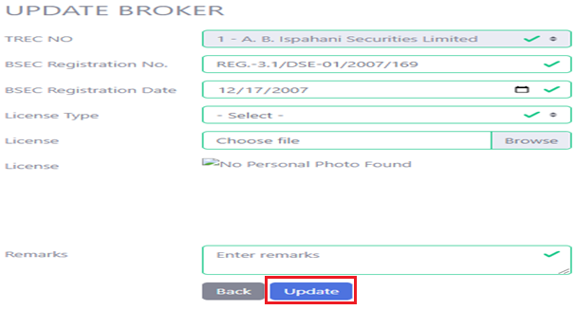
Description: After done with editing click on “Update”.

Status History
Process: Log in > Broker Management
> Broker License
> Active/Suspended/inactive/cancelled
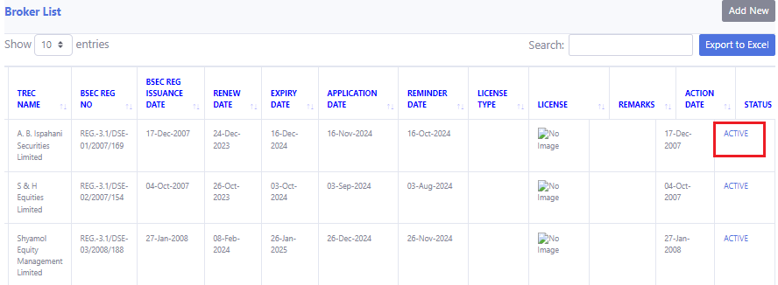
Description: Click on “Active”.
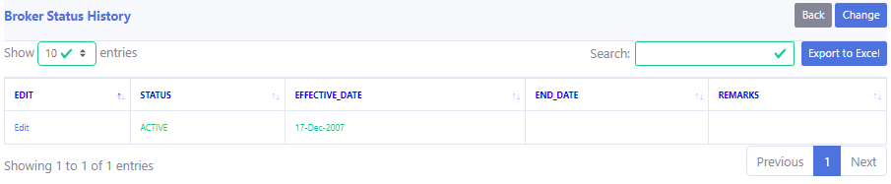
Description: Then you will see the “Status History”.

Change status
Process: Log in > Broker Management
> Broker License
> Active
> Change status

Description: Click on “Active”.
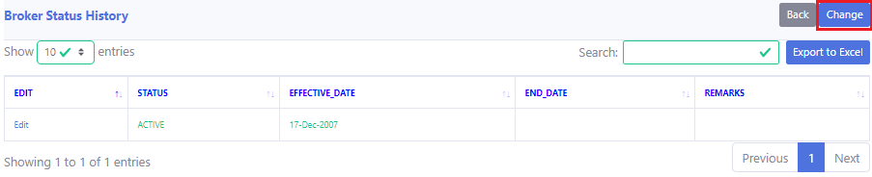
Description: Click on “Change Status”.
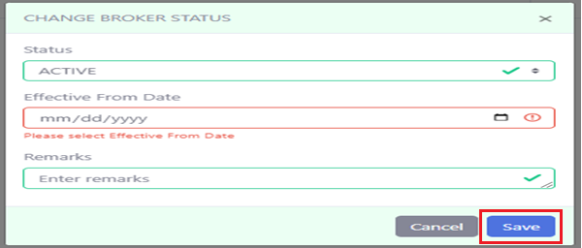
Description: After changing click on “Save Changes”. Red box must contain the valid information.

Status History Edit
Process: Log in > Broker Management
> Broker License
> Active
> Edit

Description: Click on “Active”.
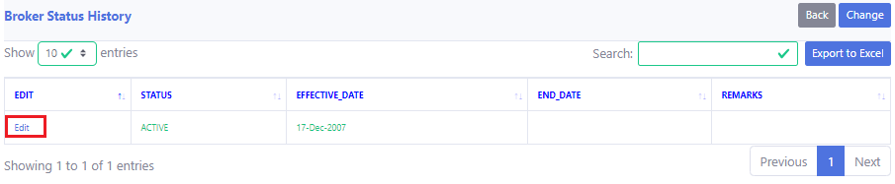
Description: Click on “Edit”.
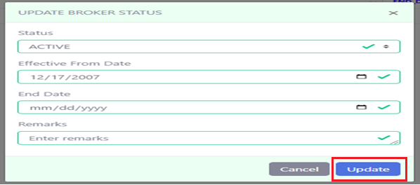
Description: After editing click on “Update”.

License Expire Remainder
Process: Log in > Broker Management
> Broker Expiry Remainder
> Broker License
> Renew
> Renew
> Broker Management
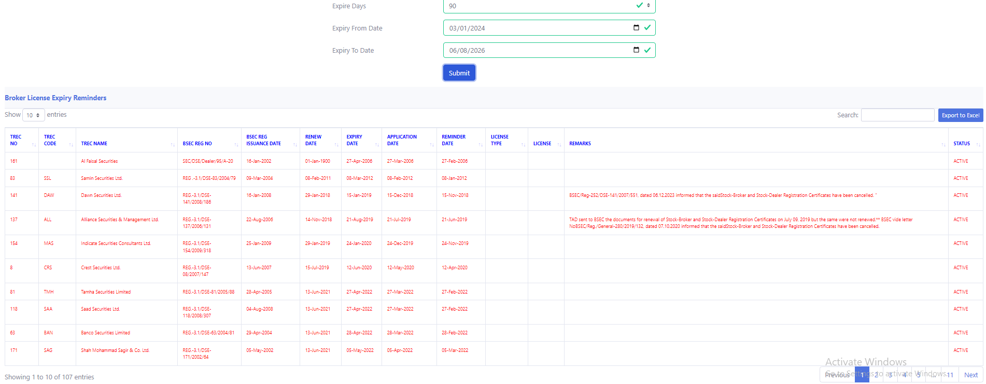
Description: See the TREC no and then go bake to the “Broker License”.
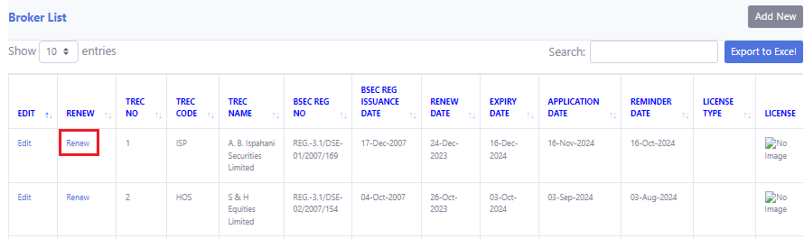
Description: On the particular TREC no click “Renew”.
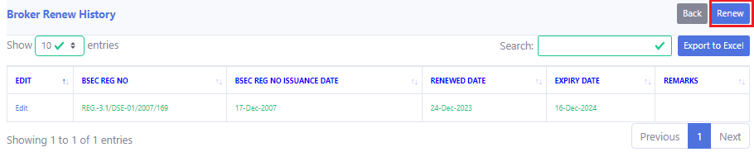
Description: Click on “Renew”.
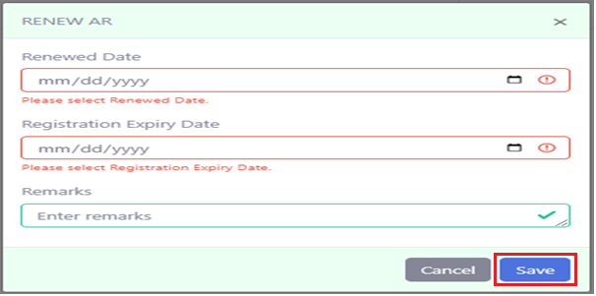
Description: After renewing click on “Save Changes”.

Description: Again go back to the “Broker Expiry Remainder” and you will see that the particular TREC is gone from there.

Renew History
Process: Log in > Broker Management
> Broker License
> Renew

Description: Click on “Renew”.
Description: you will see the “Renew history”.

Renew
Process: Log in > Broker Management
> Broker License
> Renew
> Renew

Description: Click on “Renew”.

Description: Click on “Renew”.

Description: After renewing click on “Save Changes”. Red box must contain the valid information.

Renew History Edit
Process: Log in > Broker Management
> Broker License
> Renew
> Edit

Description: Click on “Renew”.
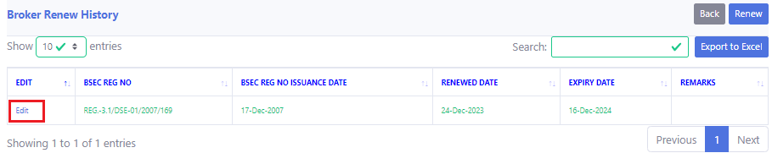
Description: Click on “Edit”.
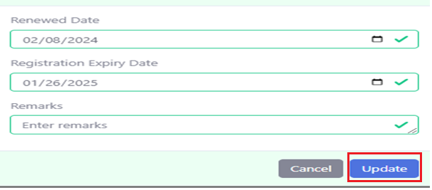
Description: After editing click on “Update”.

Dealer

Dealer list & Add Dealer
Process: Log in > Dealer Management
> Dealer License
> Add New
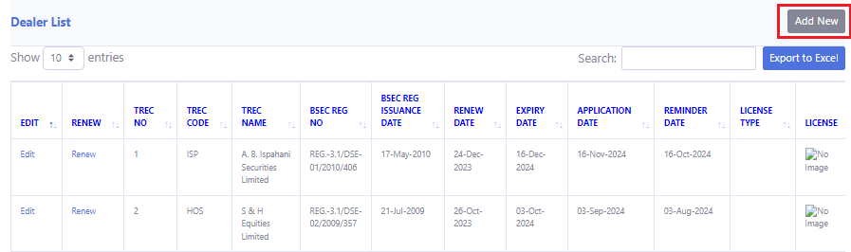
Description: Then click “Add New”.
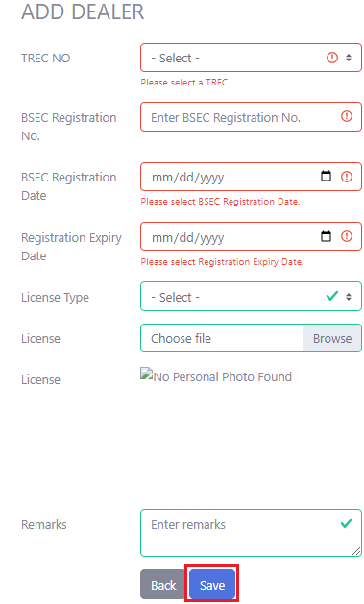
Description: The click “Save”. The red box must have to contain the right information.

Edit
Process: Log in > Dealer Management
> Dealer License
> Edit
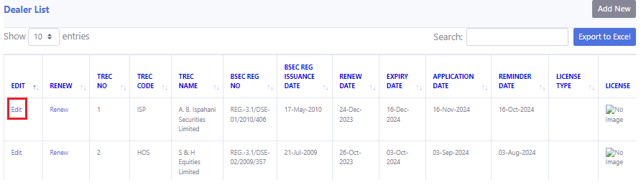
Description: Then click “Edit”.
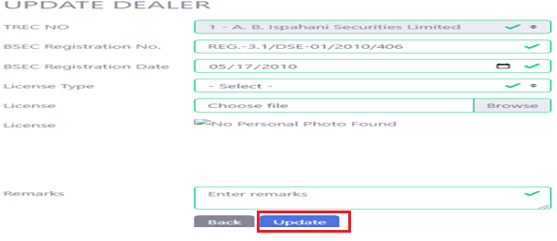
Description: After editing click on “Update”

Status History
Process: Log in > Dealer Management
> Dealer License
> Active/Suspended/inactive/cancelled
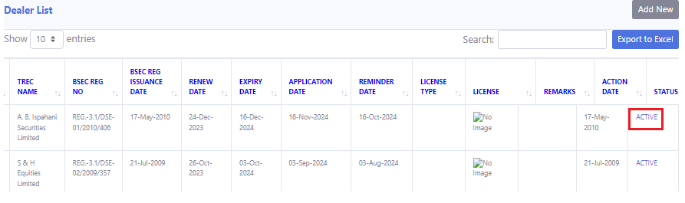
Description: Then click “Active/Suspended/inactive/cancelled”.
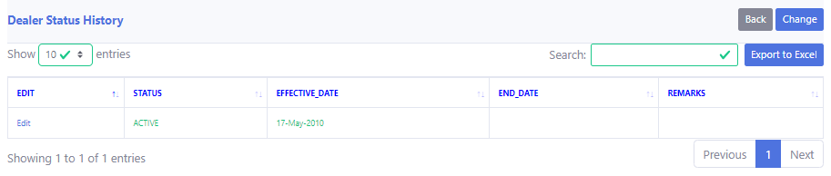
Description: Now you can see the status history.

Status History Edit
Process: Log in > Dealer Management
> Dealer License
> Active/Suspended/inactive/cancelled
> Edit

Description: Then click “Active/Suspended/inactive/cancelled”.
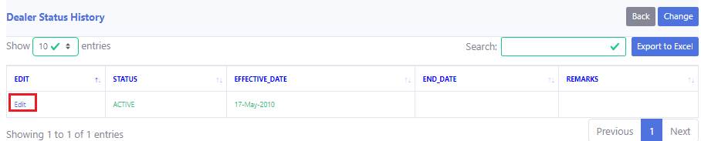
Description: Now click “Edit”.
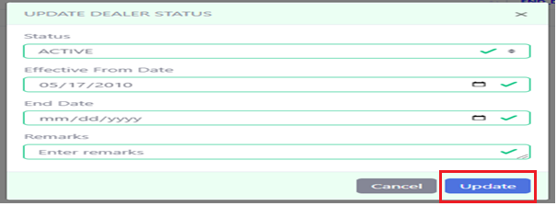
Description: After editing click “Update”.

Status History Change
Process: Log in > Dealer Management
> Dealer License
> Active/Suspended/inactive/cancelled
> Changed Status

Description: Then click “Active/Suspended/inactive/cancelled”.
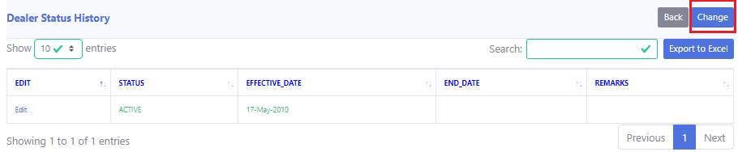
Description: Now click “Change”.
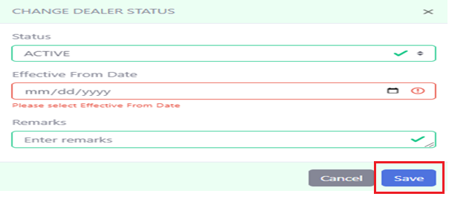
Description: After changing click “Save changes”. Red box must have to contain the valid information.

License Expiry Remainder
Process: Log in > Dealer Management
> Dealer Expiry Remainder
> Dealer License
> Renew
> Renew
> Dealer Management
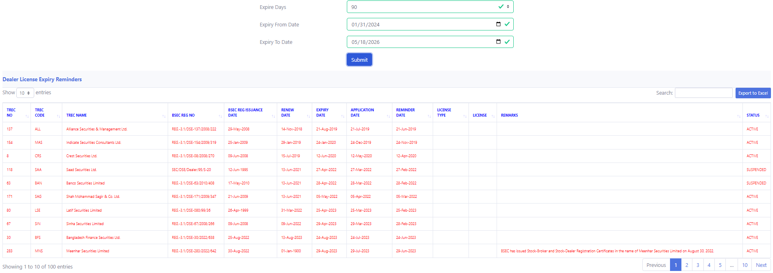
Description: See the TREC no and then go bake to the “Dealer License”.
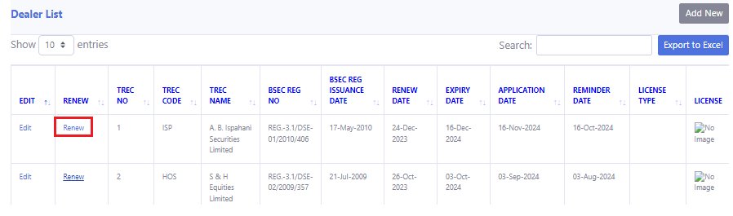
Description: On the particular TREC no click “Renew”.
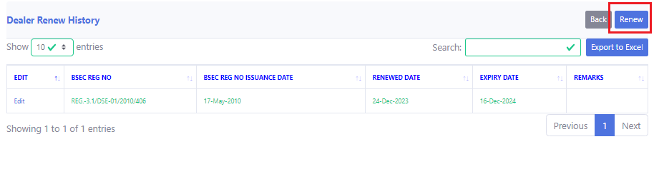
Description: Click on “Renew”.
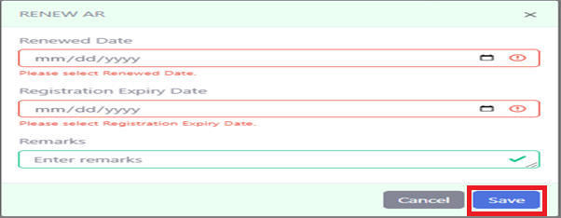
Description: After renewing click on “Save Changes”. Red box must contain the valid information.

Renew
Process: Log in > Dealer Management
> Dealer License
> Renew
> Renew

Description: Click on “Renew”.

Description: Click on “Renew”.

Description: After renewing click on “Save Changes”. Red box must contain the valid information.

Renew History
Process: Log in > Dealer Management
> Dealer License
> Renew

Description: Click on “Renew”.
Description: Now you will see the “Renew history”.

Renew History Edit
Process: Log in > Dealer Management
> Dealer License
> Renew
> Edit

Description: Click on “Renew”.
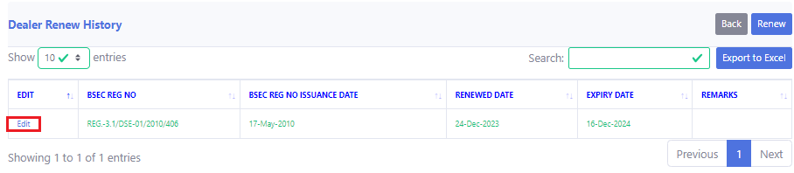
Description: Click on “Edit”.
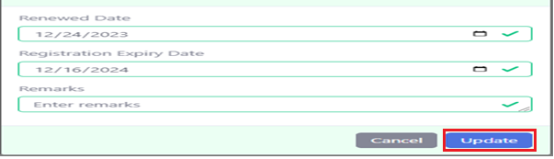
Description: After editing click on “Update”.

8. TREC Personnel

8.1 Personnel List & Add Personnel
Process: Log in > TREC Personnel
> Personnel List
>TREC NO
> Add New
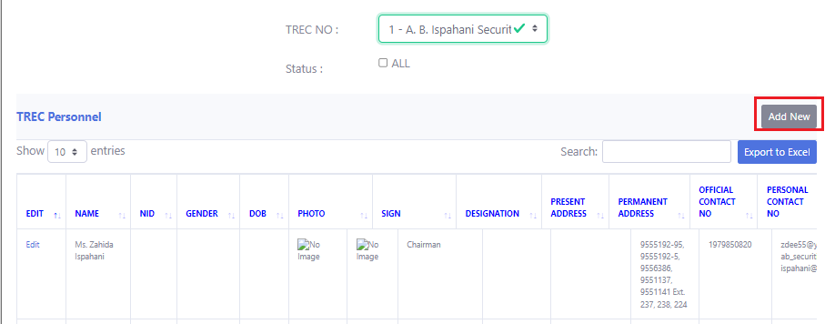
Description: Select the “TREC No” to add a new person on the TREC. Then Click “Add New”.
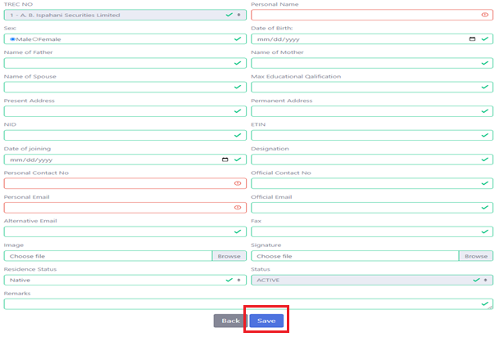
Description: After entering information click “Save”. The red box must have to contain the valid information.

Edit
Process: Log in > TREC Personnel
> Personnel List
>TREC NO
> Edit
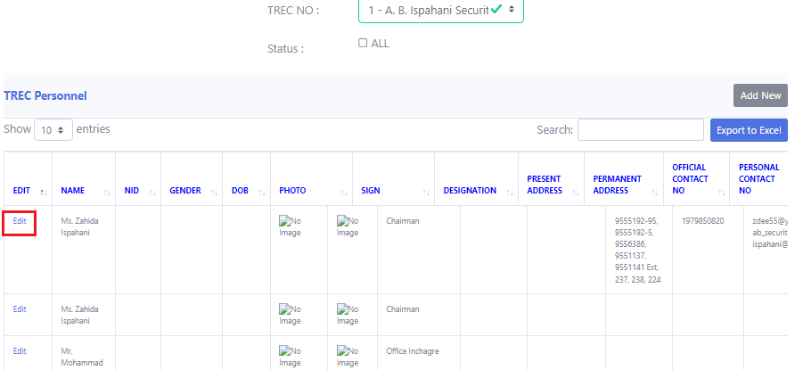
Description: Click on “Edit”.
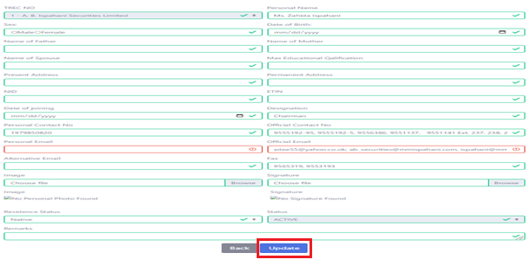
Description: After editing click “Update”. The red box must have to contain the valid information.

Authorized Representative

Authorized Representative List & Add Authorized Representative
Process: Log in > AR Management
> Authorized Representative
> TREC No
> Add New
.
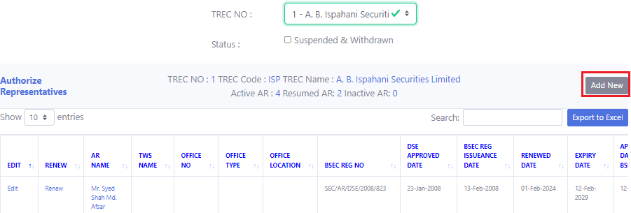
Description: Click “Add New”.
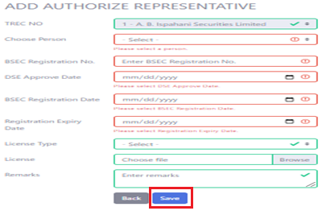
Description: Give the information and click “Save”. Red box must have to contain the valid information.

Edit
Process: Log in > AR Management
> Authorized Representative
> TREC No
> Edit
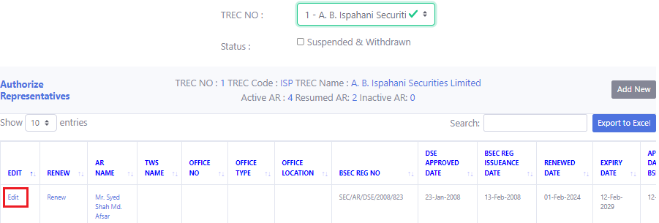
Description: Click “Edit”.
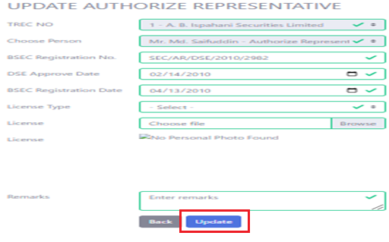
Description: After editing click “Update”.

Status History
Process: Log in > AR Management
> Authorized Representative
> TREC No
> Active/ Suspended/inactive/cancelled
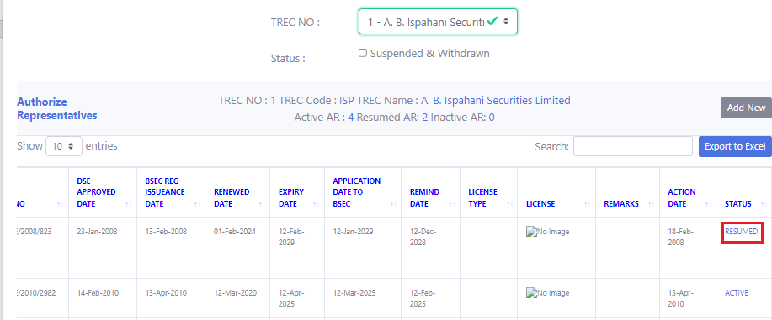
Description: Click “Active/ Suspended/inactive/cancelled”.
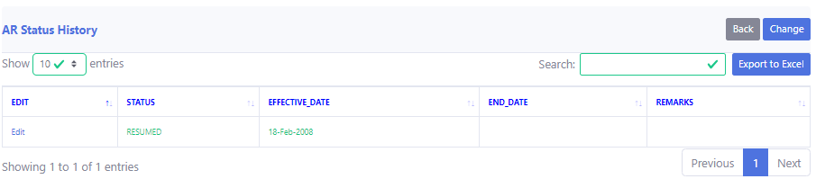
Description: Now you can see the status history.

Status History Edit
Process: Log in > AR Management
> Authorized Representative
> TREC No
> Active/ Suspended/inactive/cancelled
> Edit


Description: Click “Active/ Suspended/inactive/cancelled”.
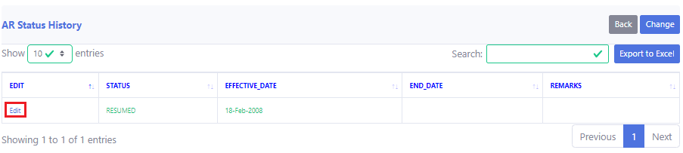
Description: Click “Edit”.
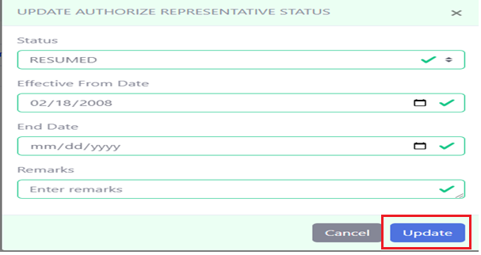
Description: After editing, click “Update”.

Status History Change
Process: Log in > AR Management
> Authorized Representative
> TREC No
> Active/ Suspended/inactive/cancelled
> Change

Description: Click “Active/ Suspended/inactive/cancelled”.
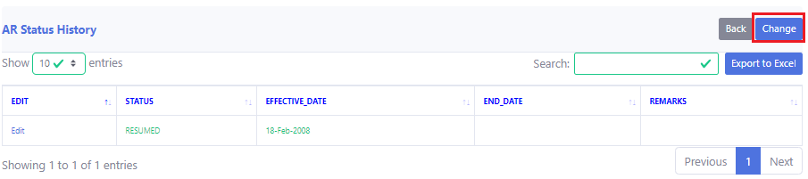
Description: Click “Change”.
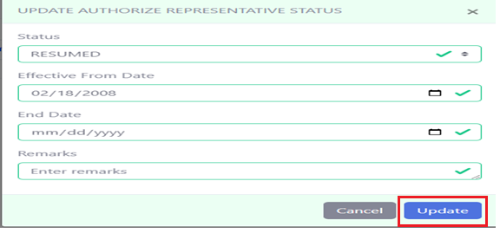
Description: After changing, click “Update”.

License Expiry Remainder
Process: Log in > AR Management
> AR Expiry Remainder
> Authorized Representative
> TREC No
> Renew
> Renew
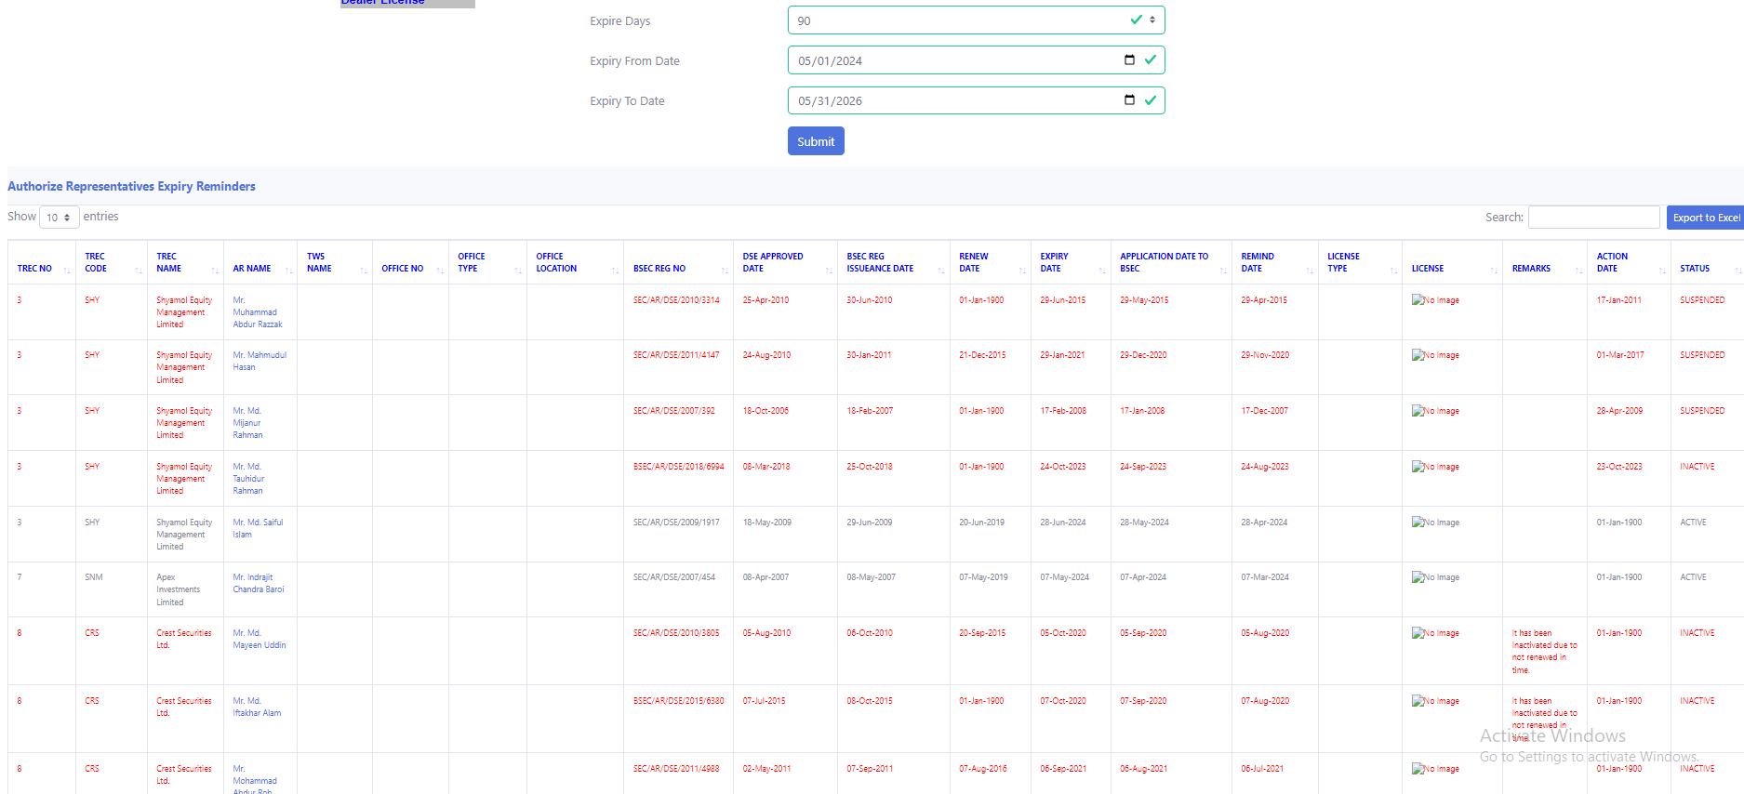
Description: After log in, click “AR management”. Then click “AR Expiry Remainder”.
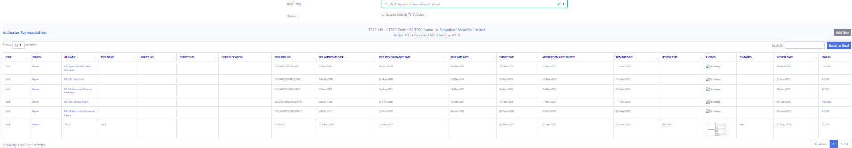
Description: Then click “Authorized Representative”.
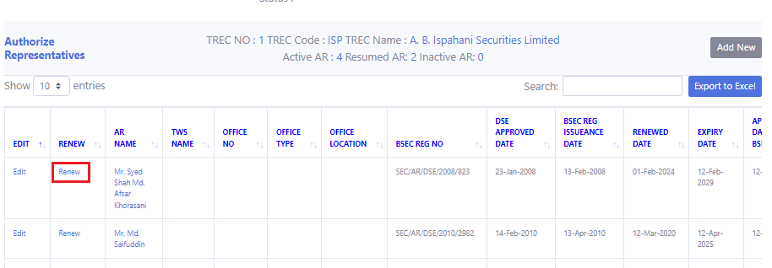
Description: Select “Renew”.
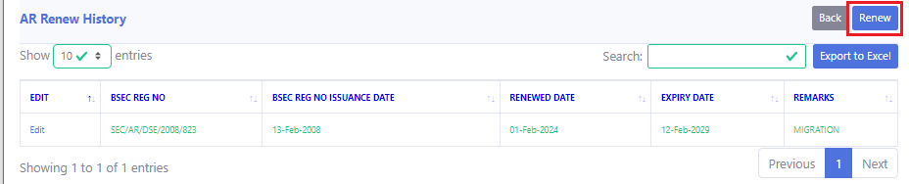
Description: Select “Renew”.
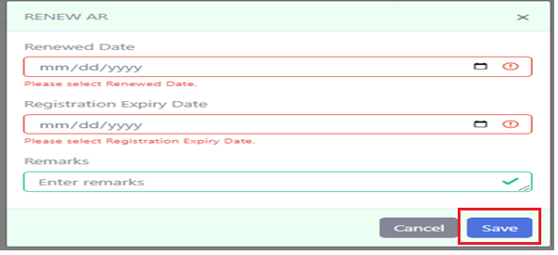
Description: After renewing, click “Save”.

Renew
Process: Log in > AR Management
> Authorized Representative
> TREC No
> Renew
> Renew

Description: Select “Renew”.

Description: Select “Renew”.

Description: After renewing, click “Save”. Red boxes must have to contain the valid information.

Renew History
Process: Log in > AR Management
> Authorized Representative
> TREC No
> Renew


Description: Select “Renew”.
Description: Now you can see the Renew History.

Renew History Edit
Process: Log in > AR Management
> Authorized Representative
> TREC No
> Renew
> Edit

Description: Select “Renew”.
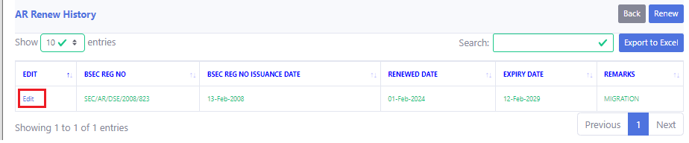

Description: Select “Edit”.
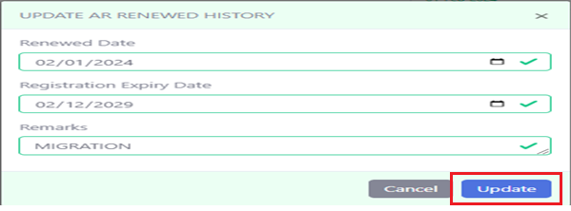
Description: After renewing, Click “Update”.

TREC Holder Representative

List & Add
Process: Log in > TREC Personnel
> TREC Holder Representative
> Add New
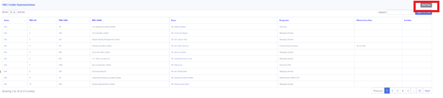
Description: Click “Add New”.
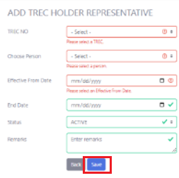
Description: Then click “Save”. Red boxes must have to contain the valid information.

Edit
Process: Log in > TREC Personnel
> TREC Holder Representative
> Edit
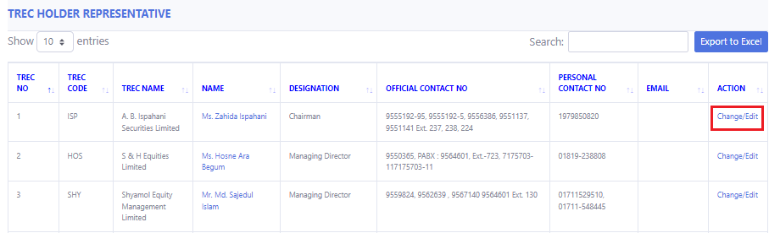
Description: Click “Edit/change”.
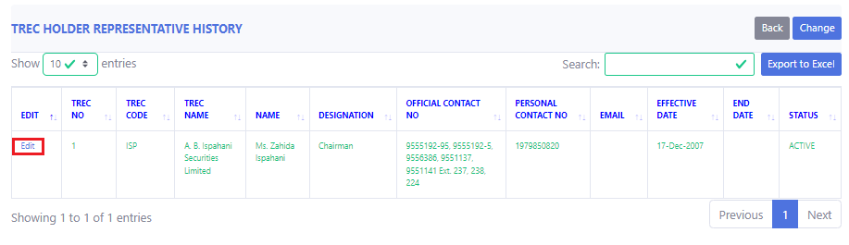
Description: Click “Edit”
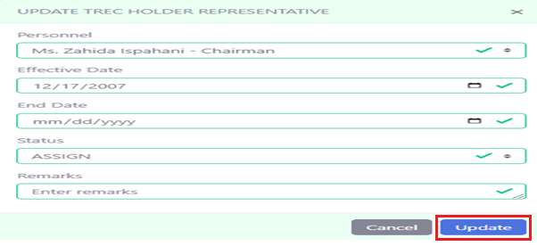
Description: After editing, click “Update”.

Status History
Process: Log in > TREC Personnel
> TREC Holder Representative
> Edit/Change

Description: Click “Edit/Change”.
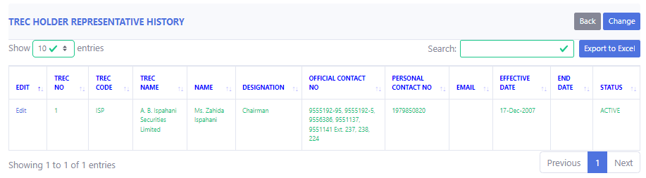
Description: Now you can see the status history.

Status Change
Process: Log in > TREC Personnel
> TREC Holder Representative
> Edit/Change
> Change

Description: Click “Edit/Change”.
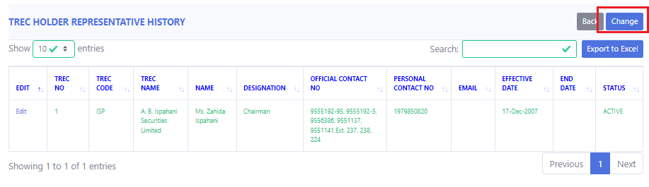
Description: Click on “Change”.
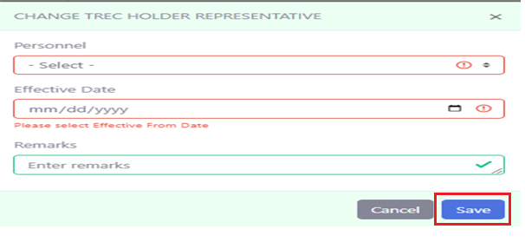
Description: After done with giving the information, click on “Save”.

Status History Edit
Process: Log in > TREC Personnel
> TREC Holder Representative
> Edit/Change
> Edit

Description: Click “Edit/Change”.
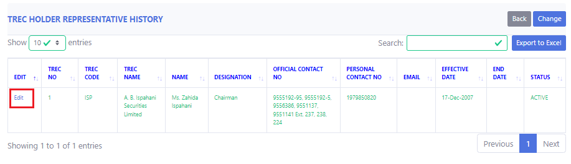
Description: Click “Edit”.

Description: After done with editing, click on “Update”.

Compliance Authorities

List & Add
Process: Log in > TREC Personnel
> Compliance Authorities
> Add New
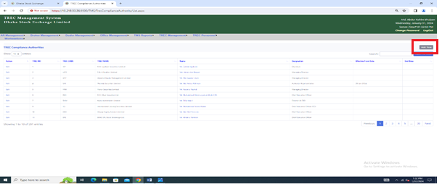
Description: Click “Add New”.
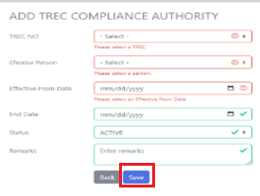
Description: Click “Save”. Red boxes must have to contain the valid information.

Edit
Process: Log in > TREC Personnel
> Compliance Authorities
> Edit
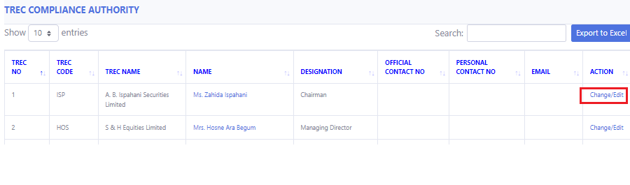
Description: Click “Change/Edit”.
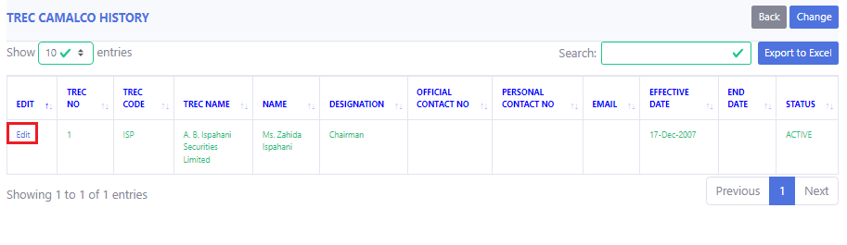
Description: Click “Edit”.
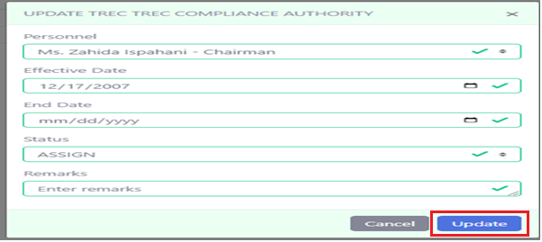
Description: Click “Update”.

Status History
Process: Log in > TREC Personnel
> Compliance Authorities
> Change/Edit

Description: Click “Edit/ Change”.
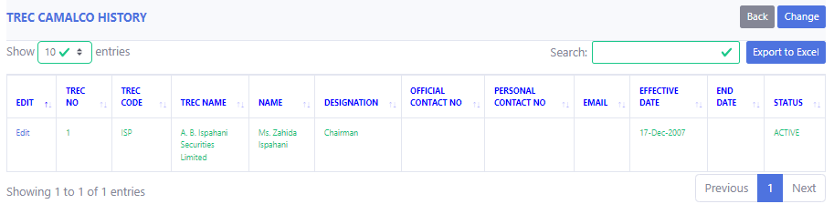
Description: Now you can see the status history.

Status History Change
Process: Log in > TREC Personnel
> Compliance Authorities
> Change/Edit
> Change

Description: Now click on “Edit/Change”.
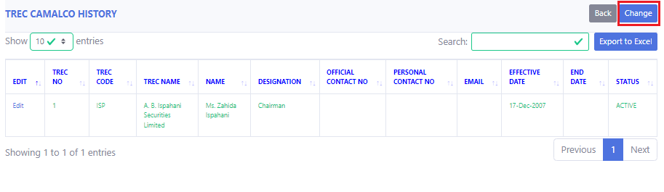
Description: Click on “Change”.
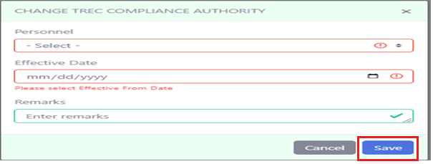
Description: After changing, click on “Save Changes”.

Status History Edit
Process: Log in > TREC Personnel
> Compliance Authorities
> Change/Edit
> Edit

Description: Now click on “Edit/Change”.

Description: Click on “Edit”.

Description: After done with editing, Click on “Update”.

TREC CAMALCO

List & Add
Process: Log in > TREC Personnel
> TREC CAMALCO
> Add New
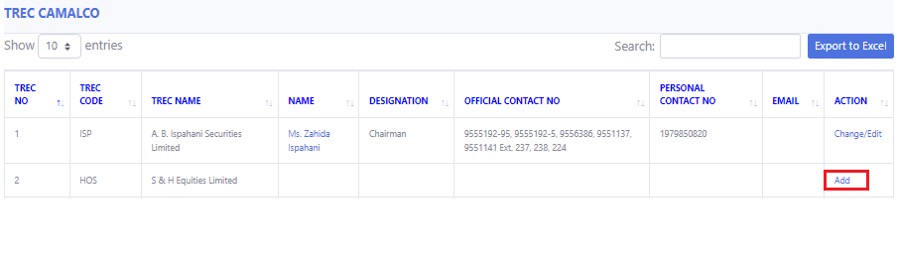
Description: Now click “Add”.
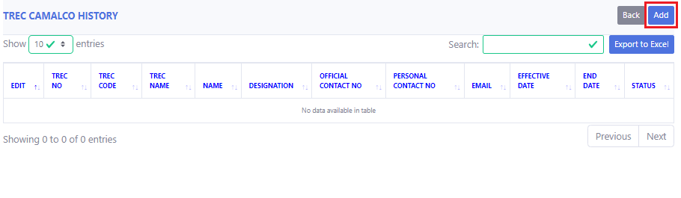
Description: Now click “Add”.
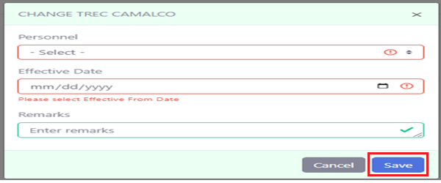
Description: Click “Save”. Red boxes should have the valid information.

Edit
Process: Log in > TREC Personnel
> TREC CAMALCO
> Edit
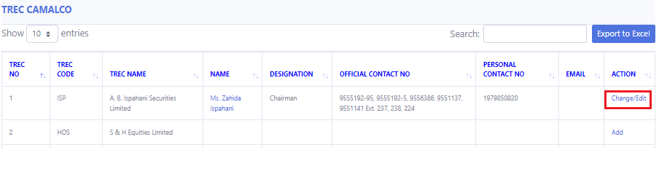
Description: Now click “Edit/Change”.
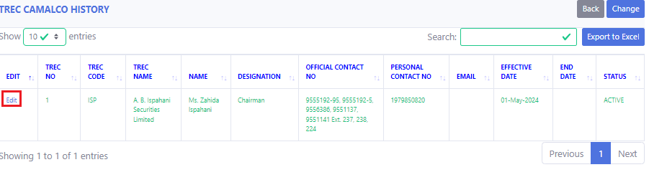
Description: Now click “Edit”.
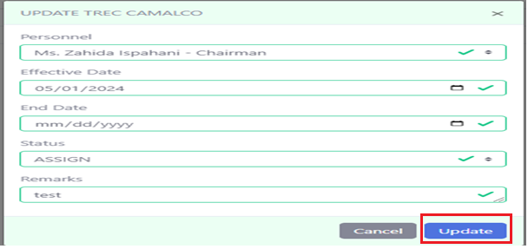
Description: After editing, click “Update”.

Status History
Process: Log in > TREC Personnel
> TREC CAMALCO
> Change/Edit

Description: Now click “Change/Edit”.
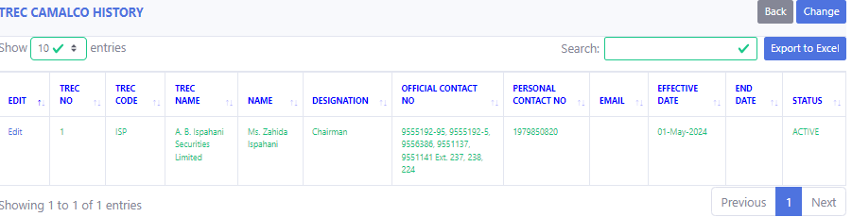
Description: Now you can see the status history.

Status Change
Process: Log in > TREC Personnel
> TREC CAMALCO
> Change/Edit
> Change

Description: Click on “Edit/Change”.
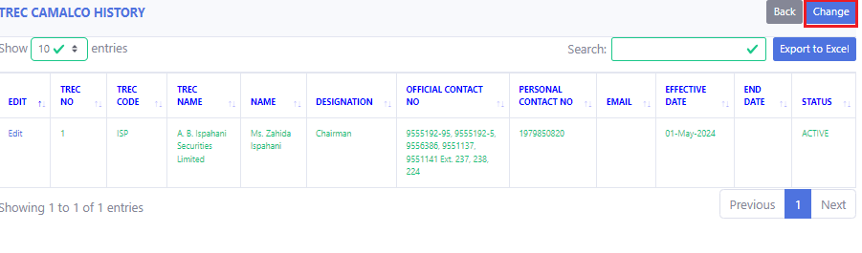
Description: Click on “Change”.
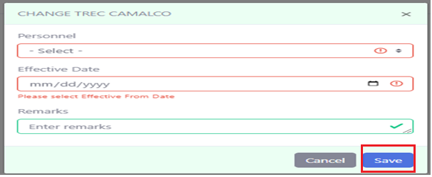
Description: After giving all the information, click on “Save Change”.

Status History Edit
Process: Log in > TREC Personnel
> TREC CAMALCO
> Change/Edit
> Edit

Description: Click on “Edit/Change”.

Description: Click on “Edit”.

Description: After done with it, Click on “Update”.

TREC Power of Attorneys

List & Add
Process: Log in > TREC Personnel
> TREC Power of Attorneys
>Add New
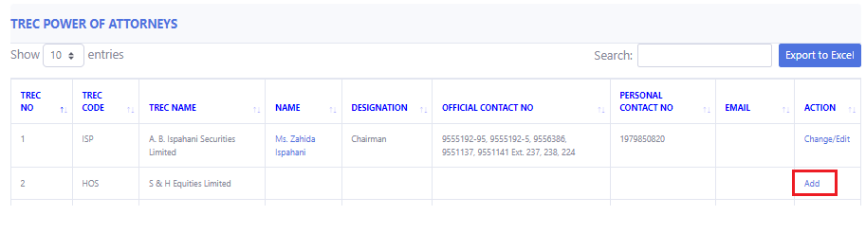
Description: Now click “Add”.
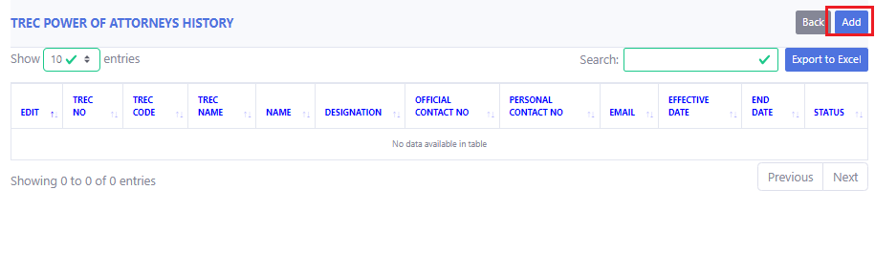
Description: Now click “Add”.
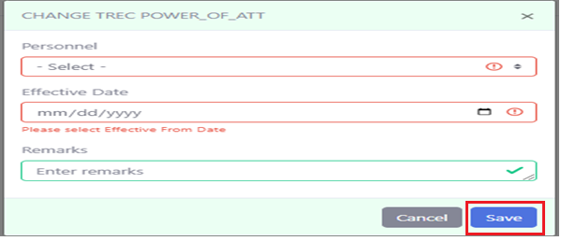
Description: Click “Save”.

Edit
Process: Log in > TREC Personnel
> TREC Power of Attorneys
> Edit/change
>Edit
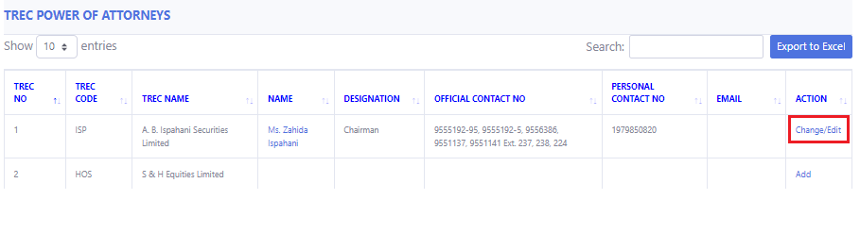
Description: Now click “Change/Edit”.
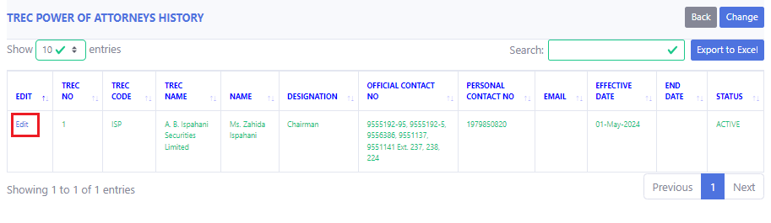
Description: Now click “Edit”.
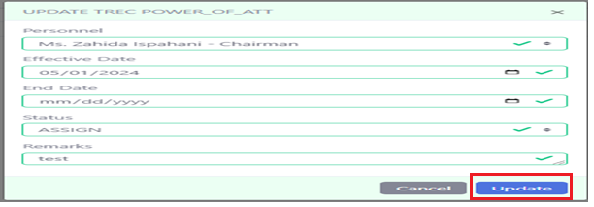
Description: Then “Update”.

Status History
Process: Log in > TREC Personnel
> TREC Power of Attorneys
> Change/Edit

Description: Now click “Edit/Change”.
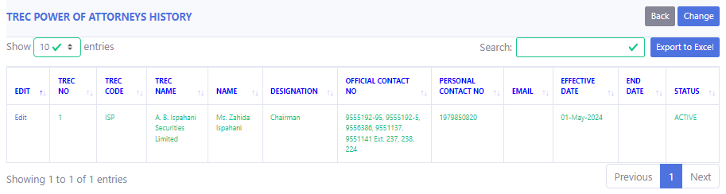
Description: Now you can see status history.

Status Change
Process: Log in > TREC Personnel
> TREC Power of Attorneys
> Change/Edit
> Change

Description: Click on “Change/Edit”.
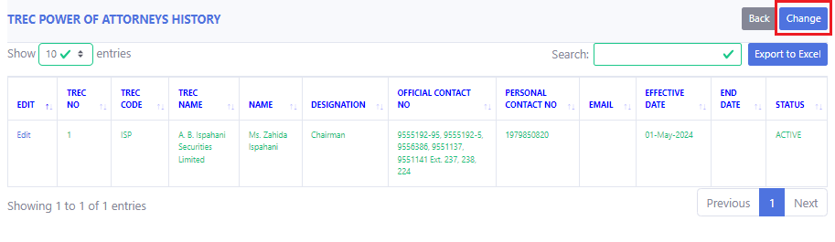
Description: Click on “Change”.
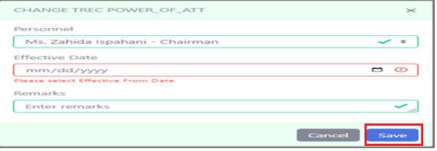
Description: After done with the changes, Click on “Save”.

Status History Edit
Process: Log in > TREC Personnel
> TREC Power of Attorneys
> Change/Edit
> Edit

Description: Click on “Change/Edit”.

Description: Click on “Edit”.

Description: After done with Editing click on “Update”.

Offices

14.1 List & Add New
Process: Log in > Office management
> TREC Office List
> TREC No
>Add New

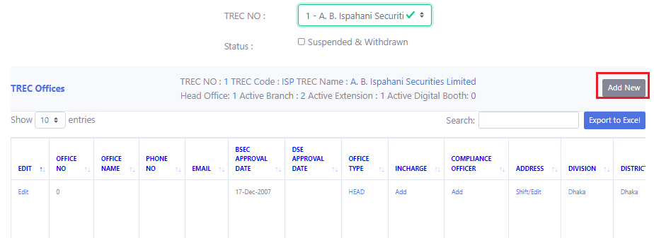
Description: Now click on the “Add new” option.
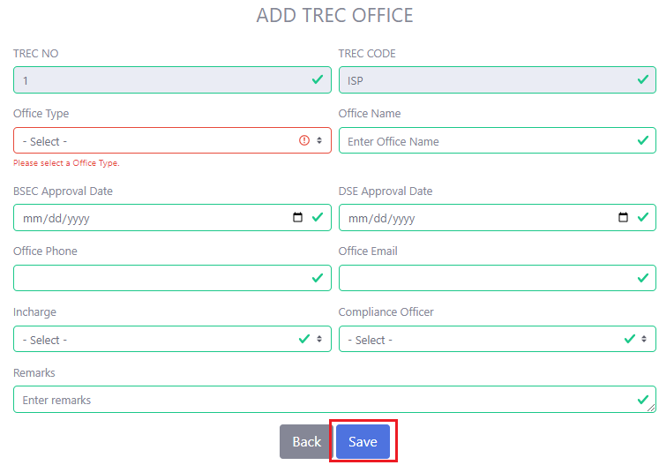
Description: After giving all the information, click on “Save”. Red box must have to contain the valid information.

14.2 Edit
Process: Log in > Office management
> TREC Office List
> TREC No
> Edit
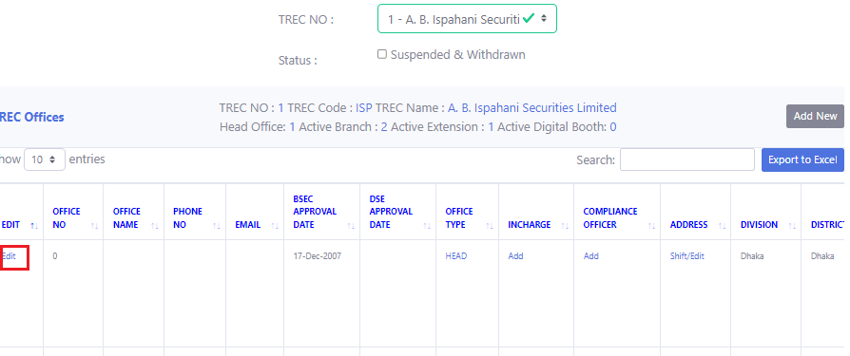
Description: Click on “Edit”.
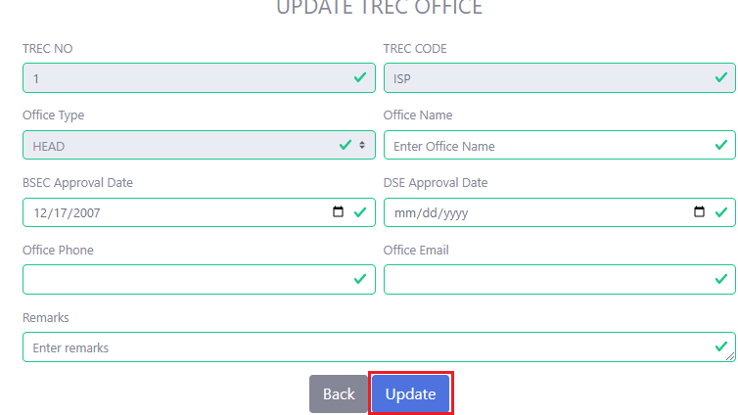
Description: After Done with editing, Click on “Update”.

14.3 Status History
Process: Log in > Office management
> TREC Office List
> TREC No
> Status (Active/Resumed/Inactive/Cancelled /Withdraw)
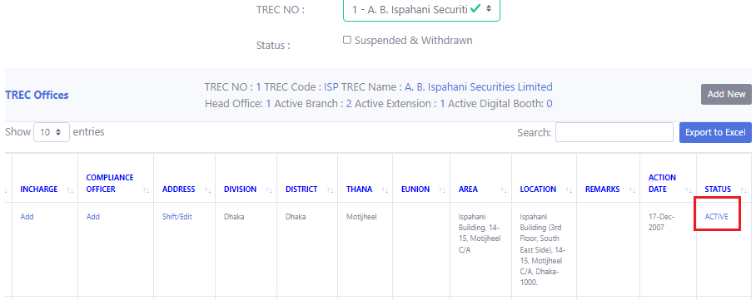
Description: Click on “Status (Active/Resumed/Inactive/Cancelled /Withdraw)” to see the Status History.
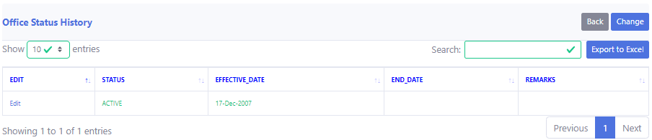
Description: Now you can see the Status History.

14.4 Status History Edit
Process: Log in > Office management
> TREC Office List
> TREC No
> Status (Active/Resumed/Inactive/Cancelled /Withdraw)
> Edit.

Description: Click on “Status (Active/Resumed/Inactive/Cancelled /Withdraw)” to see the Status History.
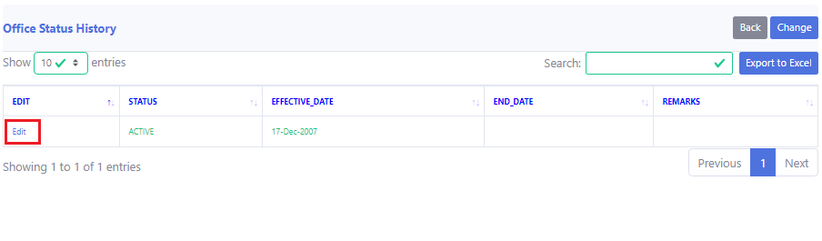
Description: Click on “Edit”
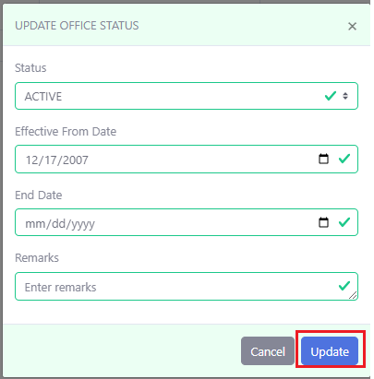
Description: After done with editing, Click on “Update”.

14.5 Status History Change
Process: Log in > Office management
> TREC Office List
> TREC No
> Status (Active/Resumed/Inactive/Cancelled /Withdraw)
> Change Status

Description: Click on “Status (Active/Resumed/Inactive/Cancelled /Withdraw)” to see the Status History.
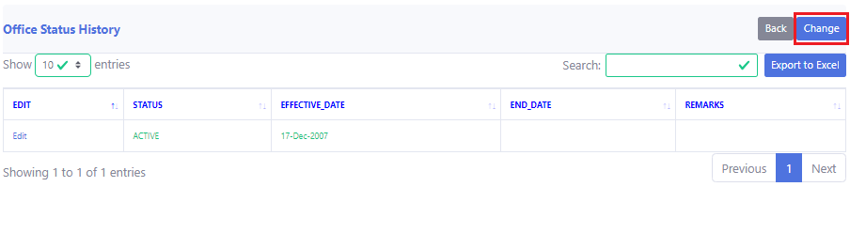
Description: Click on “Change Status”
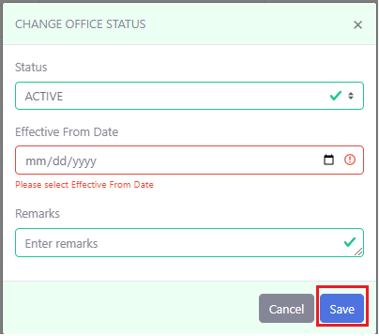
Description: After changes the status, click on “Save”.

14.6 Type History
Process: Log in > Office management
> TREC Office List
> TREC No
> Office Type (Head/Branch/Digital Booth/Extension)
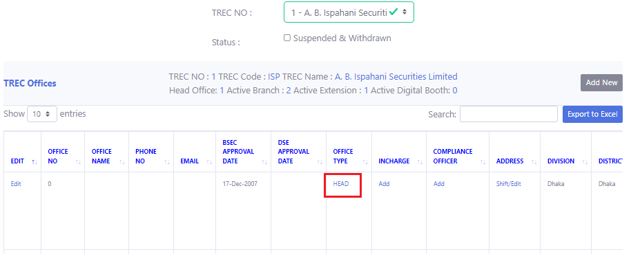
Description: Click on “Office Type (Head/Branch/Digital Booth/Extension)” to see the type history.
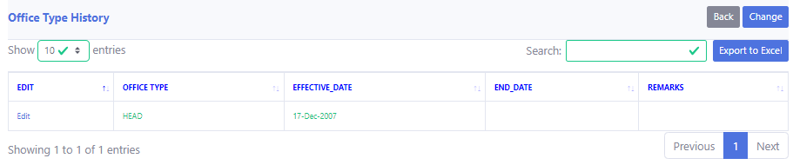
Description: Now you can see the type history

14.7 Type History Edit
Process: Log in > Office management
> TREC Office List
> TREC No
> Office Type (Head/Branch/Digital Booth/Extension)
> Edit

Description: Click on “Office Type (Head/Branch/Digital Booth/Extension)” to see the type history.
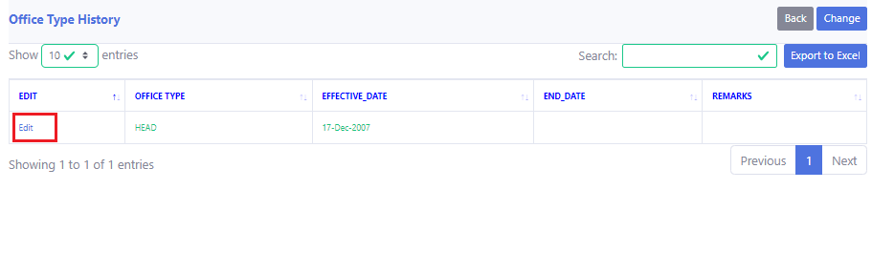
Description: Click on “Edit”
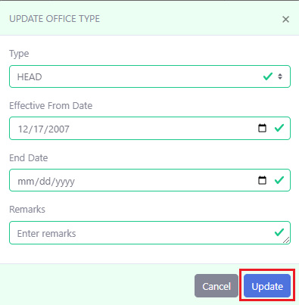
Description: After editing, click on “Update”.

14.8 Type History Change
Process: Log in > Office management
> TREC Office List
> TREC No
> Office Type (Head/Branch/Digital Booth/Extension)
> Change Status

Description: Click on “Office Type (Head/Branch/Digital Booth/Extension)” to see the type history.
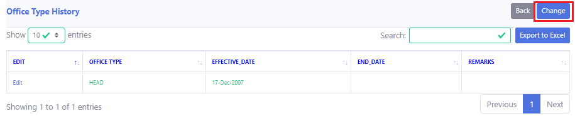
Description: Click on “Change”.
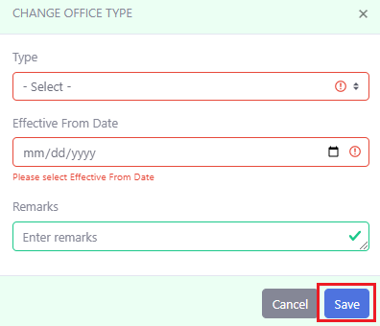
Description: Now click on “Save”.

14.9 Shift History
Process: Log in > Office management
> TREC Office List
> TREC No
> Address (Shift/Edit)
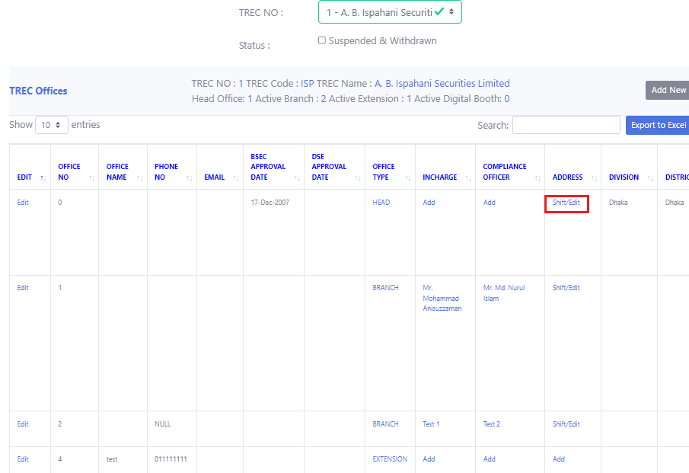
Description: Click on Address (Shift/Edit).
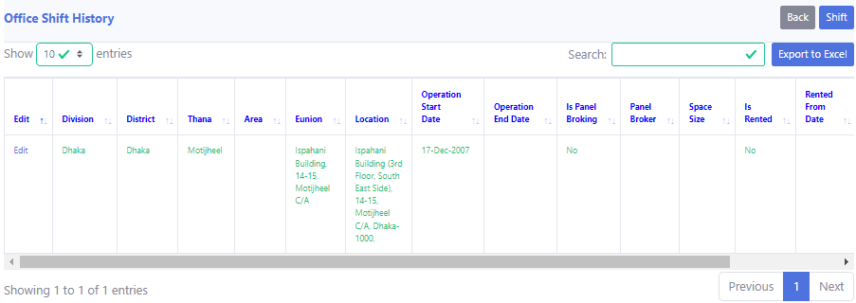
Description: Now you can see the Shift History.

14.10 Shift History Edit
Process: Log in > Office management
> TREC Office List
> TREC No
> Address (Shift/Edit)
> Edit


Description: Click on Address (Shift/Edit).
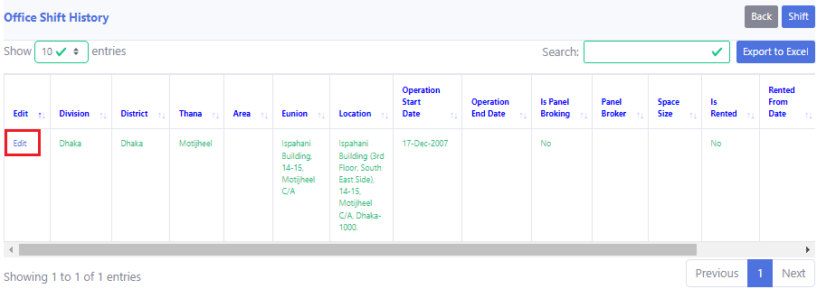
Description: Click on Edit.
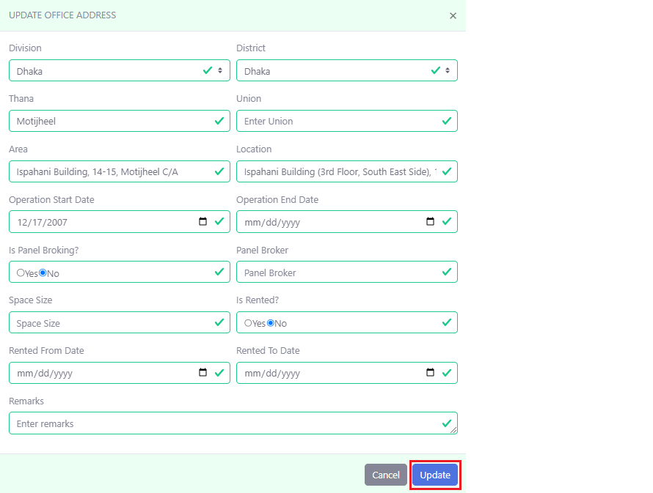
Description: After done with editing, click on “Update”.

14.11 Office Shift
Process: Log in > Office management
> TREC Office List
> TREC No
> Address (Shift/Edit)
> Shift


Description: Click on Address (Shift/Edit).
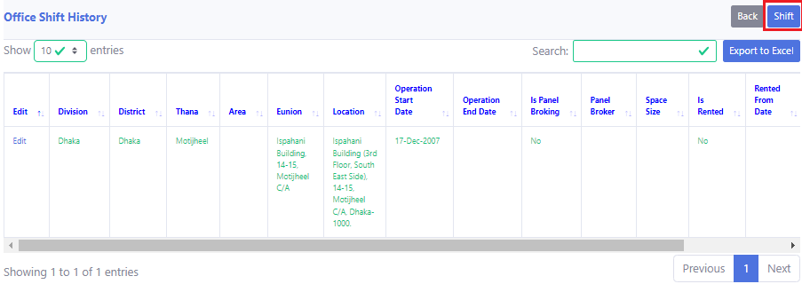
Description: Click on “Shift”
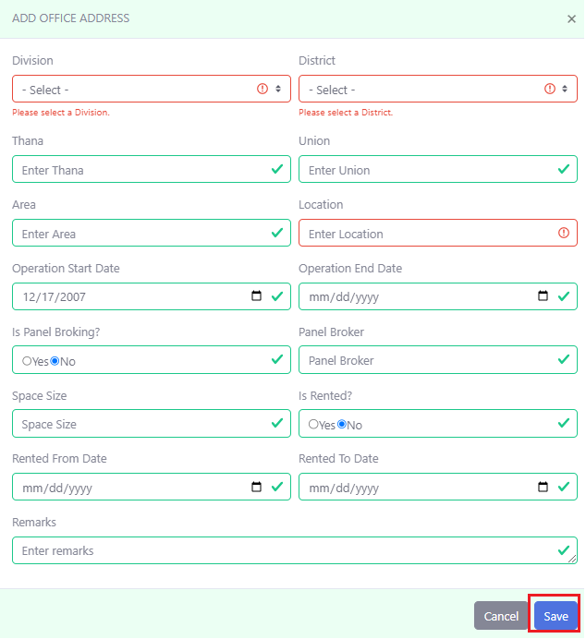
Description: After giving the information, click on Save.

14.12 In-charge History
Process: Log in > Office management
> TREC Office List
> TREC No
> In-charge (Click on the name)

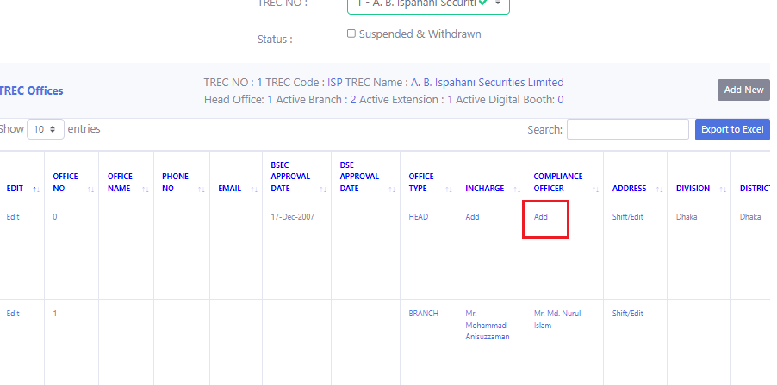
Description: Click on “In-charge”.
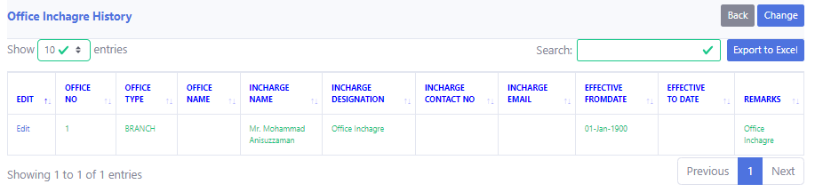
Description: Now you can see the history.

14.13 In-charge History Edit
Process: Log in > Office management
> TREC Office List
> TREC No
> In-charge (Click on the name)
> Edit

Description: Click on “In-charge”.
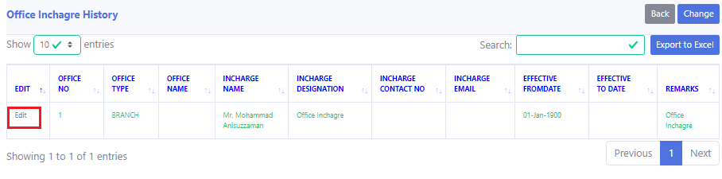
Description: Click on “Edit”.
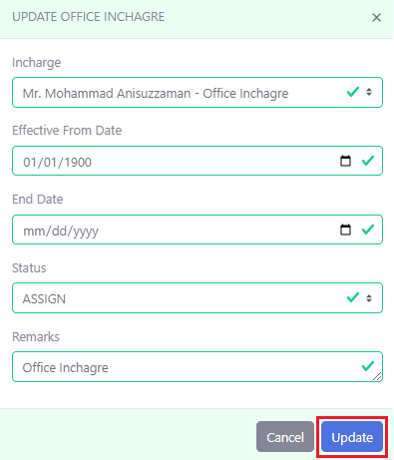
Description: Click on “Update”.

14.14 In-charge Change
Process: Log in > Office management
> TREC Office List
> TREC No
> In-charge (Click on the name)
> Change

Description: Click on “In-charge”.
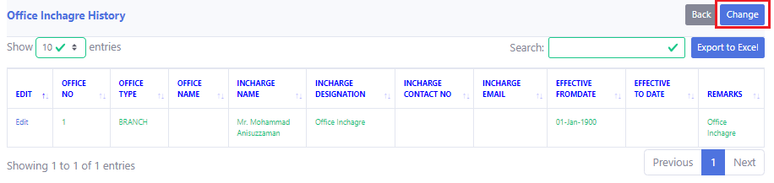
Description: Click on “Change”.
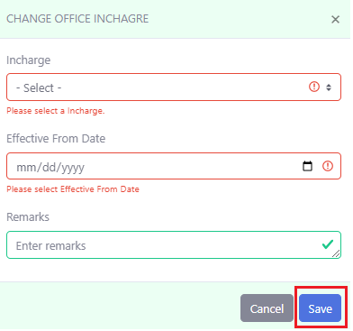
Description: Click on “Save”. Red box must have to contain the valid information.

14.15 Compliance Officer History
Process: Log in > Office management
> TREC Office List
> TREC No
> Compliance Officer (Click on the name)
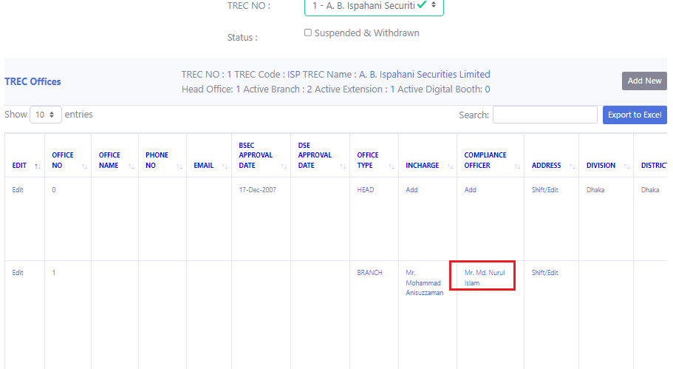
Description: Click on “Compliance Officer”.
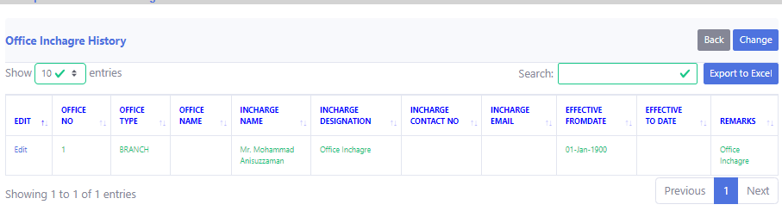
Description: Now you can see the History.

14.16 Compliance Officer History Edit
Process: Log in > Office management
> TREC Office List
> TREC No
> Compliance Officer (Click on the name)
> Edit

Description: Click on “Compliance Officer”.
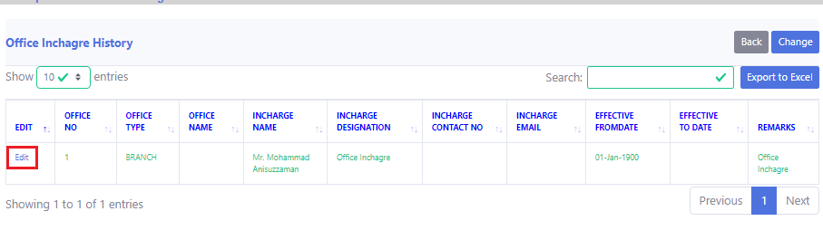
Description: Click on “Edit”.
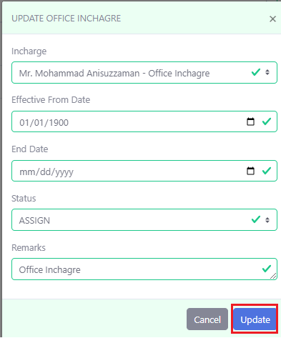
Description: Click on “Update”.

14.17 Compliance Officer Change
Process: Log in > Office management
> TREC Office List
> TREC No
> Compliance Officer (Click on the name)
> Change

Description: Click on “Compliance Officer”.
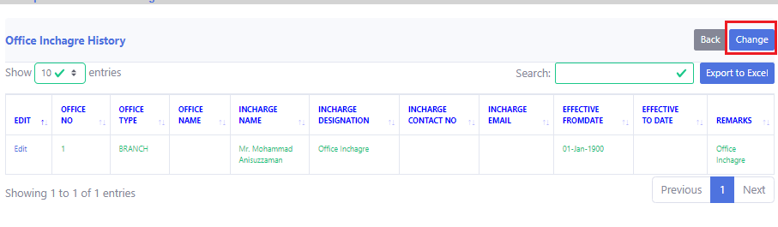
Description: Click on “Change”.
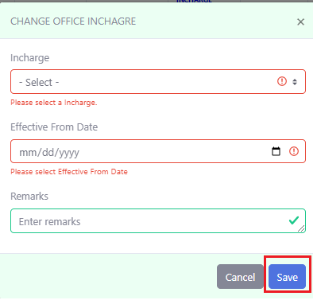
Description: Click on “Save”. Red boxes must have to contain the valid information.

Office Network

List & Add
Process: Log in > Office management
> TREC Office Network
> TREC No
> Network Info
> Add
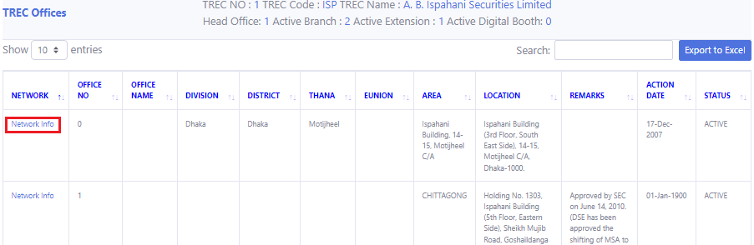
Description: Click on “Network Info”.
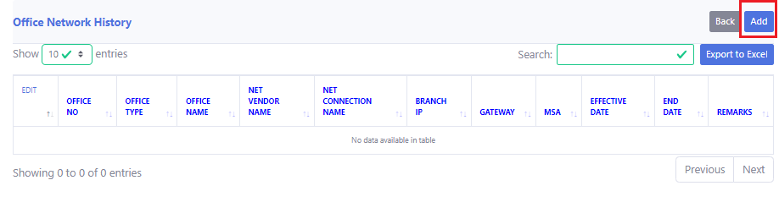
Description: Click on “Add”
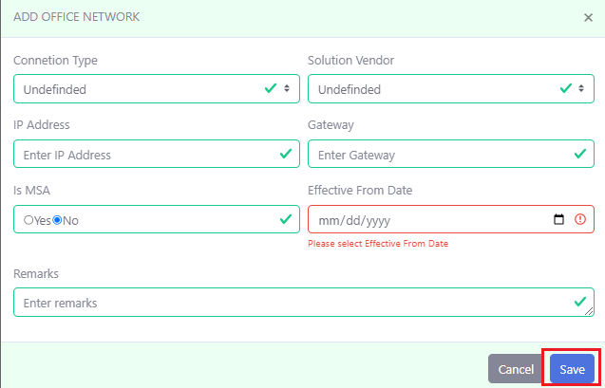
Description: Click on “Save”.

Edit
Process: Log in > Office management
> TREC Office Network
> TREC No
> Network Info
> Edit

Description: Click on “Network Info”.
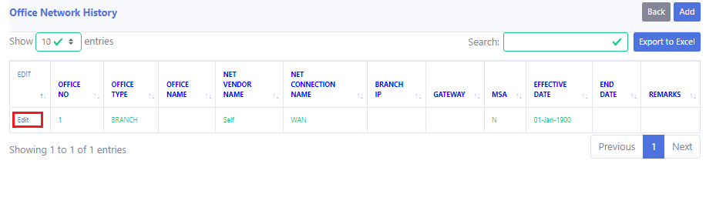
Description: Click on “Edit”.
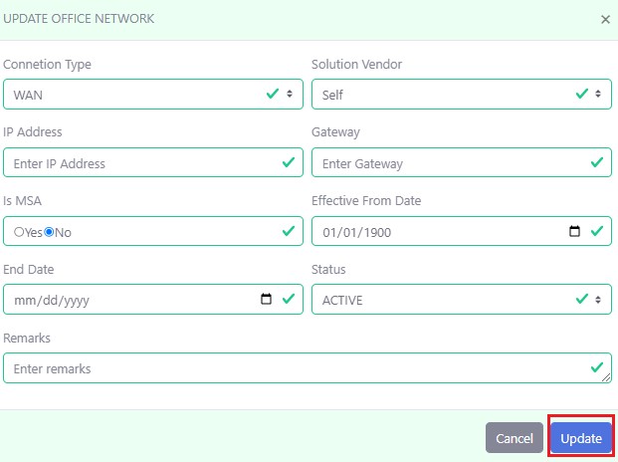
Description: After done with editing, click on “Update”.

TMS Report

AR Renew Report
Process: Log in > TMS Report
>AR Renew Report
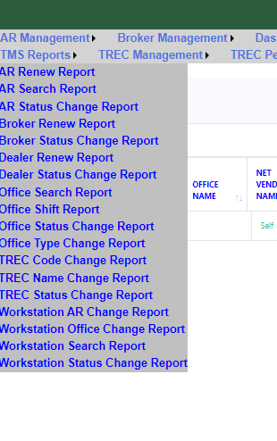
Description: After log in, click on “TMS Report”. Then click “AR Renew Report”
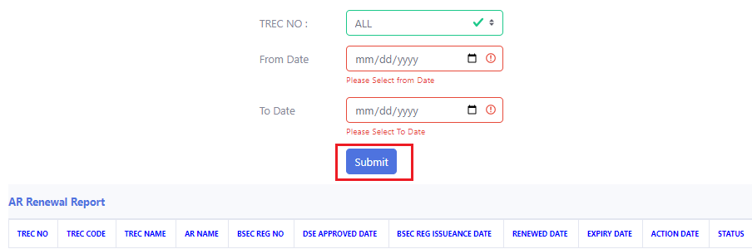
Description: Select the TREC No, give the form date and to date. Then click on submit. Now you can see the AR Renew report.

AR Search Report
Process: Log in > TMS Report
>AR Search Report

Description: After log in, click on “TMS Report”. Then click “AR Search Report”
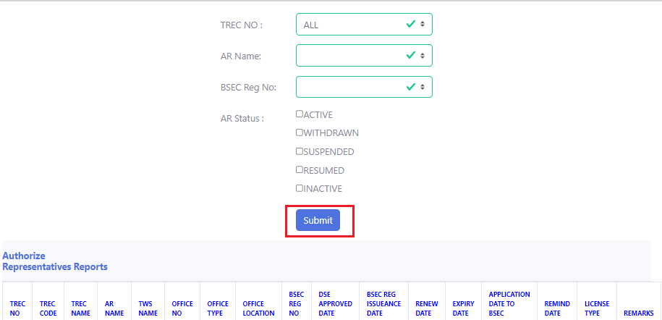
Description: Fill up the following fields and click on submit. Then you can see the AR Search Report.

AR Status Change Report
Process: Log in > TMS Report
>AR Status Change Report

Description: After log in, click on “TMS Report”. Then click “AR Status Change Report”
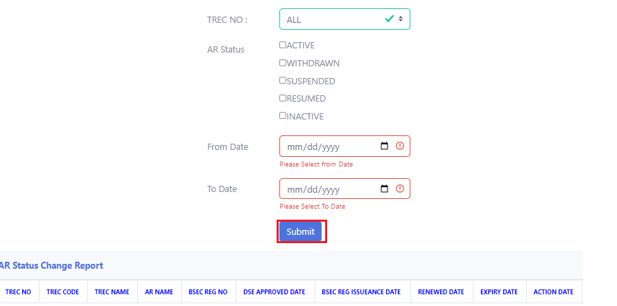
Description: Fill up the following fields and click on submit. Then you can see the AR Status Change Report.

Broker Renew Report
Process: Log in > TMS Report
>Broker Renew Report

Description: After log in, click on “TMS Report”. Then click “Broker Renew Report”.
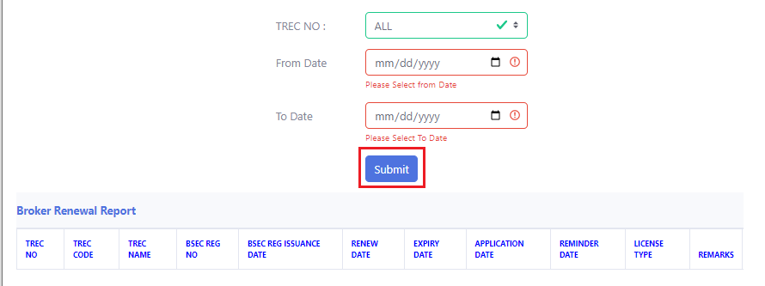
Description: Fill up the following fields and click on submit. Then you can see the Broker Renew Report.

Broker Status Change Report
Process: Log in > TMS Report
>Broker Status Change Report

Description: After log in, click on “TMS Report”. Then click “Broker Status Change Report”.
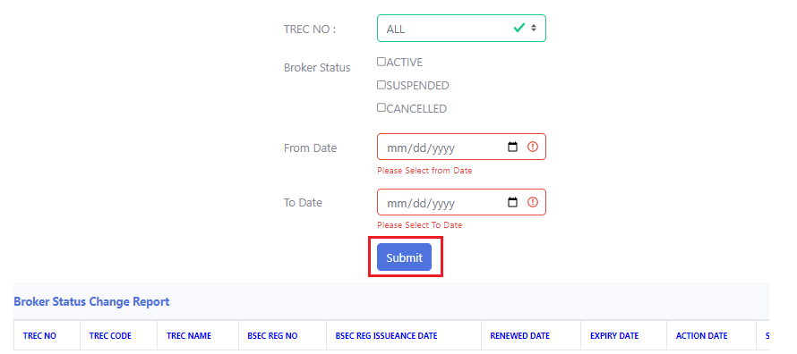
Description: Fill up the following fields and click on submit. Then you can see the Broker Status Change Report.

Dealer Renew Report
Process: Log in > TMS Report
>Dealer Renew Report

Description: After log in, click on “TMS Report”. Then click “Dealer Renew Report”.
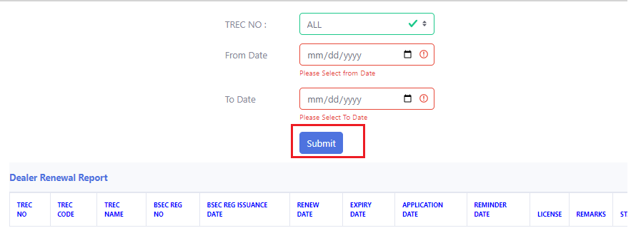
Description: Fill up the following fields and click on submit. Then you can see the Dealer Renew Report.

Dealer Status Change Report
Process: Log in > TMS Report
>Dealer Status Change Report

Description: After log in, click on “TMS Report”. Then click “Dealer Status Change Report”.
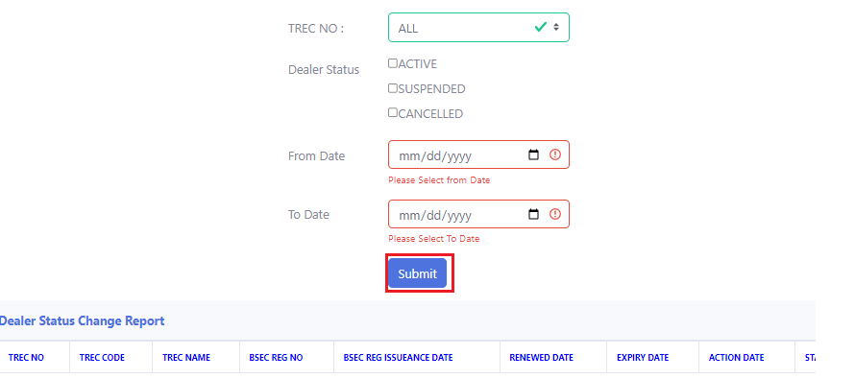
Description: Fill up the following fields and click on submit. Then you can see the Dealer Status Change Report.

Office Search Report
Process: Log in > TMS Report
>Office Search Report

Description: After log in, click on “TMS Report”. Then click “Office Search Report”.
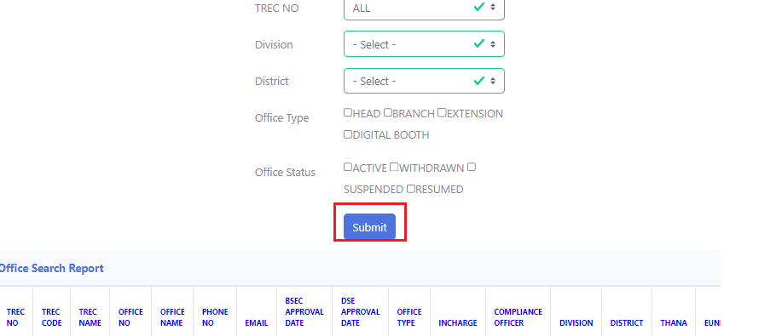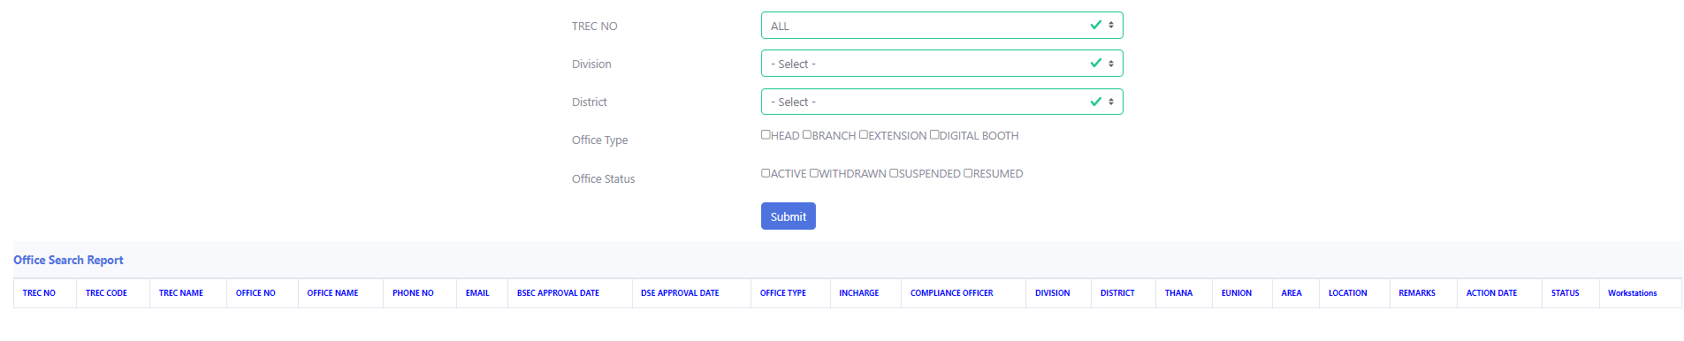
Description: Fill up the following fields and click on submit. Then you can see the Office Search Report.

Office Shift Report
Process: Log in > TMS Report
>Office Shift Report

Description: After log in, click on “TMS Report”. Then click “Office Shift Report”.
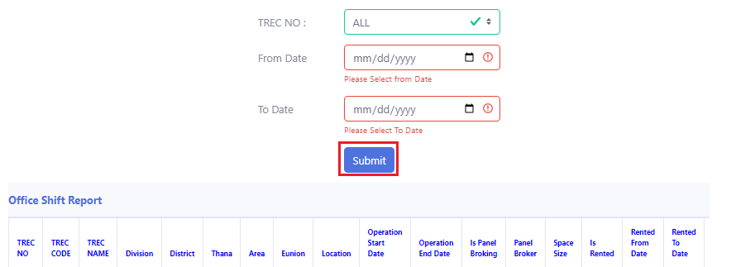
Description: Fill up the following fields and click on submit. Then you can see the Office Shift Report.

Office Status Change Report
Process: Log in > TMS Report
>Office Status Change Report

Description: After log in, click on “TMS Report”. Then click “Office Status Change Report”.
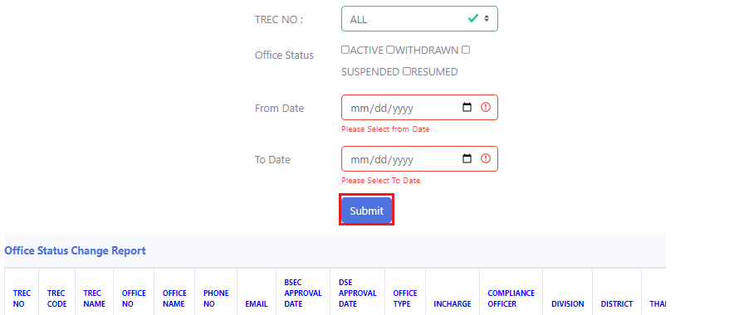
Description: Fill up the following fields and click on submit. Then you can see the Office Status Change Report.

Office Type Change Report
Process: Log in > TMS Report
>Office Type Change Report

Description: After log in, click on “TMS Report”. Then click “Office Type Change Report”.
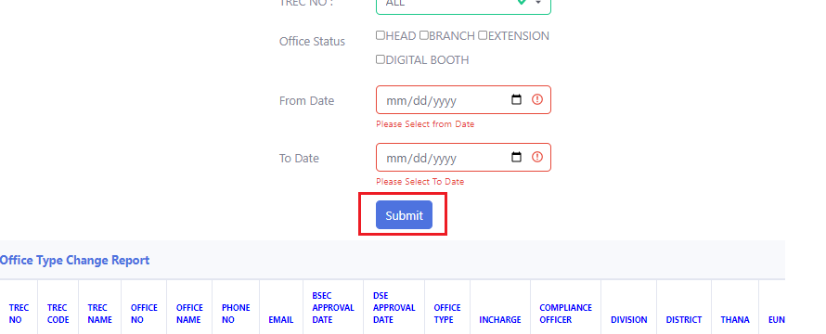
Description: Fill up the following fields and click on submit. Then you can see the Office Type Change Report.

TREC Code Change Report
Process: Log in > TMS Report
>TREC Code Change Report

Description: After log in, click on “TMS Report”. Then click “TREC Code Change Report”.
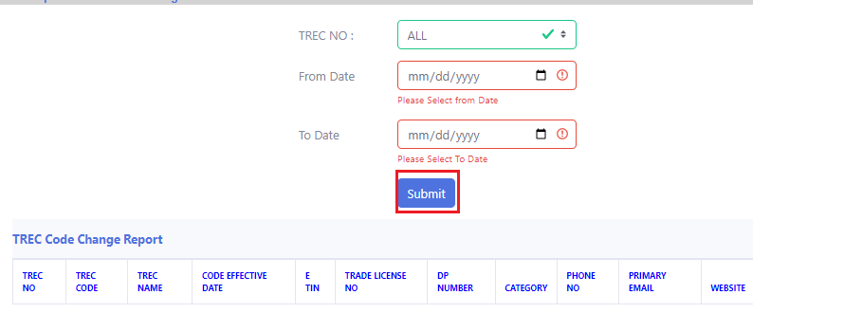
Description: Fill up the following fields and click on submit. Then you can see the TREC Code Change Report.

TREC Name Change Report
Process: Log in > TMS Report
>TREC Name Change Report

Description: After log in, click on “TMS Report”. Then click “TREC Name Change Report”.
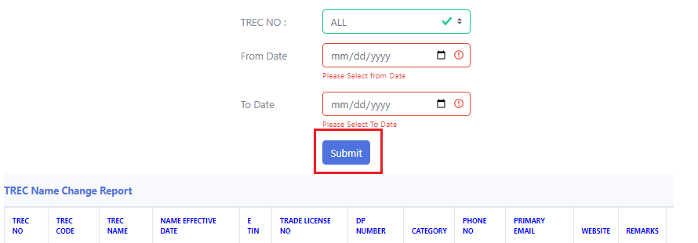
Description: Fill up the following fields and click on submit. Then you can see the TREC Name Change Report.

TREC Status Change Report
Process: Log in > TMS Report
>TREC Status Change Report

Description: After log in, click on “TMS Report”. Then click “TREC Status Change Report”.
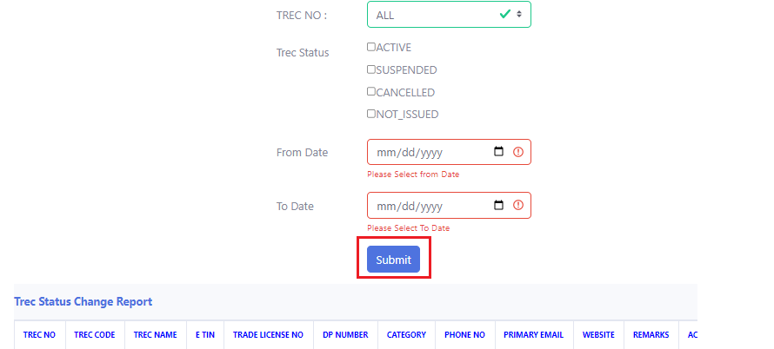
Description: Fill up the following fields and click on submit. Then you can see the TREC Status Change Report.

Workstation Change Report
Process: Log in > TMS Report
>Workstation AR Change Report


Description: After log in, click on “TMS Report”. Then click “Workstation AR Change Report”.
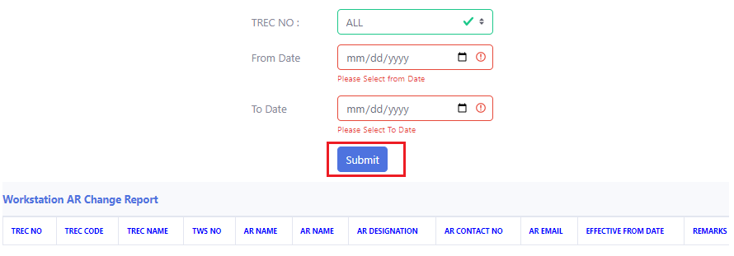
Description: Fill up the following fields and click on submit. Then you can see the “Workstation AR Change Report”.

Workstation Office Change Report
Process: Log in > TMS Report
>Workstation Office Change Report

Description: After log in, click on “TMS Report”. Then click “Workstation Office Change Report”.
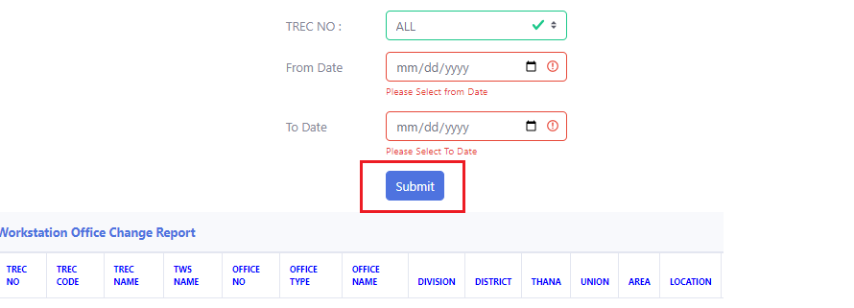
Description: Fill up the following fields and click on submit. Then you can see the “Workstation Office Change Report”.

Workstation Search Report
Process: Log in > TMS Report
>Workstation Search Report

Description: After log in, click on “TMS Report”. Then click “Workstation Search Report”.
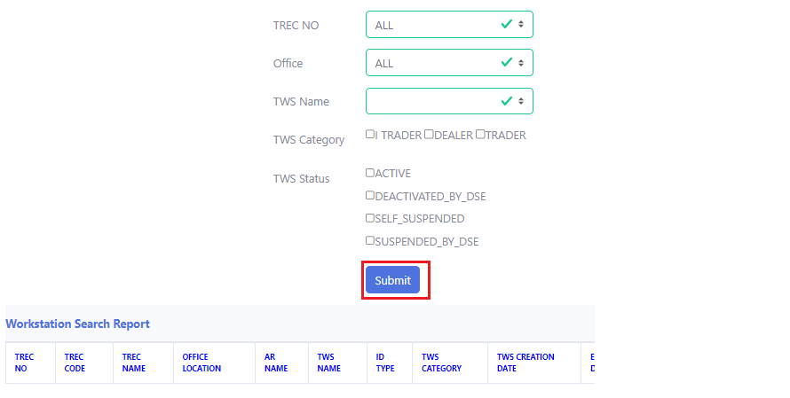
Description: Fill up the following fields and click on submit. Then you can see the “Workstation Search Report”.

Workstation Status Change Report
Process: Log in > TMS Report
>Workstation Status Change Report

Description: After log in, click on “TMS Report”. Then click “Workstation Status Change Report”.
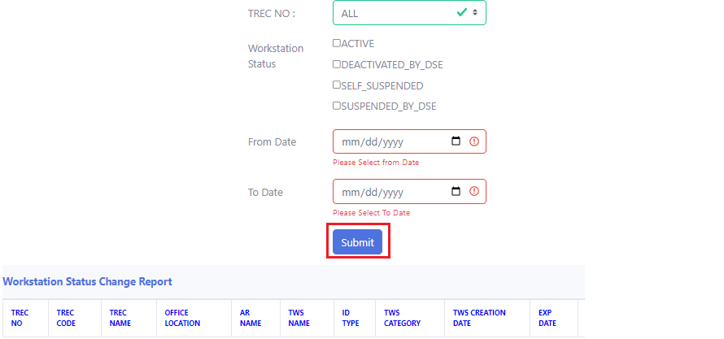
Description: Fill up the following fields and click on submit. Then you can see the “Workstation Status Change Report”.

Workstation

List & Add
Process- Login > WorkStations
> Workstation List
> TREC No
> Add new
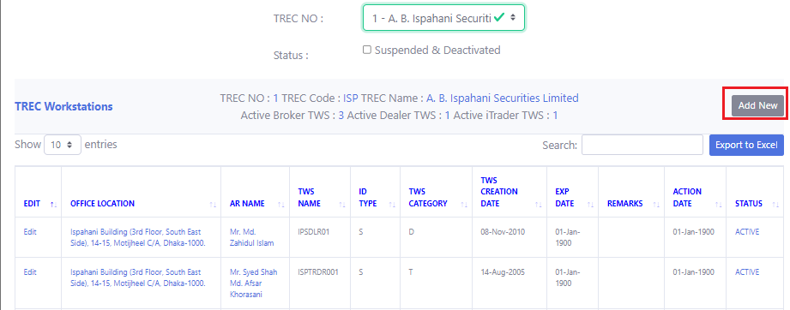
Description: Click on “Add New”
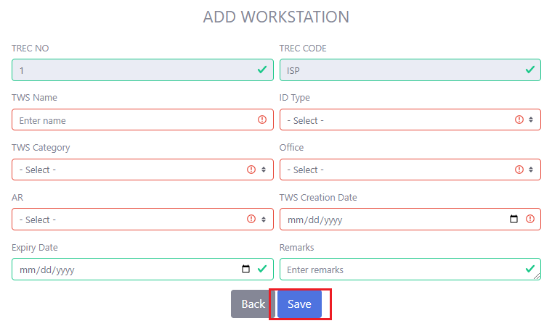
Description: Give all the required information. Then click on “Save”. The red boxes must have to contain the valid information.

Edit
Process- Login > WorkStations
> Workstation List
> TREC No
> Edit
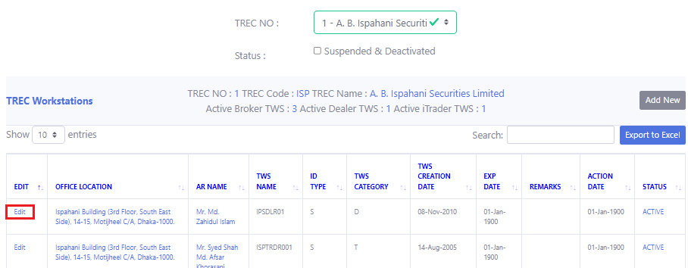
Description: Click on “Edit”.
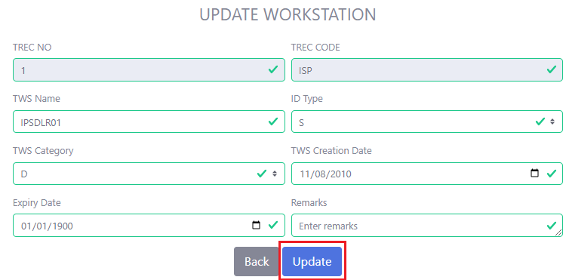
Description: After editing, click on “Update”.

Office History
Process- Login > WorkStations
> Workstation List
> TREC No
> Office location
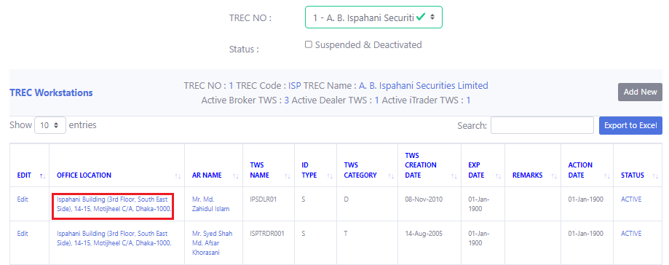
Description: Click on Office Location
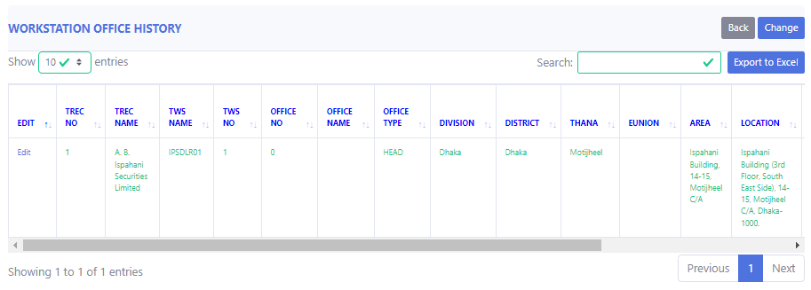
Description: Now you can see the history.

Office History Change
Process- Login > WorkStations
> Workstation List
> TREC No
> Office Location
> Change

Description: Click on Office Location
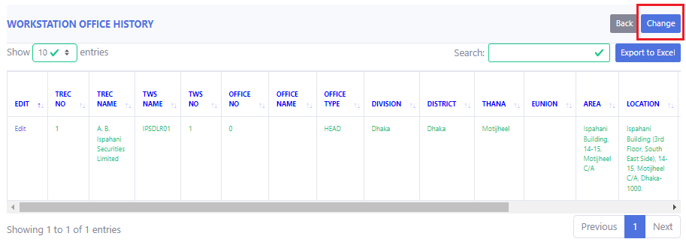
Description: Click on Change
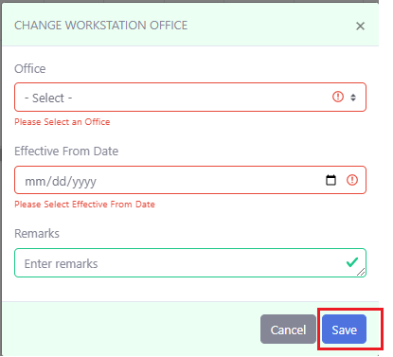
Description: After giving all the information, click on Save.

Office History Edit
Process- Login > WorkStations
> Workstation List
> TREC No
> Office Location
> Edit

Description: Click on Office Location
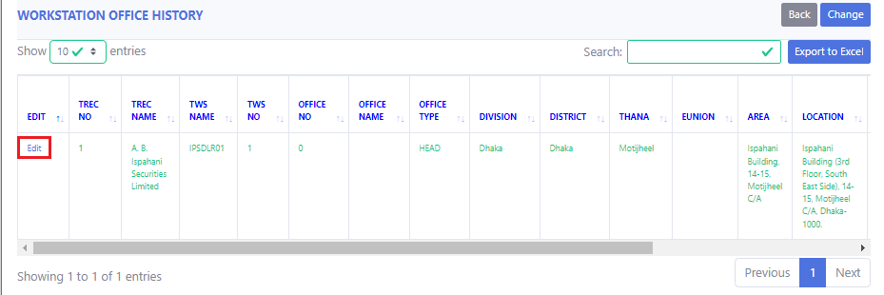
Description: Click on Edit
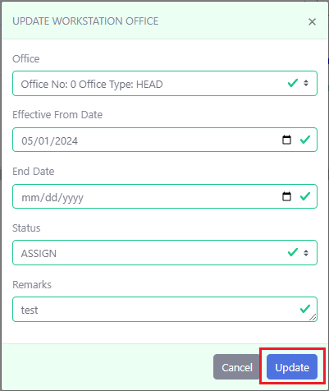
Description: After done with editing, click on Update.

AR History
Process- Login > WorkStations
> Workstation List
> TREC No
> AR Name
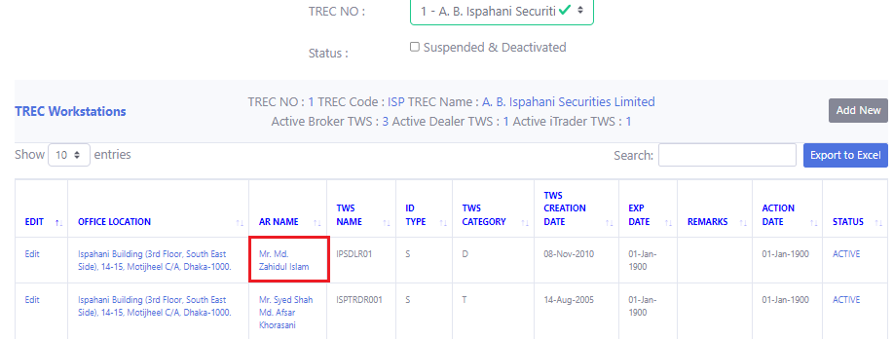
Description: Now click on “AR Name”.
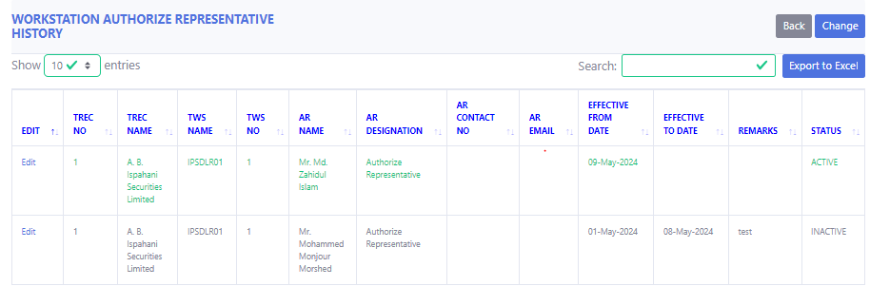
Description: Now you can see the history.

AR History Change
Process- Login > WorkStations
> Workstation List
> TREC No
> AR Name

Description: Click on “AR Name”.
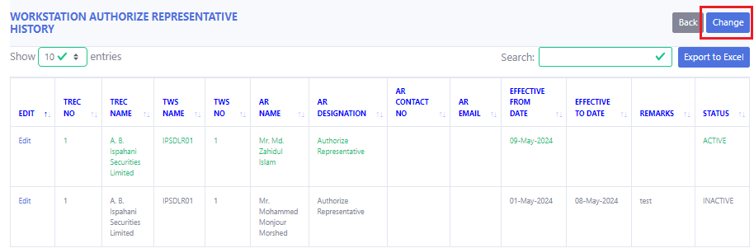
Description: Click on “Change”
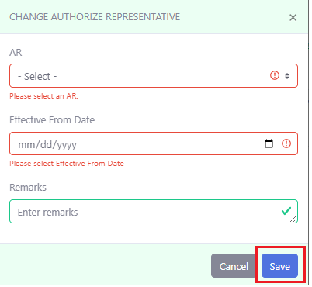
Description: After changing, click on Save.

AR History Edit
Process- Login > WorkStations
> Workstation List
> TREC No
> AR Name
> Edit

Description: Click on “AR Name”.
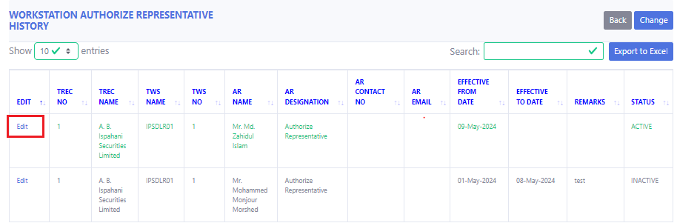
Description: Click on “Edit”
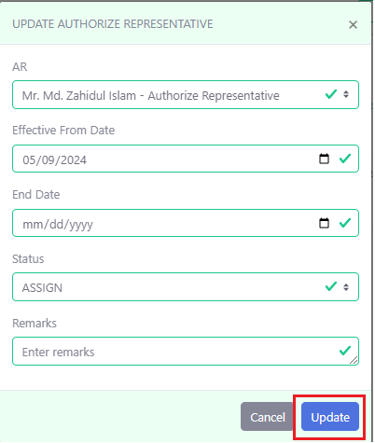
Description: After editing, click on “Update”.

Status History
Process- Login > WorkStations
> Workstation list
> TREC No
> Status
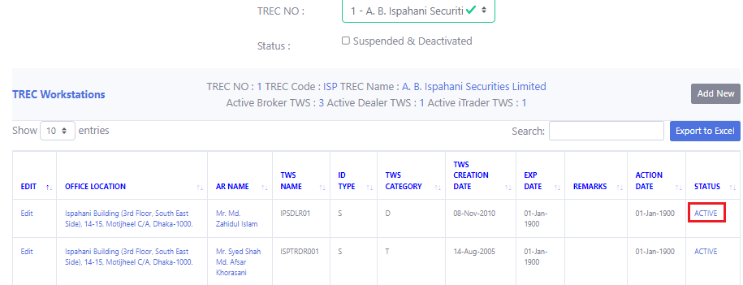
Description: Click on “Status”.
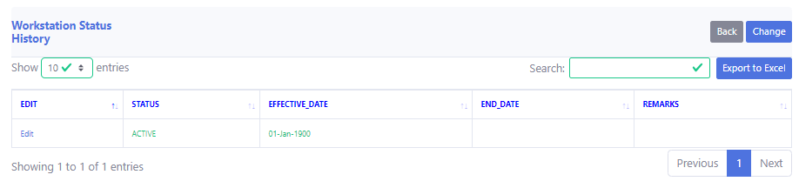
Description: Now you can see the status history.

Status Change
Process- Login > WorkStations
> Workstation list
> TREC No
> Status
> Change

Description: Click on “Status”
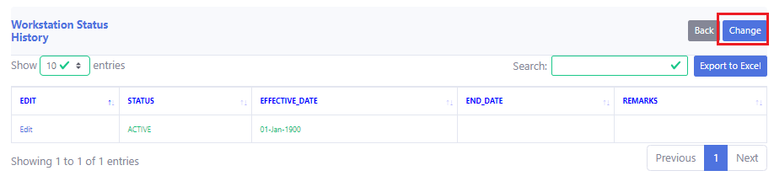
Description: Click on “Change”
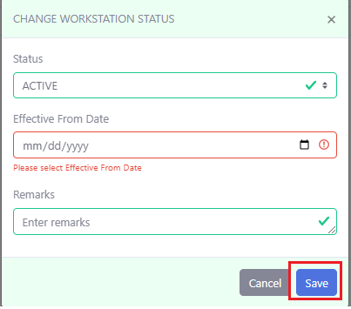
Description: After giving all the information, Click on “Save Changes”.

Status Edit
Process- Login > WorkStations
> Workstation list
> TREC No
> Status
> Edit.

Description: Click on Status.
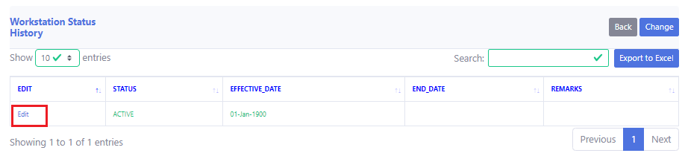
Description: Click on Edit.
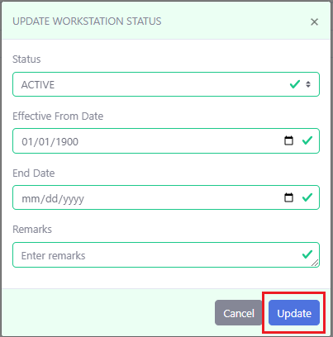
Description; After editing, Click on “Update”.

