Hosting your website

A descriptive guide on hosting your website on Azure.

1. Visit <https://portal.azure.com/> and login with your credentials.
2. You will see the following page after you are logged in:

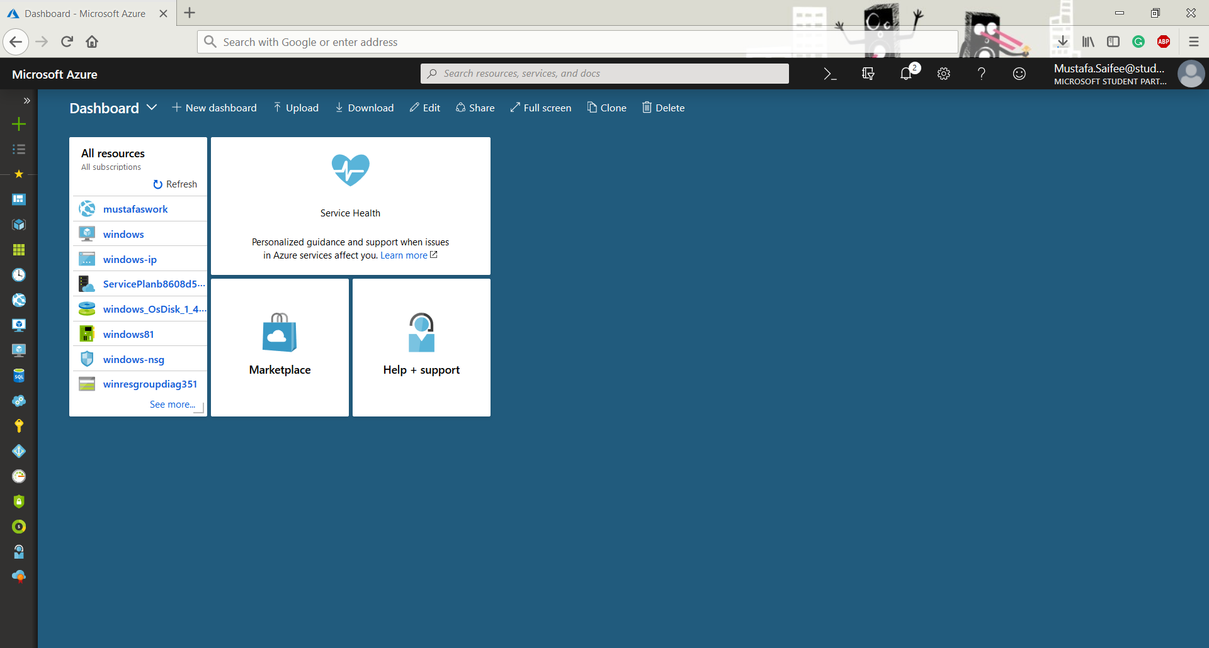

1. Now to create a web app you have two options from where you can initiate the procedure:
2. By clicking on the plus icon on the right most column

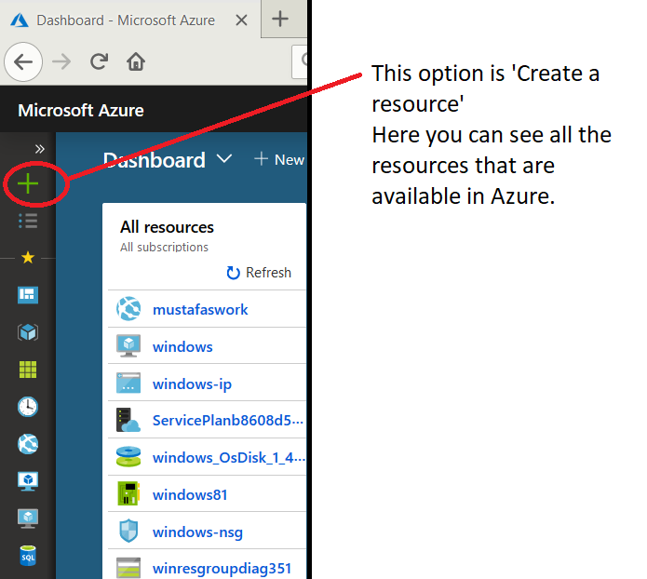

After clicking the + symbol, a pane will appear where you have to type ‘web’ and a few options will appear. Select “Web App”

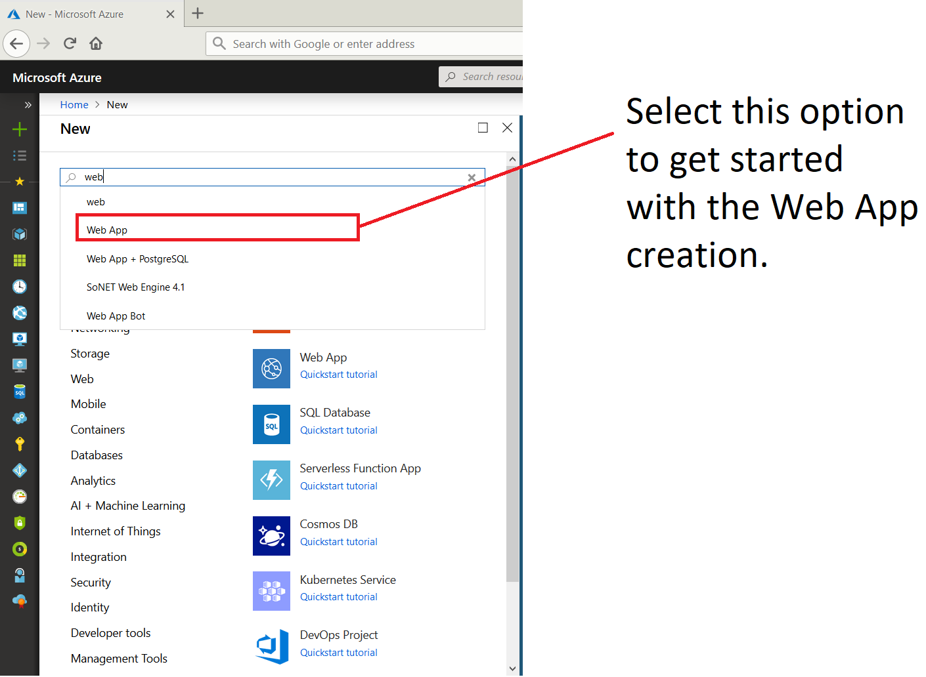

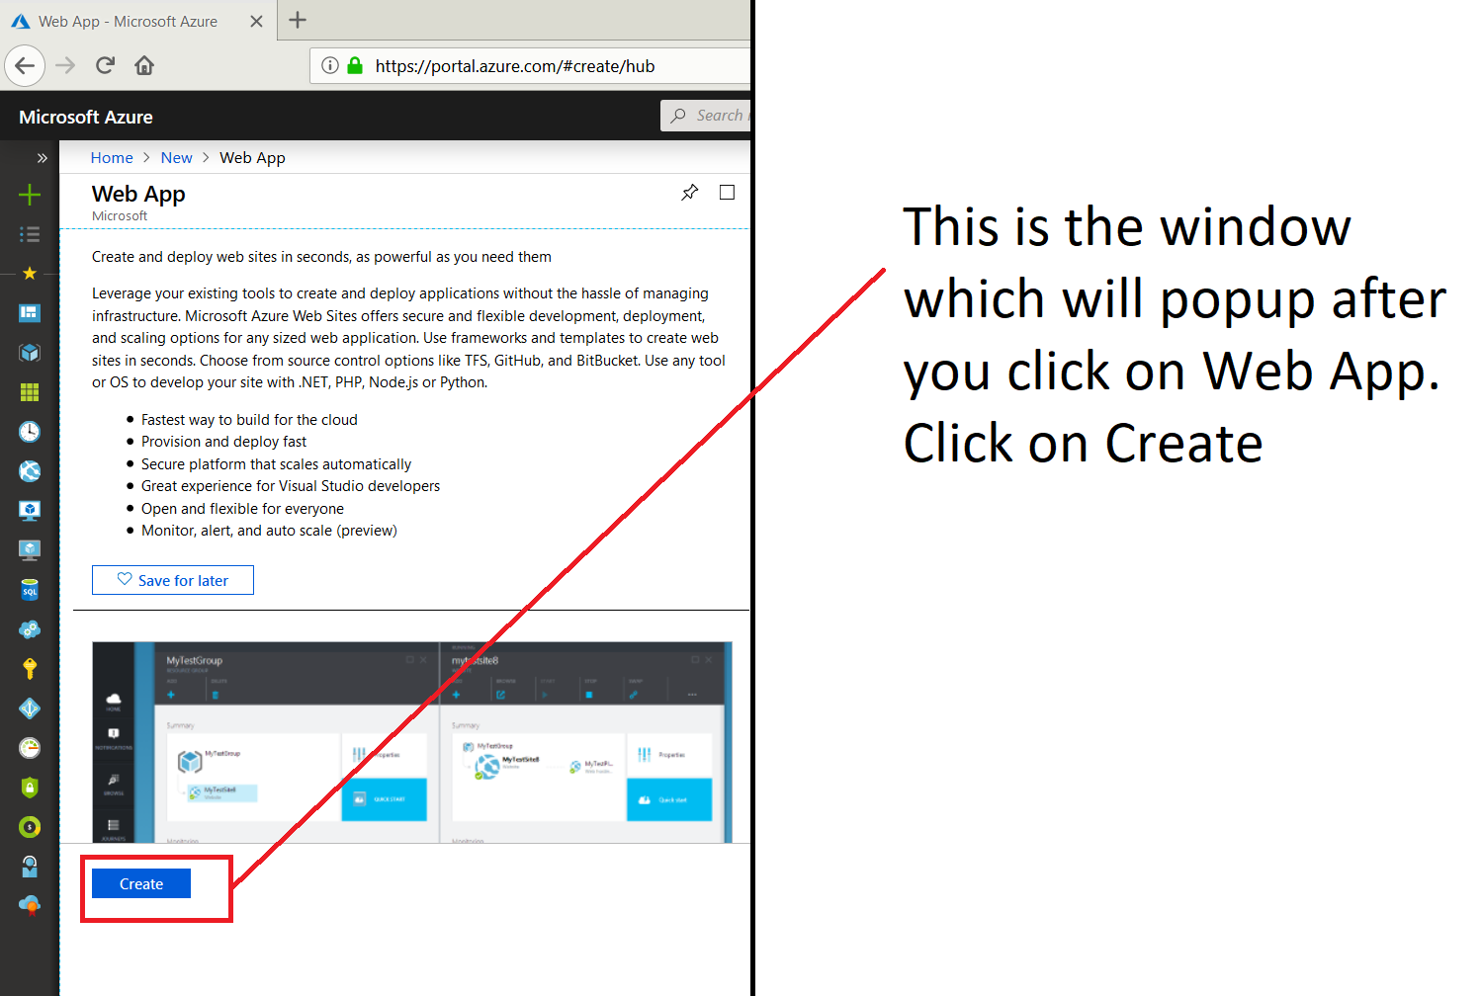

Alternate procedure:

b. By clicking the globe like symbol:

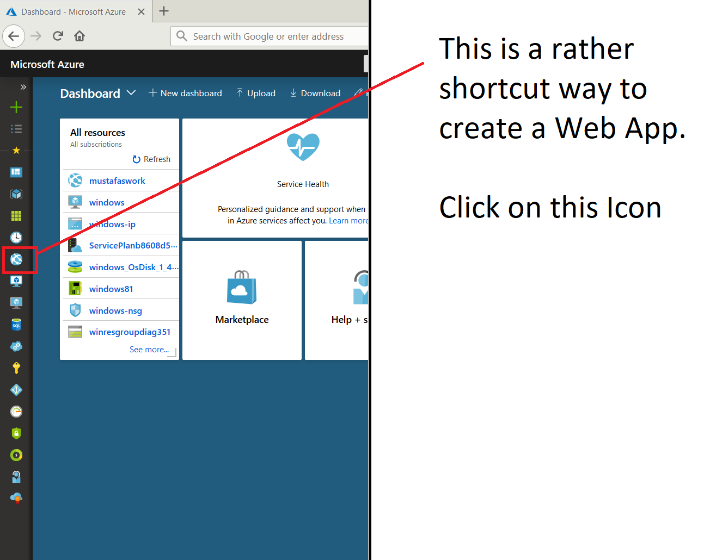

After clicking that symbol, a new window will appear as follows, click on +Add:

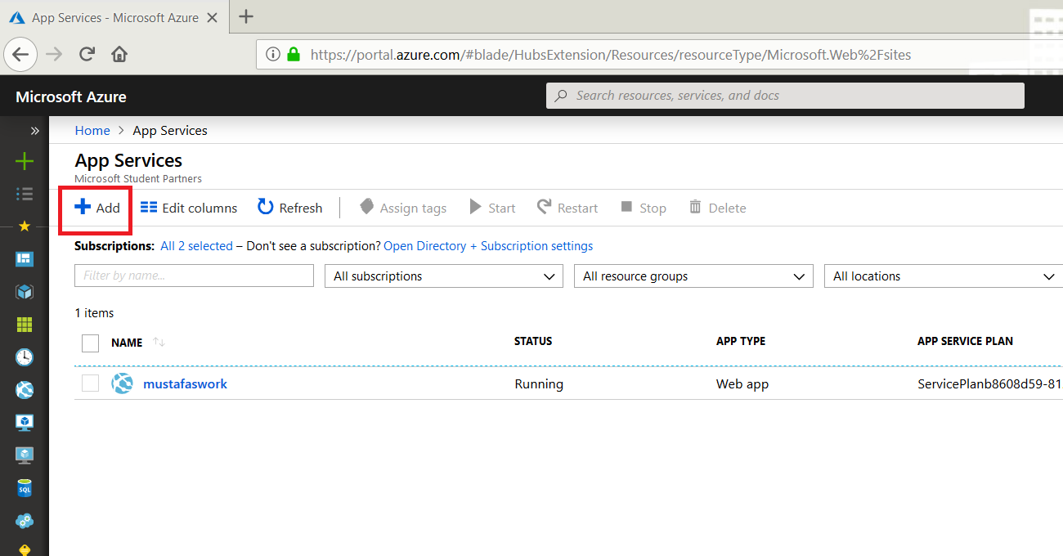

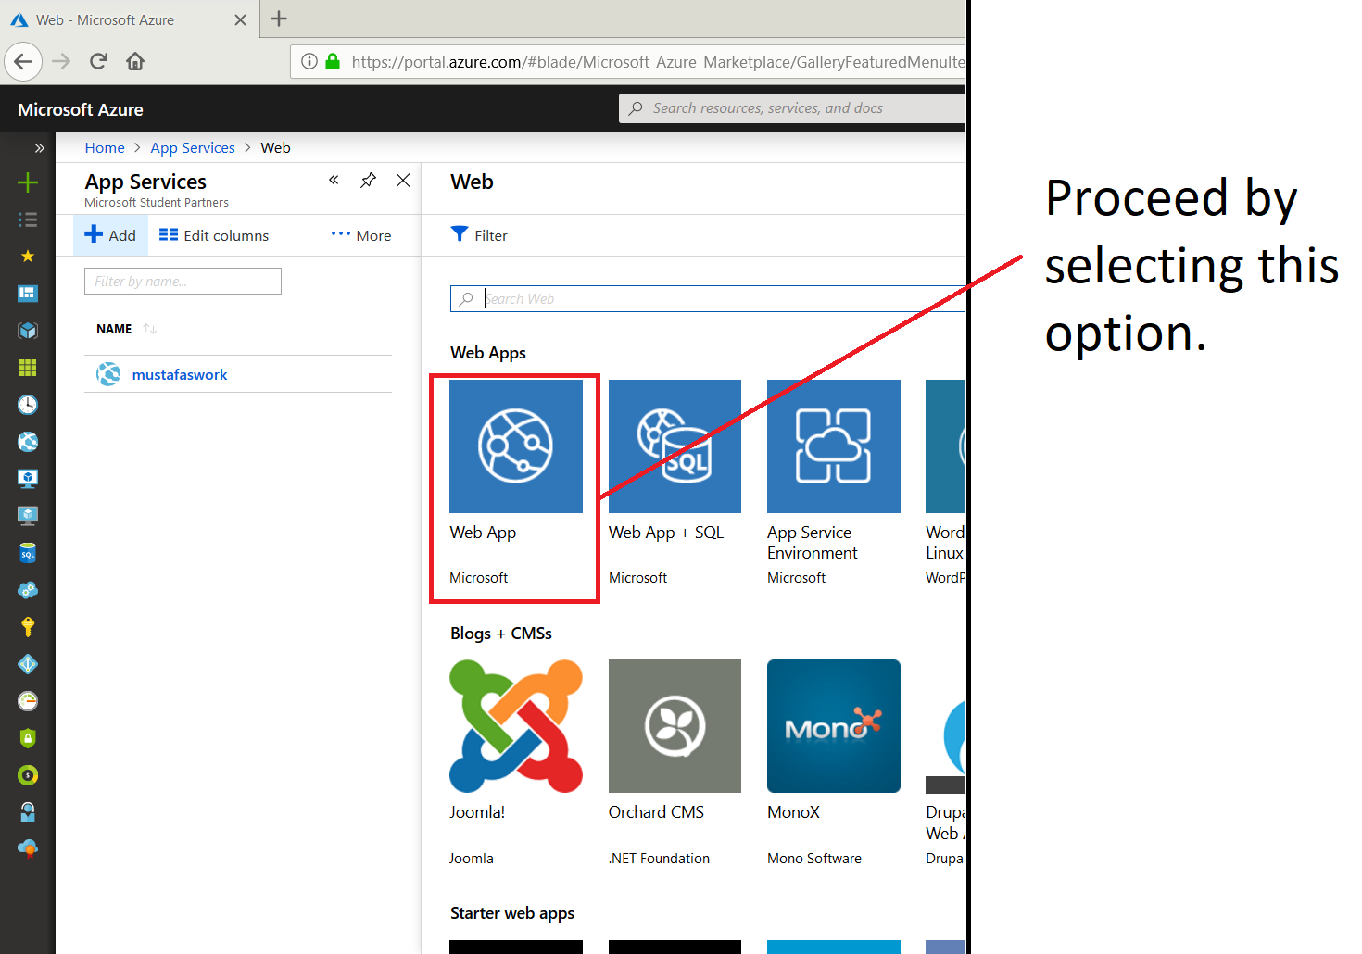

Click on **Create**

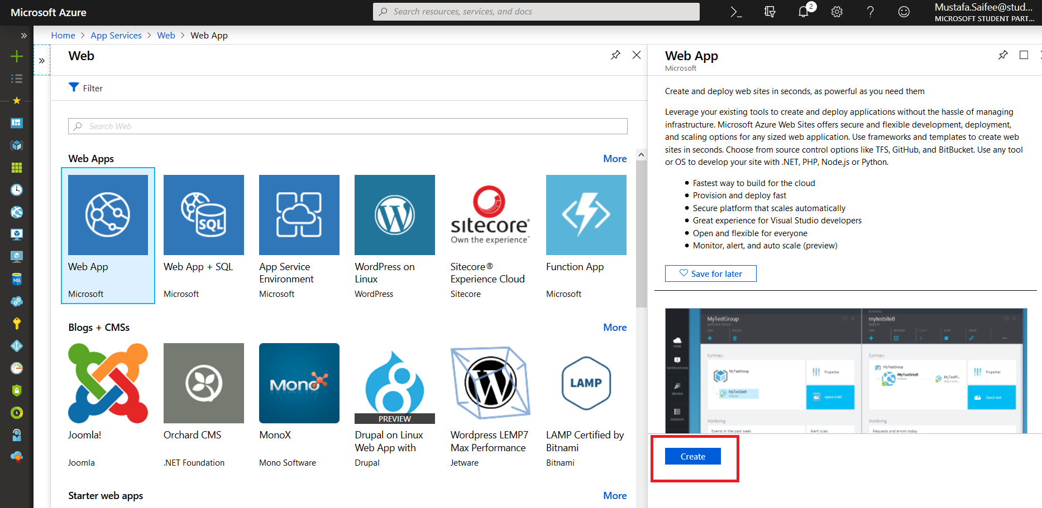

1. After clicking on Create from either of the procedures, we have to fill the following details:

App Name: (some desired name you want as the website name)

Subscription: (whichever subscription you have available)

Resource Group: (Create New: to create a new one) (Use Existing: If you already have made a resource group for a previous application)

OS: Windows

Leave rest as it is.

Click **Create.**

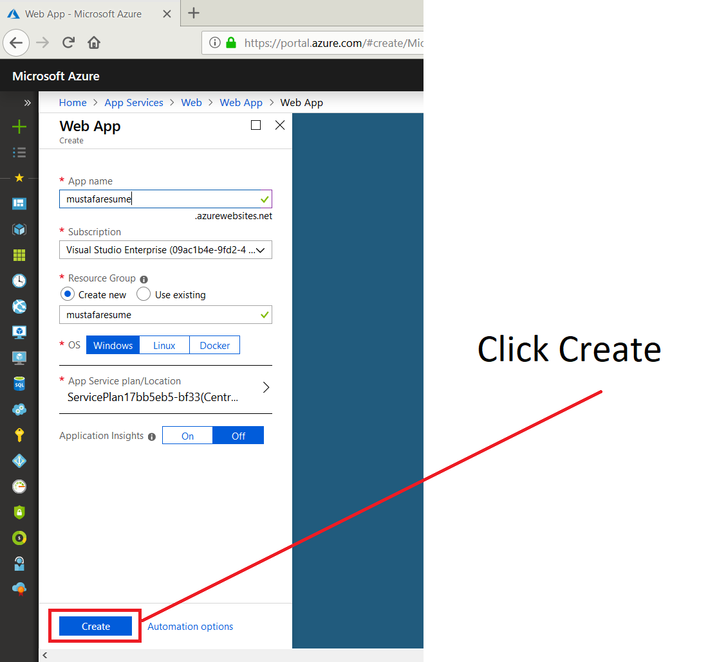

After this the Deployment will start.

Check in the notification for the Deployment Progress:

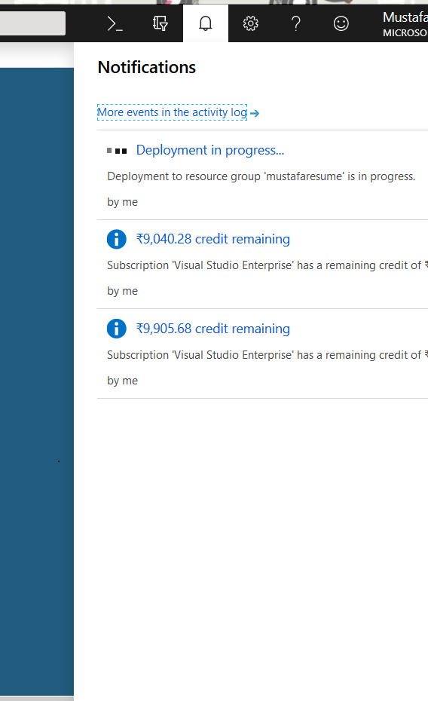Wait till the Deployment is Successful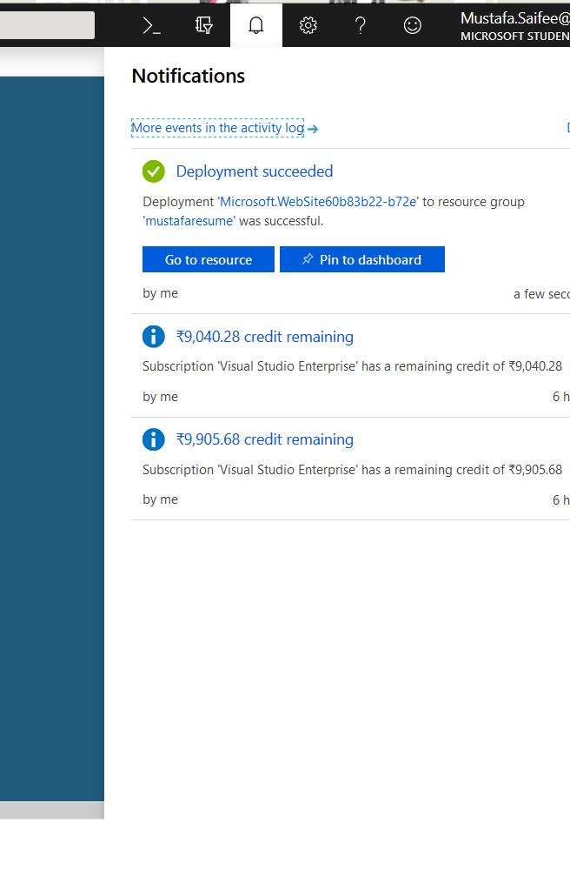

1. Click on **Pin to dashboard**
2. Click on **Go to resource**
3. A new window will appear as follows:

Here click on ‘Deployment options’ in the left pane

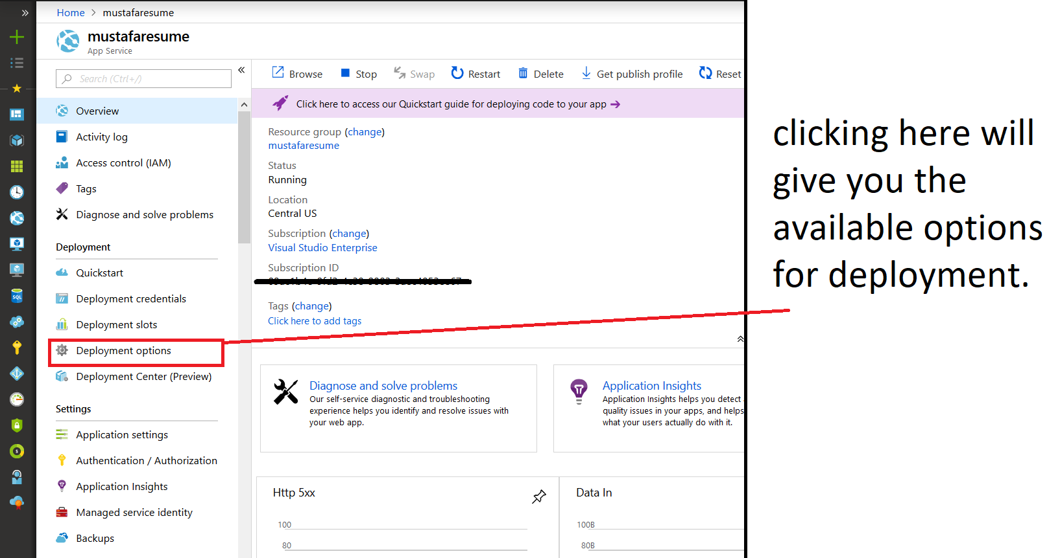

1. Click on Choose Source: Configure required settings; Select ‘Github’

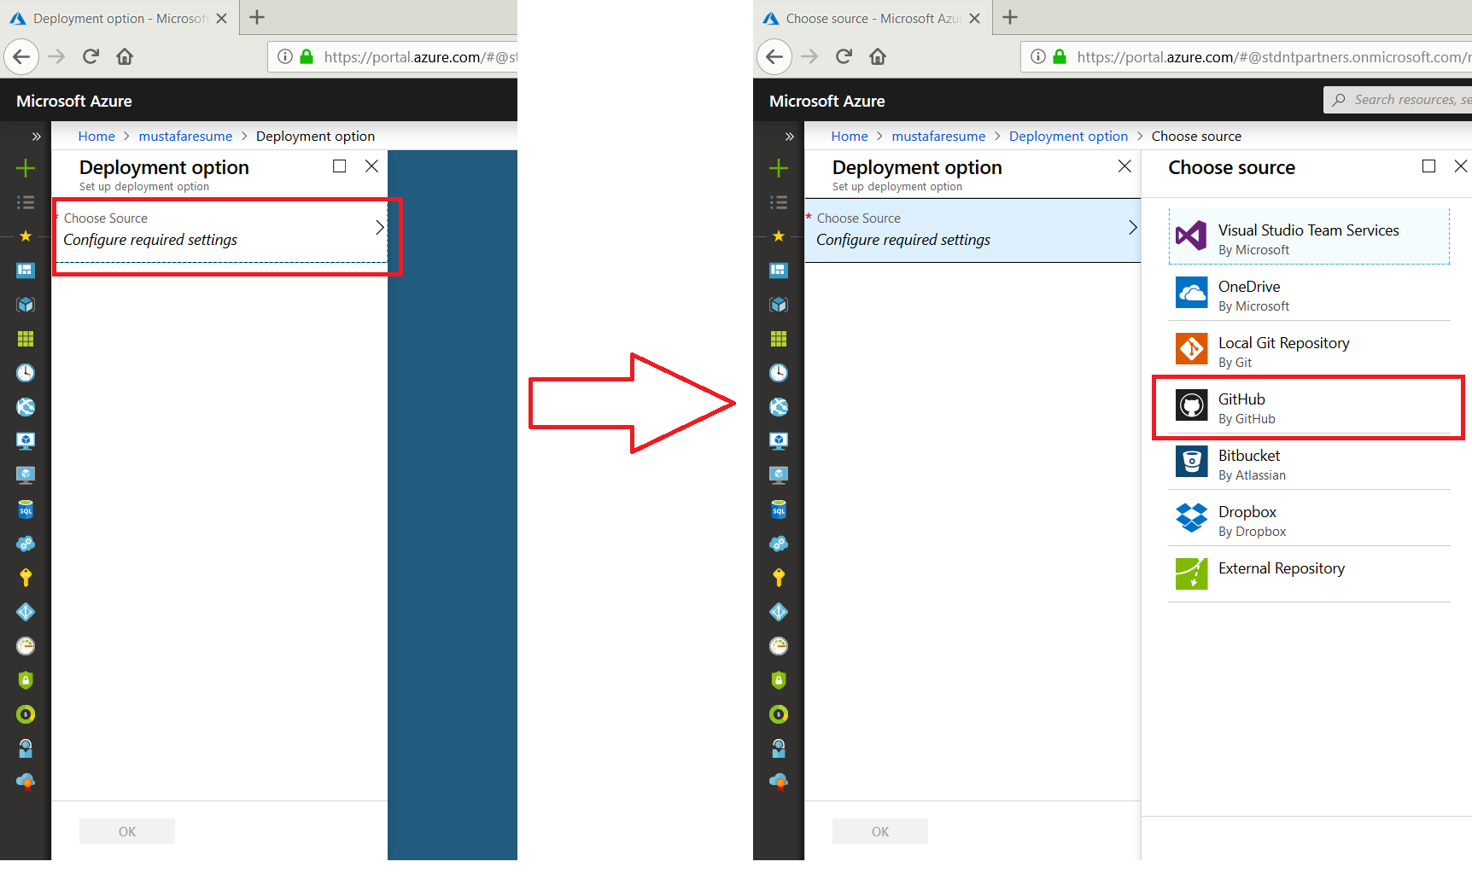

1. A Github Configuration Window will open up as follow, select options respectively.

Also select the repo in which you have stored your Website Files.

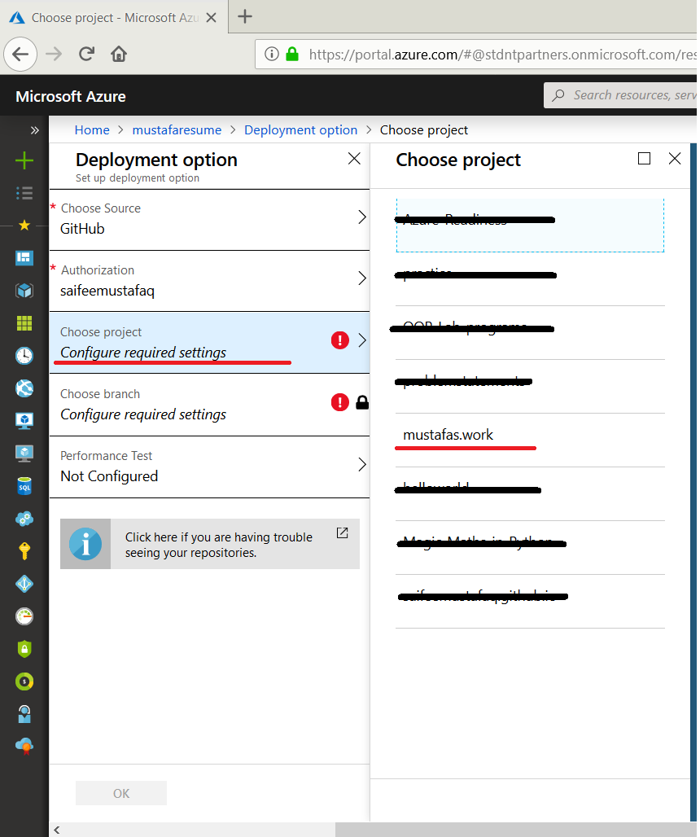

Leave the rest of the options, and click OK.

1. Click on Overview from the left pane.
2. You will see the details of your web app.
3. Finally, click on the URL to test your website.

