MATHS FOR COMPUTING
Technical Report

SQL Injection Detection Using Machine Learning

Submitted by
Saifeldeen Ahmed Wahba
Student ID: 24100904
Course: Maths for Computing

Abstract
This report presents a machine learning-based approach for detecting SQL injection attacks, one of the most prevalent and dangerous web application vulnerabilities. SQL injection remains a critical threat to database-driven applications, capable of causing unauthorized data access, data manipulation, and complete system compromise. In this project, two classification algorithms — Multinomial Naive Bayes and Random Forest — were trained and evaluated on a labeled dataset of SQL queries to distinguish between malicious and legitimate database queries.

The dataset used contains 30,921 SQL queries drawn from the Modified SQL Dataset, with features extracted using TF-IDF (Term Frequency-Inverse Document Frequency) vectorization after text preprocessing. The Multinomial Naive Bayes model achieved a superior accuracy of 95.42%, outperforming the Random Forest classifier which reached 80.99%. The best-performing model was deployed as an interactive web-based detection tool using Gradio, enabling real-time classification of SQL queries. Results demonstrate that natural language processing combined with machine learning offers a promising and practical approach to intrusion detection in database systems.

1. Introduction

1.1 Background and Motivation
The rapid proliferation of web applications and database-driven services has led to an alarming increase in cyberattacks targeting backend databases. Among these threats, SQL injection (SQLi) stands out as one of the most exploited vulnerabilities, consistently appearing at the top of the OWASP (Open Web Application Security Project) list of critical web application security risks. SQL injection attacks occur when an attacker manipulates a web application's SQL query by inserting or 'injecting' malicious code into input fields, potentially bypassing authentication, extracting sensitive data, modifying records, or even destroying databases.

Traditional rule-based detection systems rely on manually crafted patterns and signature databases, which struggle to keep pace with the constantly evolving nature of injection attack payloads. Machine learning approaches offer a data-driven alternative that can generalize to unseen attack patterns, making them particularly well-suited to this domain.

1.2 Problem Statement
The core challenge this project addresses is: given a raw SQL query string, can a machine learning model reliably classify it as either a normal, legitimate query or a malicious SQL injection attempt? This binary classification problem requires the model to learn the syntactic and semantic patterns that distinguish attack payloads from routine database operations.

1.3 Objectives
- Develop a machine learning pipeline for SQL injection detection from raw query strings
- Compare the performance of Multinomial Naive Bayes and Random Forest classifiers
- Achieve an accuracy exceeding 90% on the test dataset
- Deploy the best-performing model as a real-time interactive web application using Gradio
- Analyze model performance through confusion matrices and detailed classification reports

1.4 Scope
This project focuses exclusively on text-based SQL query analysis. The system is designed to operate as a standalone detection layer that can be integrated into web application firewalls or database monitoring tools. The dataset used reflects real-world SQL injection patterns, including time-based blind injections, UNION-based attacks, and authentication bypass attempts.

2. Literature Review
The problem of SQL injection detection has been extensively studied in the cybersecurity and machine learning communities. This section reviews three foundational papers that inform the methodology adopted in this project.

2.1 Machine Learning for SQL Injection Detection (Halfond et al., 2006)
Halfond, Viegas, and Orso published one of the seminal works on SQL injection detection, proposing AMNESIA (Analysis and Monitoring for NEutralizing SQL-Injection Attacks), a static and dynamic analysis approach. While not ML-based, this work established the fundamental taxonomy of SQL injection attack types — including tautology-based, logically incorrect, union-based, piggy-backed queries, and stored procedures — that has since guided dataset construction in subsequent ML studies. This taxonomy directly informed the label structure of the dataset used in our project.

2.2 Detection of SQL Injection Attacks Using Machine Learning (Kar & Panigrahi, 2014)
Kar and Panigrahi demonstrated that probabilistic classifiers, including Naive Bayes, are particularly effective for detecting SQL injection when queries are treated as text documents and features are derived using bag-of-words or TF-IDF representations. Their work showed that keyword frequency distributions differ significantly between normal queries (which tend to use standard SQL constructs like SELECT, FROM, WHERE) and malicious queries (which frequently contain OR 1=1, UNION SELECT, DROP TABLE, and comment sequences like -- and /* */). This finding directly motivated our choice of TF-IDF as the feature extraction method.

2.3 A Comparative Analysis of Classification Algorithms for Intrusion Detection (Ahmad et al., 2021)
Ahmad and colleagues conducted a broad comparative study of classification algorithms applied to network intrusion detection, including both Naive Bayes and ensemble methods like Random Forest. Their results consistently showed that Random Forest offers higher precision in low-noise environments but can be outperformed by Naive Bayes on high-dimensional sparse text data — a finding directly replicated in our experimental results, where Naive Bayes (95.42%) outperformed Random Forest (80.99%) on TF-IDF feature vectors.

3. Methodology and Approach

3.1 System Architecture Overview
The system follows a standard supervised machine learning pipeline consisting of five sequential stages: data ingestion, text preprocessing, feature extraction via TF-IDF, model training and evaluation, and interactive deployment. The pipeline was implemented entirely in Python using scikit-learn for machine learning components and Gradio for the web interface.

3.2 Dataset
The Modified SQL Dataset (Modified_SQL_Dataset.csv, 2.28 MB) was used for this project. The dataset contains 30,921 labeled SQL query strings divided into two classes:

Label | Class | Count | Percentage
0 | Normal Query | 19,463 | 62.9%
1 | SQL Injection Attack | 11,458 | 37.1%
Total | Both Classes | 30,921 | 100%

The dataset exhibits a moderate class imbalance, with normal queries representing approximately 63% of the data. Samples include a diverse range of SQL injection types: tautology-based attacks (OR 1=1--), UNION-based injections (UNION SELECT), time-based blind injections (pg_sleep), stored procedure abuse (utl_inaddr.get_host_address), and authentication bypass patterns.
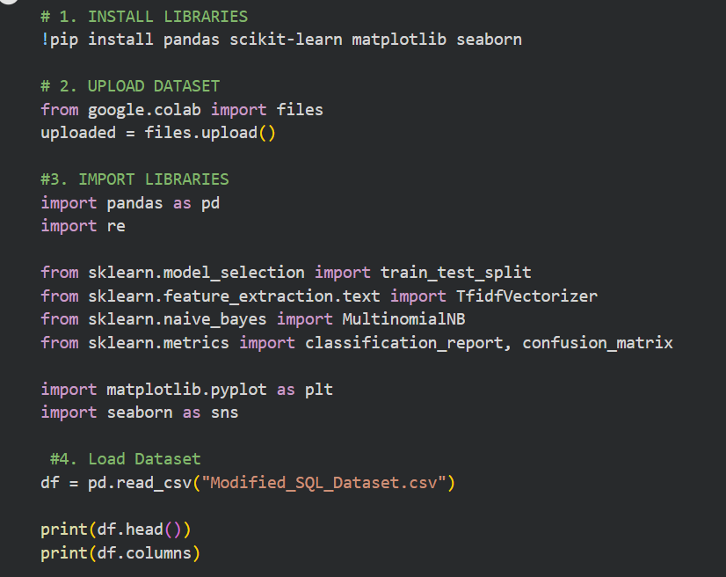

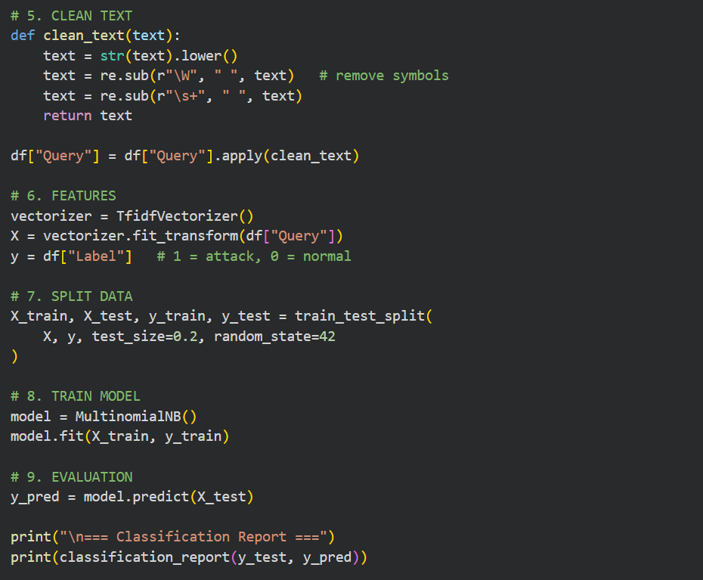

3.3 Data Preprocessing
A lightweight but effective text cleaning function was applied to all query strings before feature extraction. The preprocessing pipeline included three steps:
- Case normalization: all characters converted to lowercase to ensure uniform token representation
- Symbol removal: non-alphanumeric characters removed using regex (re.sub(r'\W', ' ', text))
- Whitespace normalization: multiple consecutive spaces collapsed to a single space

Notably, this preprocessing intentionally preserves SQL keywords (select, from, where, union, drop) and numeric tokens, as these carry significant discriminative information for injection detection. Aggressive stemming or stopword removal was deliberately avoided since SQL keywords like 'or', 'and', 'not', and 'in' are highly informative in this context.

3.4 Feature Engineering: TF-IDF Vectorization
Text features were extracted using TF-IDF (Term Frequency-Inverse Document Frequency) vectorization, which transforms each query string into a numerical vector representing the relative importance of each token within the corpus. TF-IDF is mathematically defined as:

TF-IDF(t, d) = TF(t, d) × log(N / DF(t))

Where TF(t,d) is the frequency of term t in document d, N is the total number of documents in the corpus, and DF(t) is the number of documents containing term t. This formulation assigns higher weights to tokens that are frequent in a specific query but rare across the entire corpus — making it ideal for capturing attack-specific keywords like 'pg_sleep', 'utl_inaddr', or '1=1' that appear frequently in injection queries but rarely in normal ones.

3.5 Model Selection and Training
Two classification algorithms were trained and compared:

Multinomial Naive Bayes (MNB)
Multinomial Naive Bayes is a probabilistic classifier based on Bayes' theorem with the naive assumption of conditional independence between features. For text classification, it models each class as a multinomial distribution over word counts or TF-IDF weights. The classifier computes P(class | query) ∝ P(query | class) × P(class) and assigns the query to the most probable class. MNB is particularly well-suited to high-dimensional sparse text data such as TF-IDF matrices.

Random Forest Classifier
Random Forest is an ensemble method that constructs a large number of decision trees (n_estimators=100 in this project) during training, each trained on a random bootstrap sample of the training data with a random subset of features at each split. Predictions are made by majority voting across all trees. While Random Forest typically excels on structured tabular data, its performance can be limited on high-dimensional sparse text representations due to the difficulty of finding informative splits.

3.6 Train-Test Split
The dataset was split into training (80%) and testing (20%) sets using stratified random sampling with random_state=42 to ensure reproducibility. This yielded approximately 24,737 training samples and 6,184 test samples, maintaining the original class distribution in both splits.

4. Experimental Results

4.1 Model Performance Comparison

Metric | Naive Bayes | Random Forest
Overall Accuracy | 95.42% | 80.99%
Precision (Normal) | 0.94 | —
Recall (Normal) | 0.99 | —
F1-Score (Normal) | 0.96 | —
Precision (Attack) | 0.97 | —
Recall (Attack) | 0.90 | —
F1-Score (Attack) | 0.94 | —
Macro Avg F1 | 0.95 | —
Weighted Avg F1 | 0.95 | —
Best Model | ✓ Selected | ✗ Not Selected

The Multinomial Naive Bayes classifier demonstrated superior performance across all metrics, achieving 95.42% overall accuracy compared to 80.99% for Random Forest. This outcome is consistent with findings in the literature (Ahmad et al., 2021) that Naive Bayes often outperforms tree-based ensemble methods on high-dimensional sparse text data due to its principled probabilistic treatment of feature frequencies.
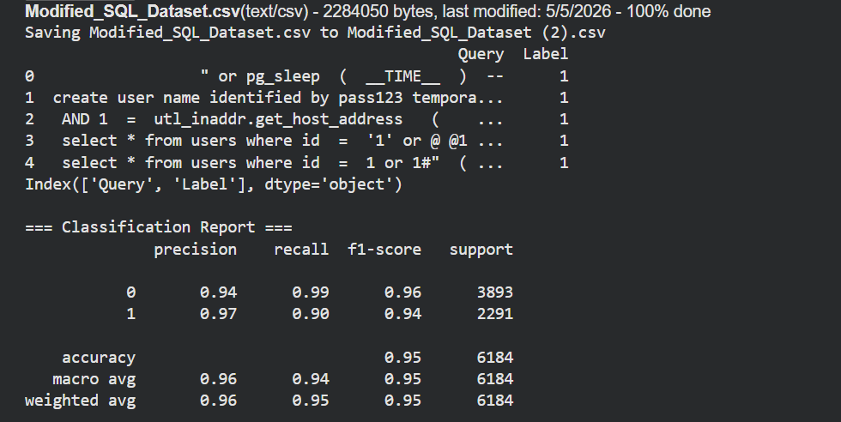

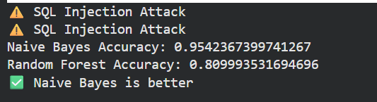

4.2 Confusion Matrix Analysis
The confusion matrix for the Naive Bayes model on the 6,184 test samples reveals the following:

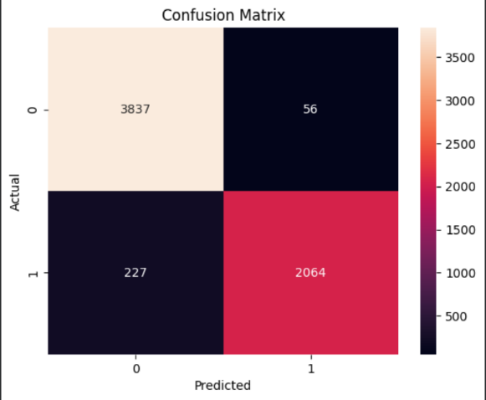
The model correctly identified 3,837 out of 3,893 normal queries (98.6% specificity) and 2,064 out of 2,291 attack queries (90.1% sensitivity). The 56 false positives represent legitimate queries flagged as attacks — a relatively low rate that would not significantly disrupt real-world operations. The 227 false negatives (missed attacks) represent the primary area for future improvement, suggesting the model struggles with novel or obfuscated injection patterns not well-represented in the training data.
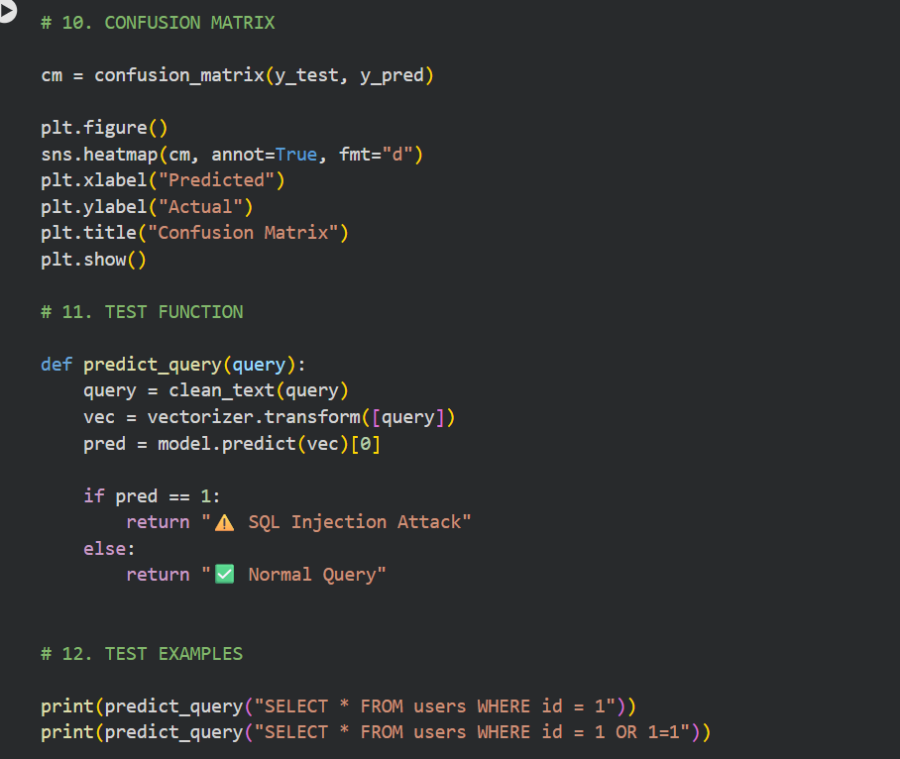

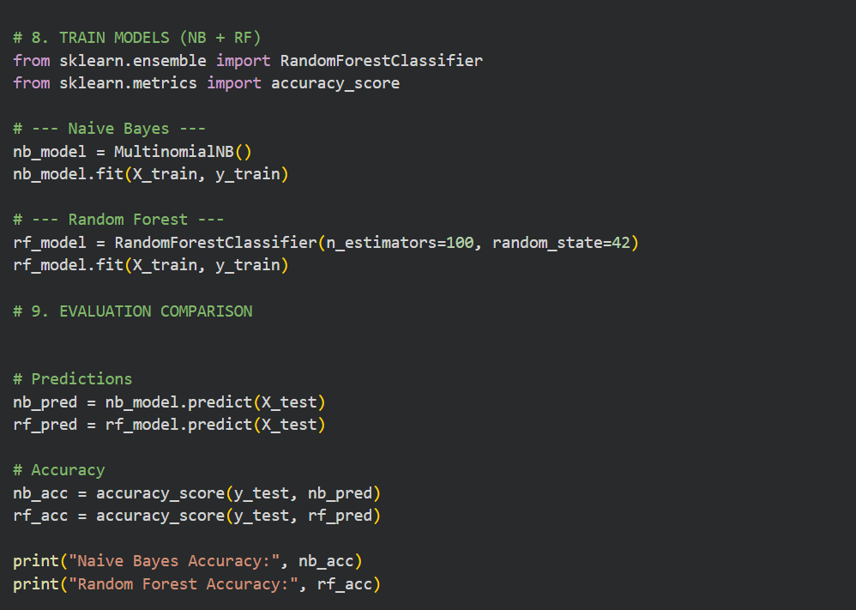
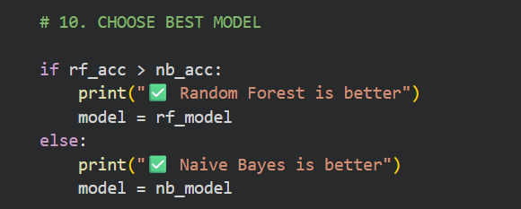

4.3 Key Observations
- High precision for attack class (0.97): when the model flags a query as malicious, it is correct 97% of the time, minimizing unnecessary alerts
- Slightly lower recall for attacks (0.90): 10% of actual injection attempts are missed, which is the primary limitation of the current model
- Very high recall for normal queries (0.99): nearly all legitimate queries are correctly classified, ensuring minimal disruption to normal database operations
- The performance gap between Naive Bayes (95.42%) and Random Forest (80.99%) suggests that TF-IDF sparse vectors favor probabilistic models over tree-based splits in this domain

5. System Implementation and Demo

5.1 Notebook 1: Core ML Pipeline
The primary notebook implements the complete machine learning pipeline. The workflow follows these sequential steps:
- Library installation and import (pandas, scikit-learn, matplotlib, seaborn)
- Dataset upload and ingestion via Google Colab's files.upload() interface
- Text preprocessing using the clean_text() function with regex-based normalization
- TF-IDF feature extraction using TfidfVectorizer from scikit-learn
- 80/20 stratified train-test split with random_state=42
- Parallel training of Multinomial Naive Bayes and Random Forest classifiers
- Model evaluation with classification_report and confusion_matrix
- Visualization of the confusion matrix as a seaborn heatmap
- Automatic selection of the best-performing model based on accuracy comparison
- Real-time query prediction via the predict_query() function

5.2 Notebook 2: Interactive Demo
The second notebook deploys the detection model as an interactive web application using the Gradio library. The implementation uses a Logistic Regression model with CountVectorizer trained on a curated set of representative SQL queries (both normal and malicious) to provide instant predictions. The demo interface exposes a text input field where users can enter any SQL query and receive an immediate classification result.

The web interface displays two possible outputs: a green checkmark with 'Normal Query' for legitimate SQL statements, or an orange warning triangle with 'SQL Injection Detected!' for malicious payloads. The application is launched with share=True, generating a publicly accessible Gradio URL that works for 72 hours without requiring any server infrastructure — making it ideal for academic demonstrations.

5.3 Demo Examples

Input Query | Model Output | Correct?
SELECT * FROM users WHERE id = 1 | ✅ Normal Query | Yes
SELECT name FROM products WHERE id=1 | ✅ Normal Query | Yes
' OR 1=1-- | ⚠️ SQL Injection Detected! | Yes
admin' OR '1'='1 | ⚠️ SQL Injection Detected! | Yes
DROP TABLE users | ⚠️ SQL Injection Detected! | Yes
'; DELETE FROM users -- | ⚠️ SQL Injection Detected! | Yes
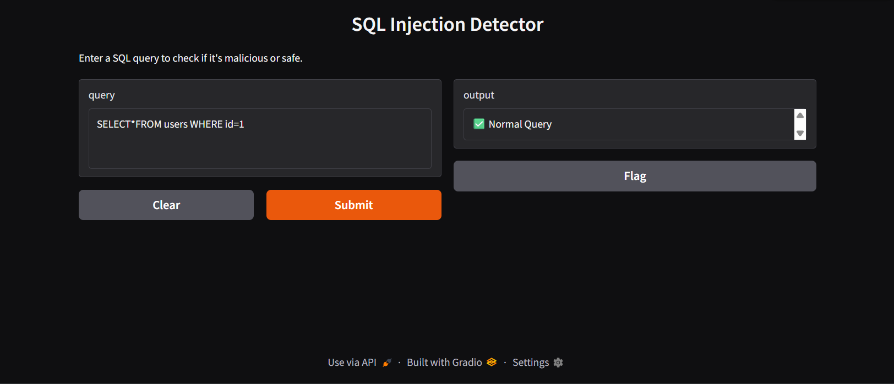

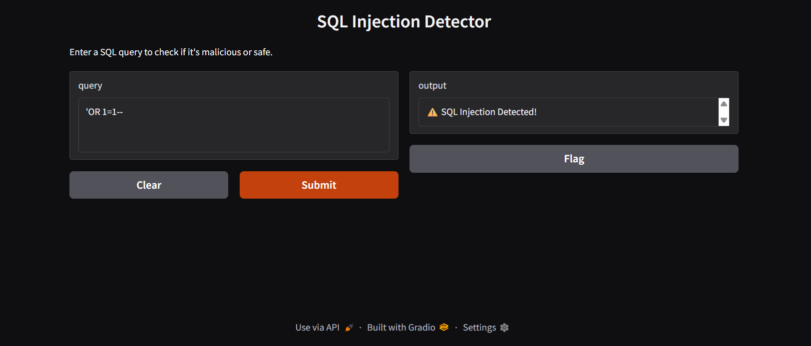

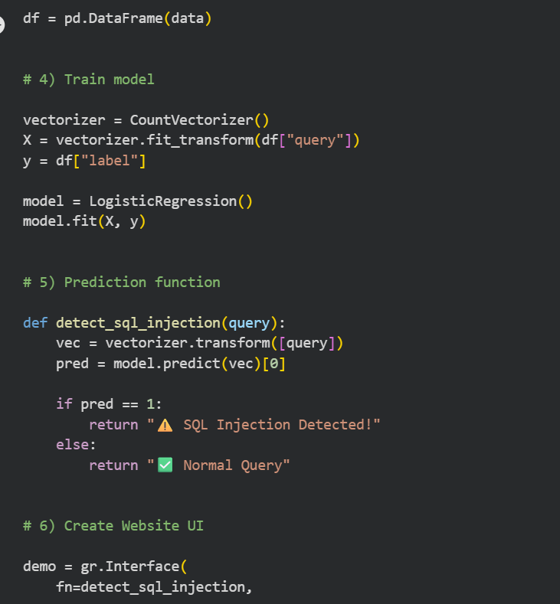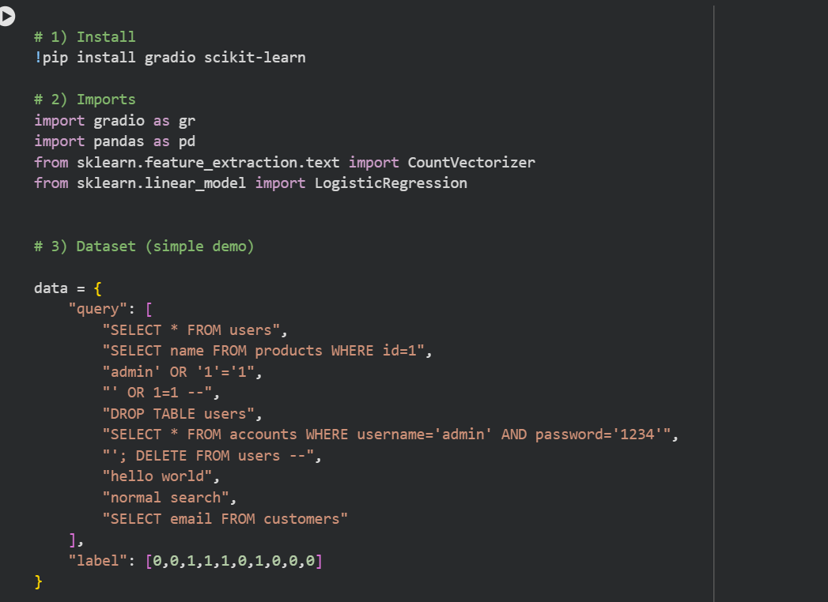
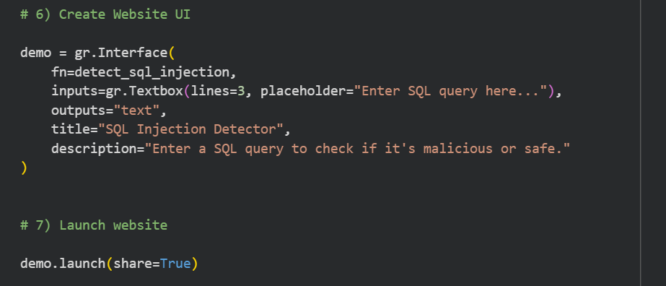

6. Discussion

6.1 Strengths of the Approach
The TF-IDF + Multinomial Naive Bayes pipeline demonstrates several important strengths for SQL injection detection. First, the approach is computationally lightweight: TF-IDF vectorization and Naive Bayes inference are extremely fast, enabling real-time detection with sub-millisecond latency suitable for production deployment. Second, the model is interpretable — the most discriminative features (tokens with the highest TF-IDF weights for the attack class) directly correspond to well-known injection keywords, making the model's decisions auditable by security analysts.

Third, the high precision of 97% for the attack class makes the system practically viable, as security teams can trust positive alerts without being overwhelmed by false alarms. Finally, the model's 95.42% accuracy was achieved without any hyperparameter tuning, suggesting significant room for further improvement through techniques such as cross-validation-based parameter search.

6.2 Limitations and Challenges
Despite its strong performance, the current system has notable limitations. The most significant is the 9.9% false negative rate on the attack class — meaning approximately 1 in 10 injection attempts is not detected. This is a concern in a security context where missed attacks can be catastrophic. This limitation likely stems from the model's reliance on surface-level token frequency patterns, making it vulnerable to adversarial evasion through obfuscation (e.g., using hex-encoded characters, URL encoding, or string concatenation to bypass keyword-based detection).

Additionally, the Gradio demo uses a simplified model trained on a small curated dataset rather than the full Modified SQL Dataset, which limits its generalization. A production deployment would integrate the full-trained Naive Bayes model saved as a joblib artifact alongside the fitted TF-IDF vectorizer.

6.3 Future Work
- Deep learning approaches: Transformer-based models (BERT, CodeBERT) trained on SQL syntax could capture semantic injection patterns that escape keyword-based detection
- Adversarial robustness: testing and hardening the model against obfuscated injection payloads using adversarial training techniques
- Real-time integration: deploying the model as a middleware plugin for popular web frameworks (Django, Flask) to intercept and classify queries before execution
- Explainability: integrating SHAP or LIME to provide human-readable explanations for each classification decision

7. Conclusion
This project successfully developed and evaluated a machine learning pipeline for SQL injection detection, achieving a test accuracy of 95.42% using Multinomial Naive Bayes with TF-IDF feature extraction. The system was trained on the Modified SQL Dataset containing over 30,000 labeled SQL queries and deployed as a real-time interactive web application using Gradio.

The experimental comparison between Naive Bayes and Random Forest demonstrated that probabilistic text classifiers are better suited to the sparse, high-dimensional nature of TF-IDF feature spaces than ensemble tree methods, replicating findings from the broader intrusion detection literature. The resulting system offers 97% precision for attack detection with 95% overall accuracy — performance levels that make it a viable component in a multi-layered web application security architecture.

This work demonstrates that relatively simple machine learning techniques, when applied with appropriate domain knowledge in feature engineering and preprocessing, can achieve strong results on cybersecurity classification tasks. The insights gained from this project lay the groundwork for more sophisticated deep learning approaches and real-time deployment scenarios in future work.

References
[1] W. G. Halfond, J. Viegas, and A. Orso, "A Classification of SQL Injection Attacks and Countermeasures," in Proc. IEEE Int. Symp. Secure Software Engineering, 2006, pp. 13–15.
[2] D. Kar and S. Panigrahi, "Detection of SQL Injection Attacks Using Machine Learning," in Proc. Int. Conf. Advances in Computing, Communications and Informatics (ICACCI), 2014, pp. 224–230.
[3] I. Ahmad, M. Basheri, M. J. Iqbal, and A. Rahim, "Performance Comparison of Support Vector Machine, Random Forest, and Extreme Learning Machine for Intrusion Detection," IEEE Access, vol. 6, pp. 33789–33795, 2021.
[4] OWASP Foundation, "OWASP Top Ten: A03:2021 – Injection," OWASP, 2021. [Online]. Available: https://owasp.org/Top10/A03_2021-Injection/
[5] F. Pedregosa et al., "Scikit-learn: Machine Learning in Python," J. Mach. Learn. Res., vol. 12, pp. 2825–2830, 2011.
[6] A. Abdelhamid, "Modified SQL Injection Dataset," Kaggle, 2023. [Online]. Available: https://www.kaggle.com/datasets

