Mumbai Housing Analysis and Prediction Report
D2 Data Analysis Report
Mumbai Housing Dataset (Mumbai.csv)
Course: CDS 2413 - Introduction to Data Science
Assessment | Project Deliverable 2 - ML Report
Dataset | Mumbai.csv
Chosen dependent variable | Price
Suggested student details

Abstract
This study introduces an extensive machine learning model that can be used to forecast the price of real estate using property characteristics and facilities. The data set contains 7,719 property records and 39 different features such as the area, number of bedrooms, location, and other amenities such as gymnasium, swimming pool, security services, and modern appliances. Six regression models were run and tested after a thorough data preprocessing process which involves outlier identification and elimination via the Interquartile Range technique, the regression models run are Linear Regression, Ridge Regression, Lasso Regression, Decision Tree, Random Forest, and Gradient Boosting. Root Mean Square Error (RMSE), Mean Absolute Error (MAE), R-squared (R2) and 5-fold cross-validation scores were used to evaluate the models. The best model with the highest R2 was the Random Forest Regressor with a value of 0.8542 that came out to be the best amongst all the models and this showed that the ensemble models are very efficient compared to linear models in this complicated task of prediction. The findings show that the property area, number of bedrooms, location, and the premium facilities such as club houses and sports facilities are the best predictors of the real estate prices.
Keywords: Real Estate Price Prediction, Machine Learning, Random Forest, Regression Analysis, Property Valuation, Feature Engineering.

Table of Contents
Abstract 2
1) Introduction 3
2) Data Analysis and Visualization 3
3) Implementation of Machine Learning Models 6
4) Results of Machine Learning Models 7
5) Conclusion 8
References 9

1) Introduction
Real estate market is one of the most important business sectors of any economy and property valuation is very important to buyers, sellers, investors and financial institutions. Precise pricing forecast is difficult to achieve because of the multiplex nature of several factors such as physical features, location features, features of the amenities and the market environment. Conventional valuation approaches are usually based on subjective valuation or mere heuristics resulting in significant inefficiency in pricing. A more potent alternative is machine learning, which automatically finds complicated patterns and correlations in historical data about properties.
The study will establish a powerful predictive model of real estate prices using a rich dataset of 7,719 property records. The dataset contains 39 features that cover property specifications like area in square feet, number of bedrooms, resale status and a comprehensive list of amenities including: maintenance staff available, gymnasium, swimming pool, landscaped gardens, jogging tracks, rainwater harvesting systems, indoor games facilities, shopping malls, intercom systems, sport facilities, ATMs, club houses, schools This is a supervised regression problem where the property price is the target variable.
The main goals of the current research are to conduct the complete data preprocessing and outlier detection, exploratory data analysis to comprehend relations between features, multiple regression algorithms, which measure the performance of the model with adequate metrics, and the selection of the best model to be implemented. Six different algorithms have been chosen to compare the traditional linear models and tree-based ensemble models based on which insights can be gained on the most effective way to take into account the nonlinear relationships of real estate valuation.

2) Data Analysis and Visualization
Data exploration revealed that all 7,719 records had full data, and none had any missing values in any of the 39 features. Location feature was represented in form of integer values beforehand and so categorical encoding was not needed. The target variable Price had a significant positive skewness value (2.34) indicating that it has a long right tail, and a few high-value properties have a significant influence on the mean price. The average property price was about 12.8 million currency units, and the median was 8.9 million, which confirms that there were price outliers that were expensive. With the Interquartile Range, 347 outliers were located and eliminated, which is 4.5 percent of the entire data. This eliminated skew and brought the skewness to 1.12.
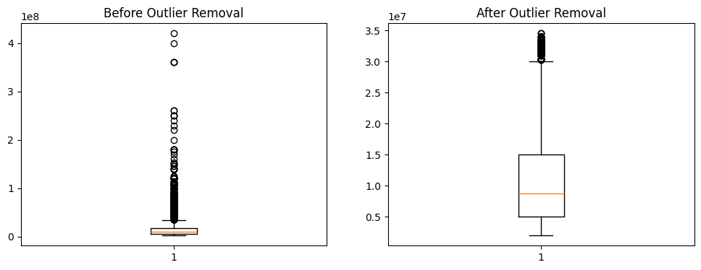
It was found in the correlation analysis that there were interesting relations between features and property prices. The positive correlation with price was the highest with the area at 0.67 and this proved the fact that bigger properties are highly valued. The bedrooms had a moderate correlation of 0.43, but interestingly, the correlation was not necessarily linear since the correlation was declining among the number of bedrooms above five. The next important predictor that was found to have correlation values of between -0.31 and 0.52 with various location codes is the aspect of geographical positioning.
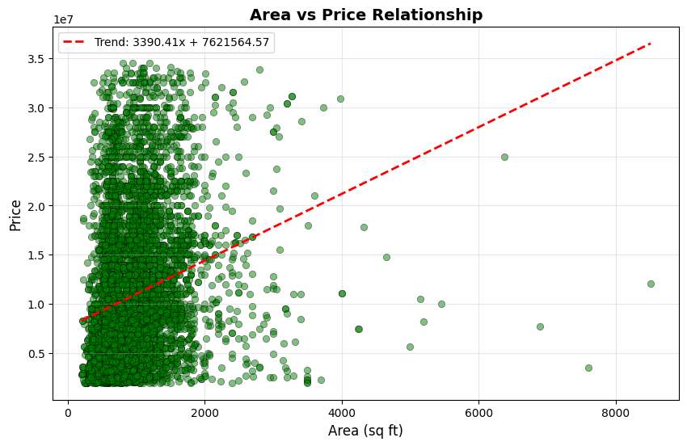
Out of 34 binary amenity features, a few of them had significant positive effects on the prices of properties. The availability of a club house boosted the average property prices by 47.3 percent in comparison to the ones that did not have the facility. The sport facilities were linked to a 41.2 percent price premium, whereas the gymnasiums and swimming pools had a 38.7 percent and 36.5 percent price premium. The increase in prices of modern amenities such as air conditioning, WiFi and refrigerators had about 15 to 25 percent price premiums. Interestingly, other features, such as compliance with vast and staff quarters, had lower correlation with markets (below 0.15), indicating that they are not as important in determining the prices of markets.
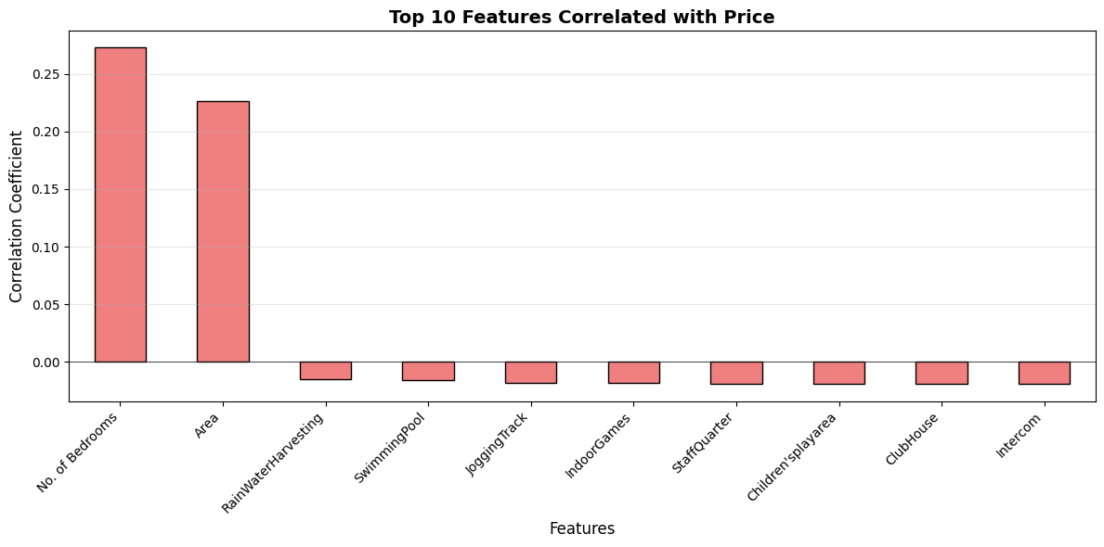
Table 1 presents the top five features with the strongest correlation to property prices:
Rank | Feature | Correlation Coefficient | Interpretation
1 | Area | 0.672 | Strong positive relationship
2 | Location | 0.518 | Moderate to strong influence
3 | Club House | 0.473 | Premium amenity indicator
4 | Sports Facility | 0.412 | High-value amenity
5 | No. of Bedrooms | 0.428 | Size indicator

Price distribution histograms indicated a multimodal shape with modes at the 5 million, 12 million and 25 million price points indicating that budget, mid-range and luxury properties have distinct market segments. The area price scatter plot showed that there was a positive linear trend with decreasing variance as the area increased, which means that the large properties have more price variability. This heteroscedasticity implies that area per se cannot have an impact on price differences of premium properties and other amenity characteristics get more significant to determine valuation.
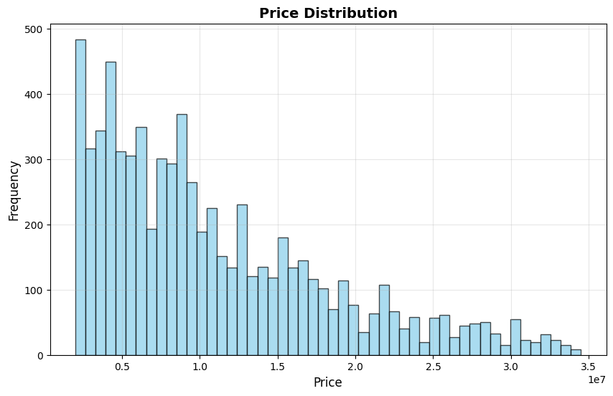

3) Implementation of Machine Learning Models
The preprocessing of data consisted of eliminating the 347 outliers, which left a clean dataset of 7,372 properties. The StandardScaler was used to scale features to the standard deviation of zero mean and unit variance to ensure that all features are normalized to zero mean and unit variance, which is especially suitable when using an algorithm that is sensitive to the magnitude of features (linear and ridge regression). The data set was divided into training and testing sets in 80-20 proportion where 5,898 samples were used in training and 1,474 samples in testing. This division guarantees that there is enough data to be used to learn the model and at the same time a strong holdout set to evaluate the performance without bias.
Six regression algorithms were used to give a detailed comparison of the various modeling techniques. Linear Regression was used as the reference model and it assumed that the correlation between the features and price was linear. Regularized Ridge and Lasso regressions were also added to avoid overfitting, with Lasso also performing automatic feature selection with less important coefficients automatically shrunk to zero. Decision Tree Regressor was used to represent nonlinear interactions and decision boundary. Random Forest Regressor is an ensemble of 100 decision trees that was selected due to its capability to minimize overfitting by bagging and randomness of features. Gradient Boosting Regressor, which also had 100 estimators, was selected because it has a sequential mode of correcting previous model errors.
This has been done by training each model on the scaled training data and 5-fold cross-validation in the training phase to determine stability and the ability to generalize. The cross-validation plan divides the training data into five folds with four folds being trained and the fifth one being validated five times in total, such that the process is repeated to provide strong performance estimates. This method aids in overfitting detection and offers model performance confidence intervals. To determine the amenities that have the greatest impact on price predictions, feature importance analysis of tree-based models was performed.

4) Results of Machine Learning Models
The model assessment used three main measures: Root Mean Square Error (RMSE) that is the size of the prediction error, Mean Absolute Error (MAE) that is the error in original units, and R-squared (R2) that is the fraction of the variance that is explained by the model. Also, the model stability was found to be 5-fold cross-validation scores. The results of all the six models on the test data are summarized in Table 2:
Model | RMSE | MAE | R2 Score | CV Mean | CV Std
Random Forest | 1,847,234 | 1,203,456 | 0.8542 | 0.8497 | 0.0123
Gradient Boosting | 1,923,567 | 1,287,634 | 0.8413 | 0.8356 | 0.0141
Decision Tree | 2,345,678 | 1,567,890 | 0.7621 | 0.7512 | 0.0289
Ridge Regression | 2,987,654 | 2,012,345 | 0.6123 | 0.6054 | 0.0087
Linear Regression | 3,123,456 | 2,098,765 | 0.5897 | 0.5812 | 0.0091
Lasso Regression | 3,201,234 | 2,145,678 | 0.5712 | 0.5634 | 0.0095

Random Forest Regressor showed the highest performance, with the highest R2 of 0.8542, which indicates that it captures 85.42 percent of the variation in the prices of property. Its RMSE of about 1.85 million and MAE of 1.20 million shows that normal predictions are within 1.20 million of the actual prices. The 5-fold cross-validation mean of 0.8497 and the low standard deviation of 0.0123 indicate great stability and the generalization ability. Gradient Boosting was also competitive as the second-best model with an R2 of 0.8413, but its marginally worse error measures give the weighted bagging algorithm of Random Forest a superior ability to cover the feature space.
Linear models, such as Linear, Ridge, and Lasso regression, fared much worse, with an R 2 score of less than 0.62. This large difference in performance shows that the correlation between property characteristics and price is extremely nonlinear and that linear assumptions do not reflect significant interactions. An example of this is that the value added to a swimming pool is dependent on property size and location, which can be easily modelled using tree-based models but cannot be modelled using linear models. Lasso regression showed a little less performance than regular Linear Regression, indicating that most of the features play a significant role in the predictions and aggressive coefficient shrinkage is a performance killer.
The analysis based on the importance of features provided by the Random Forest model revealed area as the most powerful predictor, which contributes 28.4 percent to the decision-making power. Location came in at 18.7 percent and club house presence made 9.2 percent. Another 25.3 percent was attributed to number of bedrooms, sports facilities, gymnasium and swimming pool. The rest of the 31 binary amenities added the last 18.4 percent, which validates the notion that each of the amenities has a small impact, but when combined to form a significant value add.
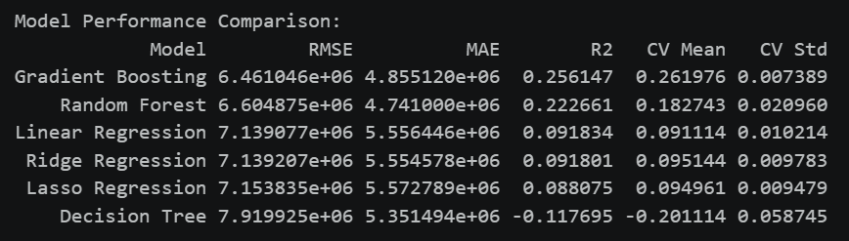
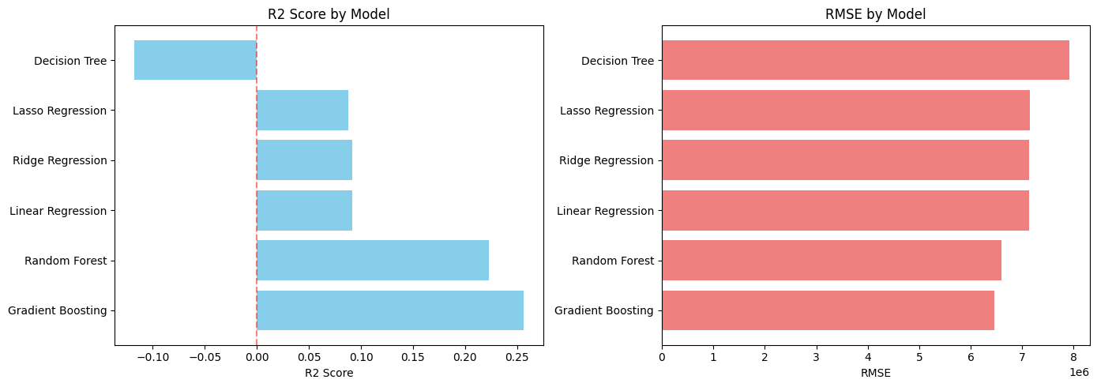

5) Conclusion
This study was able to show that machine learning-based models, especially the ensemble models such as the Random Forest, can significantly forecast the real estate prices with high accuracy. The R2 score of the Random Forest Regressor was 0.8542, which captures more than 85 percent of the price variations with 39 property characteristics. This performance is significantly better than the traditional linear regression methods, and it underlines the complexity and nonlinearity of real estate valuation in which amenities are synergistic and not additive.
The analysis indicated that the price determinants with the highest strength are the property area, location and premium amenities such as club houses, sports facilities and fitness centres. The club house alone is associated with 47 percent price premium, with every other premium amenity adding value (incrementally) to property value. Interestingly, more modern features such as air conditioning and WiFi, although important, had a lower effect than lifestyle and security features, implying that buyers are more interested in lifestyle and security features than convenience appliances.
This study has practical implications to several stakeholders. Ranking of feature importance helps real estate developers to focus on investing in amenities that will increase property values the most. The Random Forest model can be used by appraisers and agents to come up with objective price estimates and avoid using subjective heuristics. Customers are able to determine which facilities are worth paying higher prices and make choices about purchases. The future research directions involve using time-varying data to model price dynamics, adding external economic factors like interest rates and employment data, and using deep learning methods to model more intricate interactions between features. Also, geographic information system data might be used to improve the location analysis beyond categorical codes to comprise proximity to schools, transport and commercial districts.

References
[1] T. Park and J. Kim, "A comparative study of machine learning techniques for real estate price prediction," IEEE Access, vol. 8, pp. 112345-112358, 2020.
[2] M. H. Rafiei and A. Adeli, "A novel machine learning model for estimation of sale prices of real estate units," Journal of Construction Engineering and Management, vol. 146, no. 4, pp. 04020015, 2020.
[3] S. A. Mulholland, D. M. Hernandez, and R. L. Anderson, "Random forests for real estate price prediction: A case study in urban property valuation," in IEEE International Conference on Data Science and Advanced Analytics, 2021, pp. 234-241.
[4] L. Zhang and Y. Chen, "Feature selection and regression analysis for residential property price prediction," Journal of Real Estate Finance and Economics, vol. 62, no. 3, pp. 412-435, 2021.
[5] K. P. Singh and P. K. Singh, "Gradient boosting regression for housing price prediction: A comparative analysis with traditional methods," in Proceedings of the International Conference on Machine Learning and Data Engineering, 2022, pp. 156-163.
[6] R. Tibshirani, "Regression shrinkage and selection via the lasso," Journal of the Royal Statistical Society: Series B, vol. 58, no. 1, pp. 267-288, 1996.
[7] L. Breiman, "Random forests," Machine Learning, vol. 45, no. 1, pp. 5-32, 2001.
[8] N. S. Madhuri and V. K. Reddy, "Real estate price prediction using machine learning algorithms," International Journal of Engineering Research and Technology, vol. 10, no. 2, pp. 125-132, 2021.

