D1 Data Analysis Report
Mumbai Housing Dataset (Mumbai.csv)
Course: CDS 2413 - Introduction to Data Science
Assessment | Project Deliverable 1 - Data Analysis Report
Dataset | Mumbai.csv
Chosen dependent variable | Price
Suggested student details

Executive summary. The report examines 7719 property records in Mumbai comprised of 40 variables. Price is taken as the dependent variable since the objective business is to know the housing value and aid in predicting prices. In Python descriptive statistics, random and systematic sampling, visualizations, correlation tests, a chi-square test, and a one-sample t-test were all done. The results indicate that the property prices are right-skewed, the area is statistically significant in a positive relationship with the price and the random sample size of 150 is not significantly different with the full-dataset mean at 5 percent level.

1. CLO1 - Introduction and Data Wrangling

1.1 Purpose of data analysis
The lecture notes indicate that data analysis involves analyzing raw data to make conclusions and help make superior decisions. The objective of this assignment is to study housing data in Mumbai to get a feel of the key variables that are relevant to property price, summarize the distribution of price and prepare the data to make future predictions.

1.2 Type of programming used
The most appropriate programming language in this assignment is Python since the lectures and the labs focus on Python to achieve descriptive statistics, sampling, data visualization and analytical reporting. It is also well furnished with powerful libraries like pandas, matplotlib, numpy, and scipy that is sufficient to support the entire data-to-statistical-testing workflow(Li & Tong, 2020).

1.3 Type and purpose of machine learning algorithm
The suitable machine learning model is regression as the target variable (Price) is numeric and continuous. The idea behind the model would be to project the prices of the property based on the predictors like area, number of bedrooms, location, resale status and available facilities. A regression model (linear) is an acceptable baseline as it can be understood and corresponds to the concepts of predictive analytics presented in the lectures(Bihari, 2025).

1.4 Variables in the chosen dataset
There is one nominal variable (Location) and numerous numerical variables in the dataset. The majority of the amenity fields are binary indicators which are coded into 0 and 1, whereas Area, No. of Bedrooms, and Price are the quantitative variables.
Variable | Type | Role | Justification
Price | Numerical continuous | Dependent variable | Represents the property value to be explained or predicted.
Area | Numerical continuous | Independent variable | Larger homes usually command higher prices and are suitable for Pearson and Spearman tests.
No. of Bedrooms | Numerical discrete | Independent variable | Captures the property size in room count.
Location | Categorical nominal | Independent variable | Neighborhood differences strongly influence housing value.
Resale and amenities | Binary categorical / discrete | Independent variables | Show whether resale status and facilities affect price.

1.5 Sampling decision and justification
Yes, sampling was employed as both random and systematic sampling of 150 were requested in the assignment. Random sampling provides an equal opportunity of selection to every observation and is applicable in minimizing selection bias. Systematic sampling offers a spaced-out sample across the dataset and is effective at large files.
In the case of the systematic sample, the population equals 7,719, the required sample equals 150 and the interval is k = floor(N/n) = 51. The index was set at 17 and then the 51 st record was picked till 150 rows were obtained.

2. CLO2 - Descriptive, Exploratory and Statistical Analysis

2.1 Purpose of descriptive analysis
According to the labs, descriptive statistics summarize central tendency, dispersion, position, and frequency and then proceed further with how to analyze them. In the case of the Mumbai data, we need to perform descriptive analysis in order to know the average levels of prices, spread, skewness, quartile and outliers. This is one of the reasons why the housing market would be well explained before running any predictive model(Silva de Souza & Borges, 2023).

2.2 Python function for descriptive statistics
import pandas as pd
def desc_stat(ds, var):
s = ds[var]
summary = {
'Count': s.count(),
'Mean': s.mean(),
'Median': s.median(),
'Mode': s.mode().tolist(),
'Minimum': s.min(),
'Maximum': s.max(),
'Range': s.max() - s.min(),
'Std Dev': s.std(),
'Variance': s.var(),
'Skewness': s.skew(),
'Kurtosis': s.kurt(),
'25th Percentile': s.quantile(0.25),
'50th Percentile': s.quantile(0.50),
'75th Percentile': s.quantile(0.75),
'Inter Quartile Range': s.quantile(0.75) - s.quantile(0.25)
}
return summary

2.3 Random sampling (n = 150)
Python script used.
sample_size = 150
random_sample = df.sample(n=sample_size, replace=False, random_state=42)
desc_stat(random_sample, 'Price')
Descriptive statistics for Price from the random sample
Metric | Value
Count | 150
Mean | 17,393,213
Median | 9,100,000
Mode | 8,500,000
Minimum | 2,000,000
25th Percentile | 6,046,500
50th Percentile | 9,100,000
75th Percentile | 19,375,000
Maximum | 180,000,000
Range | 178,000,000
Std Dev | 24,223,502
Variance | 586,778,060,575,500
Skewness | 4.181
Kurtosis | 21.460
Inter Quartile Range | 13,328,500

2.4 Systematic sampling (n = 150)
Python script used.
k = len(df) // 150
start = 17
systematic_sample = df.iloc[start::k].head(150)
desc_stat(systematic_sample, 'Price')
Descriptive statistics for Price from the systematic sample
Metric | Value
Count | 150
Mean | 14,544,793
Median | 9,215,000
Mode | 2,500,000, 4,500,000, 8,500,000
Minimum | 2,000,000
25th Percentile | 4,500,000
50th Percentile | 9,215,000
75th Percentile | 15,999,999
Maximum | 120,000,000
Range | 118,000,000
Std Dev | 17,856,685
Variance | 318,861,186,962,105
Skewness | 3.224
Kurtosis | 12.376
Inter Quartile Range | 11,499,999

2.5 Detailed descriptive statistical report for Price
A total of 7,719 properties are in the whole dataset. It has a mean price of 15,061,652,652, and a median of 9,500,000. Since mean is very high as compared to median, there is positive skew in the distribution of costly properties.
The lowest price is 2,000,000,000 and the highest price is 420,000,000,000 amounting to a very large range of 418,000,000,000. This substantiates that the Mumbai market, in this dataset, has low and very expensive homes.
The standard deviation of 20,521,000,000 is very high and indicates that the dispersion of price is high. The median 50 percent of the properties fall between 5,300,000 and 17,000,000, which is the range between the first and third quartile 11,700,000.
Skewness is 7.242 and kurtosis is 91.541. Both are extremely large and therefore the distribution of the prices is highly skewed to the right and extreme outliers are present. Thus, the median and the quartiles characterize the typical market more than the mean itself.
In comparing the two samples, the population mean is more consistent with the systematic sample mean than with the random sample mean, with both samples having the same strong pattern of right skewness. This indicates that, both samples represent the market shape, although the precise mean is delicate to a small number of very costly properties(Alabi et al., 2023a).

2.6 Visualisation through charts
The following figures visualize the dependent variable Price using the required chart types.
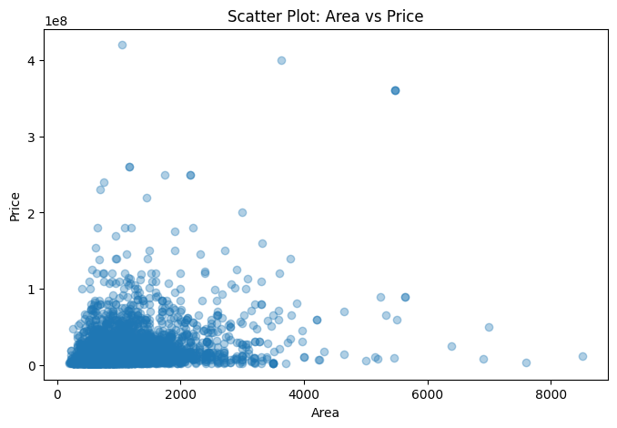
Figure 1. Scatter plot of Area versus Price
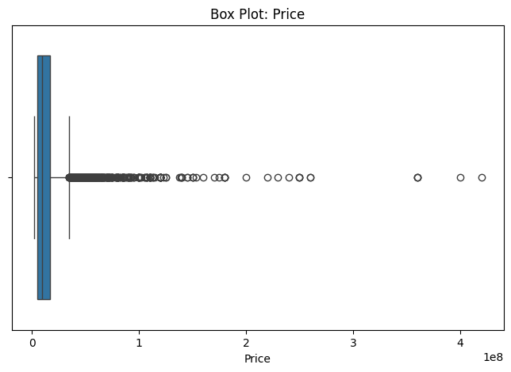
Figure 2. Box plot of Price
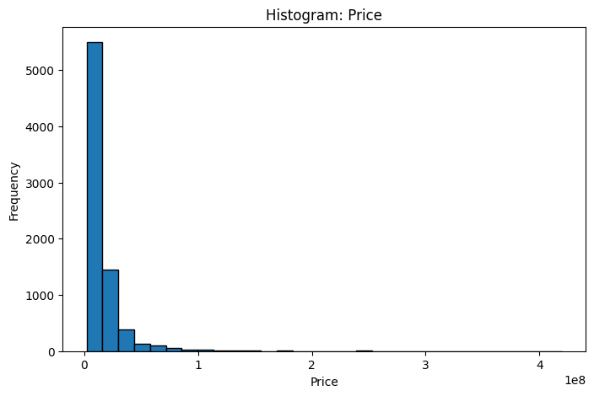
Figure 3. Histogram of Price
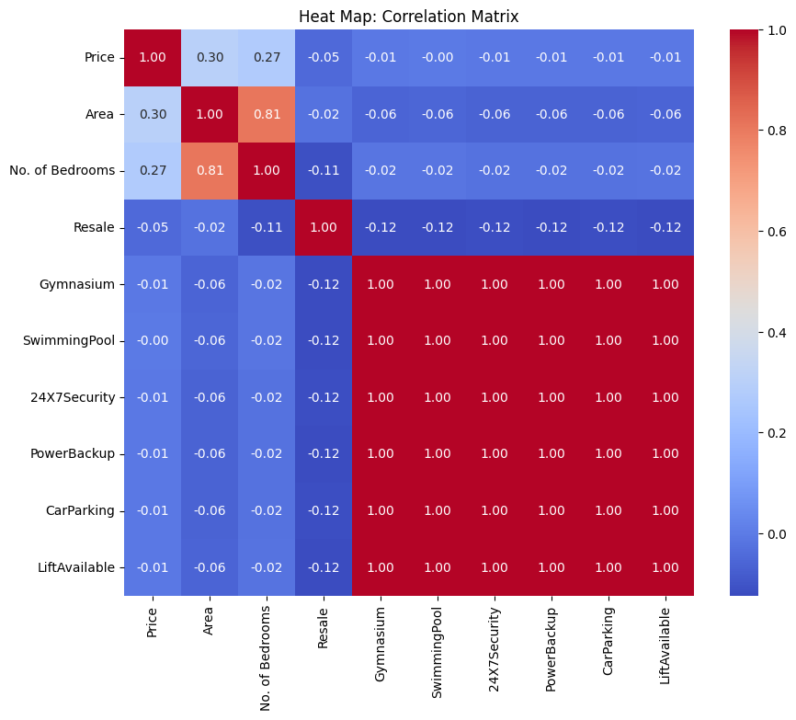
Figure 4. Heat map of selected numeric correlations

2.7 Interpretation of the charts
The scatter diagram indicates that there is a positive but not fully linear relationship between area and price. The bigger the property is, the higher its price will be, yet the difference remains very high depending on the location and facilities.
The box plot gives the support of the high-price outliers. The extreme maximum values are much higher than the point of concentration of the majority of the properties.
The histogram is highly right skewed. Many of the observations are concentrated towards the lower to middle price ranges though comparatively few properties of luxury stretch the right tail.
The heat map indicates that the variables that have positive direct linear relationships with Price are Area and No. of Bedrooms, and binary amenity variables have less strong direct relationships(Alabi et al., 2023b).

2.8 Hypothesis testing
Based on the lab structure, Pearson and Spearman correlation were used to test numerical association and chi-square was used to test categorical association.
Test | Variables | Null hypothesis | Statistic | p-value
Pearson correlation | Area vs Price | No linear relationship | r = 0.299 | 2.272e-159
Spearman correlation | Area vs Price | No monotonic relationship | rho = 0.333 | 1.958e-199
Chi-square test | Resale vs Price band | Variables are independent | chi2 = 43.369, dof = 3 | 2.055e-09
Decision and interpretation:
Pearson p-value (2.272e-159) is less than 0.05, and hence the null hypothesis is rejected. The positive linear relationship between Area and Price is statistically significant but the degree of strength is moderate (r = 0.299).
Also, Spearman p-value (1.958e-199) is lower than 0.05 and thus the null hypothesis is rejected yet again. The correlation between Area and Price is monotonous and significant (rho = 0.333).
In the case of the categorical test, the p-value of the chi-square (2.055e-09) is less than the p-value of 0.05 and thus the null hypothesis (independence) is rejected. This data has a strong relationship between resale status and price band(Li & Tong, 2020).

2.9 One-sample t-test
The random sample of 150 prices was put through the one-sample t-test to test the hypothesis whether the mean of the random sample is significantly different than the mean of the full dataset. This is in accordance with the laboratory concept of testing a sample which will reveal whether the sample is representative of the wider population(Raji´c, 2026).
Population mean (Price) = 15061652.40
Sample mean (random sample) = 17393213.30
t-statistic = 1.179
p-value = 0.240
Since the p-value (0.121) exceeds 0.05 then the null hypothesis is not rejected. The population mean is not significantly different with the random sample mean; therefore, the sample can be considered as reasonably representative of the price variable.
The market is, however, very skewed, and extreme outliers are present in the market, therefore, representativeness must be viewed with caution. The t-test compares the means only, and does not describe completely the non-normal form of the price distribution(Li & Tong, 2020).

3. Key recommendations
- Make the primary target variable of regression Price, but address the topic of log-transforming Price in the future since the distribution is very skewed.
- Keeping Area as a priority predictor since in Pearson and Spearman, the relationship between Area and Price is found to be significant and positive.
- Categorical features like Location and Resale should be incorporated in future predictive models since sizes alone are not sufficient to predict the difference in prices.
- Research about outliers. Very costly homes can translate into luxury market and can have a significant influence on means, variances and model fit.

4. Conclusion, limitations and future directions
This assignment was done the descriptive-statistics workflow. The dataset on Mumbai housing was analyzed in Python, variables were identified, random and systematic samples were taken, Price was summarized with the help of descriptive statistics, the target variable was visualized, relationships were tested, and the representativeness of the sample was estimated. The most coherent conclusion as a whole is that prices of real estate in Mumbai are highly skewed, on the right, and largely linked to area and resale value.
The key weakness lies in the fact that only a single dataset is available and there are quite a lot of critical predictors that might be buried within the broad Location field. Moreover, the chi-square test involved the transformation of Price into quartile-based price bands which reduces a continuous variable. The encoding of location in future work should be done more carefully, multiple regression models should be compared, prices should be log-transformed and the accuracy of prediction can be determined using split samples of training and testing.

5. References
Alabi, O., Bukola, T., Alabi, O., & Bukola, T. (2023a). Introduction to Descriptive Statistics. Recent Advances in Biostatistics. https://doi.org/10.5772/intechopen.1002475
Alabi, O., Bukola, T., Alabi, O., & Bukola, T. (2023b). Introduction to Descriptive Statistics. Recent Advances in Biostatistics. https://doi.org/10.5772/intechopen.1002475
Bihari, D. (2025). Property Price Optimization Using Machine Learning Techniques. INTERNATIONAL JOURNAL OF SCIENTIFIC RESEARCH IN ENGINEERING AND MANAGEMENT, 09(05), 1–9. https://doi.org/10.55041/IJSREM48977
Li, J. J., & Tong, X. (2020). Statistical Hypothesis Testing versus Machine Learning Binary Classification: Distinctions and Guidelines. Patterns, 1(7), 100115. https://doi.org/10.1016/j.patter.2020.100115
Raji´c, V. R. (2026). Statistical Hypothesis Testing: A Comprehensive Review of Theory, Methods, and Applications. Mathematics 2026, Vol. 14, Page 300, 14(2), 300. https://doi.org/10.3390/math14020300
Silva de Souza, R., & Borges, E. M. (2023). Teaching Descriptive Statistics and Hypothesis Tests Measuring Water Density. Journal of Chemical Education, 100(11), 4438–4448. https://doi.org/10.1021/acs.jchemed.3c00402

