BLOCK
We must create a 2x1x1 block, which normally means a block with length =2,
height=1 ,width=1.
LENGTH=2
DEPTH/WIDTH=1

H=1
LENGTH=2

LENGTH=2

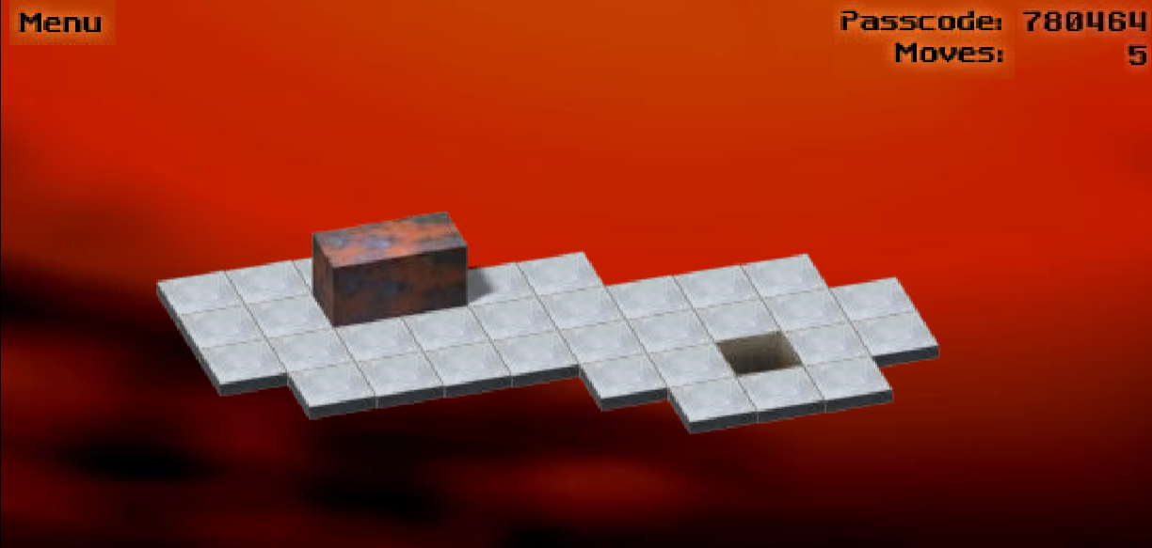
WIDTH=1
HEIGHT=1
LENGTH=2

AS WE CAN SEE WHEN THE BLOCK IS IN Lying flat (length visible)
HEIGHT=1, WIDTH=1, LENGTH=2. THE MOST IMPORTANT THING IS LENGTH. THE POSITION OF THE LENGTH DECIDES HOW MANY BLOCK/TILE THE BLOCK WILL ACQUIRE.
HERE THE BLOCK ACQUIRE 2 BLOCKS.

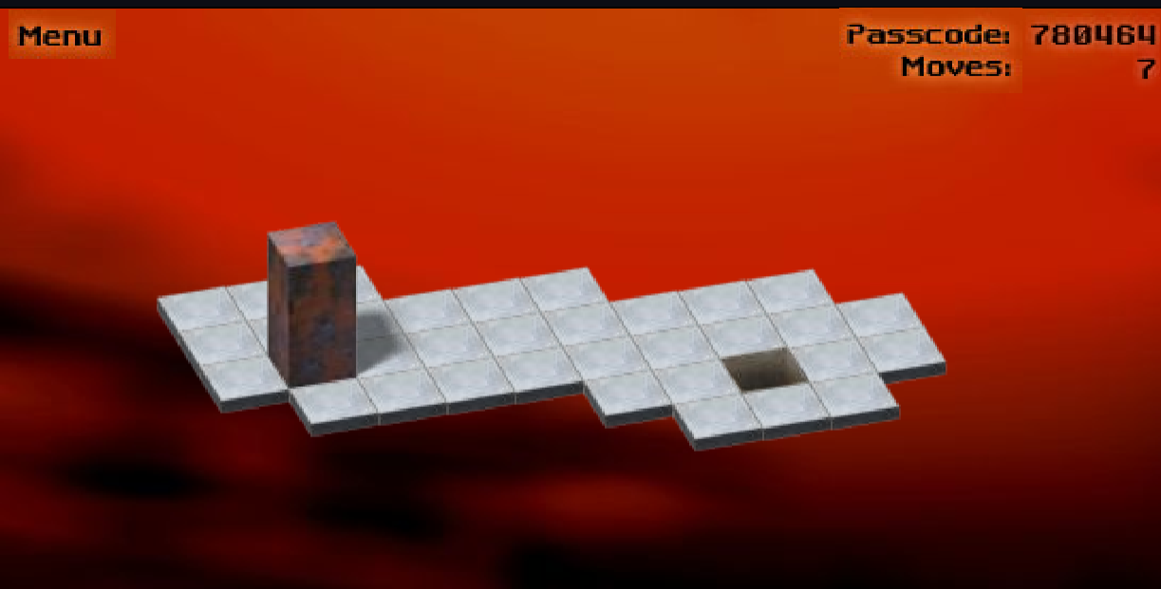
HEIGHT=1
LENGTH=1

LENGTH=2
HEIGHT=2

WIDTH=1
WHEN THE BLOCK IS STANDING STILL THE LENGTH BECOMES HEIGHT=2 & THE HEIGHT BECOMES LENGTH=1.
AS DISCUSSED BEFORE, LENGTH = HOW MANY TILES THE BLOCK WILL ACQUIRE.
SO HERE THE BLOCK ACQUIRES 1 TILE.

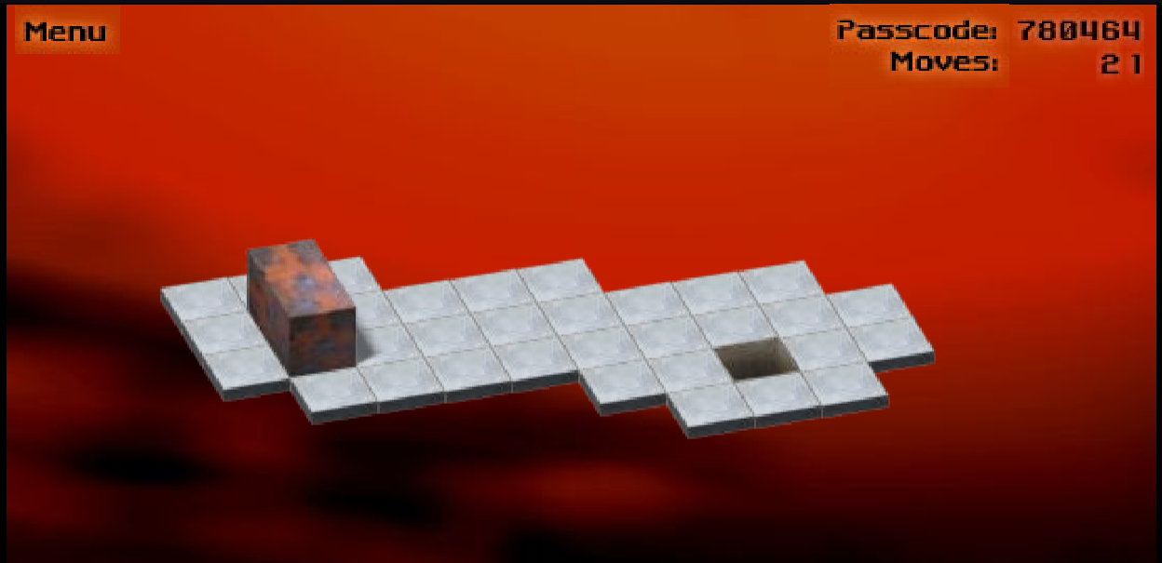
IN THIS CASE ALSO LENGTH=2 HEIGHT=1 WIDTH=1. SO THE BLOCK ACQUIRES 2 TILES .

SO IN SUMMARY WE ARE CONCLUDING THAT THE LENGTH OF THE BLOCK DEPENDIDNG ON THE ORIENTATION DECIDES HOW MANY TILE IT ACQUIRES .
LYING FLAT/VERTICAL =2 TILE
STANDING STILL=1 TILE

POSITION
STANDING STILL
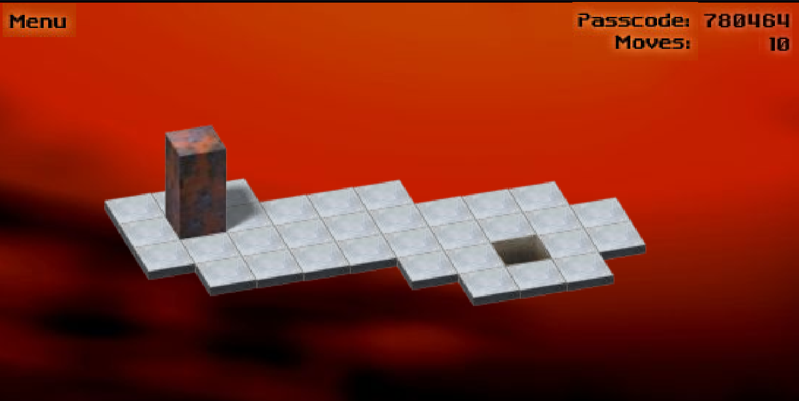
In this case, the block is standing still, and the position of the block is [X]

HORIZONTAL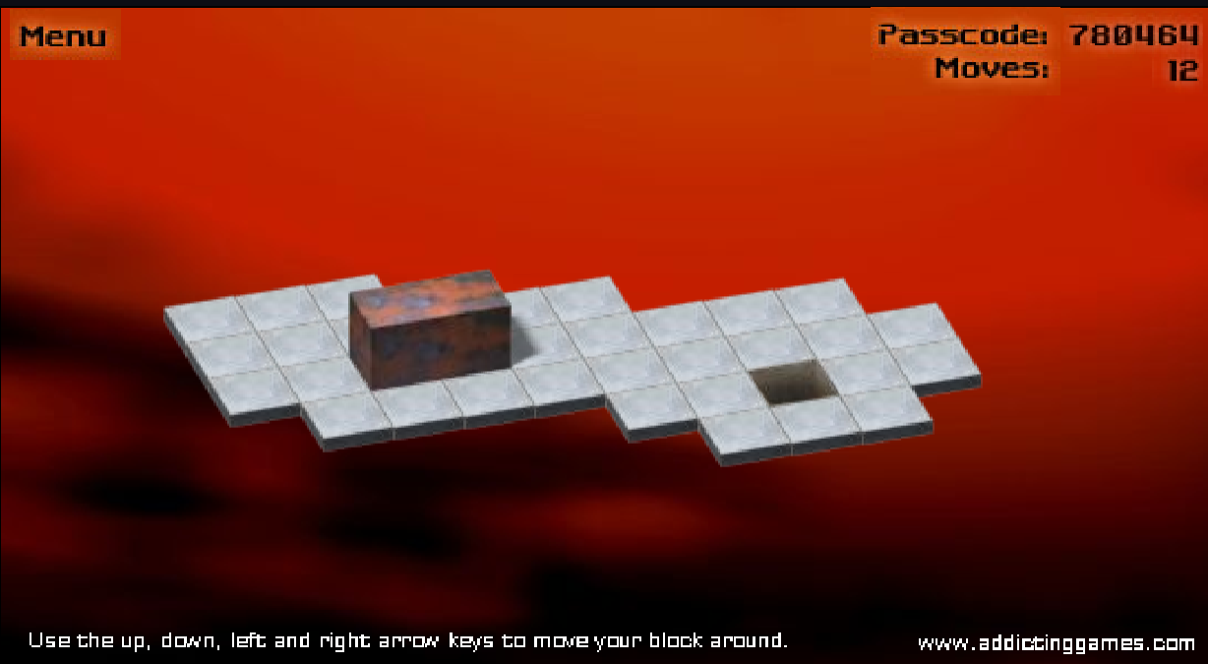
In this case, the block is vertical, and the position of the block is [X][X]

VERTICAL
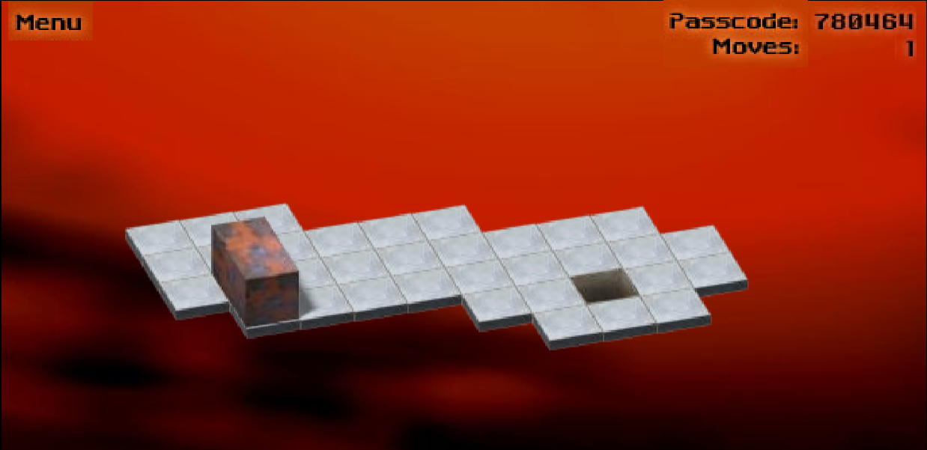
In this case, the block is lying horizontally, and the position of the block is [X]
[X]

Movement

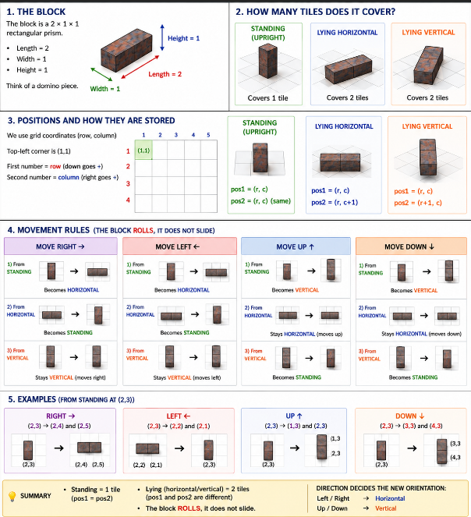

Before | After
[X] | vertical
horizontal | standing
vertical | moves up
RIGHT ARROW ⬆️ Move UP
Before | After
[X] | [X][X] (horizontal)
[X][X] | [X] (standing)
[X][X] | [X][X] (moves right, stays vertical)

CODE LOGIC
MOVING RIGHT
""" First, understand the logic visually

There are 3 cases.

CASE 1 — Standing to the right

Before:

[X]

After:

[X][X]

standing becomes horizontal

Position logic

Before:

pos1 = (r,c)
pos2 = (r,c)

After:

pos1 = (r, c+1)
pos2 = (r, c+2)

CASE 2 — Horizontal to RIGHT

Before:

[X][X]

After:

[X]

horizontal becomes standing

Position logic

Before:

(r,c)
(r,c+1)

After:

(r,c+2)
(r,c+2)

CASE 3 — Vertical to RIGHT

Before:

[X]
[X]

After:

[X]
[X]

stays vertical
just shifts right

Position logic

Before:

(r,c)
(r+1,c)

After:

(r,c+1)
(r+1,c+1)
"""

def move_right(self):

orientation = self.get_orientation()

r1, c1 = self.pos1
r2, c2 = self.pos2

if orientation == "standing":

self.pos1 = (r1, c1 + 1)
self.pos2 = (r1, c1 + 2)

elif orientation == "horizontal":

self.pos1 = (r1, c1 + 2)
self.pos2 = (r1, c1 + 2)

elif orientation == "vertical":

self.pos1 = (r1, c1 + 1)
self.pos2 = (r2, c2 + 1)

MOVING LEFT
CASE 1 — Standing → LEFT
Before:

[X]

After:

[X][X]

standing becomes horizontal

Position logic

Before:

pos1 = (r,c)
pos2 = (r,c)

After:

pos1 = (r, c-1)
pos2 = (r, c-2)

CASE 2 — Horizontal → LEFT
Before:

[X][X]

After:

[X]

horizontal becomes standing

Position logic

Before:

(r,c)
(r,c+1)

After:

(r,c-1)
(r,c-1)

CASE 3 — Vertical → LEFT
Before:

[X]
[X]

After:

[X]
[X]

vertical becomes vertical

Position logic

Before:

(r,c)
(r+1,c)

After:

(r,c-1)
(r+1,c-1)

def move_left(self):

orientation = self.get_orientation()

r1, c1 = self.pos1
r2, c2 = self.pos2

if orientation == "standing":

self.pos1 = (r1, c1 - 2)
self.pos2 = (r1, c1 - 1)

elif orientation == "horizontal":

self.pos1 = (r1, c1 - 1)
self.pos2 = (r1, c1 - 1)

elif orientation == "vertical":

self.pos1 = (r1, c1 - 1)
self.pos2 = (r2, c2 - 1)

MOVING UP
CASE 1 — Standing → UP

Before:

[X]

After:

[X]
[X]

becomes vertical

Position logic

Before:

(r,c)

After:

(r-2,c)
(r-1,c)

CASE 2 — Horizontal → UP

Before:

[X][X]

After:

[X]

becomes standing

Position logic

Before:

(r,c)
(r,c+1)

After:

(r-1,c)
(r-1,c)

CASE 3 — Vertical → UP

Before:

[X]
[X]

After:

[X]
[X]

stays vertical
shifts upward

Position logic

Before:

(r,c)
(r+1,c)

After:

(r-1,c)
(r,c)

def move_up(self):

orientation = self.get_orientation()

r1, c1 = self.pos1
r2, c2 = self.pos2

if orientation == "standing":

self.pos1 = (r1 - 2, c1)
self.pos2 = (r1 - 1, c1)

elif orientation == "horizontal":

self.pos1 = (r1 - 1, c1)
self.pos2 = (r1 - 1, c1)

elif orientation == "vertical":

self.pos1 = (r1 - 1, c1)
self.pos2 = (r2 - 1, c2)

MOVING DOWN
CASE 1 — Standing → DOWN

Before:

[X]

After:

[X]
[X]

becomes vertical downward

Position logic

Before:

(r,c)

After:

(r+1,c)
(r+2,c)

CASE 2 — Horizontal → DOWN

Before:

[X][X]

After:

[X]

becomes standing

Position logic

Before:

(r,c)
(r,c+1)

After:

(r+1,c)
(r+1,c)

CASE 3 — Vertical → DOWN

Before:

[X]
[X]

After:

[X]
[X]

stays vertical
shifts downward

Position logic

Before:

(r,c)
(r+1,c)

After:

(r+1,c)
(r+2,c)

def move_down(self):

orientation = self.get_orientation()

r1, c1 = self.pos1
r2, c2 = self.pos2

if orientation == "standing":

self.pos1 = (r1 + 1, c1)
self.pos2 = (r1 + 2, c1)

elif orientation == "horizontal":

self.pos1 = (r1 + 1, c1)
self.pos2 = (r1 + 1, c1)

elif orientation == "vertical":

self.pos1 = (r1 + 1, c1)
self.pos2 = (r2 + 1, c2)

VALID POSITION FINDER

Valid vs Invalid positions

Because currently:

my block can move ANYWHERE

Even:

outside board
onto holes (0)
We must now teach the Board to answer:
“Is this position valid?”

Remember Board’s job

Board:

stores map
checks rules

NOT movement.

What is a valid position?

A position is valid if:

✅ inside board
✅ not on 0

💡 Example board
1 1 1
1 2 1
0 1 9

VALID
(1,1)

because:

inside board
value not 0
INVALID
(2,0)

because:

grid[2][0] = 0

FIRST we need a helper function

In board.py

We create:

is_valid_position()

def is_valid_position(self, position):

row, col = position

if row < 0 or row >= len(self.grid):
return False

if col < 0 or col >= len(self.grid[0]):
return False

if self.grid[row][col] == 0:
return False

return True

Explnation

🔹 row, col = position

Example:

position = (1,2)

Then:

row = 1
col = 2
🔹 row < 0

* Above board?

Example:

(-1,2)

INVALID.

🔹 row >= len(self.grid)

If board has 3 rows:

0
1
2

Then row 3 is outside.

🔹 col < 0

* Left outside board.

🔹 col >= len(self.grid[0])

* Right outside board.

🔹 self.grid[row][col] == 0

* Hole tile.

Lose.

🔹 return True

If none failed:

valid position

