# **🏎️ F1 AI Race Predictor**

An intelligent Formula 1 race prediction dashboard that combines real F1 data with advanced simulation algorithms to predict race outcomes across all 24 F1 circuits.

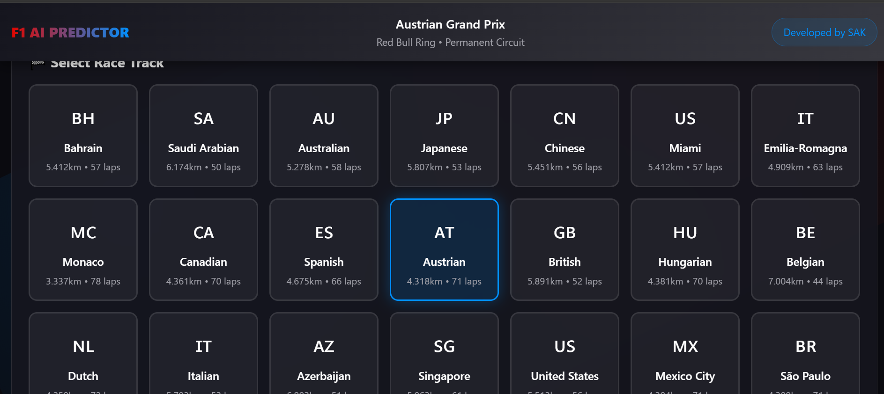

## **🚀 Features**

### **🎯 Core Functionality**

* **24 F1 Circuits** - Complete 2025 season calendar with realistic track characteristics
* **AI-Powered Predictions** - Enhanced XGBoost-inspired model with weighted feature ensemble
* **Interactive Qualifying** - Drag-and-drop grid editor with realistic qualifying simulation
* **Dual Prediction Modes** - Realistic vs Chaos mode for different levels of unpredictability
* **Real-time Tuning** - Adjust model weights to see how predictions change

### **📊 Advanced Features**

* **Position Tracking** - See exactly how many positions each driver gained/lost from their starting grid position
* **Realistic Race Simulation** - Accurate time gaps, DNF probabilities, and safety car effects
* **Weather Integration** - Dynamic weather conditions affecting race outcomes
* **Track Characteristics** - Power, downforce, braking, tire degradation, and overtaking difficulty analysis

### **🎛️ User Experience**

* **Responsive Design** - Works seamlessly on desktop, tablet, and mobile
* **Interactive Model Tuning** - 5 adjustable feature weights with real-time updates
* **Visual Race Results** - Comprehensive results table with realistic F1 timing gaps
* **Chaos Mode** - Toggle for maximum unpredictability (15% crash rates, miracle drives!)

## **🛠️ Tech Stack**

* **Frontend**: Vanilla JavaScript (ES6+), CSS3, HTML5
* **Architecture**: Modular component-based structure
* **Algorithms**: Weighted ensemble model inspired by XGBoost
* **Design**: Modern glassmorphism UI with F1-inspired theming
* **Performance**: Zero external dependencies, fully client-side

## **🚀 Quick Start**

### **Prerequisites**

* Modern web browser (Chrome, Firefox, Safari, Edge)
* No additional installations required!

### **Usage**

1. **Select a Track** - Choose from 24 F1 circuits
2. **Customize Grid** - Use the qualifying simulator or edit grid positions manually
3. **Tune the Model** - Adjust feature weights to see how they affect predictions
4. **Toggle Chaos Mode** - For maximum F1 unpredictability!
5. **Analyze Results** - View podium predictions and complete race results

## **📈 Prediction Model**

### **Core Algorithm**

The prediction engine uses a **Weighted Feature Ensemble** approach:

adjustedTime = basePace + Σ(featureWeight × featureValue)

### **Features (Adjustable Weights)**

1. **Track Suitability (85%)** - Team-specific performance on each circuit
2. **Clean Air Race Pace (90%)** - Driver lap times in optimal conditions
3. **Qualifying Performance (85%)** - Grid position impact and overtaking difficulty
4. **Team Performance (68%)** - Constructor standings and recent form
5. **Weather Impact (45%)** - Rain probability and temperature effects

### **Simulation Modes**

* **Realistic Mode**: 4% incident rate, strategic position changes
* **Chaos Mode**: 15% incident rate, dramatic position swings, miracle drives

## **🏁 Project Structure**

f1-ai-race-predictor/

├── index.html # Main HTML file

├── css/ # Stylesheets

│ ├── styles.css # Main styles

│ └── components/ # Component-specific styles

├── js/ # JavaScript modules

│ ├── main.js # Application entry point

│ ├── data/ # F1 data (tracks, drivers, teams)

│ ├── modules/ # Core functionality modules

│ └── utils/ # Helper functions

├── assets/ # Images and icons

└── docs/ # Documentation

## **🎯 Key Components**

### **Prediction Engine (js/modules/prediction-engine.js)**

* Weighted feature calculations
* Track suitability analysis
* Driver skill modeling
* Weather impact simulation

### **Race Simulator (js/modules/race-simulator.js)**

* Realistic time gap calculations
* DNF probability modeling
* Safety car effects
* Position change tracking

### **Qualifying Simulator (js/modules/qualifying-simulator.js)**

* Driver skill-based grid generation
* Track-specific qualifying simulation
* Weather condition effects

## **📊 Data Sources**

### **Track Data**

* **24 Official F1 Circuits** with characteristics:
  + Power requirement (0-100%)
  + Downforce requirement (0-100%)
  + Braking difficulty (0-100%)
  + Tire degradation factor (0-100%)
  + Overtaking opportunities (0-100%)

### **Driver Data**

* **20 Current F1 Drivers** with metrics:
  + Base race pace (lap times)
  + Qualifying skill rating
  + Consistency factor
  + Overtaking ability

### **Team Performance**

* Constructor-specific track suitability ratings
* Historical performance analysis
* Reliability factors

## **🔮 Roadmap**

### **Coming Soon**

* [ ] **Custom Tire Strategies** - Test your inner race engineer!
* [ ] **Sprint Race Simulation** - Saturday sprint predictions
* [ ] **Championship Predictor** - Season-long points projections
* [ ] **Historical Data** - Compare with past seasons

### **Future Enhancements**

* [ ] **Machine Learning Integration** - Real TensorFlow.js models
* [ ] **Live Data API** - Real-time F1 telemetry
* [ ] **Advanced Analytics** - Lap-by-lap simulation
* [ ] **Multiplayer Predictions** - Compete with friends

## **🤝 Contributing**

Contributions are welcome! Please read our [Contributing Guide](https://claude.ai/chat/docs/CONTRIBUTING.md) for details.

### **Development Setup**

# Fork the repository

# Clone your fork

git clone https://github.com/yourfork/f1-ai-race-predictor.git

# Create a feature branch

git checkout -b feature/amazing-feature

# Make your changes and commit

git commit -m 'Add amazing feature'

# Push to your fork and create a Pull Request

## **📝 License**

This project is licensed under the MIT License - see the [LICENSE](https://claude.ai/chat/LICENSE) file for details.

## **🙏 Acknowledgments**

* **Maria Antalya** - Original XGBoost F1 prediction model inspiration
* **Formula 1** - For the amazing sport that inspired this project
* **F1 Community** - For the passion and data that makes projects like this possible

## **📧 Contact**

* **GitHub**:https://github.com/saifkhan1293
* **LinkedIn**:www.linkedin.com/in/saif-khan-958803261
* **Email**: saifahmedkhan2009@gmai.com

**Built with ❤️ for the F1 community**

*From someone who went from "what's a DRS?" to building race predictors in record time* 🏁