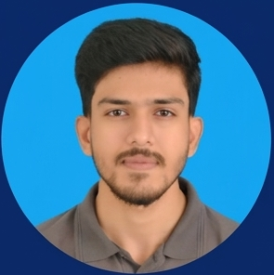  CORE SKILLS  • WordPress development and customization  • Elementor and Elementor Pro  • Template Kits and reusable layouts  • Figma to WordPress conversion  • Advanced Custom Fields  • Custom Post Types and dynamic content  • HTML and CSS  • JavaScript and jQuery  • Responsive web development  • WordPress speed optimization  • WooCommerce (basic)  • PHP (currently learning)  ADDITIONAL EXPOSURE  • Git version control  • Bootstrap  • Shopify (basic)  • Dart and Flutter  LANGUAGES  • Urdu  • English  AVAILABILITY  • Available for WordPress opportunities and freelance projects | SAIFULLAH  Junior WordPress Developer  Email: saifaptech30@gmail.com  Location: Karachi, Pakistan  Phone: +92 349 2843463  LinkedIn: linkedin.com/in/saif-khan-771705241  10+ months professional experience • 15+ projects delivered  PROFESSIONAL SUMMARY  Junior WordPress Developer with 10+ months of professional experience building responsive client websites from custom Figma designs. Strong with Elementor and Elementor Pro, template kits, Advanced Custom Fields, Custom Post Types, HTML and CSS, with working knowledge of JavaScript and jQuery. Also familiar with basic WooCommerce workflows and performance-focused customization, while currently strengthening PHP skills for deeper WordPress and plugin development.  EXPERIENCE  Junior WordPress Developer | Evolversoft · Karachi  Mar 2026 - Present  Build and customize client WordPress websites with Elementor and Elementor Pro, convert custom Figma designs into responsive layouts, work with Advanced Custom Fields and Custom Post Types, and handle front-end refinement, responsive fixes and performance-focused customization.  WordPress Intern | Evolversoft · Karachi  Nov 2025 - Feb 2026  Completed four months of hands-on WordPress training and client work using Elementor, template kits, Figma-to-WordPress implementation, responsive page building and day-to-day website customization.  EDUCATION  Bachelor of Science in Computer Science (BSCS) | Virtual University of Pakistan - Current, 2nd Semester  Three-Year Software Engineering Program | Aptech Metro Star Gate, Karachi  Completed two years of software engineering studies at Aptech followed by one year of Technical Board examinations.  Matriculation - Computer Science | Fazaia Degree College Faisal, Karachi  SELECTED WORDPRESS PROJECTS  • Vital Nora Live website ↗  • Velora Wellness Studio Live website ↗  • Drone Spraying Victoria Live website ↗  • Identity Center Live website ↗  • Deltatones Live website ↗  • Harvest Connect Live website ↗

