Supplementary methods and tables

Cognitive prognosis in Parkinson disease: Model benchmarking and independent validation
Mahvish Khan¹˒⁴, Saif Khan²˒⁴*, Mohtashim Lohani³˒⁴, Sundeep S. Bhagwath², Shadab Mirza²
Dr Saif Khan, Associate Professor, Department of Basic Dental and Medical Sciences, College of Dentistry, University of Ha’il, Saudi Arabia. Email: sf.khan@uoh.edu.sa
This resource integrates the complete PPMI benchmark with the separately locked LCC reduced-model experiment. It retains the original questions, search limits and outcome-exposure history. Numerical CSVs and the LCC implementation are in the accompanying supplementary files. Only aggregate results and model parameters are distributed; participant-level records remain controlled.

Supplementary methods

Analysis sequence and scope
The original Clinical_hallmark analysis selected five genes and 11 Hallmark pathways from earlier transcriptomic work and tested them beyond core and enhanced clinical comparators. Its 36-month enhanced-plus-combined-RNA comparison remained primary. Subsequent individual feature, pathway, expanded-panel and GA studies were exploratory extensions. This paper synthesizes the matched clinical benchmark and reports the original RNA comparison for provenance. It does not merge unmatched plasma, Olink or earlier motor-prognosis studies into the same performance ranking. The internal source cohort was repeatedly analyzed. Of the 307 participants at 36 months, 292 had contributed to the earlier 558-person RNA discovery analysis and 233 were eligible for an earlier plasma cognitive analysis.

Eligibility and calendar rules
The source flow was 410 exact baseline RNA specimens, 387 with baseline timing/diagnosis/MoCA readiness, 354 after excluding 33 SWEDD participants, and 351 after requiring enhanced cognitive scores and forms. RNA phases contributed 250 and 101 participants. Among 351, unavailable timed MoCA records numbered 14, 28 and 42; selected-score quality holds numbered 4, 2 and 2; retained outcomes numbered 333, 321 and 307. The three windows were 9–15, 21–27 and 33–39 months. Selection preceded quality filtering and did not substitute a more favorable record. A 280-person common-outcome subset existed. Baseline sex was corroborated across baseline RNA, unified baseline and native screening information; this did not imply a later TRANS demographic visit occurred before index. Five missing diagnosis durations were retained for training-only imputation.

Missingness and preprocessing
Each numerical feature received its training median, then training mean and population-SD scaling. All-missing training columns were set to zero, and near-zero SD was replaced by one. A fixed missing indicator was retained for every numerical column. Categorical variables used complete fixed dictionaries, including unknown values. Test-form controls followed the selected parent cognitive test. No outcome imputation, future test forms, future medication values or withdrawal flags entered the predictors. The enhanced scores were complete by cohort construction. Medication status and examination state had no source variation. Optional predictor missingness was handled by the locked preprocessing; availability itself should not be interpreted as a biological effect.

Splits and penalties
One identity-component master allocation was inherited across horizons: five outer folds and three inner folds. Neither outcomes nor later follow-up availability determined that allocation. All learned preprocessing and selection were refitted within each inner training partition and the corresponding outer training partition. Ridge penalties were 0.001, 0.01, 0.1, 1 and 10; the intercept was not penalized. Ties within 10⁻¹² favored the larger penalty. The earlier clinical comparators used pooled inner MAE; later fixed panels and R²-oriented searches used pooled inner MSE. MSE normalization by the fixed outcome variance does not change candidate ranking. Calibration slope and intercept were descriptive regressions of observed outcomes on predictions, not target recalibration.

Search design and termination
The final v4 NSGA-II searches used population and offspring sizes of 1,024, a 10,000-generation ceiling, and crossover probability 0.9 and independent mutation probability 1/d per optional bit. Initial candidates included null, full, singleton, leave-one-out and reference panels, with remaining initialization random. Each of 30 arm/horizon/fold contexts had 20 main and five confirmation restarts. Each restart could visit at most 200,000 distinct masks. Stopping required at least 400 generations and 50,000 distinct masks, two consecutive 200-transition plateaus with progress below 10⁻⁵, and selected-mask stability. All 25 restarts had to satisfy stagnation checks. Main and confirmation objective envelopes had to match the combined envelope at each attainable burden within 10⁻⁴ normalized MSE; at least three of five confirmation restarts had to approach the combined best within that tolerance. Matched random search could not outperform the GA envelope beyond the locked tolerance. Hard limits alone were not accepted as convergence. These conditions support empirical stabilization, not exhaustive coverage.

Search verification and audit limitation
Frozen verification checked 24,596,833 stored cache records and 368,952,555 recorded ridge solves across search and controls, 750 restart summaries and 60 outer models. These counts include repeated evaluations of the same modest participant sample and do not enlarge the independent sample size. Final predictions and metrics were independently reconstructed without model retraining. Completed restarts had discarded full per-generation trajectories. The audit checked recorded stopping summaries, minimum coverage and generation bounds, and main/confirmation/random envelopes, but could not replay every historical plateau. The original audit status was PASS_WITH_DOCUMENTED_AUDIT_LIMITATION. The integrated comparison independently verified 54 metric rows, 459 contrasts and 270 feature sets.

Earlier GA recipes
Earlier core-mandatory MAE and MSE searches used an accuracy anchor plus a one-standard-error allowance calculated from three inner-fold errors. Among eligible visited candidates they favored smaller acquisition burden. The later MoCA-mandatory optional-feature search and final v4 searches instead prioritized best pooled MSE, without that allowance. Their rows therefore compare complete model-selection recipes, not only mandatory-feature constraints. The unrestricted null mask meant intercept-only; the MoCA-mandatory null optional mask meant MoCA-only. Performance assigned to a recipe cannot be assigned retrospectively to a consensus feature subset.

Temporal evaluation
The temporal candidate frame contained 570 participants; 227 unique participants were eligible at one or more horizons, and 33 had outcomes at all three. There were 222, 182 and 43 calendar-selected outcomes; score checks retained 221, 182 and 43; withdrawal holds and comparator availability led to final counts of 213, 175 and 39. Index years were 2023–2025. Non-MoCA sources were frozen on 20 October 2026 and MoCA was refreshed on 28 October before any temporal scoring. The amended audit added seven valid pairs and two participants without changing earlier bound outcomes. Historical diagnosis-date fallback and age rules were frozen before scoring. No overlaps with source clinical training/test identities were found; 224 of 227 had earlier motor-model exposure. The clinical models were equal-weight ensembles of five earlier MAE-tuned outer models. Typical change used the average of the five stored source-fold median offsets. No temporal data were used for fitting or recalibration. The 28 October MoCA amendment preceded temporal scoring; it did not create an external cohort or remove prior motor-analysis exposure.

Temporal sensitivity interpretation
Complete-core samples were 204, 171 and 38; age-resolution exclusions left 207, 171 and 39. Other frozen sensitivities used stricter provenance or the common 33-person follow-up subset. The age-excluded 36-month result is an explicit alias of the main 36-month result, not a new independent analysis. Median elapsed follow-up was 13, 25 and 36 months, and median MoCA change was zero at each horizon. Absence of a timed outcome does not by itself establish dropout, death or a complete opportunity for follow-up. The full sensitivity metrics and intervals are in Table S6. The 24-month age-resolution exclusion gave enhanced-minus-core MAE −0.141 (95% interval −0.273 to −0.005; n=171). Its enhanced-minus-persistence interval crossed zero. This prespecified exploratory sensitivity does not supersede the uncertain main 24-month contrast.

Preserved RNA methods
Raw counts were transformed within sample as log₂(1 + 10⁶ × count / total count across all 58,780 genes). The fixed genes were LINC01806, CISD2, CDK6, CPT1A and NPIPB8. A training gene required at least 10 counts in at least max(3, ceiling[0.20 × training n]) samples and nonconstant log expression. Training-standardized eligible member expression was averaged for each fixed Hallmark set, then the pathway score was standardized using training information. At least five eligible members were required. Failed features remained fixed zero columns without replacement. A block-penalized ridge used the clinical penalty grid above and RNA penalties 0.01, 0.1, 1 and 10. Each augmented arm also offered all five clinical-only candidates as genuine RNA-off options. Selection used pooled inner MAE; ties preferred RNA-off, then larger RNA and clinical penalties. This allowed an augmented arm to return the clinical prediction exactly. Zero-width intervals in RNA-off results are not biological equivalence.

Uncertainty and interpretation
The internal comparison supplied every pair among 18 recipes at each horizon, giving 459 contrasts. Bootstrap resampling was paired by participant identity with 5,000 replicates. Contrast direction in CSV is model a minus model b; lower MAE and higher R² are preferable. These are conditional intervals from frozen predictions, without multiplicity adjustment or a full rerun of fitting and selection. No noninferiority or equivalence margin was prespecified. The main paper does not claim that maximum observed R² estimates performance on untouched data. Manuscript preparation used frozen aggregate evidence plus descriptive summaries of locked predictor matrices. No models were retrained and no participant was rescored. Only one master fold partition was used; no repeated-outer-cross-validation uncertainty is represented. The conditional intervals also omit the broader adaptive sequence of study choices.

Table S1 Cohort flow and follow-up availability
Stage | Source | Temporal
Initial audited frame | 410 RNA participants | 570 later candidates
Baseline eligible frame | 351 | 227 eligible at ≥1 horizon
12-month outcome | 333 | 213
24-month outcome | 321 | 175
36-month outcome | 307 | 39
All three outcomes | 280 | 33
Index years | 2010–2016 | 2023–2025

Table S2 Predictor definitions
Substantive predictor | Panel membership | Acquisition group
Age | Core | demographic history
Sex | Core | demographic history
Education | Core | demographic history
Baseline MoCA | Core; compact 4 | MoCA
Diagnosis duration | Core | PD history
MDS-UPDRS II | Core | MDS UPDRS II
MDS-UPDRS III | Core | MDS UPDRS III
GDS-15 | Core | GDS15
Medication status | Core | medication history
Motor examination state | Core | MDS UPDRS III
SDMT | Optional 18; compact 4 | SDMT
HVLT immediate recall | Optional 18; compact 4 | HVLT
HVLT delayed recall | Optional 18; compact 4 | HVLT
Animal fluency | Optional 18 | Animal fluency
Letter-number sequencing | Optional 18 | LNS
Judgment of line orientation | Optional 18 | JLO
HVLT recognition discrimination | Optional 18 | HVLT
REM sleep behaviour symptoms | Optional 18 | RBDSQ
Autonomic gastrointestinal | Optional 18 | SCOPA AUT
Autonomic urinary | Optional 18 | SCOPA AUT
Autonomic cardiovascular | Optional 18 | SCOPA AUT
Postural systolic BP drop | Optional 18 | postural BP
Postural diastolic BP drop | Optional 18 | postural BP
Trait anxiety | Optional 18 | STAI
Apathy | Optional 18 | MDS UPDRS I
Subjective cognitive complaint | Optional 18 | MDS UPDRS I
APOE ε4 dosage | Optional 18 | APOE assay
Neutrophil-to-lymphocyte ratio | Optional 18 | CBC differential
APOE ε4 dosage is the allele count. NLR is the neutrophil-to-lymphocyte ratio from the historical CBC. Autonomic domains are gastrointestinal, urinary and cardiovascular components; blood-pressure drops compare postural measurements. Apathy and subjective cognitive complaint are baseline MDS-UPDRS I items. These are the frozen feature bindings, not newly selected thresholds. Core and enhanced scores are baseline variables; future values are outcomes or audit information only. Full encoded columns include the attached form controls and missing indicators.

Table S3 Complete internal model metrics
The accompanying Table_S3_All_54_Internal_Metrics.csv contains all 18 recipes at all three horizons, including R², MSE, RMSE, MAE, mean prediction error, calibration slope/intercept and out-of-range prediction fraction. Fig. S1 displays their R² estimates. Table 2 gives the main reference models. The additional rows include optional-18-only, earlier GA recipes and matched final random-search controls.

Table S4 All paired internal contrasts
Table_S4_All_459_Paired_Contrasts.csv supplies every comparison with its horizon, participant count, difference, conditional interval, bootstrap count and seed. The difference is a minus b. Figures and text use explicitly oriented contrasts; reversing a contrast negates its estimate and reverses/negates its interval endpoints.

Table S5 Selection frequencies
Table_S5_Feature_Selection_Frequencies.csv records selection counts by model, feature and horizon. Table_S5b_All_270_Feature_Sets.csv lists the exact fold-specific sets and acquisition groups. Fig. S2 displays the unrestricted final GA. Counts measure inclusion among five outer models and are not causal effects, coefficient magnitudes or evidence that a feature would be selected in another cohort.

Table S6 Temporal evaluation and sensitivities
Evaluation | n | ΔMAE | 95% conditional interval
main 12 | 213 | -0.069 | -0.195 to 0.058
complete core 12 | 204 | -0.053 | -0.184 to 0.078
strict inputs 12 | 213 | -0.089 | -0.219 to 0.039
exclude age resolved 12 | 207 | -0.069 | -0.196 to 0.057
common horizons 12 | 33 | -0.082 | -0.401 to 0.232
main 24 | 175 | -0.128 | -0.262 to 0.004
complete core 24 | 171 | -0.118 | -0.245 to 0.008
strict inputs 24 | 175 | -0.127 | -0.254 to 0.002
exclude age resolved 24 | 171 | -0.141 | -0.273 to -0.005
common horizons 24 | 33 | -0.106 | -0.460 to 0.237
main 36 | 39 | -0.012 | -0.334 to 0.304
complete core 36 | 38 | 0.045 | -0.254 to 0.348
strict inputs 36 | 39 | -0.045 | -0.335 to 0.259
exclude age resolved 36 | 39 | -0.012 | -0.334 to 0.304
common horizons 36 | 33 | 0.004 | -0.339 to 0.339
Differences are enhanced minus core. The full model-specific metrics, calibration summaries and conditional intervals are in Table_S6_Temporal_Metrics_All_Sensitivities.csv. The age-excluded 36-month row reuses the main result by design.

Table S7 Original RNA contrasts
The 11 fixed Hallmark sets were apical junction, apoptosis, coagulation, complement, heme metabolism, hypoxia, IL6–JAK–STAT3 signaling, inflammatory response, interferon alpha response, interferon gamma response and PI3K–AKT–mTOR signaling. Full frozen membership and gene-version bindings remain in the original analysis contract; no pathways were selected using cognitive outcomes.
Horizon and comparator | RNA block | ΔMAE | 95% conditional interval | Off folds
12 core | Genes5 | 0.0168 | -0.0127 to 0.0480 | 1
12 core | Hallmark11 | -0.0027 | -0.0178 to 0.0121 | 1
12 core | Combined | 0.0059 | -0.0222 to 0.0329 | 1
12 enhanced | Genes5 | 0.0076 | -0.0266 to 0.0424 | 0
12 enhanced | Hallmark11 | 0.0005 | -0.0066 to 0.0074 | 2
12 enhanced | Combined | 0.0055 | -0.0146 to 0.0264 | 0
24 core | Genes5 | 0.0065 | -0.0033 to 0.0166 | 3
24 core | Hallmark11 | 0.0144 | -0.0223 to 0.0533 | 2
24 core | Combined | 0.0345 | -0.0114 to 0.0824 | 2
24 enhanced | Genes5 | 0.0026 | -0.0088 to 0.0140 | 3
24 enhanced | Hallmark11 | 0.0108 | -0.0137 to 0.0376 | 2
24 enhanced | Combined | 0.0125 | -0.0176 to 0.0429 | 2
36 core | Genes5 | 0.0000 | 0.0000 to 0.0000 | 5
36 core | Hallmark11 | 0.0059 | -0.0076 to 0.0192 | 4
36 core | Combined | 0.0071 | -0.0080 to 0.0227 | 4
36 enhanced | Genes5 | 0.0000 | 0.0000 to 0.0000 | 5
36 enhanced | Hallmark11 | 0.0077 | -0.0019 to 0.0168 | 4
36 enhanced | Combined | 0.0028 | -0.0012 to 0.0067 | 4
Differences are augmented minus clinical-only MAE. Combined RNA with the enhanced comparator at 36 months was the original primary comparison. Off folds counts selections of the clinical-only option among five outer folds. The original seed-specific intervals are retained; they need not equal intervals recomputed under a later unified comparison seed. Full precision is retained in Table_S7_Original_RNA_Contrasts.csv.

Reporting map and author declarations

Data and participants
Main Methods and Tables 1 and 3; Tables S1 and S13. The internal PPMI, later PPMI and independent LCC populations have distinct eligibility and timing rules. PPMI development records have prior analysis exposure; LCC outcomes were audited for eligibility before predictive evaluation.

Outcome and predictors
Main Methods and Supplementary Table S2. Outcome is continuous future MoCA; predictor selection is entirely baseline-bound.

Model development and evaluation
Main Methods and supplementary search, preprocessing and temporal sections. Fixed penalties, grouped folds, inner-only selection and separate temporal ensembles are described.

Results and uncertainty
Main Tables 1–5 and Figs. 1–4; complete CSV Tables S3–S14. Internal and temporal intervals are conditional and unadjusted. External paired intervals additionally use Bonferroni-adjusted 98.33% levels for the three prespecified GDS15 contrasts.

Implementation and availability
Controlled participant-level records are available only through approved source access. Earlier PPMI code and aggregate supplements are in the cited public repository. The LCC implementation, aggregate results and reduced-model equations accompany this version; no source records or individual prediction files are distributed.

Author declarations
Author names, affiliations, contributions, funding and competing interests are provided in the main manuscript. The manuscript acknowledges PPMI, LCC/MJFF and AMP-PD. AI assistance in code, verification, plotting and drafting is disclosed; authors are accountable for interpretation and final approval.

Additional reporting and interpretation details

Table S8 Distinct analysis questions and original primary contrasts
Analysis stage | Designated question | Result and interpretation
Original RNA study | 36-month enhanced + five genes/11 Hallmarks minus enhanced MAE | +0.002754 (−0.001184, 0.006681). No demonstrated benefit for this tested representation.
Final v4 GA study | 36-month unrestricted GA minus MoCA-mandatory GA R² | 0.000; conditional interval zero within floating-point precision. No observed gain from relaxing mandatory MoCA.
Temporal clinical evaluation | 12-month enhanced minus core MAE | −0.069 (−0.195, 0.058). Earlier clinical ensembles only; no compact-panel or final-GA temporal evaluation.
Current clinical emphasis | Matched core, enhanced, compact and expanded comparisons at all three horizons | Exploratory integration after prior source-outcome use. No new primary hypothesis or confirmatory validation is assigned.
Independent LCC reduced-model validation | Paired MAE with minus without GDS15 at nominal 12/24/36 months | −0.054/+0.081/+0.036; all 95% and adjusted 98.33% intervals include zero. Scope: separately trained reduced clinical models.
Separate contracts defined these questions before their own runs. This does not imply that the broader research program or current reporting emphasis was prospectively specified. Numerical near-zero GA intervals reflect identical evaluated predictions; they are not a population equivalence test. The GA contrast shown uses the unified comparison records; the original GA bootstrap seed differs, but the zero result is unchanged.

Table S9 Descriptive internal calibration
Panel | Months | Slope | Intercept | Mean error
Four cognitive scores | 12 | 1.028 | -0.736 | 0.007
Four cognitive scores | 24 | 1.032 | -0.836 | -0.003
Four cognitive scores | 36 | 1.033 | -0.873 | -0.011
Expanded 28 predictors | 12 | 1.250 | -6.588 | 0.005
Expanded 28 predictors | 24 | 1.251 | -6.588 | -0.011
Expanded 28 predictors | 36 | 1.233 | -6.150 | -0.004
Calibration regresses observed scores on fixed out-of-fold predictions; ideal slope/intercept are one/zero. Mean error is predicted minus observed. Values are descriptive, with no calibration uncertainty intervals or target recalibration. They cannot establish comparative calibration superiority. Full unrounded results remain in Table S3.

Table S10 Tuning criterion and paired enhanced-minus-core error
Inner tuning | Months | MAE difference | 95% conditional interval
MSE | 12 | -0.094 | -0.179 to -0.013
MSE | 24 | -0.116 | -0.220 to -0.015
MSE | 36 | -0.144 | -0.230 to -0.057
MAE | 12 | -0.114 | -0.199 to -0.033
MAE | 24 | -0.086 | -0.184 to 0.013
MAE | 36 | -0.176 | -0.271 to -0.078
Negative values favor enhanced assessment. Both loss functions select a ridge penalty on the same inner validation participants, but need not choose the same prediction rule. These intervals use the unified comparison seed, retain all horizons and are unadjusted. The MAE-tuned 24-month interval crosses zero. Fig. 2 shows the MSE-tuned comparison; it is not evidence of tuning-independent benefit.

Target, generalization and clinical utility
The target is future observed MoCA in this eligibility-defined frame. It is not a causal treatment effect, a competing-risk cognitive outcome or a dementia diagnosis. No formal clinical utility threshold, noninferiority margin, cost study or decision intervention was evaluated. Source eligibility depended on RNA and enhanced-test availability even for clinical-only comparisons. Site transportability and performance of the four-score or final GA candidates in a new population remain untested. No additional participant scoring was performed for this revision.

Additional internal quality and verification details
Clinical predictors were selected from screening or baseline assessments in the three calendar months preceding the baseline RNA month-end index. Ties for follow-up proximity favored the earlier assessment and then fixed source ordering. Monthly dates cannot determine within-month ordering. Death and withdrawal records were used for eligibility checks, not predictors or surrogate outcomes.
PPMI MoCA scores required 26 item fields. Reported totals had to agree with either the unadjusted sum or the education-corrected score; one point was added for pre-index education of 12 years or less when the unadjusted score was below 30. Unresolved fluency score/word-count discrepancies remained quality holds. Neither missing outcomes nor failed selected scores were replaced.
Independent numerical reconstruction reproduced 54 internal metric rows, 459 paired contrasts and 270 feature sets, with maximum metric discrepancy below 2.5 × 10⁻¹⁴. The final GA audit verified 30 search contexts, 750 restart summaries, 60 outer models and stored objective envelopes. Audit coverage includes the retained stopping summaries and convergence envelopes; full per-generation histories were not retained for completed restarts, limiting retrospective replay of every plateau decision.

Patient and public involvement
Patients and members of the public were not directly involved in the design, conduct, interpretation or reporting of this secondary analysis.

Independent LCC validation methods
The independent-cohort experiment used the LCC Ashkenazi Jewish New York longitudinal export dated 26 June 2017, obtained on 4 November 2026, with AMP-PD release 2023_v4release_1027 clinical and identity records. Its design was locked before model fitting and evaluation. The two horizon-specific ridge recipes used baseline MoCA, completed age and sex, with or without GDS15. These were newly specified reduced models, not subsets formed by deleting coefficients from the full PPMI models. They were trained exclusively in a separately defined PPMI sample without RNA or detailed cognitive-test eligibility requirements.
To avoid an ambiguous second MoCA education correction, source development required documented education of 13–40 years and LCC required native higher-education categories 3 or 6 without contradictory lower categories. Education determined eligibility, not a numerical predictor. PPMI MoCA items were range-checked and reconciled with totals and fluency fields; LCC supplied integer totals in the range 0–30 were retained only when native and harmonized records agreed. LCC item-level verification was unavailable. Baseline GDS15 required all 15 binary items and agreement with the standard reverse-scored sum. LCC baseline MoCA and GDS15 came from native V01 with the same recorded whole-year age; this does not prove same-day acquisition.
Released participant mappings, nonempty shared global identifiers, whole-genome-sequence duplicate links, provider aliases and existing identity components screened for known PPMI overlap. Among 114 native LCC participants with baseline Parkinson disease and longitudinal MoCA, six known PPMI links and 24 unmapped participants were excluded. The remaining 84 had released genomic inventory coverage without a listed identity-related flag. Timing, education, baseline consistency and complete-feature rules yielded matched samples of 16, 28 and 34, representing 46 distinct people. Unknown cross-enrollment or family relatedness cannot be excluded. LCC outcomes had been inspected for eligibility and score concordance before the lock, but did not inform predictive tuning.
PPMI baseline was anchored to the native baseline GDS assessment month; MoCA was the latest screening/baseline assessment no later than that index within three months. Outcomes used the nearest recorded-month assessment within ±3 months of each target, selected before quality checks. LCC required unique AMP M0 and nominal M12, M24 or M36 records with the previously locked sequence checks. Actual LCC visit dates were unavailable, so nominal follow-up is not equivalent to the PPMI calendar windows. Records were not re-anchored to a later nominal baseline, outcomes were not imputed, and no alternate favorable record was substituted.
Development samples were 301, 292 and 281 PPMI participants. Five fixed identity-grouped source folds selected penalties from 0.001, 0.01, 0.1, 1, 10 and 100 by pooled validation MSE, with ties favoring stronger regularization. Means and population standard deviations were learned in each source training partition; there was no imputation. The ridge objective was mean squared error plus λ times the squared coefficient norm, with an unpenalized intercept. The 180 tuning fits and six full-source fits were completed and independently verified before LCC scoring. Source coefficients and preprocessing were then frozen; there was no LCC-driven recalibration, clipping, fitting or feature selection. Unchanged baseline MoCA and baseline plus the PPMI mean change were prespecified descriptive benchmarks. This mean-change rule differs from the earlier internal and temporal median-change benchmark.

Outcome quality and source harmonization
LCC education categories 3/6 represent more than 12 years; category 2 spans 9–13 years and remained ambiguous. Supplied MoCA totals were retained without another education increment. In LCC, item-level MoCA reconstruction was unavailable. Five GDS15 items were reverse-scored: GDSSATIS, GDSGSPIR, GDSHAPPY, GDSALIVE and GDSENRGY. The other ten affirmative items were summed in their standard direction. A valid baseline required 15 binary responses, exact supplied-total agreement and the same recorded MoCA/GDS assessment age.
Source ages were floored to completed years in the range 18–89 and checked against harmonized screening age within one year. Sex was harmonized as female=0 and male=1; native PPMI and LCC coding differed and was corroborated. Known PPMI components linked to any mapped LCC component were excluded from development. WGS inventory and released duplicate/QC information were identity-screening evidence, not new genomic sequencing or kinship analysis. Family identifiers were unavailable.

External uncertainty and verification
For LCC, the primary family was paired MAE with GDS15 minus MAE without GDS15 at all three horizons; negative values favor GDS15. Twenty thousand paired bootstrap resamples of known identity components per horizon produced pointwise 95% intervals and Bonferroni-adjusted 98.33% intervals for this family. Secondary metrics were MAE, RMSE, R² relative to the LCC horizon mean, prediction-minus-observed bias and predictions outside 0–30. Negative R² was retained; invalid zero-variance resamples were excluded only for that metric, and a confidence interval required at least 95% valid replicates. Intervals condition on fixed source models and retained target records; they omit source-refitting uncertainty, unknown family dependence, uncertain dates and selection. Benchmark rankings are descriptive and were not added to the confirmatory contrast family.
A separate implementation passed 703 external-evaluation checks. It reconstructed all 312 model and benchmark prediction values from sealed coefficients and source bindings and independently reproduced metrics, contrasts, bootstrap distributions and confidence limits without importing production numerical prediction or metric functions. Maximum absolute discrepancies were 3.6 × 10⁻¹⁵ for predictions and 1.4 × 10⁻¹⁴ across bootstrap statistics. A guard prevented fitting during evaluation; six fixed-model calls generated 156 learned predictions, supplemented by 156 benchmark values. Independent source-model verification had previously passed 2,140 checks. Computational verification demonstrates numerical reproducibility rather than clinical validity.
Bootstrap generators used NumPy PCG64 with seed 20261105 + horizon in months, with linear-interpolated percentile quantiles. All known components in the retained LCC horizon samples contained one selected participant. The first execution attempt stopped during a checksum read before loading LCC rows or generating predictions. Only the new access-guard wrapper was corrected; the sealed protocol, numerical launcher and six models were unchanged. One completed external evaluation was then independently reconstructed. This implementation detail did not trigger a second model choice or an outcome-dependent cohort amendment.

Table S11 External metric estimates and uncertainty
Table_S11_LCC_Metrics.csv supplies all 60 model/benchmark metric entries across three nominal horizons, including point estimates, pointwise 95% intervals and valid bootstrap denominators. Table 4 in the main manuscript shows the corresponding point estimates. Differences between horizon-specific samples prevent interpreting these scores as a within-person performance trajectory.

Table S12 Primary GDS15 contrasts
Nominal months | n | ΔMAE | 95% interval | Adjusted 98.33%
12 | 16 | -0.054 | -0.267 to +0.165 | -0.317 to +0.217
24 | 28 | +0.081 | -0.111 to +0.292 | -0.150 to +0.343
36 | 34 | +0.036 | -0.099 to +0.171 | -0.130 to +0.203
The primary family contains all three paired contrasts. No subgroup, alternate education scenario, target recalibration, clipping analysis or complete-all-horizons model was added after external scoring. Benchmark comparisons remained descriptive.

Table S13 Reduced-model cohort characteristics
Table_S13_Reduced_Cohort_Characteristics.csv gives baseline means, sample standard deviations and sex counts for the exact six source/target horizon samples. These descriptive aggregates were prepared for this manuscript from the locked feature matrices, without re-running prediction, fitting or eligibility selection. Main Table 3 displays these values.

Table S14 Frozen reduced-model equations
Predicted MoCA = intercept + bMoCA × baseline MoCA + bage × completed age + bsex × male indicator + bGDS × GDS15. Use male=1 and female=0. For Reduced3 the GDS15 term is absent. The table reports original-unit coefficients derived algebraically from the sealed standardized coefficients and source means/scales. No refitting or target-data transformation was performed. Full-precision values, selected penalties and source mean-change offsets are in Table_S14_Frozen_Reduced_Model_Equations.csv. Displayed values below are rounded for readability.
Months | Recipe | Intercept | MoCA | Age | Male | GDS15
12 | reduced3 | 18.614602 | 0.504797 | -0.088279 | -0.836328 | Not included
12 | reduced4 | 19.346159 | 0.497533 | -0.092306 | -0.834234 | -0.127095
24 | reduced3 | 12.862338 | 0.668438 | -0.072309 | -0.321625 | Not included
24 | reduced4 | 13.752662 | 0.655124 | -0.075425 | -0.324479 | -0.146316
36 | reduced3 | 17.045047 | 0.544680 | -0.079350 | -0.771471 | Not included
36 | reduced4 | 18.601035 | 0.495626 | -0.077453 | -0.749018 | -0.153894
Selected λ was 0.01 for both 12- and 24-month models and the 36-month Reduced3 model, and 0.1 for 36-month Reduced4. For a sum-of-squares ridge library, alpha = ntraining × λ. The PPMI-only mean-change offsets were −0.704319, −0.739726 and −0.658363 at 12, 24 and 36 months. These offsets define the external typical-change benchmark; they must not be substituted for the earlier median-change benchmark.

Data versions and source acknowledgement
Native PPMI clinical and RNA data were obtained on 20 October 2026; temporal MoCA was refreshed on 28 October 2026. The independent validation used LRRK2C20170626_AJ_Long_NY_sites.csv from the MJFF LCC portal, obtained on 4 November 2026, together with AMP-PD release 2023_v4release_1027 clinical and identity/QC records in the local October 2026 archive. The LCC database clarification document was updated August 2020. Resource names identify provenance; they do not imply that all AMP-PD or LCC modalities were model inputs.
The main manuscript supplies PPMI, MJFF/LCC and AMP-PD acknowledgements. LCC study methods are described by Saunders-Pullman et al (2018), https://doi.org/10.1001/jamaneurol.2017.4019. AMP-PD clinical harmonization documentation: https://amp-pdrd.org/harmonized-clinical-assessments. LCC case-report forms: https://www.michaeljfox.org/sites/default/files/media/document/LRRK2C%20All%20in%20One%20-%20updated.pdf. Accessed 7 November 2026.

Original PPMI baseline characteristics
Characteristic | 12 months  Source  n=333 | 12 months  Temporal  n=213 | 24 months  Source  n=321 | 24 months  Temporal  n=175 | 36 months  Source  n=307 | 36 months  Temporal  n=39
Age, years | 61.5 (9.8) | 64.2 (9.8) | 61.6 (9.9) | 64.1 (10.2) | 61.6 (9.8) | 64.6 (7.7)
Male sex, n (%) | 214 (64.3) | 126 (59.2) | 208 (64.8) | 110 (62.9) | 202 (65.8) | 25 (64.1)
Education, years | 15.6 (2.8) | 16.4 (2.8) | 15.7 (2.8) | 16.4 (2.7) | 15.7 (2.8) | 16.7 (2.3)
Baseline MoCA | 27.1 (2.4) | 27.0 (2.4) | 27.1 (2.4) | 27.1 (2.6) | 27.2 (2.3) | 28.0 (1.7)
Diagnosis duration, years | 0.5 (0.5) [m=5] | 1.0 (1.5) | 0.5 (0.5) [m=5] | 0.8 (0.8) | 0.5 (0.5) [m=5] | 0.9 (1.3)
MDS-UPDRS II | 6.1 (4.3) | 7.2 (5.1) | 5.9 (4.1) | 7.0 (4.9) | 5.8 (4.1) | 7.5 (5.5)
MDS-UPDRS III | 21.2 (8.9) | 22.8 (9.9) [m=9] | 20.7 (8.8) | 22.7 (10.0) [m=4] | 20.6 (9.0) | 21.1 (8.9) [m=1]
GDS-15 | 2.4 (2.5) | 2.2 (2.4) | 2.4 (2.5) | 2.2 (2.4) | 2.4 (2.5) | 1.7 (2.0)
SDMT | 41.3 (9.7) | 42.9 (10.1) | 41.3 (9.7) | 42.7 (9.8) | 41.5 (9.7) | 45.3 (9.3)
HVLT immediate recall | 24.7 (4.7) | 24.3 (5.0) | 24.6 (5.0) | 24.1 (5.3) | 24.7 (4.9) | 25.0 (4.3)
HVLT delayed recall | 8.5 (2.5) | 8.2 (3.0) | 8.4 (2.6) | 8.1 (3.0) | 8.5 (2.6) | 8.5 (2.8)
On PD medication, n (%) | 0 (0.0) | 21 (10.0) [m=2] | 0 (0.0) | 6 (3.4) | 0 (0.0) | 2 (5.1)
Values are mean (SD), except sex and medication status. m denotes missing values. Source refers to the original internal benchmarking cohort; these are not the separately defined reduced-model source samples in main Table 3.
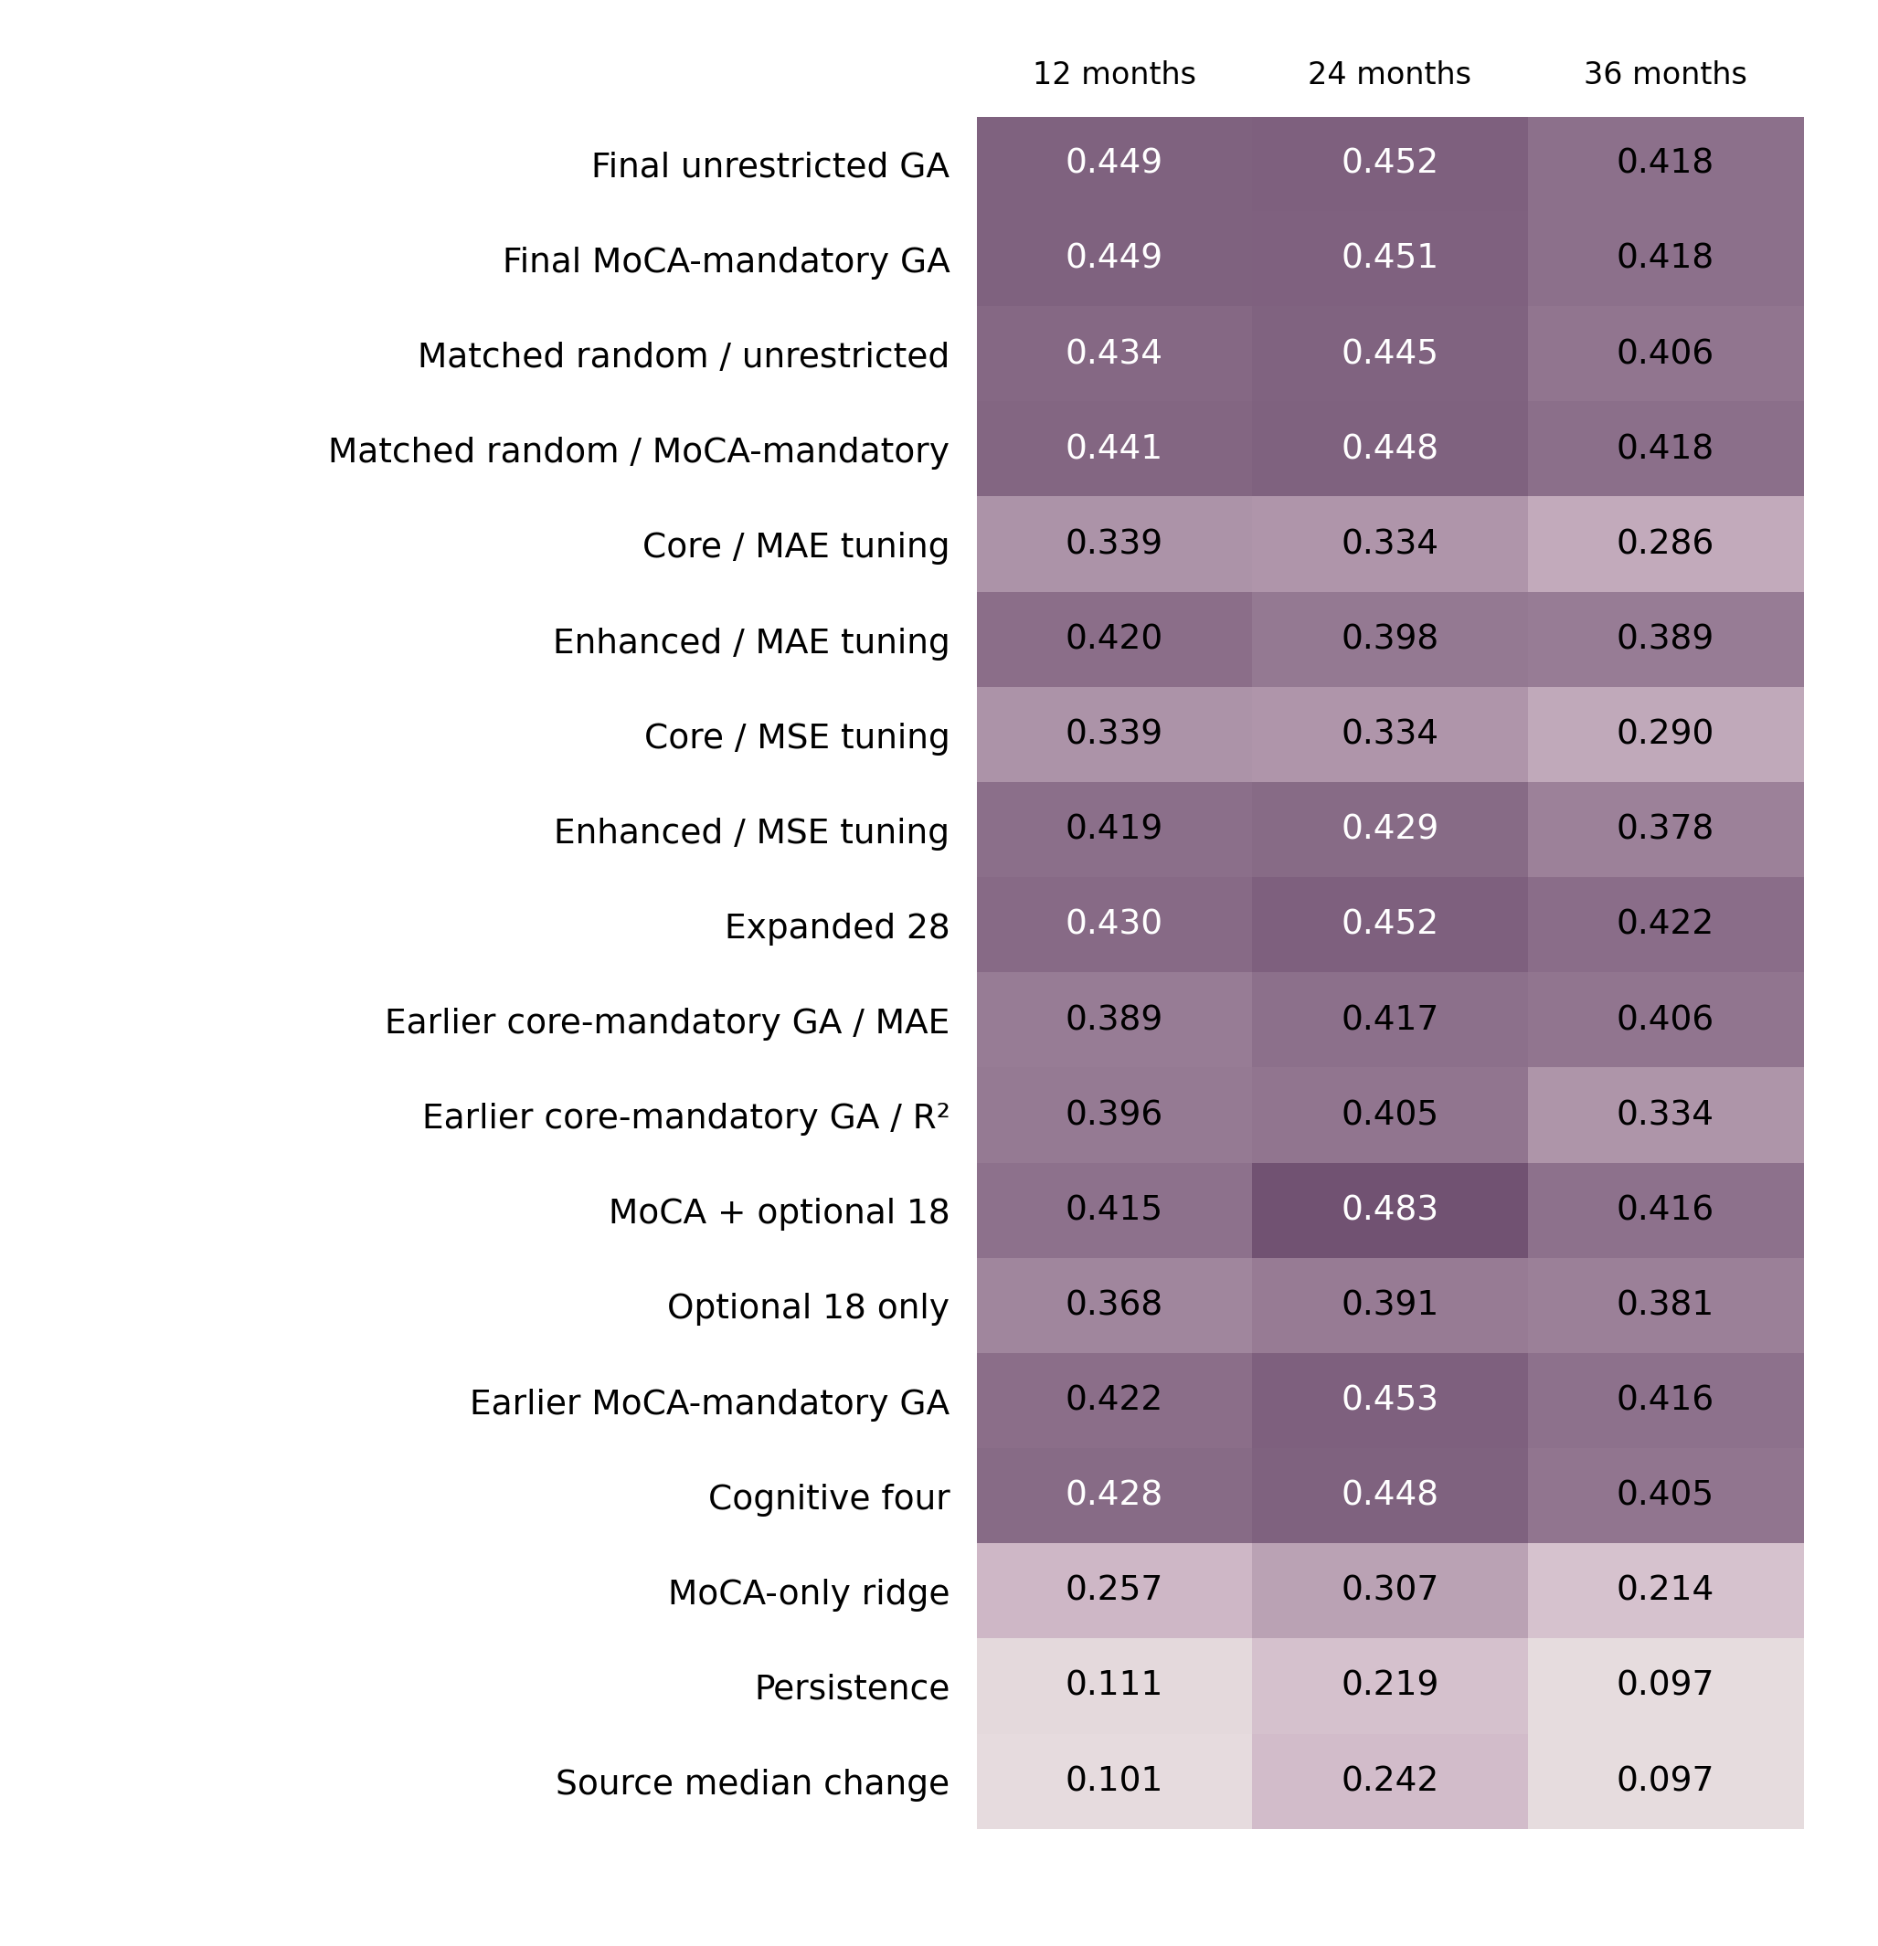
Fig. S1 Complete internal benchmark of 18 recipes across three horizons. Samples and folds are matched within each horizon (n=333, 321 and 307). Each cell reports a verified R² estimate. Fixed panels, GA recipes and matched random-search controls retain their specified tuning and selection rules. These comparisons evaluate complete prediction procedures; detailed metrics and paired uncertainty intervals appear in Tables S3–S4

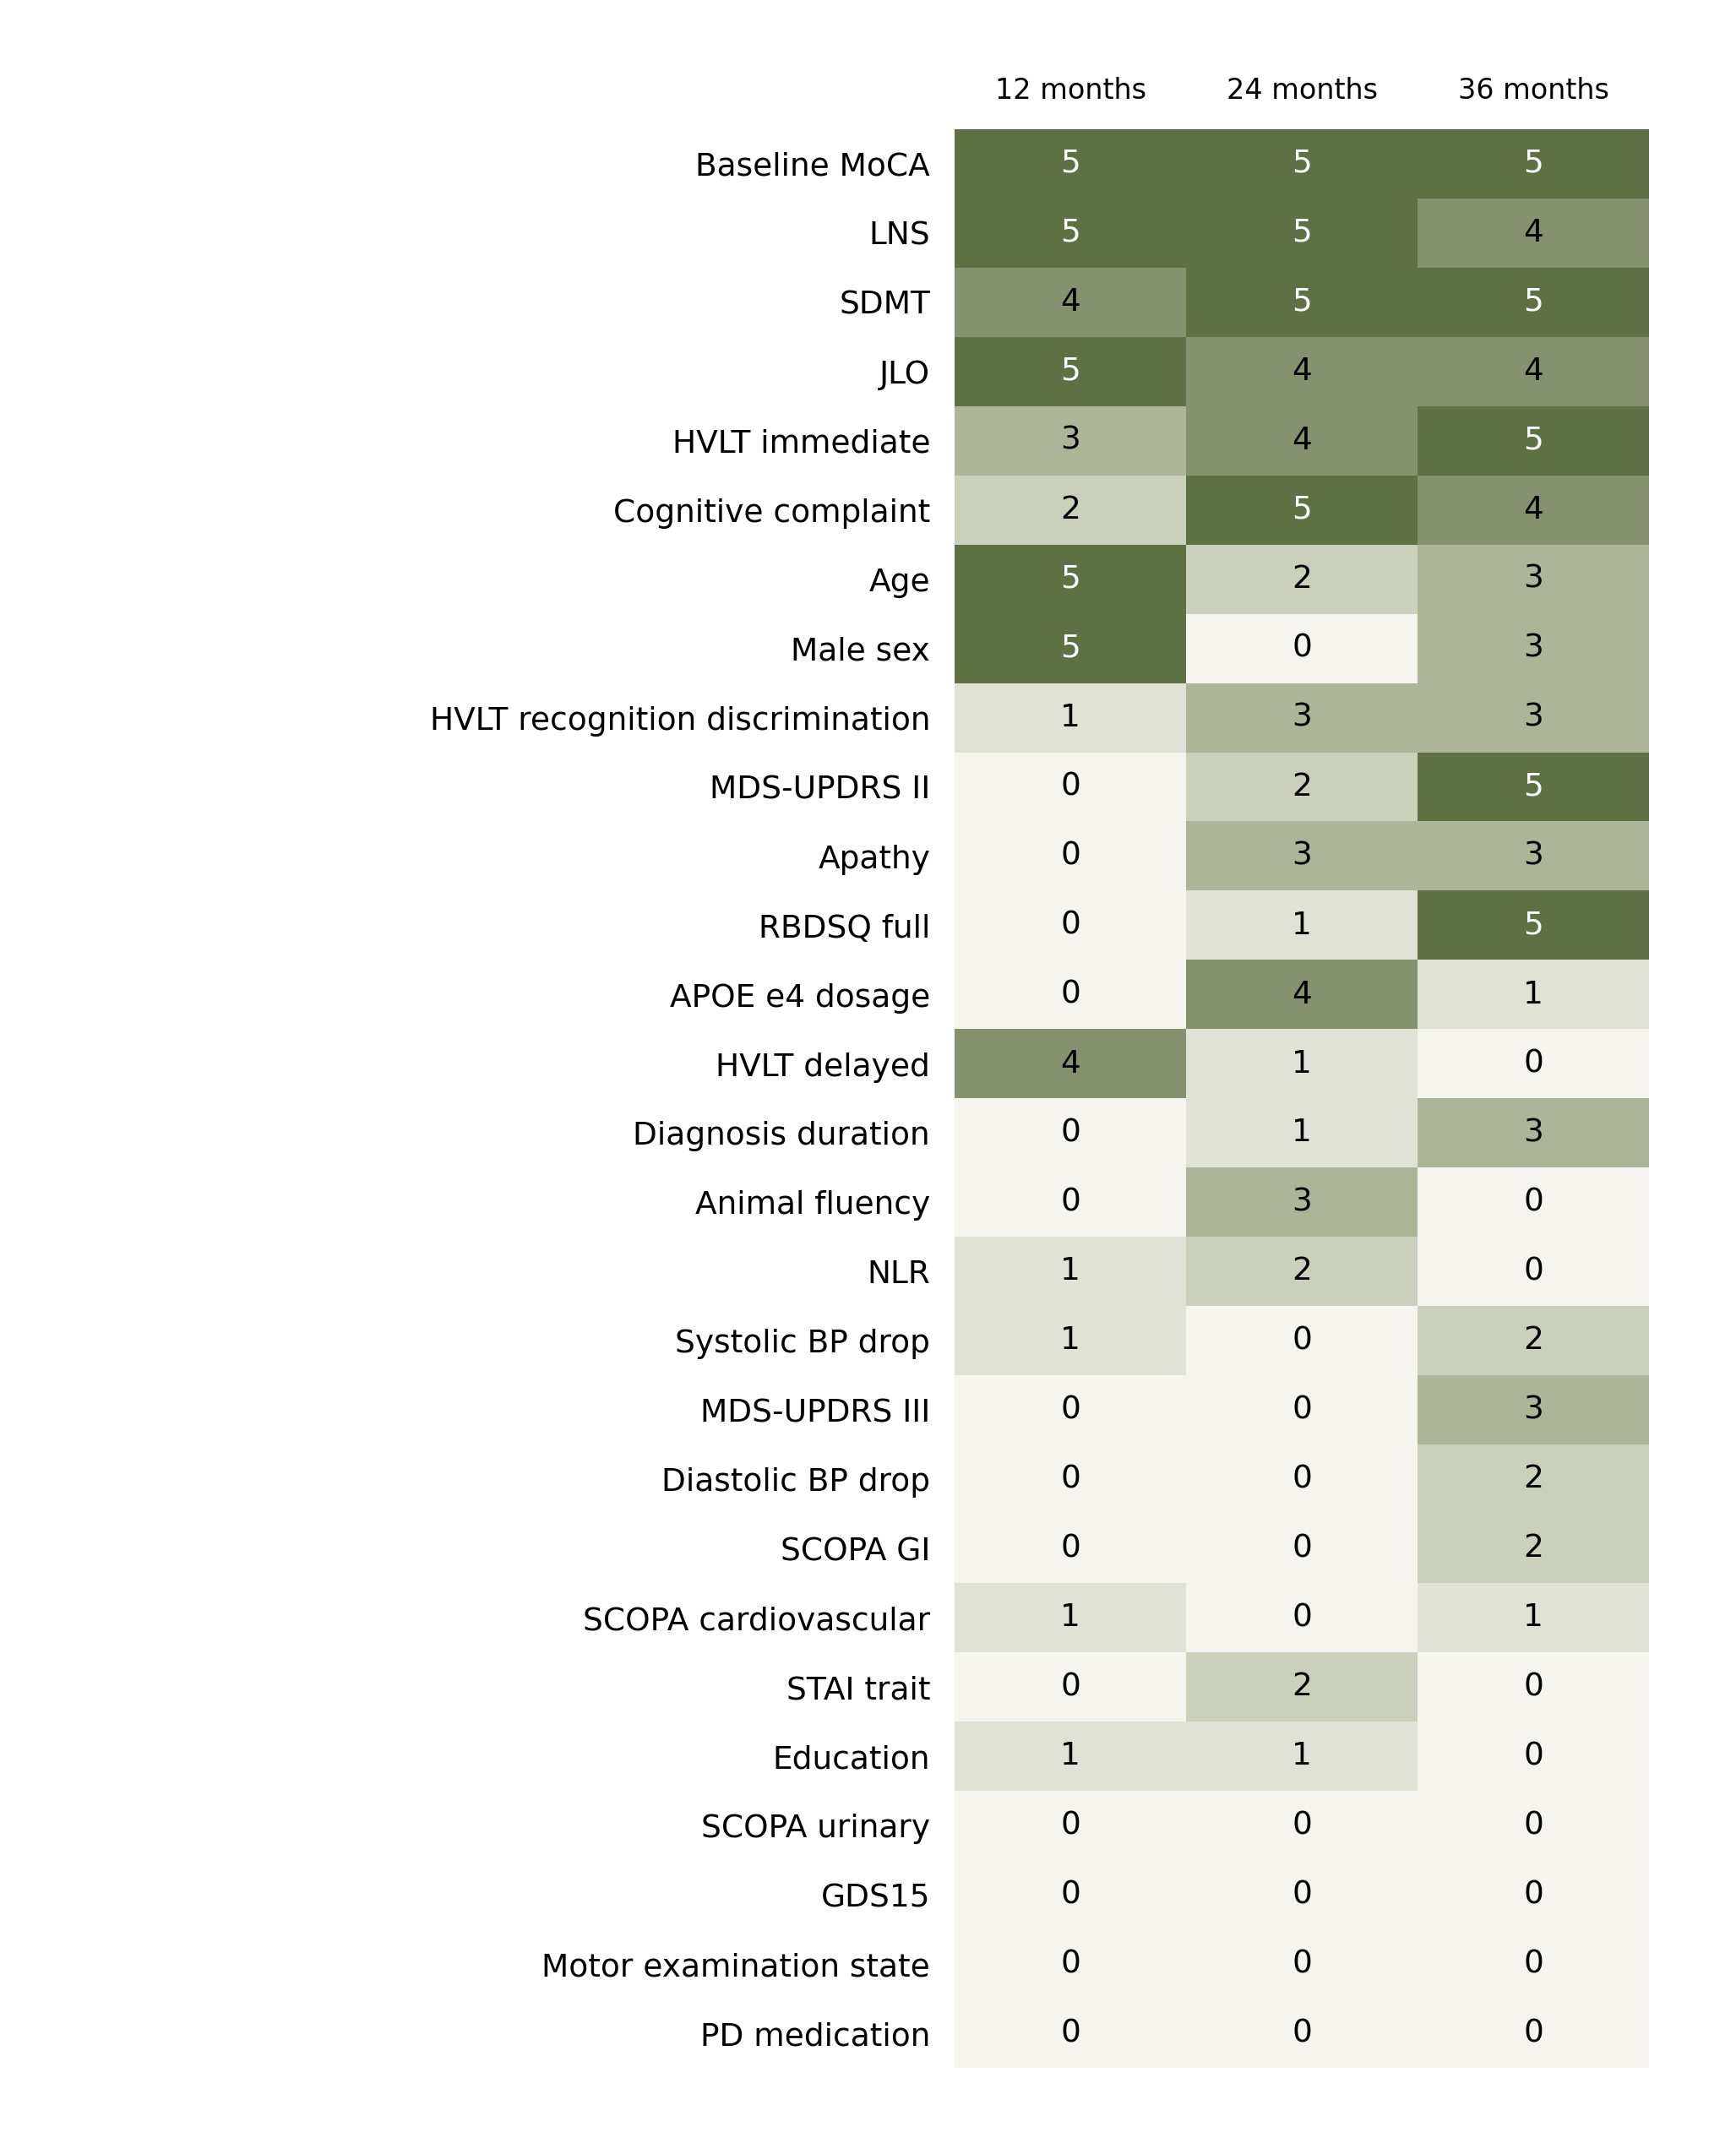
Fig. S2 Selection stability for the final unrestricted GA. Cells show selection counts across five outer folds at each horizon. Features are ordered by total selection frequency, then name. Frequencies describe the consistency of predictor inclusion across training partitions; performance estimates correspond to the complete fold-specific selection procedure. Baseline MoCA was selected in all 15 outer folds

