Saudi raw-data integration: methods, findings and implications
Exploratory supplementary analysis, 3 October 2026. All 19 files in the raw-data batch were assessed for their appropriate role. Population and insurance observations were integrated into new analyses; documentation files informed source eligibility. The original disease-rate models, primary comparisons and interval scores remain unchanged.

Methods: population harmonisation
The MOH 2022 table was reconstructed from its 68 age–sex–nationality cells and verified against Table 1-3 of the 2023 Statistical Yearbook, which credits GASTAT. It was combined with existing GASTAT 2023/2024 counts to form 204 cells. Totals included citizens and non-citizens. The 2022 export specifies a reference year but not an exact population date; the GASTAT methods define the later estimates at 1 July. The 840-cell GASTAT 2010–2024 export duplicated GCC-Stat numerically. Three date-like labels were mapped to 0–4, 5–9 and 10–14 solely in derived data, with exact cell matching retained. Four GCC-Stat cells labelled 65–69 equalled complete 65+ totals; the new 2022 linkage uses the verified MOH cells and flags this ambiguity. [D5; D4; D3; gastat_methods]

Methods: fixed-rate count sensitivity
For each sex, outcome and year (2022/2023), national and GBD/UN populations were harmonised to eight age bands, 45–49 through 75–79 and 80+. Within the open 80+ group, the reference rate was the GBD-population-weighted average of the four available age-specific rates. Alternative count = national population × reference rate / 100,000. These are fixed-rate counterfactual counts, not independently observed cases. Allocation limits assign the whole 80+ population to the minimum or maximum observed age-specific rate. They bound the consequence of an unspecified within-band mix while holding rates fixed; they are not confidence intervals, prediction intervals or comprehensive uncertainty bounds. No national 80–84/85–89/90–94/95+ counts are claimed. [D1; gbd_nonfatal; gbd_fatal]

Methods: conditional projections
Previously saved 2023-origin prevalence/incidence rate projections from the adapted TCN and the local/non-neural champions were reused without refitting. For national anchor year a (2022 or 2024), broad-age population in year t was N(a) × U(t)/U(a), using UN WPP 2024 growth in the same broad age and sex. The 80+ total was allocated alternatively by the GBD-2023-aligned UN-growth age profile or the UN age profile for year t. Both options exactly preserve the national broad-age total. The 2022 versus 2024 anchors also reveal sensitivity to the observed national age distribution. All four original TCN 2028 sex-combined count results were reproduced to numerical precision. The new scenarios use later-vintage information and are conditional projections, not prospective backtests or selected “best” forecasts. [D1; D2; wpp_methods; D4; D5]

Methods: insurance composition
All seven CHI quarterly workbooks were parsed from their preserved originals, including the ODS file. Subscriber and insured-person indicators were retained separately. Fourteen detailed-to-headline count reconciliations passed. All-age sex and nationality composition in Q2 2024 were compared with GASTAT 2024. The exported count-per-resident ratio is a descriptive snapshot ratio, not an insurance-coverage probability or person-year exposure. Original age categories were retained; 61 >=Age remained ambiguous and was excluded from any asserted oldest-age definition. The separate 2024 beneficiary-class CSV was reconciled independently and was not equated with a quarterly total. [chi_data; chi_class; chi_terms; D4]

Findings: persistent oldest-age sensitivity
In 2022, GBD-implied populations at ages 80+ were 38.23% below the MOH/GASTAT national count in males and 49.28% below in females. The corresponding 2023 differences were 37.39% and 49.65%. This shows that the broad discrepancy also occurs in the added year; it does not identify which demographic source is correct. At fixed 2023 GBD rates, national denominators raised conditional prevalent counts at ages 45+ by 12.41% in males and 18.18% in females. The oldest-age prevalence shares changed from 19.27% to 27.38% in males and from 17.24% to 28.97% in females. All six outcomes and both years are retained in Supplementary Table S9.

Findings: similar total burden can conceal a different age profile
For 2028, the adapted-TCN prevalence total was 31,844 under GBD-2023-aligned UN growth, 37,144 under unaligned UN medium populations, 38,053 under the national-2022 anchor, and 37,165 under the national-2024 anchor. The national examples use the GBD-aligned within-80+ allocation. Their oldest-age shares were 24.73%, 29.55%, 35.22% and 34.25%, respectively. Thus the UN and national-2024 scenarios differed by only about 21 total cases while differing by 4.70 percentage points in the oldest-age share. This is a composition sensitivity, not a forecast-accuracy improvement. Using UN within-80+ weights instead changed the national-2024 prevalence total to 37,238 and its oldest-age share to 34.38%. Incidence and the two comparator families are included in Supplementary Table S11.

Findings: insurance records represent a selected population
In Q2 2024, the all-age CHI insured-person indicator summed to 12,381,657. Males comprised 73.10% and non-citizens 66.31%; all-age national population shares were 62.08% and 44.38%, respectively. Male non-citizens represented 55.59% of the insured-person snapshot versus 34.24% nationally. This identifies demographic differences in the source population, not observed Parkinson underdiagnosis or nationality-specific disease risk. A future claims validation must define a compatible insured population, ascertainment algorithm and observation period before comparing its outcomes with national forecasts. Both CHI indicators and all seven snapshots are retained in Supplementary Table S10.

Data eligibility and limitations
The NHRSP HISS and NCD files contain codebooks and a questionnaire, not observations. Neither inspected instrument identifies Parkinson’s disease specifically. The NPHIES visible top-10 summaries omit a Parkinson outcome series; omission from a top-10 list does not mean zero disease. The previously decoded embedded table contains aggregate service rows without the required age, sex, diagnosis and patient identifiers. The data-use agreement and access pages do not establish access approval. These files strengthen the eligibility assessment but cannot be added as disease-model observations. [nhrsp_hiss; nhrsp_ncd; chi_nphies; nhrsp_access]

Interpretation and reporting decision
The integrated data improve denominator handling, demonstrate that age composition matters beyond aggregate counts, and specify the demographic limits of claims-based validation. They provide no new observed Parkinson outcomes and therefore do not demonstrate improved forecast accuracy or interval calibration. National and GBD population definitions remain incompletely aligned; the 2022 reference date and within-80+ national detail are unresolved. Nationality is used for demographic description only. The primary age range remains 45+, the oldest ages remain visible, and the joint-primary and reliability conclusions are retained.

Supplementary Table S9: national denominator sensitivity
Year | Sex | GBD population 80+ | National population 80+ | GBD difference (%)
2022 | Female | 39,270 | 77,419 | -49.28
2022 | Male | 48,880 | 79,136 | -38.23
2023 | Female | 40,805 | 81,046 | -49.65
2023 | Male | 51,264 | 81,878 | -37.39
The complete machine-readable bundle includes all compatible ages and six outcomes. National 2022 reference date is not established; later GASTAT counts are mid-year.

Supplementary Table S10: CHI insured-person composition
Period | Insured persons | Male (%) | Non-citizen (%)
3/31/2022 | 10,166,330 | 71.76 | 64.10
12/31/2021 | 9,534,473 | 71.01 | 63.76
الربع الحالي Q4 2023 | 11,935,483 | 72.88 | 65.60
الربع الحالي Q1 2024 | 12,161,034 | 73.09 | 65.97
الربع الحالي Q2 2024 | 12,381,657 | 73.10 | 66.31
Q4 2025 | 14,426,335 | 74.02 | 67.95
Q2 2026 | 14,794,947 | 73.99 | 68.29
Selected snapshots; no continuous annual panel or Parkinson numerator. Source: Council of Health Insurance; authors’ calculations. Subscriber results are supplied separately.

Supplementary Table S11: conditional 2028 counts and composition
Outcome | Population scenario | Count aged 45+ | 80+ share (%)
incidence | GBD 2023 + UN growth | 4,557 | 17.29
incidence | National 2022 + UN growth | 5,203 | 25.66
incidence | National 2024 + UN growth | 5,130 | 24.69
incidence | UN medium | 5,242 | 20.25
prevalence | GBD 2023 + UN growth | 31,844 | 24.73
prevalence | National 2022 + UN growth | 38,053 | 35.22
prevalence | National 2024 + UN growth | 37,165 | 34.25
prevalence | UN medium | 37,144 | 29.55
The same saved TCN rate projections underlie every row. National rows assume a GBD-aligned within-80+ distribution; the full bundle includes UN-weight alternatives and both comparator families. No scenario is an independently verified forecast.

Supplementary Figure S34: demographic integration
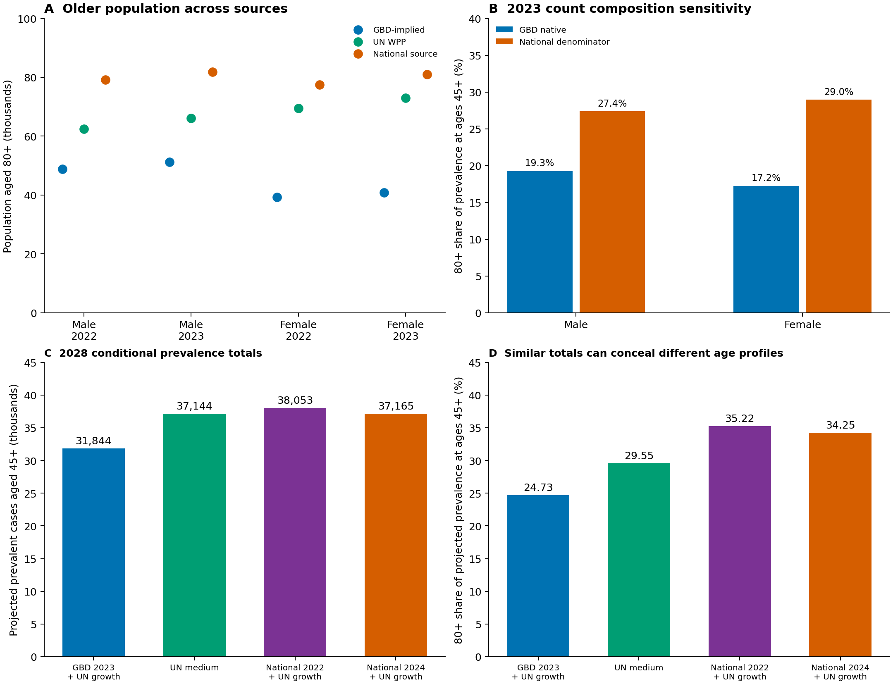
A, population at ages 80+ in 2022/2023. B, 2023 prevalence composition with GBD rates held fixed. C–D, 2028 prevalence totals and oldest-age shares under four population scenarios. National scenarios preserve observed broad-age totals and assume GBD-aligned within-80+ weights. The figure depicts conditional accounting, not new prevalence observations or prediction intervals. Sources: GBD 2023, UN WPP 2024, GASTAT and MOH; authors’ calculations.

Supplementary Figure S35: insurance composition
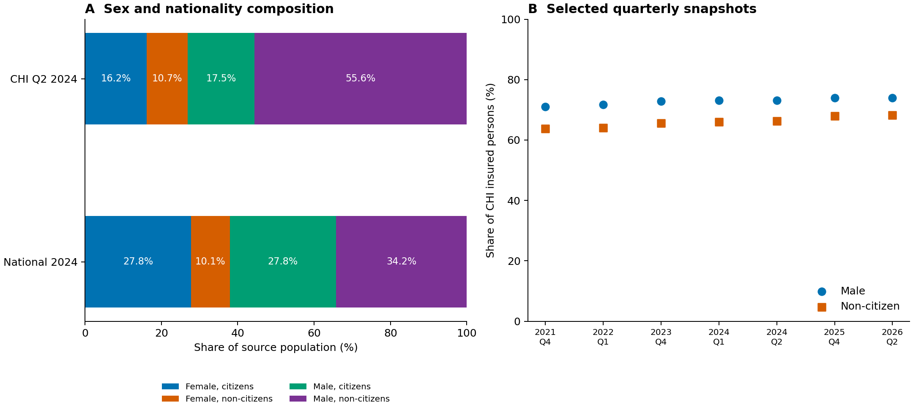
A, all-age sex–nationality composition of the Q2 2024 CHI insured-person snapshot and national 2024 population. B, male and non-citizen shares in seven selected CHI snapshots. No age-band interpolation or Parkinson outcome inference was performed. Sources: Council of Health Insurance and GASTAT; authors’ calculations.

Source references
[D1] Global Burden of Disease Collaborative Network. Global Burden of Disease Study 2023 (GBD 2023) Results [dataset]. Institute for Health Metrics and Evaluation; publication date not stated. https://vizhub.healthdata.org/gbd-results/ (1 October 2026, date of source/citation review).
[gbd_nonfatal] GBD 2023 Disease and Injury and Risk Factor Collaborators. Burden of 375 diseases and injuries, risk-attributable burden of 88 risk factors, and healthy life expectancy in 204 countries and territories, including 660 subnational locations, 1990-2023: a systematic analysis for the Global Burden of Disease Study 2023. Lancet 2025;406:1873-1922. https://doi.org/10.1016/S0140-6736(25)01637-X
[gbd_fatal] GBD 2023 Causes of Death Collaborators. Global burden of 292 causes of death in 204 countries and territories and 660 subnational locations, 1990-2023: a systematic analysis for the Global Burden of Disease Study 2023. Lancet 2025;406:1811-1872. https://doi.org/10.1016/S0140-6736(25)01917-8
[D2] United Nations, Department of Economic and Social Affairs, Population Division. World Population Prospects 2024: Online Edition [dataset]. United Nations; 2024. https://population.un.org/wpp/ (1 October 2026, date of source/citation review).
[wpp_methods] United Nations, Department of Economic and Social Affairs, Population Division. World Population Prospects 2024: Methodology of the United Nations population estimates and projections [report]. United Nations; 2024. https://population.un.org/wpp/assets/Files/WPP2024_Methodology-Report_Final.pdf (1 October 2026, date of source/citation review).
[D3] GCC Statistical Centre. Population: DF_PSS_DEM_POP, version 1.0 [dataset]. GCC-Stat; publication date not stated. https://dp.marsa.gccstat.org/dataset/population (1 October 2026, date of source/citation review).
[D4] General Authority for Statistics. Population Estimates Publication 2024 and accompanying Population estimates EN workbook [dataset]. General Authority for Statistics; publication date not stated. https://www.stats.gov.sa/documents/d/guest/population-estimates-en (1 October 2026, date of source/citation review).
[D5] Ministry of Health, Kingdom of Saudi Arabia. Statistical Yearbook 2023 [report]. Ministry of Health, Kingdom of Saudi Arabia; publication date not stated. https://www.moh.gov.sa/Ministry/Statistics/book/Documents/Statistical-Yearbook-2023.xlsx (1 October 2026, date of source/citation review).
[gastat_methods] General Authority for Statistics. Methodology and Quality Report for Population Projections and Estimates Statistics [report]. General Authority for Statistics; publication date not stated. https://www.stats.gov.sa/en/w/methodology-and-quality-report-for-population-projections-and-estimates-statistics (1 October 2026, date of source/citation review).
[chi_data] Council of Health Insurance. Open Data: health-insurance beneficiary statistics, selected quarterly releases 2021–2026 [dataset]. Council of Health Insurance; publication date not stated. https://www.chi.gov.sa/en/open-data/Pages/Indicators-and-statistics.aspx (1 October 2026, date of source/citation review).
[chi_class] Council of Health Insurance. CHI beneficiary class to the Age group 2024 [dataset]. Council of Health Insurance; publication date not stated. https://www.chi.gov.sa/en/open-data/Pages/Indicators-and-statistics.aspx (1 October 2026, date of source/citation review).
[chi_terms] Council of Health Insurance. Requirements for using the open data of the Council of Health Insurance [Internet]. Council of Health Insurance; publication date not stated. https://www.chi.gov.sa/en/open-data/Pages/requirements.aspx (1 October 2026, date of source/citation review).
[chi_nphies] Council of Health Insurance. Top 10 by gender — NPHIES [dataset]. Council of Health Insurance; publication date not stated. https://www.chi.gov.sa/en/open-data/Pages/Indicators-and-statistics.aspx (1 October 2026, date of source/citation review).
[nhrsp_hiss] BinDhim N, Al thumairi N, Basyouni M. Health Indicators Surveillance System (HISS) [dataset]. Sharik Health Association; 2020. https://doi.org/10.60840/nhrsp-f207 (1 October 2026, date of source/citation review).
[nhrsp_ncd] The National Heart Center (NHC) of the Saudi Health Council, The General Directorate of National Health Policies and Economics at the Saudi Health Council, The Center for Health Research Studies (CHRS) at the Saudi Health Council. Leveraging ABSHER Platform to Assess NCDs Burden in Saudi Arabia [dataset]. Saudi Health Council; 2021. https://doi.org/10.60840/nhrsp-a355 (1 October 2026, date of source/citation review).
[nhrsp_access] Saudi Health Council. National Health Research and Studies Portal: access workflow and user guide [Internet]. Saudi Health Council; publication date not stated. https://shc.gov.sa/ar/EServices/Pages/nhrsp.aspx (1 October 2026, date of source/citation review).

