**Instructions for Lab Experiments (Online)**

1. All the laboratory would be conducted on Scheduled date and time on online mode.
2. Lab sheets would be provided which would contain the question. Students should solve the problems.
3. **Working Directory:**
   1. **Windows**: press Windows Key + R and type cmd and enter
   2. Type cd Desktop : You would be in C:\Users\**Your Computer Name**\ Desktop
   3. md JAVA, cd JAVA, md Lab1….so in

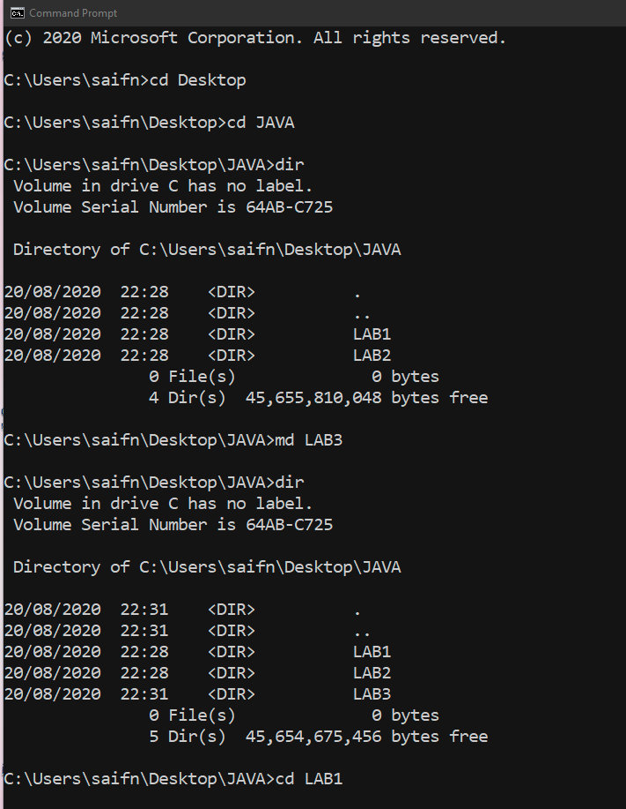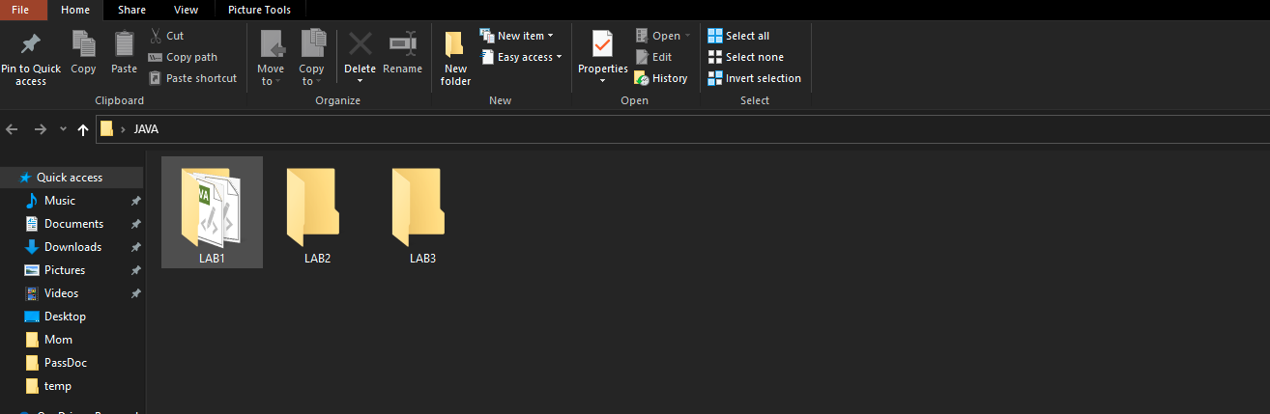

As observed from above the **Computer name would not be same for everyone** :P . The name of the your PC/Laptop should be visible as a proof that you have at least run the code in your personal PC/ Laptop. The snap of console based output should be seen and taken. The snap of console based output should be seen and taken.

1. **Submission:** the submission details should contain
   1. Snap picture of the output using Snip & Sketch on console ( shouldn’t be shared among the students)
   2. One page writeup (softcopy) on word, which contains Aim, Experiments, Outputs(your snaps of output) and Conclusion.
   3. Make a folder in your above working director as LAB1…..LAB8 respectively for each lab and store the above files
   4. The due date for each submission of labs would until next lab. Submission after due date will result in decreases in marks.
   5. All the codes of lab would be uploaded on google drive
   6. On Google Drive Create a folder name “Your_PNR_No_JAVA”, Share that folder with me and TA: Rashmi Dharwadkar (rashmi.dharwadkar@dypiu.ac.in ). In that folder, upload the folder LAB1, LAB2… etc which contains your codes etc.

**Note: NO SHARING of Codes / Output/ or experimental writeup with your friends.**