

ONLINE COVID-19
TEST AND
VACCINATION
BOOKING SYSTEM
SUBMITTED BY:
M. Afeer
- 1599236
Muslim Kambrani
- 1599441
Muhammad Anas
- 1612399
Saif Nawaz
- 1600504
CERTIFICATE OF COMPLETION
This is to certify that the students mentioned above have successfully completed their CPISM Semester I E-Project titled “Online COVID-19 Test and Vaccination Booking System” under the guidance of Sir Talha, submitted to Aptech Computer Education on 22nd June 2025.
We would like to express our sincere gratitude to our instructor, family, and friends for their continuous support and encouragement during the development of this project.
- Problem Definition
- Customer Requirement Specification
- Project Plan
- E-R Diagrams
- Algorithms
- GUI Standards Document
TABLE OF CONTENTS
- Interface Design Document
- Task Sheet

- Unit Testing Check List
- Final Check List
- Project Screenshots and Codes
The global outbreak of the Coronavirus has created significant challenges in accessing healthcare services, particularly for testing and vaccination. Many individuals struggle to find centralized systems to book appointments, track their health status, or receive timely updates. This lack of a unified platform has led to confusion and delays in managing the pandemic. Our project addresses this issue by developing a web application that simplifies the process of booking Covid-19 tests and vaccinations, ensuring efficient coordination between patients, hospitals, and administrators.
PROBLEM DEFINITON
CUSTOMER REQUIREMENT SPECIFICATION
The system should:
- Allow patients to register and book test/vaccine appointments.
- Allow hospitals to register, manage appointments, and update test/vaccine status.
- Provide admin with control over user/hospital approvals and report management.
- Offer data filtering (by date/week/month) and export.

PROJECT PLAN
Task Days Status

Analysis 2 OK
Design 4 OK
Development 8 OK
Testing 2 OK
Documentation 2 OK

ER DIAGRAM
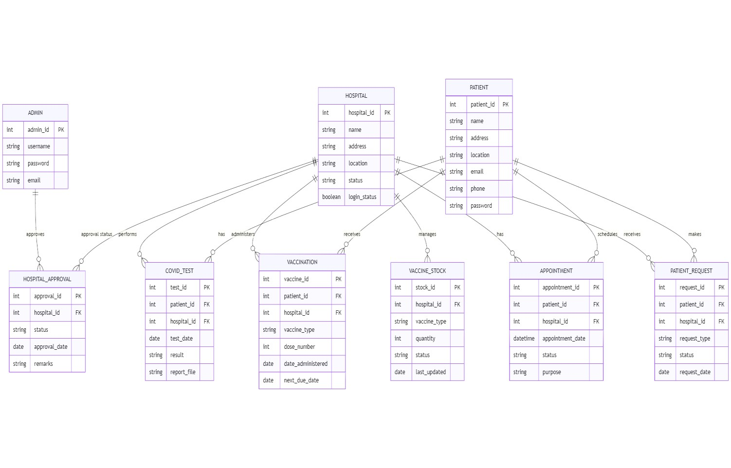
ALGORITHM EXPLANATION
- Login Authentication Algorithm
- Booking Filter and Export Algorithm
- Status Update Algorithm
GUI STANDARDS
- Font: Sans Serif, minimum size 14px
- Button colors: Green for Approved, Red for Cancelled, Yellow for Pending
- Consistent layout across all pages
INTERFACE DESIGN
- Admin Panel:
o View/manage hospitals, patients, reports, booking status - Export booking reports by date/week/month
- Hospital Panel:
o Manage patients - Update test/vaccine status - Accept/reject appointment requests
- Patient Panel:
  - Book appointments - View appointment/test status - Access profile and history

TASK SHEET
Module | Task Description | Assigned To | Status
Admin | Export & Approval Functionality |  | Done
Hospital | Result/Vaccine Update, Requests |  | Done
Patient | Booking + Appointment History |  | Done
GUI Design | UI Layout and Icons |  | Done
UNIT TESTING CHECK LIST
Module | Function | Pass/Fail
Login | Admin/Hospital/Patient | Pass
Booking | Create/View/Edit/Cancel | Pass
Reports | Export + Date Filters | Pass
FINAL CHECK LIST
  - All modules functional ✔ o All test cases passed ✔ o Responsive Design implemented ✔ o Database backup taken ✔ o Final demo completed ✔

SCREENSHOTS

