

Faculty of Science

**Course**: CSCI 2020U: Software Systems Development and Integration

**Semester:** Winter 2016

**Component:** Midterm Lab Exam

**Topic:** Loading and saving files, 2D graphics

**Overview**

In this lab exam, you will read data from a CSV file and generate a scatter plot for some of the values.

**Instructions**

You can use any operating system or environment for this laboratory assignment. It is recommended, but not required, that you use IntelliJ for this lab.

You will create a new directory (or IntelliJ IDEA project) called midterm. Download the file fish-radiation-data-2015.csv, which is a CSV file that contains radioactivity levels for various fish samples taken from Canadian pacific. Write a function, loadAndPlotData(), that reads in the CSV file and plots some of the column values in a scatter plot:

private void loadAndPlotData(File inputFile, GraphicsContext gc) {

…

}

The columns to be plotted, and the colours to be used, are given below:

1. Cs-137 (Bq/kg) (Color.RED)
2. Cs-134 (Bq/kg) (Color.BLUE)
3. K-40 (Bq/kg) (Color.GREEN)
4. Po-210 (Bq/kg) (Color.FUCHSIA)

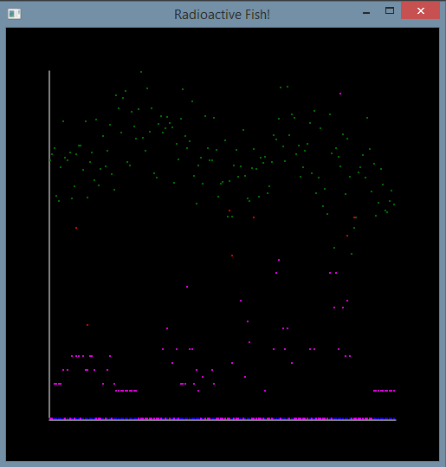

**Figure 1: The application’s output**

**How to Submit**

Submit your complete project directory, as a ZIP file (e.g. Midterm_FirstName_LastName.zip), to Blackboard. Before you submit the file, open the ZIP file in Windows Explorer, to verify that your Main.java file is located there.

***Note****: Be sure that the source code included is from the correct project. If you submit the wrong file, you will be unable to re-submit once the exam period has ended.*