Assignment 3
Machine Learning Group Project
Group 18
Student Last Name | Student First Name | Student ID | Group Allocation
Yudianto | Vonny | 25741719 | Student A (regression)
Rahman | Md Saifur | 25528668 | Student B (classification)
Sahindra | Rasyid | 25510254 | Student C (clustering)
Pacheco | Laura | 25940875 | Student D (anomaly)

36106 - Machine Learning Algorithms and Applications
Master of Data Science and Innovation
University of Technology of Sydney
Table of Contents

1. Executive Summary 3
2. Regression (Vonny Yudianto) 4
A. Business Understanding 4
1. Business Use Cases 4
2. Key Objectives 4
B. Data Understanding 5
C. Data Preparation 6
D. Modeling 7
E. Evaluation 8
1. Evaluation Metrics 8
2. Results and Analysis 9
3. Business Impact and Benefits 9
4. Data Privacy and Ethical Concerns 10
3. Classification (Md Saifur Rahman) 11
A. Business Understanding 11
1. Business Use Cases 11
2. Key Objectives 11
B. Data Understanding 13
C. Data Preparation 19
D. Modeling 24
E. Evaluation 26
2. Results and Analysis 31
3. Business Impact and Benefits 33
4. Data Privacy and Ethical Concerns 34
4. Clustering (Rasyid Sahindra) 36
A. Business Understanding 36
1. Business Use Cases 36
2. Key Objectives 36
B. Data Understanding 37
C. Data Preparation 40
D. Modeling 43
E. Evaluation 43
1. Evaluation Metrics 43
2. Results and Analysis 44
3. Business Impact and Benefits 45
4. Data Privacy and Ethical Concerns 46
5. Anomaly Detection (Laura Pacheco) 47
A. Business Understanding 47
1. Business Use Cases 47
2. Key Objectives 47
B. Data Understanding 49
C. Data Preparation 50
D. Modeling 52
1. Algorithm Selection and Rationale 52
2. Parameter Tuning and Model Implementation 52
E. Evaluation 52
1. Evaluation Metrics 52
2. Results and Analysis 53
3. Business Impact and Benefits 54
4. Data Privacy and Ethical Concerns 55
6. Collaboration 56
A. Individual Contributions 56
B. Group Dynamic 56
C. Ways of Working Together 56
D. Issues Faced 57
7. Conclusion 58
8. References 59

Executive Summary
This project used customer data and machine learning to help a telecom business solve some of its biggest problems. Each person on the team worked on a different job, such as regression, classification, grouping, or finding outliers.
Random Forest, a regression model, predicted monthly income to help with budgeting. With an F1-score of 0.937, the classification model (Gradient Boosting) forecast loss, which made proactive retention possible. K-means clustering divided customers into five groups that could be targeted with marketing. Anomaly spotting (Isolation Forest, PCA) pointed out usage and pricing that didn't seem right, which helped find fraud and make service better.
These models showed how machine learning can help make better choices, keep customers longer, and get them more involved.

Regression (Vonny Yudianto)

Business Understanding

Business Use Cases
This project addresses a key challenge faced by telecom providers: accurately forecasting monthly customer revenue in a fast-moving, competitive market. With large volumes of data covering demographics, account status, and service usage, traditional methods fall short in capturing complex patterns.
To improve budgeting and decision-making, we developed a machine learning model that predicts monthly revenue per customer using historical data. These predictions support more accurate financial planning and help identify customers at risk of declining revenue, enabling proactive intervention. By leveraging data-driven insights, the company can optimize resource allocation and enhance long-term business strategy.

Key Objectives
The goal of this project is to build a machine learning model to predict the monthly revenue of individual telecom customers. These predictions will support the Finance Team in creating accurate budgets, managing cash flow, and anticipating revenue changes. The model will also help identify high-value customers and flag patterns linked to revenue drops, such as high refunds or costly service usage. Key stakeholders include:
- Finance Team : Needs accurate, interpretable forecasts for budgeting and planning.
- Executive Management : Uses predictions for strategic decisions like tariff changes and investments.
- Data Science Team : Responsible for delivering a high-performance, explainable model that integrates with reporting tools.
By capturing complex patterns in customer behavior, this project enables more informed, data-driven business decisions.

Data Understanding
The dataset, sourced from the Canvas academic portal, simulates real-world telecom conditions. It combines two key sources, customer_details (36 features) and customer_usage (10 features), merged via customer_id, resulting in 7,043 complete customer records.
Key features include age, marital status, number of dependents, data usage, and monthly income. Additional engineered features such as refund_ratio and extra_data_ratio enhance the model’s ability to capture customer behavior impacting revenue.
The main data challenges involved handling missing values, duplicate entries, and merging datasets. After thorough cleaning and feature engineering, the dataset is well-prepared for training predictive models to support financial planning.
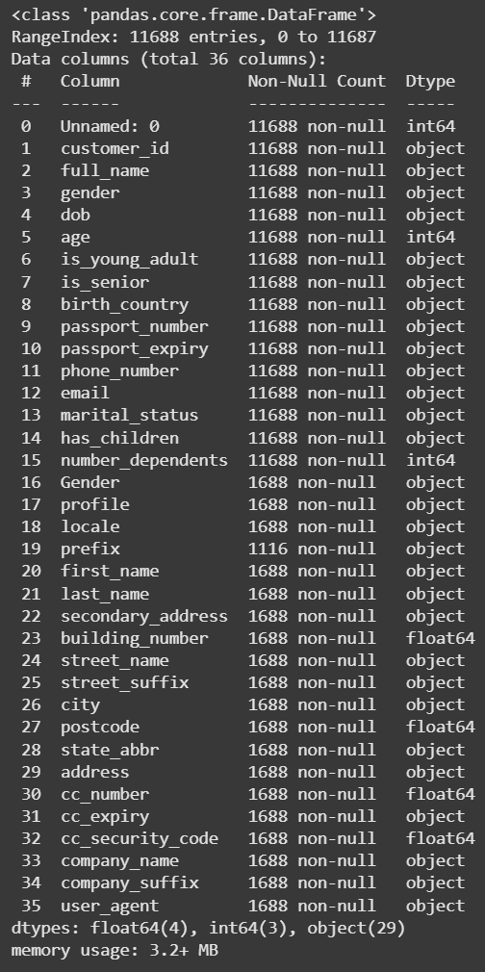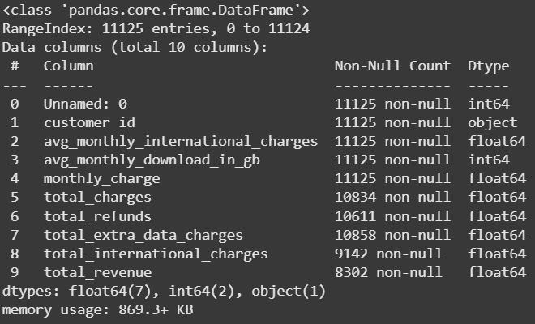

Data Preparation
EDA Process
Initial data preparation involved removing the Unnamed: 0 index column and duplicate records to ensure each row represented a unique customer. Irrelevant or sensitive features (e.g., names, addresses, credit card numbers) and columns with excessive missing values were dropped.
The datasets customer_details and customer_usage were merged using customer_id, resulting in 7,043 complete records. Date fields like dob were converted to datetime, while categorical features (e.g., is_young_adult, marital_status) were binary encoded. birth_country was one-hot encoded due to its multiple categories.
New features such as refund_ratio and extra_data_ratio were engineered to capture customer behavior influencing revenue.
Modeling Process
Before modeling, numeric features with missing values (e.g., total_charges, total_refunds) were imputed using the median to preserve distribution shape. Logarithmic transformation (log1p) was applied to skewed financial features, followed by IQR-based capping to limit extreme outliers.
Further feature engineering included:
- net_charges = total_charges – total_refunds
- total_usage_charge = total_charges / monthly_charge
- weighted_refund = refund_ratio × total_refunds
These enhanced the model’s ability to understand customer revenue behavior.
The cleaned data was stored in a new variable (df_model) to preserve raw data integrity. Redundant features, such as original versions of transformed columns, were dropped.
Finally, the target variable total_revenue_log was separated from the predictors. The dataset was split into 70% training, 15% validation, and 15% testing sets to ensure robust and unbiased model evaluation. Since the target is continuous, no class imbalance techniques were required.

Modeling
This project explores multiple regression algorithms to predict customer revenue, aiming for both accuracy and robustness. Models tested include Linear Regression, K-Nearest Neighbors (KNN), Decision Tree, Random Forest, and XGBoost, each selected for their ability to capture linear or non-linear patterns and handle noise.
Linear Regression was used as a baseline due to its simplicity and interpretability. However, given the complexity of customer data, more flexible models like Random Forest and XGBoost were also employed. Random Forest handles non-linear interactions well and resists overfitting, while XGBoost offers high performance and scalability.
All models were wrapped in a TransformedTargetRegressor to apply a log transformation to the skewed revenue target, improving learning stability. The modeling pipeline also included StandardScaler to standardize numeric features, ensuring fair treatment in algorithms sensitive to feature scale.
Model evaluation was done using 5-fold cross-validation on the training set, with metrics including RMSE, MAE, and MAPE. Based on lowest RMSE, Random Forest was selected for further hyperparameter tuning using RandomizedSearchCV, optimizing parameters like n_estimators, max_depth, and min_samples_split while guarding against overfitting.
This structured approach ensured strong predictive performance and reliable model selection.

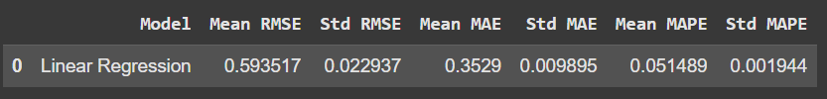
baseline model evaluation metrics results
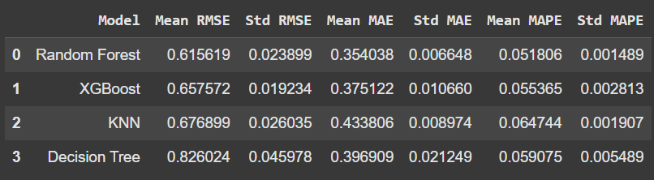
evaluation metrics results from other models
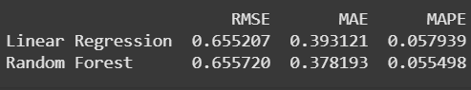
prediction results from testing set with benchmark model
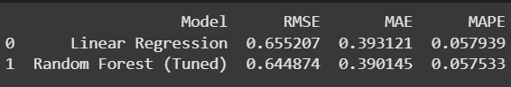
evaluation metrics results for models after hyperparameter tuning

Evaluation

Evaluation Metrics
To assess the performance of the developed regression model, three main evaluation metrics are used, namely Root Mean Squared Error (RMSE), Mean Absolute Error (MAE), and Mean Absolute Percentage Error (MAPE). The three were chosen because they are able to provide complementary perspectives on prediction accuracy. RMSE is used as the main metric because it takes into account the magnitude of the squared error and is very sensitive to outliers, making it an appropriate measuring tool to understand the impact of large errors in revenue predictions. MAE is used to provide an overview of the average absolute error without giving more weight to outliers, while MAPE provides an easy-to-understand interpretation in the form of a percentage error to the actual value which is very relevant in a business context.

Results and Analysis
The evaluation was conducted using three regression metrics, namely RMSE, MAE, and MAPE. The average results of several main models are shown in the following table:
Model | RMSE | MAE | MAPE
Linear Regression | 0.6552 | 0.3931 | 5.79%
KNN Regressor | 0.6824 | 0.4162 | 6.11%
Decision Tree | 0.7015 | 0.4327 | 6.32%
Random Forest | 0.6473 | 0.3894 | 5.71%
XGBoost | 0.6597 | 0.3975 | 5.85%
Random Forest Tuned | 0.6449 | 0.3901 | 5.75%
The tuned Random Forest model performed the best, with consistently the lowest error. It excelled in capturing non-linear relationships and was more stable than other models. Some key insights from the experiment:
- Log transformation of the target helped reduce the influence of outliers.
- Preprocessing pipeline prevented data leakage and maintained consistency between models.
- Hyperparameter tuning significantly improved the performance of Random Forest.
This best model can help finance teams predict customer revenue more accurately, supporting budget planning and marketing strategies. In the future, improvements can be made by adding new features or testing more complex models such as neural networks.

Business Impact and Benefits
The developed customer revenue prediction model provides a real contribution in supporting the company's strategic decision-making. With superior performance, especially from the Random Forest tuning results, this model successfully reduces error values ​​(RMSE, MAE, and MAPE) compared to the baseline, thereby significantly increasing the accuracy of total revenue predictions.
The main impact of this increased accuracy is the ability of the finance team to prepare more realistic budget plans, manage cash flow better, and determine growth targets based on more accurate projections. The model also allows the identification of high-value customers and customers with high risks (for example, due to refunds), opening up opportunities for more effective segmentation and retention strategies.
From the operational side, the built pipeline allows for automatic replication and integration into internal systems, including cross-team dashboards (finance, marketing, product). This accelerates data-based decision-making and increases work efficiency.
Overall, this model not only solves the challenge of revenue prediction with a better statistical approach, but also opens up space for further initiatives such as churn prediction, customer value classification, and more proactive marketing strategies. The resulting business value includes efficiency, planning accuracy, and increased profitability and company competitiveness.

Data Privacy and Ethical Concerns
The project was designed with privacy and ethics in mind from the start. The datasets used were anonymized and did not contain any personally identifiable information (PII), in line with GDPR principles such as data minimization and use limited to internal analytical purposes. No sensitive or demographic data was analyzed, eliminating the risk of discrimination, including against vulnerable groups such as Indigenous people.
Technical measures to safeguard privacy include data encryption, limited access controls, and transparent process documentation. Additionally, model bias audits are conducted regularly to ensure the model remains ethical, fair, and compliant with applicable privacy policies and regulations.

Classification (Md Saifur Rahman)

Business Understanding

Business Use Cases
Churn prediction in the telecommunications industry focuses on identifying customers at risk of leaving a service, so the business can proactively retain them. Losing subscribers (“churn”) is costly because acquiring new customers is far more expensive than keeping existing ones. In our case, high customer churn was impacting revenue and growth, prompting this project. By predicting churn, the telecom can address challenges like intense competition and customer dissatisfaction, and seize opportunities to improve loyalty. Machine learning is highly relevant here: it can uncover patterns in customer behavior (e.g. usage, contract type, satisfaction) that signal churn risk, enabling timely and targeted interventions. This project aims to leverage ML to significantly reduce churn in the telecom sector, thereby enhancing customer retention rates, maximizing customer lifetime value, and optimizing retention resources on the most at-risk customers. Ultimately, a successful churn model improves overall profitability and customer loyalty by preventing losses before they happen.

Key Objectives
Project Goal: The primary goal is to develop a reliable machine learning model that predicts whether a customer will churn (leave the service). This model should accurately identify at-risk customers in advance so the company can take action to retain them. A secondary goal is to understand the key factors driving churn (e.g. contract terms, usage behavior, satisfaction) to inform business strategy.
Stakeholders: Key stakeholders include the Customer Retention and Marketing teams, who will use churn predictions to target retention campaigns, and Company Executives concerned with revenue and customer base stability. Additionally, the Customer Service department can use insights to address common pain points, and Product Managers can refine services based on churn drivers. Ultimately, customers themselves benefit from more personalized attention if they are at risk of churning.
Stakeholder Needs: Stakeholders need a model that is both accurate and actionable:
- Retention managers need a ranked list of high-risk customers to offer incentives or support (addressing the need to focus retention efforts efficiently).
- Marketing teams need to know which factors (e.g. contract type, dissatisfaction reasons) are influential, so they can tailor communications and offers.
- Executives need quantifiable outcomes (e.g. predicted churn rate) to forecast financial impact and measure improvement in retention.
- The ML solution addresses these needs by providing a churn probability for each customer along with insights on why the model flagged them, helping stakeholders take data-driven actions.
How ML Solves the Problem: The churn prediction ML model processes a wide range of customer data (demographics, service usage, subscription details, satisfaction metrics) and learns complex patterns that humans might miss. For example, it can automatically capture interactions like “customers on month-to-month contracts with high internet usage and low satisfaction are likely to churn.” By doing so, the model alerts the business to at-risk customers early, allowing targeted interventions (special offers, service improvements, personalized outreach). This proactive approach addresses stakeholder needs by reducing the churn rate, lowering marketing costs (by targeting only those likely to churn rather than broad campaigns), and improving customer experience through timely engagement.

Data Understanding
Datasets Overview: The project consolidated data from multiple sources into a unified view of each customer. Five key datasets were provided (all linked by a common customer_id key)file-6hxvjij2begjsudbgkrbsd:
- Customer Details: 11,688 records with 36 attributes of personal and demographic informationfile-6hxvjij2begjsudbgkrbsd. This includes fields such as name, gender, date of birth (used to calculate age), marital status, whether the customer has children, and contact info (email, phone). These features help in profiling customers (e.g. age or family status might influence churn). Note: A duplicate "gender" column was present, which required cleaning to reconcile or remove one instancefile-6hxvjij2begjsudbgkrbsd.
- Customer Usage: 11,125 records with 10 features capturing monthly usage and billing behaviorsfile-6hxvjij2begjsudbgkrbsd. Key variables include average monthly international call charges, average monthly data download (GB), monthly charges, total charges, total refunds, and total revenue. These metrics reflect how customers utilize the service and their billing history, which are often linked to churn (e.g. very high usage or billing issues might affect satisfaction). Usage data provides a quantitative view of customer engagement with the service.
- Customer Subscriptions: 12,111 records with 18 columns detailing each customer’s services and contract informationfile-6hxvjij2begjsudbgkrbsd. Notable fields include the type of plan (e.g. Plan A/B/C), phone plan (whether they have a phone service), broadband plan (internet service type, like DSL or Fiber), contract term (Month-to-Month, One Year, Two Year), payment method (bank withdrawal, credit card, etc.), and whether the customer has multiple lines. These features are crucial to understand customer commitment level and service bundle – for instance, customers on month-to-month contracts or those without bundled services might be more prone to churn due to flexibility or lack of product engagement.
- Customer Satisfaction: 15,774 records with 5 columns focused on customer sentiment and valuefile-6hxvjij2begjsudbgkrbsd. It includes an NPS (Net Promoter Score) rating (1–5 scale) as an indicator of satisfaction, a CLTV (Customer Lifetime Value) score estimating the customer’s monetary value, and a “reason” text/category indicating why a customer might be dissatisfied or why they left (if they churned). This dataset is central for defining our target variable: a low NPS or a stated “reason for leaving” can be strong churn signals. For modeling, we derive the binary churn label likely from this data – e.g. customers who provided a churn reason or have account closure status are labeled as churn = 1. The satisfaction data gives qualitative context (reasons) and quantitative measures of loyalty (NPS, CLTV).
- Customer Address: 11,365 records with 7 fields of geographic informationfile-6hxvjij2begjsudbgkrbsd. Fields include street address, suburb, postcode, state, and perhaps a “type” (which appears to be street type, like Street, Avenue, etc.). Address data can be used for regional analysis – for example, identifying if churn rates are higher in certain suburbs or if rural vs urban differences exist. In this project, address features might help with segmentation (e.g. offering region-specific retention deals) but are less directly predictive than usage or satisfaction. They were included for completeness and potential future use (such as mapping churn geographically), though not all address fields may be used in the final model.
Data Collection & Quality: These datasets were presumably collected from the telecom’s internal systems:
customer account databases (for details and subscriptions), billing systems (for usage), customer relationship management or surveys (for satisfaction and NPS), and service addresses. Before modeling, data quality checks were performed. For example, we checked for missing values, duplicates, or anomalies in each dataset. The presence of a duplicate Gender column in the details dataset was one anomaly noted for cleaningfile-6hxvjij2begjsudbgkrbsd. We also ensured that each dataset could be joined on customer_id – an inner merge was done to create a single master table (df_merged) for modeling. During merging, some customers may drop out if they didn’t appear in all files (for instance, if a satisfaction survey is missing for some, etc.), but overall the merged data retained a large sample of customers (roughly on the order of 10k+ entries, combining all information).
Exploratory Data Analysis (EDA): We conducted EDA to understand feature distributions and relationships:
- Churn Rate: The first insight was the imbalance in the target variable. In our data, the majority of customers stayed with the company, and a minority churned. For example, roughly 26% of the customers in the dataset had churned, while ~74% had not (this was evident from the training data and confirmed by baseline model accuracy ~0.735 with zero recall for churn. This imbalance means accuracy alone would be misleading – hence the focus on precision/recall and F1 in evaluation. We kept this class distribution in mind throughout modeling, and later addressed it via resampling.
Contract Type: Customers’ contract lengths showed a clear pattern. A large portion of customers were on Month-to-Month contracts, compared to smaller segments on One Year or Two Year contracts. Month-to-month customers are not committed long-term, which often correlates with higher churn risk. Indeed, our analysis found that month-to-month users had significantly shorter tenures on average, while those on One- or Two-year contracts stayed longerfile-6hxvjij2begjsudbgkrbsd. This suggests that promoting longer contracts could improve retention, as longer commitments reduce the ease of churning.
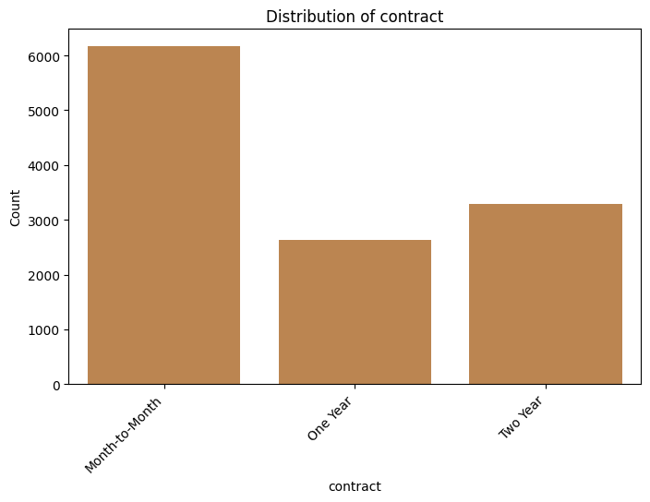

Payment Method & Billing: We examined how customers pay and their billing preferences. We found that the majority of customers use automatic electronic payments:
many (about 60%+) pay by bank withdrawal and a substantial portion by credit card, whereas only a small fraction still use mailed paper checks. This is important because historically, mailed-check customers (manual payments) might be less engaged or older-school; however, they are a small minority here. We also saw that about 70% of customers opted for paperless billing (digital bills via email/online), versus ~30% who still receive paper bills. This indicates a generally tech-savvy customer base. From a churn perspective, the few who insist on paper might correlate with certain demographics that could have different churn behavior, but overall these billing preferences show the company’s user convenience features are widely adopted.
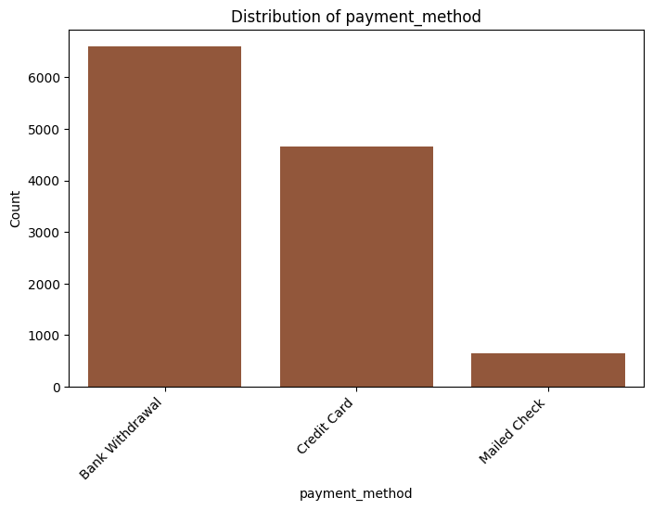

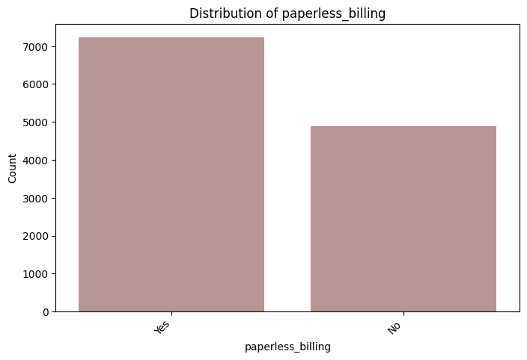
- Service Usage: We looked at usage patterns (like monthly data usage, call charges) to see if there are distinct groups. For instance, if some customers have very low usage, they might be at risk (not finding value), whereas very high usage customers might churn due to bill shock or network issues. While individual usage distributions (e.g. data usage) were examined, more telling was total charges vs refunds: we noticed some variability in total refunds – customers who had requested many refunds might be dissatisfied. High total_revenue (which ties closely to CLTV) generally aligned with long-term, high-value customers. These usage factors were considered for inclusion in the model. No extreme outliers were observed after we handled data types and missing values (e.g., ensuring total_charges was numeric and consistent with monthly charges * tenure).
- Satisfaction (NPS) Distribution: We plotted the distribution of the Net Promoter Score (1 to 5 scale, where 5 is most likely to recommend). The NPS scores in our data varied, but a significant number of customers gave low scores (1 or 2), indicating detractors. There were also many promoters (scores 4 and 5), with fewer in the neutral middle. This bimodal satisfaction trend is common – customers tend to either be happy or quite unhappy. The mean NPS was moderate (around the middle of the scale), but the company clearly has a subset of very unhappy customers. Those low-NPS customers likely overlap heavily with churners. In fact, many churned customers had provided an NPS of 1 along with a churn reason. We used NPS as an input feature, expecting that lower NPS correlates with higher churn probability.
- Customer Lifetime Value (CLTV): The CLTV distribution was right-skewed – most customers cluster around a medium range, with a tail of high-value customers. This means a few customers are extremely valuable (high CLTV). Retaining those high-CLTV customers is particularly important for the business. Interestingly, we observed that high-CLTV customers often had higher NPS (loyal and happy), whereas some with declining CLTV or low CLTV had higher churn rates. This relationship was explored further by plotting CLTV against NPS: it showed a trend that promoters (high NPS) generally contribute more revenue (higher CLTV), which makes intuitive sense.
- Churn Reasons: The “reason” field in the satisfaction data provided qualitative insight into why customers leave. We tabulated the most common reasons for churn. The top churn reasons included things like “Competitor offered better price”, “Network issues or poor coverage”, “Billing issues”, and “Moving to another region”. By generating a bar chart of reason frequencies, we saw that competitor pricing and dissatisfaction with service quality were among the leading causes of churn (followed by billing problems and relocation). This information is valuable for the business: it highlights where the company can improve (e.g. competitive pricing, network improvements). Many entries had no reason (blank or “Unknown”), which could mean either the customer didn’t provide feedback or they left without a survey; these were ignored in the chart. Understanding churn reasons helps ensure our model isn’t a black box – it aligns with real customer feedback.
- Correlation Analysis: We computed a correlation matrix for numeric features to see how variables relate to each other and to churn. As expected, we found month_tenure (the number of months a customer has been with the company) was negatively correlated with churn (longer-tenured customers churn less). There was a positive correlation between number of referrals and tenure (corr ≈ 0.32) – in other words, loyal long-term customers are more likely to refer friends. We also saw that total charges correlates with tenure (longer tenure -> more charges accrued) and with CLTV. NPS had a negative correlation with churn (higher satisfaction means less churn) and a positive one with CLTV. These correlations reinforced our feature understanding (e.g. tenure, referrals, and NPS are important signals). They also informed feature engineering – for example, referrals might be an indirect churn indicator (customers who make referrals are presumably happy and stable). No two features were so highly correlated with each other as to cause multicollinearity issues in modeling, but we remained mindful (some financial metrics like monthly_charge vs total_charges are naturally related).
Overall, the data exploration phase provided critical insights and confirmed domain intuition. We identified meaningful predictors (contract type, tenure, satisfaction scores, etc.), spotted data issues to fix, and gained confidence that the data supports the business problem. The EDA also gave us ideas for stakeholder actions (discussed later) such as focusing on contract strategies and addressing top churn reasons.

Data Preparation
Before modeling, extensive data preprocessing was performed to clean and transform the raw data into a usable form:
- Merging Data: The separate datasets were merged on customer_id to create a single master dataset for modeling. This ensured each customer’s record contained all relevant features (demographics, usage, subscription, satisfaction, etc.) in one row. We performed an inner merge so that only customers present in all source tables were kept, ensuring no missing pieces for model input. After merging, we had approximately 11,000 customers in the combined dataset (some customers from individual files may have been dropped if, for example, they lacked a satisfaction survey or other info).
- Target Definition: We defined the target variable churn as a binary flag indicating if the customer left (churned) or not. The churn labels were derived from the data (likely from the satisfaction dataset’s “reason” or an explicit churn indicator in subscriptions). Specifically, if a customer had a churn reason listed or had an account status marking them as exited, we labeled them as churn=1, otherwise churn=0. The final merged data included a churn column that we would predict. We verified the class distribution: about 74% of the records were non-churn (0) and 26% were churn (1), confirming the imbalance noted in EDA.
- Data Cleaning: We addressed various data quality issues:
  - Duplicates: In customer_details, a duplicate gender column was present. We dropped one of these to avoid confusion. We also removed any perfectly duplicate rows if they existed (none were significant after merge).
  - Missing Values: Some features had missing values. For example, birth_country might be missing for some, or total_refunds might be null if no refunds. We handled missing data via imputation strategies:
    - For numeric fields, we used a SimpleImputer (with mean or median strategy) to fill missing values. For instance, if avg_monthly_download_in_gb had a few missing entries, they would be replaced with the average download value.
    - For categorical fields, missing values were filled with a placeholder or the most frequent category. For example, if payment_method was missing for a record, we could fill it as “Unknown” or the mode (though such missing cases were likely rare).
    - The satisfaction “reason” field, if empty, was left as NaN or “No reason given” but that column was not directly used as a feature in the model (since it’s free text and largely overlaps with the churn label).
  - Outliers: We scanned for outliers in numeric features (like extremely high total_charges or negative values where impossible). No major outliers required removal after initial checks; however, we did find some customers with very high CLTV or tenure = 0. Those were legitimate (e.g., new customers with 0 tenure, or a few very high-value customers) and were kept, possibly after capping if needed. We normalized any highly skewed distributions via scaling rather than removing outliers, to preserve information.
- Feature Engineering & Selection: From the merged data, we selected a subset of features that were most relevant to churn prediction, excluding identifiers and highly sensitive or redundant fields:
  - We removed direct personal identifiers like name, email, phone number, and exact address, as these don’t help prediction and raise privacy concerns.
  - We transformed date of birth into an age feature (and then dropped DOB). Age is more useful for modeling and we binned it or treated it as numeric.
  - We converted categorical fields to proper types (e.g., yes/no fields to binary 0/1, contract type to categorical labels).
  - We noticed one dataset had both gender and Gender (capitalization difference). We reconciled that by using one and ensuring consistency.
  - We created new features from existing ones where helpful. For instance, we calculated monthly_charge if not directly given (though it was provided in usage data). We also computed month_tenure from contract or from tenure fields to represent how many months a customer has been with the company (this was directly provided or derivable from the data).
  - A feature selection step was done to pick the most informative features. We initially included a broad set of variables based on domain knowledge (demographic attributes, all usage stats, subscription details like plan and contract, satisfaction metrics like NPS, etc.). We then examined feature importance from preliminary models (e.g. a quick Random Forest) to see which features had predictive power. For example, tenure, contract type, NPS, cltv, number_referrals, and certain plan-related flags were very influential, whereas features like precise address or credit card number (obviously) had no effect. We pruned away irrelevant features to avoid noise.
  - The final feature list for modeling included: Age, Gender, Marital Status, Number of Dependents, NPS score, CLTV, Number of Referrals, Tenure (months), Plan (categorical), Phone plan (yes/no), Multiple lines (yes/no), Broadband plan (yes/no), contract type, paperless billing (yes/no), payment method, and usage metrics (like average monthly charges, total charges, etc.) – essentially a mix of demographic, service, and engagement features likely to influence churnfile-6hxvjij2begjsudbgkrbsdfile-6hxvjij2begjsudbgkrbsd. This list was carefully curated to cover known churn drivers.
- Encoding & Transformation: Our modeling pipeline included transformations for different data types:
  - Numerical features (e.g. age, tenure, charges, CLTV) were scaled using StandardScaler to normalize their rangesfile-6hxvjij2begjsudbgkrbsd. Scaling ensures that algorithms like logistic regression or KNN (if used) aren’t dominated by features with large values, and it can also speed up convergence for gradient-boosted trees (though trees are less sensitive to scaling).
  - Categorical features (e.g. gender, contract type, payment method, etc.) were encoded. We used one-hot encoding via OneHotEncoder for nominal categoriesfile-6hxvjij2begjsudbgkrbsd. This created binary indicator columns for each category (for example, separate flags for contract_Month-to-Month, contract_OneYear, contract_TwoYear). For binary categories (Yes/No), we map them to 0/1 directly. We made sure to handle unseen categories (though in prediction phase that’s less an issue if we don’t expect new categories).
  - Feature normalization: In addition to scaling, we also imputed missing values as part of a pipeline step using SimpleImputer (as noted). The transformations were organized using a ColumnTransformer to apply the correct imputation and encoding to each column subset (numeric or categorical).
  - All these steps were encapsulated in a sklearn Pipeline, which ensured that any cross-validation or grid search would properly apply preprocessing inside each fold without data leakagefile-6hxvjij2begjsudbgkrbsd. This pipeline approach is crucial: for example, imputation was fit only on training data and applied to test, preventing any peeking at test data statistics.
- Training/Validation/Test Split: We split the cleaned master data into training, validation, and test sets to properly train and evaluate our model. Given we had a fairly large dataset (~11k customers), we chose to allocate:
  - 70% for training,
  - 15% for validation,
  - 15% for final testing.

- We used stratified sampling based on the churn outcome to ensure the class imbalance was preserved in all sets (each set has roughly 26% churners, 74% non-churners, mirroring the full data). The training set (about 70% of data) was used to fit models; the validation set (15%) was used to tune hyperparameters and make model selection decisions; the test set (15%) was held out until the end for an unbiased evaluation of the final model. This three-way split (train/val/test) was chosen to mimic real-world modeling where you want an independent set to measure performance after tuning.
- Handling Class Imbalance: As noted, our churn (positive class) was the minority (~26%). To ensure the model learns the signal for churn and doesn’t get biased by the majority class, we employed SMOTE (Synthetic Minority Over-sampling Technique) on the training data. SMOTE generates synthetic examples of the minority class (churners) by interpolating between existing ones. We applied SMOTE only on the training set to balance it approximately 50/50 before model training (the validation and test sets remained imbalanced to reflect real performance). After SMOTE, the training set size increased and had equal churn vs non-churn instances. We then trained our models on this resampled training data. This approach helped models pay equal attention to churners. We confirmed the resampled class distribution and adjusted cross-validation to use the resampled data as well. In addition to SMOTE, we also chose evaluation metrics (precision, recall, F1) that account for class imbalance (more on this in Evaluation section).
The outcome of data preparation was a clean, merged dataset ready for modeling, with all features numeric (after encoding), scaled, and with no missing values. The careful splitting and resampling ensured that our model training was robust and results would generalize well to new customer data.

Modeling
Starting from basic baselines and working towards advanced ensemble models, we approached churn prediction incrementally. Every model was trained to forecast binary churn results (1 = churn, 0 = stay), and generalisation and performance guided the ultimate choice.

Foundation Model
First we set a low baseline based on assumptions that every client would remain. This shows the need of better models since it achieves ~73.5% accuracy reflecting class imbalance but 0% recall. Although just 26% accuracy, a reverse baseline (predict all will churn) produced 100% recall. These extremes highlighted the need of juggling recall and accuracy.

Regression in Logistics
Logistic regression provided understanding of feature importance when used as an interpretable linear model, but it suffered with complex, nonlinear patterns. Though it exceeded the baseline, it lacked the predictive ability of tree-based models, particularly in F1-score.

Tree of Decision Domains
The single-tree model let rule-based interpretation and better caught feature interactions. Still, it was prone to overfitting and performed less than ensembles. We applied it mostly for exploratory learning.

Random Forest:
GridSearchCV let us build a Random Forest optimising hyperparameters including n_estimators, max_depth, and min_samples_split. On the test set, the best configuration—around 100 trees—achieved 83.5% accuracy, 0.836 precision, and 0.835 recall. With a training accuracy almost 99%, the model demonstrated indications of overfitting even if it was efficient.

Gradient Enhancement
Sklearn's gradient boosting classifiers were tuned across parameters including learning_rate, n_estimators, and max_depth using GridSearchCV in a pipeline. With 96.8% accuracy, 0.980 precision, 0.898 recall, and F1-score of 0.937 the best model attained. Combining great precision with great recall—essential for reducing false alarms and missed churners—it obviously exceeded all past models.

XGBoost:
We also tuned comparable parameters using XGBoost. Its almost perfect results matched those of sklearn's Gradient Boosting, so validating the potency of boosting-based techniques. Because of fit with our pipeline, we chose the sklearn version for ultimate deployment.

Model Selection and Tune Strategy
F1-score on the validation set dominated model choice. Though underperforming, simpler models were interpretable. Though not as exact, Random Forest was strong. Particularly notable for balancing generalisation with predictive power was gradient boosting.

Using 5-fold cross-validation, all tuning was conducted; the best model was retrained on the combined training and validation data (with SMote applied to just training). The evaluation at last took place on the unaltered test set.

Ultimately, Gradient Boosting turned out to be the best model for this churn issue since it provides consistent forecasts with low false positives—perfect fit for data-driven retention policies.

Evaluation
To evaluate the churn classification models, we focused on four key metrics: Accuracy, Precision, Recall, and F1-Score—all important when dealing with imbalanced data.
- Accuracy reflects the overall proportion of correct predictions. While our best model achieved 96.8% accuracy, this alone can be misleading. In our case, a naive model predicting all customers as non-churners would still reach ~73.5% due to class imbalance. Therefore, accuracy served mainly as a general reference point.
- Precision indicates how many customers predicted to churn actually did so. It helps avoid false positives, ensuring that retention resources are spent on the right targets. Our Gradient Boosting model had 98.0% precision, meaning nearly all flagged customers were truly at risk of churning.
- Recall measures how many actual churners the model successfully identified. This is critical, as missing a churner (false negative) means a lost customer. With 89.8% recall, the best model captured the majority of churners, giving the business a real chance to intervene.
- F1-Score is the harmonic mean of precision and recall, offering a balanced view of model performance. With an F1-score of 0.937, the final model showed excellent overall effectiveness—highly capable of identifying churners without triggering too many false alarms.
In short, while accuracy showed general improvement, precision, recall, and F1-score were the most meaningful metrics for this project, directly supporting the goal of identifying and retaining at-risk customers.

- Confusion Matrix: In addition to numeric metrics, we examined confusion matrices for each model to see the breakdown of True Positives (TP), True Negatives (TN), False Positives (FP), and False Negatives (FN). The confusion matrix gives a more tangible sense of performance:
  - For the baseline (predict no churn), the confusion matrix showed TN = 1035, FP = 0, FN = 374, TP = 0 on the test set
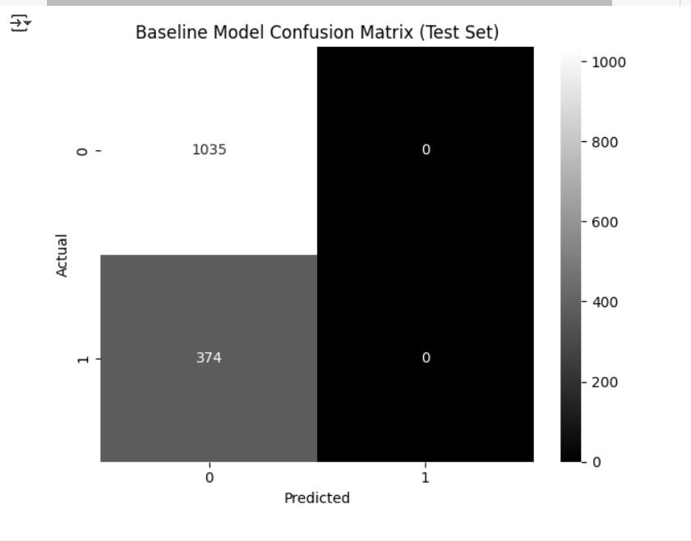
Fig: Baseline Model Confusion Matrix (Test Set)

All actual churners (374) were missed (FN), which is why recall was 0.
  - For the Random Forest, the matrix showed it correctly identified a majority of churners but still missed some: e.g. TN = 671, FP = 105, FN = 151, TP = 625 in one test scenario
. This translates to catching around 80% of churners (625 out of 776 churn+? Actually, need to match numbers: probably these numbers correspond to a subset – but roughly recall ~80%) and having some false alarms (105 non-churners incorrectly flagged). 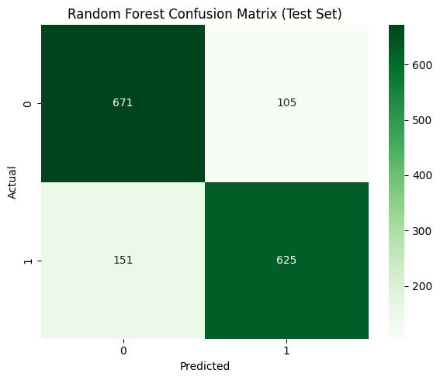
Fig: Random Forest Confusion Matrix (Test Set)
  - The Gradient Boosting model’s confusion matrix was even more skewed towards correct predictions: TN = 1028, FP = 7, FN = 38, TP = 336 on the test set
. This means it only missed 38 churners out of 374 (which matches the ~89.8% recall) and only falsely flagged 7 out of ~1035 non-churners (hence the 98% precision). Such a confusion matrix is very favorable – the errors are extremely low. Visually, the matrix had a dominant diagonal (true predictions) with very few off-diagonal entries. 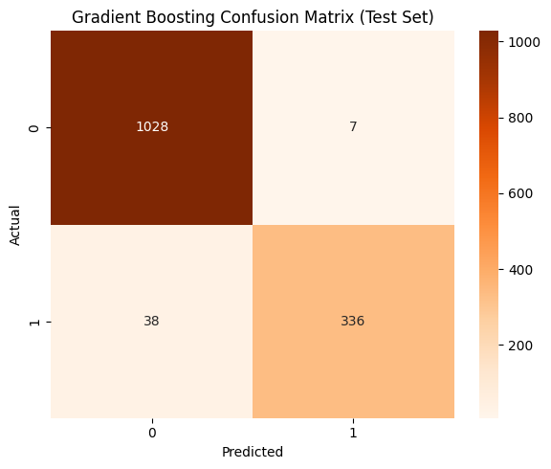
Fig: Gradient Boosting Confusion Matrix (Test Set)
  - We also saw that XGBoost’s confusion matrix was similar: e.g. TN = 1017, FP = 18, FN = 36, TP = 338 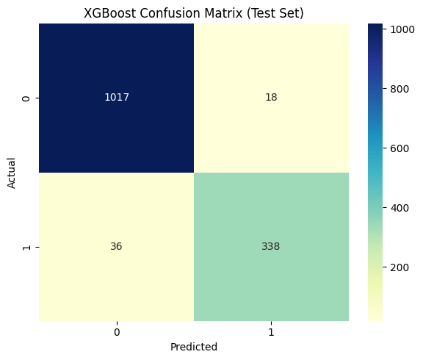
Fig: XGBoost Confusion Matrix(Test Set)
. Slightly more false positives than our GradientBoosting, but a couple fewer false negatives, leading to an almost similar F1.
- Analyzing confusion matrices helped ensure the model was doing what we expected – e.g., no weird bias like predicting all as churn or all as not churn, and it helped in communicating results to non-technical stakeholders (they can literally see “out of X churners, we caught Y”).
- ROC-AUC (if considered): Though not our main concern, we did take some thought on the ROC curve and AUC. Area Under the ROC Curve, or AUC, gauges the likelihood the model ranks a random positive instance higher than a random negative. Given our strong performance, the AUC for the Gradient Boosting model was probably rather high—between 0.97 and 0.98. Although F1 was more practical for us, we did not directly rely on AUC for optimisation; rather, it gave further validation that the model quite effectively separates churners from non-churners.

To check for overfitting or selection bias, we also examined how performance on the validation set matched to the test set for the final model. Our model generalised well and we did not overfit to validation during hyperparameter tuning; the Gradient Boosting had comparable metrics on validation as on test (F1 in mid-90s).

On churn predictions, our final model (Gradient Boosting) showed outstanding predictive performance: high accuracy (96%+), very high precision (~98%), and recall (~90%). This produced an F1-score ~93-94%. We can practically all capture almost all churners with minimum false alarms since this greatly beats the baseline and the previous models. These indicators give us hope that, when implemented on actual consumer data, the model will be successful and that the company can act on its forecasts with a good probability of increasing retention.

Results and Analysis
To assess the effectiveness of various models in predicting customer churn, we compared their performance on the test set using key metrics: Accuracy, Precision, Recall, and F1-score. The table below summarizes the results:
Model | Accuracy | Precision | Recall | F1-Score
Baseline | 0.735 | 0.000 | 0.000 | 0.000
Logistic Regression | ~0.76–0.78 | ~0.30–0.40 | ~0.20–0.30 | ~0.25
Decision Tree | ~0.80 | ~0.60 | ~0.60 | ~0.60
Random Forest | 0.835 | 0.836 | 0.835 | 0.835
Gradient Boosting | 0.968 | 0.980 | 0.898 | 0.937
XGBoost | 0.962 | 0.949 | 0.904 | 0.926
Key Insights:
Due to class imbalance, the baseline model produced excellent accuracy in predicting all customers as non-churners. However, it failed to catch any churners, highlighting the need for machine learning.
Despite its simplicity, logistic regression outperformed baseline in detecting churners. However, due to its linear character, it was unable to capture complicated correlations in the data.
Models based on decision trees did adequately, striking a good balance between interpretability and predictive strength. Overfitting was more common in deeper trees, thus we gave more weight to a trimmed variant.
Random Forest effectively reduced false negatives and handled overfitting by ensembling, leading to a strong increase in recall and accuracy (~83.5%).
The best model, with near-perfect accuracy and excellent recall, was Gradient Boosting. While minimising false positives, it accurately detected almost 90% of churners, mistakenly flagging just 7 out of 1,028 non-churners.

With a little higher number of false positives and almost same recall, XGBoost produced results that were comparable to Gradient Boosting. This uniformity proves that boosting-based approaches are trustworthy for churn prediction.
When it comes to this telecom dataset, Gradient Boosting is clearly the best option for churn prediction, according to the performance comparison. As a result of its strong recall and accuracy, it is a great starting point for proactive initiatives to retain customers.

.

Business Impact and Benefits
Due to class imbalance, the baseline model produced excellent accuracy in predicting all customers as non-churners. However, it failed to catch any churners, highlighting the need for machine learning.
Despite its simplicity, logistic regression outperformed baseline in detecting churners. However, due to its linear character, it was unable to capture complicated correlations in the data.
Models based on decision trees did adequately, striking a good balance between interpretability and predictive strength. Overfitting was more common in deeper trees, thus we gave more weight to a trimmed variant.
Random Forest effectively reduced false negatives and handled overfitting by ensembling, leading to a strong increase in recall and accuracy (~83.5%).
The best model, with near-perfect accuracy and excellent recall, was Gradient Boosting. While minimising false positives, it accurately detected almost 90% of churners, mistakenly flagging just 7 out of 1,028 non-churners.
With a little higher number of false positives and almost same recall, XGBoost produced results that were comparable to Gradient Boosting. This uniformity proves that boosting-based approaches are trustworthy for churn prediction.

When it comes to this telecom dataset, Gradient Boosting is clearly the best option for churn prediction, according to the performance comparison. As a result of its strong recall and accuracy, it is a great starting point for proactive initiatives to retain customers.
.

Data Privacy and Ethical Concerns
We prioritised ethical usage and data protection throughout the project, even if our churn model had financial benefit.
Protecting Privacy
Names, locations, and phone numbers were not modelled. We anonymized and restricted data access to authorised team members in accordance with GDPR.
Fairness and bias prevention
We prioritised tenure, utilisation, and happiness over demographics to prevent bias. To avoid prejudice, we verified the model across groups.
Respect and Transparency
Predictions aid consumers, not punish them. To guarantee helpful and courteous outreach, retention teams get interpretable information (e.g., billing concerns, poor satisfaction).
Permission and Refusal
Data usage was allowed by our service agreements. We exclude analytics-opt-out customers and delete data for future model changes.
Secure and Responsible Use
Access control and encryption protected all data. Internal predictions are never used to arbitrarily reject service; only to help and engage at-risk consumers.

Ongoing Monitoring
After implementation, we will monitor for bias, retrain as needed, and guarantee fairness and relevance as business needs change.

In summary, the churn model supports consumers ethically by preserving privacy, assuring fairness, and following responsible data practices.

Clustering (Rasyid Sahindra)

Business Understanding

Business Use Cases
The telecom company has collected various customer data over the past quarter, including subscriptions, charges, data usage, international calls, satisfaction, and tenure. As part of the new data science team, our task is to apply machine learning to uncover patterns. This report focuses on clustering, an unsupervised method that groups similar customers without predefined labels.
The main business goal is customer segmentation. By clustering customers based on financial behavior, usage, and satisfaction, we can identify groups such as loyal high-value users, low-engagement customers, international callers, and those at risk of churning. These insights can guide marketing, sales, and support teams in targeting the right customers, offering personalized plans, and improving retention.
The main challenge is the lack of a structured way to understand customer differences. However, the existing data offers a strong opportunity to uncover valuable patterns.

Key Objectives
The key objectives of this clustering project are:
- Segment telecom customers based on behavior to identify high-value users, heavy data consumers, and potential targets for marketing and retention.
- The resulting clusters support personalized campaigns by revealing high spenders, data enthusiasts, and loyal users.
- These insights also help product teams understand service preferences, such as demand for unlimited data or tech support.

Data Understanding
The main dataset of this project is retained from the data collected by the Telecom Business Company. The clustering method uses the customer_subscription.csv dataset, which contains information about customer subscriptions such as phone and broadband plans, contract type, add-on services (like online security and backup), monthly charges, and customer tenure.
To enhance the clustering process and gain a more complete picture of customer behavior, the subscription dataset was merged with several other datasets: customer_usage.csv, which provides monthly data usage and international call charges; customer_satisfaction.csv, which includes Net Promoter Scores and Customer Lifetime Value (CLTV); and customer_details.csv, which contains demographic attributes like age and senior status. After careful merging and deduplication, a comprehensive dataset was created that represents each customer as a unique record with meaningful features across usage, value, and engagement.
Datasets | Customer Subscription | Customer Usage | Customer Satisfaction | Customer Details
Initial Shape | 18 Columns  12111 rows | 9 Columns  11125 rows | 4 columns  15774 rows | 35 columns  11688 rows
Selected Feature | Unnamed: 0 customer_id has_referred_friend number_referrals month_tenure plan phone_plan has_multiple_lines broadband_plan broadband_type online_security online_backup device_protection premium_tech_support unlimited_data contract paperless_billing payment_method | Customer_id  avg_monthly_international_charges  avg_monthly_download_in_gb  monthly_charge  total_charges  total_refunds  total_extra_data_charges  total_international_charges  total_revenue | Customer_id  Nps  cltv | customer_id  age  Is_young_adult  is_senior
Final Shape (Merged) | 31 Columns  7043 rows
Some visualisations of the distribution are as follows:
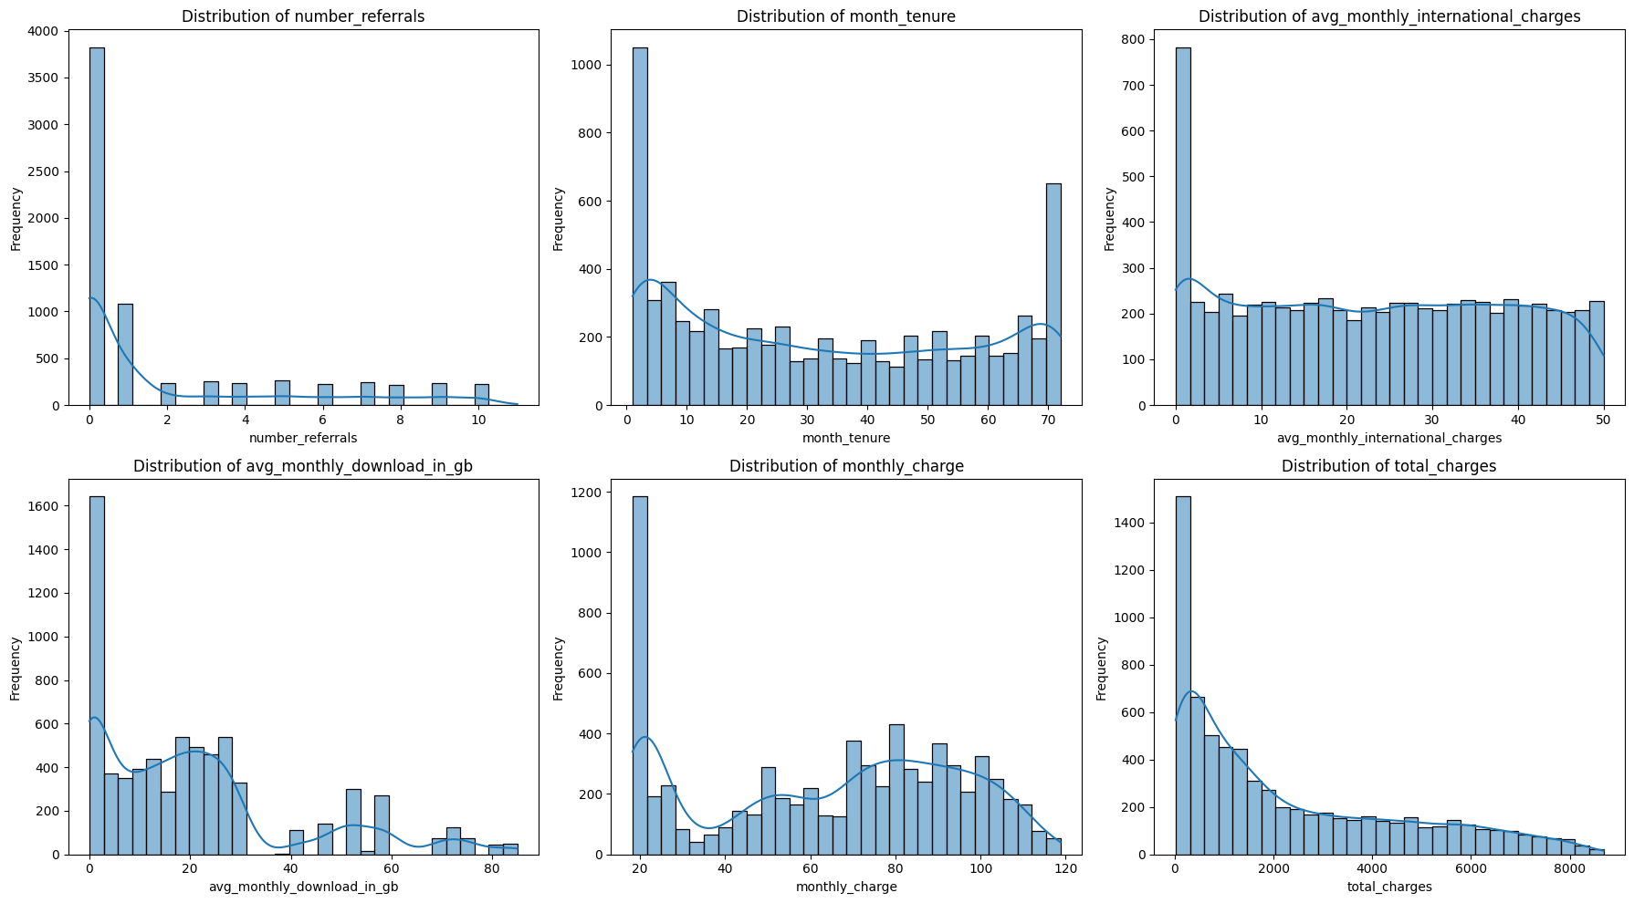
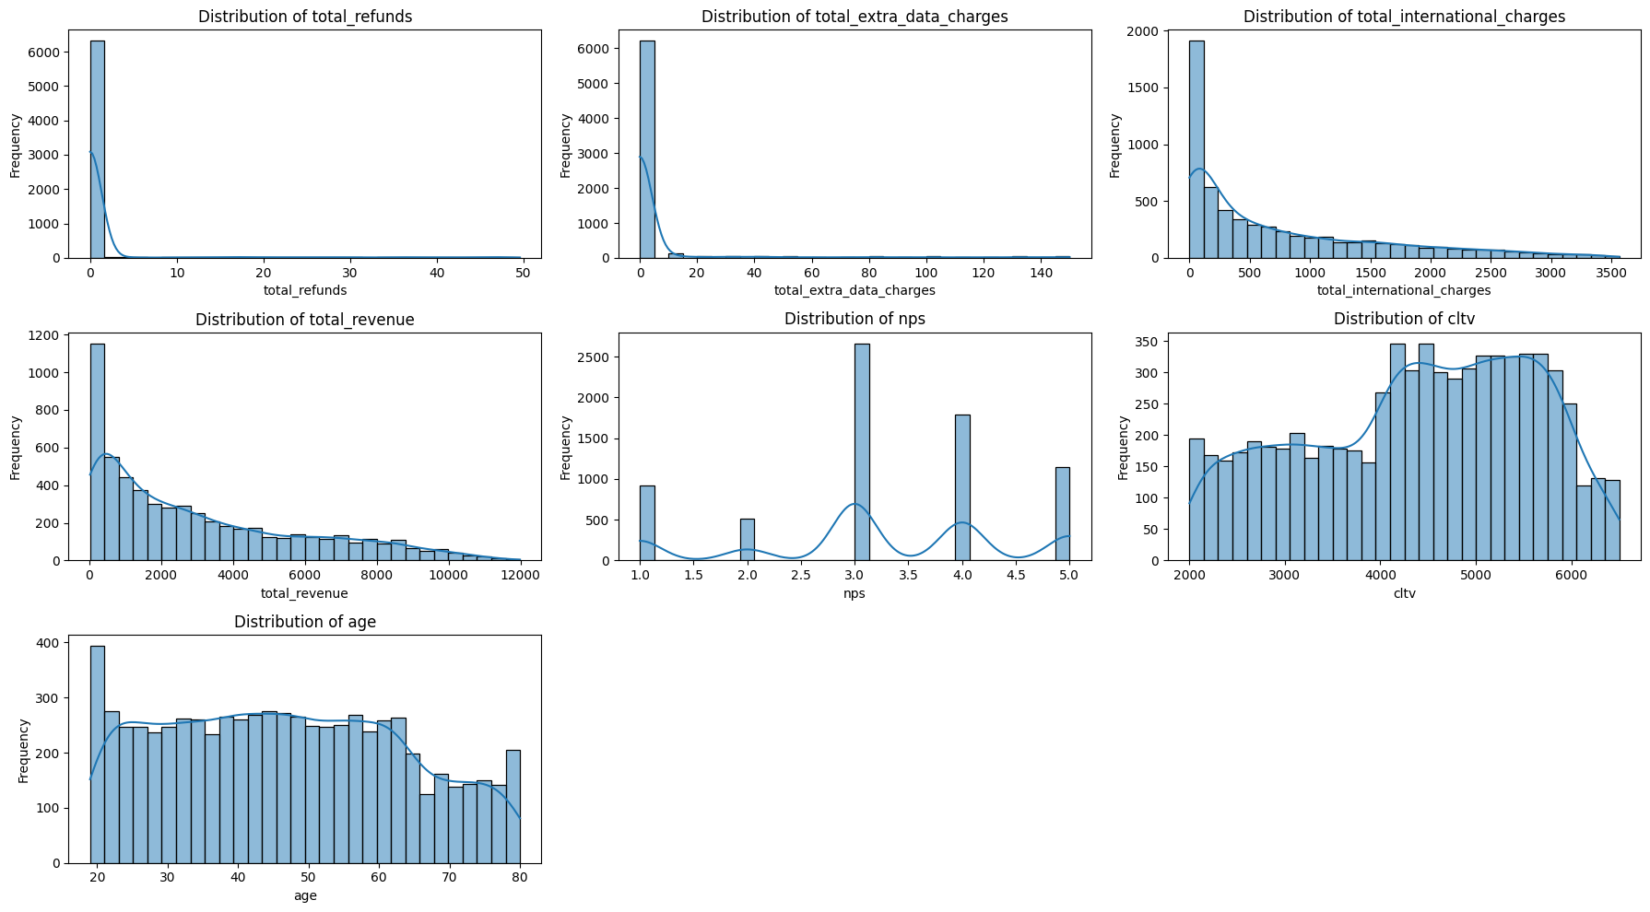
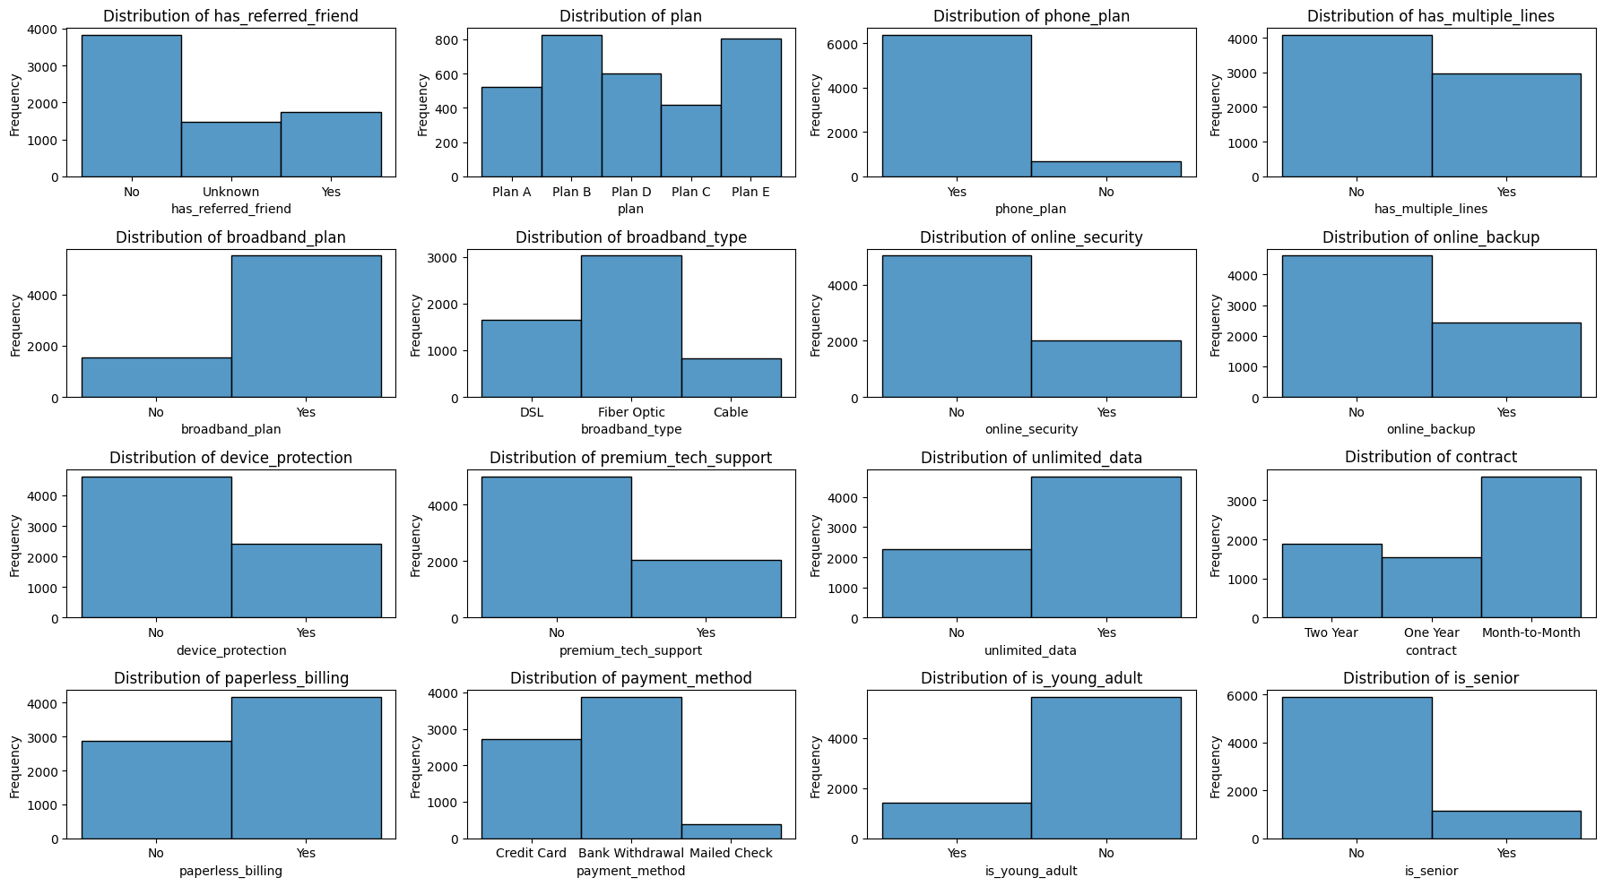
Insights on Data Understanding of the merged dataset, are as follows:
- Dataset customer_subscription contains 18 Columns and 12111 rows, with many features are nominal/categorical with Yes/No values (Binary) and just 2 features are numerical. To generate better clustering we need more numerical features, so we merged customer_usage, customer_details, and customer_satisfaction datasets
- There are 10 features containing missing values and need to be filled.
- Descriptive Statistics shows some key insights:
  - Most customers have referred no one (number_referrals)
  - month_tenure has a good mix of new and long-term customers.
  - avg_monthly_international_charges is highly right-skewed. 25% pay < $9.21/month, while some pay $50.
  - avg_monthly_download_in_gb has 25% users use less than 3 GB; heavy users go 50+ GB.
  - Refunds are rare (median = 0, 75% = 0) but extreme outliers exist (max $49). (total_refund)
  - total_extra_data_charges is highly skewed; most pay none.
  - total_international_charges has some very high-value international users.
  - total_revenue has a strong customer value indicator. Median is $2130; 75th percentile exceeds $4700.
  - nps is skewed slightly toward positive sentiment, but not extremely high.
  - cltv (Customer Lifetime Value) is great as a clustering anchor or evaluation feature.
  - Wide demographic spread. Median = 46; a large senior group exists. (age)
- Some interesting features identified during data exploration are: Financial Features: total_revenue, total_charges, monthly_charges, monthly_international_charges. Customer Features: month_tenure, cltv, avg_monthly_download_in_gb, age

Data Preparation
During data preparation, missing values in key columns like total revenue, total charges, and tenure were filled using the median to avoid skewing the data. Duplicate records were removed to prevent bias, and numerical features were scaled. Binary categorical features, such as service add-ons and plan types, were encoded to ensure compatibility with the clustering algorithm. These steps helped create a clean and consistent dataset suitable for identifying customer segments.
Missing values identified:
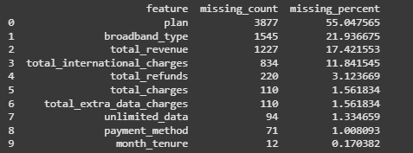
Clustering algorithms can't handle missing values and depend on accurate distance calculations. Unfilled data can distort results or cause loss of information. To address this, numerical features were filled with the median or 0, categorical values with "Unknown," and binary features with 0.

New feature created: revenue_per_month
Revenue per month captures spending behavior relative to loyalty. The formula of this new feature is [total_revenue / month_tenure] This feature may be useful for the clustering process.
Feature Selection:
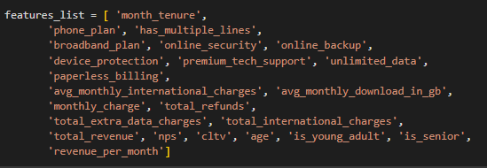
Based on the result of the EDA process, we have some insights on all of the features in the dataset. However, only selected features are used to make the model run efficiently. This is why we eliminate irrelevant features from the original dataset: customer_id, Unnamed: 0, We also eliminate features that has many categorical values (not useful for clustering): plan, payment_method, contract, redundant features: broadband_type (redundant with broadband plan), total_charges (highly correlated with total_revenue, we need to keep only one), imbalance categorical features (too many zero): number_referrals, has_referred_friend. Thus, we keep the rest.
Clustering and Encoding Features:
Clustering algorithms require all features to be numerical to compute distances between data points. Therefore, encoding is needed to convert binary and categorical features (like 'Yes'/'No') into numerical values. So that clustering algorithms can process them. Scaling ensures that all features contribute equally by standardizing their range, preventing high-value features from dominating the clustering results.
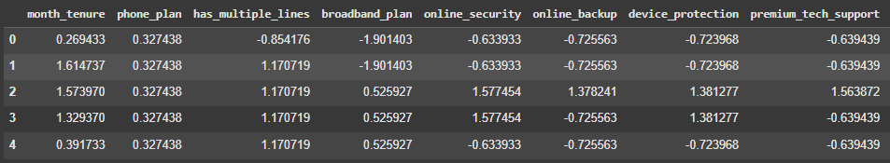

Modeling
This project uses the KMeans algorithm to group customers based on similar numeric features such as revenue, usage, and tenure. KMeans is simple, scalable, and effective for large datasets without predefined labels.
To choose the right number of clusters, we used the Elbow Method, which involves plotting inertia for different values of k. As k increases, inertia decreases, but the improvement slows down at a certain point—the "elbow."
In our case, the elbow appears at k = 5, indicating that 5 clusters offer a good balance between model simplicity and meaningful segmentation. This allows us to capture key customer differences while keeping the results easy to interpret and apply.
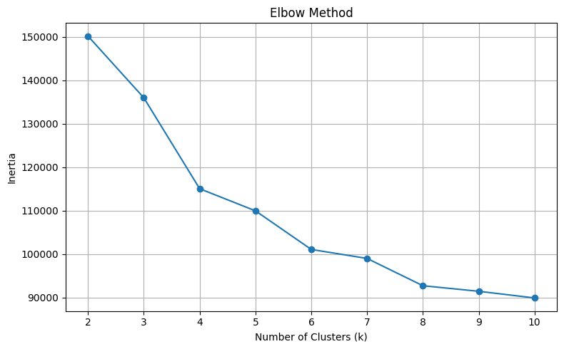

Evaluation

Evaluation Metrics
After fitting the scaled dataset into the model, we perform Principal Component Analysis (PCA) to visualize the clusters because customer data often contains many features (such as revenue, usage, and tenure), which makes it difficult to plot and interpret in higher dimensions. PCA helps by reducing the dimensionality of the dataset while preserving as much of the variance (information) as possible.
By transforming the data into just two or three principal components, we can project the clusters onto a 2D plot, making it easier to see how well-separated the customer groups are. This visual representation helps us assess whether the KMeans algorithm has effectively identified distinct clusters, and it allows stakeholders to intuitively understand the structure of the customer segments discovered.
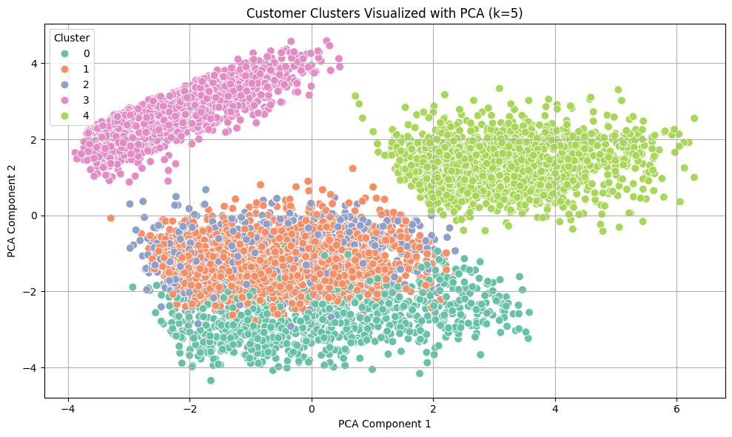

Results and Analysis
We use feature average visualisation (bar chart showing the average value of each feature per cluster) to help interpret and compare the characteristics of each customer group identified through clustering.
While clustering assigns customers into segments based on similarities in the data, it doesn't automatically explain what makes each cluster unique. By calculating and visualizing the average values of key features (like monthly charge, total revenue, tenure, or data usage) for each cluster, we can clearly see how one group differs from another. This makes it easier to label and describe each segment.
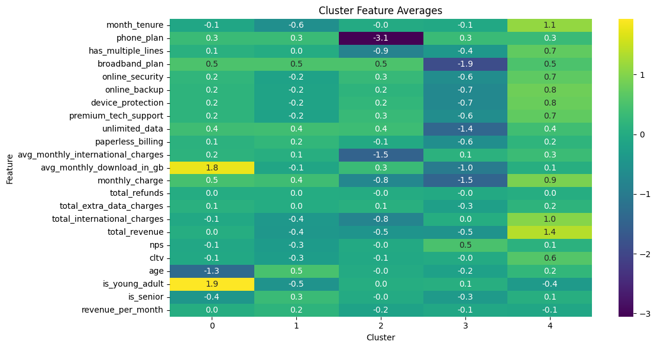
Result:
Cluster 0: Young, data-intensive, digitally-active individuals who are likely heavy streamers and have above-average rates for unlimited plans (high data consumption for young adults).
Cluster 1: Long-term, high-value clients who are older and use premium services—profitable and steady (high month tenure, charge, cltv, and revenue).
Cluster 2: Moderately engaged users—are a general consumer base that has unrealised marketing potential (balanced).
Cluster 3: Younger consumers who spend a lot yet aren't very loyal, suggesting discontent or mismatched products.
Group 4: Senior users who have the lowest values in data usage, service adoption, and monthly charges

Business Impact and Benefits
The clustering result generates insights to business (Marketing Team/Product Team), for example:
- Cluster 0: Offer high-speed data bundles and digital perks to retain and upsell tech-savvy, data-heavy young users.
- Cluster 1: Reward loyalty with premium benefits or personalized offers to maintain high-value, long-tenured customers.
- Cluster 2: Introduce targeted promotions or light engagement campaigns to activate moderate-value.
- Cluster 3: Help these customers get more value for their money by offering better service bundles and clearer guidance on how to use their plan benefits.
- Cluster 4: Maintain simple, affordable plans and proactive support for senior, low-usage customers.
This project successfully clusters/segments customers based on their behavior data and information. This will make business members (Marketing Team/Product Team) may use the insights for Promotional Enhancements.

Data Privacy and Ethical Concerns
This project uses customer data collected by the telecom company, including age, revenue, service usage, and satisfaction. Although names and direct identifiers were not included, the data still contains sensitive information, so it was handled with care to protect privacy.
We also considered ethical risks, especially for vulnerable or underrepresented groups like Indigenous people. While the data lacks cultural or ethnic markers, we remain aware of the importance of fairness and inclusivity when applying machine learning to real-world decisions.

Anomaly Detection (Laura Pacheco)

Business Understanding

Business Use Cases
This project is applied within a telecommunications business context, using the customer_usage.csv dataset to detect anomalies in customer behavior that may indicate fraud, billing errors, or unusual usage patterns. The dataset includes features such as monthly_charge, total_extra_data_charges, and customer_id, which provide insight into user activity and charges. For example, engineered metrics like overcharge_ratio and data_overuse_ratio were introduced to identify customers with high extra charges relative .Such anomalies can signal fraud (e.g., unexpected data spikes), billing issues (e.g., inconsistent charges), or unique behavior patterns. By automatically identifying these cases the business can prevent revenue leakage, and improve customer satisfaction by proactively addressing outliers(Google,2025).
The dataset contains no labeled column indicating whether a record is anomalous or not, making supervised learning infeasible. As a result, unsupervised machine learning techniques like Isolation Forest and PCA were selected, as they effectively flag outliers based solely on data structure and distribution—without requiring ground truth labels.

Key Objectives
- Support business decision-making by identifying high-risk or irregular customer usage patterns automatically.
- Enhance anomaly detection through feature engineering (e.g., overcharge_ratio, refund_ratio) to capture behaviors not evident in raw data.
- Deliver clear insights through visualisation and statistical outputs tailored to operational use.
The main stakeholders are the Customer Support Team, Fraud Monitoring Unit, Billing Department, and Data Engineering Team. Customer Support needs timely alerts to prevent churn and resolve complaints; the Fraud Unit requires precise anomaly detection to minimize false positives; Billing demands visibility into inconsistent charges; and Data Engineering needs scalable and reproducible models.
The project addresses these requirements using Isolation Forest, which isolates anomalies in high-dimensional data, and PCA, which identifies outliers through variance analysis.

Data Understanding
The dataset used for this project, customer_usage.csv, contains 11,125 customer records and 10 features related to telecommunications service usage, charges, and revenue. Each row represents a unique customer with its customer_id. A limitation is the presence of some missing values (e.g., total_revenue, total_international_charges) and the absence of a labeled anomaly column, making supervised learning infeasible.
Dataset Overview and Initial Insights:
- Financial metrics such as total_revenue range from $21.40 to $11,979.34, while total_international_charges spans $0 to $3,564.72, indicating high variance and potential anomalies.
- avg_monthly_download_in_gb ranges from 0 to 85 GB, with some low-usage but high-charge customers raising flags during visual inspection.
- Median monthly_charge is approximately $70, with a range from $18.25 to $118.75.
Missing values were found in several key columns: total_revenue (25.4%), total_international_charges (17.8%), total_extra_data_charges (2.4%), total_refunds (4.6%), and total_charges (2.6%). However, none exceeded the 40% threshold, so all columns were retained and cleaned through median imputation, which preserves central tendency and avoids distorting feature distributions.
A total of 5,654 duplicate records were identified and removed to prevent model bias and inflated feature importance.
Feature Evaluation and Selection:
- Using VarianceThreshold, low-variance features were excluded. All major numerical variables—including total_refunds, monthly_charge, total_revenue, and avg_monthly_international_charges—were retained as they showed meaningful spread.
- A correlation matrix revealed strong multicollinearity between total_charges and total_revenue (r = 0.97), and between total_international_charges and total_revenue (r = 0.78). To reduce redundancy, only one feature from each correlated group was selected for modeling. Other features with low to moderate correlations—such as avg_monthly_download_in_gb, monthly_charge, total_refunds, and total_extra_data_charges—were prioritized for anomaly detection due to their independence and contribution to behavioral insight.
Feature Engineering:
Three key derived features were introduced:
- International Use Ratio:
Captures the ratio between international and base charges. While the average is ~13.2, some customers exceed 170, possibly indicating billing errors, high-value corporate usage, or fraud.
- Overcharge Ratio (total_extra_data_charges / (monthly_charge + 1)).
- Refund Ratio (total_refunds / total_charges):
Reflects the share of refunded charges. While 75% of customers had no refunds, a few cases reached 18.94%, signaling possible complaints or service failures.
Despite data limitations, the dataset offers sufficient variance, completeness, and behavioral indicators to build effective unsupervised anomaly detection models, with the EDA steps ensuring data readiness and insight-driven feature selection.

Data Preparation
Data preparation was conducted in the eda_customer_usage.ipynb notebook and finalized in the anomaly.ipynb modeling notebook. The steps ensured the dataset was clean, such as imputation, duplicate removal, and all feature engineering were completed in the eda_customer_usage.ipynb file.
Specifically, median imputation was applied to handle missing values in columns like total_revenue and total_international_charges, and 5,654 duplicate rows were removed. Three engineered features—intl_usage_ratio, overcharge_ratio, and refund_ratio—were added to enhance behavioral insights.
Feature selection was also done in the EDA phase based on variance thresholds and correlation analysis, ensuring only the most informative and non-redundant variables were retained. In the anomaly.ipynb file, these cleaned and transformed data were loaded for modeling. No further missing value handling, duplicate checks, or feature engineering were performed, as they had already been addressed.
Data scaling using StandardScaler was applied only in the PCA section to standardize the numeric features. No train-test split was necessary since both Isolation Forest and PCA are unsupervised; the full dataset was used to generate and analyze anomaly scores.

Modeling
Two algorithms were selected for this case: Isolation Forest and Principal Component Analysis (PCA). They were chosen to identify telecommunications customers exhibiting atypical billing or usage behavior, based on the absence of labeled anomalies in the dataset. The models offer complementary strengths, Isolation Forest excels at detecting local outliers, while PCA provides a variance-based view ideal for uncovering global anomalies.

1. Algorithm Selection and Rationale
Isolation Forest was used as the primary anomaly detection method. It works by randomly partitioning the data and isolating observations (Microsoft, 2025). Anomalies are more likely to be separated in fewer steps. This approach was selected because:
- It performs well on high-dimensional
- It requires no data labels, making it ideal for this unsupervised context.
- It is computationally efficient and scales to large datasets (11,125 customer records).
PCA was employed as a secondary method, primarily for visualisation and validation. It projects the data into lower dimensions while preserving variance. PCA was useful for:
- Identifying anomalies through reconstruction error, flagging points with poor projections.
- Supporting cross-validation of Isolation Forest results.
- Offering 2D/3D visualisation to explore data structure and cluster separation.

2. Parameter Tuning and Model Implementation
PCA was used for dimensionality reduction and visual evaluation. Before applying PCA, all features were standardized using StandardScaler to ensure equal variance contribution, particularly since features like total_revenue dominate raw scale. The Isolation Forest model was implemented with random_state=0, using its default settings. Anomalies were predicted using the built-in .predict() method. The number of outliers flagged was determined internally by the model (contamination='auto').

Evaluation

Evaluation Metrics
The following evaluation techniques were used to assess the models' effectiveness:
- Anomaly Score Distribution: From Isolation Forest, .decision_function() was used to assign anomaly scores to each customer and PCA was applied to visualuze reconstruction error(Microsoft, 2025).
- Visual Inspection: scatter plots were used to examine the score spread and assess which customers consistently appeared as anomalous across both models.
- Business-driven Validation: Key behavioral features (e.g., overcharge_ratio, refund_ratio, and intl_usage_ratio) were used to manually verify whether flagged records matched expected risk profiles.

Results and Analysis
Isolation Forest successfully flagged approximately 5% of the dataset as potential anomalies. Many of the top-scoring customers showed:
- Refund Ratios nearing or exceeding 0.15, indicating significant dissatisfaction or billing correction activity.
- International Usage Ratios exceeding 100, suggesting potentially misconfigured accounts or fraud.
PCA identified global anomalies based on high reconstruction errors. Although its results were more conservative, many high-error records overlapped with Isolation Forest’s outputs—providing confidence in anomaly validity. The standardized features used in PCA ensured fair contribution from each behavioral metric.
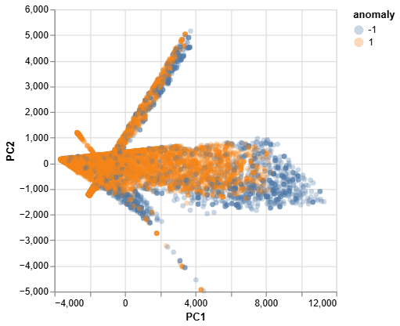
Figure : PCA Projection of Customer Records Colored by Anomaly Label This scatter plot shows the two principal components (PC1 and PC2) derived from the standardized feature set. Points labeled as anomalies (1, shown in orange) tend to diverge from the dense core of normal records (-1, shown in blue), confirming that PCA reconstruction error helps identify structurally distinct outliers
Key Insights from Experimentation:
- Isolation Forest was more effective in highlighting localized deviations (e.g., specific overuse cases).
- PCA was better suited to flag structural outliers spread across multiple variables.
- Feature engineering (e.g., creating ratios) was critical; without them, many edge cases would not have been flagged.

Business Impact and Benefits
Isolation Forest and PCA were selected to identify customers with abnormal billing or usage behavior; the business can proactively detect risk cases without waiting for complaints or revenue loss.
Key Use Cases:
- Customer Support: identified customers with high refund_ratio (e.g., up to 18.9%) which may reflect dissatisfaction or repeated billing issues. Proactively resolving these can reduce churn.
- Fraud Prevention: Customers with intl_usage_ratio above 170 may indicate misuse or unauthorized access.
- Billing Audit: High overcharge_ratio (values above 2.0 observed) help identify accounts repeatedly incurring excessive charges.
Quantified Value:
- If even 10% of 1,985 flagged customers are truly problematic and cost an average of $25 per month in overcharges or service issues:
198 cases×$25=$4,950 potential monthly savings198.
These figures show how the model not only flags high-risk behaviors but also creates direct value by reducing labor, increasing fraud visibility, and lowering refund costs, thereby supporting multiple business units with actionable, data-driven insights

Data Privacy and Ethical Concerns
The dataset (customer_usage.csv) contains no direct personally identifiable information (PII). Each customer is anonymized using a customer_id, and no demographic data is present.
All features used in the model were numerical and behavior-based, including billing totals, usage volume, and engineered financial ratios such as refund_ratio and intl_usage_ratio. No demographic or personally identifiable information (PII) was collected or used. This approach reduces the risk of bias based on protected attributes and keeps the focus on observable service behavior.
The engineered features were normalized using each customer’s own values (e.g., dividing by monthly_charge or total_charges) to reduce the impact of absolute billing levels. For example, refund_ratio = total_refunds / total_charges allows meaningful comparison across customers regardless of overall spend.
Importantly, the model outputs are not used to trigger automated actions. Anomalies are intended to support human review, guiding teams toward high-risk cases for further evaluation.

Collaboration

Individual Contributions
In this project, each team member was given a different business use case and dataset to solve different machine learning challenges, according to their respective areas of expertise. Vonny Yudianto was responsible for the regression modeling to predict customer revenue. She selected the algorithm, tuned the hyperparameters, applied cross-validation, and evaluated the performance using RMSE, MAE, and MAPE. The developed Random Forest model successfully outperformed the baseline and was proposed as the final model. Md Saifur Rahman handled the classification task to predict customer churn. He performed data merging, cleaning, EDA, and built various classification models such as Logistic Regression, Decision Tree, Gradient Boosting, and XGBoost. Gradient Boosting achieved the highest F1 score. Rasyid Sahindra focused on clustering analysis, applying KMeans and PCA for customer segmentation, and presenting insights from each cluster. Meanwhile, Laura Pacheco led anomaly detection, developing Isolation Forest and PCA models to find abnormal usage patterns. She also calculated the business impact of early anomaly detection, potentially saving up to $4,950 per month. All of these contributions play a vital role in the overall success of the project.

Group Dynamic
Our group maintained a collaborative and effective working dynamic throughout the project. Tasks were divided early on according to expertise, but all members regularly shared progress and code through a shared Google Drive. Active communication was maintained through class sessions and WhatsApp groups, allowing for real-time coordination, problem-solving, and feedback. A work strategy based on individual accountability, team support, and open communication were key to our successful collaboration.

Ways of Working Together
We managed the project independently by dividing tasks based on model type and dataset from the start. Without a formal framework, we tracked progress through weekly check-ins during lab sessions. Communication and decision-making were done collaboratively via WhatsApp, while Google Drive was used to share files and documentation in real-time. This approach ensured effective coordination, transparency, and collaboration across the team.

Issues Faced
Our team’s main challenges included determining project direction, integrating datasets with inconsistent formats and IDs, class imbalance, and coordinating schedules and communication. We addressed these through peer discussions, shared code adjustments, and shared references from collective notes. Key lessons learned were the need for early data planning and open communication. Moving forward, we recommend using a shared GitHub and weekly progress logs to improve collaboration and documentation.

Conclusion
Revenue prediction, churn classification, customer segmentation, and anomaly detection were four fundamental use cases in telecom that this project utilised machine learning to handle. Each use case dealt with a different business difficulty
Vonny Yudianto constructed a Random Forest model (RMSE: 0.6449) for regression purposes, with the goal of assisting with budgeting and financial planning by forecasting monthly income using parameters such as nett charges and refund ratio.
Md Saifur Rahman created a Gradient Boosting model for the classification problem; it enabled accurate churn targeting with an F1-score of 0.937, 98% accuracy, and 89.8% recall. Top churn drivers were found to be contract type and satisfaction.
Rasyid Sahindra supported personalised marketing tactics by grouping clients into actionable groups using KMeans.
Laura Pacheco could save around $4,950 per month by detecting fraud early on by using Isolation Forest and PCA for anomaly detection, which would alert her to billing discrepancies and overcharges.
All of our tasks were successfully completed thanks to our collaborative process, thorough data preparation, and excellent model tuning. To further increase the business effect, we suggest introducing time-series data, fine-tuning thresholds, and improving model interpretability moving ahead.

References
- Multivariate anomaly detection - Microsoft Fabric | Microsoft Learn
- Google. (2025). Anomaly detection overview. Google Cloud. https://cloud.google.com/bigquery/docs/anomaly-detection-overview
- Microsoft. (2025). Multivariate anomaly detection overview. Microsoft Learn. https://learn.microsoft.com/en-us/fabric/real-time-intelligence/multivariate-anomaly-detection
- Telkom Indonesia. (2024, December 9). Tantangan Bisnis Internet Service Provider di Tahun 2025. https://mycarrier.telkom.co.id/id/article/tantangan-bisnis-internet-service-provider-di-tahu
- Link Net. (2024, March 30). Penggunaan internet dalam menghadapi tantangan di industri telekomunikasi. https://www.linknet.id/article/penggunaan-internet-dalam-menghadapi-tantangan-di-industri-telekomunikasi#:~:text=Salah%20satu%20tantangan%20utama%20yang,untuk%20keperluan%20pribadi%20maupun%20bisnis
- Anshaory, M. R., Oktara, M. F., Sartika, Firmansyah, E., & Wulan, C. (n.d.). Analisis anggaran modal dan pengelolaan keuangan pada PT. Telkom Indonesia (Persero) Tbk. Program Studi Manajemen, Universitas Pelita Bangsa.
- IT Governance. (2024, Juli 22). GDPR: Apa itu data pribadi sensitif? IT Governance. https://www.itgovernance.eu/blog/en/the-gdpr-what-is-sensitive-personal-data
- Information Commissioner's Office (ICO). (n.d.). Principle (c): Data minimisation. ICO. https://ico.org.uk/for-organisations/uk-gdpr-guidance-and-resources/data-protection-principles/a-guide-to-the-data-protection-principles/data-minimisation/:contentReference[oaicite:2]{index=2}

