CYMANABU
Cybersecurity Internship Program

WEEK 2 TASK SUBMISSION
Internship Domain
Cybersecurity – Network Security & Traffic Analysis
Tools Used
Kali Linux | Wireshark | VMware

Submitted By: Saif Sami
College: Oriental College of Technology
Branch: Cybersecurity
Internship: Cybersecurity Internship

TABLE OF CONTENTS
- Abstract ................................................ 1
- Project Objectives .................................... 3
- Lab Setup & Architecture ............................. 4
- Tools Used ............................................ 6
- Methodology ........................................... 7
- DNS Traffic Analysis .................................. 8
- TCP Traffic Analysis .................................. 10
- UDP Traffic Analysis .................................. 13
- ICMP Traffic Analysis ................................ 15
- HTTP Traffic Analysis ............................... 18
- Findings and Observations ........................... 21
- Security Analysis & Risk Identification ............. 22
- MITRE ATT&CK Mapping ................................ 23
- Remediation & Security Recommendations .............. 24
- Conclusion & Key Learnings ........................... 25
- References & Evidence ............................... 26

ABSTRACT
Network traffic analysis is an important process in cybersecurity that helps understand and monitor communication between devices over a network. This project focuses on capturing and analyzing network packets using Wireshark in a Kali Linux virtual machine.
The practical work involved analyzing DNS, TCP, UDP, ICMP, and HTTP traffic. Wireshark was used to examine packet details such as source and destination IP addresses, port numbers, protocol types, TCP handshake packets, and HTTP data.
The project provided practical experience in packet capture, protocol analysis, and understanding network communication. It also demonstrated how unencrypted HTTP traffic can expose readable webpage content during transmission.

PROJECT OBJECTIVES
The main objectives of this project are:
- To understand the fundamentals of network traffic analysis.
- To capture live network packets using Wireshark.
- To analyze DNS, TCP, UDP, ICMP, and HTTP protocols.
- To identify source and destination IP addresses and port numbers.
- To observe the TCP 3-way handshake.
- To examine DNS query and response communication.
- To understand the risks associated with unencrypted HTTP traffic.
- To develop practical skills in packet capture and network troubleshooting.

LAB SETUP & ARCHITECTURE.

6. LAB SETUP & ARCHITECTURE
6.1 Lab Environment
The project was performed in a Kali Linux virtual machine using Wireshark for network traffic capture and analysis.
Component | Description
Operating System | Kali Linux
Virtualization | VMware
Network Interface | eth0
Packet Analysis Tool | Wireshark
Test Environment | Personal virtual machine and network
Traffic Types | DNS, TCP, UDP, ICMP, HTTP
6.2 Network Architecture
The Kali Linux VM generated network traffic and captured packets through its eth0 interface. The traffic included communication with the configured DNS server and a remote web server.
Network Flow:
Kali Linux VM (192.168.52.128)
↓
eth0 Network Interface
↓
VMware Virtual Network
↓
DNS Server (192.168.52.2) / Remote Web Server
6.3 Lab Safety
All packet captures were performed in the user's own virtual machine and for educational analysis. The project focused on observing network traffic and protocol behavior.

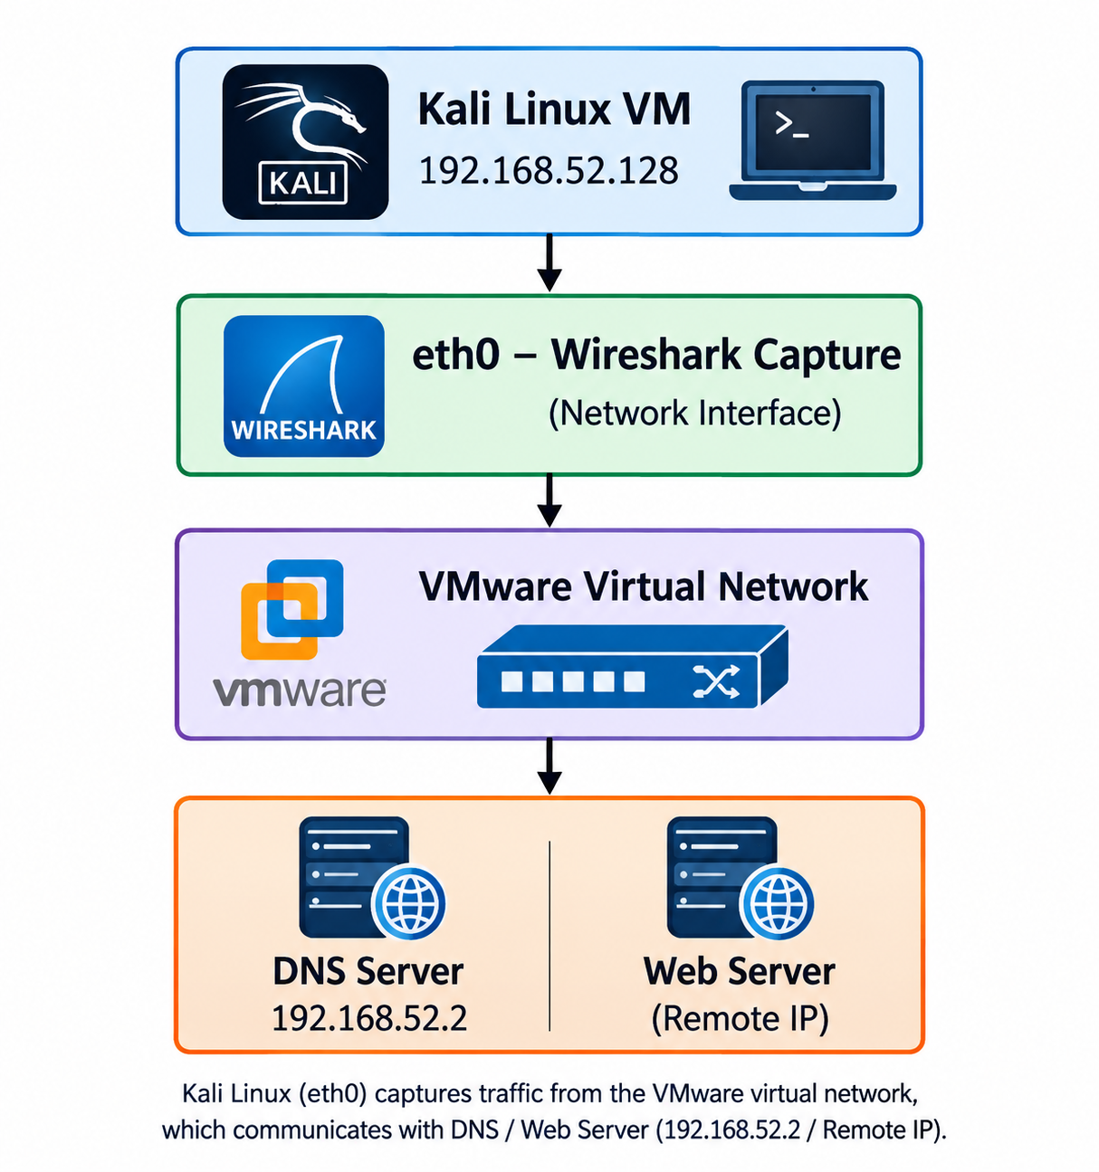

4. Tools Used
The following tools and technologies were used for performing the network traffic analysis:
Tool / Technology | Purpose
Kali Linux | Operating system used for the security lab
VMware | Used to run the Kali Linux virtual machine
Wireshark | Capturing and analyzing network packets
Terminal | Generating network traffic and running commands
TCP/IP | Network communication protocols analyzed
DNS | Domain name resolution traffic analysis
HTTP | Unencrypted web traffic analysis
ICMP | Connectivity and diagnostic traffic analysis
UDP | Connectionless network traffic analysis
TCP | Reliable connection-oriented traffic analysis
4.1 Traffic Generation Commands
The following commands were used to generate traffic for analysis:
- nslookup example.com — DNS traffic
- curl http://example.com — TCP/HTTP traffic
- ping -c 4 192.168.52.2 — ICMP traffic
- curl http://neverssl.com — HTTP traffic

5. Methodology
The network traffic analysis was performed using a controlled Kali Linux virtual lab. Wireshark was used to capture packets generated by different network activities.
5.1 Step-by-Step Methodology
- Started the Kali Linux virtual machine in VMware.
- Verified the network interface eth0 and IP address 192.168.52.128.
- Opened Wireshark and selected the eth0 interface for packet capture.
- Generated DNS traffic using nslookup example.com.
- Generated TCP and HTTP traffic using curl.
- Generated ICMP traffic using ping.
- Applied Wireshark display filters to identify specific protocols.
- Analyzed source and destination IP addresses, ports, packet types, and communication patterns.
- Captured screenshots of important packets as evidence.
- Recorded the observations and findings for each analyzed protocol.
Used5.2 Wireshark Filters
Protocol | Wireshark Filter
DNS | Dns
TCP | Tcp
UDP | Udp
ICMP | Icmp
HTTP | http
Specific IP | ip.addr == 192.168.52.128
5.3 Analysis Process
The captured packets were examined individually to identify communication between the source and destination systems. Protocol-specific fields such as IP addresses, port numbers, packet types, TCP flags, and packet contents were inspected where applicable.

6. DNS Traffic Analysis
6.1 Objective
The objective of DNS traffic analysis was to observe how a domain name is resolved into an IP address and to identify the communication between the Kali Linux system and the DNS server.
6.2 Traffic Generation
The following command was used to generate DNS traffic:
nslookup example.com
6.3 Wireshark Filter
dns
6.4 Packet Details
Parameter | Observation
Source IP | 192.168.52.128
Destination IP | 192.168.52.2
Protocol | DNS
Destination Port | 53
Query | example.com
DNS Server | 192.168.52.2
The DNS query was sent from the Kali Linux system to the DNS server. The DNS server returned the resolved IP addresses for example.com.
6.5 Resolved Addresses
The observed DNS response included the following addresses:
- 104.20.23.154
- 172.66.147.243
- 2606:4700:90d5:72db:f2c5:8af:ef6b:ff98
6.6 Observation
Wireshark showed a DNS query from 192.168.52.128 to 192.168.52.2 and a corresponding DNS response from the DNS server. The traffic demonstrated the basic domain-name resolution process.
6.7 Evidence
Figure 2: DNS Traffic Capture
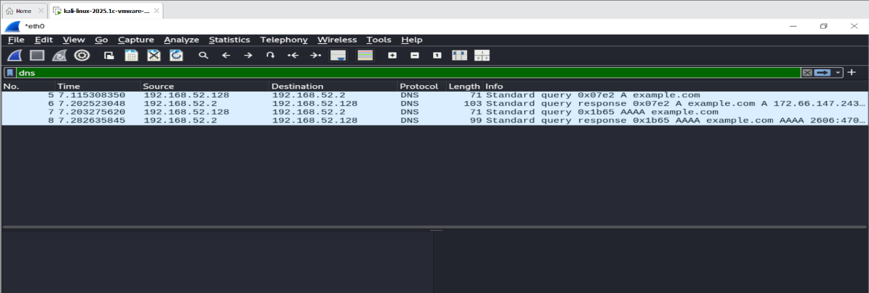
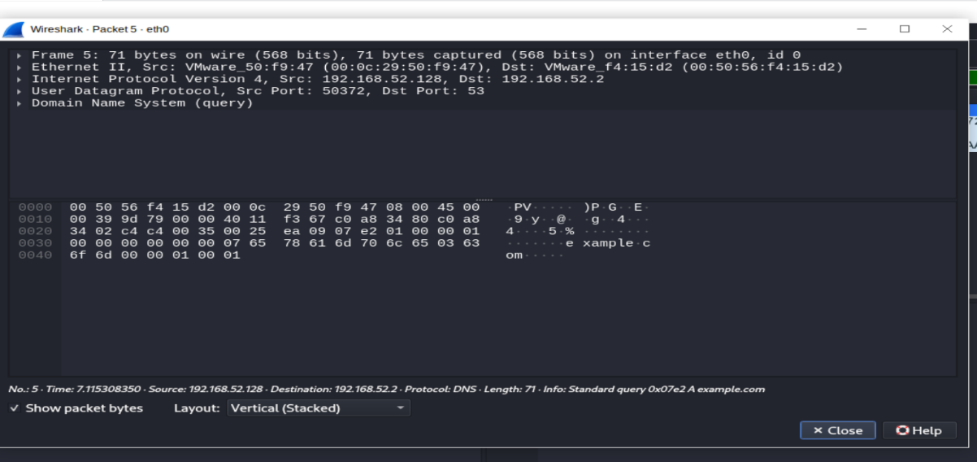
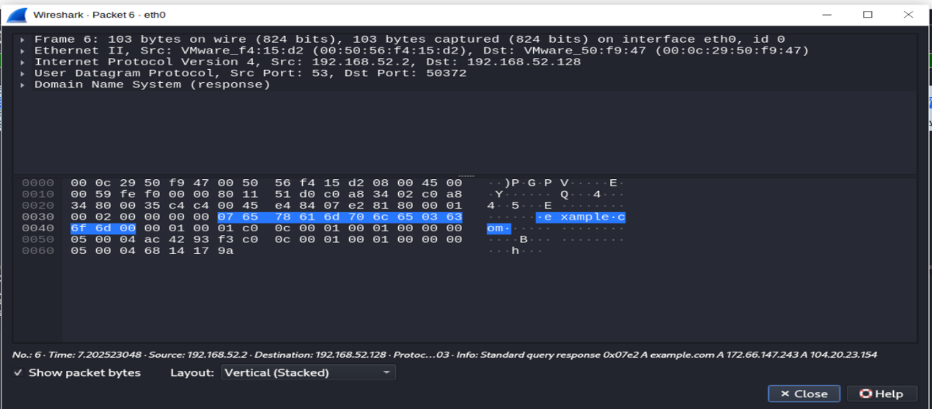

Caption: Figure 2: DNS Query and Response Captured Using Wireshark

7. TCP Traffic Analysis
7.1 Objective
The objective of TCP traffic analysis was to observe the TCP three-way handshake and understand how a reliable connection is established between two systems.
7.2 Traffic Generation
The following command was used to generate TCP traffic:
curl http://example.com
7.3 Wireshark Filter
tcp
7.4 TCP Three-Way Handshake
The captured traffic showed the TCP connection establishment process:
- SYN — 192.168.52.128 → 104.20.23.154
- SYN-ACK — 104.20.23.154 → 192.168.52.128
- ACK — 192.168.52.128 → 104.20.23.154
This sequence represents the TCP three-way handshake used to establish a connection before data transmission.
7.5 Packet Analysis
Parameter | Observation
Source IP | 192.168.52.128
Destination IP | 104.20.23.154
Protocol | TCP
Connection Process | SYN → SYN-ACK → ACK
Purpose | Connection establishment
7.6 Observation
The Wireshark capture clearly showed the TCP three-way handshake. The client first sent a SYN packet, the remote server responded with SYN-ACK, and the client completed the process with an ACK packet.
7.7 Evidence
Figure 3: TCP Three-Way Handshake
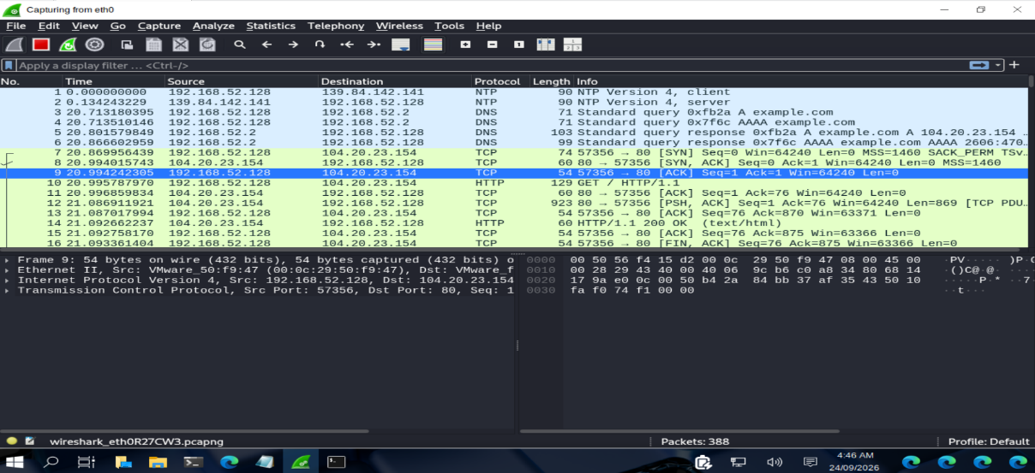
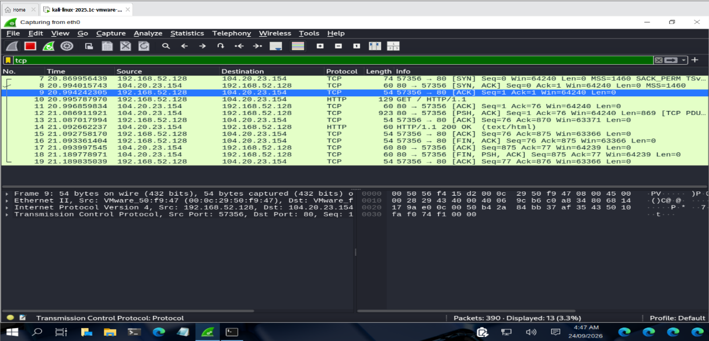
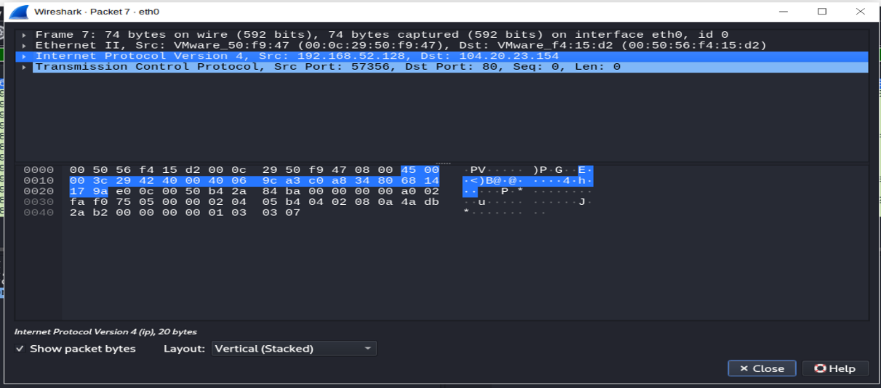
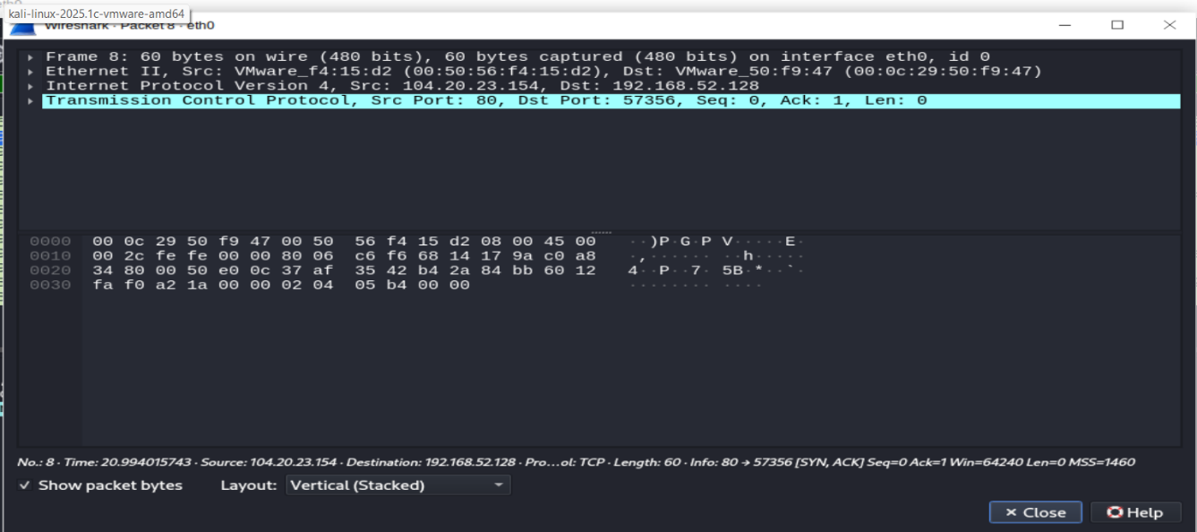
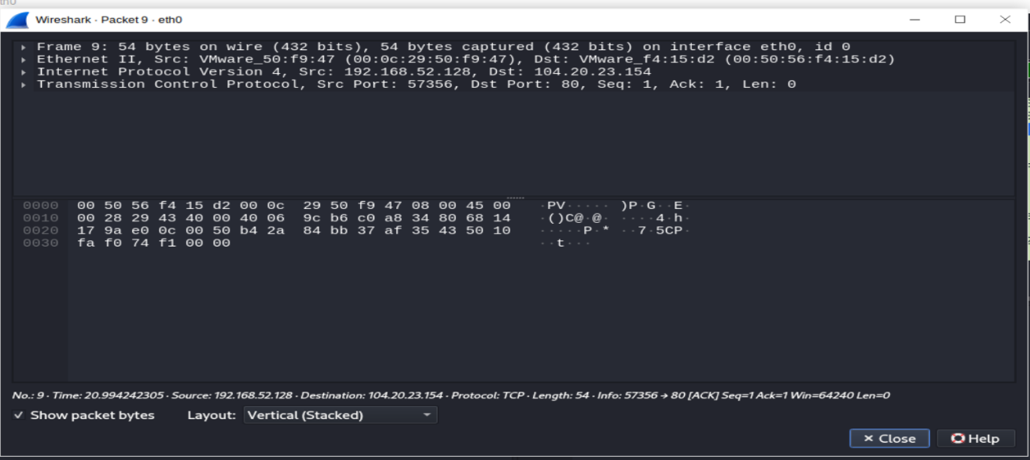

Caption: Figure 3: TCP Three-Way Handshake Captured Using Wireshark

8. UDP Traffic Analysis
8.1 Objective
The objective of UDP traffic analysis was to observe connectionless communication and identify the UDP packet used for DNS communication.
8.2 Traffic Generation
The following command was used to generate UDP-based DNS traffic:
nslookup example.com
8.3 Wireshark Filter
udp
8.4 Packet Details
Parameter | Observation
Frame | 26
Source IP | 192.168.52.128
Destination IP | 192.168.52.2
Protocol | UDP
Source Port | 55663
Destination Port | 53
Packet Length | 71 bytes
8.5 Observation
The captured packet showed UDP communication from the Kali Linux system to the DNS server. The destination port was 53, which is commonly used for DNS queries. Unlike TCP, UDP does not establish a connection using a three-way handshake before transmitting data.
8.6 Evidence
Figure 4: UDP Traffic Capture
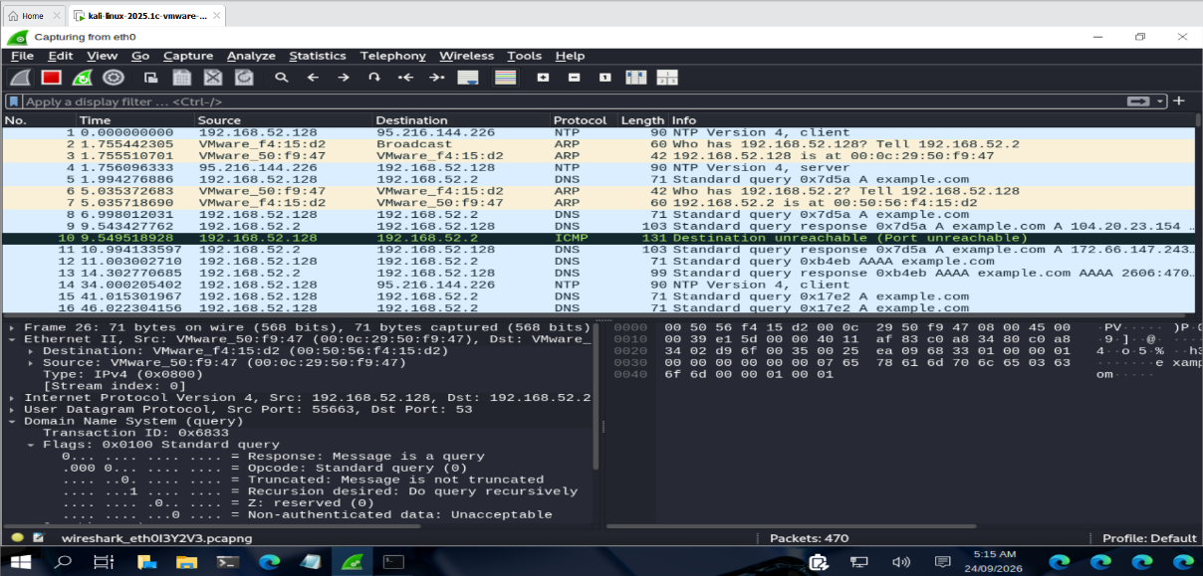
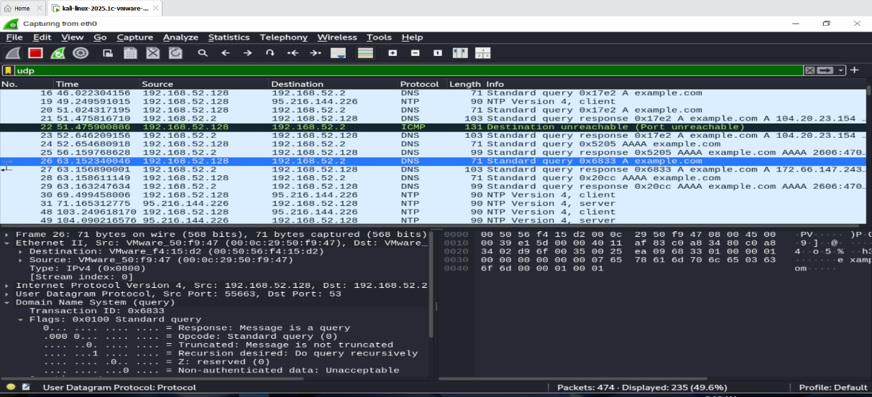
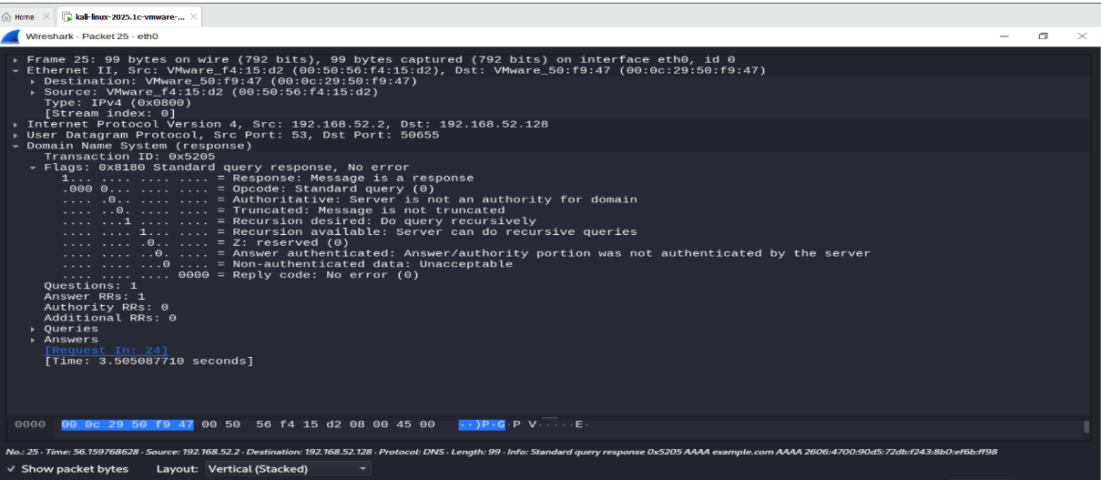

Caption: Figure 4: UDP DNS Traffic Captured Using Wireshark

9. ICMP Traffic Analysis
9.1 Objective
The objective of ICMP traffic analysis was to observe ICMP Echo Request and Echo Reply packets used to test network connectivity.
9.2 Traffic Generation
The following command was used:
ping -c 4 192.168.52.2
9.3 Wireshark Filter
icmp
9.4 Packet Details
Parameter | Observation
Request Source | 192.168.52.128
Request Destination | 192.168.52.2
Reply Source | 192.168.52.2
Reply Destination | 192.168.52.128
Protocol | ICMP
Request | Echo Request
Response | Echo Reply
Packet Size | 98 bytes
9.5 ICMP Communication
The captured traffic showed:
Echo Request:
192.168.52.128 → 192.168.52.2
Echo Reply:
192.168.52.2 → 192.168.52.128
The Echo Request is sent to check connectivity, while the Echo Reply indicates that the destination responded.
9.6 Observation
Wireshark successfully captured ICMP Echo Request and Echo Reply packets between the Kali Linux system and the DNS server. This demonstrated basic network connectivity between the two systems.
9.7 Evidence
Figure 5: ICMP Traffic Capture
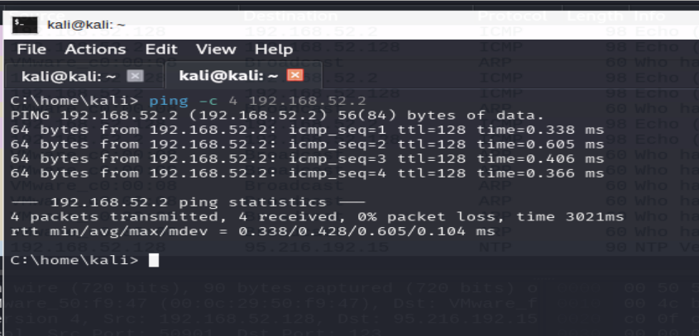
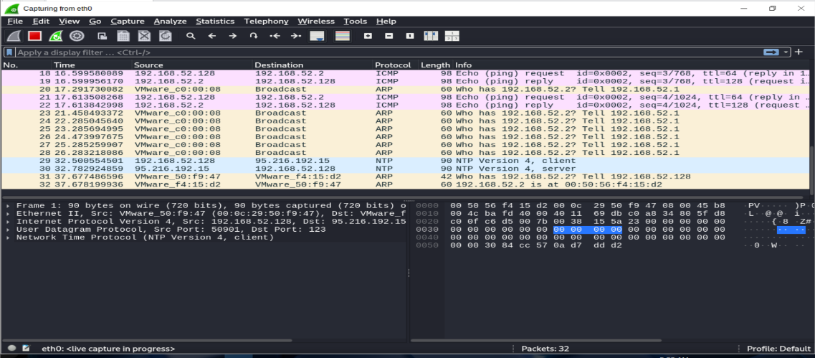
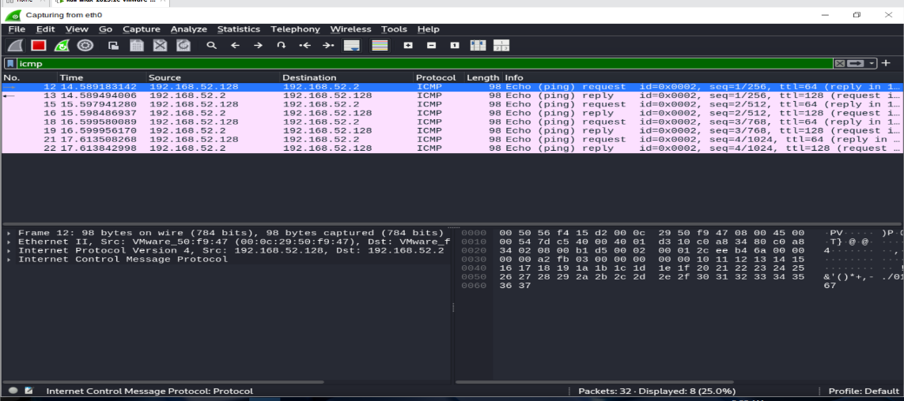
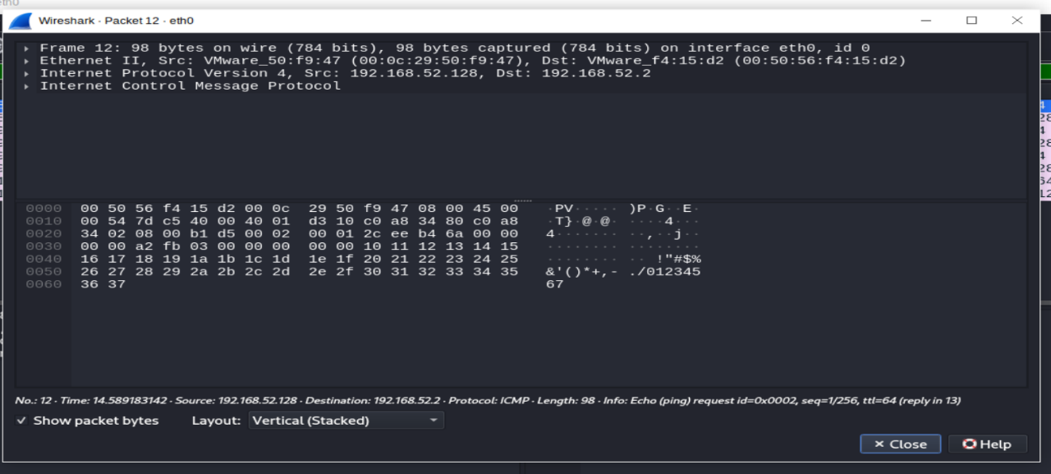
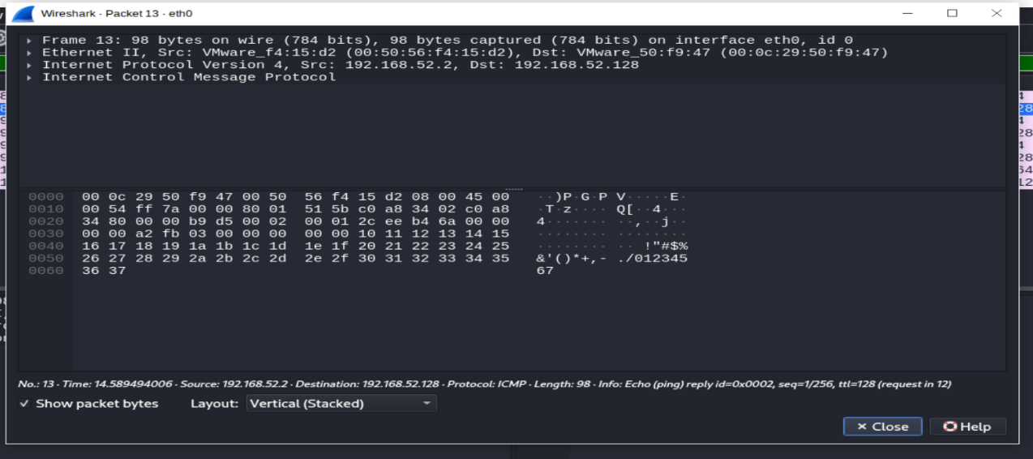

Caption: Figure 5: ICMP Echo Request and Echo Reply Captured Using Wireshark

10. HTTP Traffic Analysis
10.1 Objective
The objective of HTTP traffic analysis was to observe unencrypted web traffic and examine the data transmitted between the client and web server.
10.2 Traffic Generation
The following command was used:
curl http://neverssl.com
10.3 Wireshark Filter
http
10.4 Packet Details
Parameter | Observation
Source IP | 34.223.124.45
Destination IP | 192.168.52.128
Protocol | HTTP over TCP
Source Port | 80
Destination Port | 36820
Frame | 68
TCP Payload | 1661 bytes
Frame Size | 1715 bytes
Content Type | text/html
10.5 Traffic Analysis
The captured packet contained HTTP response data from the web server. The reassembled TCP data contained readable HTML content from the website.
Because HTTP traffic is not encrypted, the transmitted HTML content could be inspected directly in the packet capture.
10.6 Observation
The Wireshark capture demonstrated that HTTP data can be viewed in readable form when transmitted without encryption. This highlights the security advantage of using HTTPS for web communication.
10.7 Evidence
Figure 6: HTTP Traffic Capture
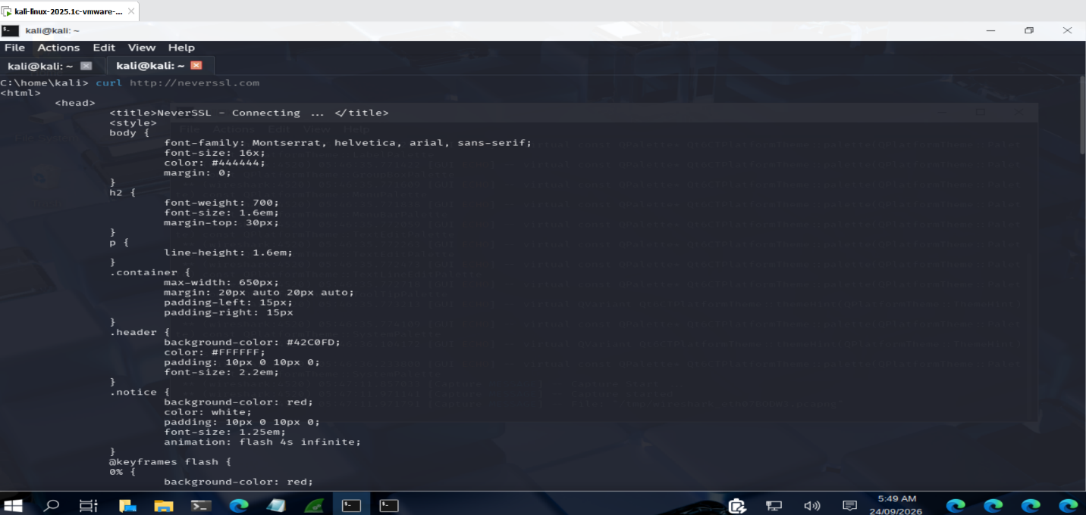
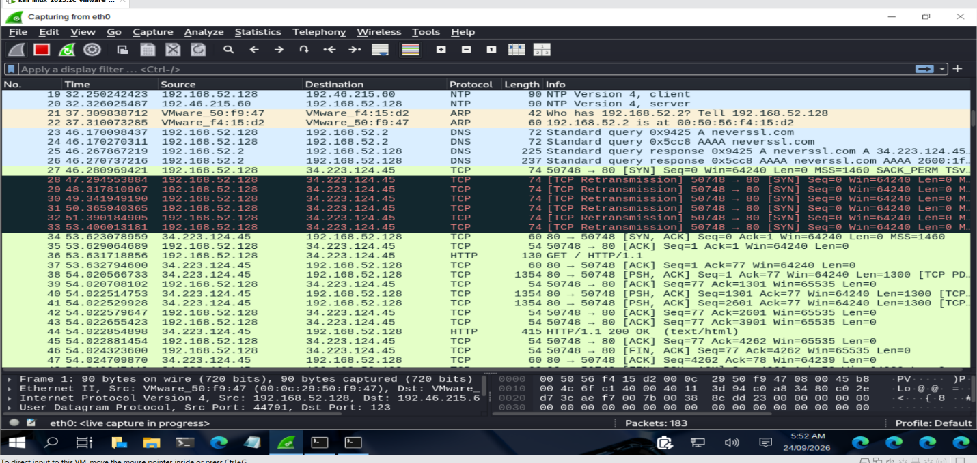
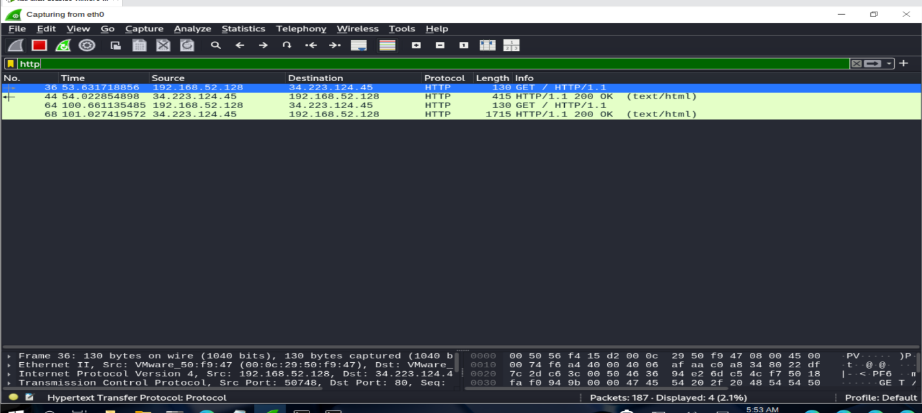
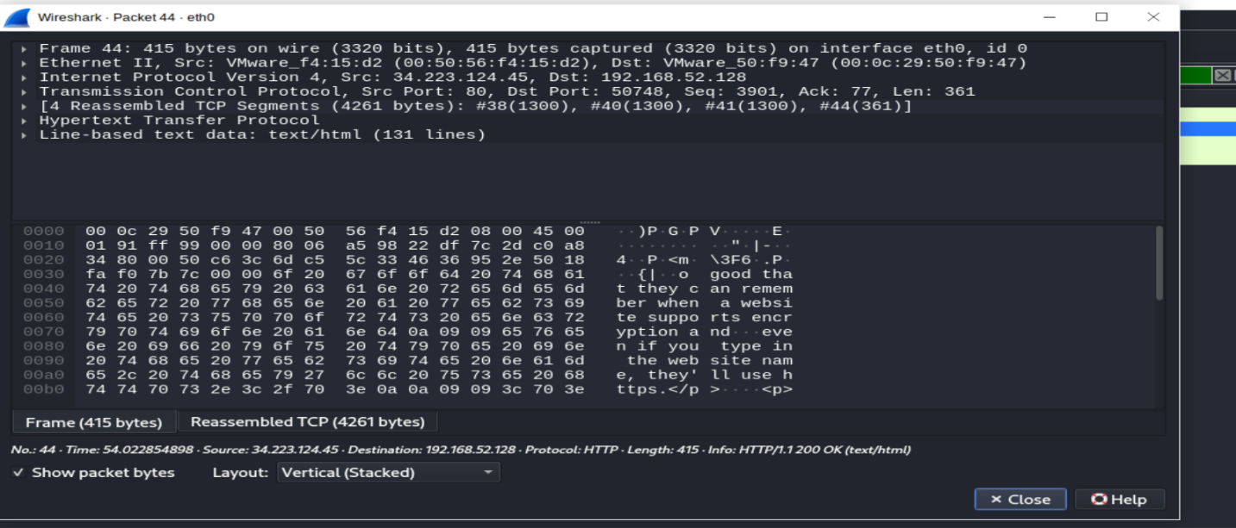

Caption: Figure 6: HTTP Traffic and Readable HTML Data Captured Using Wireshark

11. Findings and Observations
The captured network traffic was analyzed using Wireshark. The major findings for each protocol are summarized below.
11.1 Summary of Findings
Protocol | Key Finding
DNS | DNS query and response traffic was observed between the Kali Linux system and DNS server.
TCP | TCP three-way handshake (SYN, SYN-ACK, ACK) was successfully identified.
UDP | UDP traffic was observed during DNS communication using destination port 53.
ICMP | Echo Request and Echo Reply packets were captured successfully.
HTTP | Readable HTML data was observed in unencrypted HTTP traffic.
11.2 Detailed Observations
DNS:
The DNS capture demonstrated the process of resolving a domain name into IP addresses. Communication was observed between 192.168.52.128 and the DNS server 192.168.52.2.
TCP:
The TCP capture clearly demonstrated the three-way handshake required to establish a reliable connection. The sequence was SYN, SYN-ACK, and ACK.
UDP:
UDP traffic was identified during DNS communication. The captured packet used destination port 53 and demonstrated connectionless communication.
ICMP:
ICMP Echo Request and Echo Reply packets confirmed communication between the Kali Linux system and the DNS server.
HTTP:
The HTTP capture contained readable HTML content. This demonstrated that data transmitted through unencrypted HTTP can be inspected in a packet capture.
11.3 Security Observations
The analysis demonstrated that different network protocols have different communication characteristics. Packet analysis can provide useful information such as source and destination addresses, ports, protocol types, TCP flags, and transmitted content.
The HTTP capture particularly demonstrated the security limitation of transmitting web content without encryption. HTTPS should be used where confidentiality and integrity of web communication are required.

12. Security Analysis & Risk Identification
The captured traffic was analyzed from a network-security perspective to identify observable security considerations.
12.1 Security Analysis
Area | Observation | Security Consideration
DNS | DNS queries and responses were visible | DNS traffic can reveal domain-resolution activity
TCP | Connection establishment was visible | TCP metadata can reveal communicating endpoints and ports
UDP | DNS communication used UDP port 53 | UDP does not provide connection establishment like TCP
ICMP | Echo Request and Reply were visible | ICMP can be useful for network discovery and troubleshooting
HTTP | HTML content was readable | Unencrypted HTTP can expose transmitted web data
12.2 Identified Risks
1. Unencrypted HTTP Traffic
The HTTP capture contained readable HTML data. Unencrypted HTTP can expose information transmitted between a client and server.
2. Network Information Disclosure
Packet captures can reveal IP addresses, ports, protocols, and communication patterns. This information may be useful for network troubleshooting but can also provide useful information to an unauthorized observer.
3. DNS Visibility
DNS queries can reveal the domains being resolved by a system. This can provide information about network activity.
12.3 Recommended Security Measures
- Use HTTPS instead of unencrypted HTTP.
- Use secure DNS mechanisms where appropriate.
- Apply network segmentation and access controls.
- Monitor unusual network traffic using security monitoring tools.
- Restrict packet-capture access to authorized personnel.
- Use firewalls and appropriate network security controls.
- Regularly analyze network traffic for suspicious activity.

13. MITRE ATT&CK Mapping
MITRE ATT&CK is a knowledge base used to describe adversary tactics and techniques. The network traffic analysis performed in this project is relevant to the analysis of network communications and packet data.
13.1 Relevant Technique
MITRE ATT&CK Technique | Technique ID | Relevance to Project
Network Sniffing | T1040 | Wireshark was used to capture and inspect network packets and communication data.
13.2 Network Sniffing – T1040
Network Sniffing refers to monitoring or capturing network traffic to obtain information from network communications.
In this project, Wireshark was used in a controlled laboratory environment to capture DNS, TCP, UDP, ICMP, and HTTP traffic. The captured packets were analyzed to identify communication endpoints, ports, protocols, and transmitted data.
13.3 Project Relevance
The practical exercise demonstrates how packet-capture and traffic-analysis techniques can be used during network security monitoring and investigation. The activity was performed only on the authorized virtual laboratory environment.
13.4 Security Perspective
Network traffic analysis can help security professionals identify unusual communication patterns, investigate network events, and understand how systems communicate across a network.

14. Remediation & Security Recommendations
Based on the network traffic analysis, the following security recommendations can be considered to improve network communication security.
14.1 Use HTTPS
HTTP traffic observed during the analysis contained readable HTML data. Web applications should use HTTPS to encrypt communication between clients and servers.
14.2 Secure DNS Communication
DNS traffic should be protected where appropriate using secure DNS mechanisms such as DNS over HTTPS (DoH) or DNS over TLS (DoT), depending on the network requirements.
14.3 Network Monitoring
Network traffic should be continuously monitored to identify unusual connections, unexpected protocols, suspicious destinations, and abnormal communication patterns.
14.4 Firewall Configuration
Firewalls should be configured according to the principle of least privilege. Unnecessary ports and services should be restricted.
14.5 Access Control
Access to packet-capture tools and network monitoring systems should be limited to authorized users.
14.6 Network Segmentation
Critical systems should be separated using appropriate network segmentation. This can help limit the impact of a security incident.
14.7 Regular Security Analysis
Regular packet and network-log analysis can help identify unusual activity and support incident investigation.
14.8 Summary
The analysis demonstrated the importance of secure communication protocols, network monitoring, access control, and appropriate security controls in protecting network environments.

15. Conclusion & Key Learnings
15.1 Conclusion
The Network Traffic Analysis project provided practical experience in capturing and analyzing network packets using Wireshark in a controlled Kali Linux virtual environment.
DNS, TCP, UDP, ICMP, and HTTP traffic were successfully generated, captured, and analyzed. The analysis helped demonstrate DNS resolution, the TCP three-way handshake, UDP-based communication, ICMP connectivity testing, and the transmission of readable data through HTTP.
The project also demonstrated how network traffic analysis can support security monitoring and investigation. The practical observations highlighted the importance of encrypted communication, network monitoring, access control, and secure network configuration.
15.2 Key Learnings
The major skills and concepts learned during the project include:
- Understanding basic network communication.
- Using Wireshark for packet capture and analysis.
- Applying Wireshark display filters.
- Identifying DNS queries and responses.
- Understanding the TCP three-way handshake.
- Analyzing UDP communication.
- Identifying ICMP Echo Request and Echo Reply packets.
- Analyzing HTTP traffic and readable HTML data.
- Examining source and destination IP addresses.
- Identifying network ports and protocols.
- Understanding basic network security risks.
- Mapping relevant network analysis activity to MITRE ATT&CK.
- Documenting technical findings with screenshots and evidence.

16. References & Evidence
16.1 References
- Wireshark Documentation — Official documentation for packet capture and network protocol analysis.
- Kali Linux Documentation — Official documentation for the Kali Linux operating system and security tools.
- MITRE ATT&CK — Network Sniffing (T1040) technique reference.
- RFC 768 — User Datagram Protocol (UDP).
- RFC 793 — Transmission Control Protocol (TCP).
- RFC 792 — Internet Control Message Protocol (ICMP).
16.2 Project Evidence
The following screenshots were collected during the practical implementation:
No. | Evidence | Purpose
1 | NS-001_DNS_Traffic.png | DNS query and response
2 | NS-001_TCP_Handshake.png | TCP three-way handshake
3 | NS-001_UDP_Traffic.png | UDP/DNS communication
4 | NS-001_ICMP_Traffic.png | ICMP Echo Request and Reply
5 | NS-001_HTTP_Traffic.png | HTTP traffic and readable HTML
16.3 Project Repository
The complete project files, documentation, screenshots, evidence, configuration files, and supporting materials are maintained in the cybersecurity project repository.

