INTERNSHIP REPORT
WEEK 01

CYBERSECURITY INTERNSHIP
Internship Training Report

Submitted by
SAIF SAMI
Internship Domain : Cybersecurity

Internship Organization
NEXT GEN SOFTWARE HUB

Academic Institution
ORIENTAL COLLEGE OF TECHNOLOGY

Report Period
Week 01
Submission date
07 October, 2026

CIA Triad in Cybersecurity
1. Introduction
Cybersecurity is the practice of protecting computer systems, networks, applications, and data from unauthorized access, misuse, damage, or disruption.
One of the fundamental concepts of cybersecurity is the CIA Triad. CIA stands for Confidentiality, Integrity, and Availability. These three principles form the foundation for protecting information and maintaining secure systems.
2. What is the CIA Triad?
The CIA Triad is a cybersecurity model consisting of three important security principles:
- Confidentiality
- Integrity
- Availability
Organizations use these principles to identify security requirements and protect their information and systems.
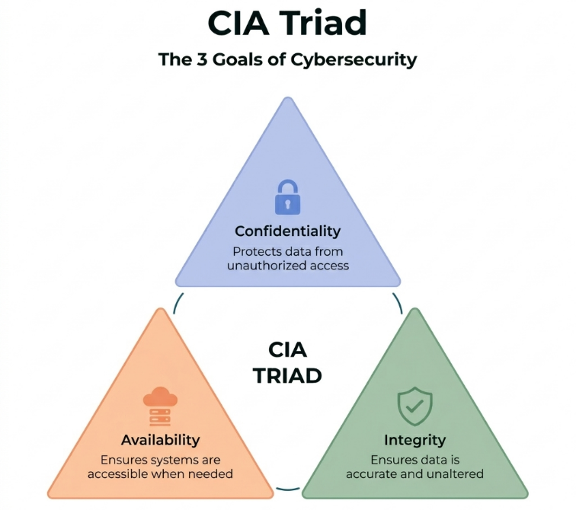
Figure 1: CIA Triad – Confidentiality, Integrity, and Availability

3. Confidentiality
Confidentiality means protecting information from unauthorized access or disclosure.
Only authorized users should be able to access sensitive information.
Example
Consider a college student database containing:
- Student names
- Roll numbers
- Contact information
- Academic records
This information should only be accessible to authorized staff and students. Passwords, access controls, and encryption can help maintain confidentiality.
Real-World Example
Online banking systems use authentication and encryption to prevent unauthorized people from accessing customers' financial information.
4. Integrity
Integrity means ensuring that information remains accurate, complete, and trustworthy.
Data should not be modified, deleted, or manipulated by unauthorized users.
Example
Suppose a college stores examination marks in a database. If an unauthorized person changes a student's marks, the information is no longer reliable.
Security controls such as access control, hashing, digital signatures, and audit logs can help protect data integrity.
Real-World Example
Financial institutions maintain transaction records carefully so that unauthorized users cannot modify account balances or transaction information.
5. Availability
Availability means ensuring that authorized users can access systems, applications, and information when they need them.
A system that is secure but unavailable to legitimate users cannot effectively provide its services.
Example
A college examination portal should remain available when students need to download examination forms or submit applications.
Organizations can improve availability through:
- Backup systems
- Redundant infrastructure
- Regular maintenance
- Disaster recovery procedures
- Protection against denial-of-service attacks
Real-World Example
Online shopping websites need to remain available during busy periods. If their servers become unavailable, customers cannot access products or complete purchases.
6. CIA Triad Example
Consider an online banking application.
Confidentiality
Only the account holder and authorized banking personnel should be able to access account information.
Integrity
Account balances and transaction records must not be changed without authorization.
Availability
Customers should be able to access their accounts and perform transactions when the banking service is operating.
This demonstrates how all three principles work together to protect information and services
7. Importance of the CIA Triad
The CIA Triad helps organizations understand their basic information-security requirements.
It helps protect:
- Sensitive information
- Customer data
- Financial information
- Business systems
- Network resources
- Applications and services
A security incident can affect one or more principles of the CIA Triad. For example, unauthorized disclosure affects confidentiality, unauthorized modification affects integrity, and a service outage affects availability.
8. Conclusion
The CIA Triad is one of the fundamental concepts of cybersecurity. Confidentiality protects information from unauthorized access, Integrity ensures that information remains accurate and trustworthy, and Availability ensures that authorized users can access systems and information when required.
Understanding these three principles provides a strong foundation for learning more advanced cybersecurity concepts such as vulnerabilities, cyber attacks, vulnerability assessment, penetration testing, and security monitoring.
9. References
- Cisco – Introduction to Cybersecurity
- Cybrary – Cybersecurity Overview
- Next Gen Software Hub Pvt. Ltd. – Cybersecurity Internship Task Plan

