Deep Learning
Midterm Project
A DNN for customer churn prediction and a CNN for image classification
Student name: SAIF UR REHMAN
Student ID: SP24 BBD 157
Date: October 31, 2026

Overview
This project builds two deep learning models on two different datasets, as required by the assignment. Each model follows the same pipeline: define a real-world problem, choose a dataset, preprocess it, design and train a network, evaluate it on unseen data, save it as a .joblib file and run inference with the reloaded file.
 | Model 1: DNN (ANN) | Model 2: CNN
Problem | Predict whether a telecom customer will churn | Recognize the object in a 32x32 photo
Task type | Binary classification (tabular data) | 10-class image classification
Dataset | Telco Customer Churn (7,043 customers) | CIFAR-10 (60,000 images)
Network | Dense 128-64-32 with BatchNorm and Dropout | 3 convolution blocks + dense classifier
Trainable parameters | 16,833 | 2,198,218
Key test result | Accuracy 78.8%, recall 66.9%, ROC-AUC 0.843 | Accuracy 91.15%
Saved model | churn_dnn_model.joblib (82 KB) | cifar10_cnn_model.joblib (8.8 MB)

Deliverables. DNN_Churn_Prediction.ipynb, CNN_CIFAR10_Classification.ipynb, churn_dnn_model.joblib, cifar10_cnn_model.joblib, and this document. All numbers and figures in this document come from the executed notebooks.

Part 1: DNN Model - Customer Churn Prediction

1.1 Problem Definition
Telecom companies lose a large share of their revenue when customers cancel their subscriptions, a problem known as churn. Acquiring a new customer costs far more than keeping an existing one, so companies want to identify customers who are likely to leave before they do, and offer them a retention deal.
Task: binary classification. Given a customer's account information (contract type, tenure, subscribed services, charges and so on), predict whether the customer will churn (Yes or No).
Success criterion: only about a quarter of customers churn, so accuracy alone is misleading (a model that always answers "No churn" is already 73.5% accurate). The model is therefore judged mainly on recall (how many real churners are found), precision (how many alarms are correct), F1 and ROC-AUC.

1.2 Dataset Description and Source
Property | Details
Name | Telco Customer Churn (IBM sample dataset)
Source link | https://github.com/IBM/telco-customer-churn-on-icp4d
Also available at | https://www.kaggle.com/datasets/blastchar/telco-customer-churn
Size | 7,043 customers, 21 columns (19 input features, customerID, and the target Churn)
Demographic features | gender, SeniorCitizen, Partner, Dependents
Account features | tenure, Contract, PaperlessBilling, PaymentMethod
Service features | PhoneService, MultipleLines, InternetService, OnlineSecurity, OnlineBackup, DeviceProtection, TechSupport, StreamingTV, StreamingMovies
Charge features | MonthlyCharges, TotalCharges
Target | Churn: 73.5% No, 26.5% Yes (imbalanced)

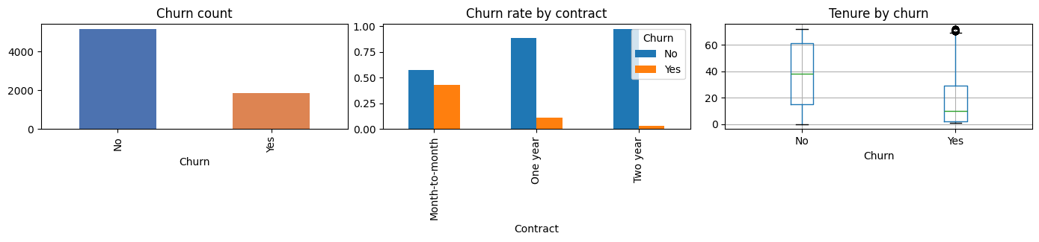
Figure 1. Exploratory analysis: class balance, churn rate by contract type and tenure by churn status.
The exploratory plots show that customers on month-to-month contracts churn far more often than those on one- or two-year contracts, and that churners tend to have a shorter tenure. These are the patterns the network is expected to learn.

1.3 Proposed Solution
A fully connected Deep Neural Network (ANN) takes the preprocessed customer features and outputs the probability that the customer will churn. Three design decisions address the specific difficulties of this dataset:
- Mixed data types: numeric columns are standardised and categorical columns are one-hot encoded.
- Class imbalance: the loss function is weighted so that missing a churner costs more than a false alarm.
- Overfitting and threshold: Batch Normalisation, Dropout, weight decay and early stopping limit overfitting, and the decision threshold is tuned on validation data instead of using the default 0.5.

1.4 Data Preprocessing
- TotalCharges is stored as text and contains blank strings for brand-new customers (tenure = 0). It was converted to a number, with blanks filled with 0.
- customerID was dropped because it is only an identifier.
- The target was encoded as Yes = 1, No = 0.
- The data was split with stratification into 70% training, 15% validation and 15% test sets, so each set keeps the same churn rate.
- StandardScaler (numeric columns) and OneHotEncoder (categorical columns) were combined in one transformer. It was fit on the training set only, to avoid data leakage, and then applied to the validation and test sets. This gives 46 input features.
- The class imbalance is handled in the loss with pos_weight = (number of non-churners) / (number of churners) in the training set.

Split | Customers | Share | Churn rate
Training | 4,930 | 70% | 26.5%
Validation | 1,056 | 15% | 26.5%
Test | 1,057 | 15% | 26.6%

1.5 Model Architecture
The network has three hidden blocks, each made of Linear, Batch Normalisation, ReLU and Dropout (0.3), followed by a single output unit. The output is a raw score (logit); a sigmoid turns it into the churn probability.
Layer | Output size | Details
Input | 46 | scaled numeric + one-hot categorical features
Dense 1 | 128 | Linear, BatchNorm, ReLU, Dropout 0.3
Dense 2 | 64 | Linear, BatchNorm, ReLU, Dropout 0.3
Dense 3 | 32 | Linear, BatchNorm, ReLU, Dropout 0.3
Output | 1 | Linear; sigmoid gives P(churn)

Training setting | Value
Trainable parameters | 16,833
Loss function | Binary cross-entropy with logits, pos_weight for class imbalance
Optimizer | Adam, learning rate 0.001, weight decay 0.0001
Learning-rate schedule | ReduceLROnPlateau (factor 0.5, patience 5)
Batch size / maximum epochs | 128 / 150
Early stopping | patience 12 epochs on validation loss; best weights restored
Random seed | 42

1.6 Training Results and Evaluation

Training
Training stopped automatically at epoch 18 through early stopping, and the weights from the epoch with the lowest validation loss (0.7222) were restored. Training and validation curves stay close together, so the network is not overfitting.
Epoch | Train loss | Train accuracy | Validation loss | Validation accuracy
1 | 0.8386 | 0.685 | 0.7780 | 0.679
5 | 0.7215 | 0.735 | 0.7290 | 0.710
10 | 0.7128 | 0.747 | 0.7320 | 0.706
15 | 0.6941 | 0.750 | 0.7289 | 0.723

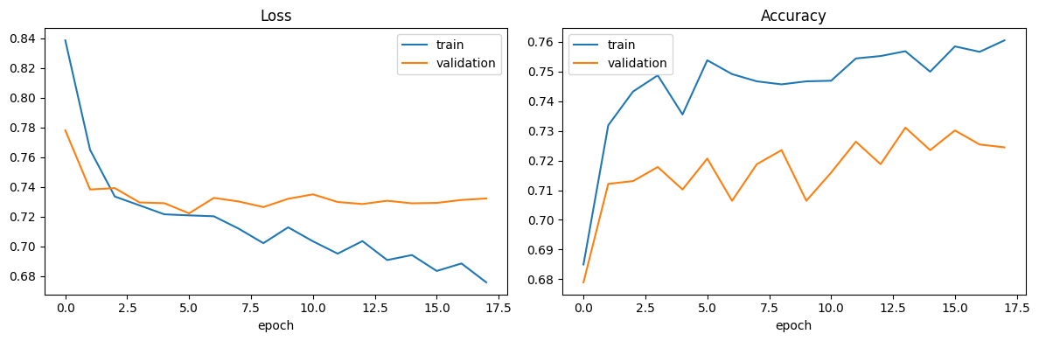
Figure 2. DNN training and validation loss and accuracy per epoch.
The accuracy during training (about 0.72 on validation) is lower than the final test accuracy because the weighted loss pushes the model to predict churn more often, and the training accuracy is computed with the default threshold of 0.5. Tuning the threshold on the validation set (best F1 at 0.633) corrects this balance.

Test-set evaluation
The threshold (0.633) was chosen on the validation set only and then applied unchanged to the 1,057 unseen test customers.
Metric | Test result
Accuracy | 0.7881
Precision (churn) | 0.5893
Recall (churn) | 0.6690
F1 score (churn) | 0.6267
ROC-AUC | 0.8434

Class | Precision | Recall | F1 | Support
No churn | 0.87 | 0.83 | 0.85 | 776
Churn | 0.59 | 0.67 | 0.63 | 281

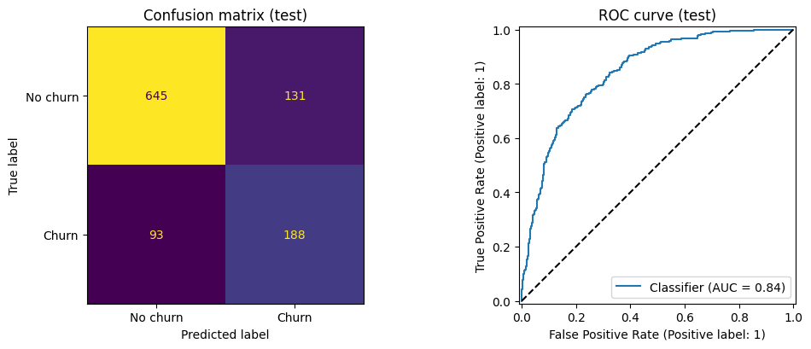
Figure 3. Confusion matrix and ROC curve on the test set (AUC = 0.84).
 | Predicted: No churn | Predicted: Churn
Actual: No churn | 645 (true negatives) | 131 (false positives)
Actual: Churn | 93 (false negatives) | 188 (true positives)

Interpretation. The model finds 188 of the 281 customers who actually left (67%). It raises 131 false alarms, which is the price of that recall; for a retention campaign this is usually acceptable, because offering a discount to a customer who would have stayed costs much less than losing a customer. The ROC-AUC of 0.84 means that a randomly chosen churner receives a higher risk score than a randomly chosen non-churner 84% of the time.

1.7 Saved Model and Inference
The trained model was saved as churn_dnn_model.joblib (82 KB). The file stores the network weights, the architecture settings, the fitted preprocessing transformer, the tuned threshold (0.633), the expected input columns and the test metrics, so a new application can reproduce training-time preprocessing exactly.
In the inference step the notebook loads the .joblib file from disk, rebuilds the network and predicts churn for new customers from their raw fields. Results:
Customer | Churn probability | Prediction | Actual
Hand-written: month-to-month, fibre, no add-ons, tenure 2 months | 0.8978 | Churn | -
Hand-written: two-year contract, tenure 60 months, security and support | 0.1779 | No churn | -
Held-out test customer 1 | 0.6760 | Churn | Churn
Held-out test customer 2 | 0.2518 | No churn | No churn
Held-out test customer 3 | 0.0937 | No churn | No churn
Held-out test customer 4 | 0.3572 | No churn | No churn
Held-out test customer 5 | 0.0379 | No churn | No churn

The high-risk profile is correctly scored as very likely to churn and the loyal profile as unlikely to churn, and all five held-out customers shown were classified correctly. As a consistency check, the reloaded model reproduced the in-memory test probabilities with a maximum difference of 0.00005 (the 4-decimal rounding of the printed probabilities).

1.8 Conclusion (DNN)
The DNN reached a test accuracy of 78.8%, precision of 0.589, recall of 0.669, F1 of 0.627 and ROC-AUC of 0.843 on 1,057 unseen customers, clearly better than the 73.5% baseline of always predicting "No churn". Class weighting and a validation-tuned threshold made the model useful for the actual business goal of finding customers at risk, at the cost of a moderate number of false alarms. Dropout, Batch Normalisation, weight decay and early stopping kept training and validation performance aligned.
Limitations and future work: results come from a single train/validation/test split; the model was not compared with other methods such as gradient boosting, which is often strong on tabular data; techniques such as SMOTE or focal loss and SHAP-based explanations of individual predictions could improve and explain the results further.

Part 2: CNN Model - Object Recognition on CIFAR-10

2.1 Problem Definition
Many real-world systems must recognise what appears in a photo automatically: sorting images in photo and e-commerce apps, content moderation, wildlife camera traps, driver-assistance systems and robotics. Doing this by hand-written rules is impractical because the same object looks different under different angles, lighting and backgrounds.
Task: multi-class image classification. Given a small colour image, predict which of 10 object categories it shows: airplane, automobile, bird, cat, deer, dog, frog, horse, ship or truck.

2.2 Dataset Description and Source
Property | Details
Name | CIFAR-10
Source link | https://www.cs.toronto.edu/~kriz/cifar.html (loaded through torchvision.datasets.CIFAR10)
Size | 60,000 colour images of 32x32 pixels: 50,000 training and 10,000 test images
Classes | 10 mutually exclusive classes, perfectly balanced (6,000 images per class)
Split used | 45,000 training / 5,000 validation / 10,000 test

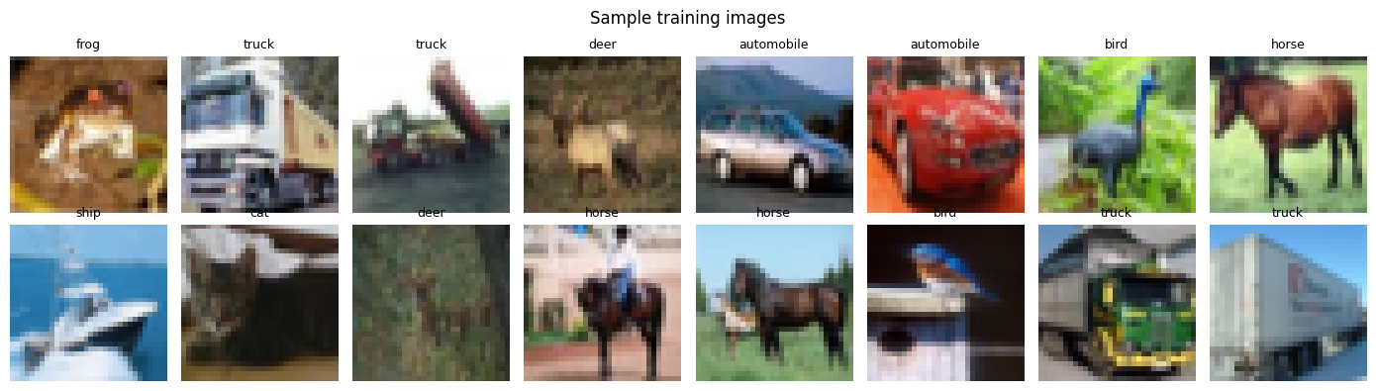
Figure 4. Sample CIFAR-10 training images with their class labels.

2.3 Proposed Solution
A Convolutional Neural Network learns visual features directly from pixels. Convolution layers detect edges, textures and shapes, pooling layers reduce the image resolution while keeping the strongest responses, and dense layers turn the extracted features into class scores. To get good accuracy from only 45,000 training images, the solution combines:
- per-channel input normalisation;
- data augmentation (random crops and horizontal flips) so the network sees a different variant of each image every epoch;
- Batch Normalisation and Dropout for regularisation;
- the AdamW optimizer with a One-Cycle learning-rate schedule for fast, stable convergence.

2.4 Data Preprocessing
- Pixel values were scaled to the range [0, 1] and normalised per channel with the CIFAR-10 training mean (0.4914, 0.4822, 0.4465) and standard deviation (0.2470, 0.2435, 0.2616).
- Augmentation was applied to the training images only: random 32x32 crop from a 4-pixel padded image, and random horizontal flip.
- The validation and test images receive no augmentation, only normalisation, so the evaluation reflects real, unmodified images.
- 5,000 of the 50,000 training images were held out as a validation set with a fixed random seed; the official 10,000 test images were kept untouched for the final evaluation.

2.5 Model Architecture
The network has three VGG-style convolution blocks. Each block has two 3x3 convolutions (each followed by Batch Normalisation and ReLU), a 2x2 max pooling that halves the resolution, and Dropout. The channel count doubles from block to block while the image size shrinks, followed by a small dense classifier.
Stage | Output shape | Details
Input | 3 x 32 x 32 | normalised RGB image
Block 1 | 64 x 16 x 16 | 2 x (Conv 3x3, BatchNorm, ReLU), MaxPool 2, Dropout 0.1
Block 2 | 128 x 8 x 8 | 2 x (Conv 3x3, BatchNorm, ReLU), MaxPool 2, Dropout 0.2
Block 3 | 256 x 4 x 4 | 2 x (Conv 3x3, BatchNorm, ReLU), MaxPool 2, Dropout 0.3
Flatten | 4,096
Dense | 256 | Linear, BatchNorm, ReLU, Dropout 0.5
Output | 10 | class scores (softmax gives probabilities)

Training setting | Value
Trainable parameters | 2,198,218
Loss function | Cross-entropy
Optimizer | AdamW, weight decay 0.0005
Learning-rate schedule | One-Cycle, maximum learning rate 0.003
Batch size / epochs | 128 / 25
Hardware | GPU (CUDA) on Google Colab, mixed precision
Model selection | weights from the epoch with the best validation accuracy
Random seed | 42

2.6 Training Results and Evaluation

Training
Validation accuracy rose from 52.5% after the first epoch to 91.7% at the end, and the best validation accuracy (91.72%, epoch 24) was used for the final model. Training accuracy reached 94.5%, only about 2.8 percentage points above validation accuracy, which shows mild overfitting that augmentation and Dropout kept under control.
Epoch | Train loss | Train accuracy | Validation loss | Validation accuracy
1 | 1.6272 | 0.4058 | 1.3016 | 0.5250
5 | 0.7816 | 0.7267 | 0.7338 | 0.7464
10 | 0.5092 | 0.8271 | 0.5157 | 0.8268
15 | 0.3496 | 0.8812 | 0.3542 | 0.8818
20 | 0.2244 | 0.9237 | 0.2615 | 0.9086
25 | 0.1599 | 0.9450 | 0.2510 | 0.9170

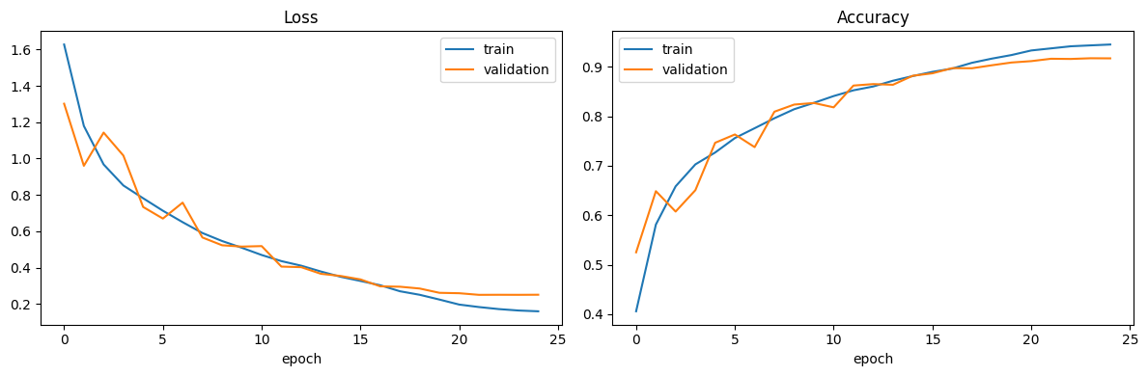
Figure 5. CNN training and validation loss and accuracy over 25 epochs.

Test-set evaluation
The CNN classified 9,115 of the 10,000 unseen test images correctly: test accuracy 91.15% (random guessing would give 10%). Precision, recall and F1 are all 0.911 on average across the 10 balanced classes.
Class | Precision | Recall | F1 | Support
airplane | 0.912 | 0.919 | 0.915 | 1000
automobile | 0.948 | 0.969 | 0.958 | 1000
bird | 0.895 | 0.866 | 0.880 | 1000
cat | 0.845 | 0.774 | 0.808 | 1000
deer | 0.912 | 0.925 | 0.919 | 1000
dog | 0.834 | 0.889 | 0.861 | 1000
frog | 0.929 | 0.935 | 0.932 | 1000
horse | 0.939 | 0.940 | 0.940 | 1000
ship | 0.949 | 0.950 | 0.950 | 1000
truck | 0.951 | 0.948 | 0.949 | 1000

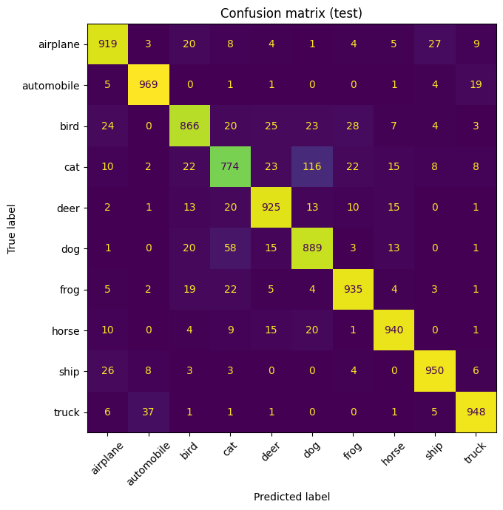
Figure 6. Confusion matrix on the 10,000 test images.
Interpretation. Vehicles and ships are recognised best (F1 of about 0.95 for automobile, ship and truck), because they have distinctive shapes. Animals are harder: cat has the lowest F1 (0.808), and the confusion matrix shows the largest error is 116 cats predicted as dogs, followed by 58 dogs predicted as cats. Other notable confusions are truck and automobile (37 and 19) and airplane and ship (27 and 26), pairs that look alike at 32x32 resolution.
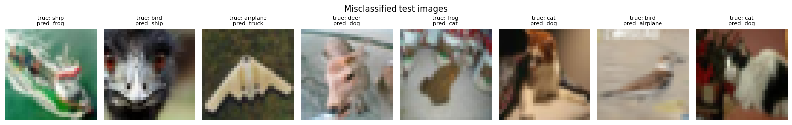
Figure 7. Examples of misclassified test images (true and predicted class above each image).

2.7 Saved Model and Inference
The trained CNN was saved as cifar10_cnn_model.joblib (8.8 MB). The file contains the network weights, the architecture settings, the class names and the normalisation constants, so inference applies exactly the same preprocessing as training.
In the inference step the notebook loads the .joblib file, rebuilds the network, and classifies images through a predict_image function that accepts any picture (it is converted to RGB, resized to 32x32 and normalised). The notebook also lets the user upload their own photo.
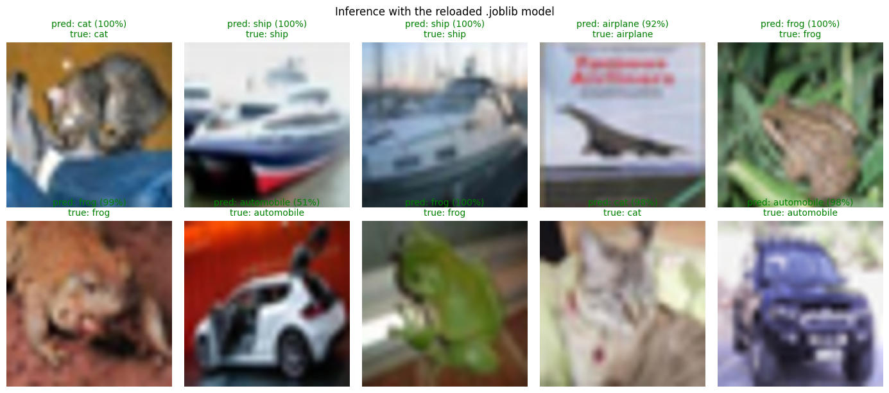
Figure 8. Predictions of the reloaded .joblib model on ten test images (green = correct).
- All ten displayed test images were classified correctly. Nine were predicted with 92% to 100% confidence; the lowest confidence was 51% for one automobile image (the white car with open doors).
- Top-3 output for test image 0: cat 99.67%, dog 0.32%, frog 0.006%.
- Consistency check: the reloaded model scored 0.9115 on the full test set, identical to the in-memory model.

2.8 Conclusion (CNN)
The CNN achieved 91.15% accuracy on the 10,000 test images of CIFAR-10, with balanced per-class performance (macro F1 0.911). Convolution blocks with Batch Normalisation, data augmentation, Dropout and a One-Cycle learning-rate schedule produced a model that generalises well: validation accuracy followed training accuracy closely, and the final gap was under 3 percentage points. The remaining errors are concentrated in visually similar classes, mainly cat versus dog, which is expected for tiny 32x32 images.
Limitations and future work: the input resolution is very low; deeper architectures such as ResNet, transfer learning from ImageNet-pretrained models, and stronger augmentation such as CutMix or MixUp are the natural next steps to push accuracy above 95%.

Part 3: Overall Conclusion and Submission Files
Both models met the requirements of the assignment: each solves a real-world problem on its own dataset, is trained with a documented preprocessing pipeline, is evaluated on a held-out test set with appropriate metrics, is saved as a .joblib file and is reloaded for inference. The DNN shows how weighted loss and threshold tuning make a network useful on an imbalanced tabular problem (ROC-AUC 0.843, recall 0.669), and the CNN shows how convolution, augmentation and regularisation reach 91.15% accuracy on a 10-class image problem.
File | Contents
DNN_Churn_Prediction.ipynb | Source code and outputs for Model 1 (churn prediction)
CNN_CIFAR10_Classification.ipynb | Source code and outputs for Model 2 (CIFAR-10)
churn_dnn_model.joblib | Trained DNN, preprocessing transformer and decision threshold
cifar10_cnn_model.joblib | Trained CNN, class names and normalisation constants

How to reproduce. Open each notebook in Google Colab and choose Runtime > Run all. The DNN notebook runs on a CPU in a few minutes; the CNN notebook should use a GPU runtime. Both notebooks download their datasets automatically. To use a saved model in a new session, define the corresponding network class (ChurnDNN or CifarCNN, shown in each notebook), then load the .joblib file with joblib.load and rebuild the network from the stored configuration and weights.
Why .joblib. joblib stores Python objects efficiently, which lets one file hold the network weights together with the scikit-learn preprocessing objects (scaler and encoder) that inference depends on.

