CMOS NAND Gate Without Capacitive Load:
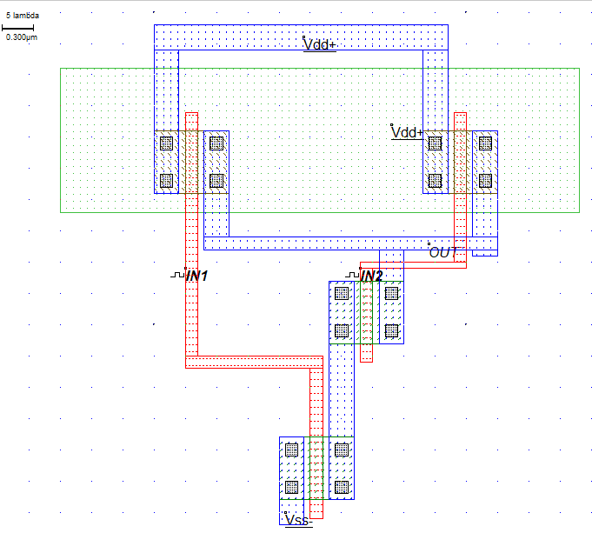
Simulation Results:
Voltage vs Time
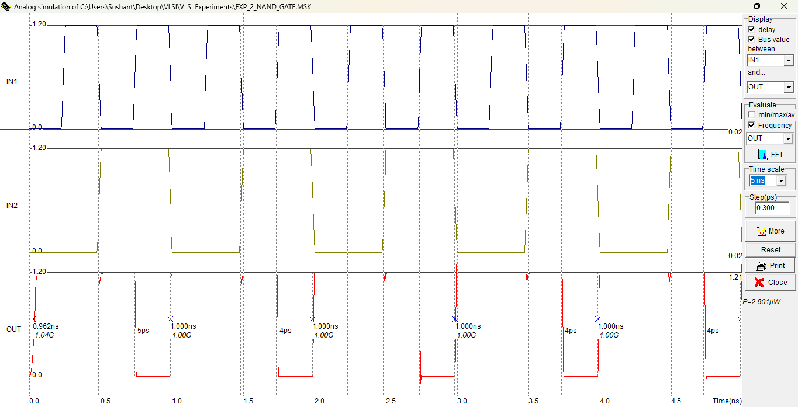

CMOS NAND with Capacitive Load
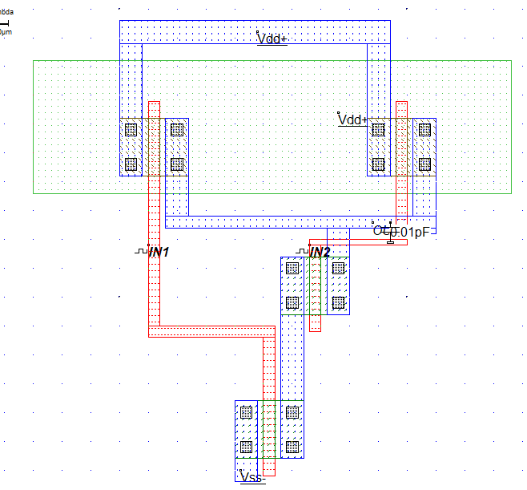

Voltage vs Time:
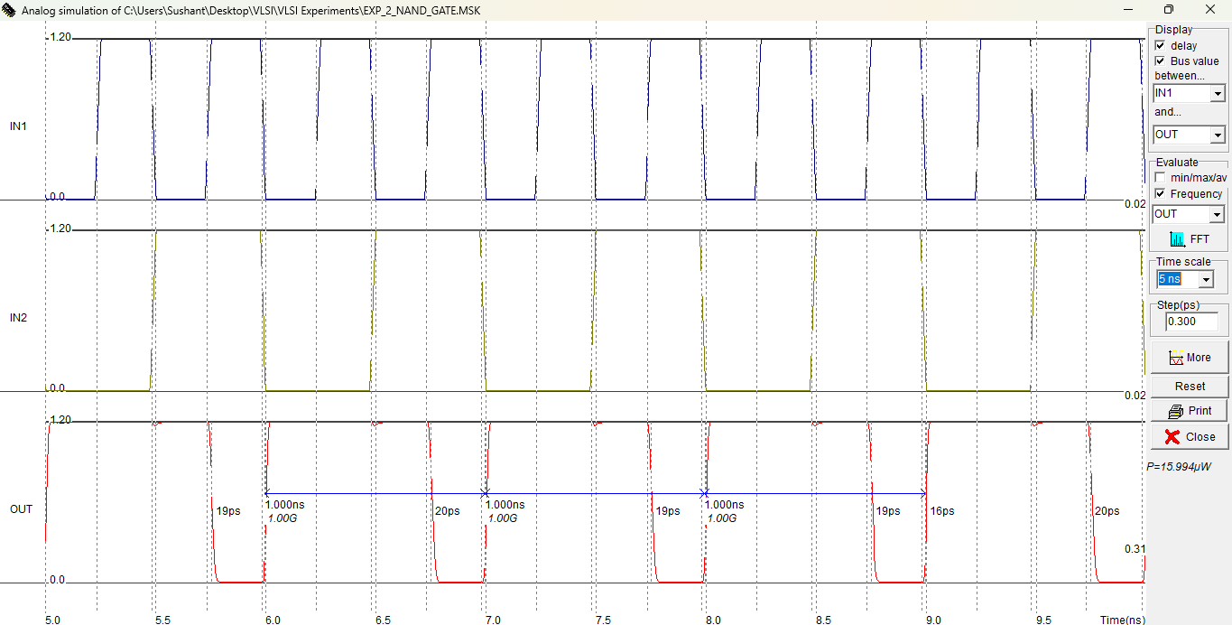

CMOS NOR gate without Capacitive Load:
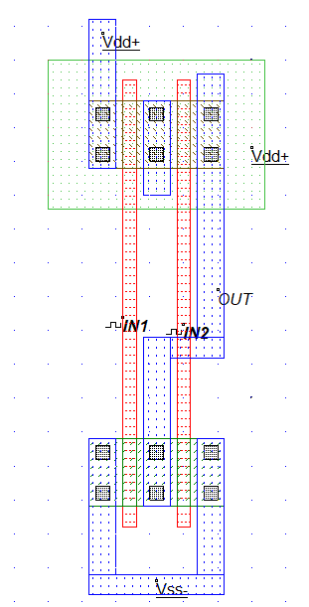

Simulation Results:
Voltage vs Time
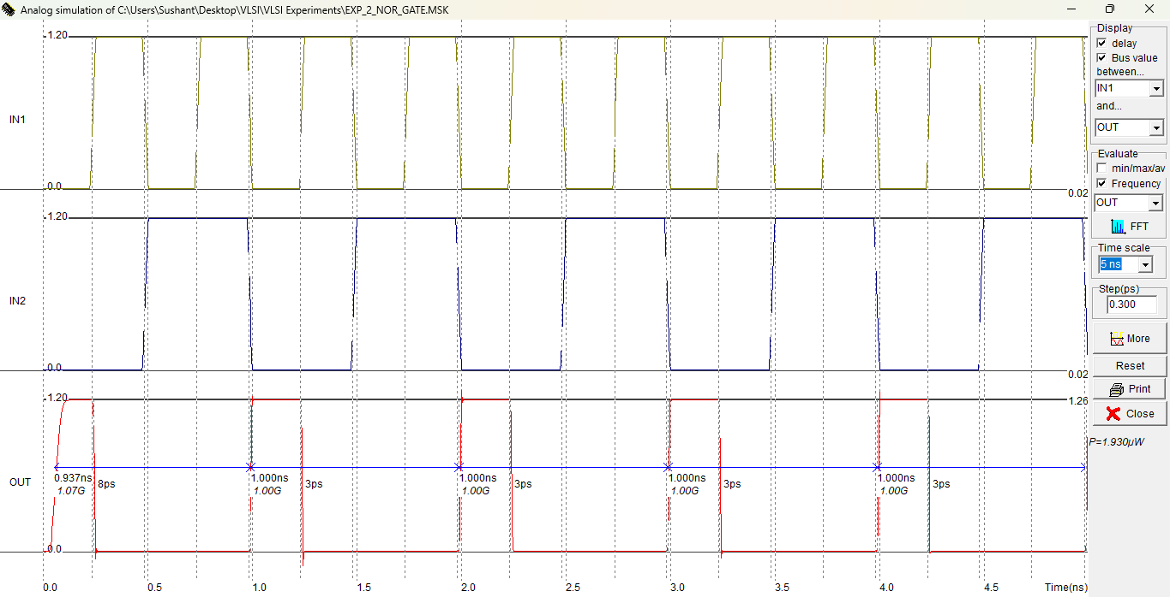
CMOS NOR Gate with Capacitive Load:
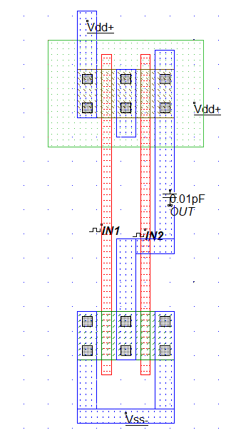
Simulation Results:
