CMOS Layout for Half Adder:
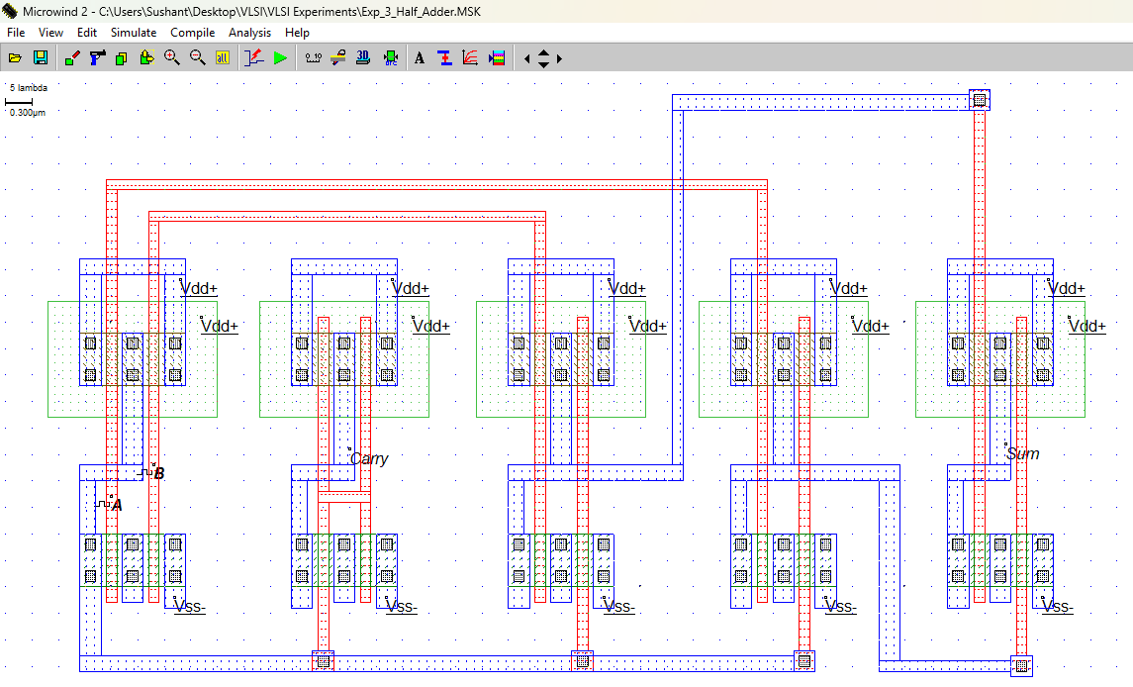

Simulation Results:
Voltage vs Time
