CMOS Inverter Without Capacitive Load Layout:
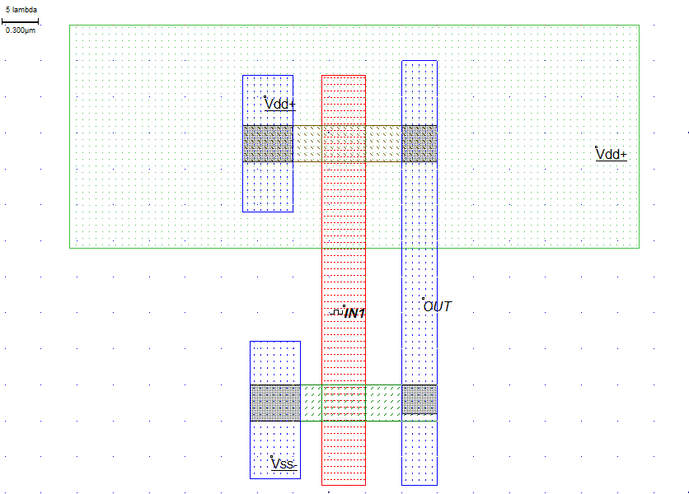
Simulation Result:
1.Voltage vs Time
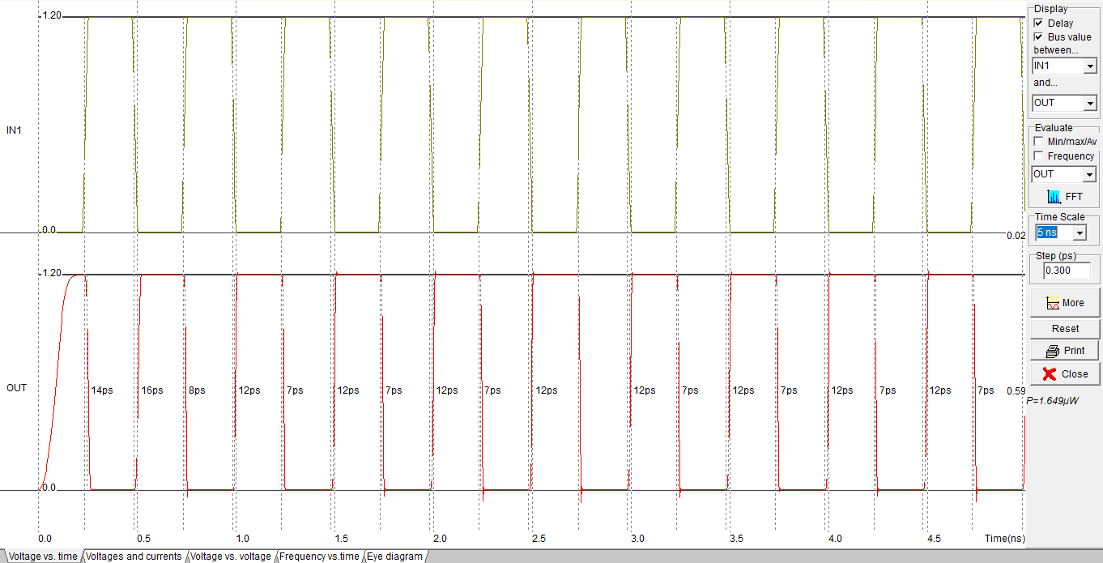

CMOS Inverter with Capacitive Load Layout:
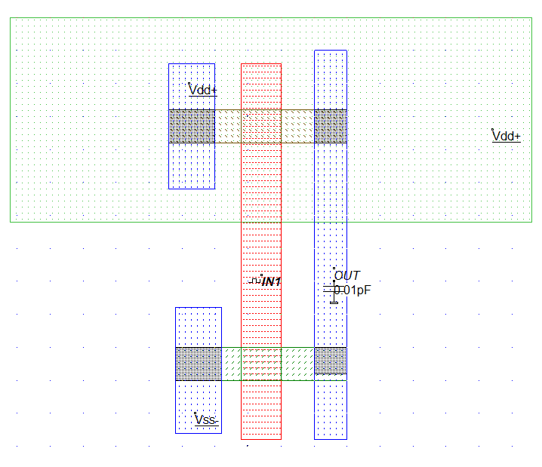

1.Voltage vs Time
