Experiment 8: Model and verify Modulo-N-Counter (MOD_N) using VHDL and implement on FPGA and evaluate power and timing performance.
Program:

library IEEE;
use IEEE.STD_LOGIC_1164.all;
use ieee.std_logic_arith.all;
use ieee.std_logic_unsigned.all;
entity modN_counter is
generic(n: integer := 128);
port(
clk : in STD_LOGIC;
reset : in STD_LOGIC;
dout : out STD_LOGIC_VECTOR(6 downto 0)
);
end modN_counter;
architecture A_modN of modN_counter is
signal temp:std_logic_vector(22 downto 0);
signal sclk:std_logic;
begin
p11: process(clk,reset)
begin
if(reset='1')then temp<=(others=>'0');
elsif(clk'event and clk='1') then
temp<= temp + 1;
end if;
end process;
sclk<=temp(22);
counter : process (sclk,reset) is
variable m : integer range 0 to (n-1) := 0;
begin
if (reset='1') then
m := 0;
--elsif (rising_edge (clk)) then
elsif(sclk'event and sclk='1') then
m := m + 1;
end if;
if (m=(n)) then
m := 0;
end if;
dout<= conv_std_logic_vector (m,7);
end process counter;
end A_modN;

UCF File:
NET "reset" LOC = "E4";
NET "CLK" LOC ="L15";
NET "dout<0>" LOC = "U18"; # Bank = 1, Pin name = IO_L52N_M1DQ15, Sch name = LD0
NET "dout<1>" LOC = "M14"; # Bank = 1, Pin name = IO_L53P, Sch name = LD1
NET "dout<2>" LOC = "N14"; # Bank = 1, Pin name = IO_L53N_VREF, Sch name = LD2
NET "dout<3>" LOC = "L14"; # Bank = 1, Pin name = IO_L61P, Sch name = LD3
NET "dout<4>" LOC = "M13"; # Bank = 1, Pin name = IO_L61N, Sch name = LD4
NET "dout<5>" LOC = "D4"; # Bank = 1, Pin name = IO_L61P, Sch name = LD3
NET "dout<6>" LOC = "P16"; # Bank = 1, Pin name = IO_L61P, Sch name = LD3
#NET "dout<7>" LOC = "N12";
Simulation Results:

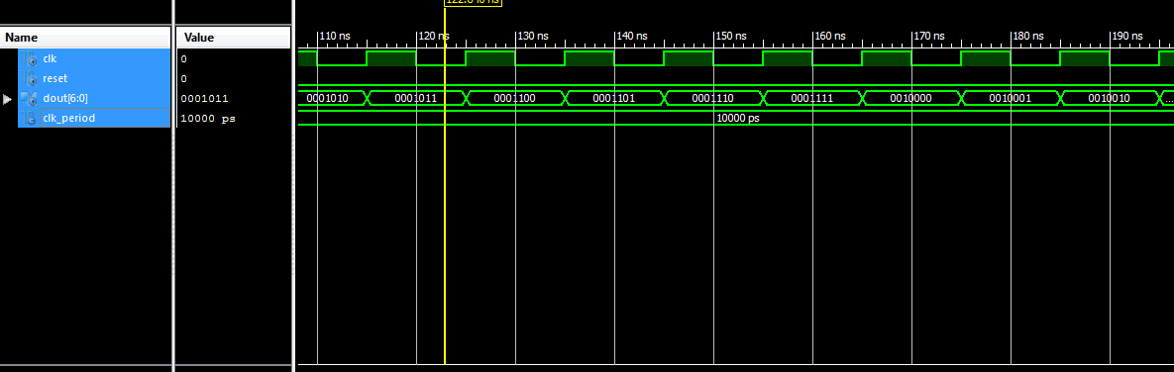
Implementation on FPGA Board:
